DSP LAB TEST 2 report:

M Amshunath

22EE10042

Experiment 4 set 1:

1.

Matlab code to determine and plot X1 and X2

clc

clear

close all

%F1=5000sam/sec

%F2=1000sam/sec

t1=-0.005:0.0002:0.005;

t2=-0.025:0.001:0.025;

%time limits assigned

%as mentioned

x1=exp(-1000*abs(t1));

x2=exp(-1000*abs(t2));

X1=zeros(50);

X2=zeros(50);

%determination of X1(jw) and X2(jw) using for loop

for i=1:50

X1(i)=0;

for j=1:50

X1(i)=X1(i)+x1(i)*exp(-j*2*pi*(i-1)*(j-1)/50);

end

end

for i=1:50

X2(i)=0;

for j=1:50

X2(i)=X2(i)+x2(i)*exp(-j*2*pi*(i-1)*(j-1)/50);

end

end

figure;

subplot(4,1,1);

stem(t1,x1);

title('with sampling frequency as 5000');

xlabel('t with limits as (-0.005,0.005)');

ylabel('x1(n)');

subplot(4,1,2);

stem(t2,x2);

xlabel('t with limits as (-0.025,0.025)');

ylabel('x2(n)');

title('with sampling frequency as 1000');

subplot(4,1,3);

plot(X1);

xlim([1,50]);

title('plot of X1');

subplot(4,1,4);

plot(X2);

xlim([1,50]);

title('plot of X2');

sgtitle('M Amshunath 22EE10042');

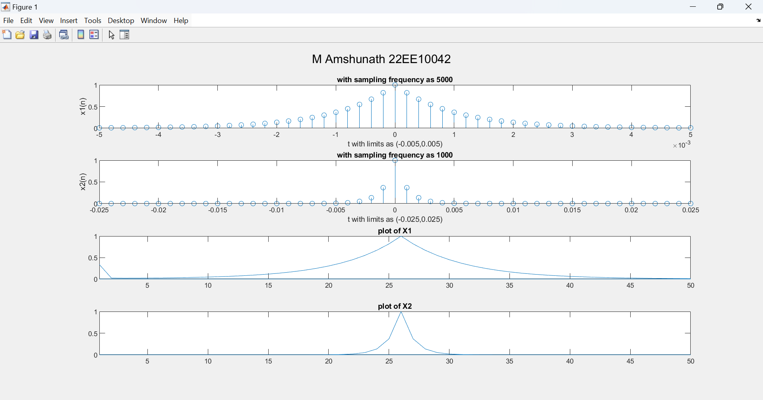

Plots of x1(n), x2(n),X1(jw)X2(jw).

2.

Reconstruction of the xo(t) signal from x1(n) and x2(n) using sinc function

Matlab code:

clc

clear

close all

%F1=5000sam/sec

%F2=1000sam/sec

t1=-0.005:0.0002:0.005;

t2=-0.025:0.001:0.025;

%time limits assigned

%as mentioned

x1=exp(-1000*abs(t1));

x2=exp(-1000*abs(t2));

t1_re=-0.005:0.00004:0.005;

x1_re=zeros(length(t1_re));

t2_re=-0.025:0.0002:0.025;

x2_re=zeros(length(t2_re));

%reconstructed vectors

for i= 0:(length(x1)-1)

for j=0:4

x1_re(5*i+j+1)=x1(i+1)*sinc(0.00004*j);

end

end

for i= 0:(length(x1)-1)

for j=0:4

x2_re(5*i+j+1)=x2(i+1)*sinc(0.0002*j);

end

end

figure;

stem(t1, x1, 'r');

hold on;

stem(t1_re, x1_re, 'b');

legend('Sampled Signal', 'Reconstructed Signal (Sinc Interpolation)');

title('Signal Reconstruction using Sinc Interpolation');

figure;

stem(t2, x2, 'r');

hold on;

stem(t2_re, x2_re_sinc, 'b');

legend('Sampled Signal', 'Reconstructed Signal (Sinc Interpolation)');

title('Signal Reconstruction using Sinc Interpolation');

sgtitle('M Amshunath 22EE10042');

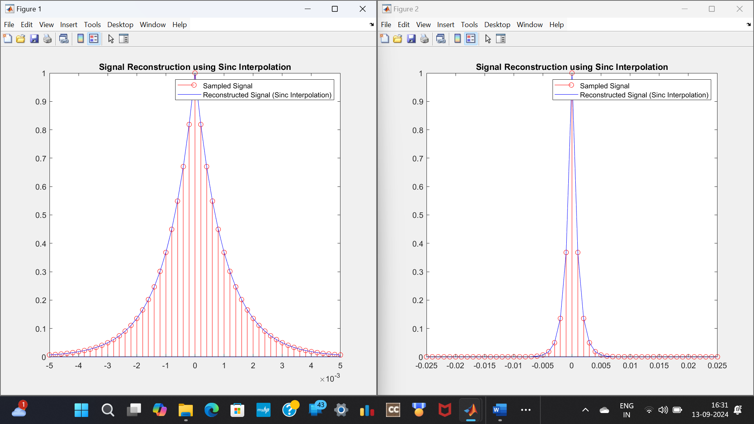

Plots of the sampled signals at different rates and the respective reconstructed signals .

3.

Determining the maximum error between actual signal and reconstructed signal

Matlab code used:

X1=exp(-1000*abs(t1_re));

X2=exp(-1000*abs(t2_re));

e1=zeros(length(x1_re));

e2=zeros(length(x2_re));

for i=1:length(e1)

e1(i)=abs(X1(i)-x1_re(i));

end

for i=1:length(e2)

e2(i)=abs(X2(i)-x2_re(i));

end

figure;

stem(t1_re, e1, 'r');

hold on;

title('error between x1_reconstructed and xo');

sgtitle('M Amshunath 22EE10042');

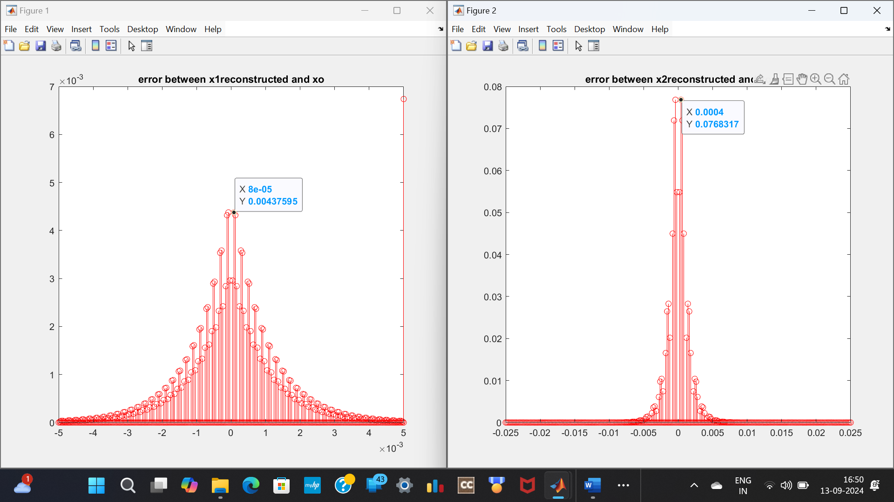Plots of errors with maximum points marked for both the cases