Criterion B: Design
Note: Design will differ from the final product due to client specifications. See Appendix A for more details.

Table of Contents

Table of Contents…………………………………………………………………………………………………………………………1

Complete Diagram……………………………………………………………………………………………………………………….2

Start Menu…………….…………………………………………………………………………………………………………………….3

Log In…………………………………………………………………………………………………………………………………………..5

Create Account…………………………………………………………………………………………………………………………….7

View Window……………………………………………………………………………………………………………………………….9

Add Entry……………………………………………………………………………………………………………………………………11

Edit Entry……………………………………………………………………………………………………………………………………13

Delete Entry……………………………………………………………………………………………………………………………….15

UML Diagram……………………………………………………………………………………………………………………………..17

Test Plan……………………………………………………………………………………………………………………………………..18

Complete Diagram

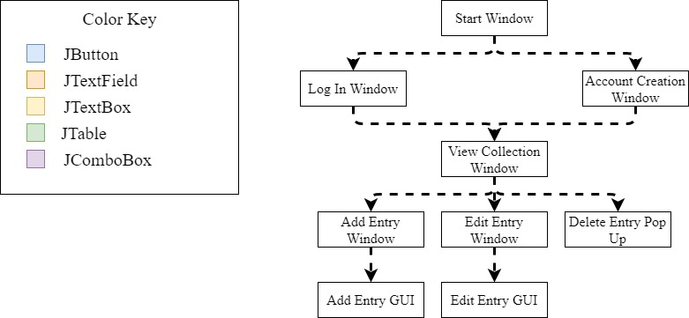

Start Menu Diagram
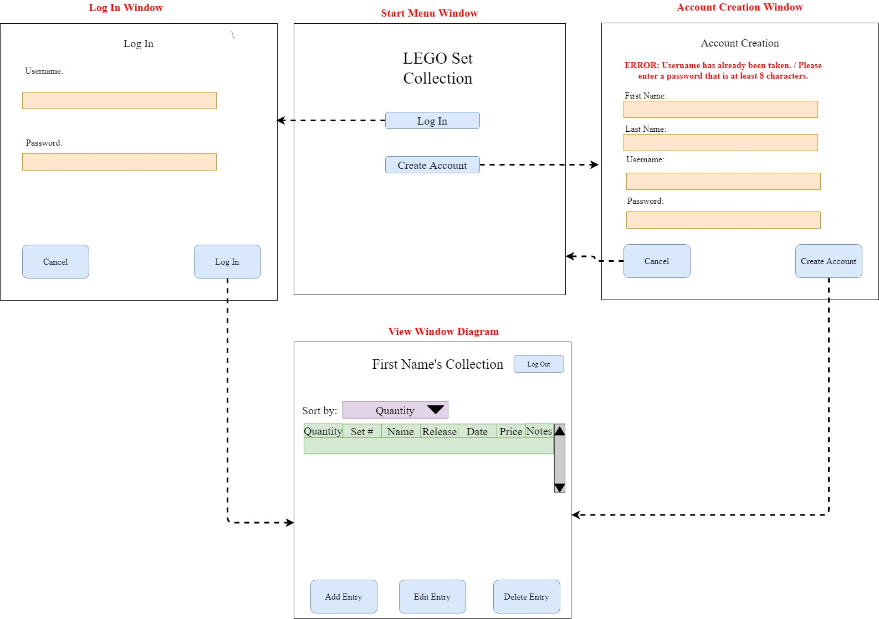

Start Menu Flowchart

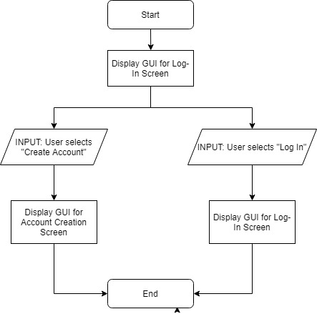
Log In Window Diagram

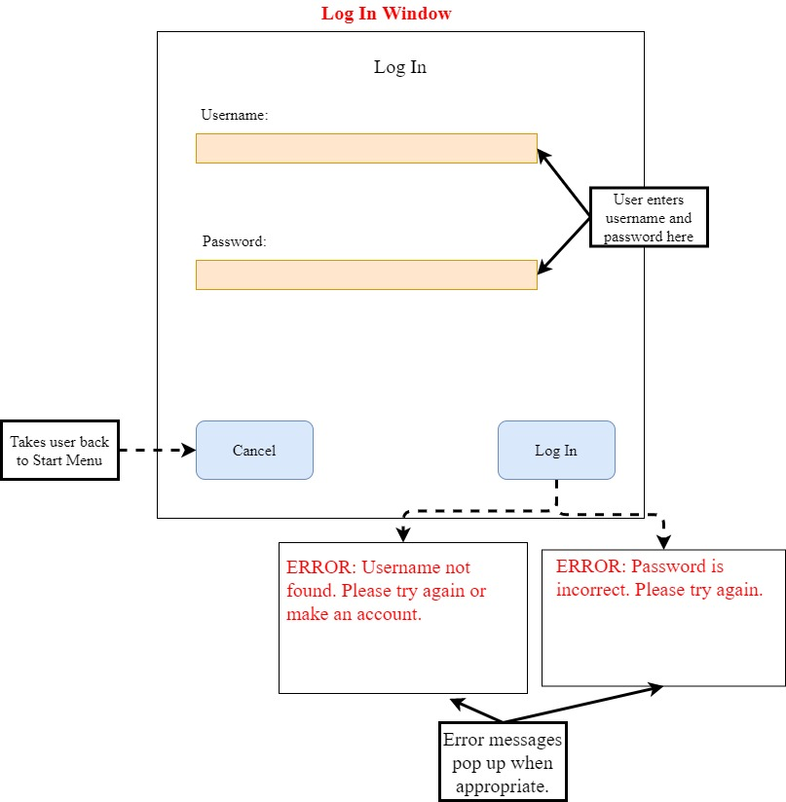
Log In Window Flowchart

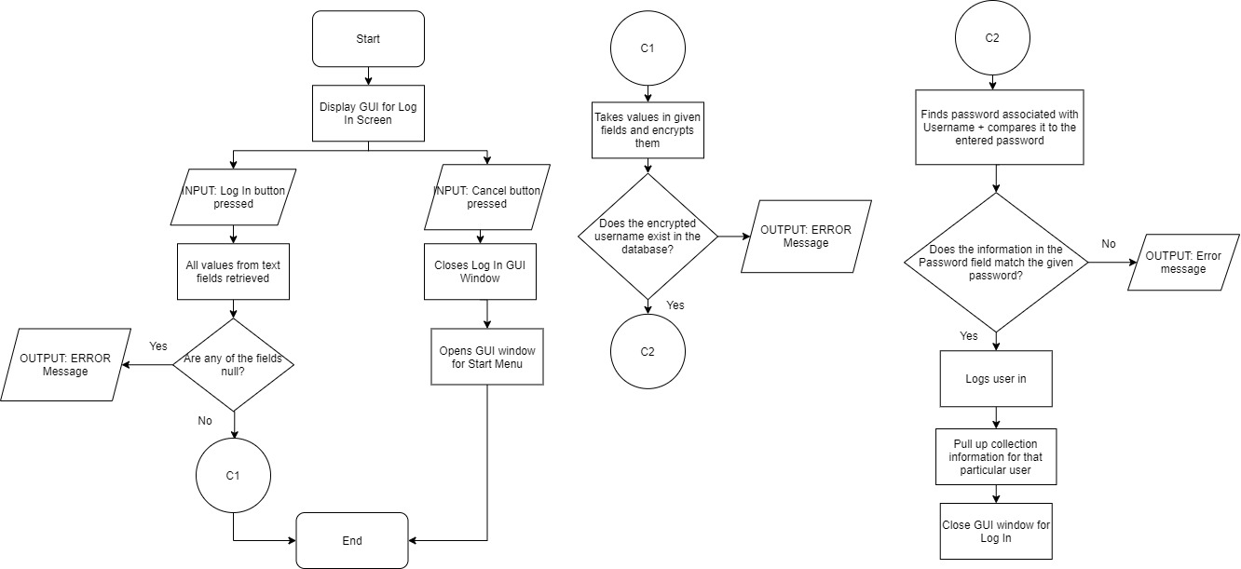

Account Creation Window

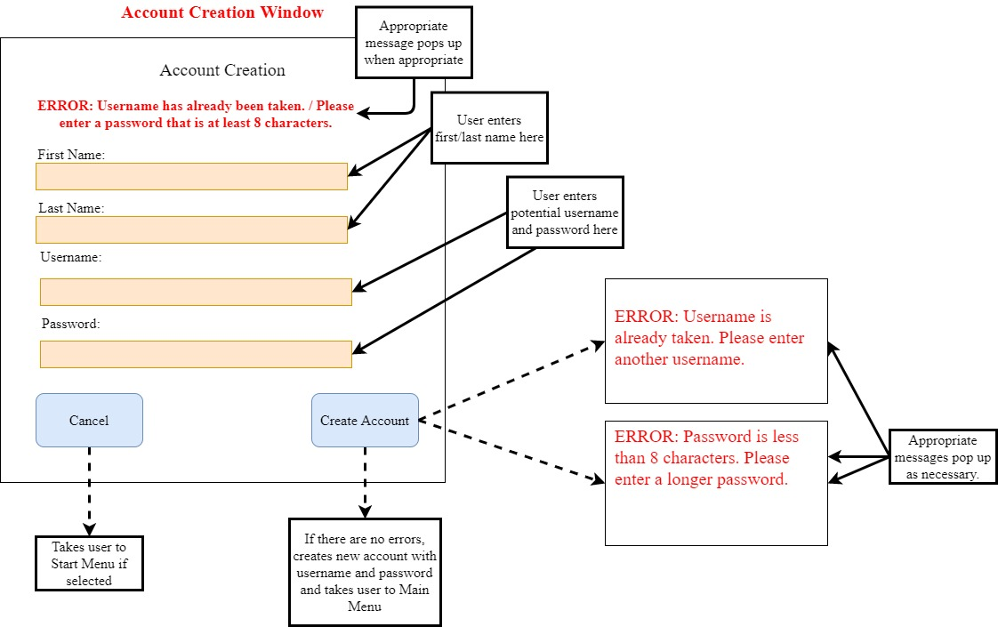
Account Creation Flowchart

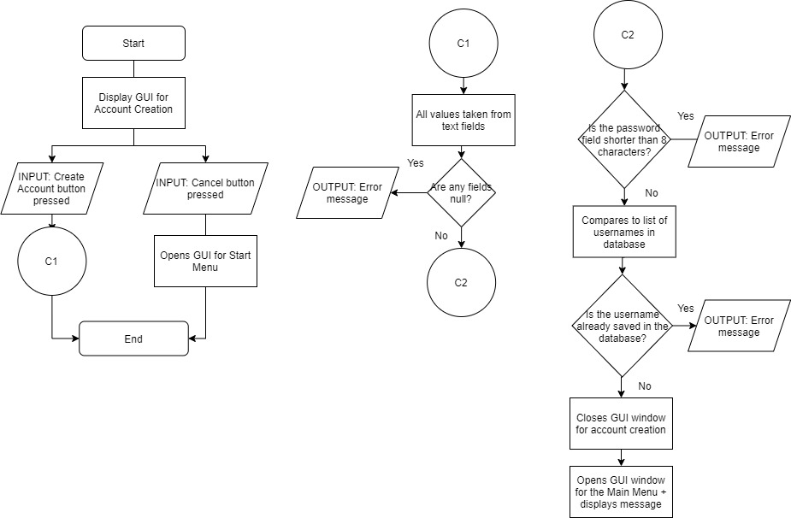

View Window Diagram
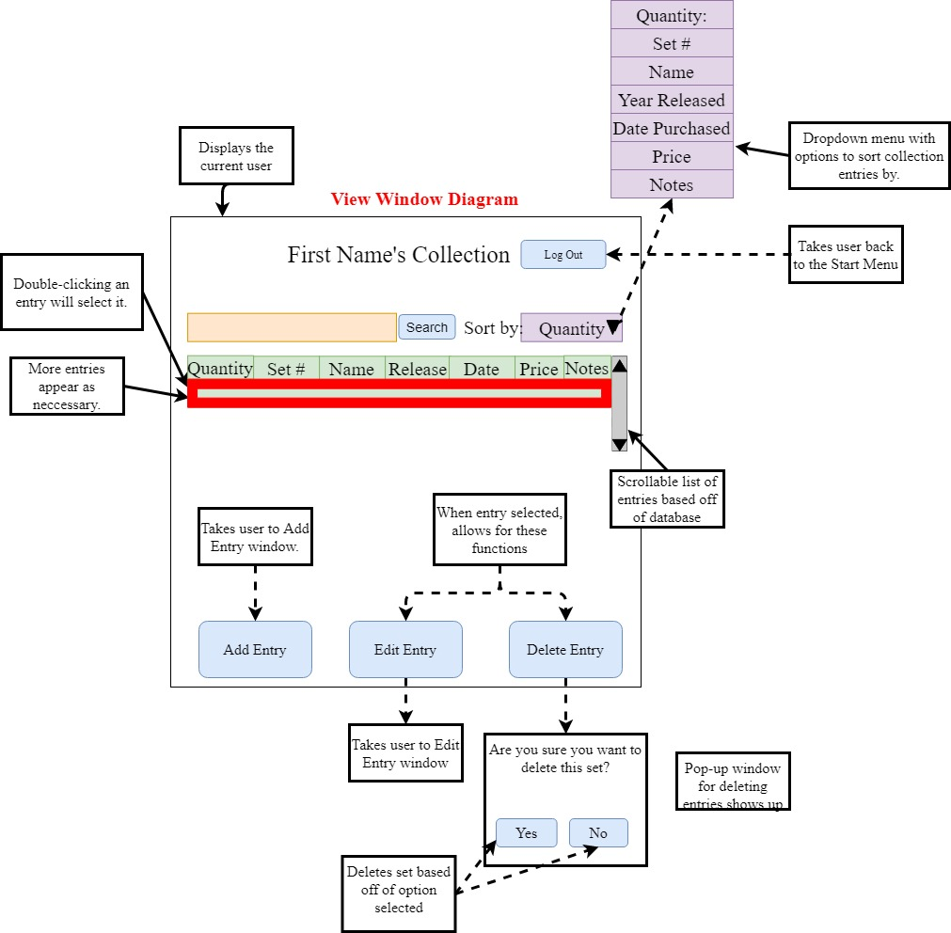

View Window Flowchart
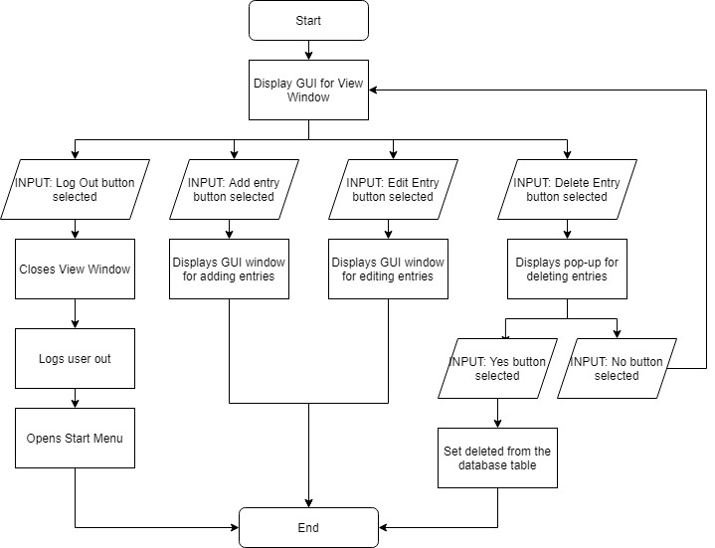

Add Entry Diagram

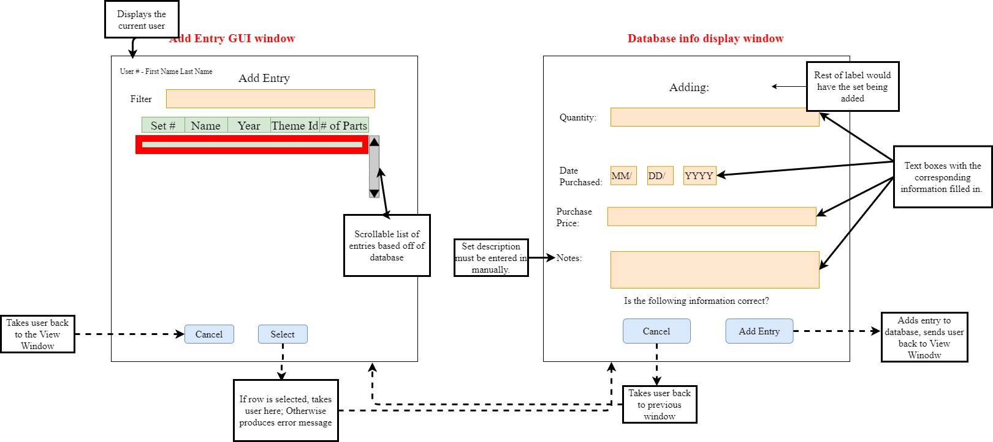

Add Entry Flowchart

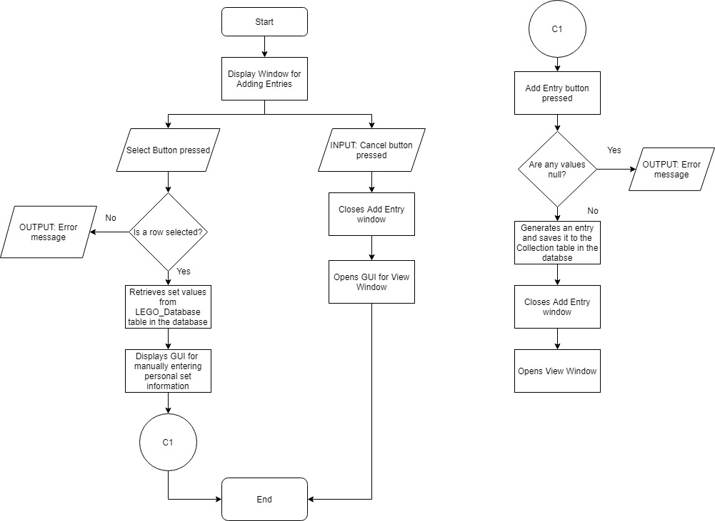

Edit Entry Diagram

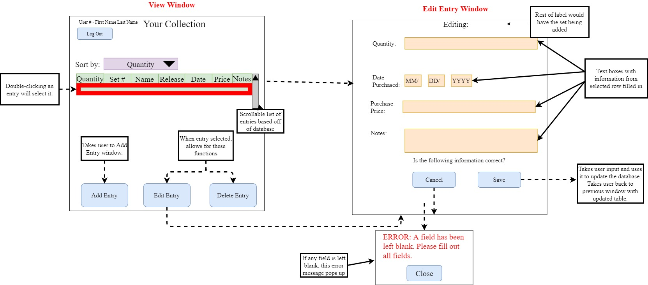
Edit Entry Flowchart

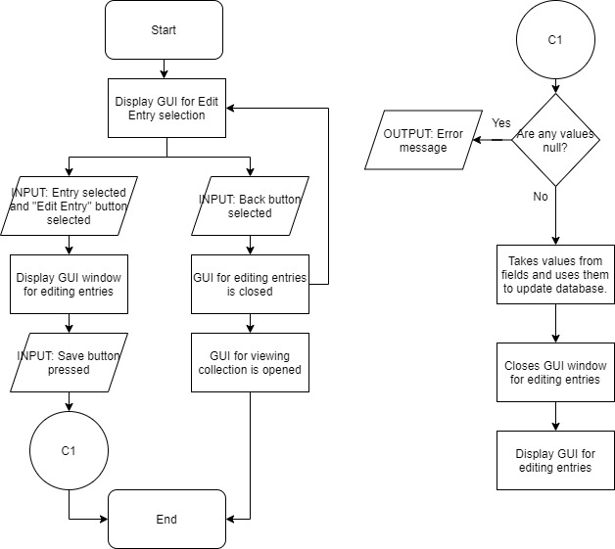

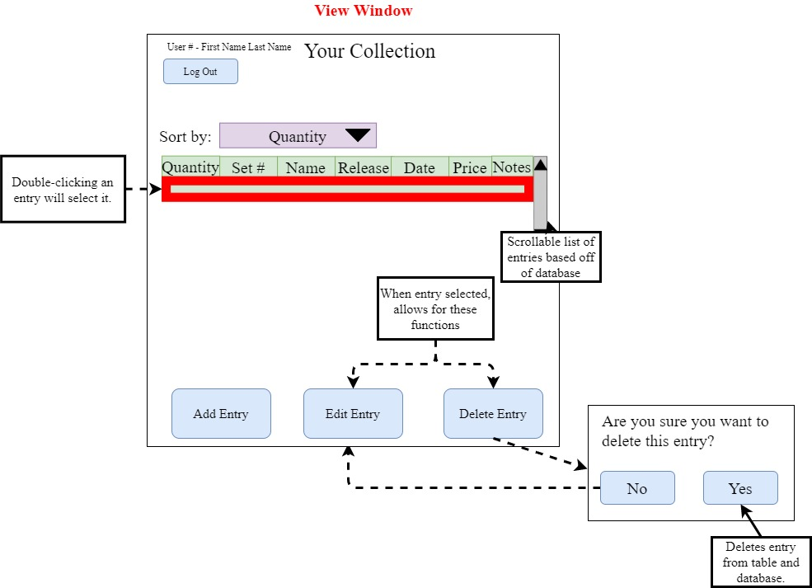
Delete Entry
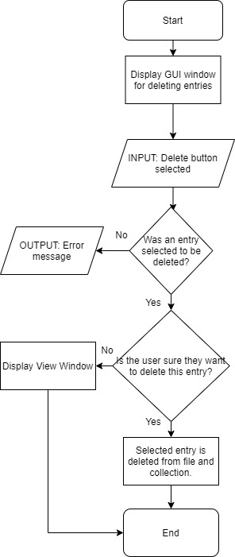
Delete Entry Flowchart

UML Diagram
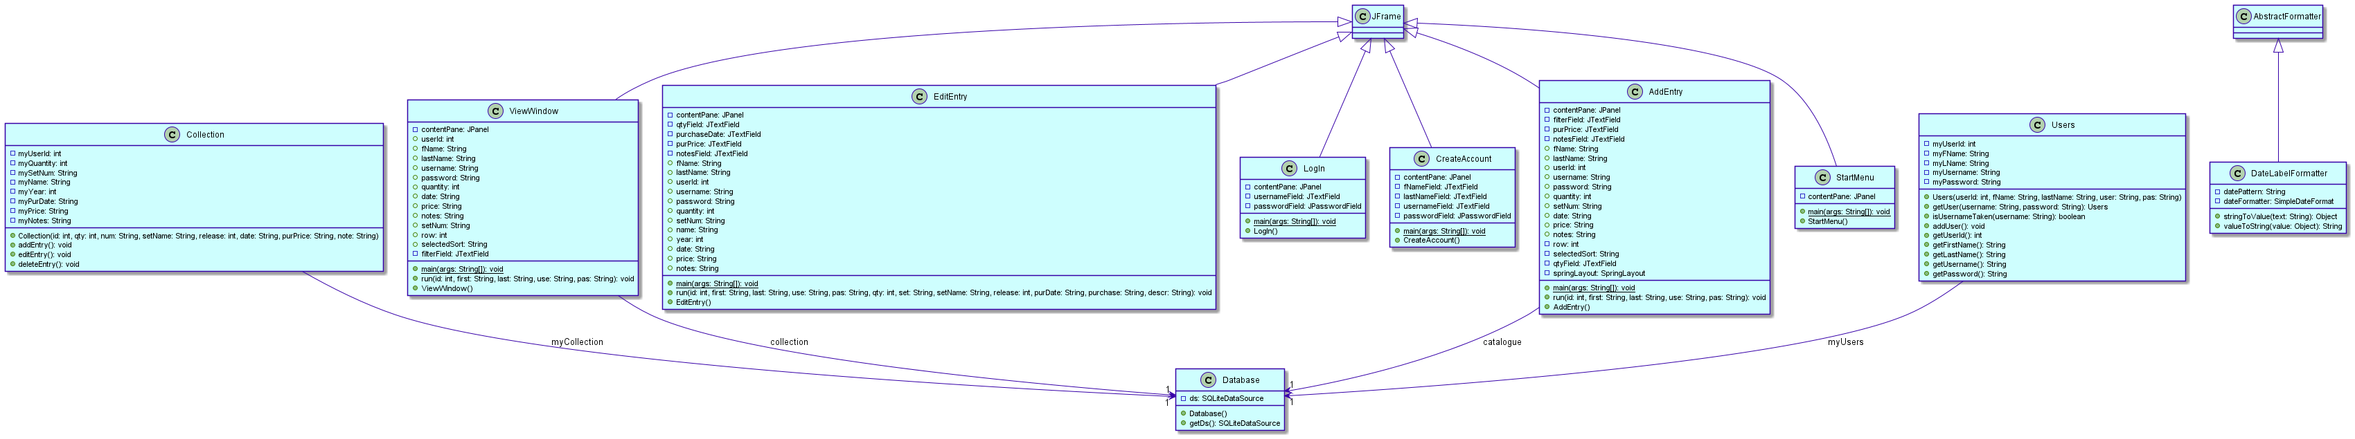
Test Plan

Action to Test | Test Procedure | Success Criteria
The program should allow the user to log in and out of the GUI program. | Log in and out of the program. | Logs in and out of the program successfully.
The program should be able to retain all data when the program is closed and opened, and also when the user logs in and out. | Open and close the program. Log in and out of the program. In both cases, see if all table components are maintained correctly. | All data is maintained in the tables.
The program should allow users to create new accounts. | Create an account and see if its information is stored in the account file. | The account’s username, password, and collection information is stored in the account file.
The program should be able to store information from different users within different accounts. | Check the account table and see if each user’s information is stored correctly. | Each account has its own information saved in its own designated spot.
The program should allow the user to add entries manually when they select a row from a table with all available sets and manually enter information. | Add an entry to the collection. Check the collection table in the SQLite Database. | The correct entry pops up and the new entry is successfully added to the collection file and Viewing Table.
The program should allow the user to delete entries. | Delete an entry. Check the collection table in the SQLite Database. | The selected entry has been deleted from the SQLite Database and Viewing Table.
The program should allow the user to edit entries. | Edit an entry. Check the collection table in the SQLite Database. | The edited entry’s new information is correctly inputted in the collection file and Viewing Table.
The program should have search bar functionality that connects to the catalogue. | Enter a value in the filter box. See if the search bar filters results from the catalogue appropriately. | All sets with the appropriate keywords should appear and the appropriate information should be pulled into its individual entry.

