Criterion B: Design
Note: These designs have been modified according to client specifications. They will differ from the final product due to further client specifications. See Appendix A for details.

Table of Contents
Complete Diagram 2
Start Menu Diagram 3
Start Menu Flowchart 4
Log In Window Diagram 5
Log In Window Flowchart 6
Account Creation Window 7
Account Creation Flowchart 8
View Window Diagram 9
View Window Flowchart 10
Add Entry Diagram 11
Add Entry Flowchart 12
Edit Entry Diagram 13
Edit Entry Flowchart 14
Delete Entry 15
Delete Entry Flowchart 16
UML Diagram 17
Test Plan 18

Complete Diagram

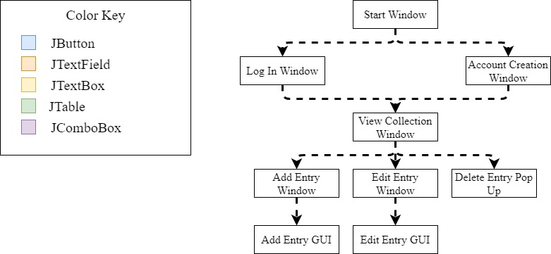

Start Menu Diagram
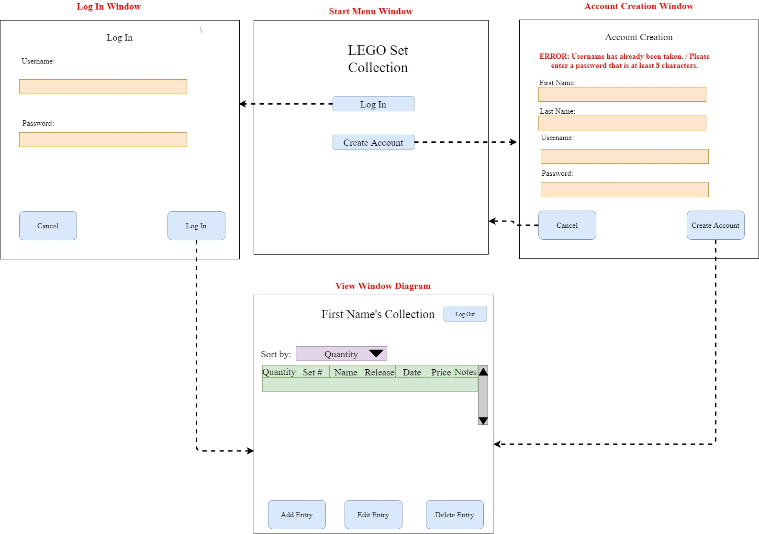

Start Menu Flowchart

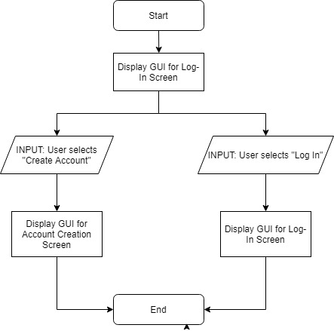

Log In Window Diagram

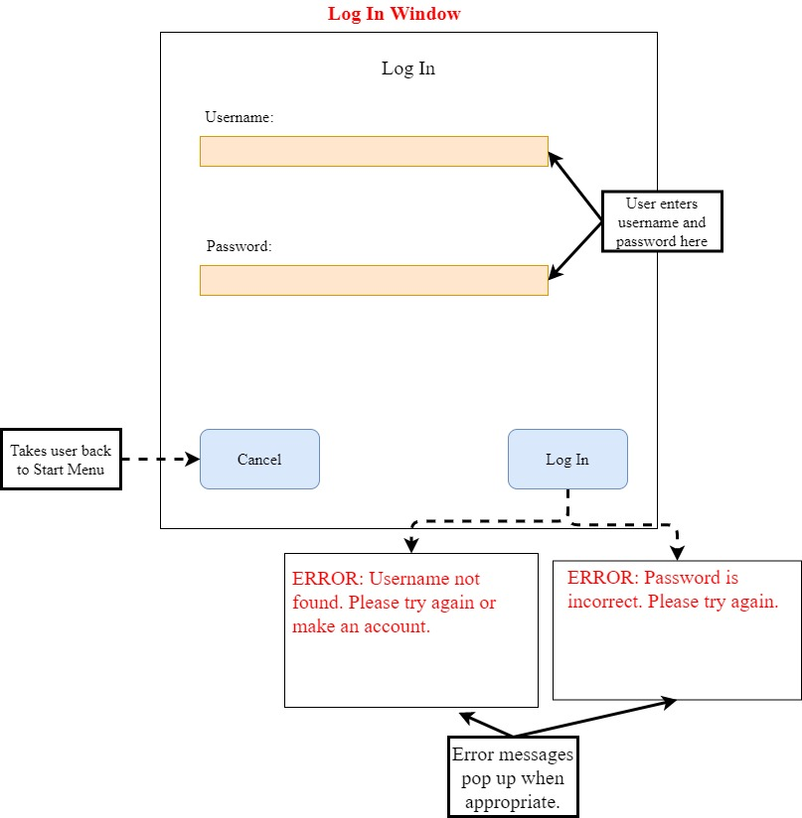

Log In Window Flowchart

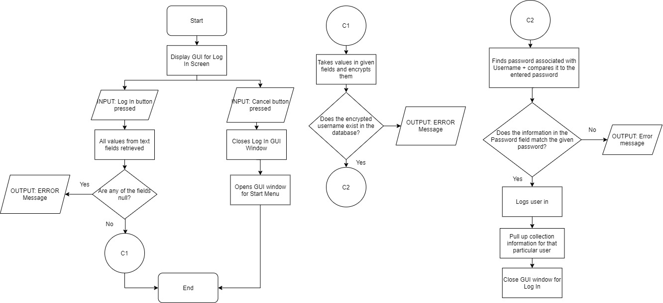

Account Creation Window

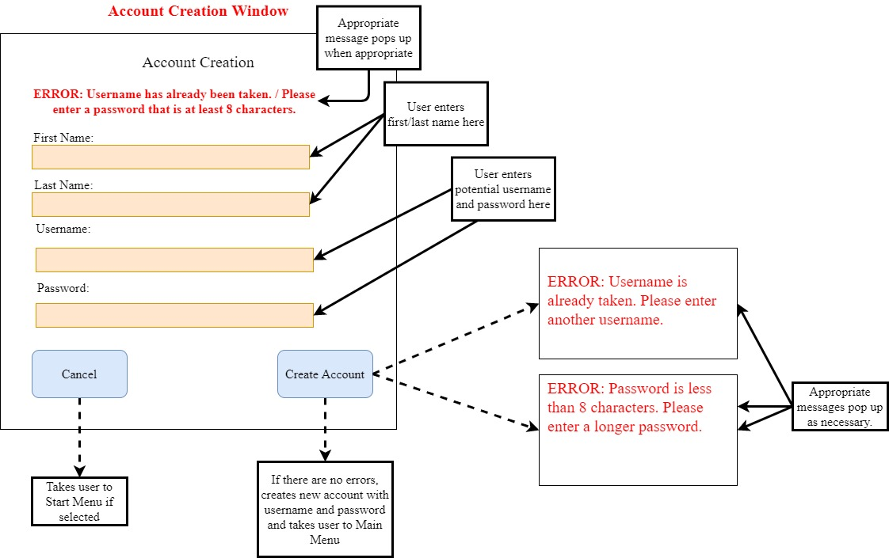

Account Creation Flowchart
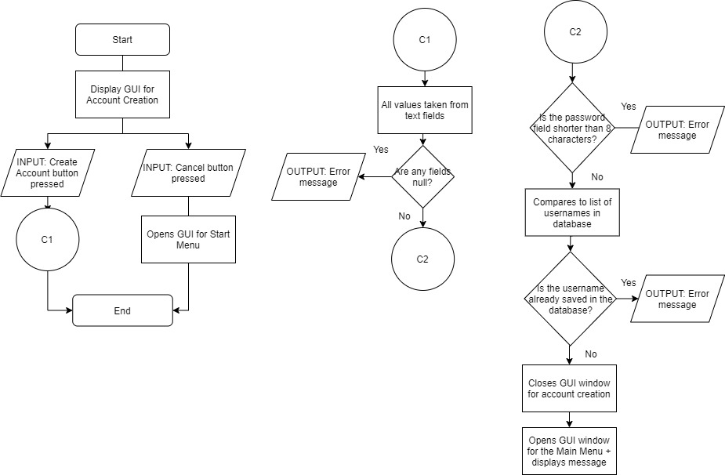

View Window Diagram
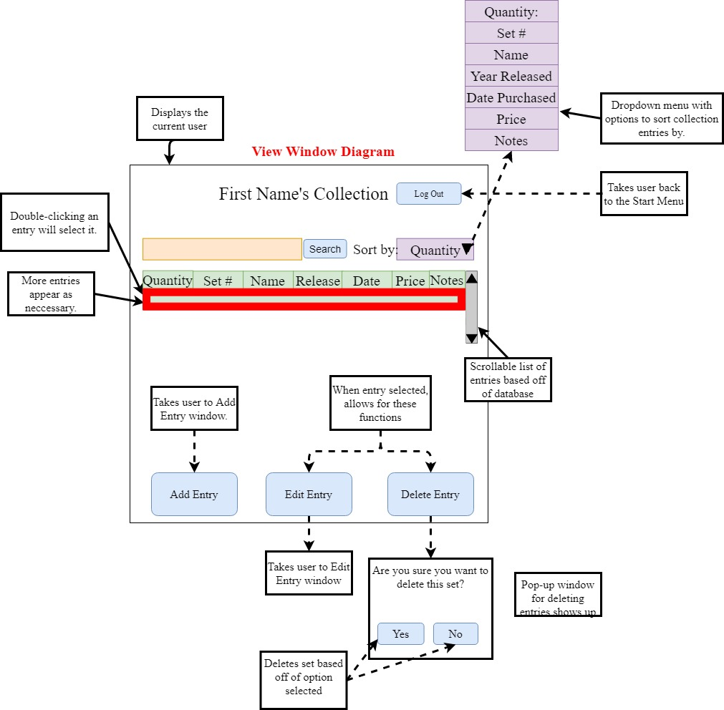

View Window Flowchart

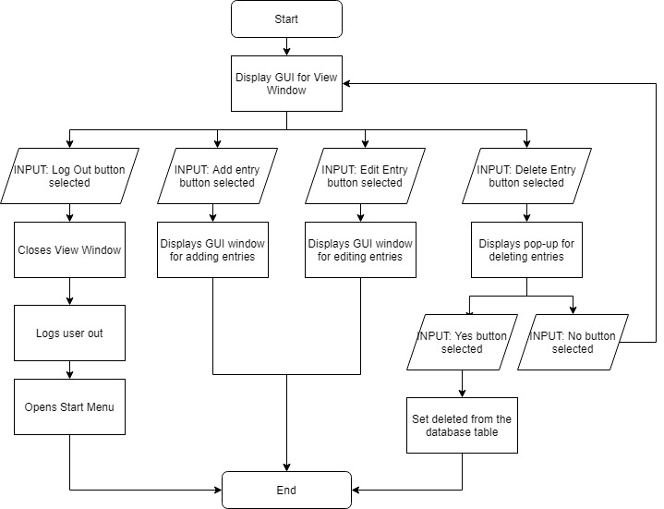

Add Entry Diagram

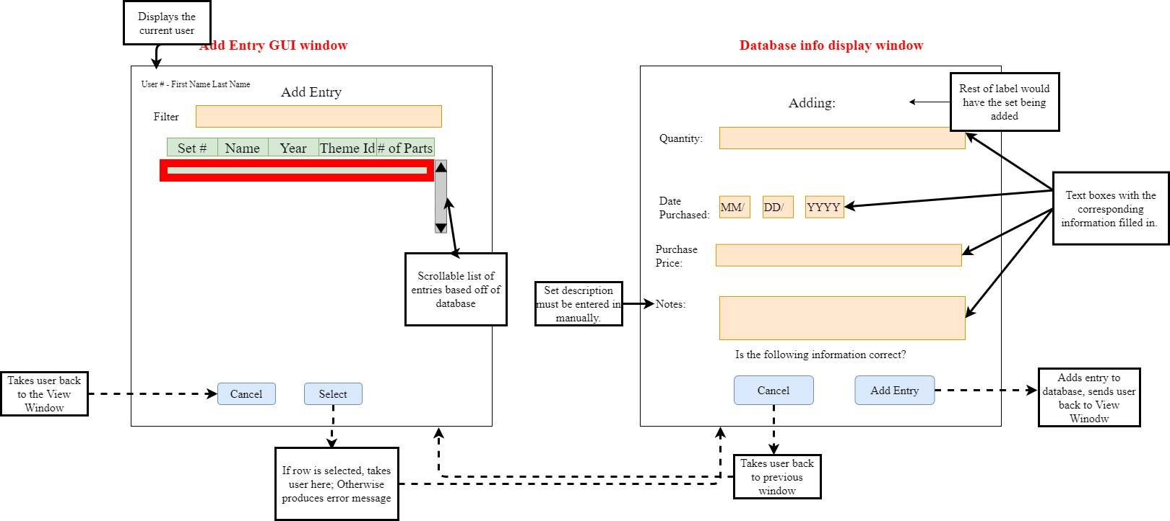

Add Entry Flowchart

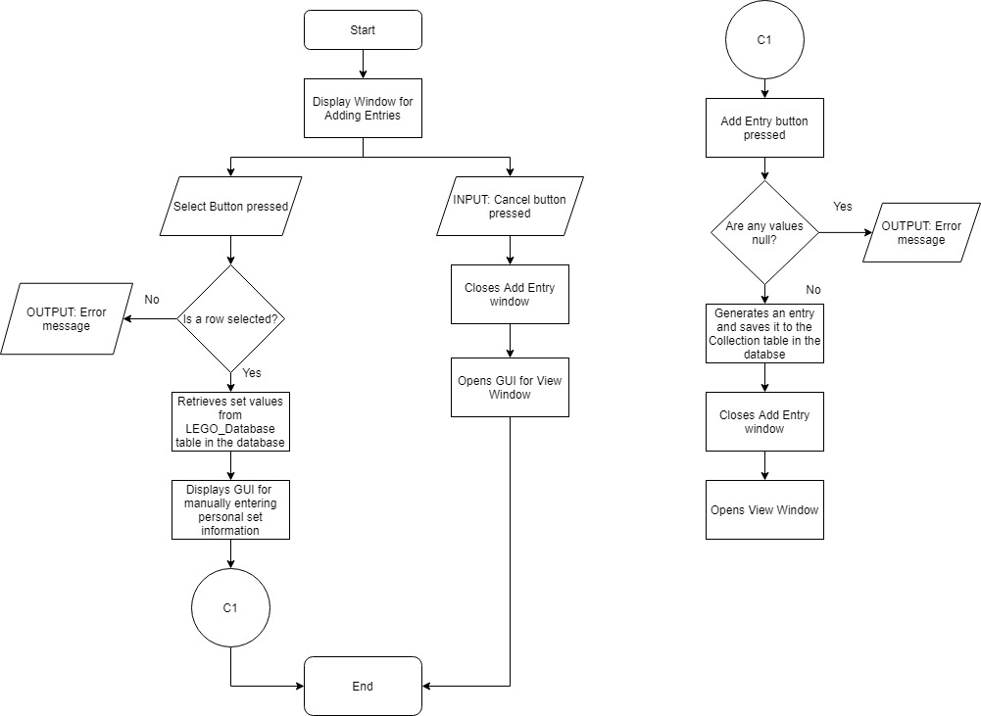

Edit Entry Diagram

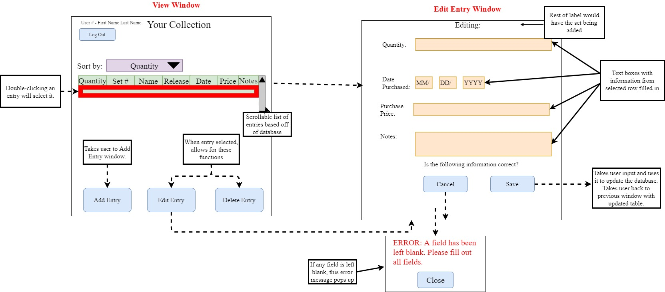

Edit Entry Flowchart

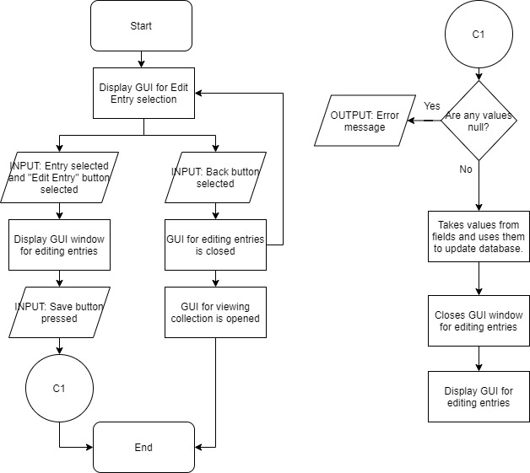

Delete Entry
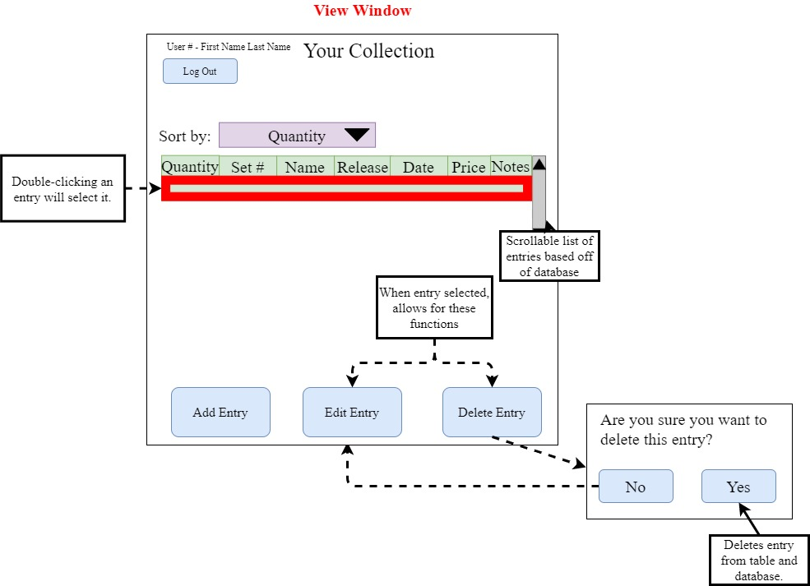

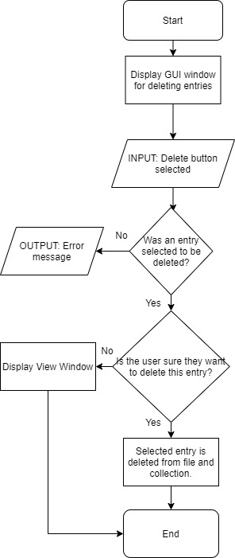
Delete Entry Flowchart

UML Diagram

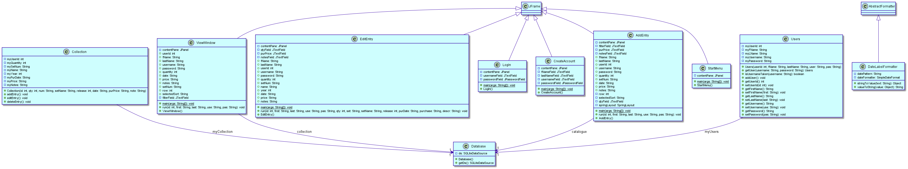

Test Plan

Action to Test | Test Procedure | Success Criteria
The program should allow the user to log in and out of the GUI program. | Log in and out of the program. | The user can log in and out of the program successfully.
The program should be able to retain all data when the user logs in and out. | Log in and out of the program. The user’s collection table should be maintained. | All data is maintained correctly in the user’s collection table.
The program should allow users to create new accounts. | Create an account and see if its information is stored in the account file. | The user should be able to log in and out of their account, and view their collection in a new account.
The program should be able to store information from different users in the correct account. | Add an entry to one user’s collection. Log out and check another user’s account to confirm that the added set is not present. | The collections of each user only contain sets that that user added.
The program should allow the user to add entries. | Add an entry to the collection. Check the collection table in the View Window. | The correct entry pops up and the new entry is successfully added to the collection file and Viewing Table.
The program should allow the user to delete entries. | Delete an entry. Check the collection table in the View Window. | The selected entry has been deleted from the user’s collection table in the View Window.
The program should allow the user to edit entries. | Edit an entry. Check the collection table in the View Window. | The edited entry’s new information is correctly displayed in the user’s collection table in the View Window.
The program should have search bar functionality that connects to the catalogue. | Enter a value in the filter box. See if the search bar filters results from the catalogue appropriately. | All sets with names that contain the keyword should appear and the appropriate information should be pulled into its individual entry.
The program should allow the user to sort the information in their collection by the column headers of the collection table. | Click on a column header to sort by. See if the sets are sorted appropriately. | The sets in the collection should be sorted by the selected column header in ascending order.

