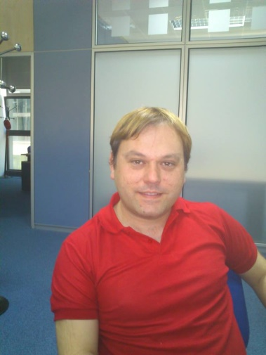**Antonio Manuel Siles Aguilar**

Personal details

Place and date of birth: Málaga (Spain) , 19th August 1977.

Sex: Male

Address: Gonzalo de Córdoba 8, 2 C. Madrid (Spain).

Marital status: Married

Telephone number: +34 651 98 73 68

Email: amsilesaguilar@gmail.com

Education

Degree in Environmental Sciences. University of Granada. (Spain). February 2000.

Erasmus grant in Mälardalens Högskola (Sweden).

Other courses and skills:

* Javascript and DHTML (Aula Mentor, MEC = ministerio de Educación y Cultura, Spanish ministry of Education and Culture)
* Java and J2EE (Aula Mentor, MEC)
* HTML (Sunion Academy)
* SQL and MySQL (Aula Mentor, MEC)
* Apache (Aula Mentor, MEC)
* Flash and Dreamweaver (SUNION)
* GWT, Google Web Toolkit (Aula Mentor, MEC)
* AJAX (Aula Mentor, MEC)
* Qlikview (Qliktech Iberica S.L.)
* Managing performance (Learning Tree International, London, UK)
* Oracle database administration (Esf-Group Academy)
* Android application development (Aula Mentor, MEC)
* Git, Version Control System.

Working experience

* **January 2008 – Present. Analyst and developer at CGI Spain**.

Consultant for IT developments, web-sites, e-commerce and Multimedia platform.

Specialist in JAVA/JEE development and associated frameworks. Knowledge of the most current programming languages: Java, Spring, Hybris, AngularJs, Php, Banksphere, Business Intelligence(Qlikview), etc...

Projects:

* + October 2016 – Present. Real State Agency Anida (BBVA) Front-development.

Technologies : ExtJS, Javascript, HTML , AJAX.

Tasks: HTML development and calls to web services by AJAX.

* + September 2016 – September 2017. Risk Engineering Front development (BBVA)

Front development for Risk Engineering Department of important Spanish bank.

Technologies : AngularJS, Nodejs, Javascript, HTML , Spring and Java.

Tasks: HML development, AngularJs services and directives, Spring controllers and calls to web services.

* + June 2016 – August 2016. Ferrovial pilot project.

Developer and analyst in a pilot project to implement free flow in North Carolina(USA) highways.

Performance: Analysis/breakdown of requirements, software development (cronjobs, jsp pages, ...), technical and functional documentation management. Involved technologies: Java, Spring, Jsf, Javascript, etc...

* + January 2016 – May 2016. Hybris developer.

Back-end developer with hybris technology: Webservices, validations, cronjobs, email management, etc.. Other involved technologies: Java and Spring framework.

Development for an important company (supermarket) located in Canada. Project in cooperation with CGI Germany.

* + November 2013 – December 2015. Danish Mini One Stop Shop (Skat)

Front-end developer: Web pages (Jsp/Html), Javascript, JQuery, styles (Css), Webservices, Weblogic, JPA, Maven, etc...

Project for Danish Tax Ministery in cooperation with CGI Denmark.

* + February 2011 – September 2013. Santander Online Video Platform (Produban).

Project management, technical assistance, functional analysis, incidence managament and customer support.

Cgi worked in partnership with Agile Contents S.L, offering our client, Santander bank, a Saas Multimedia Management System: Video and audio management, searcher and multimedia advanced components (players).

Technologies: HTML5, Javascript, Flash, Css, JQuery, etc...

* + January 2008 – January 2011. Banksphere developer (Isban)

Development, analysis and testing of Banksphere applications for international department of Santander bank. Skills at Banksphere programming (Mira and Vega), testing, interfaces, user-models, functional analysis, logic models (Rational Rose), templates, migration of software (Deneb), etc.

* June 2005 – November 2007. Second chief of hotel reception.

Billing, booking, customer service, reservations and administrative tasks.

* September 2000 – June 2005. Getafe Air Base.

Activation, registration and coordination of flight plans. Meteorological information service. Skilled at the language of teletypes for aeronautical communication.

Language skills

* English. High level (C1).

Certificate in advanced English by language-learning school Goya (Madrid). June 2005.

English intensive course (Embassy CES Melbourne, Australia).

* German. High level (C1).

Certificate in advanced German by language-learning school Goya (Madrid). June 2013.

Studying C2 at Goethe Institut in Madrid currently.

* Swedish. Medium level (B1).

Certificate in advanced Swedish by language-learning school Jesús Maestro (Madrid). June 2006.

Swedish summer courses (Svenska Institutet, Sweden. Sundsvall 2002 and Gotemburg 2004).

* French. Low level(A1).