**2.4 Test your implementation:**

**Qualitatively evaluate your system's performance and write them up in your report. Especially, are their evolution family members got successfully retrieved? Why or why not?**

For our graphs below we used a ranking system to rank the top ten results of each algorithm and feature. 10 being the best match and 1 being the worst. We then summed the rankings of matches that were of the same evolution line or type for each individual algorithm or feature.

General Statistics:

|  |  |  |
| --- | --- | --- |
|  | Sum of all Evolution Rank | Sum of all Matching Type Rank |
| Average Color Pixel | 42 | 518 |
| Spatial Grid of Average Pixel Color | 25 | 364 |
| Color Histograms | 38 | 363 |
| Edge Detection-Image Segmentation | 29 | 357 |
| SSD | 58 | 778 |
| Angle Between Vectors | 76 | 824 |

The Feature that got the best results for both finding an evolution and finding a matching type Pokémon was the Average Color Pixel and the best algorithm for both was the Angle Between Vectors. The Average Color Pixel worked well because a lot of the evolution lines and typing use a lot of the same colors.

The algorithms seemed to work better on Pokémon whose types had a defined color scheme such as grass, bug, water or fire type. The dragon type Pokémon did not work as well with finding their evolution lines or typing since the color scheme is not as universal.

**Also, test your system with other images from online resources, could be natural images.**



The three images above were used in our database and since the Average Color Pixel and Angle Between Vectors were the best feature and algorithm we used them exclusively for these images. The top ten results are below.

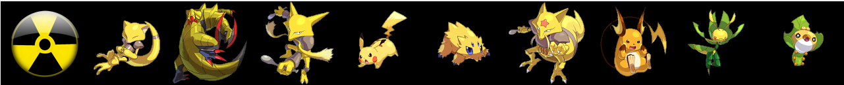





For each image, there was a definite pattern when it comes to the Pokémon Type and even returned a lot of Pokémon from the same evolution lines. The yellow Radiation image returning a lot of Electric and some grass types. The red Mario image only returned fire types and what was interesting was that the top ten returned were all strictly Fire type and not a mix of two types. The green Yoshi image only returned bug and grass type Pokémon which is to be expected since green shows up a lot in both plant life and bugs.

