README: Question 5 Clinical Data RESTful API using FASTAPI

## Q5 — Clinical Trial Data API (FastAPI)

**Purpose:** REST API to query adverse-event data: filter by severity and/or treatment arm, and get subject-level risk scores.

### Contents

| Path | Description |
|------|-------------|
| `main.py` | FastAPI app: `GET /`, `POST /ae-query`, `GET /subject-risk/{subject_id}` |
| `requirements.txt` | fastapi, uvicorn, pandas, pydantic |
| `data/adae.csv` | Input AE dataset (expected columns include USUBJID, AESEV; ACTARM optional) |

### How to run

```bash
cd Q5
pip install -r requirements.txt
uvicorn main:app --reload
```

- API: <http://127.0.0.1:8000>
- Docs: <http://127.0.0.1:8000/docs>

### Endpoints

- **GET /** — Health check.
- **POST /ae-query** — Body: `{ "severity": ["SEVERE"], "treatment_arm": "Placebo" }` (optional). Returns matching record count, unique subject count, and subject list.
- **GET /subject-risk/{subject_id}** — Returns risk score and category (Low/Medium/High) for a subject.

---

Execute in the Q5 folder the following:
> pip install -r requirements.txt
> uvicorn main:app --reload –port 8000

Follow link to http://127.0.0.1:8000

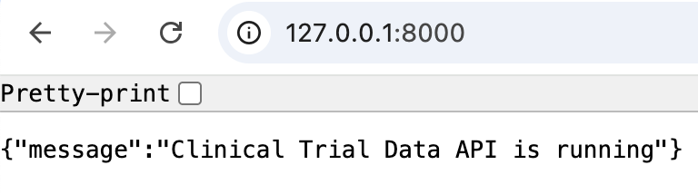

On browser navigate to docs folder, url: http://127.0.0.1:8000/docs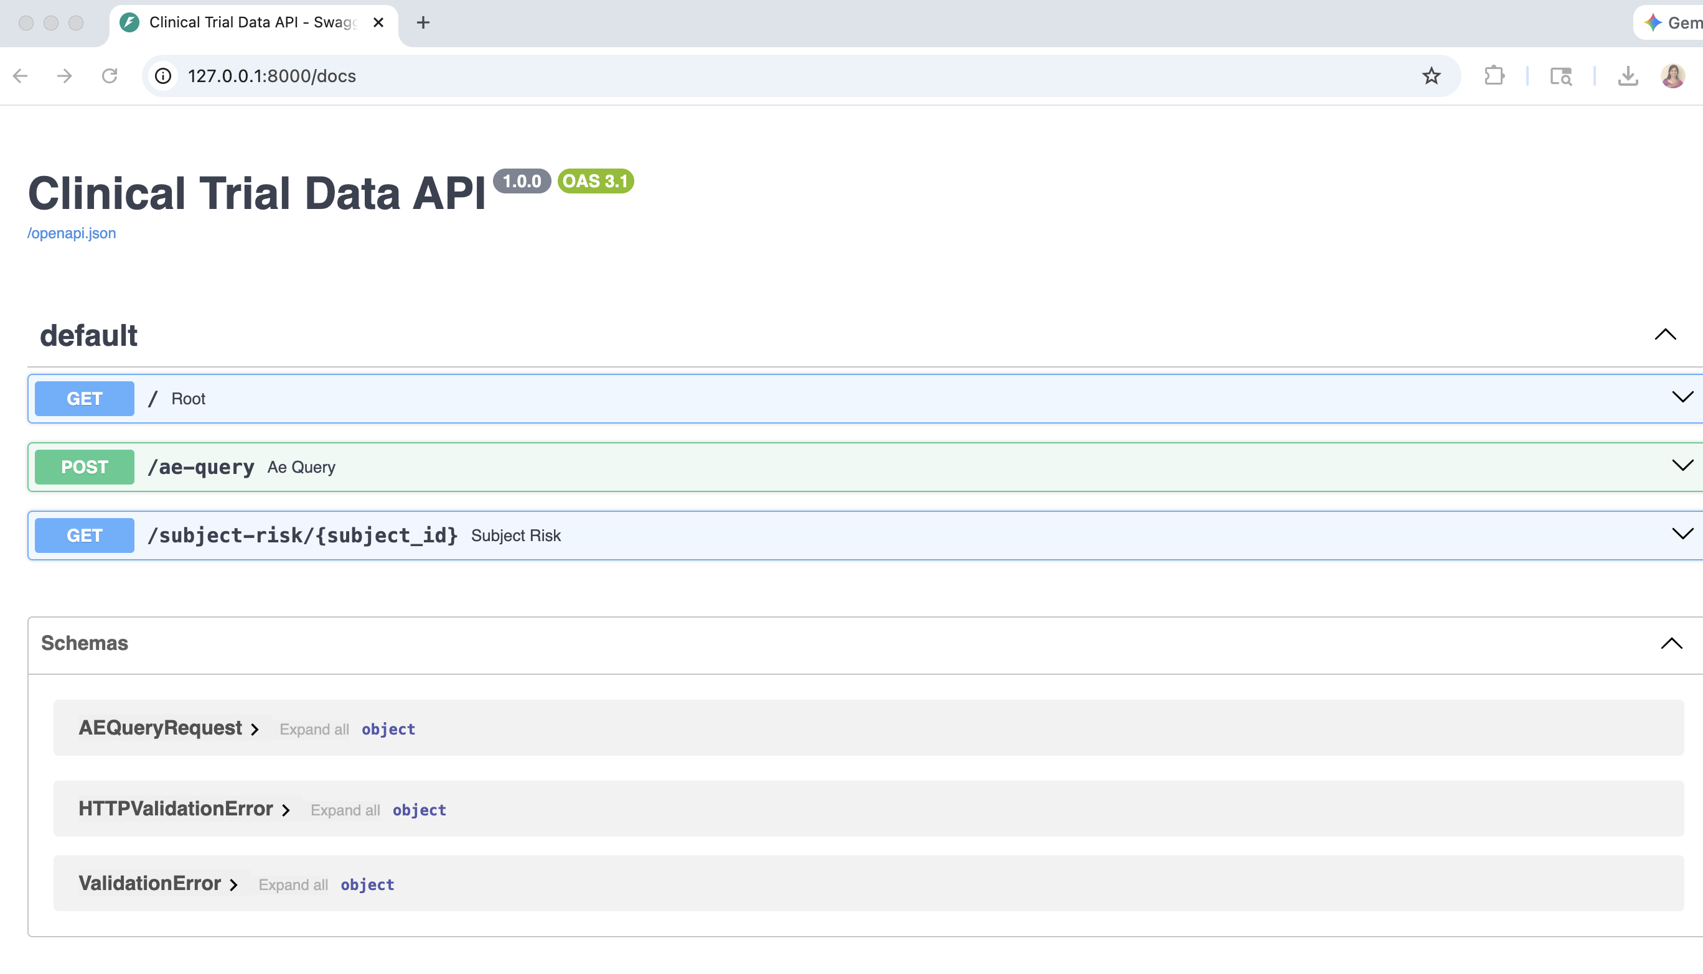
- Expand the POST/ae-query arrow dropdown -> click try it out button -> edit the severity string and execute to get subjects of that severity. Treatment arm is optional and this filter will be applied only if ACTARM column is present in the ae dataset. This dataset has no ACTARM, and the ae-query with and without the treatment arm specified gives the same result as this filter is not applied.

POST/ ae-query : {
"severity": [
"SEVERE", “MODERATE”
]
}

No Treatment arm | Treatment arm specified
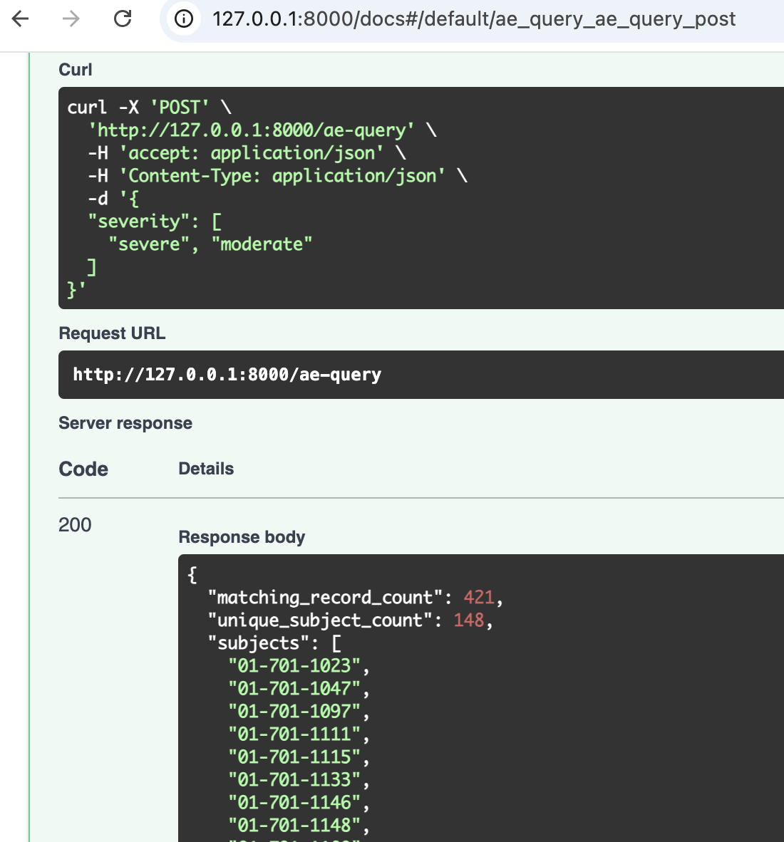 | 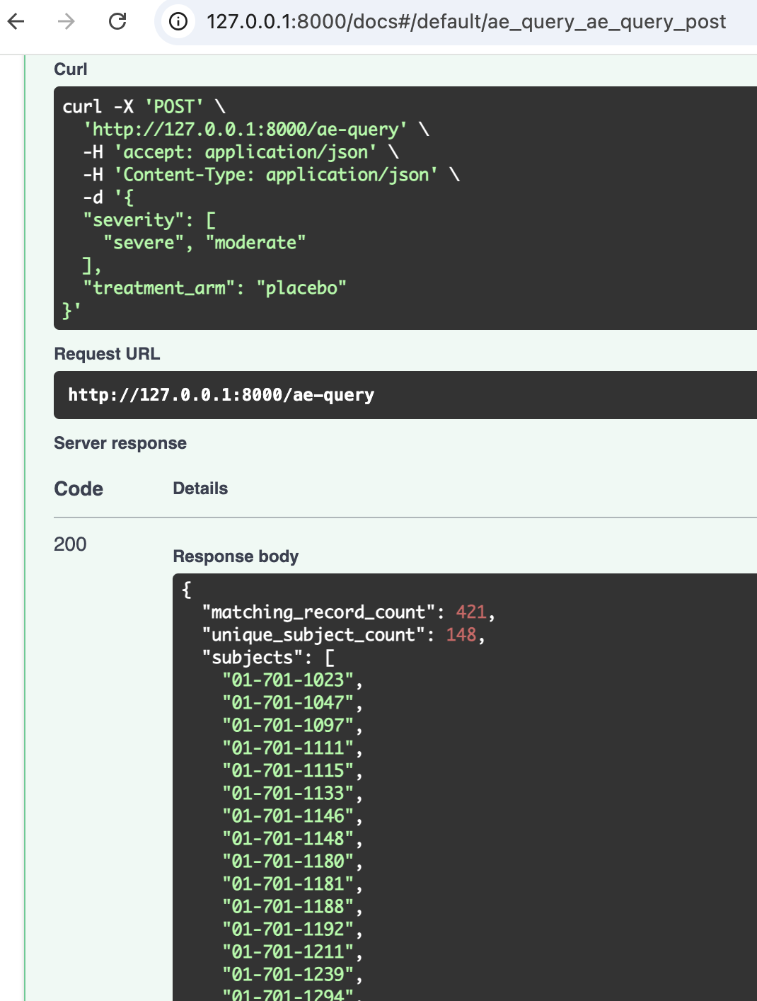

Same output as no ACTARM in this dataset. Filter not applied.

- Expand the GET/subject-risk/{subject_id} arrow dropdown -> click try it out button -> enter subject id and execute to get risk score.
GET: /subject-risk/{subject_id}
Risk score of subject 01-701-1097

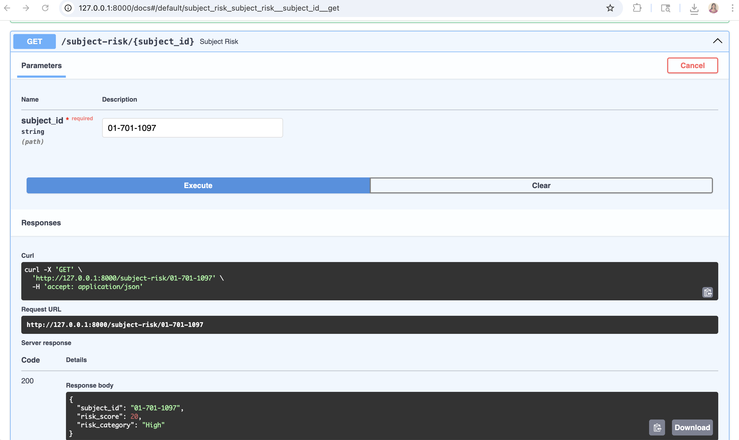

404 HTTP exception for subject that does not exist:
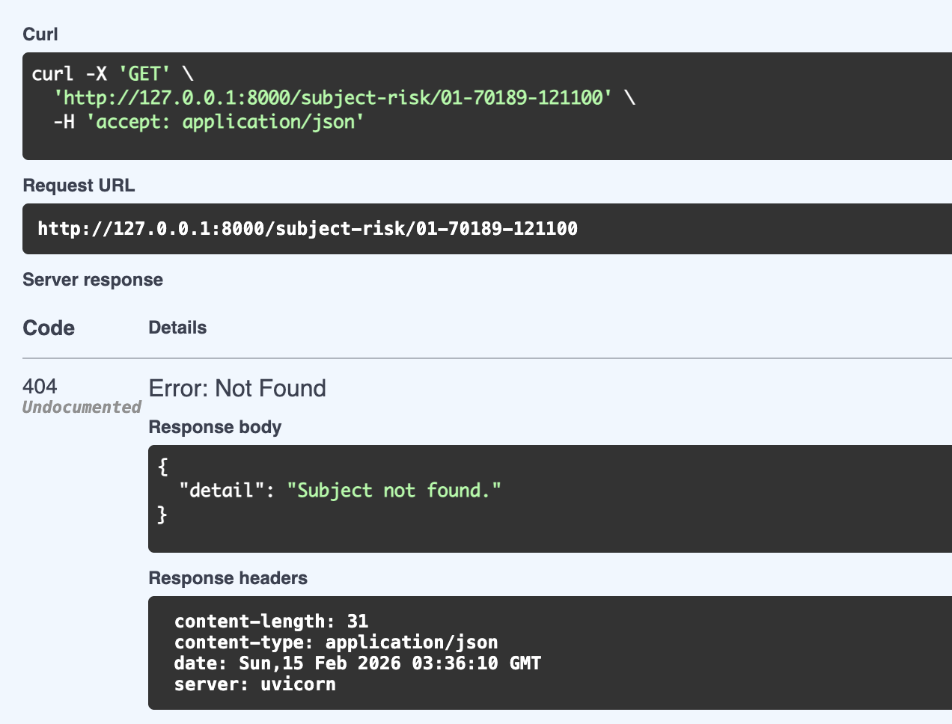

Terminal log:
