README: Question 6 ClinicalTrialDatalAgent

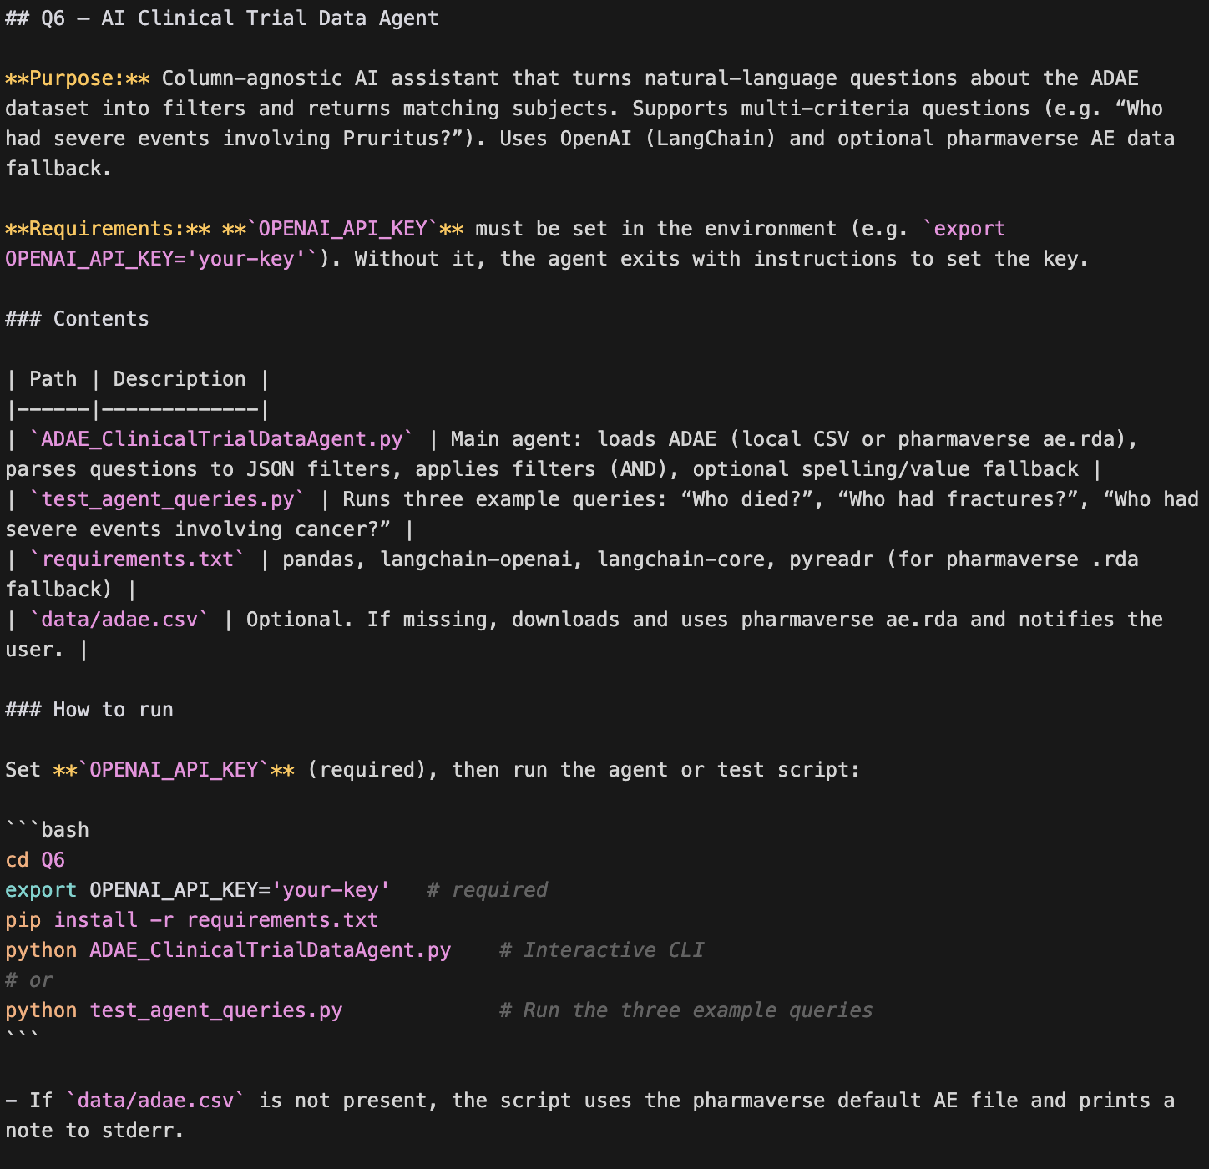

Download the entire Q6 folder from git.

To use this agent, set your OpenAI API key.
Option 1 - Export in your shell (bash/zsh):
export OPENAI_API_KEY='your-api-key-here'
Option 2 - In the same terminal before running:
OPENAI_API_KEY='your-api-key-here'
python ADAE_ClinicalTrialDataAgent.py
Get an API key at: https://platform.openai.com/api-keys

cd <”to the Q6 folder with code ADAE_ClinicalTrialDataAgent.py”>

Install requirements:
pip install -r requirements.txt

RUNNING the test script, test_agent_queries.py.
At a terminal prompt execute the following:
python test_agent_queries.py

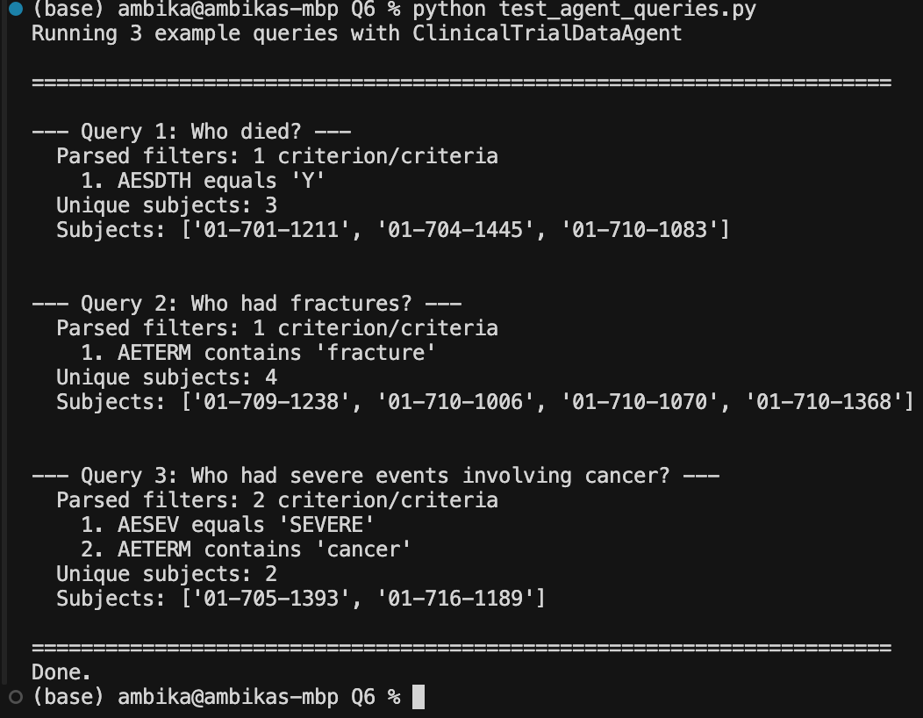

RUNNING the agent:

- At a terminal prompt execute the following:
- python ADAE_ClinicalTrialDataAgent.py

- Ask questions.

Suggested questions:
- Patients with fractures
- Who died? (sudden death and also implying death as in suicide and myocardial infraction)
- Who had diarrhea? (spelt DIARRHOEA in AETERM)
- Who had severe events?
- Who had severe events involving cancer? (AND clause)
- Who had severe events within 15 days of study?

Example outputs:

