**# DeePaperScan**

A Deep Learning model that detects paper corners in pictures / videos

# ##Definition

**### Project overview**

Mobile Scanners often use computer vision (ex. OpenCv) to detect corners of scanned paper images in their smartphone apps. The main reasons are that the solution works well on basic cases and secondly it is easily deployable for real time usage (doesn't require a lot of hardware compute).

My main motivation for this project is to check if training a Deep Neural Network on a labeled dataset of image corners can showcase good results in real time scenario by detecting image corners

# ###Problem Statement

Image scanner that detects Paper/document corners in Image / video using a Convolution Neural Networks model

There are 4 corners positions to detect of a paper document (Top left, Top right, Bottom left, Bottom right) in different backgrounds.

Some of the most popular similar usecases available in Open Source community are Facial/hand Keypoint Detection, Human pose estimation ...

In Machine Learning terms this is a Regression task that is also known as keypoints / landmark detection. The model takes a resized Gray image with size (197,350,1) as input and produces the expected output that is the x,y coordinates of the 4 corners of a document.

# ###Metrics

Mean Squared Error MSE loss is the default loss used for regression problems

MSE Formula:

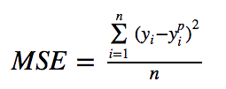[https://miro.medium.com/max/255/1*mlXnpXGdhMefPybSQtRmDA.png](https://miro.medium.com/max/255/1*mlXnpXGdhMefPybSQtRmDA.png)

MSE is calculated as the average of the squared differences between the predicted and actual values. The result is always positive regardless of the sign of the predicted and actual values and a perfect value is 0. The squaring means that the model is punished for making larger mistakes.

Mean squared logarithmic error MSLE is a variation of the [MSE](https://peltarion.com/knowledge-center/documentation/modeling-view/build-an-ai-model/loss-functions/mean-squared-error).

MSLE loss formula:

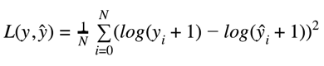

<https://peltarion.com/static/msle_01.png>

where y is the true value and ŷ is the predicted value.

The MSLE has the ability of relaxing the punishing effect of large differences in large predicted values.

The difference between the MSLE loss and the MSE loss can be showcased in this example:

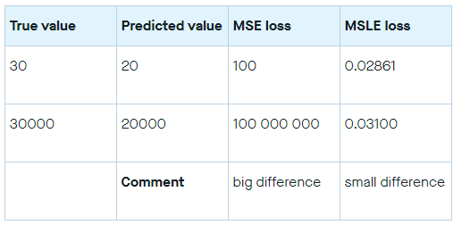

We can see that MSLE loss only cares about the relative difference between the true and the predicted value.

MSLE is the right metric when you don’t want large errors to be significantly more penalized than the small ones.

- The Metric loss we’ll be using: MSLE

# ##Analysis

**###Data Exploration**

The dataset comes from the SMARTDOC 2015 competition (Smartphone Document Capture and OCR Competition)

(link)[https://sites.google.com/site/icdar15smartdoc/challenge-1/challenge1description] [1] The video dataset when downloaded, has the following structure:

smartdoc-dataset-set/

├── background01

│ ├── datasheet001.avi

│ ├── datasheet002.avi

│ ├── datasheet003.avi

│ ├── datasheet004.avi

│ ├── datasheet005.avi

│ ├── letter001.avi

│ ├── letter002.avi

│ ├── letter003.avi

│ ├── letter004.avi

│ ├── letter005.avi

│ ├── magazine001.avi

│ ├── magazine002.avi

│ ├── magazine003.avi

│ ├── magazine004.avi

│ ├── magazine005.avi

│ ├── paper001.avi

│ ├── paper002.avi

│ ├── paper003.avi

│ ├── paper004.avi

│ ├── paper005.avi

│ ├── patent001.avi

│ ├── patent002.avi

│ ├── patent003.avi

│ ├── patent004.avi

│ ├── patent005.avi

│ ├── tax001.avi

│ ├── tax002.avi

│ ├── tax003.avi

│ ├── tax004.avi

│ └── tax005.avi

├── background02

│ ├── datasheet001.avi

│ ...

│ └── tax005.avi

├── background03

│ ...

├── background04

│ ...

└── background05

...

└── tax005.avi

It contains 5 directories (image backgrounds), and 150 video files -30 for each background- (AVI container, XVID codec, no audio), where image frames are taken from different angles.

The videos resolution 1920x1080.

The output Xml files structure:

smartdoc-dataset-set/

├── background01

│ ├── datasheet001.gt.xml

│ ├── datasheet002.gt.xml

│ ├── datasheet003.gt.xml

│ ├── datasheet004.gt.xml

│ ├── datasheet005.gt.xml

│ ├── letter001.gt.xml

│ ├── letter002.gt.xml

│ ├── letter003.gt.xml

│ ├── letter004.gt.xml

│ ├── letter005.gt.xml

│ ├── magazine001.gt.xml

│ ├── magazine002.gt.xml

│ ├── magazine003.gt.xml

│ ├── magazine004.gt.xml

│ ├── magazine005.gt.xml

│ ├── paper001.gt.xml

│ ├── paper002.gt.xml

│ ├── paper003.gt.xml

│ ├── paper004.gt.xml

│ ├── paper005.gt.xml

│ ├── patent001.gt.xml

│ ├── patent002.gt.xml

│ ├── patent003.gt.xml

│ ├── patent004.gt.xml

│ ├── patent005.gt.xml

│ ├── tax001.gt.xml

│ ├── tax002.gt.xml

│ ├── tax003.gt.xml

│ ├── tax004.gt.xml

│ └── tax005.gt.xml

├── background02

│ ├── datasheet001.gt.xml

│ ...

│ └── tax005.gt.xml

├── background03

│ ...

├── background04

│ ...

└── background05

...

└── tax005.gt.xml

Each Xml file contains labeled data of each frame of the corresponding video: One frame block contains this form:

```

```

<frame index="$frame_index" rejected="false">

<point name="bl" x="$blx" y="bly"/>

<point name="tl" x="$tlx" y="tly"/>

<point name="tr" x="$trx" y="try"/>

<point name="br" x="$brx" y="bry"/>

</frame>

where:

* `$frame_index` is the index of the frame, starting at 1.
* `$blx` and `$bly` are the coordinates of the bottom left point of the object
* `$tlx` and `$tly` are the coordinates of the top left point of the object
* `$trx` and `$try` are the coordinates of the top right point of the object
* `$brx` and `$bry` are the coordinates of the bottom right point of the object

# ###Exploratory Visualization

Example of frames (taken from videos) and ground truth key-points (in red) in different backgrounds

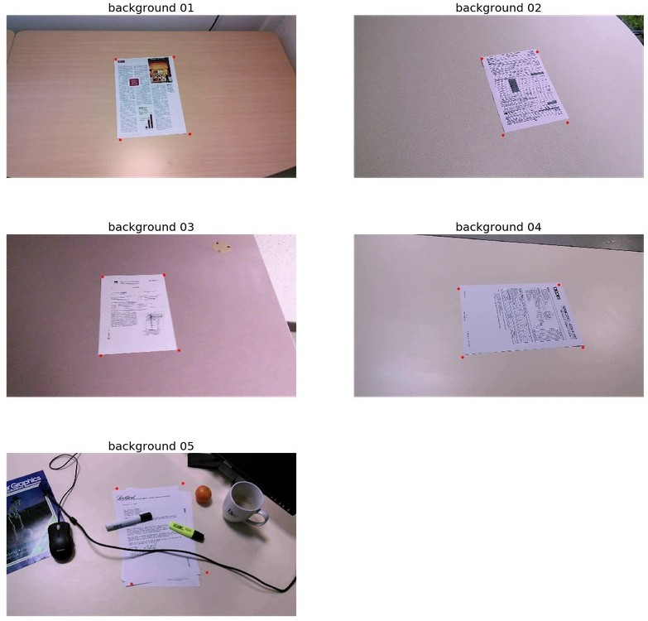

The key-points as shown in the image above are correctly positioned but not perfectly (ex. Background 5)

The Videos’ frame size: 1920x1080

I discuss later the methodology used to extract videos to images

# ###Algorithms and Techniques

* libraries used: Keras (with Tensorflow Backend)

The algorithm we will be using is a Convolutional neural networks or CNN that is going to extract important features from images and try to predict image corner coordinates.

CNN is a Deep Learning algorithm which can take in an input image, assign importance to various aspects/objects in the image and be able to differentiate one from the other. It can also be called Feature Extractor for object detection/segmentation problems.

The role of the CNN is to reduce the images into a form which is easier to process, without losing features which are critical for getting a good prediction

Here an example of an architecture of a CNN model:

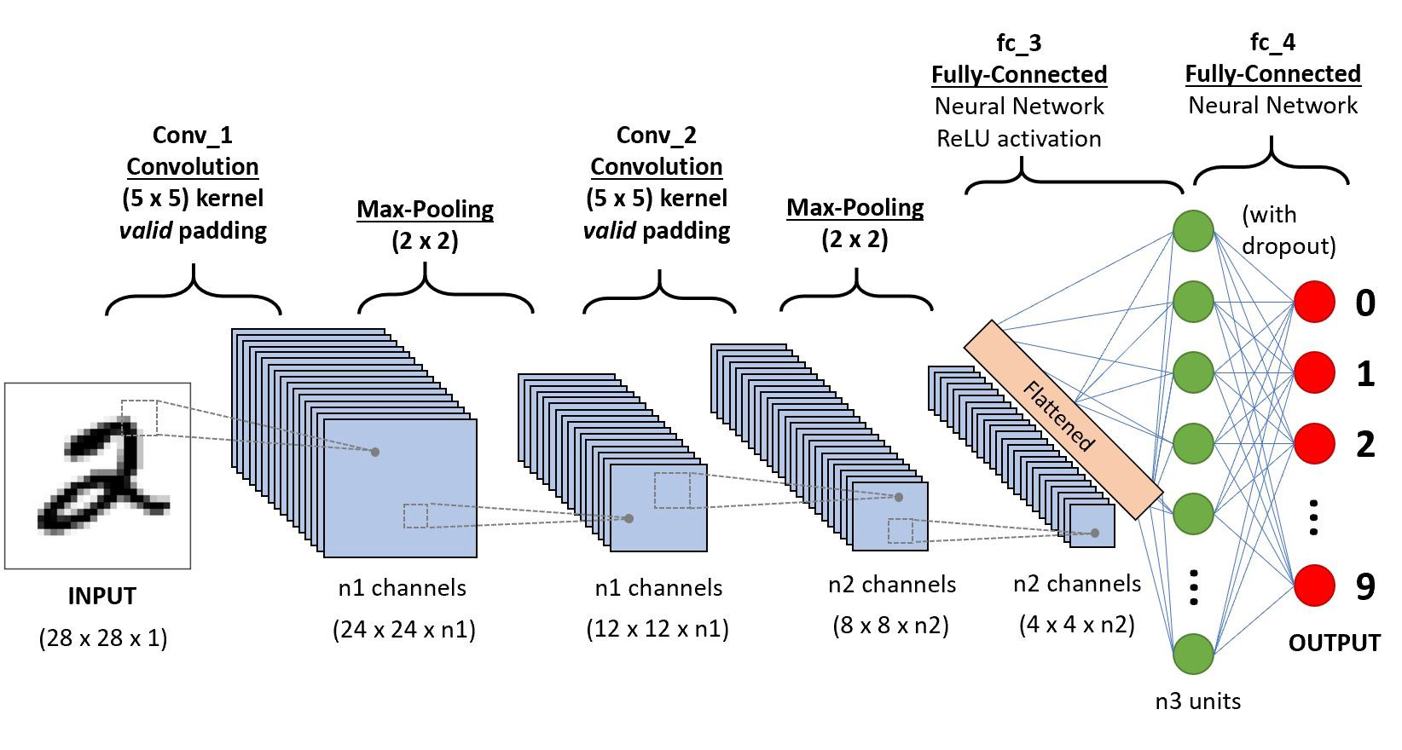

[https://miro.medium.com/max/1644/1*uAeANQIOQPqWZnnuH-VEyw.jpeg](https://miro.medium.com/max/1644/1*uAeANQIOQPqWZnnuH-VEyw.jpeg)

Some of the standard type of layers that we can find in a CNN model are:

* Convolutional layer,
* Pooling layer,
* Fully connected layer

The convolutional layer consists basically of a filter kernel (in matrix form) that has a role to find specific features inside the image (ex. Horizontal/vertical lines,…)



[https://miro.medium.com/max/526/1*GcI7G-JLAQiEoCON7xFbhg.gif](https://miro.medium.com/max/526/1*GcI7G-JLAQiEoCON7xFbhg.gif)

In the image above the image in green and the filter in yellow is 3x3 matrix:



It moves to the right with a certain Stride Value (in this case S=1) until it parses the complete width. Moving on, it hops down to the beginning (left) of the image with the same Stride Value and repeats the process until the entire image is traversed.

The value 4 results from the matrix multiplication between the first 3x3 slide on the top left of the image and the kernel filter.

Here an example to calculate the convolution layer on RGB image using 3 different filter kernels:

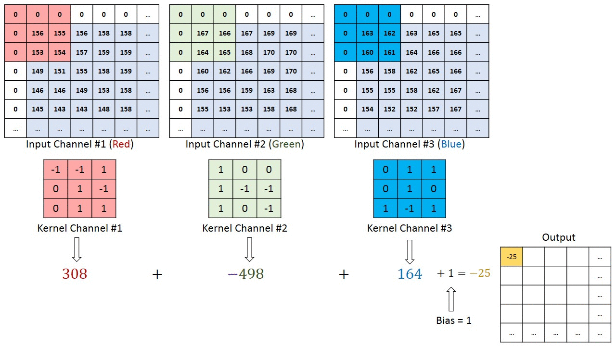

[https://miro.medium.com/max/1280/1*ciDgQEjViWLnCbmX-EeSrA.gif](https://miro.medium.com/max/1280/1*ciDgQEjViWLnCbmX-EeSrA.gif)

The pooling layer consists on reducing the size of the image features for computational reasons and to remove noise and outliers.

There are two types of pooling (shown in the image below):

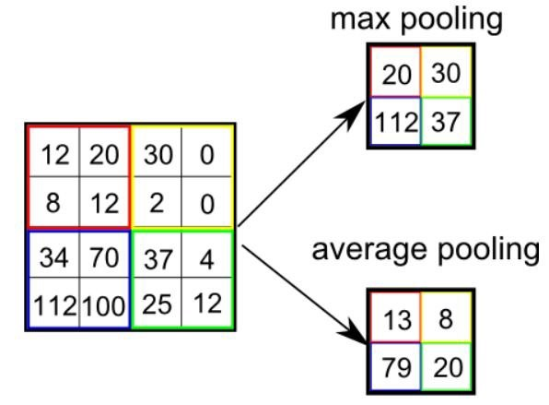

Average pooling: returns the average value from the portion of the image.

Max pooling: returns the maximum value from the portion of the image.

Max pooling is known to perform noise cancellation in top of dimensionality reductions on input images.

We’ll be using max pooling layers along with Conv layers.

A fully connected layer or Dense layer is a linear operation (often called flattening) in which every input is connected to every output by a weight (so there is n_inputs * n_outputs weights) .

# ###Benchmark

As The challenge had been canceled, there are no benchmark results for this dataset found on internet.

I will create a first small model to check if the image setup is working properly and try to showcase the first results.

The benchmark model will contain only one convolutional layer for setting the baseline performance, more detail of the architecture bellow:

_________________________________________________________________

Layer (type) Output Shape Param #

=================================================================

conv2d_1 (Conv2D) (None, 195, 348, 32) 320

_________________________________________________________________

max_pooling2d_1 (MaxPooling2 (None, 97, 174, 32) 0

_________________________________________________________________

dropout_1 (Dropout) (None, 97, 174, 32) 0

_________________________________________________________________

flatten_1 (Flatten) (None, 540096) 0

_________________________________________________________________

dense_1 (Dense) (None, 8) 4320776

=================================================================

Total params: 4,321,096

Trainable params: 4,321,096

Non-trainable params: 0

After 200 epochs

Validation loss: 0.0199219942891172

Validation mae: 10.58103322982788

Training loss: 0.0050

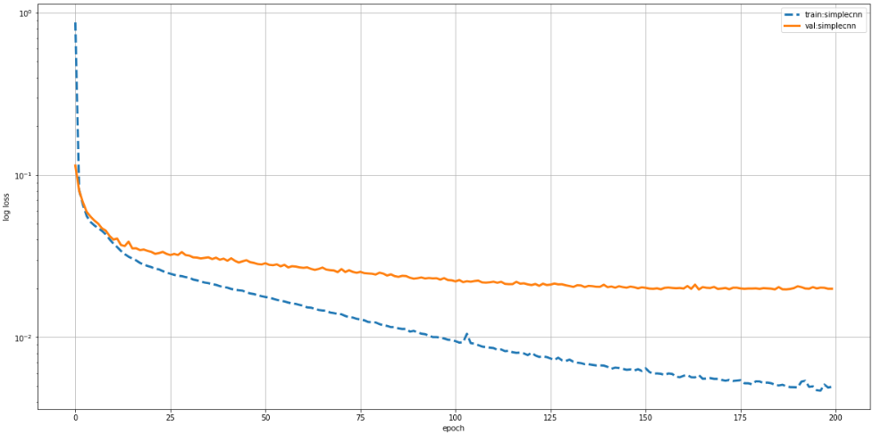

TODO show images performance of the model

I will be training the model for 200 epochs to check the consistency of the model

The first step is to test on images that come from the same dataset

The second step is to test on images taken from my smartphone (new image with different background, angle, lighting, resolution ...)

# ##Methodology

# ###Data Pre-processing

After downloading the dataset, it needs to be pre-processed. Here are the main steps to create the train and validation data

1. I need to parse all xml files and store them in One dataframe that contains filenames and corners coordinates. The script:

DF_l = []

for background_tup in backgrounds:

print(background_tup)

background = background_tup[0]

bg = background_tup[1]

xmls = [el for el in os.listdir(background) if ".xml" in el]

for xml in xmls:

xtree = et.parse(os.path.join(background,xml))

xroot = xtree.getroot()

xs, ys, idxs, names = [], [], [], []

for node in xroot.iter('point'):

names.append(node.attrib["name"]) xs.append(node.attrib["x"]) ys.append(node.attrib["y"])

for node in xroot.iter('frame'):

idxs.append(node.attrib["index"])

# idxs = [x for item in idxs for x in repeat(item, 4)]

idxs = [bg+"-"+xml.split(".gt")[0]+"-f"+idx+".jpg" for idx in idxs]

temp_df = pd.DataFrame(list(zip(names,xs,ys)),columns=["names","xs","ys"])

brx = temp_df[temp_df["names"]=="br"]["xs"] bry = temp_df[temp_df["names"]=="br"]["ys"]

tlx = temp_df[temp_df["names"]=="tl"]["xs"] tly = temp_df[temp_df["names"]=="tl"]["ys"]

blx = temp_df[temp_df["names"]=="bl"]["xs"] bly = temp_df[temp_df["names"]=="bl"]["ys"]

trx = temp_df[temp_df["names"]=="tr"]["xs"]

Try = temp_df[temp_df["names"]=="tr"]["ys"]

df = pd.DataFrame(list(zip(idxs,blx,bly,tlx,tly,brx,bry,trx,Try)),

columns=["filenames","BLx","BLy","TLx","TLy","BRx","BRy","TRx","TRy"])

DF_l.append(df)

The dataframe contains 24889 images (frames)

1. I need to convert videos to frames and save them to images using this script:

# save all videos to frames

for background_tup in backgrounds[:]:

print(background_tup)

background = background_tup[0]

bg = background_tup[1]

videos = [el for el in os.listdir(background) if ".avi" in el]

for video in videos:

im_path = os.path.join(background,video)

vidcap = cv2.VideoCapture(im_path)

length = int(vidcap.get(cv2.CAP_PROP_FRAME_COUNT))

print( length )

success,image = vidcap.read()

count = 0

while success:

output_file = "{}-{}-f{}.jpg".format(bg, video.replace(".avi",""), count)

cv2.imwrite(os.path.join(output_path,output_file), image) # save frame as JPEG file

success,image = vidcap.read()

# print('Read a new frame: ', success)

count += 1

1. Create a random sample dataframe. As video frames looks each other, Doing a random sampling of sub 10k images seems to be enough for training

sample_df = pd.concat(DF_l).sample(7000)

1. Split to train/validation

The validation set is 0.01 % of the sample data, I didn’t want to shrink the size of the sample used for training

The script splits to train/validation and create corresponding image folders:

train, val = train_test_split(clean_df, test_size=0.01) for sample in [[train,train_path],[val,validation_path]]:

filenames = sample[0]["filenames"].values.tolist()

for filename in filenames:

shutil.copyfile(os.path.join(output_path,filename),os.path.join(sample[1],filename))

1. Prepare the input image

Image resizing including landmarks doesn’t come default in Keras. I used a function from this link [https://github.com/fizyr/keras-retinanet/blob/8f7e7414db193832572773ea503c26edab405b96/](https://github.com/fizyr/keras-retinanet/blob/8f7e7414db193832572773ea503c26edab405b96/keras_retinanet/utils/image.py) [keras_retinanet/utils/image.py](https://github.com/fizyr/keras-retinanet/blob/8f7e7414db193832572773ea503c26edab405b96/keras_retinanet/utils/image.py) that resizes image and returns the scale that we apply to landmarks

The processed images final shape is (197,350,1)

# ###Implementation

1. Prepare model

The model is wrapped in one function. I had to specify:

* The height, width and the number of channels of the image in the first convolution layer that is (197, 350,1)
* The output size in the last dense / fully connected layer that is 8
* For the model compilation, I used the RMSprop as an optimizer and mean_squared_logarithmic_error as metric loss

1. Training

* The architecture of the CNN model that we’ll be using:

```

Layer (type) Output Shape Param #

=================================================================

conv2d_3 (Conv2D) (None, 195, 348, 32) 320

activation_5 (Activation) (None, 195, 348, 32) 0

max_pooling2d_3 (MaxPooling2 (None, 97, 174, 32) 0

|  |  |
| --- | --- |
| dropout_5 (Dropout) (None, 97, 174, 32) | 0 |
| conv2d_4 (Conv2D) (None, 96, 173, 64) | 8256 |
| activation_6 (Activation) (None, 96, 173, 64) | 0 |
| max_pooling2d_4 (MaxPooling2 (None, 48, 86, | 64) 0 |
| dropout_6 (Dropout) (None, 48, 86, 64) | 0 |
| conv2d_5 (Conv2D) (None, 47, 85, 128) | 32896 |
| activation_7 (Activation) (None, 47, 85, 128) | 0 |

max_pooling2d_5 (MaxPooling2 (None, 23, 42, 128) 0

dropout_7 (Dropout) (None, 23, 42, 128) 0

flatten_1 (Flatten) (None, 123648) 0

dense_3 (Dense) (None, 500) 61824500

activation_8 (Activation) (None, 500) 0

dropout_8 (Dropout) (None, 500) 0

dense_4 (Dense) (None, 500) 250500

activation_9 (Activation) (None, 500) 0

dropout_9 (Dropout) (None, 500) 0

dense_5 (Dense) (None, 8) 4008

=================================================================

Total params: 62,120,480

Trainable params: 62,120,480

Non-trainable params: 0

```

I had to lower the batch size to 64 as it doesn’t fit the Gpu memory Training 1000 epochs took around 2.7 hours on GPU

# ###Refinement

Future works to test/optimize the solution (In order):

* Data augmentation

Data augmentation seems to be an important step to make a more intelligent / robust model that is going to tackle images orientation (real life scenario)

Keras image generation is easy step but only for image classification. For key point detection need to prepare a custom function that is going to scale for each generated image key points.

Data generation means more images and thus more training time. Worth it if results get better

* Box detection + key point detection

All tutorials concerning the facial Key point Detection use a kind of object detection to detect the face and crop it, this seems effective to remove noise and focus only on the face. Thus, it would minimize considerably the loss when training for key point detection.

* Testing other CNN architectures / Transfer learning
* Optimization / GridSearch
* Specific model

One other method that may work is by creating 1 model for 1 key-point, it means for our use case we need to create 4 different models. However, there is a risk of overlapping at the same time. For ex. for a flipped document, is the model trained enough to detect if text is flipped or not (ex. BL key-point may overlap with TL key-point and vice-versa). This mainly depends on the quality of the dataset.

# ##Results

**###Model Evaluation and Validation**

After 1000 epochs of training, the loss seems to stabilize after 600 epochs. A lot of fluctuation in the validation set, mainly due to the small size of the sample. The train loss usually is smaller than the validation loss, which is coherent.

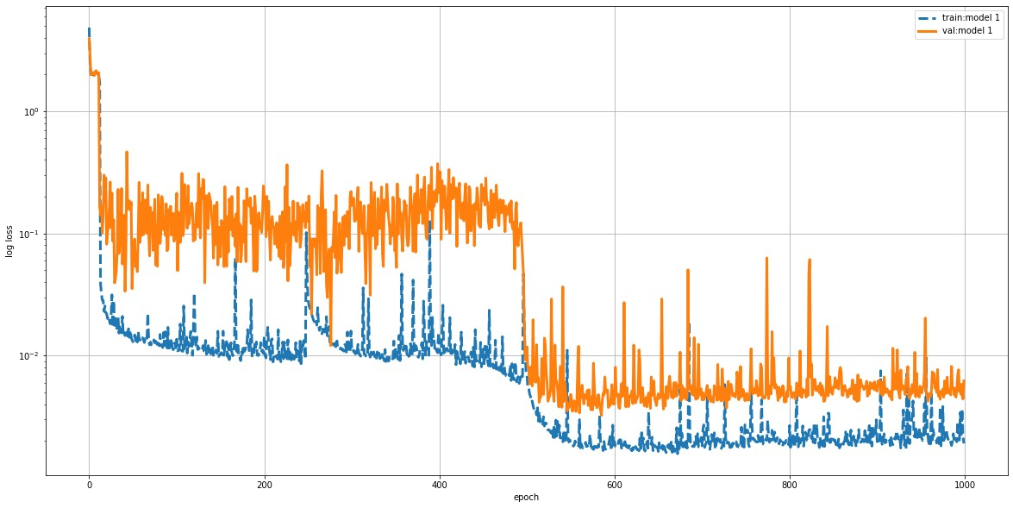

Compared to the benchmark model, the performance is better but not a big difference between the two

# ###Justification

Below a set of images tested on validation data:

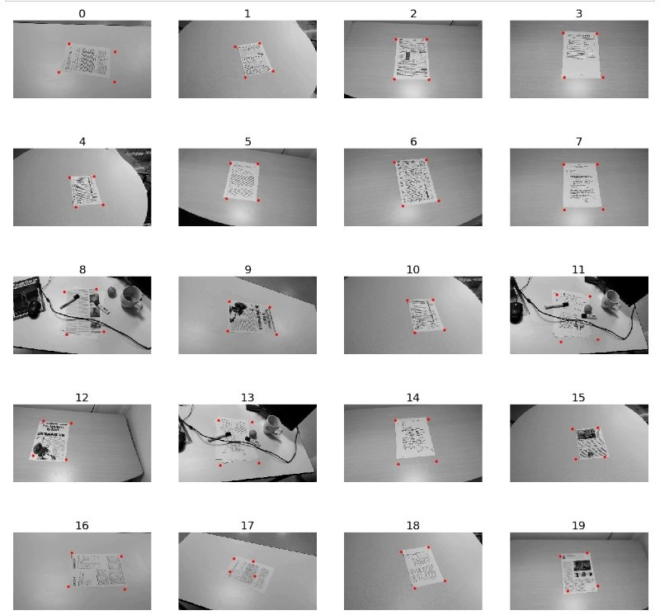

Below resized images taken from smartphone to test the solution:

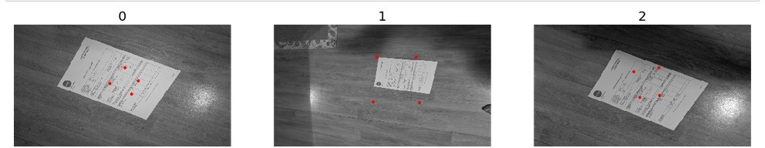

The final results showcase that the model is specific and not generalized well on non-seen images or backgrounds.

This model can work well in similar environment (when optimized) where the pictures have been taken but would be difficult to apply it to different images.

This model does not solve the recent problem, Further work is needed to optimize the model, and/or to build more generalized dataset (different type of cameras, lighting, backgrounds).