Ui开发教程

## Tab切换事件绑定方法：

$('[data-toggle="tab"]','.resourcetypelist').bind('shown.bs.tab',function(){

loadResourceOperations($(this).attr('resourceType'),$(this).attr('resourceName'),roleId,roleType);

});

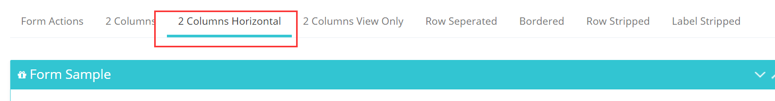

## 菜单设置

菜单上面添加fullpageload=*"true"可以控制模块是否整体页面刷新*

iframe=*"true" 控制工作区为iframe*

icon=*"icon-home" 控制菜单显示的图标*

## Form表单提交插件用法

$('form',ModelDialog.getCurrentModal())

.ajaxSubmit(

{

type : 'POST',

url : usercontextpath+'/sysmanager/user/saveSmUsersOrder.page',

forceSync : **false**,

dataType : 'json',

beforeSubmit : **function**() {

App.startPageLoading({message: '保存中...'});

},

error : **function**(xhr, ajaxOptions,

thrownError) {

PlatformCommonUtils.warn(thrownError) ;

},

success : **function**(responseText,

statusText, xhr, $form) {

window.setTimeout(**function**() {

App.stopPageLoading();

}, 2000);

**var** msg = responseText;

**var** title = '用户排序';

**var** tiptype = "success";

**if** (msg == 'success') {

msg = "用户排序完毕"

PlatformCommonUtils.success(msg,**function**(){

closeUserActionModel();

afterSaveUser();

}) ;

} **else** {

PlatformCommonUtils.warn(msg) ;

}

}

});

## 提示框使用方法

$(".btn-backuplog").bind("click",**function**(){

PDP.confirm('确定要归档日志数据吗?',**function**(){

$.ajax({

type: "POST",

url : usercontextpath+"/logmanager/backuplog.page",

data :{},

dataType : 'json',

async:**false**,

error : **function**(xhr, ajaxOptions,

thrownError) {

PDP.warn(thrownError) ;

},

beforeSend: **function**(XMLHttpRequest){

},

success : **function**(responseText){

**if**(responseText=="success"){

PDP.success("日志归档成功!");

}**else**{

PDP.warn("日志归档失败:"+responseText);

}

querylog();

}

});

});

})

## 系统操作日志记录方法

**try** {

**long** starttime = System.*currentTimeMillis*();

**this**.logManager.backuplog();

**long** endtime = System.*currentTimeMillis*();

LogManagerInf logMgr = ConfigManager.*getInstance*().getLogManager();

String userrelName = AccessControl.*getAccessControl*().getUserName();

String userAccount = AccessControl.*getAccessControl*().getUserAccount();

SimpleDateFormat format = DataFormatUtil.*getSimpleDateFormat*("yyyy-MM-dd HH:mm:ss");

String operContent = " 归档日志[开始时间:"

+ format.format(**new** Timestamp(starttime)) + ",结束时间"

+ format.format(**new** Timestamp(endtime)) + ",耗时"+(endtime - starttime)/1000+"秒]";

String openModle = "日志管理";

logMgr.log(userAccount + "(" +userrelName + ")", operContent,

openModle, AccessControl.*getAccessControl*().getMachinedID());

**return** "success";

} **catch** (Exception e) {

*logger*.error("", e);

**return** StringUtil.*exceptionToString*(e);

}

## 字典管理试用案例

<td> <dict:itemname type=*"sex"* colName=*"userSex"*/> </td>

<td> <dict:itemname type=*"userType"* colName=*"userType"*/> </td>

<td> <dict:itemname type=*"userIsvalid"* colName=*"userIsvalid"*/></td>

## Jstree增加节点后刷新树节点方法

var tree = jQuery.jstree.reference("#jstree");  
tree.refresh();