Ali Tejani, amt3639

Caroline Yao, chy253

Lab 5 Report

**Requirements document**

The goal of the document is to provide a clear an unambiguous description of what the project does.

1. Overview

1.1. Objectives: Why are we doing this project? What is the purpose?

The objectives of this project are to design, build and test a music player. Educationally, students are learning how to interface a DAC, how to design a speaker amplifier, how to store digital music in ROM, and how to perform DAC output in the background. Your goal is to play your favorite song.

1.2. Process: How will the project be developed?

The project will be developed using the TM4C123 board. There will be **two on-board switches and one external switch** that the operator will use to control the music player. The system will be built on a solderless breadboard and run on the usual USB power. The system may use the on board switches or off-board switches. A hardware/software interface will be designed that allows software to control the player. There will be at least three hardware/software modules: switch input, DAC output, and the music player. The process will be to design and test each module independently from the other modules. After each module is tested, the system will be built and tested.

1.3. Roles and Responsibilities: Who will do what? Who are the clients?

EE445L students are the engineers and the TA is the client. Students are expected to make minor modifications to this document in order to clarify exactly what they plan to build. Students are allowed to divide responsibilities of the project however they wish, but, at the time of demonstration, both students are expected to understand all aspects of the design. **Ali will create the music and interface, and Caroline will create and test the hardware.**

1.4. Interactions with Existing Systems: How will it fit in?

The system will use the TM4C123 board, a solderless breadboard, and the speaker as shown in Figure 5.1. It will be powered using the USB cable. You may use a +5V power from the lab bench, but please do not power the TPA731 or the speaker with a voltage above +5V.

1.5. Terminology: Define terms used in the document.

**SSI:** device to transmit data with synchronous serial communication protocol

**Linearity:** measure of straightness of a curve

**Frequency response:** frequency at which the gain drops to 0.707 of the normal value.

**Loudness:** amplitude of the wave

**Pitch:** frequency of the wave

**Instrument:** used to create music

**Tempo:** speed of a song

**Envelope:** shape of the note (amplitude vs time)

**Melody:** a sequence of single notes that is musically satisfying

**Harmony:** the combination of simultaneously sounded musical notes to produce chords and chord progressions having a pleasing effect

1.6. Security: How will intellectual property be managed?

The system may include software from StellarisWare and from the book. No software written for this project may be transmitted, viewed, or communicated with any other EE445L student past, present, or future (other than the lab partner of course). It is the responsibility of the team to keep its EE445L lab solutions secure.

2. Function Description

2.1. Functionality: What will the system do precisely?

If the operator presses the play/pause button the music will play or pause. If the operator presses the play/pause button once the music should pause. Hitting the play/pause again causes music to continue. The play/pause button does not restart from the beginning, rather it continues from the position it was paused. If the rewind button is pressed, the music stops and the next play operation will start from the beginning. There is a mode switch that allows the operator to change the instrument.

There must be a C data structure to hold the music. There must be a music driver that plays songs. The length of the song should be at least 30 seconds and comprise of at least 8 different frequencies. Although you will be playing only one song, the song data itself will be stored in a separate place and be easy to change. The player runs in the background using interrupts. The foreground (main) initializes the player, then executes **for(;;){}** do nothing loop. If you wish to include LCD output, this output should occur in the foreground. The maximum time to execute one instance of the ISR is **2.23 microseconds***.* You will need public functions **Rewind**, **Play** and **Stop**, which perform operations like a cassette tape player. The **Play** function has an input parameter that defines the song to play. A background thread implemented with output compare will fetch data out of your music structure and send them to the DAC.

There must be a C data structure to store the sound waveform or instrument. You are free to design your own format, as long as it uses a formal data structure (i.e., **struct**). The generated music must sound beautiful utilizing the SNR of the DAC. Although you only have to implement one instrument, it should be easy to change instruments.

2.2. Scope: List the phases and what will be delivered in each phase.

Phase 1 is the preparation; phase 2 is the demonstration; and phase 3 is the lab report. Details can be found in the lab manual.

2.3. Prototypes: How will intermediate progress be demonstrated?

A prototype system running on the TM4C123 board and solderless breadboard will be demonstrated. Progress will be judged by the preparation, demonstration and lab report.

2.4. Performance: Define the measures and describe how they will be determined.

The system will be judged by three qualitative measures. First, the software modules must be easy to understand and well-organized. Second, the system must employ an abstract data structures to hold the sound and the music. There should be a clear and obvious translation from sheet music to the data structure. Backward jumps in the ISR are not allowed. Waiting for SSI output to complete is an acceptable backwards jump. Third, all software will be judged according to style guidelines. Software must follow the style described in Section 3.3 of the book*.* There are three quantitative measures. First, the SNR of the DAC output of a sine wave should be measured. Second, the maximum time to run one instance of the ISR will be recorded. Third, you will measure power supply current to run the system. There is no particular need to optimize any of these quantitative measures in this system.

2.5. Usability: Describe the interfaces. Be quantitative if possible.

There will be three switch inputs. The DAC will be interfaced to a 32-ohm speaker.

2.6. Safety: Explain any safety requirements and how they will be measured.

If you are using headphones, please verify the sound it not too loud before placing the phones next to your ears.

3. Deliverables

3.1. Reports: How will the system be described?

A lab report described below is due by the due date listed in the syllabus. This report includes the final requirements document.

3.2. Audits: How will the clients evaluate progress?

The preparation is due at the beginning of the lab period on the date listed in the syllabus.

3.3. Outcomes: What are the deliverables? How do we know when it is done?

There are three deliverables: preparation, demonstration, and report.

**Circuit Design**

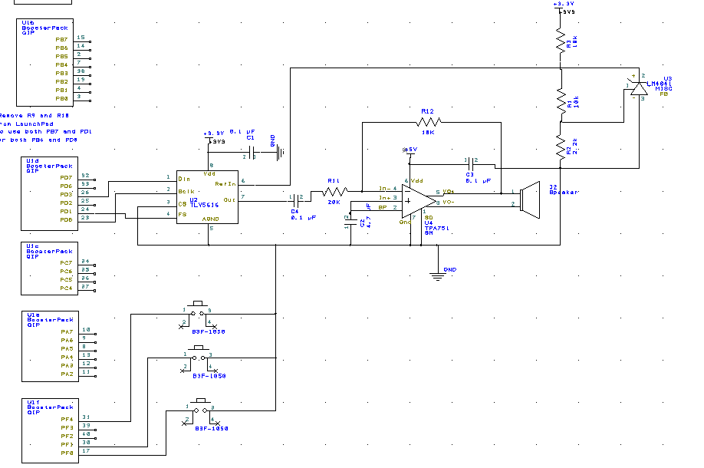

**Software Design**

Data Flow:



Call Graph:

Music

DAC Hardware

Timer Hardware

DAC driver

Timer Driver

Switch Hardware

Switch Driver

Main program

**Measured Data**

Data and calculated resolution, range, precision and accuracy

|  |  |  |  |
| --- | --- | --- | --- |
| Digital Input | Expected Output | Analog Output | Accuracy (Percent) |
| 500 | 0.3906 | 0.392 | 0.36 |
| 1000 | 0.7813 | 0.792 | 1.37 |
| 1500 | 1.1719 | 1.18 | 0.69 |
| 2000 | 1.5625 | 1.54 | -1.44 |
| 2500 | 1.9531 | 1.92 | -1.69 |
| 3000 | 2.3438 | 2.36 | 0.69 |
| 3500 | 2.7344 | 2.68 | -1.99 |
| 4095 | 3.1992 | 3.17 | -0.91 |
|  |  |  |  |
| Reference Voltage | 1.6 |  |  |
| Range | 3.2 |  |  |
| Precision | 4096 |  |  |
| Resolution | 0.00078125 |  |  |
| Average Accuracy | -0.365 |  |  |

Time Domain: 880 Hz

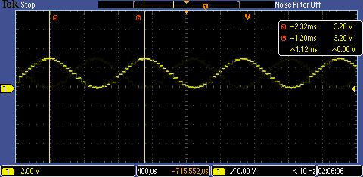

Frequency Domain:

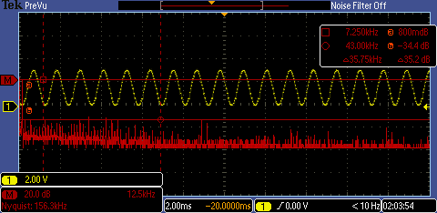

SNR = 0.8 dB – (34.4 dB)

Maximum time required to execute the periodic interrupt service routines

Systick: 1.15 µs/18.4 µs = 6.25%

Timer1: 1.4 µs/47.8 µs = 2.93%

Timer2: 1.74 µs/141.2 µs = 1.23%

Timer3: 2.23 µs/213 µs = 0.715%

RMS Voltage

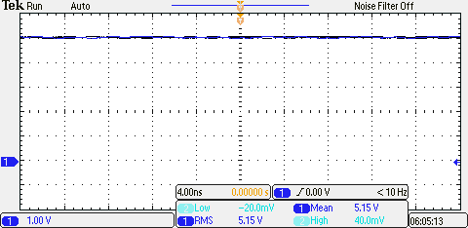

Current Measurement without Speaker: 78 mA

Current Measurement without Speaker: 114 mA

**Analysis and Discussion**

1. Briefly describe three errors in a DAC
   1. Gain Error: the shift in slope of actual analog output from ideal analog output
   2. Offset Error: the shift in actual analog output from ideal analog output
   3. Full Scale Error: combination of offset error and gain error
2. Calculate the data available and data required intervals in the SSI/DAC interface. Use these calculations to justify your choice of SSI frequency.
   1. Data available: propagation delay after positive clock edge to next positive clock edge
   2. Data required: 8 ns before negative clock edge to 5 ns after clock edge
   3. Positive clock edge + delay <= negative clock edge – 8ns
      1. Delay <= .5* period – 8 ns
      2. 5 ns <= .5* period
      3. Period => 5/.5 = 50 ns
   4. Our SSI had to be less than 1/(50 ns) = 20MHz
3. How is the frequency range of a spectrum analyzer determined?
   1. The frequency range is 0 to ½*sampling rate of the spectrum analyzer, according to the Nyquist Theorem
4. Why did we not simply drive the speaker directly from the DAC? I.e., what purpose is the TPA731?
   1. The TPA731 amplifies the current that is provided to the speaker, since the DAC cannot provide enough current to the speaker.