EE445L Laboratory Manual
Spring 2017
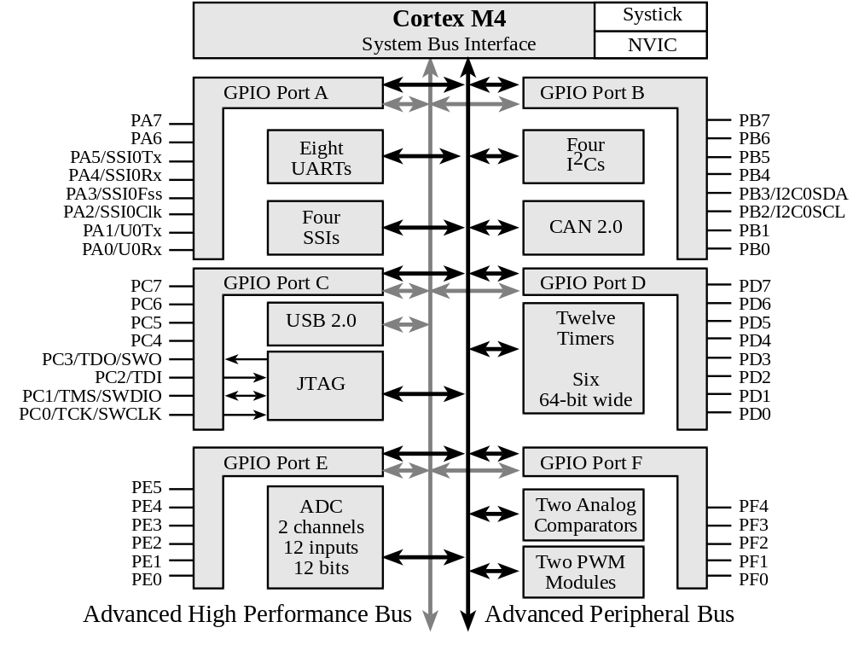

Jonathan W. Valvano
Electrical and Computer Engineering
University of Texas at Austin

In Case of Emergency Dial 911

email: valvano@mail.utexas.edu
web: http://users.ece.utexas.edu/~valvano

This laboratory assignment accompanies the book, Embedded Systems: Real-Time Interfacing to ARM Cortex M Microcontrollers, ISBN-13: 978-1463590154, by Jonathan W. Valvano, copyright © 2016.
Table of Contents
Lab introduction (rules and procedures) (this Labintro.doc)
Lab 1. ASCII to fixed-point output
Lab 2. Debugging, oscilloscope fundamentals, logic analyzer, dump profile
Lab 3. Alarm clock, LCD, edge-triggered interrupt, and timer interrupts
Lab 4. Wifi, IoT, LCD
Lab 5.12-bit DAC, SPI, Music player, audio amp
Lab 6. Introduction to PCB Layout, PCB Artist (paper design only)
Lab 7. Design and Layout of an Embedded System
Lab 8. Software drivers for an Embedded System
Lab 9. Temperature measurement, ADC, LCD
Lab 10. DC Motor controller
Lab 11. Final Design and Evaluation of Embedded System

Parts you may need on long term checkout from the lab checkout
3 – Bypass capacitors (any value 0.01 to 0.22uF)
3 – Switches that plug into a protoboard,
1 – 32-ohm speaker or similar (Labs 3, 5)
1 – PN2222 (Lab 3)
1 – TIP120 NPN Darlington motor driver (Lab 10)
1 – 1N914 snubber diode (Lab 10)
1 – DC motor with tachometer (4-wire, 5V) (Lab 10)
1 – 30k, 50k, or 100k NTC thermistor (Lab 9)

I. Introduction to EE445L Laboratory

I.1. Grading Policies (Labs 7, 8, 11 have different grading policies)
Groups will consist of exactly two students. Lab partners have separate checkout grades+, but share the preparation*, report*, software quality*, and late penalty grades*. For each lab assignment, there are a number of preparation tasks that must be completed before the laboratory period. The following activities occur in this order at the beginning of lab, you turn in your preparation, the TA will give a short lab lecture, the TA will check your preparation, and if possible the TA will return the preparation to you.
Responsibility grade
Attendance 5+
Attendance is an important part of EE445L. All students must attend all lab sections.
Preparation 15*
Preparation, is a submission on Canvas, includes your software, which is due at the start of lab. The software should be typed into the computer and compiled with no syntax errors. Preparation does not usually involve running and debugging, but it should not be handwritten. Preparation also includes hardware circuit diagrams, which are also due at the start of lab. Handwritten diagrams are acceptable for the prep, but diagrams in the report must be generated using a CAD package. Hardware diagrams include chip numbers, pin numbers, resistor/capacitor types and tolerances, connections to computer. You are responsible for the procurement of all necessary parts before lab starts. As part of the preparation, hardware circuits but not necessarily built or debugged. See specific instructions for each lab.
Software Quality (see the section on software style guidelines later on in the lab manual) 20*
Documentation, comments, choice of good variable and function names
Proper style, organization, modular structure, ease of understanding
Report (10) Final hardware circuit diagrams (must be generated using a CAD program) 25*
(15) Results, performance/data graphs (handwritten/scanned drawings are OK)
Reports will be due 11:59pm of the assigned day, submitted as a pdf.
Checkout, demonstration to TA
Performance, correctness of the program function 20*
Interface to the human operator, menus, error messages
Oral understanding of engineering tradeoffs 15+
Both students must be present, together, during checkout
Penalty 2 points per day, up to two days, for late checkout
No late checkout after two days
No late preparations allowed
Late Report -5/day*
Total 100+
If a TA other than yours checks out your lab, please email your TA specifying the time, date, lab number and the other TA’s name. Also, please follow up with both TAs to make sure you got credit for the lab. Please include the following information at the beginning of each of your software files:
1) Students’ names
2) TA name
3) Date of last change
4) Lab assignment number
5) Purpose of the software module
6) Hardware configuration

I.2. SAFETY REGULATIONS:

IN CASE OF EMERGENCY DIAL 911 or Emergency info 512-232-9999

Since there will be times when students will work other than the regularly scheduled lab sections, it is necessary that certain regulations be observed for the convenience and safety of all. Since the possibility of lethal shock exists in those circuits utilizing low potentials, the following should always be observed:
1. Working alone in a lab room is not permitted.
2. Working after regular hours without written permission is not permitted.
3. Work benches must be clear of all coats, knapsacks and extraneous materials. Coat racks are desired for those desiring this convenience. Otherwise all materials must be stored under the work area or out of the way.
4. Shoes must be worn in the lab at all times. Shoes represent a significant protection against electrical shock.
5. Smoking, food and beverages (e.g., coffee) are not permitted anywhere in the lab area.
IN CASE OF INJURY OR SHOCK:
Turn off power, do not move the injured. Start artificial respiration if breathing has stopped. Have someone else call 911 if CPR is needed.

IN CASE OF FIRE:
Turn off the power, call 911, fight fire with available extinguisher, have someone clear the building.

I.3. LAB PROCEDURES AND POLICIES

FIRST LAB: There are no labs during the week that classes begin. Go to the regularly scheduled lab the week following the week classes begin. During this time, you will be introduced to the lab equipment. You will also be instructed on lab procedures and grading policy. If you missed your regularly scheduled lab, attend one of the other lab periods. Note that attending a lab session for which you are not registered is not permitted except during the first week of classes.

LAB PARTNERS: Every student is required to have a lab partner. You will perform all labs with a partner. Students choose their own lab partners during the first week.

LAB EQUIPMENT USAGE: Lab hours are posted in the laboratory. There are no sign-up sheets, but cooperation is expected. If you start debugging on a station, you may stay as long as you like, with three exceptions:
You must leave when the ECE labs are closed for the day;
You must leave during the first half-hour of the other regularly scheduled lab periods;
You may not leave the station unattended for more than 15 minutes.

If you would like to use a station that has been left unattended for more than 15 minutes:
1) Carefully disconnect the hardware and eject any USB disks;
2) Do not save any software files;
3) Return all materials (hardware, disks, paper) to the front desk;
4) Leave a note on the station with your name and time;
5) Write a note to the TA describing exact times listing what you turned in.

LAB LECTURE: The purpose of the lab lecture is to provide necessary information to complete the lab. The scope of the lectures will be material relevant to the lab. The lecture will be conducted during the first 15 minutes of each lab session.

LAB PREPARATION: Lab preparation must be performed prior to the regularly scheduled lab period. All software must be written, edited and designed before coming to the lab. Hardware must be designed down to the pin numbers. Label all resistance and capacitance values and types. For example, 1kΩ 5% carbon, or 0.01µF 5% ceramic. In this way, the lab period may be spent in debugging your system with the TA’s help. The preparation is due at the start of the lab. Preparation includes gathering all the physical components required to perform the lab.

LAB REPORT: Each lab report is bound separately. There is a Deliverables section that details the specific components required for that lab report. The lab report typically includes the following items:
A) Objectives (1/2 page maximum)
B) Hardware Design. Detailed hardware designs with pin numbers.
Generated using a CAD program like PCB Artist
Include all external devices used (chips, R’s C’s values and types)
Show connections to the microcontroller board.
C) Software Design (no software printout in the report)
Draw figures illustrating the major data structures used,
A call-graph illustrating the modularity of the software components
Draw data-flow graph showing how data is processed
D) Measurement Data
Whenever appropriate, enter data into MatLab or Excel, or take photographs of the screen. Include graphs and figures as specified in the assignment.
E) Analysis and Discussion (answers to specific questions given in the assignment)

CHECKOUT: A rough draft of your hardware diagrams and your source code listings must be shown to the TA before you demonstrate. If your experiment works, you will be assigned a good score on the performance part. The TA will ask the partners oral questions that test your “understanding” of the computer engineering concepts of the lab. The partners will answer separate questions and receive separate “understanding” grades. You must get your rough draft software listings signed and dated by a TA to prove that the lab was completed in a satisfactory manner. Late checkouts will result in lost points. Ask you TA how to turn in materials.

I.5. Web sites
Electronic parts http://www.jameco.com/
Electronic parts http://www.digikey.com/
Electronic parts http://www.mouser.com/
Surplus parts http://www.bgmicro.com
Surplus parts http://www.allelectronics.com
Sensors http://www.sparkfun.com
robot parts http://www.robotstore.com/
robot sensors http://www.parallax.com/
robot parts http://www.towerhobbies.com/
enclosures http://www.pactecenclosures.com/

I.6. Legal Stuff
The opinions expressed in these notes do not necessarily reflect the opinions of the University, its management or its big time financial donors. Also, there shall be no bologna, Bevis, mustard, chewing the cables, free lunch, sob stories, running & screaming, whining, hitting, spitting, kicking, biting, or tag backs. Quit it or we’re telling. (Enjoy the course.)

IO | Ain | 0 | 1 | 2 | 3 | 4 | 5 | 6 | 7 | 8 | 9 | 14
PA0 |  | Port | U0Rx |  |  |  |  |  |  | CAN1Rx
PA1 |  | Port | U0Tx |  |  |  |  |  |  | CAN1Tx
PA2 |  | Port |  | SSI0Clk
PA3 |  | Port |  | SSI0Fss
PA4 |  | Port |  | SSI0Rx
PA5 |  | Port |  | SSI0Tx
PA6 |  | Port |  |  | I₂C1SCL |  | M1PWM2
PA7 |  | Port |  |  | I₂C1SDA |  | M1PWM3
PB0 | USB0ID | Port | U1Rx |  |  |  |  |  | T2CCP0
PB1 | USB0VBUS | Port | U1Tx |  |  |  |  |  | T2CCP1
PB2 |  | Port |  |  | I₂C0SCL |  |  |  | T3CCP0
PB3 |  | Port |  |  | I₂C0SDA |  |  |  | T3CCP1
PB4 | Ain10 | Port |  | SSI2Clk |  | M0PWM2 |  |  | T1CCP0 | CAN0Rx
PB5 | Ain11 | Port |  | SSI2Fss |  | M0PWM3 |  |  | T1CCP1 | CAN0Tx
PB6 |  | Port |  | SSI2Rx |  | M0PWM0 |  |  | T0CCP0
PB7 |  | Port |  | SSI2Tx |  | M0PWM1 |  |  | T0CCP1
PC4 | C1- | Port | U4Rx | U1Rx |  | M0PWM6 |  | IDX1 | WT0CCP0 | U1RTS
PC5 | C1+ | Port | U4Tx | U1Tx |  | M0PWM7 |  | PhA1 | WT0CCP1 | U1CTS
PC6 | C0+ | Port | U3Rx |  |  |  |  | PhB1 | WT1CCP0 | USB0epen
PC7 | C0- | Port | U3Tx |  |  |  |  |  | WT1CCP1 | USB0pflt
PD0 | Ain7 | Port | SSI3Clk | SSI1Clk | I₂C3SCL | M0PWM6 | M1PWM0 |  | WT2CCP0
PD1 | Ain6 | Port | SSI3Fss | SSI1Fss | I₂C3SDA | M0PWM7 | M1PWM1 |  | WT2CCP1
PD2 | Ain5 | Port | SSI3Rx | SSI1Rx |  | M0Fault0 |  |  | WT3CCP0 | USB0epen
PD3 | Ain4 | Port | SSI3Tx | SSI1Tx |  |  |  | IDX0 | WT3CCP1 | USB0pflt
PD4 | USB0DM | Port | U6Rx |  |  |  |  |  | WT4CCP0
PD5 | USB0DP | Port | U6Tx |  |  |  |  |  | WT4CCP1
PD6 |  | Port | U2Rx |  |  | M0Fault0 |  | PhA0 | WT5CCP0
PD7 |  | Port | U2Tx |  |  |  |  | PhB0 | WT5CCP1 | NMI
PE0 | Ain3 | Port | U7Rx
PE1 | Ain2 | Port | U7Tx
PE2 | Ain1 | Port
PE3 | Ain0 | Port
PE4 | Ain9 | Port | U5Rx |  | I₂C2SCL | M0PWM4 | M1PWM2 |  |  | CAN0Rx
PE5 | Ain8 | Port | U5Tx |  | I₂C2SDA | M0PWM5 | M1PWM3 |  |  | CAN0Tx
PF0 |  | Port | U1RTS | SSI1Rx | CAN0Rx |  | M1PWM4 | PhA0 | T0CCP0 | NMI | C0o
PF1 |  | Port | U1CTS | SSI1Tx |  |  | M1PWM5 | PhB0 | T0CCP1 |  | C1o | TRD1
PF2 |  | Port |  | SSI1Clk |  | M0Fault0 | M1PWM6 |  | T1CCP0 |  |  | TRD0
PF3 |  | Port |  | SSI1Fss | CAN0Tx |  | M1PWM7 |  | T1CCP1 |  |  | TRCLK
PF4 |  | Port |  |  |  |  | M1Fault0 | IDX0 | T2CCP0 | USB0epen
Table 2.7. PMCx bits in the GPIO_PORTx_PCTL_R register on the TM4C specify alternate functions. PB1, PB0, PD4 and PD5 are hardwired to the USB device. PA0 and PA1 are hardwired to the serial port. PWM is not available on LM4F120.

