Clustering Techniques in Unsupervised Learning: A Comprehensive Overview

Introduction
Clustering is one of the most popular methods in unsupervised learning, where the goal is to group similar data points without predefined labels. Unlike supervised learning, clustering relies solely on the inherent patterns in data to identify structures. It has applications across industries, such as customer segmentation, anomaly detection, and image compression.
This article provides a detailed explanation of three prominent clustering techniques: K-Means Clustering, Fuzzy C-Means Clustering, and Hierarchical Clustering, along with their working principles, advantages, disadvantages, and real-world applications.

Table of Contents
Clustering Techniques in Unsupervised Learning: A Comprehensive Overview 1
Introduction 1
Clustering: Classification vs. Clustering 2
Classification: 2
Clustering: 2
Clustering Techniques 2
1. K-Means Clustering 2
How it Works: 2
2. Fuzzy C-Means Clustering 3
How it Works: 3
3. Hierarchical Clustering 6
How it Works: 6
Advantages: 7
Disadvantages: 7
Optimal Clustering 7
Comparison of Techniques 7
Conclusion 7
Explanation of the Two Methods 8
Hierarchical Clustering Type 8
Explanation of the Two Methods 9
Hierarchical Clustering Type 9
Key Differences Between the Two Approaches 10
1. Elbow Method 10
2. Silhouette Score 10
3. Gap Statistic 11
4. Domain Knowledge 11
5. Other Heuristics 11

Clustering: Classification vs. Clustering

Classification:
- A supervised learning method where the algorithm learns from labeled data to classify new data into predefined categories.
- Example: Classifying emails as spam or not spam.

Clustering:
- An unsupervised learning method that groups similar data points into clusters based on their features.
- Example: Segmenting customers based on purchasing patterns.
While classification is about prediction, clustering focuses on discovery, making it crucial for exploratory data analysis.

Clustering Techniques

1. K-Means Clustering
K-Means is a simple and fast algorithm that partitions data into KKK clusters. Each cluster is defined by its centroid, and points are assigned to the nearest centroid.

How it Works:
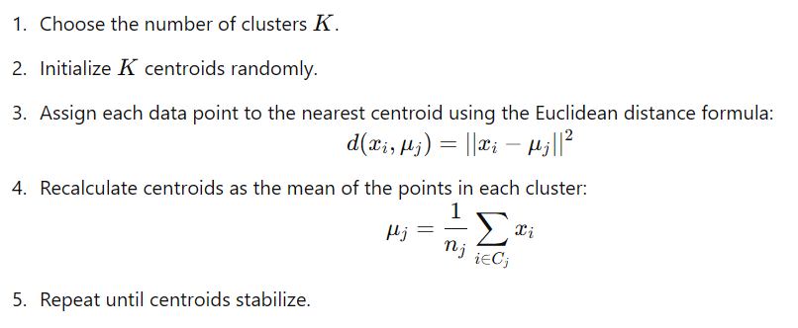

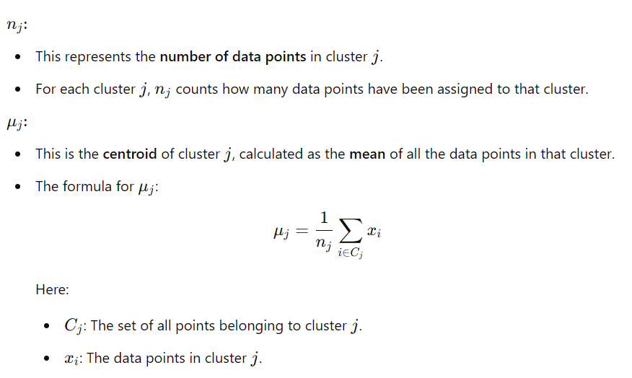

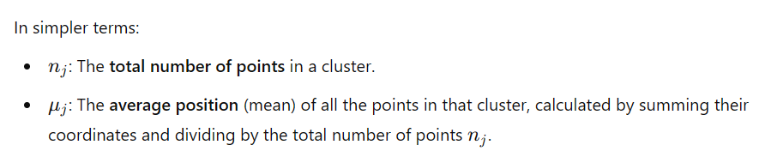

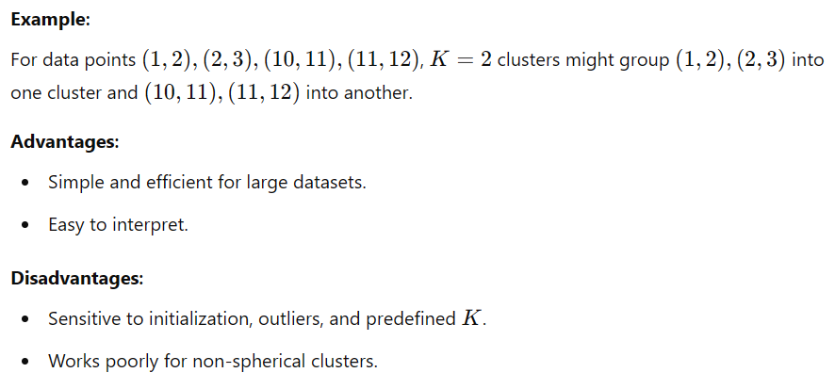

2. Fuzzy C-Means Clustering
Fuzzy C-Means is a soft clustering algorithm where data points can belong to multiple clusters with varying degrees of membership.

How it Works:

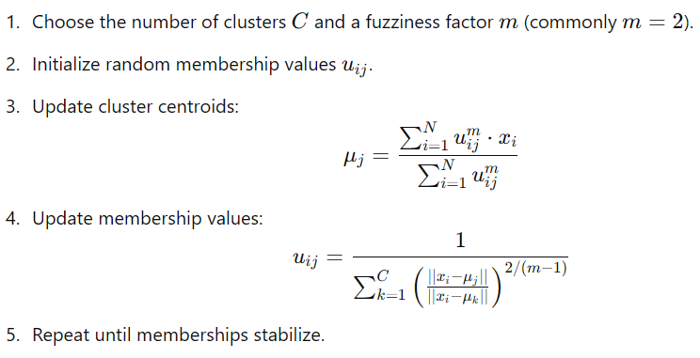
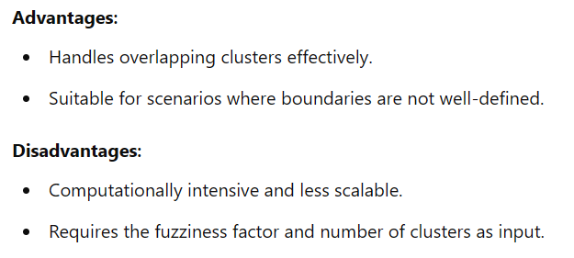

3. Hierarchical Clustering
Hierarchical clustering creates a tree-like structure of clusters, called a dendrogram, which illustrates the relationships between clusters.

How it Works:
- Treat each data point as its own cluster.
- Compute distances between clusters using linkage methods:
  - Single linkage: Minimum distance.
  - Complete linkage: Maximum distance.
  - Average linkage: Mean distance.
- Merge the closest clusters.
- Repeat until all points belong to one cluster or a desired number of clusters.

Advantages:
- No need to predefine K.
- Provides a dendrogram for visual insights.

Disadvantages:
- Computationally expensive for large datasets.
- Sensitive to noise and outliers.

Optimal Clustering
To achieve the best clustering results:
- Choose the Right Algorithm:
  - Use K-Means for large, simple datasets.
  - Use Fuzzy C-Means for overlapping data.
  - Use Hierarchical Clustering for smaller datasets requiring relationship insights.
- Evaluate Clustering Quality:
  - Elbow Method: Determine the optimal K by observing where the "within-cluster sum of squares" flattens.
  - Silhouette Score: Measures how well each data point fits within its cluster.
  - Davies-Bouldin Index: Lower values indicate better clustering.
- Preprocess Data:
  - Normalize features to ensure fair comparison.
  - Handle outliers to avoid skewed results.

Comparison of Techniques
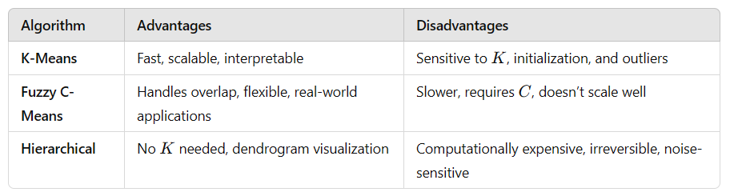

Conclusion
Clustering is an essential technique for exploratory data analysis, enabling data-driven decision-making in the absence of labels. The choice of algorithm depends on the dataset and the clustering objective. K-Means is ideal for speed and simplicity, Fuzzy C-Means excels with overlapping data, and Hierarchical Clustering is perfect for smaller datasets with hierarchical insights.
By understanding the strengths and limitations of these algorithms, data scientists and analysts can unlock valuable patterns and insights from raw data, paving the way for innovative applications across industries.

Explanation of the Two Methods
- Dendrogram with linkage (Hierarchical Clustering Visualization):
  - The code using scipy.cluster.hierarchy to create a dendrogram represents Agglomerative Hierarchical Clustering.
  - It creates a hierarchical structure of clusters by progressively merging smaller clusters into larger ones until all points belong to one cluster.
  - The dendrogram visualizes this process, showing how clusters are formed at each step. The method='ward' specifies the Ward's linkage criterion, which minimizes the total within-cluster variance.
  - This is a visualization tool to help decide the optimal number of clusters by observing the height of the splits in the dendrogram.
- Agglomerative Clustering (AgglomerativeClustering from sklearn):
  - This is also Agglomerative Hierarchical Clustering, but instead of creating a dendrogram, it directly computes the clusters.
  - The linkage='ward' parameter ensures that Ward's method is used to merge clusters based on minimizing variance.
  - The n_clusters=5 parameter specifies the desired number of clusters.
  - The method clusters the data by repeatedly merging clusters until only the specified number of clusters remain.

Hierarchical Clustering Type
Both methods belong to Agglomerative Hierarchical Clustering, which:
- Starts with each data point as its own cluster (bottom-up approach).
- Iteratively merges clusters based on a linkage criterion, such as:
  - Ward's method: Minimizes variance within clusters.
  - Single linkage: Based on the minimum distance between points in clusters.
  - Complete linkage: Based on the maximum distance.
  - Average linkage: Based on the average distance.
The dendrogram is a tool to visualize the hierarchy, while the AgglomerativeClustering directly generates the final clusters.

The clustering methods mentioned in your code snippets are examples of Hierarchical Clustering techniques.

Explanation of the Two Methods
- Dendrogram with linkage (Hierarchical Clustering Visualization):
  - The code using scipy.cluster.hierarchy to create a dendrogram represents Agglomerative Hierarchical Clustering.
  - It creates a hierarchical structure of clusters by progressively merging smaller clusters into larger ones until all points belong to one cluster.
  - The dendrogram visualizes this process, showing how clusters are formed at each step. The method='ward' specifies the Ward's linkage criterion, which minimizes the total within-cluster variance.
  - This is a visualization tool to help decide the optimal number of clusters by observing the height of the splits in the dendrogram.
- Agglomerative Clustering (AgglomerativeClustering from sklearn):
  - This is also Agglomerative Hierarchical Clustering, but instead of creating a dendrogram, it directly computes the clusters.
  - The linkage='ward' parameter ensures that Ward's method is used to merge clusters based on minimizing variance.
  - The n_clusters=5 parameter specifies the desired number of clusters.
  - The method clusters the data by repeatedly merging clusters until only the specified number of clusters remain.

Hierarchical Clustering Type
Both methods belong to Agglomerative Hierarchical Clustering, which:
- Starts with each data point as its own cluster (bottom-up approach).
- Iteratively merges clusters based on a linkage criterion, such as:
  - Ward's method: Minimizes variance within clusters.
  - Single linkage: Based on the minimum distance between points in clusters.
  - Complete linkage: Based on the maximum distance.
  - Average linkage: Based on the average distance.
The dendrogram is a tool to visualize the hierarchy, while the AgglomerativeClustering directly generates the final clusters.

Key Differences Between the Two Approaches
Method | Purpose | Output
dendrogram | Visualize the hierarchy of clusters and decide cluster count | A hierarchical tree structure (dendrogram)
AgglomerativeClustering | Compute final clusters with a predefined number of clusters | Cluster labels for the data points

In summary, these are two aspects of Agglomerative Hierarchical Clustering: visualization and direct clustering with a specified number of clusters.

Choosing the right number of clusters, k

Choosing the right number of clusters, k, in k-means clustering is important to get meaningful groupings. Here are some common methods to determine k:

1. Elbow Method
- How it works:
  - Run k-means for different values of k (e.g., 1 to 10).
  - Calculate the inertia (sum of squared distances between data points and their cluster centers).
  - Plot k vs. inertia.
  - Look for the "elbow" point where the inertia starts decreasing more slowly. That’s your optimal k.

2. Silhouette Score
- How it works:
  - Calculate the silhouette score for different values of k.
  - The silhouette score measures how well data points fit within their clusters (higher is better, range is -1 to 1).
  - Choose the k with the highest silhouette score.

3. Gap Statistic
- How it works:
  - Compare the total within-cluster variance for your data to a null reference distribution (random data).
  - The optimal k is where the gap between your data and the reference data is the largest.

4. Domain Knowledge
- How it works:
  - Use prior knowledge about the dataset or problem to determine a reasonable k.
  - For example, if you're clustering customers, you might already know the typical number of customer segments.

5. Other Heuristics
- Knee Method: Similar to the Elbow Method but focuses on identifying a "knee" in the curve.
- Rule of Thumb: If unsure, k is often chosen as k = sqrt(n / 2), where n is the number of data points, though this is a rough estimate.

# 5. Other Heuristics for Determining Optimal k
# Knee Method:
# Similar to the Elbow Method but focuses on identifying a "knee" in the curve.
# Rule of Thumb:
# If unsure about the number of clusters (k), you can use this rough estimate:
# k = sqrt(n / 2), where n is the number of data points.

