Table of Contents
Decision Tree 2
Key Terms in Decision Trees: 2
Example: 3
CART Gini Impurity and ID3 Information Gain 3
1. CART (Classification and Regression Trees) - Gini Impurity 3
Example: 3
2. ID3 (Iterative Dichotomiser 3) - Information Gain 4
Entropy: 4
Information Gain: 5
Example: 5
Difference Between Gini Impurity and Information Gain 5
Intuition: 5
How CART Selects the Best Feature Using Gini Impurity 5
1. Binary Tree Structure 6
2. Multi-Branching Tree Structure 7
Conclusion: 7
3. Which One Should You Use? 8
Decision Tree Algorithms: ID3, C4.5, and C5.0 8
1. ID3 (Iterative Dichotomiser 3) 8
Key Features: 8
Example of Splitting: 8
2. C4.5 8
Improvements Over ID3: 9
Why It’s Better: 9
3. C5.0 9
Improvements Over C4.5: 9
Why It’s the Best: 9
Summary: 10

Decision Tree
A Decision Tree is a flowchart-like structure used in decision-making or machine learning. It helps to make decisions or predictions by splitting data into smaller and smaller groups based on certain conditions, like a game of "20 Questions."

Key Terms in Decision Trees:
- Root Node:
  - The starting point of the tree.
  - Represents the entire dataset or the first decision you need to make.
  - Example: "Is the weather sunny or rainy?"
- Parent Node:
  - A node that has branches leading to other nodes (child nodes).
  - Think of it as a question that needs an answer to decide what to do next.
  - Example: "Is the weather sunny?" can be a parent node leading to "Yes" or "No."
- Child Node:
  - The nodes that come out of a parent node.
  - They represent the result of a decision made at the parent node.
  - Example: If the parent question is "Is the weather sunny?" the child nodes could be "Yes" and "No."
- Leaf Node:
  - The endpoint of a branch where no more decisions are made.
  - Represents a final outcome or prediction.
  - Example: "Play outside" or "Stay inside."
- Branch:
  - A connection between nodes, showing the path taken after a decision.
  - Example: From "Is the weather sunny?" the branch labeled "Yes" leads to "Play outside."
- Subtree:
  - A part of the tree that itself can be thought of as a smaller tree.
  - Contains a parent node, branches, and child nodes.
  - Example: If your tree has many questions, one question and its related answers can form a subtree.
- Splitting:
  - The process of dividing a node into smaller nodes based on conditions.
  - This is like asking a question to separate data into groups.
  - Example: Splitting on "Is the weather sunny?" divides data into sunny and not sunny groups.
- Pruning:
  - The process of removing unnecessary branches or nodes to simplify the tree and avoid overfitting (too much detail that works only for training data).
  - Think of it as trimming a tree to make it healthier.
  - Example: If a branch doesn't improve the accuracy of predictions, you can cut it off.

Example:
Imagine you're deciding whether to go outside and play:
- Root Node: "Is the weather good?"
- Splitting: "Good" leads to "Yes" and "No."
- Child Nodes: For "Yes" → "Is it sunny?" For "No" → "Stay inside."
- Leaf Nodes: If sunny → "Play outside." If not sunny → "Read a book."
This step-by-step breakdown makes the decision clearer, just like a Decision Tree.

CART Gini Impurity and ID3 Information Gain
When building decision trees, we need a way to decide which feature/question to split on at each step. Both CART and ID3 use different methods to measure how "good" a split is.

1. CART (Classification and Regression Trees) - Gini Impurity
Gini Impurity measures how "mixed" a group of items is. The goal is to create groups that are as "pure" as possible, meaning they mostly contain one class (e.g., all "Yes" or all "No").

Example:
- You have a jar of candies, some red and some green.
- If all candies are red (pure), Gini Impurity is 0 (perfect split).
- If the jar has an equal mix of red and green candies, Gini Impurity is high (impure).
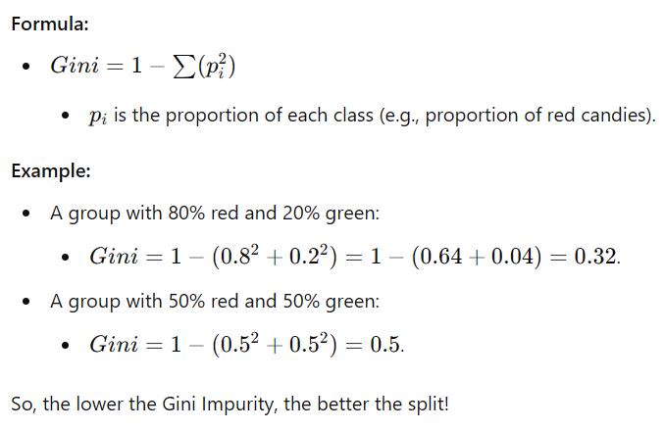

2. ID3 (Iterative Dichotomiser 3) - Information Gain
Information Gain measures how much "uncertainty" is reduced after a split. It’s based on entropy, a concept from information theory.

Entropy:
- Entropy measures how "messy" or "uncertain" a group is.
- A perfectly pure group (all one class) has 0 entropy.
- A 50-50 mix (completely uncertain) has the highest entropy.

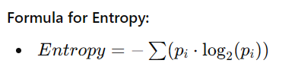
Information Gain:
- Information Gain = Entropy (before split) - Weighted Entropy (after split).

Example:
- Before split: A group has 50% "Yes" and 50% "No" → Entropy = 1.
- After split: One subgroup is 80% "Yes," another is 20% "Yes."
  - Calculate entropy for each subgroup, weight them by size, and subtract from 1.
The split with the highest Information Gain is chosen.

Difference Between Gini Impurity and Information Gain
- Gini Impurity (CART):
  - Focuses on how "mixed" the classes are.
  - Easier to calculate and faster.
- Information Gain (ID3):
  - Focuses on reducing uncertainty.
  - Uses logarithms, so it’s slightly more complex.

Intuition:
- Gini Impurity is like asking, "How much of the jar is mixed?"
- Information Gain is like asking, "How much confusion was removed by splitting?"
Both methods aim to create splits that make the data as pure and predictable as possible!

How CART Selects the Best Feature Using Gini Impurity
- Step 1: Calculate Gini Impurity for the Current Dataset (Parent Node)
Before splitting, calculate the overall Gini Impurity for the dataset.

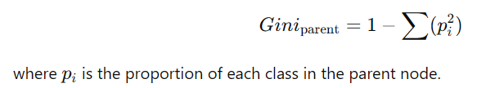
- Step 2: Split the Dataset for Each Feature
For every feature, divide the dataset into groups based on its values (like splitting by "Sunny" vs "Rainy" in a weather dataset).
- Step 3: Calculate Gini Impurity for Each Split (Child Nodes)
For each split, calculate the Gini Impurity for the resulting child nodes.
Example for two child nodes:

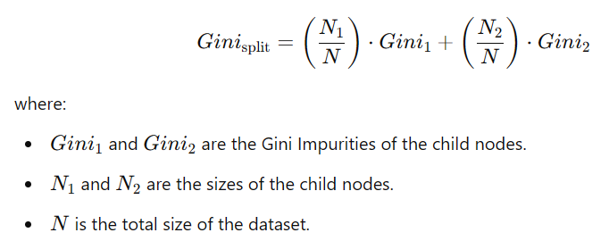

Step 4: Calculate the Gini Gain
Subtract the weighted Gini Impurity of the split from the parent Gini Impurity:

Step 5: Select the Feature with the Highest Gini Gain
The feature that produces the largest reduction in Gini Impurity (i.e., highest Gini Gain) is chosen for the split.

1. Binary Tree Structure
- In binary trees, each node splits into exactly two branches (yes/no, true/false, or <= threshold / > threshold).
- Common in Algorithms: Binary trees are often used in implementations like CART (Classification and Regression Trees).
- Advantages:
  - Simpler structure.
  - Easier to code and optimize (especially for numerical features).
  - Works well for both categorical and numerical data.
- Example:

Root: Is Color = Red?
├── Yes: Grape (Leaf)
└── No: Is Color = Yellow?
├── Yes: Needs Further Splitting
└── No: Mango (Leaf)

2. Multi-Branching Tree Structure
- In multi-branching trees, each node can split into multiple branches based on the unique values of a categorical feature.
- Common in Algorithms: Multi-branching is seen in ID3 or C4.5, where splitting by a categorical feature like "Color" produces a branch for each category (e.g., Green, Yellow, Red).
- Advantages:
  - More compact representation when dealing with categorical features.
  - Fewer levels in the tree for categorical splits (compared to binary splits).
- Example
Root: Color?
├── Green: Mango (Leaf)
├── Yellow: Needs Further Splitting
└── Red: Grape (Leaf)

Conclusion:
- Both structures are valid in a Decision Tree, depending on the algorithm.
- You can have 3 branches from a node (multi-branching) in certain implementations, but most modern decision trees, like CART, represent the tree as a binary tree structure for simplicity and efficiency.

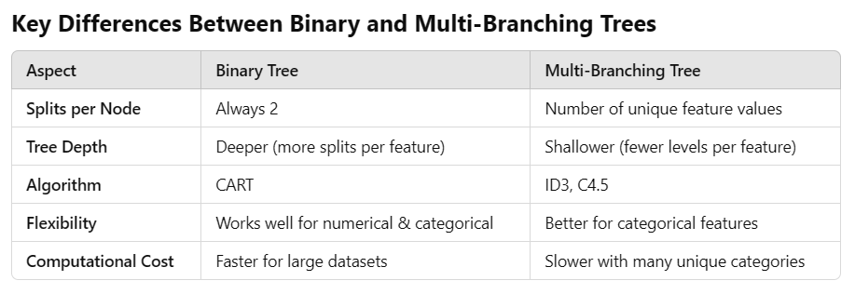

3. Which One Should You Use?
- Binary Trees:
  - Are simpler and more common in many modern libraries like Scikit-Learn.
  - Often preferred for numerical data or mixed datasets.
- Multi-Branching Trees:
  - Are more natural for purely categorical datasets with many unique values per feature.
  - May be harder to implement and optimize.

Decision Tree Algorithms: ID3, C4.5, and C5.0
These three algorithms—ID3, C4.5, and C5.0—are successive improvements in Decision Tree algorithms, each building on the previous one.

1. ID3 (Iterative Dichotomiser 3)
ID3 is the foundational algorithm for decision tree construction.

Key Features:
- Feature Selection Using Information Gain:
  - ID3 selects the feature that provides the highest Information Gain at each step.
  - Information Gain measures how much uncertainty (or "entropy") is reduced when a dataset is split by a feature.
- Works Best for Categorical Data:
  - ID3 handles categorical features well but struggles with numerical features (e.g., splitting continuous variables like "age").
- No Pruning:
  - ID3 builds the tree to its full depth, which can lead to overfitting.

Example of Splitting:
- Dataset: A weather dataset with features like Outlook (Sunny, Rainy), Humidity (High, Low), and Play? (Yes, No).
- ID3 starts by calculating the Information Gain for each feature and selects the one with the highest gain (e.g., "Outlook").
- Repeats this process recursively until all data is classified.

2. C4.5
C4.5 is an improved version of ID3, introduced by Ross Quinlan, and it fixes many of ID3's limitations.

Improvements Over ID3:
- Handles Numerical Features:
  - C4.5 can handle continuous data by introducing thresholds.
  - Example: For a feature like "Age," it might split the data into Age≤30\text{Age} \leq 30Age≤30 and Age>30\text{Age} > 30Age>30.
- Uses Gain Ratio Instead of Information Gain:
  - Gain Ratio adjusts for bias in Information Gain, which tends to favor features with many unique values.
  - This leads to more balanced and meaningful splits.
- Pruning:
  - C4.5 introduces pruning to avoid overfitting.
  - It removes unnecessary branches that do not improve the tree’s accuracy on unseen data.
- Handles Missing Data:
  - C4.5 can work with datasets where some feature values are missing, unlike ID3.

Why It’s Better:
- C4.5 is more versatile and robust because it works with both categorical and numerical data and avoids overfitting better than ID3.

3. C5.0
C5.0 is the next evolution of decision trees, based on C4.5, and improves performance further.

Improvements Over C4.5:
- Faster and More Memory Efficient:
  - C5.0 is optimized for speed and can handle much larger datasets than C4.5.
- Boosting:
  - C5.0 includes boosting as an option, which improves the tree’s accuracy by combining multiple trees (ensemble method).
- Weights for Features:
  - You can assign weights to features, making it more flexible for handling imbalanced data.
- Smaller Trees:
  - C5.0 tends to produce smaller, more compact trees that are easier to interpret than those generated by C4.5.
- Handles Noise Better:
  - Improved algorithms make it less sensitive to noisy or inconsistent data.

Why It’s the Best:
- C5.0 is the most efficient and accurate among the three. It’s a commercially enhanced version of C4.5, often used in real-world applications for large datasets.

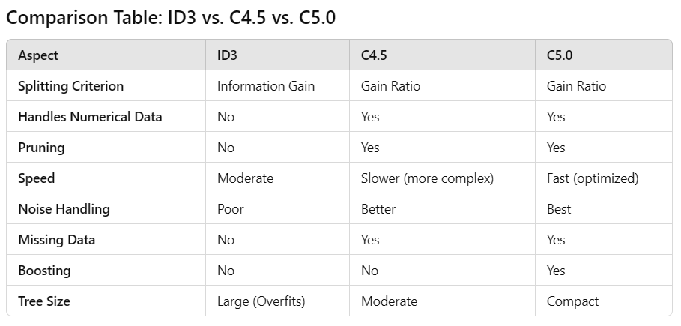

Summary:
- ID3:
  - Simple, good for categorical data.
  - Overfits and doesn’t handle numerical data or missing values well.
- C4.5:
  - More advanced, supports numerical data and pruning.
  - Slower but more accurate.
- C5.0:
  - Fastest, most efficient, and most robust.
  - Includes boosting and creates smaller, cleaner trees.

1. Bootstrapping the Data
- What It Is: A technique to create multiple datasets by randomly sampling (with replacement) from the original data.
- How It Works:
  - Imagine your dataset has 100 rows.
  - Bootstrapping creates new datasets (called bootstrap samples) by randomly picking rows with replacement.
  - Some rows will appear multiple times, and others might be missing in a bootstrap sample.
- Why It's Useful:
  - Helps in creating diverse datasets for training multiple models.
  - Reduces overfitting by making models less dependent on specific rows.

2. Bagging (Bootstrap Aggregating)
- What It Is: A method to combine the predictions of multiple models to improve overall performance.
- How It Works:
  - Create multiple bootstrap samples from the dataset.
  - Train a separate model on each sample.
  - Combine predictions (e.g., average for regression or majority vote for classification).
- Why It's Useful:
  - Reduces variance and prevents overfitting.
  - Models become more robust because they rely on slightly different data.
Example: Bagging Decision Trees
- Train 10 decision trees, each on a different bootstrap sample.
- Predict by taking the majority vote from all trees.

3. Random Forest (RF)
- What It Is: An advanced version of Bagging, where each decision tree is made more random.
- How It Works:
  - Like Bagging, create bootstrap samples and train multiple decision trees.
  - At each split in a tree, instead of considering all features, randomly select a subset of features.
  - Combine predictions from all trees (majority vote or average).
- Key Difference:
  - Randomness at Feature Level: This prevents trees from being overly similar, making the forest more diverse.
- Why It's Useful:
  - Handles large datasets and features well.
  - Resistant to overfitting due to randomness.
- Real-Life Example: Predicting loan defaults or spam detection.

4. Boosting
- What It Is: A technique where models are trained sequentially, and each new model focuses on the mistakes made by the previous models.
- How It Works:
  - Train the first model on the data.
  - Identify where the first model made mistakes.
  - Train the next model to focus on these mistakes (e.g., give more weight to misclassified points).
  - Repeat the process, combining the predictions of all models.
- Why It's Useful:
  - Boosting builds stronger models by "learning from mistakes."
  - Often leads to high accuracy.
- Real-Life Example: Gradient Boosting, used in XGBoost or LightGBM for tasks like predicting stock prices or customer churn.

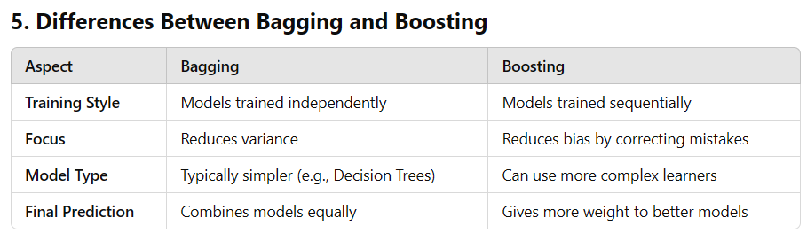
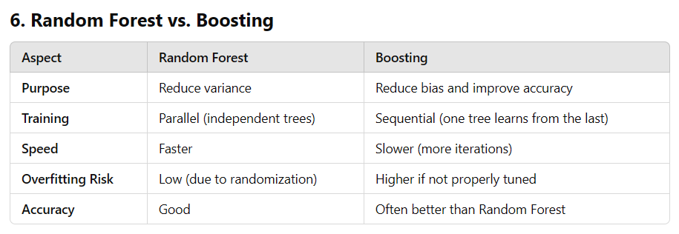

Key Takeaways:
- Bootstrapping: Randomly sample data with replacement to create diverse datasets.
- Bagging: Train models on bootstrapped datasets and combine predictions to reduce variance.
- Random Forest: A special case of Bagging that adds randomness in feature selection for each split.
- Boosting: Sequentially trains models, with each new model focusing on mistakes made by the previous ones, improving accuracy.

