Linear Discriminant Analysis (LDA):

What is LDA?
Linear Discriminant Analysis (LDA) is a dimensionality reduction technique used in machine learning and statistics. Unlike Principal Component Analysis (PCA), which focuses on maximizing variance in the data, LDA aims to maximize the separation between multiple classes. It finds a linear combination of features that best separates the classes.

LDA vs PCA
Aspect | LDA | PCA
Objective | Maximize class separation | Maximize variance
Supervised/Unsupervised | Supervised (uses class labels) | Unsupervised (does not use labels)
Feature Prioritization | Maximizes between-class variance while minimizing within-class variance | Focuses on global variance
Application | Classification | Exploratory data analysis, preprocessing

How LDA Works: Step-by-Step
- Compute the Mean Vectors:
For each class, calculate the mean vector of the features.
- Scatter Matrices:
  - Within-class scatter matrix (Sw): Measures how samples of the same class vary.
  - Between-class scatter matrix (Sb): Measures how the means of the classes differ.
Mathematically:
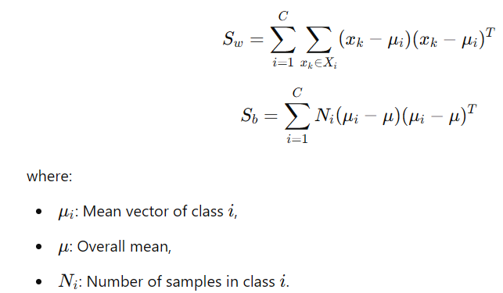

- Solve the Generalized Eigenvalue Problem:
Solve the equation:

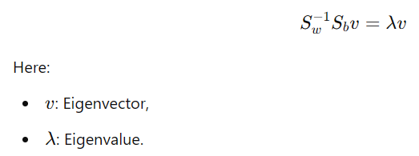
The eigenvector with the highest eigenvalue is the best discriminant direction.
- Project Data onto New Axis:
Select the top k eigenvectors to reduce dimensions while maintaining class separability.

Where and When is LDA Used?
- Where: LDA is used in supervised learning scenarios, especially for datasets with clear class labels and moderate dimensions.
- When: When the goal is to improve classification performance by reducing dimensions while retaining class information.

Missing Ratio Value
In data preprocessing, missing ratio value refers to the proportion of missing data in a dataset. Handling missing values is crucial before applying LDA. Strategies include:
- Removing features or samples with high missing ratios.
- Imputing missing values using mean, median, or more advanced techniques.

Low Variance Filter
- A low variance filter removes features with little variability, as they contribute less to data separation or analysis. Variance of a feature is calculated as:
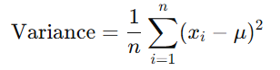

Features with variance below a threshold (e.g., 0.01) are discarded.

Applications of LDA
- Image Recognition: Face recognition (e.g., Fisherface algorithm).
- Text Classification: Spam detection, sentiment analysis.
- Medical Diagnosis: Disease classification using patient data.
- Finance: Fraud detection by separating legitimate and fraudulent transactions.

Key Takeaway Formula
LDA maximizes the Fisher Criterion:
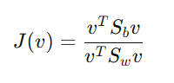
​
where:
- v: Projection vector.
The goal is to maximize J(v) by finding v.

By focusing on class separability, LDA serves as a robust tool in supervised learning pipelines, especially when dimensionality reduction is essential for better visualization or model performance.

Let’s walk through a simple example with two classes in 2D space to illustrate within-class scatter matrix (Sw​) and between-class scatter matrix (Sb​).
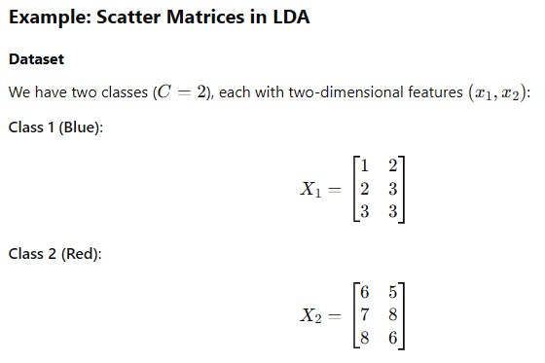
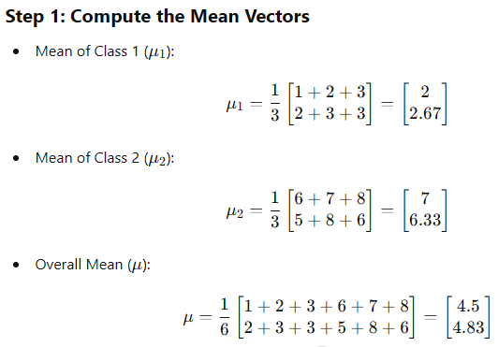

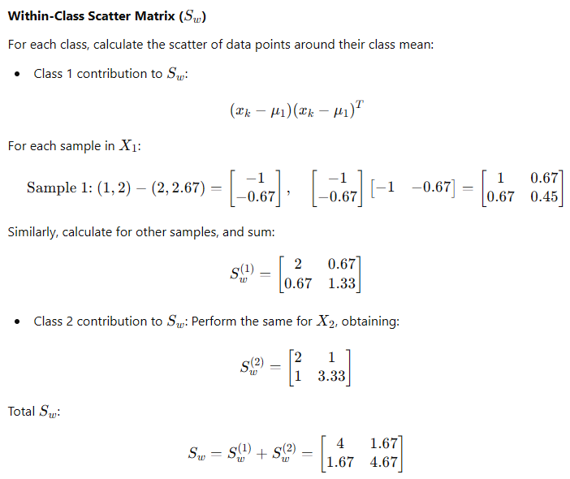

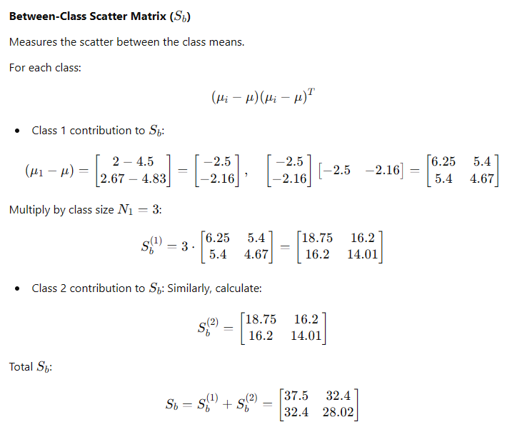

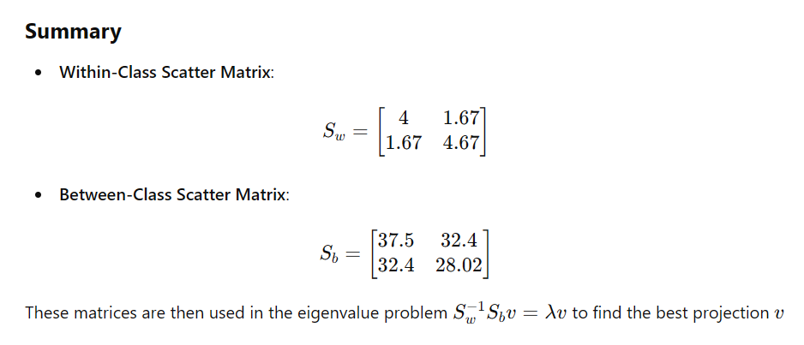

import numpy as np

# Define Within-Class Scatter Matrix (Sw)
Sw = np.array([[4, 1.67],
[1.67, 4.67]])

# Define Between-Class Scatter Matrix (Sb)
Sb = np.array([[37.5, 32.4],
[32.4, 28.02]])

# Solve the generalized eigenvalue problem Sw^(-1) * Sb
eigvals, eigvecs = np.linalg.eig(np.linalg.inv(Sw).dot(Sb))

# Sort eigenvalues and corresponding eigenvectors in descending order
sorted_indices = np.argsort(-eigvals)
eigvals = eigvals[sorted_indices]
eigvecs = eigvecs[:, sorted_indices]

eigvals, eigvecs

Result
(array([1.12579407e+01, 5.53378492e-03]),
array([[ 0.87479472, -0.6538917 ],
[ 0.48449376, 0.75658816]]))

Eigenvalues
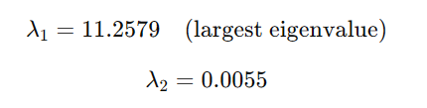

Eigenvectors (Corresponding to Each Eigenvalue)
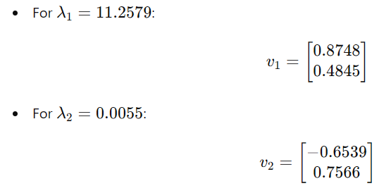

Projection Direction
The eigenvector corresponding to the largest eigenvalue (v1​) is the direction that maximizes class separability. This means we project the data onto:
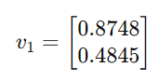
This projection vector can now be used to reduce the data to one dimension while maximizing class separation. Would you like to proceed with projecting the data or visualizing it?

import numpy as np

# Define Within-Class Scatter Matrix (Sw)
Sw = np.array([[4, 1.67],
[1.67, 4.67]])

# Define Between-Class Scatter Matrix (Sb)
Sb = np.array([[37.5, 32.4],
[32.4, 28.02]])

# Solve the generalized eigenvalue problem Sw^(-1) * Sb
eigvals, eigvecs = np.linalg.eig(np.linalg.inv(Sw).dot(Sb))

# Sort eigenvalues and corresponding eigenvectors in descending order
sorted_indices = np.argsort(-eigvals)
eigvals = eigvals[sorted_indices]
eigvecs = eigvecs[:, sorted_indices]

eigvals, eigvecs

The second eigenvector (v2​) corresponding to the smaller eigenvalue (λ2​=0.0055) is less significant in Linear Discriminant Analysis (LDA). Here's why:

Why is v2​ not used?
- Significance of Eigenvalues:
  - Eigenvalues indicate how much variance or class separation is explained by their corresponding eigenvectors.
  - The largest eigenvalue (lambda λ1​) corresponds to the direction (v1​) that captures the most class separability.
  - The second eigenvalue (lambda λ2​) is much smaller, meaning the corresponding eigenvector (v2​) contributes negligibly to class separation.
- Dimensionality Reduction Goal:
  - In LDA, the maximum number of dimensions to retain is C−1, where C is the number of classes.
  - For two classes (C=2), the data is projected onto a single dimension, using only v1​.
- Interpretation of v2​:
  - v2​ is orthogonal to v1​ and captures variance in a direction less relevant to separating the classes.
  - It may be used for exploratory purposes but isn't the primary axis for class separation.

When is v2​ Used?
If there are more than two classes (C>2), LDA retains the top C−1 eigenvectors. For example:
- For C=3, the top two eigenvectors (v1​ and v2​) would be used to project the data into 2D space.

