RIDGE
LASSO
ELASTIC-NET

RIDGE L2 Regularization

1. What is Ridge Regression?
- Ridge Regression is a technique used in linear regression to handle problems where the independent variables (features) are highly correlated (multicollinearity).
- It modifies the standard Ordinary Least Squares (OLS) regression by adding a penalty term to the loss function to prevent the model from overfitting and to stabilize the coefficient estimates.

2. What is OLS (Ordinary Least Squares)?
- In standard linear regression, OLS minimizes the Residual Sum of Squares (RSS):

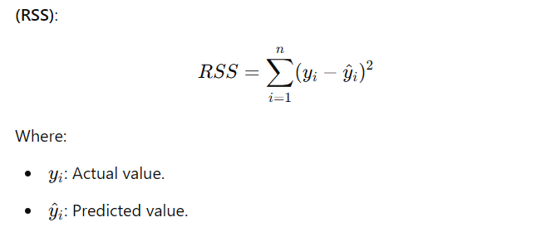

OLS finds the coefficients (www) that minimize RSS, giving the best-fitting line for the training data

3. Why OLS Struggles with Multicollinearity
- Multicollinearity means that some features are strongly correlated, making it hard for OLS to determine the individual contribution of each feature.
- Problems caused by multicollinearity:
  - Unstable Coefficients: Small changes in the data can cause large fluctuations in the coefficients.
  - Overfitting: The model may fit the noise in the training data, leading to poor generalization on new data.

4. How Ridge Regression Fixes This
- Ridge Regression modifies the OLS loss function by adding a penalty term for large coefficients:

Key Idea:
- The penalty term discourages the model from assigning large values to the coefficients.
- This shrinks the coefficients toward zero, making the model more stable and less sensitive to multicollinearity.

5. Ridge Estimate vs. OLS Estimate

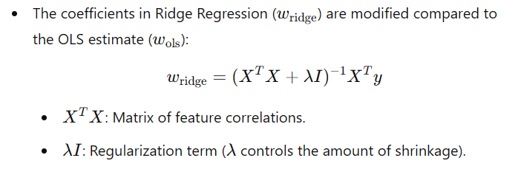

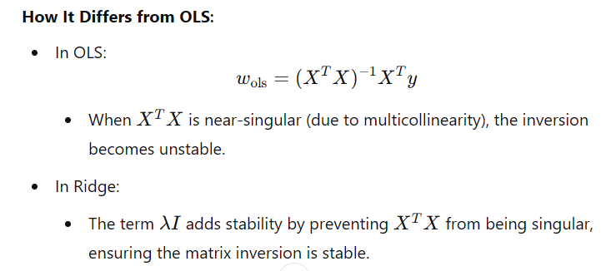

6. Why Ridge Works for Multicollinearity
- Reduces Variance: By shrinking coefficients, Ridge Regression reduces the sensitivity of the model to small changes in the data.
- Balances the Bias-Variance Trade-off:
  - Introduces a small bias (due to shrinkage).
  - Significantly reduces variance, improving generalization.
- Distributes Impact Among Correlated Features: Rather than assigning extreme values to some features, Ridge spreads the influence across correlated variables.

7. Understanding in Simple Terms
Imagine you’re fitting a regression model with two features that are strongly correlated (e.g., height and weight):
- OLS: Struggles to decide how much weight to give to each feature because they convey overlapping information. It may assign extreme values to the coefficients, leading to instability.
- Ridge: Adds a penalty for large coefficients. It reduces the coefficients’ magnitude, ensuring they’re more balanced and the model is more stable.

8. Key Points to Remember
- Multicollinearity: When predictors are highly correlated, OLS can lead to unstable coefficients.
- Ridge Solution: Stabilizes the model by shrinking coefficients and adding a penalty for their size.
- Controlled by λ\lambdaλ: The regularization strength (lambda λ) determines how much shrinkage is applied. Higher lambda λ = more shrinkage.

9. Trade-offs of Ridge Regression
- Ridge reduces overfitting and improves generalization.
- However, it does not perform feature selection (unlike Lasso). All features remain in the model, even if their influence is small.

Summary
- Ridge Regression adds a penalty (L2 regularization) to the OLS loss function.
- It shrinks coefficients, addressing issues with multicollinearity and overfitting.
- While it stabilizes the model and improves generalization, it doesn’t eliminate irrelevant features like Lasso does. It’s most effective when you want to keep all features but ensure stability and reliability.

Lasso L1 Regression (Least Absolute Shrinkage and Selection Operator)

1. What is Lasso Regression?
- Lasso Regression is a type of linear regression that not only helps prevent overfitting but also performs feature selection.
- It does this by adding a penalty term to the loss function, just like Ridge Regression, but with a twist:
  - Instead of penalizing the square of the coefficients (L2 norm, Ridge), Lasso penalizes the absolute values of the coefficients (L1 norm).

2. What Makes Lasso Special?
- Lasso can shrink the coefficients of less important features all the way to zero.
- This means it can completely eliminate irrelevant or redundant features from the model, making it a powerful tool for feature selection.

3. The Loss Function in Lasso
The cost function for Lasso Regression is:

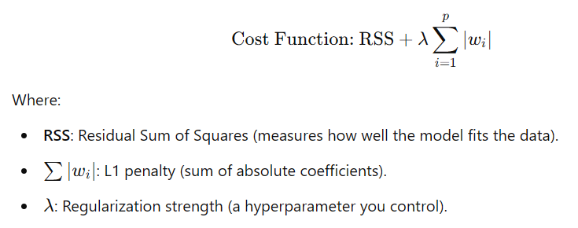

4. How Does Lasso Work?
- Shrinkage: The L1 penalty forces the model to minimize coefficients that don’t contribute much to the target variable.
- Feature Selection: If the penalty (λ\lambdaλ) is strong enough, Lasso will shrink some coefficients exactly to zero. This effectively removes those features from the model.

5. Why Is Lasso Useful?
- Feature Selection:
  - It automatically selects the most important features by setting irrelevant ones to zero.
  - This makes the model simpler and easier to interpret.
- Handles High-Dimensional Data:
  - Works well when there are many features, some of which might not be useful.
  - Ideal for datasets where the number of features exceeds the number of samples.
- Prevents Overfitting:
  - Like Ridge Regression, Lasso reduces overfitting by penalizing large coefficients.

7. How Lasso Handles Features
Imagine you’re building a model with 10 features, but only 3 are actually important:
- OLS Regression:
  - Tries to use all 10 features, even if some are irrelevant, leading to overfitting.
- Ridge Regression:
  - Keeps all 10 features but shrinks their coefficients.
- Lasso Regression:
  - Sets the coefficients of the 7 irrelevant features exactly to zero.
  - Keeps only the 3 important features in the model.

8. The Role of λ\lambdaλ (Regularization Strength)
- λ\lambdaλ controls the strength of the penalty:
  - Small λ\lambdaλ: The penalty is weak, and the model behaves like OLS regression, keeping most coefficients nonzero.
  - Large λ\lambdaλ: The penalty is strong, shrinking more coefficients to zero and simplifying the model.

When to Use Lasso Regression
- Feature Selection:
  - You want the model to automatically pick the most important features and ignore irrelevant ones.
- High-Dimensional Data:
  - Your dataset has many features, but only a subset is relevant.
- Interpretable Models:
  - You need a sparse model (with fewer features) that’s easier to understand.

10. Example to Illustrate Lasso
Let’s say you’re predicting house prices with the following features:
- Square footage.
- Number of bedrooms.
- Proximity to schools.
- Year built.
- Roof color.
- In reality, roof color has no impact on house price.
- OLS Regression will assign some coefficient to roof color, even if it’s irrelevant.
- Ridge Regression will shrink the coefficient for roof color but won’t eliminate it.
- Lasso Regression will set the coefficient for roof color to zero, removing it from the model.

11. Summary
- What It Does:
  - Shrinks coefficients using L1 regularization.
  - Sets some coefficients to zero, effectively selecting features.
- Why It’s Useful:
  - Prevents overfitting.
  - Simplifies models by eliminating irrelevant features.
- When to Use It:
  - For feature selection, especially in high-dimensional datasets.
Lasso is an excellent choice when you want your model to be both accurate and interpretable, automatically removing unnecessary features while focusing on the most important ones!

Elastic Net: Combining L1 and L2 Regularization

Elastic Net Regression is like having the best of both worlds from Ridge (L2) and Lasso (L1) regression. It’s indeed a versatile recipe that can be applied to many problems without much restriction. However, it’s important to understand when and why it’s especially useful and what considerations to keep in mind before sprinkling it everywhere like salt and pepper.

Elastic Net combines the penalties of Lasso (L1) and Ridge (L2), allowing you to benefit from:
- Feature Selection (L1): Lasso’s ability to shrink irrelevant coefficients to zero.
- Stability (L2): Ridge’s ability to handle correlated features and stabilize the model.



Why Elastic Net Is Like a Magic Recipe
- Balances L1 and L2 Strengths:
  - Lasso may fail when features are highly correlated (it tends to select one feature and drop others arbitrarily).
  - Ridge handles correlated features well but doesn’t perform feature selection.
  - Elastic Net combines these strengths, shrinking correlated features together while still selecting important features.
- Avoids Lasso’s Limitations:
  - Lasso may struggle when the number of features exceeds the number of observations (p > n).
  - Elastic Net is more robust in high-dimensional settings.
- Versatile:
  - Works well for most regression problems, especially with a mix of relevant, irrelevant, and correlated features.
  - Suitable when you’re unsure whether to use L1 or L2 regularization.

When to Use Elastic Net
Elastic Net is particularly useful in the following scenarios:
- High-Dimensional Data:
  - When the number of features is very large (p>>np >> np>>n), such as in genetics or text data.
- Correlated Features:
  - When you suspect that some features are highly correlated and don’t want to arbitrarily drop them (a limitation of Lasso).
- Feature Selection with Stability:
  - When you want a sparse model but also need stable coefficients for correlated features.

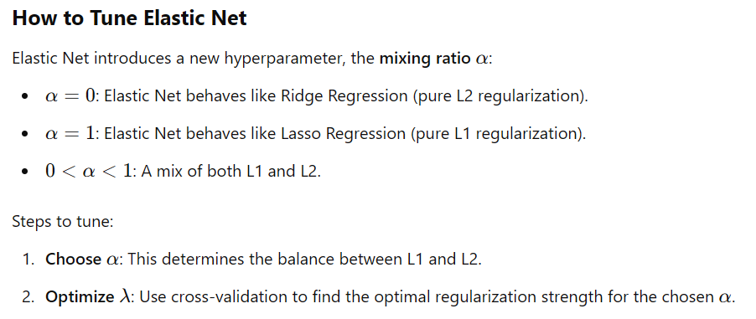

When Not to Use Elastic Net
Elastic Net is powerful, but not every problem requires it:
- When Features Are Independent:
  - If your features are not correlated and you want pure feature selection, Lasso might suffice.
- When You Don’t Need Feature Selection:
  - If you believe all features are relevant, Ridge may be a better choice since it doesn’t eliminate variables.
- Small Datasets:
  - On very small datasets, Elastic Net’s added complexity might not provide significant benefits over simpler models.

Elastic Net in a Nutshell
Think of Elastic Net as a seasoning you can add to your model when:
- Lasso feels too aggressive in eliminating features.
- Ridge feels too passive, keeping all features.
- You want a balance: Feature selection with stability, especially when features are correlated or in high-dimensional settings.
It’s like having salt (L1) and pepper (L2) in perfect proportion to make your model robust, sparse, and interpretable. While it’s versatile, remember to tune its hyperparameters (like α\alphaα) to get the right "flavor" for your specific dataset!

