Reinforcement Learning (RL)

What is Reinforcement Learning (RL)?
- Definition: A type of machine learning where an agent learns to make decisions by performing actions in an environment to maximize cumulative reward over time.
- Key Idea: The agent interacts with the environment, receives feedback (rewards or penalties), and adjusts its behavior to achieve the best outcome.

Why Learn Reinforcement Learning?
- Applications:
  - Robotics: Training robots to perform tasks autonomously.
  - Games: AlphaGo, Chess, Atari games.
  - Self-driving cars: Learning to navigate.
  - Optimization problems: Supply chain management, scheduling.
- Importance: Models dynamic decision-making processes, improving with time and experience.

Elements of Reinforcement Learning
- Agent: The learner or decision-maker.
- Environment: The space in which the agent operates.
- State (St​): A representation of the environment at time ttt.
- Action (At​): A set of all possible moves the agent can take.
- Reward (Rt​): Feedback from the environment for an action.
- Policy (π): A strategy that maps states to actions.
- Value Function: Predicts the long-term reward of a state or action.

Exploration vs. Exploitation Dilemma
- Exploration: Trying new actions to discover their effects.
- Exploitation: Using known actions that yield the highest reward.
- Challenge: Balancing between the two to maximize long-term rewards.
- Example: Choosing between eating at a favorite restaurant (exploitation) vs. trying a new one (exploration).

Epsilon-Greedy Algorithm
- Purpose: Balances exploration and exploitation.
- Mechanism:
  - With probability ϵ, explore (choose a random action).
  - With probability 1−ϵ, exploit (choose the best-known action).
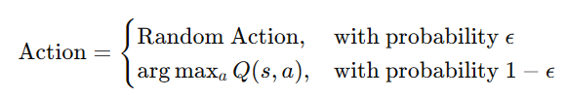
- Formula:

Markov Decision Process (MDP)
- Definition: A mathematical framework for modeling decision-making problems.
- Components:
  - States (S): All possible situations.
  - Actions (A): Possible choices.
  - Transition Probabilities (P): Probability of moving to a new state.
  - Rewards (R): Feedback for actions.
  - Policy (π): Mapping of states to actions.
- Markov Property: The future state depends only on the current state and action, not past states.

Q-Values and V-Values
- State-Value Function (V(s)):
  - Expected cumulative reward from a state.
  - Formula:
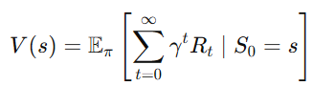
- Action-Value Function (Q(s,a)):
  - Expected cumulative reward for taking action a in state s.
  - Formula:
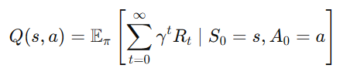

Q-Learning
- Definition: A model-free RL algorithm to learn the optimal action-value function Q(s,a)Q(s, a)Q(s,a).
- Update Rule:
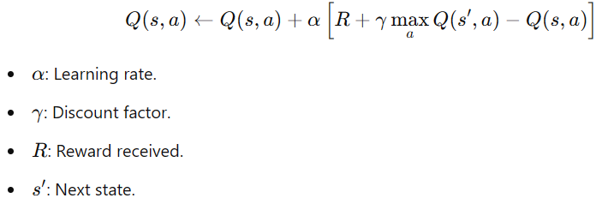

5W Approach
- What: Reinforcement Learning teaches an agent to learn from interactions and improve decision-making.
- Where: RL is applied in dynamic environments like robotics, games, and resource management.
- When: Use RL when the problem involves sequential decisions and delayed rewards.
- Why: To achieve intelligent behavior that improves with time.
- How: By modeling the problem as an MDP, using algorithms like Q-learning, and balancing exploration and exploitation.

Example
- Scenario: A robot learning to navigate a maze.
- State (S): Current position in the maze.
- Action (A): Move up, down, left, right.
- Reward (R): +1 for reaching the goal, −1 for hitting walls.
- Goal: Learn a policy (π) that maximizes the total reward.

Simple RL Flow
- Initialize: Q(s,a) arbitrarily.
- Repeat:
  - Observe state s.
  - Choose action a (using epsilon-greedy).
  - Perform action, observe reward R and next state s′.
  - Update Q(s,a) using Q-learning rule.
- End: When policy converges to the optimal solution.

0
25
1
20
50
30
2
3
20
45
70
5
5
4
10

