Module 5 - Java
Collections, Generics
Advanced Java Certification Training

Akram M'Tir

1. Write the subtract(...), divide(...) methods in module5.generics. ArithmeticOperations class.

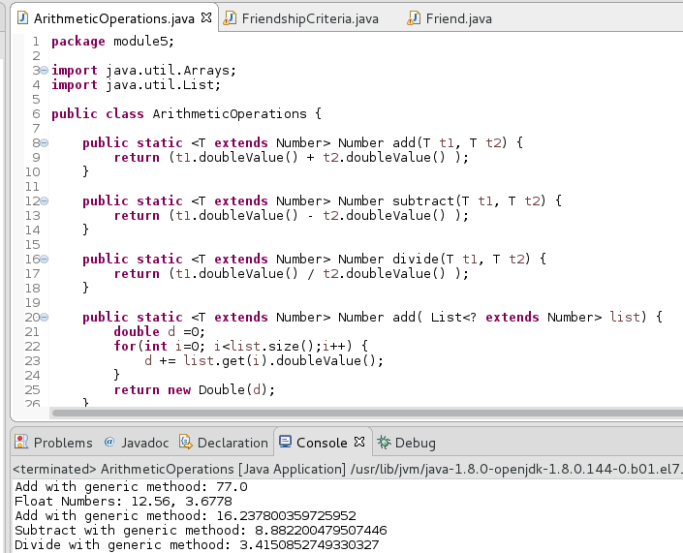

2. Write a generic method to swap positions in any kind of list [Solution.module5.generics.GenericUtils].
- Method signature: public static <T> T[] swap(T [] list, int firstPos, int secondPos)
- Throw appropriate exceptions if indexes are out of bounds.

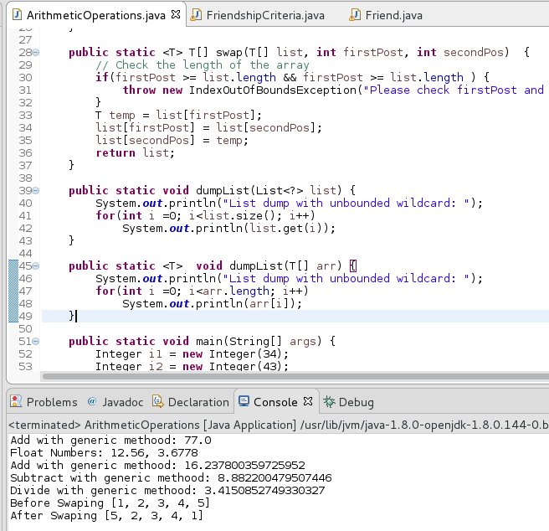

3. Write a generic class FriendshipCriteria with attributes T & S.
a. T & S should implement java.lang.Comparable.
b. Write a programme to find friends (FriendFinder) when T = lava.lang.String (which is the name) and S = java.lang.Integer (which is the age).
c. Write a programme to find friends (FriendFinder) when T = lava.lang.String (which is the name) and S = java.lang.String (which is the location).
d. Try T & S with user defined classes.
i. [Solution: module5.generics.FriendFinder, module5.generics.FriendshipCriteria]
