Module 6 - Java
Working with Files
Advanced Java Certification Training

Akram M'Tir

1. Write Write a programme to search non-recursively for filenames where the user will give the
following inputs as command line arguments
• The search directory
• The file extension

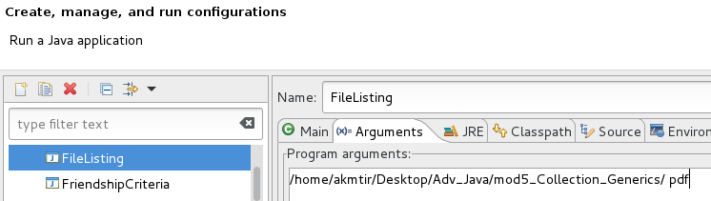

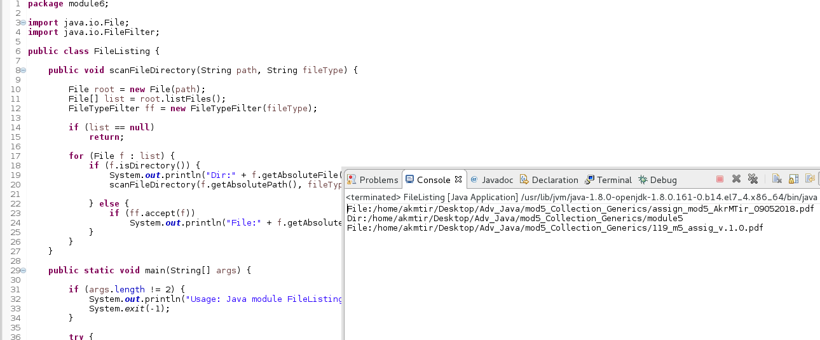
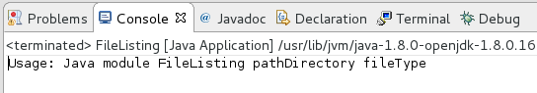

2. Write Write a method in the module6.TextFileHandler to load the file into a map, where
key=country and value = capital.

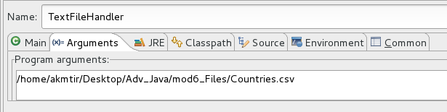

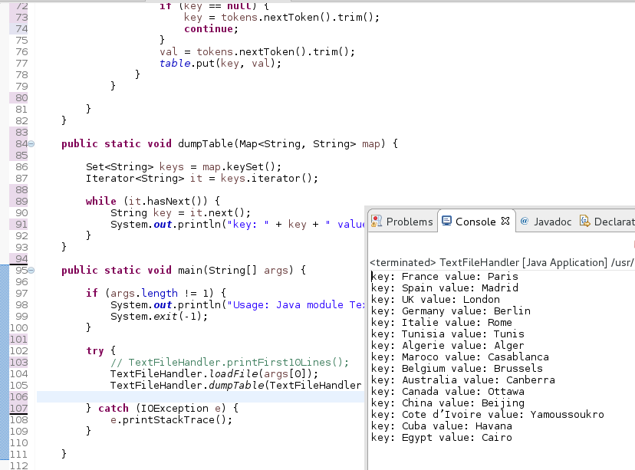

3. Write a method in the module6.TextFileHandler to write, to a file, all the country names
that starts with a letter passed as an argument, along with their capitals.
• public static void writeToFile(String newFilename, char countryNameBeginningWith) where countryNameBeginningWith = ‘S’
• Name the new file countries_s.csv

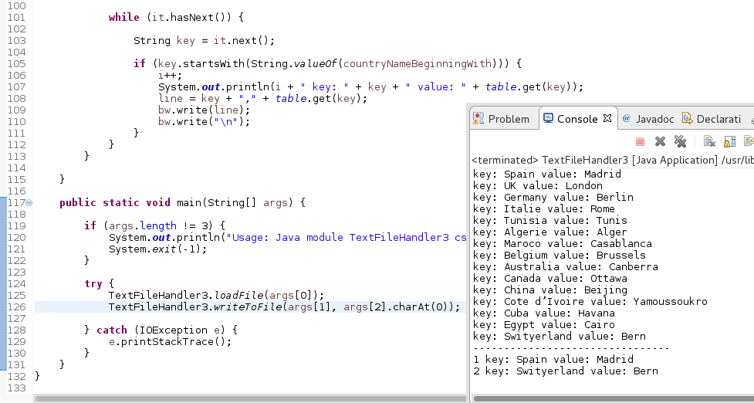

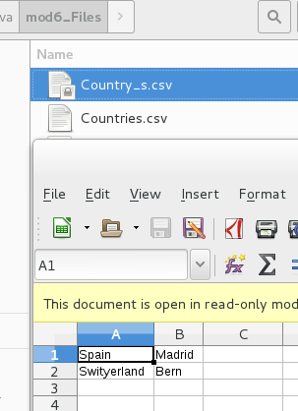

4. For the class module6.SerializationDemo
• Comment out the load(..) method call and just store the list by running the programme.
• Now change the serialVersionUID to something else.
• Comment the store(...) method call, uncomment the load(...) method call and run the programme.
What do you observe?

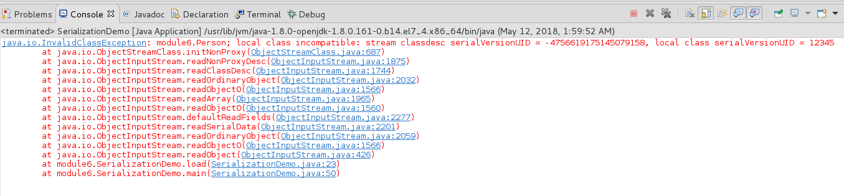
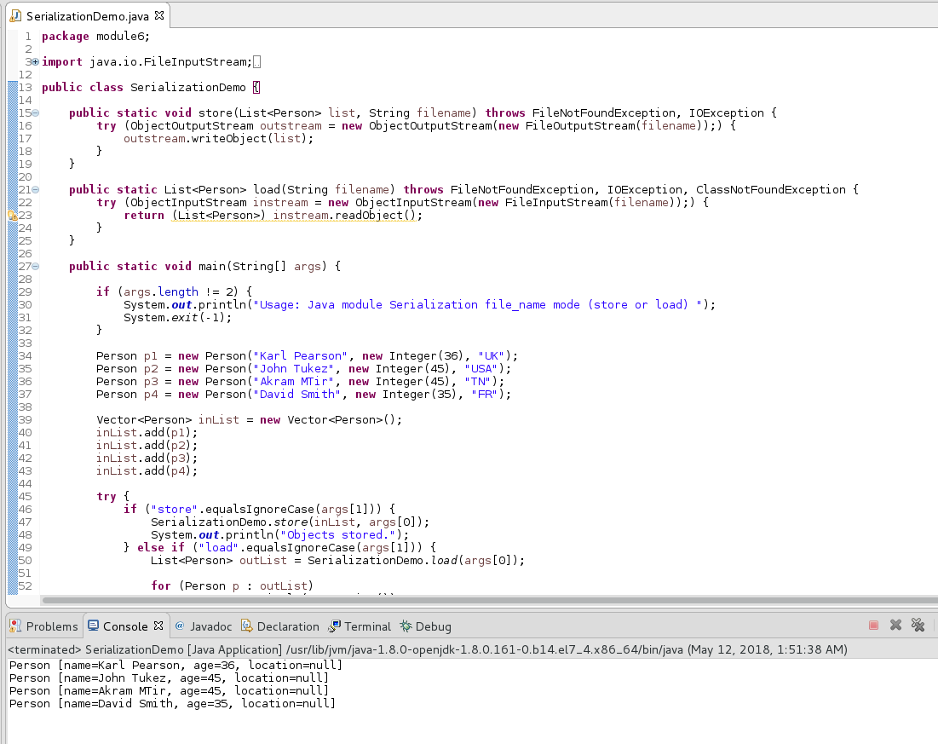

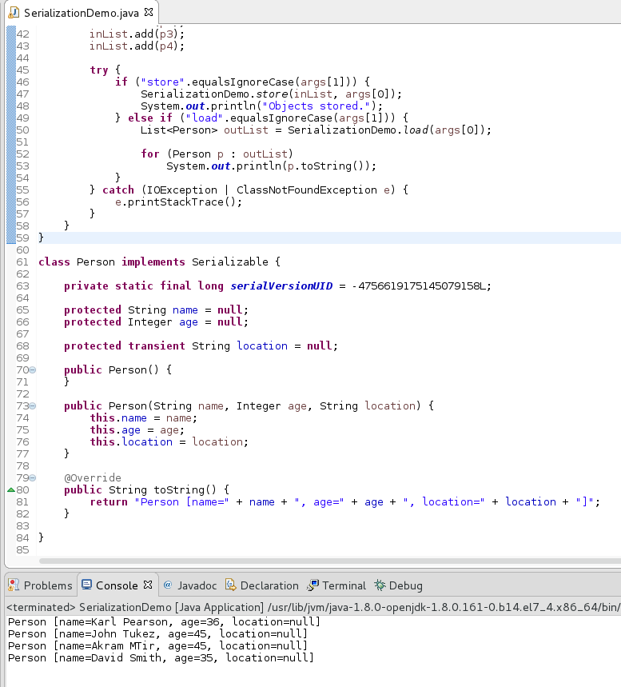

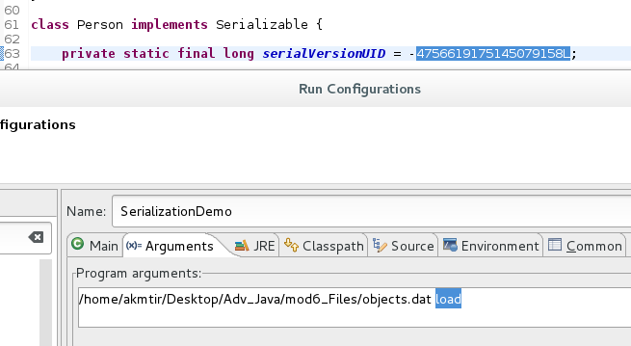

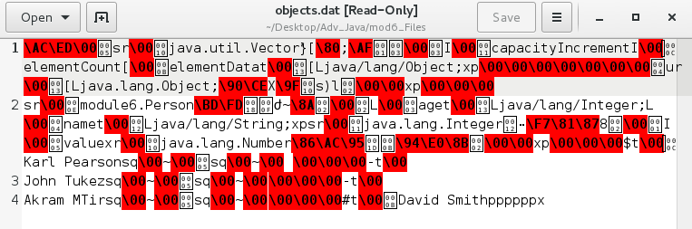

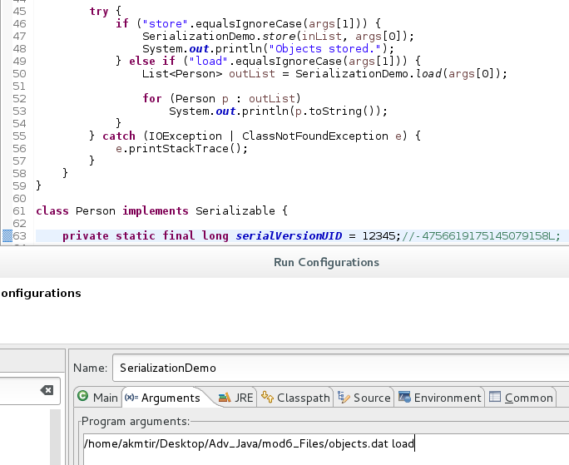

5. For the menu.xml write a programme module6.bkmenu.BKMenuPriceFinder to inquire on the price of a breakfast item. The xml filename and the item name will be supplied by the user.
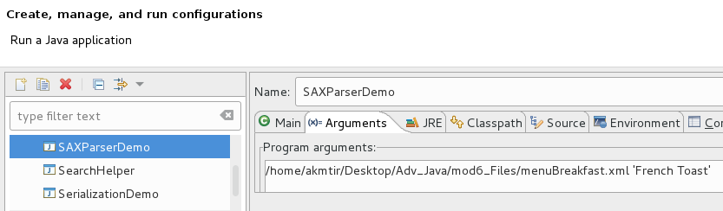
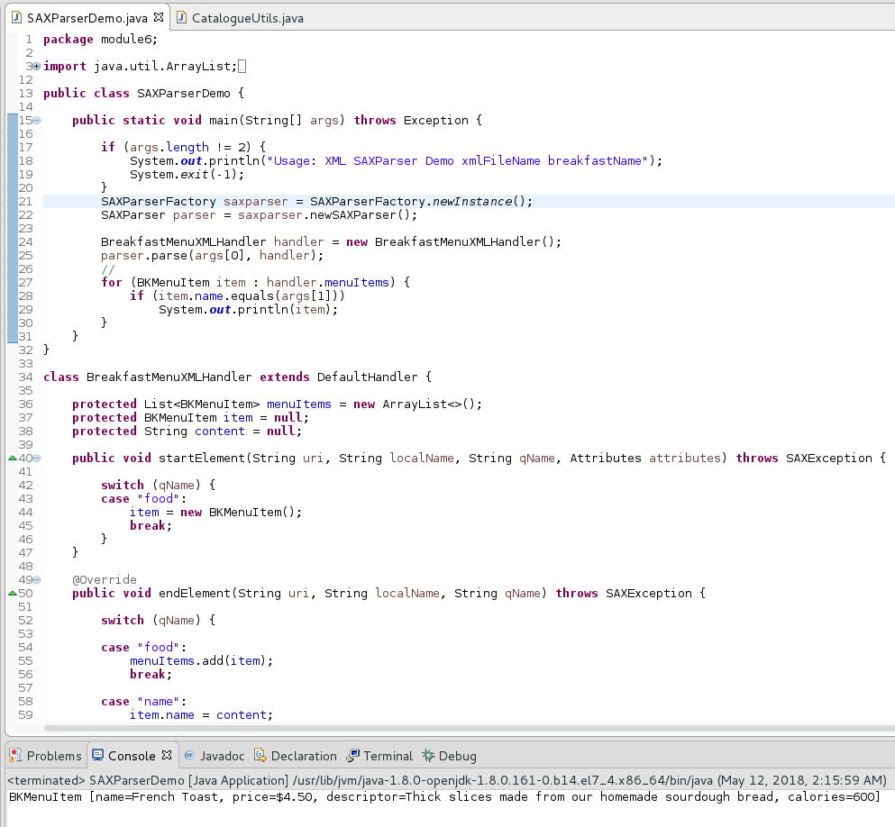

6. As an exercise check the other methods of org.xml.sax.helpers.DefaultHandler and also the interfaces that it implements.

7. Write a programme to update the price of a book based on the book ID.
• The input xml is catalogue.xml
• Don’t change the catalogue.xml, create a new xml instead.

