Module 7 - Java
Concurrency
Advanced Java Certification Training

Akram M'Tir

1. For module7.deadlock.Deadlock, modify the code to break the deadlock.

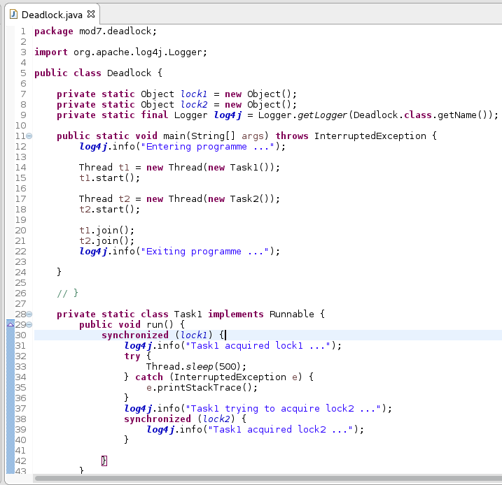
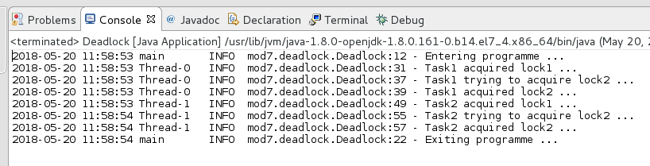
2. For module7.racecondition.RaceConditionDemo - what should I do to print the numbers of the first thread followed by the numbers of the second thread?

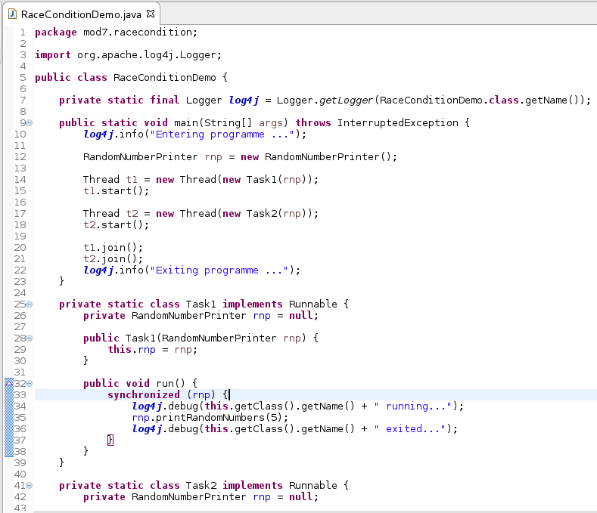
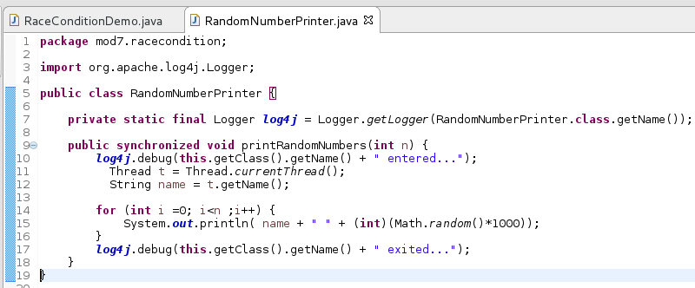

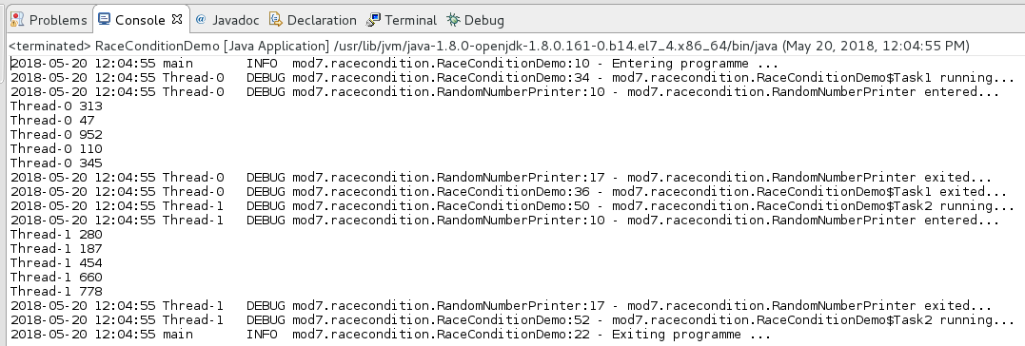

3. Write a programme where one thread writes to a console numbers 1 to N and after it has finished another thread writes the same numbers from N to 1.
• N is passed through the command line.
• The threads can be started in any order.
[Hint: Use wait()/notify() methods, inter-thread communication]

