Module 8 - Java
Working with Databases
Advanced Java Certification Training

Akram M'Tir

1. 1. Write a programme to get the student’s name for a given student’s ID from the test.student table.
a. Use stored procedure (script provided in scripts/get_name.sql).

Database, Table
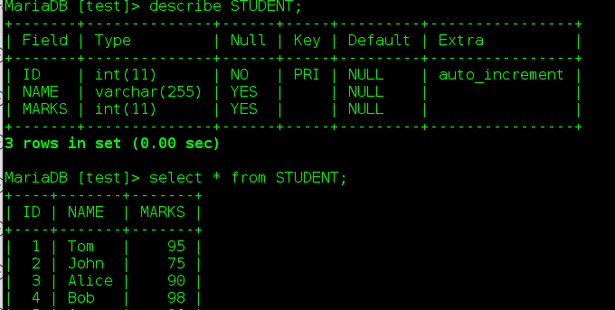
Procedure Creation and query
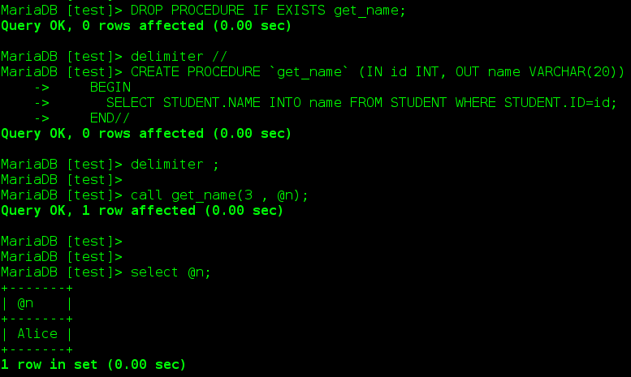

Java Code
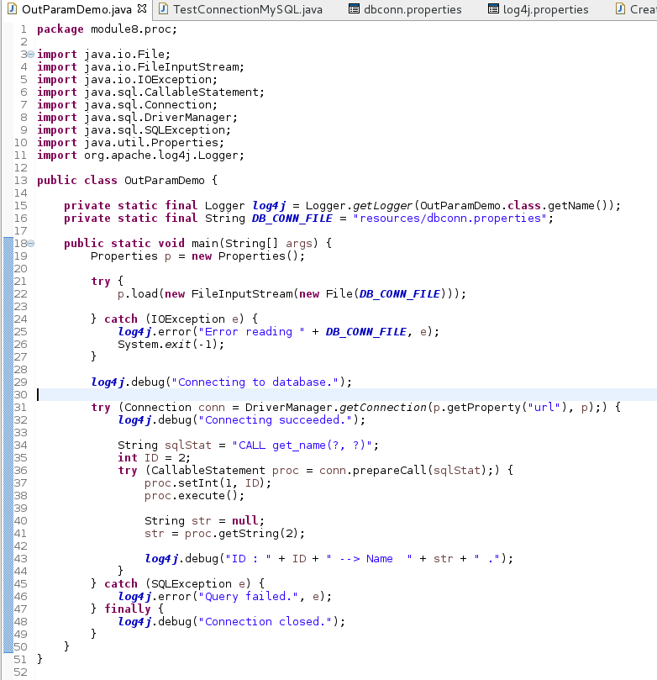

Console Log4j output

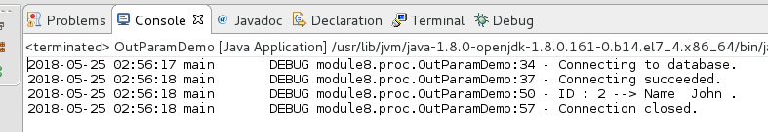

2. Write a programme that does a wildcard search of student’s name from the test.student table .
a. The search criteria should be parameterized.
b. Display the matched student’s id and name.
c. Handle the appropriate errors.

Database, Table
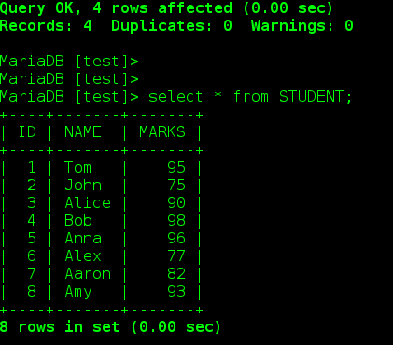

Input Arguments used for the search
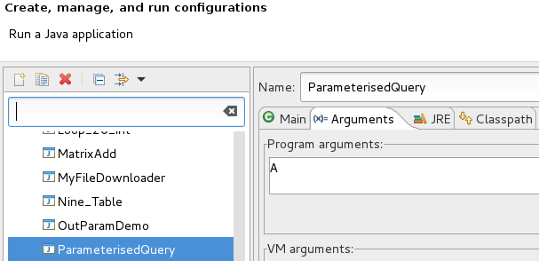

Console Log4j Output
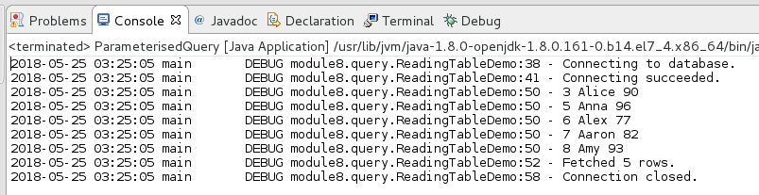

Java Code
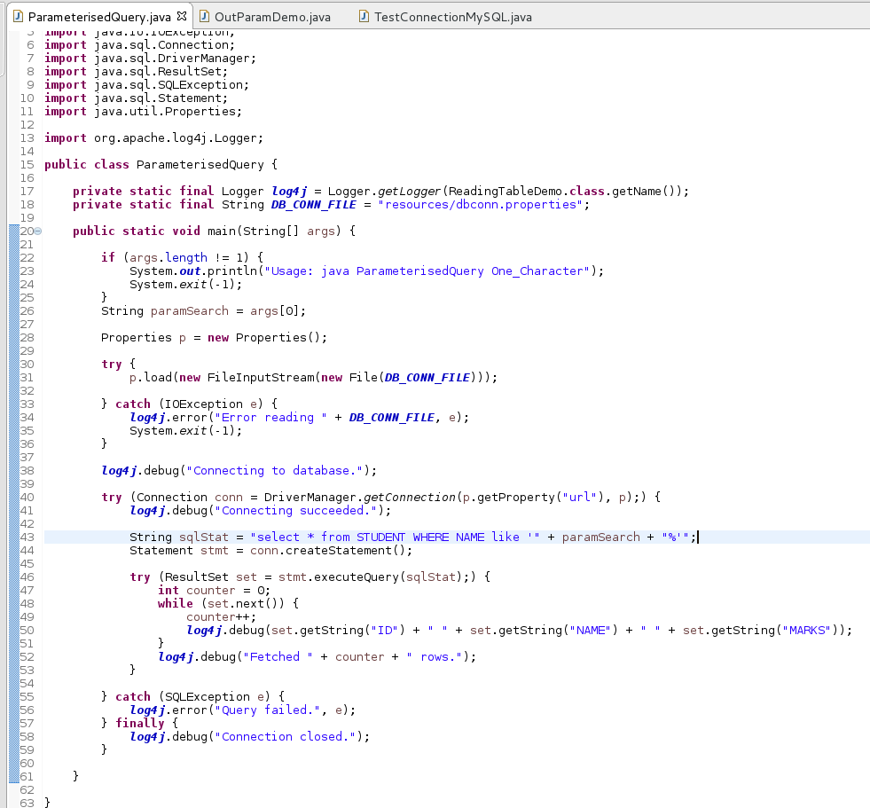

3. Write a programme to batch process insert and update statements to the test.student table.
a. Handle the appropriate errors.
b. Use save-points to define boundaries of transactions.

Batch Insert
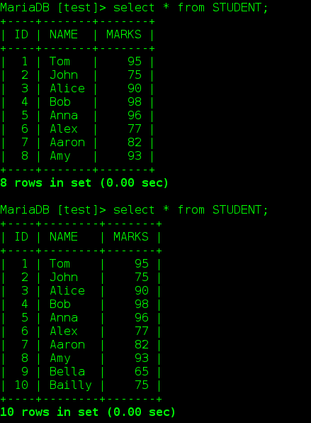

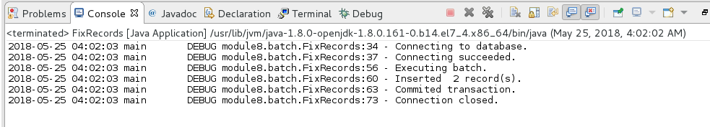

Java Code

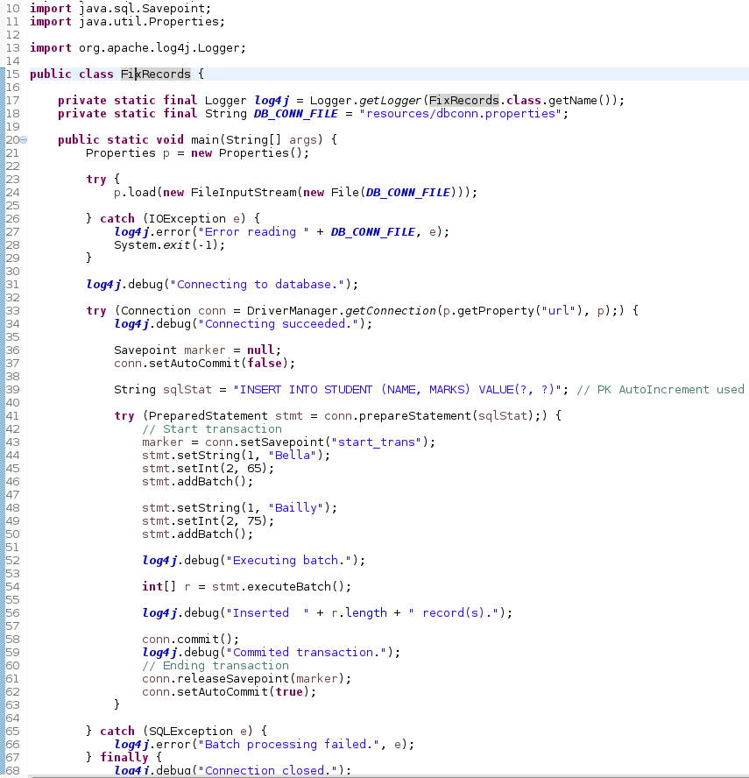

Update records Batch
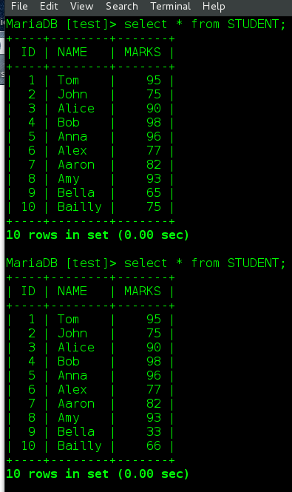

console Log4j output

