Module 9 - Java
Network Programming
Advanced Java Certification Training

Akram M'Tir

1. Write a programme to support multiple socket client connections to a server.
a. For simplicity, make it an echo server like what we saw in the code walkthrough module9.tcp.sockets.Server.
b. Use properties file to load the host and port details.
c. Handle appropriate logging with Log4j
d. Print a welcome message telling the connection number when a client connects to the server.

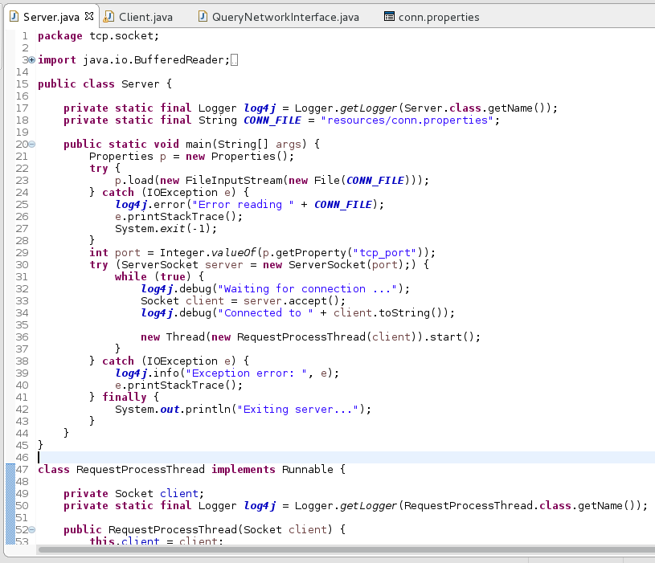
Client1

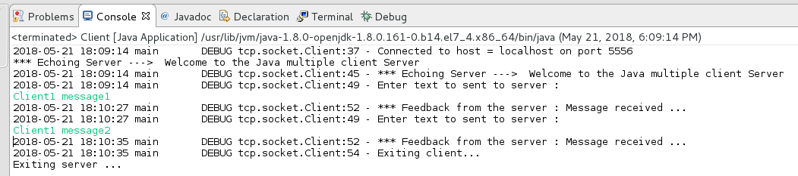

Client2

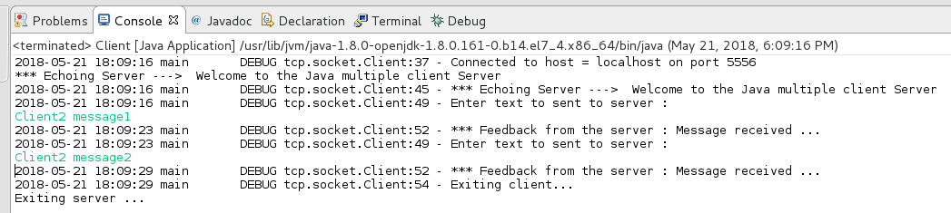

Server Side

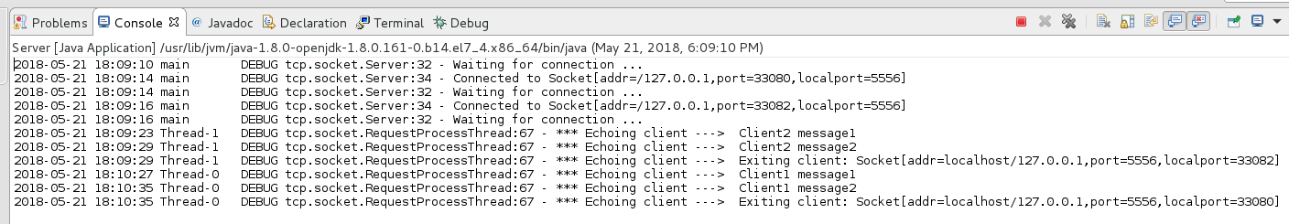

2. Write a programme to list the network interfaces on your computer. The programme should list the following:
a. Display name.
b. Is this interface running?
c. Does this interface supports multicast?
[Hint: Check the methods of java.net.NetworkInterface]

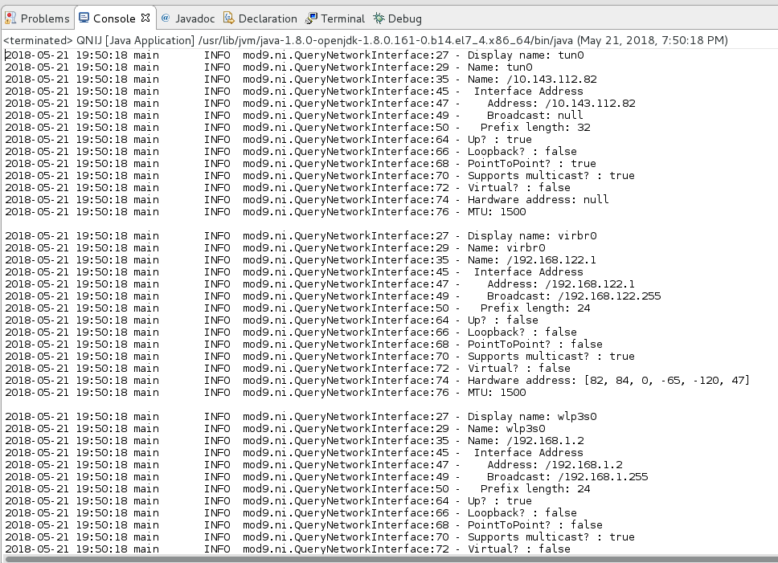

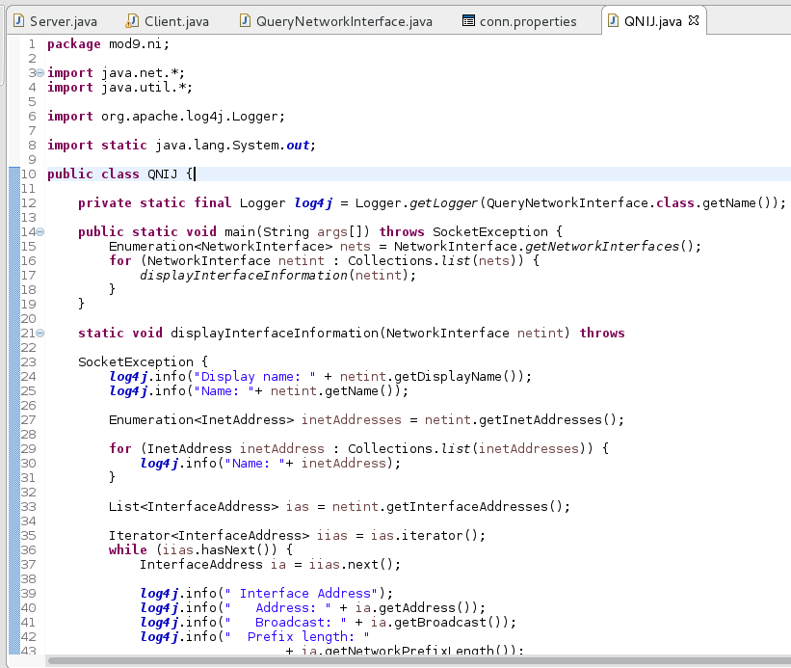

3. Write a programme to download the contents of http://www.oracle.com/events/global/en/java-outreach/resources/java-a-beginners-guide-1720064.pdf to a file with the same name.
a. Extract the filename from the URL, don’t hardcode.
b. The download folder will be supplied through the command line.
c. Show the progress as % downloaded while the downloading is happening.
d. Download in chunks of 20KB.

