NanoPi NEO2

as an

IoT-gateway module

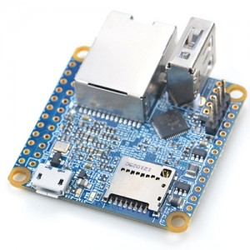

Table of Contents
Aim, purpose, summary 2
Install OS on the SD-Card 3
Boot Linux from SD-Card 3
Login via SSH 4
Update packages 5
CPU Architecture 5
System disk space usage 6
Python versions 6
Lsmod 6
UART 7
Enabling UART 7
Install the python-serial module 8
List available UARTs 9
Test your UART serial communication using python 9
To Sum-up 10
Annexes 11
Hardware Spec 11

Aim, purpose, summary
The NanoPi NEO2 is a newly released super tiny ARM board by FriendlyElec. It uses Allwinner’s 64-bit H5 quad-core SoC (ARM Cortex-A53). It has internal hexa-core Mail450 GPU, 512M DDR3 RAM. It has Gbps Ethernet and one USB host port. These features make it especially suitable for applications that require high data throughput , speedy data transmission and high performance. The idea here is to integrate this little tiny electronics within our own existing architecture to offer an IOT-gateway. As shown in the pinout diagram picture below, the NanoPi NEO2 offers 3 UARTs. (Universal asynchronous receiver-transmitter)
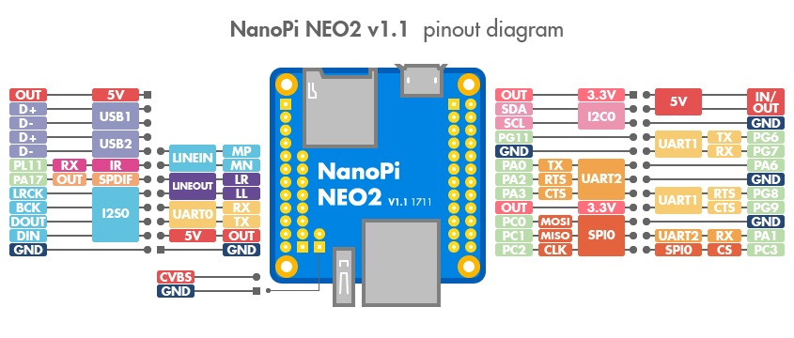
The UART0 is already used for as a Serial Debug. However, the ports UART1 and UART2 are free to use and we need to test them to demonstrate the potential of this board as IOT-gateway device.

Install OS on the SD-Card

First of all let's create an SD-card linux OS image
Download the Image File
xenial_4.14_arm64_YYYYMMDD.img.zip
FriendlyCore (base on UbuntuCore) Image File, kernel:Linux-4.14

Next, flash the image on the SD-Card
Under Windows, to flash the image, get the utilitywin32diskimager.rar.
Under Linux users can use "dd" command line.

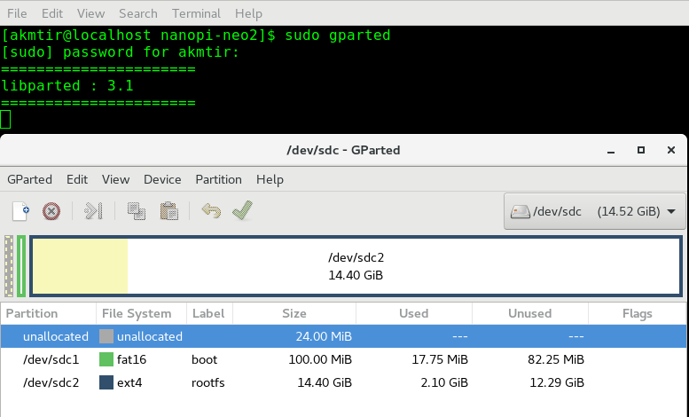
Figure 1: SD card partition

Boot Linux from the SD-Card
Insert this card into your board's BOOT slot, connect the network ehternet cable to the NanoPi board and power on (with a 5V/2A power source). If the PWR LED is on and the STAT LED is blinking this indicates your board has successfully booted.

Login via SSH
The NanoPi NEO2 doesn't have a video output interface. You can log into the board via SSH. In our test the IP address detected by our router was 192.168.1.8 as shown below.

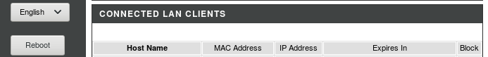

Figure 2: IP of the NanoPi NEO2

We ran the following command to log into the NanoPi NEO2:
$ ssh root@192.168.1.8
The password is fa
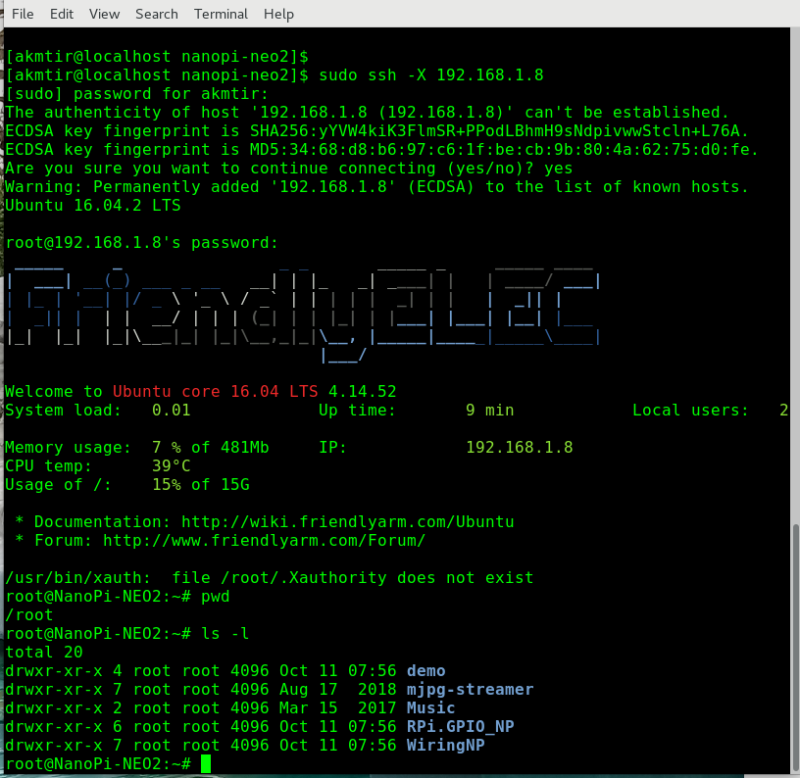

Update packages

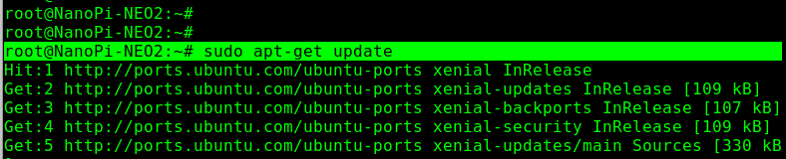

CPU Architecture
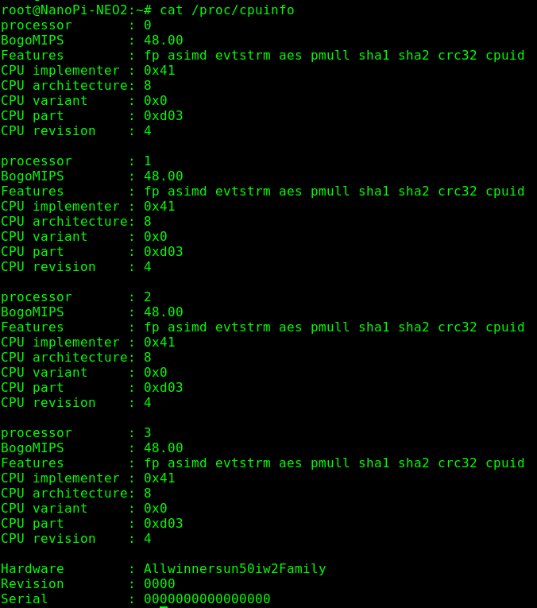

Display information about the CPU architecture

System disk space usage
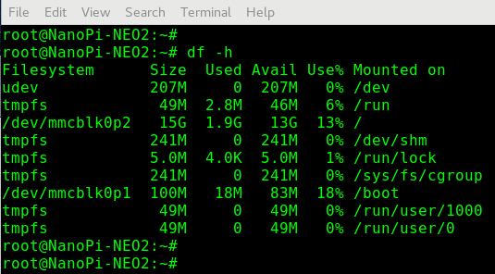
Report file system disk space usage

Python versions

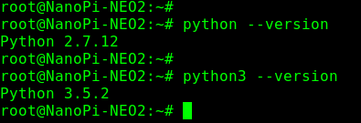

Lsmod

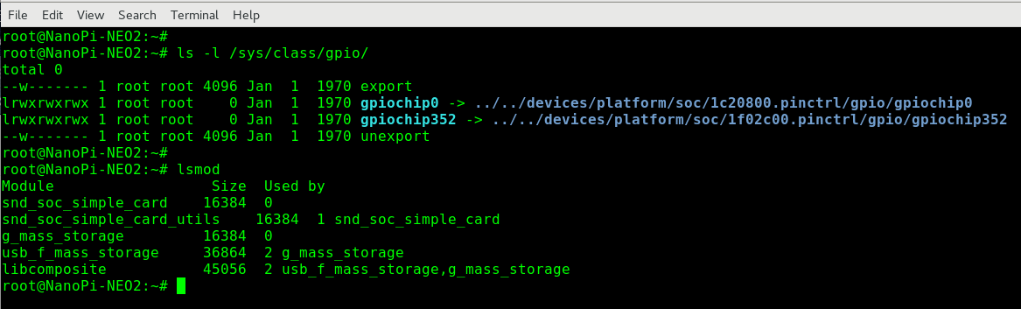
Show the status of modules in the linux Kernel

UART

Enabling UART
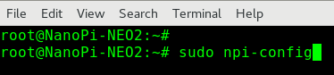

Make sure that the UART1 and 2 are enabled as shown below in the picture.
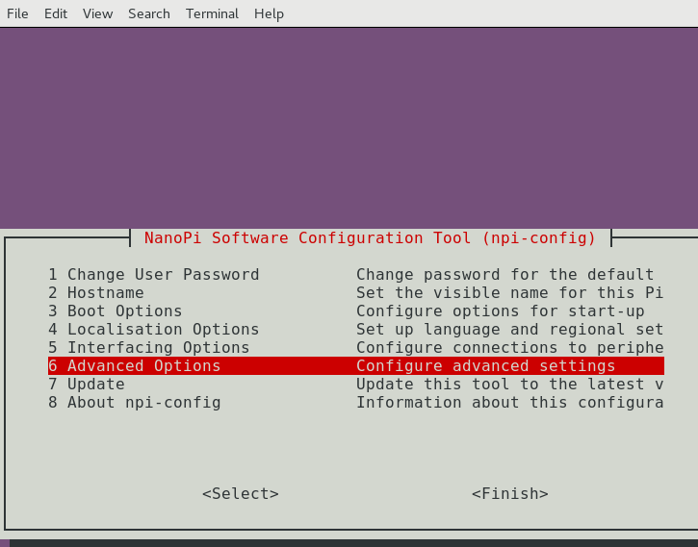

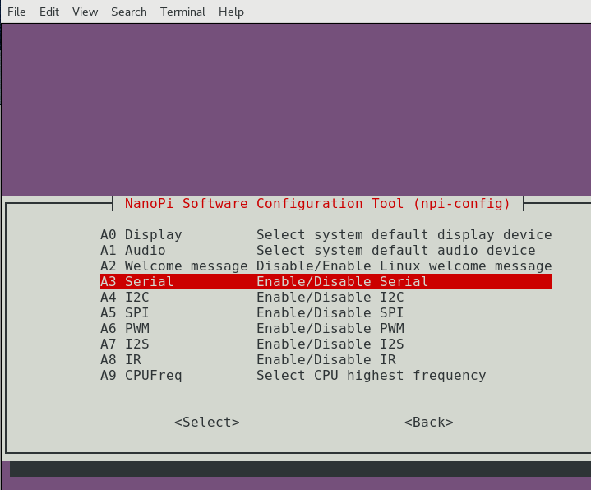

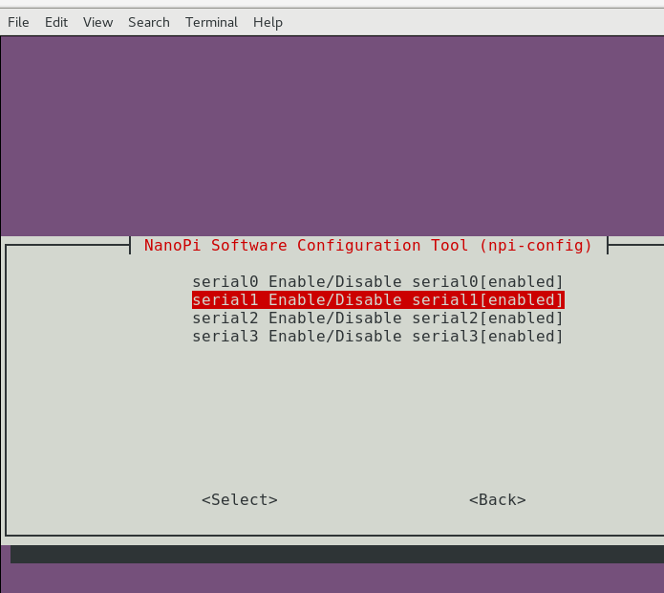

Ensure that the UART1 and 2 are enabled as shown here.

Install the python-serial module
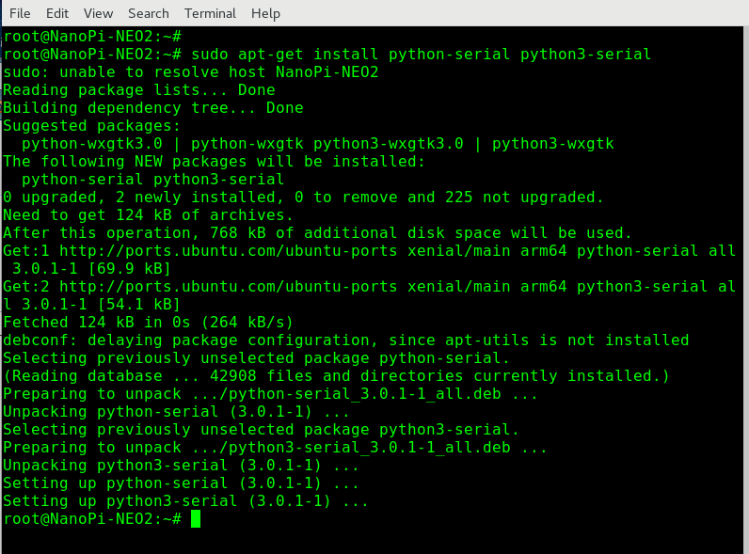
This module encapsulates the access for the serial port. It provides backends for Python running on Windows, and Linux. The module named “serial” automatically selects the appropriate backend.

List available UARTs

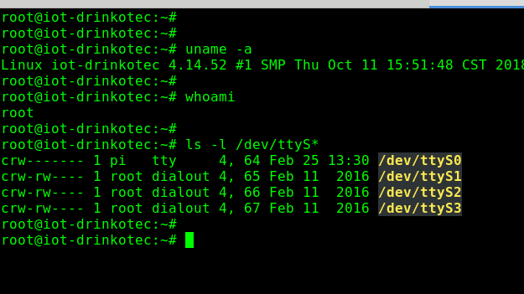

Test your UART serial communication using python
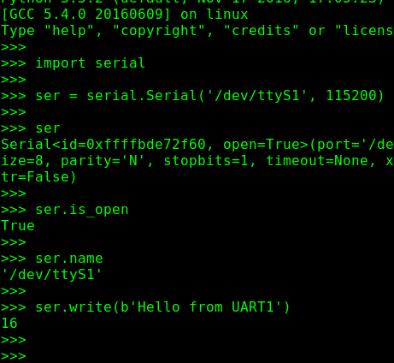

Here we open the uart1 serial port for communication and send the message “Hello from UART1” from the NanoPi NEO2.

Now on my computer I open a terminal to receive the message sent as shown below:

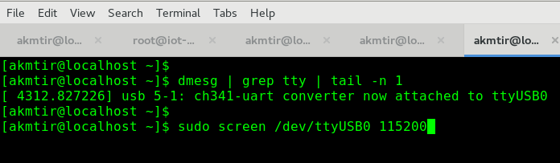

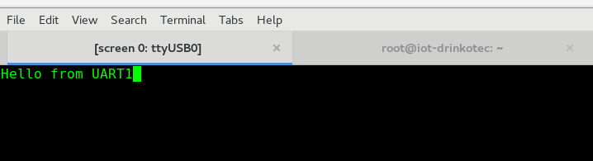
Here is the message received on my computer.

These previous steps prove that the UARTs are working properly on the NanoPI NEO2.

To Sum-up

The NanoPI NEO2 has a Gbps Ethernet, standard USB port and various popular ports and interfaces (GPIO, I2C, UART, SPI, etc.) These features make it suitable to integrate with our own existing architecture to offer an IOT-gateway.

Annexes

Hardware Spec

CPU: Allwinner H5, Quad-core 64-bit high-performance Cortex A53
DDR3 RAM: 512MB
Connectivity: 10/100/1000M Ethernet, RTL8211E-VB-CG chip
USB Host: USB Type A x 1 and USB pin header x 2
MicroSD Slot: MicroSD x 1 for system boot and storage
LED: Power LED x 1, System LED x 1
GPIO1: 2.54mm pitch 24 pin-header, compatible with Raspberry Pi's GPIO pin1 - pin 24. It includes UART, SPI, I2C, IO etc
GPIO2: 2.54mm pitch 12 pin-header. It includes USB, IR receiver, I2S, IO etc
Serial Debug Port: 2.54mm pitch 4pin-header
Audio In/Out: 2.54mm pitch 4 pin-header
MicroUSB: Power input(5V/2A) and OTG
PCB Dimension: 40 x 40mm
Working Temperature: -20℃ to 70℃
Weight: 13g(WITHOUT Pin-headers)
OS/Software: u-boot,Ubuntu Core

