Cursors

Oracle PL/SQL Cursors – Complete Overview
1️⃣ What is a cursor (reminder)
A cursor is a pointer to a result set returned by a SQL statement.
Oracle uses it to:
- execute SQL
- store the result
- process rows

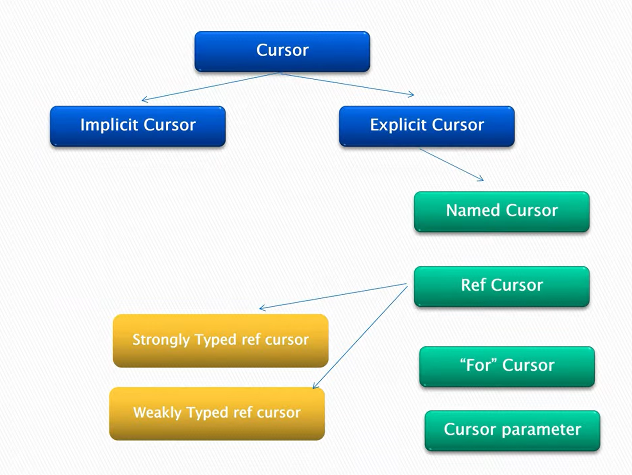

2️⃣ Main cursor categories
🔹 Implicit Cursor
Created automatically by Oracle
Used for:
- INSERT
- UPDATE
- DELETE
- MERGE
- SELECT INTO
You access it via:
SQL%FOUND
SQL%NOTFOUND
SQL%ROWCOUNT
SQL%ISOPEN -- always FALSE

Example:
UPDATE employees SET salary = salary * 1.1;
IF SQL%ROWCOUNT = 0 THEN
DBMS_OUTPUT.PUT_LINE('No rows updated');
END IF;

🔹 Explicit Cursor
Defined and controlled by the developer
Used when:
- SELECT returns multiple rows
- You need row-by-row logic
Lifecycle:
DECLARE → OPEN → FETCH → CLOSE

3️⃣ Types of Explicit Cursors
✅ 3.1 Named Cursor
This is the classic explicit cursor.
CURSOR c1 IS
SELECT first_name, salary FROM employees;
You manually open, fetch, and close it.

✅ 3.2 Cursor FOR Loop
A special explicit cursor where Oracle:
- opens the cursor
- fetches rows
- closes it automatically
👉 Best practice

BEGIN
FOR r IN (SELECT first_name, salary FROM employees) LOOP
DBMS_OUTPUT.PUT_LINE(r.first_name || ' : ' || r.salary);
END LOOP;
END;
/
✔ safer
✔ no cursor leak
✔ recommended

✅ 3.3 Cursor with Parameters
Used when the cursor query needs input values.
CURSOR c1 (p_deptno NUMBER) IS
SELECT first_name, salary
FROM employees
WHERE department_id = p_deptno;
Usage:
OPEN c1(10);

4️⃣ REF CURSOR (Cursor Variable)
A REF CURSOR is a pointer to a query, usually returned from:
- procedures
- functions
- APIs
- dynamic SQL
Used heavily in applications and reporting.

🔹 4.1 Weakly Typed REF CURSOR
Most flexible, no fixed structure.
TYPE ref_cur IS REF CURSOR;
rc ref_cur;
Can open any SELECT.

🔹 4.2 Strongly Typed REF CURSOR
Fixed structure (compile-time safety).
TYPE emp_cur IS REF CURSOR
RETURN employees%ROWTYPE;
Only compatible queries allowed.

Example REF CURSOR usage
OPEN rc FOR
SELECT first_name, salary FROM employees;

5️⃣ Cursor Attributes (Explicit & REF)
Attribute Meaning
%FOUND Last fetch returned a row
%NOTFOUND No more rows
%ROWCOUNT Rows fetched so far
%ISOPEN Cursor open?

6️⃣ Cursor parameters vs REF cursor (difference)
Feature | Cursor Parameter | REF Cursor
Compile-time query | Yes | No
Dynamic SQL | No | Yes
Return from procedure | No | Yes
Application use | Rare | Common

7️⃣ Relation to OPEN_CURSORS
- Every OPEN explicit or REF cursor consumes one slot
- Limit per session:
SELECT value FROM v$parameter WHERE name='open_cursors';
If exceeded:
ORA-01000: maximum open cursors exceeded
👉 Cursor FOR loop prevents leaks
👉 Always close REF cursors

8️⃣ Summary Table (one-glance)
Cursor Type | Who manages it | Use case
Implicit | Oracle | DML, SELECT INTO
Named Explicit | Developer | Row-by-row logic
FOR Cursor | Oracle | Safe looping
Parameter Cursor | Developer | Filtered queries
REF Cursor (weak) | Developer | Dynamic result sets
REF Cursor (strong) | Developer | Typed APIs

🧠 Golden interview line
Implicit cursors are automatic; explicit cursors are developer-controlled; REF cursors are pointers used for dynamic SQL and application integration.

