Certification Project

Q1: Create a python script called googlesearch that provides a command line utility to perform google search. It gives you the top links (search results) of whatever you want to search on google.

Q2: Create a script called location that return the location parameters of any location you
want.

Q3: Create a script called weather that return the environmental parameters (temperature (min, max), windspeed, humidity, cloud, pressure, sunrise and sunset) of any location you want; after passing arguments (like user api and city id).

Q1: Google Search Script
This script uses the googlesearch-python package to perform Google searches from the command line. You can install the package using pip install googlesearch-python.
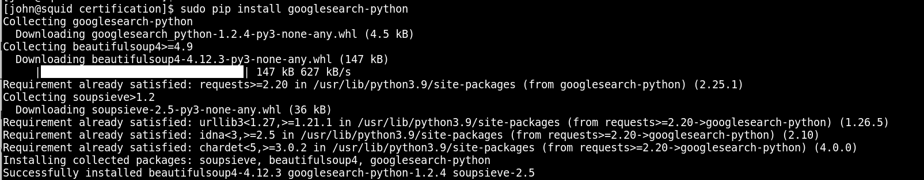
googlesearch.py:
import argparse
from googlesearch import search

def google_search(query, num_results):
for result in search(query, num_results):
print(result)

if __name__ == "__main__":
parser = argparse.ArgumentParser(description="Perform a Google search and return the top links.")
parser.add_argument('query', type=str, help="The search query.")
parser.add_argument('--num_results', type=int, default=10, help="Number of search results to return.")

args = parser.parse_args()
google_search(args.query, args.num_results)

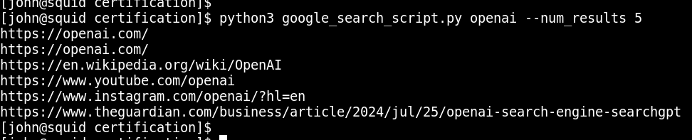

Q2: Location Script
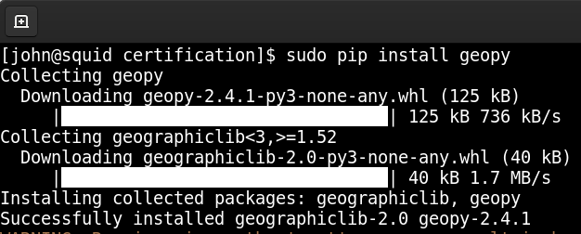
This script uses the geopy package to get the location parameters. You can install the package using pip install geopy.

location.py:

import argparse
from geopy.geocoders import Nominatim

# pip install geopy

def get_location(address):
geolocator = Nominatim(user_agent="location_script")
location = geolocator.geocode(address)
if location:
print(f"Address: {location.address}")
print(f"Latitude: {location.latitude}")
print(f"Longitude: {location.longitude}")
else:
print("Location not found")

if __name__ == "__main__":
parser = argparse.ArgumentParser(description="Get the location parameters of an address.")
parser.add_argument('address', type=str, help="The address to lookup.")

args = parser.parse_args()
get_location(args.address)

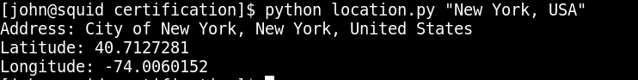

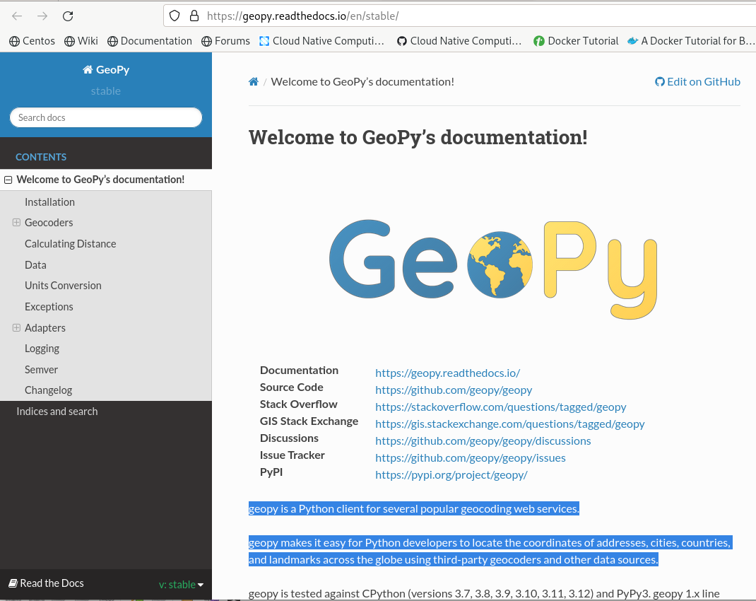

Q3: Weather Script
This script uses the requests package to get weather data from the OpenWeatherMap API. You can install the package using pip install requests.
weather.py:

import argparse
import requests

def get_weather(api_key, city_id):
url = f"http://api.openweathermap.org/data/2.5/weather?id={city_id}&appid={api_key}&units=metric"
response = requests.get(url)
data = response.json()

if data["cod"] != 200:
print(f"Error: {data['message']}")
return

weather = data['main']
wind = data['wind']
clouds = data['clouds']
sys = data['sys']

print(f"Temperature: {weather['temp']}°C")
print(f"Temperature (min): {weather['temp_min']}°C")
print(f"Temperature (max): {weather['temp_max']}°C")
print(f"Pressure: {weather['pressure']} hPa")
print(f"Humidity: {weather['humidity']}%")
print(f"Wind Speed: {wind['speed']} m/s")
print(f"Cloudiness: {clouds['all']}%")
print(f"Sunrise: {sys['sunrise']}")
print(f"Sunset: {sys['sunset']}")

if __name__ == "__main__":
parser = argparse.ArgumentParser(description="Get the weather parameters of a location.")
parser.add_argument('api_key', type=str, help="Your OpenWeatherMap API key.")
parser.add_argument('city_id', type=int, help="The city ID.")

args = parser.parse_args()
get_weather(args.api_key, args.city_id)

python weather.py YOUR_API_KEY CITY_ID

Replace YOUR_API_KEY with your actual OpenWeatherMap API key and CITY_ID with the city ID of the location you want to get the weather for. You can find city IDs on the OpenWeatherMap website.

Example
If your API key is abc123 and you want to get the weather for London, you would run:
python weather.py abc123 London

This script will print the current weather details for the specified city, including temperature, wind speed, humidity, cloudiness, pressure, sunrise, and sunset times.

