Module 2: Sequences and File Operations

Case Study I

1. What is the output of the following code?
nums = set([1,1,2,3,3,3,4,4])
print(len(nums))
Hint: Set consists unique element.
4
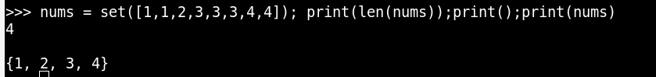

2. What will be the output?
d = {"john":40, "peter":45}
print(list(d.keys()))
Hint: d.keys() is the function which will show keys.
['john', 'peter']
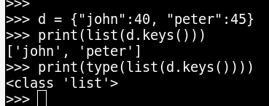

3. A website requires a user to input username and password to register. Write a program
to check the validity of password given by user. Following are the criteria for checking
password:
1. At least 1 letter between [a-z]
2. At least 1 number between [0-9]
1. At least 1 letter between [A-Z]
3. At least 1 character from [$#@]
4. Minimum length of transaction password: 6
5. Maximum length of transaction password: 12
Hint: In case of input data being supplied to the question, it should be assumed to be a
console input.

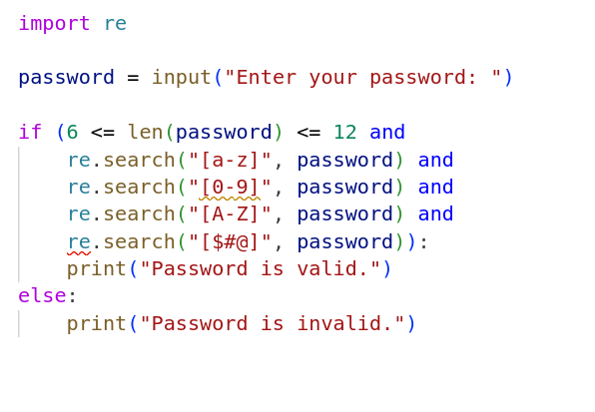
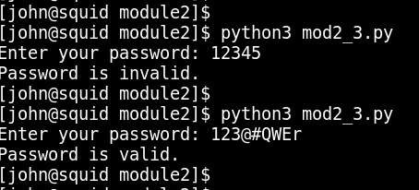

4. Write a for loop that prints all elements of a list and their position in the list.
a = [4,7,3,2,5,9]
Hint: Use Loop to iterate through list elements.
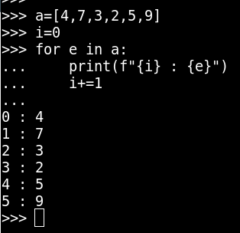

5. Please write a program which accepts a string from console and print the
characters that have even indexes.
Example: If the following string is given as input to the program:
H1e2l3l4o5w6o7r8l9d
Then, the output of the program should be:
Helloworld

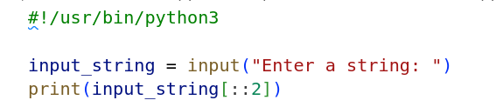
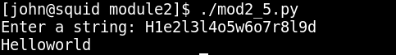

6. Please write a program which accepts a string from console and print it in reverse
order.
Example: If the following string is given as input to the program:
rise to vote sir
Then, the output of the program should be:
ris etov ot esir

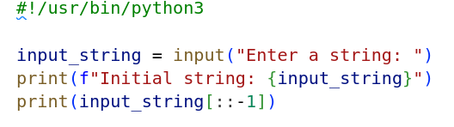
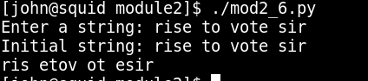

7. Please write a program which count and print the numbers of each character in a
string input by console.
Example: If the following string is given as input to the program:
abcdefgabc
Then, the output of the program should be:
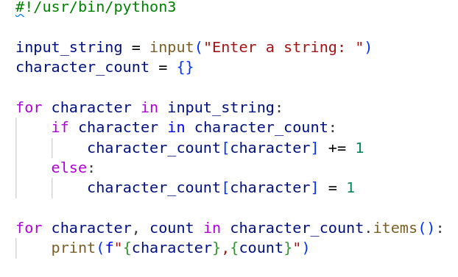
a,2
c,2
b,2
e,1
d,1
g,1
f,1

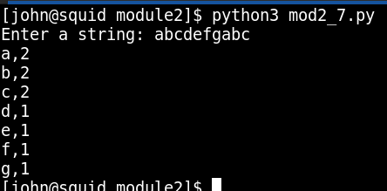

8. With two given lists [1,3,6,78,35,55] and [12,24,35,24,88,120,155], write a
program to make a list whose elements are intersection of the above given lists

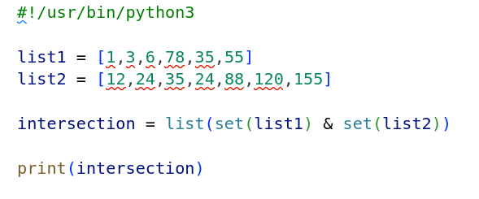

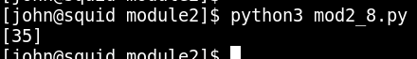

9. With a given list [12,24,35,24,88,120,155,88,120,155], write a program to print this
list after removing all duplicate values with original order reserved.

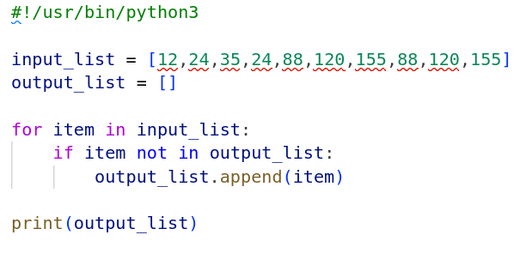

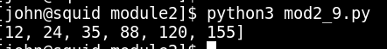

10.By using list comprehension, please write a program to print the list after removing
the value 24 in [12,24,35,24,88,120,155].

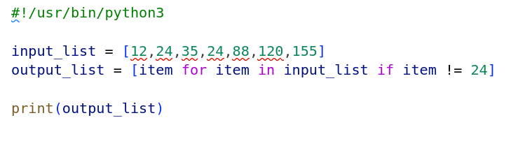
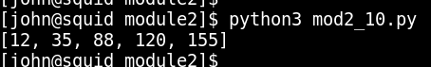

11.By using list comprehension, please write a program to print the list after removing
the 0th,4th,5th numbers in [12,24,35,70,88,120,155].

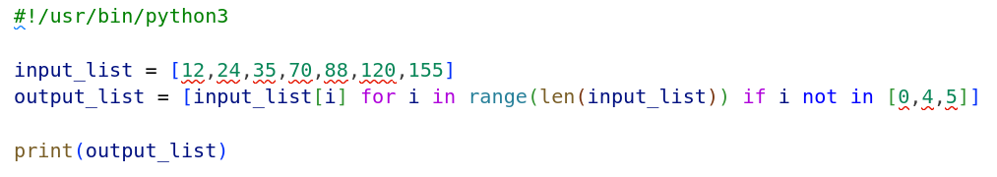
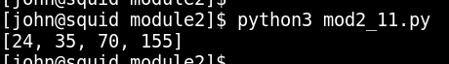

12.By using list comprehension, please write a program to print the list after removing
delete numbers which are divisible by 5 and 7 in [12,24,35,70,88,120,155].

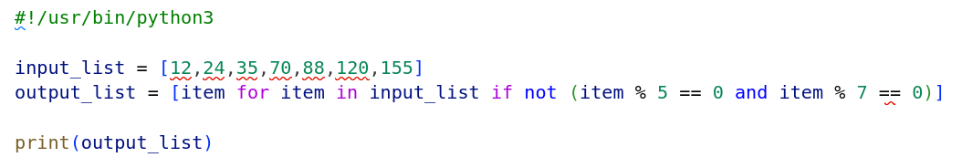
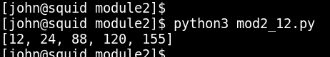

13.Please write a program to randomly generate a list with 5 numbers, which are
divisible by 5 and 7 , between 1 and 1000 inclusive.

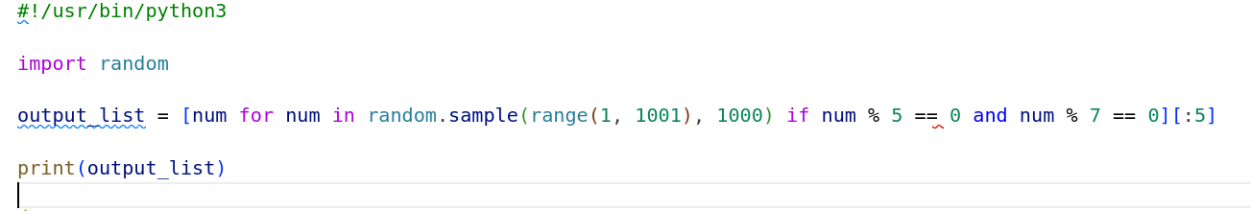
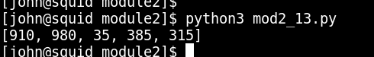

14.Write a program to compute 1/2+2/3+3/4+...+n/n+1 with a given n input by
console (n>0).
Example:
If the following n is given as input to the program:
5
Then, the output of the program should be:
3.55

