Module 3: Functions, OOP, modules, Errors & Exceptions

Case Study I

1. A Robot moves in a Plane starting from the origin point (0,0). The robot can move toward UP, DOWN, LEFT, RIGHT. The trace of Robot movement is as given following:
UP 5
DOWN 3
LEFT 3
RIGHT 2
The numbers after directions are steps. Write a program to compute the distance current position after sequence of movements. Hint: Use math module.

import math

# Initialize starting point
x, y = 0, 0

# Movements: direction and steps
movements = [("UP", 5), ("DOWN", 3), ("LEFT", 3), ("RIGHT", 2)]

# Process each movement
for direction, steps in movements:
if direction == "UP":
y += steps
elif direction == "DOWN":
y -= steps
elif direction == "LEFT":
x -= steps
elif direction == "RIGHT":
x += steps

# Calculate distance from origin
distance = math.sqrt(x**2 + y**2)

print(f"Distance from origin: {distance:.2f}")

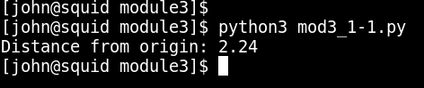

2 Data of XYZ company is stored in sorted list. Write a program for searching specific data from that list. Hint: Use if/elif to deal with conditions.

def binary_search(sorted_list, target):
"""
Perform binary search on a sorted list to find the target value.

:param sorted_list: List of sorted elements
:param target: The value to search for
:return: The index of the target if found, otherwise -1
"""
left, right = 0, len(sorted_list) - 1

while left <= right:
mid = (left + right) // 2
mid_value = sorted_list[mid]

if mid_value == target:
return mid
elif mid_value < target:
left = mid + 1
else:
right = mid - 1

return -1

# Example usage
sorted_list = [1, 2, 3, 4, 5, 6, 7, 8, 9, 10]
target = 5

index = binary_search(sorted_list, target)
if index != -1:
print(f"Target found at index: {index}")
else:
print("Target not found in the list.")

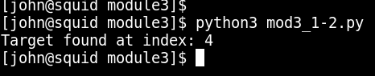

3. Weather forecasting organization wants to show is it day or night. So, write a program for such organization to find whether is it dark outside or not. Hint: Use time module.

import time

def is_it_dark():
"""
Determine if it's dark based on the current local time.
Considering dark hours from 7pm to 6am.
"""
current_time = time.localtime() # Get struct_time for local time
hour = current_time.tm_hour # Extract the hour from struct_time

# Check if it's dark
if hour >= 19 or hour < 6:
return True
else:
return False

# Example usage
if is_it_dark():
print("It's dark outside.")
else:
print("It's not dark outside.")

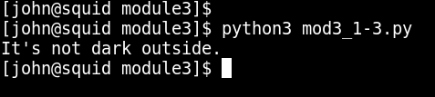

4. Write a program to find distance between two locations when their latitude and longitudes are given.
Hint: Use math module.

import math

def calculate_distance(lat1, lon1, lat2, lon2):
"""
Calculate the distance between two points on the earth (specified in decimal degrees).
"""
# Convert decimal degrees to radians
lat1, lon1, lat2, lon2 = map(math.radians, [lat1, lon1, lat2, lon2])

# Haversine formula
dlon = lon2 - lon1
dlat = lat2 - lat1
a = math.sin(dlat/2)**2 + math.cos(lat1) * math.cos(lat2) * math.sin(dlon/2)**2
c = 2 * math.asin(math.sqrt(a))
r = 6371 # Radius of earth in kilometers. Use 3956 for miles
return c * r

# Example usage
lat1 = 52.2296756
lon1 = 21.0122287
lat2 = 41.8919300
lon2 = 12.5113300

distance = calculate_distance(lat1, lon1, lat2, lon2)
print(f"Distance: {distance:.2f} kilometers")

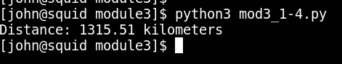

5. Design a software for bank system. There should be options like cash withdraw, cash credit and change password. According to user input, the software should provide required output.
Hint: Use if else statements and functions.

class BankAccount:
def __init__(self, account_number, name, balance, password):
self.account_number = account_number
self.name = name
self.balance = balance
self.password = password

def withdraw_cash(self, amount, password):
if password == self.password:
if amount <= self.balance:
self.balance -= amount
print(f"Withdrawal successful. Your new balance is: ${self.balance:.2f}")
else:
print("Insufficient funds.")
else:
print("Invalid password.")

def credit_cash(self, amount):
self.balance += amount
print(f"Cash credited. Your new balance is: ${self.balance:.2f}")

def change_password(self, old_password, new_password):
if old_password == self.password:
self.password = new_password
print("Password changed successfully.")
else:
print("Invalid old password.")

def main():
# Example account setup
account = BankAccount("12345678", "John Doe", 1000.0, "password123")

while True:
print("\nBank System Menu:")
print("1. Withdraw Cash")
print("2. Credit Cash")
print("3. Change Password")
print("4. Exit")
choice = input("Enter your choice: ")

if choice == "1":
amount = float(input("Enter amount to withdraw: "))
password = input("Enter your password: ")
account.withdraw_cash(amount, password)
elif choice == "2":
amount = float(input("Enter amount to credit: "))
account.credit_cash(amount)
elif choice == "3":
old_password = input("Enter your old password: ")
new_password = input("Enter your new password: ")
account.change_password(old_password, new_password)
elif choice == "4":
print("Exiting the bank system.")
break
else:
print("Invalid choice. Please choose again.")

if __name__ == "__main__":
main()

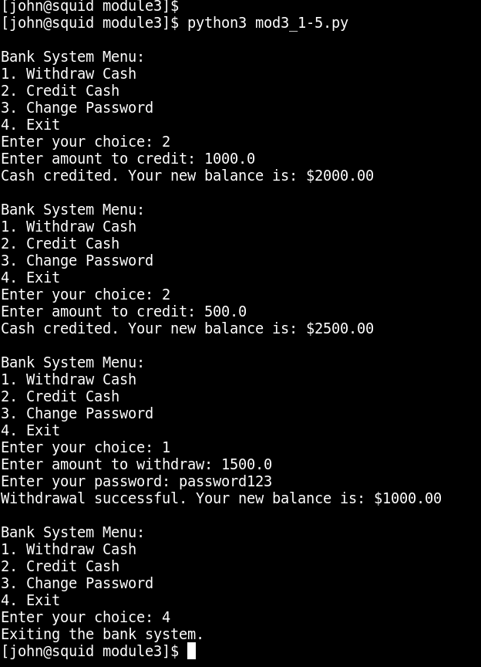

6. Write a program which will find all such numbers which are divisible by 7 but are not a multiple of 5, between 2000 and 3200 (both included). The numbers obtained should be printed in a comma-separated sequence on a single line.

# Find numbers divisible by 7 but not a multiple of 5, between 2000 and 3200
numbers = [str(number) for number in range(2000, 3201) if number % 7 == 0 and number % 5 != 0]

# Print the numbers in a comma-separated sequence
print(",".join(numbers))

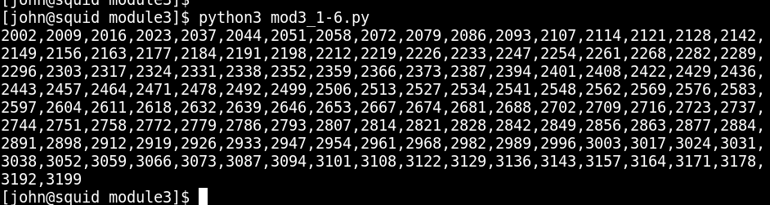

7. Write a program which can compute the factorial of a given numbers. Use recursion to find it. Hint: Suppose the following input is supplied to the program:
8
Then, the output should be:
40320

def factorial(n):
"""
Compute the factorial of a given number using recursion.
"""
if n == 0:
return 1
else:
return n * factorial(n-1)

# Example usage
n = 8
print(f"The factorial of {n} is: {factorial(n)}")

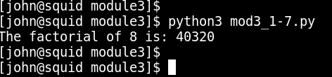

8. Write a program that calculates and prints the value according to the given formula:
Q = Square root of [(2 * C * D)/H]
Following are the fixed values of C and H: C is 50. H is 30.
D is the variable whose values should be input to your program in a comma-separated sequence.
Example:
Let us assume the following comma separated input sequence is given to the
program:
100,150,180
The output of the program should be:
18,22,24

import math

def calculate_q(d_values):
"""
Calculate and print the value of Q for each given D, using the formula:
Q = Square root of [(2 * C * D)/H]
"""
C = 50
H = 30
results = []
for D in d_values:
Q = math.sqrt((2 * C * D) / H)
results.append(int(Q))
return results

# Example usage
d_values = [100, 150, 180]
results = calculate_q(d_values)
print(",".join(map(str, results)))

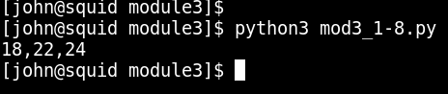

9. Write a program which takes 2 digits, X,Y as input and generates a 2-dimensional array. The element value in the i-th row and j-th column of the array should be i*j.
Note: i=0,1.., X-1; j=0,1,¡-Y-1.
Example:
Suppose the following inputs are given to the program:
3,5
Then, the output of the program should be:
[[0, 0, 0, 0, 0], [0, 1, 2, 3, 4], [0, 2, 4, 6, 8]]

def generate_2d_array(x, y):
"""
Generate a 2D array where the element value in the i-th row and j-th column is i*j.
"""
return [[i*j for j in range(y)] for i in range(x)]

# Example usage
x, y = 3, 5
array = generate_2d_array(x, y)
print(array)

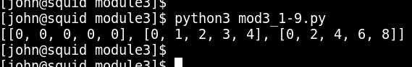

10. Write a program that accepts a comma separated sequence of words as input and prints the words in a comma-separated sequence after sorting them alphabetically.
Suppose the following input is supplied to the program:
without,hello,bag,world
Then, the output should be:
bag,hello,without,world

def sort_words(input_string):
"""
Sort a comma-separated sequence of words alphabetically.
"""
words = input_string.split(',')
words.sort()
return ','.join(words)

# Example usage
input_string = "without,hello,bag,world"
sorted_string = sort_words(input_string)
print(sorted_string)

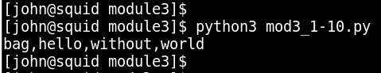

11. Write a program that accepts sequence of lines as input and prints the lines after making all characters in the sentence capitalized.
Suppose the following input is supplied to the program:
Hello world
Practice makes perfect
Then, the output should be:
HELLO WORLD
PRACTICE MAKES PERFECT

def capitalize_lines():
"""
Accepts sequence of lines as input and prints the lines after capitalizing all characters.
"""
lines = []
while True:
line = input("Enter line (or leave blank to finish): ")
if not line:
break
lines.append(line.upper())

for line in lines:
print(line)

# Example usage
capitalize_lines()

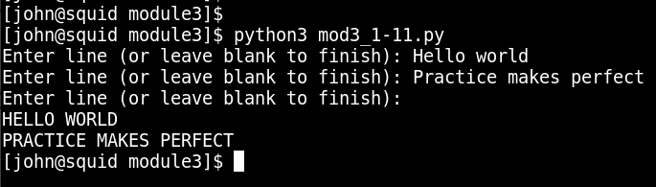

12. Write a program that accepts a sequence of whitespace separated words as input and prints the words after removing all duplicate words and sorting them alphanumerically.
Suppose the following input is supplied to the program:
hello world and practice makes perfect and hello world again
Then, the output should be:
again and hello makes perfect practice world

def remove_duplicates_sort(input_string):
"""
Remove duplicate words and sort the remaining words alphanumerically.
"""
words = input_string.split()
unique_words = sorted(set(words))
return ' '.join(unique_words)

# Example usage
input_string = "hello world and practice makes perfect and hello world again"
result = remove_duplicates_sort(input_string)
print(result)

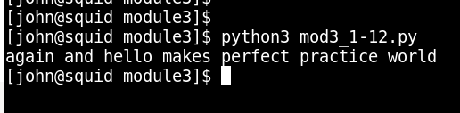

13. Write a program which accepts a sequence of comma separated 4 digit binary numbers as its input and then check whether they are divisible by 5 or not. The numbers that are divisible by 5 are to be printed in a comma separated sequence.
Example:
0100,0011,1010,1001
Then the output should be:
1010

def filter_divisible_by_5(binary_numbers):
"""
Check which binary numbers are divisible by 5 and print them in a comma-separated sequence.
"""
divisible_by_5 = [num for num in binary_numbers.split(',') if int(num, 2) % 5 == 0]
return ','.join(divisible_by_5)

# Example usage
binary_numbers = "0100,0011,1010,1001"
result = filter_divisible_by_5(binary_numbers)
print(result)

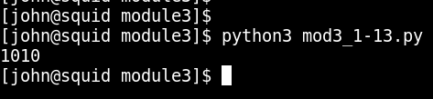

14. Write a program that accepts a sentence and calculate the number of upper case letters and lower case letters.
Suppose the following input is supplied to the program:
Hello world!
Then, the output should be:
UPPER CASE 1
LOWER CASE 9

def count_case(sentence):
"""
Calculate the number of upper case and lower case letters in a sentence.
"""
upper_case = sum(1 for char in sentence if char.isupper())
lower_case = sum(1 for char in sentence if char.islower())
return f"UPPER CASE {upper_case}\nLOWER CASE {lower_case}"

# Example usage
sentence = "Hello world!"
result = count_case(sentence)
print(result)

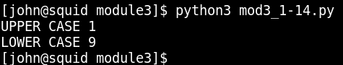

15.Give example of fsum and sum function of math library .

import math

# Example list of floating point numbers
numbers = [0.1, 0.1, 0.1, 0.1, 0.1, 0.1, 0.1, 0.1, 0.1, 0.1]

# Using sum
sum_result = sum(numbers)
print(f"Result using sum: {sum_result}")

# Using math.fsum for better precision with floating point numbers
fsum_result = math.fsum(numbers)
print(f"Result using math.fsum: {fsum_result}")

