IE University
School of Science & Technology

Semantic Framing of Mental Health During the COVID-19 Pandemic: A Subspace Modeling Approach

Álvaro Mengotti Medina
Bachelor of Data and Business Analytics
Supervised by:
Prof. Alejandro Martínez-Mingo
10 April 2026

Abstract
This project aims to analyze how Spanish news media framed mental health during the COVID-19 pandemic using semantic subspace modeling. The deep psychological effects of the pandemic‚ including anxiety‚ depression‚ loneliness‚ uncertainty‚ fatigue‚ and emotional distress‚ have been widely covered in the media. The media played a central role in shaping the definitions of issues and the narrative of the story as the crisis evolved through time․
This analysis compares embeddings derived from standard centroid-based semantic models to those from subspace projection techniques․ The study confirms that DAPT and penultimate layer extraction demonstrate potential in tracking high-fidelity semantic trajectories․ The results showed a clear trajectory moving from an "Affective" shock dominated by emotional volatility and high entropy during the 2020 lockdown‚ to a "Social" peak during the early Second Wave months (September to November 2020) with the return to school and work‚ localized lockdowns‚ and community friction‚ to a "Functional" stabilizing institutional discourse over a chronic public health crisis․ These results provide evidence that the processes of media framing are an iterative‚ socially represented function and that semantic subspaces are able to encode social well-being during historical moments of disruption․
Keywords: Mental Health, COVID-19, Media Framing, Spanish News, Semantic Change, Semantic Subspaces, Natural Language Processing.
Table of Contents
1. Introduction 6
1.1. Background and Motivation 6
1.2. Research Question and Objectives 7
1.3. Contributions 8
1.4. Scope and Assumptions 8
2. Literature review 9
2.1. Mental health disclosure during COVID-19 and media framing 9
2.2. Cognitive framing and context effects in human similarity judgements 11
2.3. Meaning, context, and conceptual subspaces 12
2.4. Diachronic semantics and measuring semantic change 13
2.5. Spanish news precedent: semantic trajectories and frames 15
2.6. Distributional and Contextualized Language Models for Longitudinal Framing Analysis 16
2.7. Research gaps and hypotheses 18
3. Methodology 19
3.1. Data Harvesting 20
3.1.1. Filtering and Keyword Refinement 21
3.1.2. Operational Adjustments and Limitations 22
3.2. NLP Infrastructure 22
3.2.1. Model Selection and Domain-Adaptive Pretraining 22
3.2.2. Embedding Extraction and Layer Strategy 23
3.2.3. Anisotropy Correction 23
3.3. Subspace Analysis 24
3.3.1. Temporal Windowing and Subspace Construction 24
3.3.2. Framing Metrics 25
4. Results 28
4.1. Corpus Validation 28
4.2. Technique Comparison and Analytical Configuration 32
4.2.1. Domain Adaptation 33
4.2.2. Layer Extraction 34
4.2.3. Geometry Correction 38
4.2.4. Analytical Configuration 39
4.3. Framing Metrics 41
4.4. Anchor Projections 44
4.5. Trajectory Projections 46
5. Discussion 47
5.1. The Temporal Narrative 47
5.2. Methodological Contributions 49
5.3. Limitations 50
6. Conclusion 51
7. References 53
Appendix A: Summary of Terms and Abbreviations 56
Appendix B: Media List 56
Appendix C: Phase 1 Data Harvesting Keywords 57
COVID-19 Filter Keywords 57
Mental Health Filter Keywords 57
Appendix D: Phase 2 Embedding Extraction Keywords 57
Appendix E: Tversky's Cognitive Psychology and Violations of Classical Geometry 58
Appendix F: Layer Comparison Drift Plot. 59
Appendix G: Correlation Table between Centroids and Subspaces for 2 Layer Strategies 59
Appendix H: Supplementary Semantic Trajectories 60
Appendix I: Media List Rolling Window 61
Appendix J: Anchors List Definitions 62
Semantic Dimensions Definitions 62
Contextualized Anchors (Examples) 63

1. Introduction

1.1. Background and Motivation
The COVID-19 crisis has sparked a massive public discussion on psychological distress, ranging from prevalent conditions such as anxiety and depression to more brief experiences such as loneliness or emotional fatigue. Besides the concerns about the risk of infection for oneself or one’s family, the pandemic has impacted our daily routines, social relationships, educational institutions, work, and the possibilities of accessing mental health services. According to the World Health Organization, the pandemic has disrupted or canceled essential mental health services in 93% of the countries (World Health Organization, 2020).
Faced with this situation, governments around the world have adopted measures of confinement as a strategy to reduce the number of infections and deaths. This extreme measure applied in life-threatening situations contributed positively by reducing the rate of infections, nevertheless, it collaterally damaged the population psychologically, economically or physically.
In Spain, according to data from the Instituto Nacional de Estadística (INE, 2021), the prevalence of self-reported low interest or pleasure in activities increased by 3.3 points, feelings of depression by 2.8 points, and sleeping problems by 2 points. These figures, beyond being clinical records, configure a social reality that the news media have been documenting, but also interpreting and constructing at the same time.
The news media constitute the main, and sometimes the only, sources of information for contemporary societies, and their frames of reference determine what we consider important, the responses that seem appropriate to us, and what we understand as urgent (Entman, 1993). By foregrounding some words and some emotional inflections while backgrounding others, the agenda of the media editors sets the agenda of their readers.
This suggests that the way media represents mental health is not merely descriptive, it is fundamentally consequential. There is evidence that the coverage may have implications for the social stigma associated with these disorders, the attitude toward help-seeking behaviors, or the adoption of high-risk behaviors such as suicidal intentions (Gunnell & Biddle, 2020; Gunnell, Appleby et al. 2020). These reasons lead us to explore not only the presence of mental health in the Spanish news during the pandemic, but also the evolution of the frames through which it is represented, and the inflections of meaning, emotionality, and narrativity throughout the different stages of the pandemic.
To address this, this thesis proposes a computational approach that models discourse meaning over time using contextual language representations and semantic subspace analysis, enabling longitudinal measurement of framing dynamics in Spanish news coverage during the pandemic.

1.2. Research Question and Objectives
This thesis addresses the following research question:
How did Spain news media frame mental health during the COVID-19 pandemic, and how did the meanings, emotions, and narrative relevance of key mental health concepts evolve over time.
To answer this question, this study pursues four objectives: (i) to build a corpus of Spanish news articles during the COVID-19 pandemic, and filter the articles that contain mental health related vocabulary; (ii) obtain the contextual embeddings for mental health constructs for each time period and represent them as a semantic subspace; (iii) to measure the diachronic changes through: semantic drift (change in meaning), valence-adjusted framing (emotional orientation), and salience/centrality (change in narrative relevance); and (iv) to explain the temporal patterns by relating results to major pandemic stages.

1.3. Contributions
This thesis makes the following contributions:
- A structured, time-indexed dataset, containing mental health lexicon during the COVID-19 pandemic, enabling semantic analysis.
- Framing operationalization‚ based on semantic subspace modeling‚ considering discourse periods as semantic structures‚ not as meanings of single words․
- A multidimensional measurement framework is proposed to study the evolution of semantic drift‚ emotional valence projection‚ and salience indicators in framing․
- Empirical visualizations that offer interpretable‚ comparable representations of framing dynamics throughout the pandemic․

1.4. Scope and Assumptions
This study focuses on news articles written in Spanish related to the COVID-19 pandemic and the discourse around mental health. The time scope of the study spans from March 2020 to March 2021 and the content scope is restricted to articles retrieved through keyword based search that aims to capture mental health related language.
The assumptions of the study are as follows: (i) contextual language models capture enough information from the semantic space to approximate the change in meaning over time; (ii) time windows provide a reasonable approximation for a diachronic analysis of the social discourse; (iii) keyword based filtering provides a practical approximation for capturing mental health related discourse, while some noise may persist.
Lastly, this thesis does not assume any causal relationship between news media coverage and mental health outcomes in the population; rather, it provides a picture of how the discourse in news media changes during the pandemic.

2. Literature review

2.1. Mental health disclosure during COVID-19 and media framing
The COVID-19 pandemic has led to common public discussion of anxiety‚ depression‚ loneliness‚ uncertainty‚ and emotional exhaustion․ Mass media coverage is often a primary source of information and interpretation during a pandemic․ The media coverage affects how mental health problems are described; what aspects are stressed‚ and how serious they appear‚ both to the public and to development of a response․ The influence of these attributes is usually explained in the concept of framing (Entman‚ 1993)‚ understood as the process of selecting and highlighting certain dimensions of the issue to promote a particular interpretation‚ diagnosis‚ and evaluation of the occurrence․
For instance‚ when examining news media coverage of mental health in the context of the COVID-19 pandemic‚ the media's framing may differ at various times during the pandemic․ For example, the framing of the initial shock and acute reactions to the pandemic might differ from that of the long-term adaptation and coping, or the responsibility of governmental institutions and policy makers. Capturing such changes requires methods that go beyond counting keywords or topics, because what matters is not only how often mental health is discussed but also how it is discussed: which concepts co-occur, what emotional tone is implied, and how the broader semantic context changes across different pandemic phases. This is where computational modeling of meaning as a function of context and time is needed in order to analyze framing over time. This enables longitudinal analysis of framing.
Mental health coverage is not a neutral topic, as discussed, media influences our perception and interpretation of problems. Reporting practices can influence stigma, help-seeking and under certain conditions harmful outcomes, as discussed in Section 1.1 (Gunnell & Biddle, 2020; Gunnell, Appleby et al., 2020). For instance, Carrasco et al. (2023) analyzed Spanish newspaper coverage of young mental health from January-June 2021. Results showed that news were mostly positive in tone (68.3%), rarely stigmatizing (5.4%) and violence related (7.3%). In addition, it was also observed that only 6% of news article offered help-seeking information. This findings align with WHO results, which showed that 93% of countries worldwide disrupted or halted mental health services (World Health Organization, 2020).
Fillmore (1982) introduced frame semantics, his work claim that words do not simply label things, they activate structured background knowledge: schemas of role, expectations and associations. For instance, reading about depression on a news article does not retrieve a definition, instead it fires a whole “network” of associated roles, expectations and prior knowledge that the reader brings without being asked to. This is not a trivial observation for media analysis. If meaning works this way, then what changes when framing shifts is not just which words appear, but which networks get activated by them.
Fauconnier and Turner (2003) expanded on Fillmore’s work, they state that meaning is not just activated but assembled, built in real time from multiple mental spaces that blend depending on context. The implication in this context is that counting keyword frequencies cannot capture what is actually happening when a frame changes.

2.2. Cognitive framing and context effects in human similarity judgements
A fundamental theoretical problem for framing principles is that meaning is not static, but rather that meaning is context-dependent and shaped by own perspective activated during the interpretation of each situation. Amos Tversky (1977) stated that human similarity judgements are often asymmetric. Many, for example, would not interpret the same way “North Korea is similar to China” than “China is similar to North Korea”. In classical geometry, if A is similar to B, then B is similar to A, however, Tversky demonstrated that human cognition does not display this cognitive behavior. This proves that people’s judgements and interpretations do not always satisfy the triangle inequality, and that human categorization is contingent on salient features and context. These results are relevant because many computational models of meaning implicitly assume fixed, symmetric distance relations in a single space, whereas framing principles suggest that interpretation is altered depending on the context.
Building on these concepts, models inspired by quantum cognition suggest that contextual effects can be represented by sequential projections, where the interpretation of a context is updated as new context is applied (Busemeyer & Bruza, 2012). In this sense, a “frame” is not just a label; it can be conceived of as a contextual constraint that alters which features become salient. This cognitive model provides the theoretical framework for this study, representing meaning not as single-point vectors in a space, which, as previously discussed, does not reflect human cognitive behavior, but as frames represented as subspaces, which allows meaning to be context-dependent representations.

2.3. Meaning, context, and conceptual subspaces
In distributional semantics (i.e., the distributional hypothesis; words that occur in similar contexts tend to have similar meanings), meaning is defined in terms of use, and in semantic space, words with nearby points share similar or are in similar contexts. However, in standard semantic vector spaces, each concept is represented by a single point, and if meaning is context-dependent (as it is for humans when interpreting sentences or words), this can pose a challenge. For example, what does the word positive mean in the following two examples?
- He tested positive for coronavirus. Meaning = infected.
- He maintained a positive attitude through the crisis. Meaning = optimism.
When we as humans read these two examples, we use the surrounding words to derive meaning, the example shows how the same word can have different meanings based on context. Traditional static models (e.g., Word2Vec) assign a single static vector representation to each word, regardless of the context. This means the model is unable to differentiate between behavioral attitudes and clinical infection, hence the importance of context-aware models for capturing the true meaning of text.
Martínez-Mingo et al. (2023) address this problem by employing conceptual subspaces and sequential projections rather than point representations. The authors demonstrate that quantum-inspired similarity models when instantiated on distributional semantic spaces, can give an account for classical cognitive phenomena, such as asymmetry, triangle inequality violations, and diagnosticity effects (see appendix E for an in depth explanation of these classical cognitive effects and violations of classical geometry). (Martínez Mingo et al., 2023; Tversky, 1977)
For a framing study, the key contribution of this perspective is that a “frame” can be represented as a subspace that highlights certain dimensions of meaning while suppressing others. For instance, if the media publish an article regarding “depression” through a clinical frame, the subspace will heavily weight dimensions (features) associated with symptoms, therapy or medication. On the other hand, if the same concept is discussed through an economic frame, the subspace will heavily weight dimensions associated with unemployment, financial crisis, or resources. As observed from the example, presenting the same topic but displayed on different frames result in different interpretations, dimensions and meaning.

2.4. Diachronic semantics and measuring semantic change
Diachronic semantics aim to measure how meanings of words and grammatical structure evolve over time. Hamilton et al. (2016) provide a widely recognized methodology for measuring semantic change using diachronic embeddings. The methodology is conceptually simple, it trains word embeddings on text from separate time periods and then aligns the resulting vector spaces. This allows to measure how far a word shifted semantically form one period to the next. What makes this more than a technical exercise is the finding that meaning change is not random, it follows detectable statistical regularities, which gives the whole approach its validity. Their approach was developed and validated on historical data (2 centuries), the data gathered for this thesis covers one natural year (March 2020 to March 2021). Whether the same regularities are detectable over a single year of data is not something Hamilton et al. address directly. This thesis proceeds on the assumption that the logic and methodology still applies at shorter timescales.
Kutuzov et al. (2018) provided an overview of the field of diachronic word representations at a time when various methods had been developed but a common language and evaluation frameworks were missing. The paper organizes the field by defining what semantic shifts are from a computational perspective, discussing the most prominent diachronic word embedding models and classifying them according to three dimensions: discrete vs. continuous time periods, whether the spaces are aligned or not and evaluation metrics. One important point of discussion is the choice of hyper-parameters such as the time periods' length and stability of alignment: these are not simply modeling choices but they determine what can be concluded. For COVID-19 coverage, the findings suggest to pay attention to the choice of time periods and to perform comparisons across time periods to tell apart actual semantic shifts and fluctuations in the representations. Employing subspace word representations circumvents a problem of the standard diachronic models: comparing individual word representations between two time periods assumes modeling the central tendency of word usages. Computing the Grassmannian distance between two subspaces, as done in this paper, accounts for the changes in the entire distribution of word embeddings. Moreover, the Grassmannian distance is invariant to orthogonal rotations of the basis, circumventing the problem of arbitrary orientation that occurs when directly comparing individual word representations across separately trained embeddings (Hamilton et al., 2016). This geometric property makes Grassmannian-based measures for semantic shifts more theoretically founded and comparable than measures relying on cosine similarities.

2.5. Spanish news precedent: semantic trajectories and frames
Although diachronic semantic models have been widely used for studying general language datasets over long time spans, the closest precedent for the current study are computational analyses that examine the temporal evolution of frames in the context of news language. Of particular relevance to the Spanish language is the study by Olivas Osuna et al. (2023). Their object of study is the representation of the Catalan nationalist conflict in the Spanish mainstream press. The authors use Latent Semantic Analysis (LSA) to analyze the diachronic evolution across years of the semantic context of a number of political terms and their increase in prominence and fragmentation‚ linking them to specific political events registered in the data․ The novelty of their work is not only methodological but also involves the proposal of specific metrics to operationalize the movements of political concepts and frames in a semantic space over time, rendering the abstract framework more tangible.
The object of study, political conflict, is clearly different from that of the current thesis, which focuses on mental health. What is relevant here is the applicability of their approach to a Spanish newspaper dataset, and the potential of quantifying framing dynamics, or the shifts of political concepts in a semantic space over time, and grounding these in an empirical reality. The latter is directly relevant to this thesis, which proceeds in Section 4 to interpret quantitative results against the actual timeline of the pandemic.
The current study deviates from Olivas Osuna et al. in its methodology. LSA generates a single model for each time period, disregarding the variation of the semantic environments of words within that time period. Replacing LSA with contextualized subspaces generated from a domain-specific Transformer model enables the semantic analysis to capture variations not only between time periods but also within a time period, depending on the context. This distinction is not negligible for a dataset in which the same keyword, e.g. anxiety, crisis, isolation, may have had different meanings depending on its context.

2.6. Distributional and Contextualized Language Models for Longitudinal Framing Analysis
One of the central questions of computational framing is the choice of text representation. Earlier distributional models produce a single vector per word type and can struggle with morphological variation and rare words. For our use case, this results in an important limitation, considering that the Spanish language is morphologically rich and requires a more subtle approach to lexical diversity. Bojanowski et al. (2017) addressed this issue by learning a character-level language model, using character n-grams. This paper was necessary, as it highlighted the need for better representations to capture the richer lexical variation of large datasets in Spanish.
More recently, the contextualized embeddings learned by Transformer models have become available. In these models, the representation of a word vector depends on the context in which the word appears. This is a key property for discourse studies, as frames may be cued by slight modifications of the context. For the Spanish language, the primary benchmark is BETO (Cañete et al., 2020), a BERT-base model featuring 12 transformer layers and a hidden layer size (d) of 768. It was trained on a 1.5 billion word dataset compiled from Spanish Wikipedia and the sources from the OPUS project, a large scale collection of open-source documents, providing the model a diverse domain vocabulary. A key feature of BETO’s training is the use of Whole Word Masking (WWM), a technique that hides (masks) the entire word, forcing the model to search and rely on deeper semantic and contextual cues to predict the missing word rather than reconstructing morphologically the missing word. In this study we focus on two specific extraction strategies, the penultimate hidden layer (d=768) and the concatenation of the last four layers (d=3072), an empirical comparison is presented in section 4.2.2.
Beyond general models, the MarIA family of models (Gutiérrez-Fandiño et al., 2021), trained on the archives of the Biblioteca Nacional de España, represent the state of the art in general National Language Understanding (NLU). This paper serves as a proof of concept of the advantages of pretraining with a large corpus of text in Spanish.
Pretraining on general text might not be optimal to represent discourse in a specific domain. Gururangan et al. (2020) demonstrate that further pretraining on in-domain unlabeled text, known as Domain-Adaptive Pretraining (DAPT), generally improves both performance and representation quality. They introduce DAPT and Task-Adaptive Pretraining (TAPT) as a multi-phase pretraining protocol, evaluating it on a range of domains and tasks and finding consistent gains. In the context of a COVID-era Spanish news corpus, DAPT provides a theoretical justification for further adapting BETO to the language, topics, and styles present in pandemic coverage, enabling the model to learn domain-specific meaning relations like “ola” denoting a peak of infection and not an ocean wave.
The final aspect to consider is the geometry of these embeddings. Contextualized embeddings tend to present anisotropic spaces, where vectors tend to occupy a subspace instead of spreading throughout the space (Ethayarajh, 2019). Anisotropy may skew the similarity computations. Following Mu et al. (2017), this paper applies an anisotropy reduction procedure to ensure the geometric correctness of the analyses presented in Section 4.2.

2.7. Research gaps and hypotheses
The reviewed literature highlights three structural gaps that motivate the present study:
- Domain gap: There are studies on diachronic framing analysis, semantic shifts, and the semantic mapping of frames applied to political discourse or other domains. However, there is a lack of research regarding mental health framing in the Spanish news during a long crisis, such as COVID-19. The work of Carrasco et al. (2023) represents a very good empirical antecedent to our study. However, their longitudinal analysis of mental health framing is restricted to a relatively short time span (early 2021), and they do not incorporate longitudinal diachronic semantic analysis or subspace methods.
- Methodological gap: There are longitudinal studies on semantic shifts and longitudinal semantic mapping of frames. However, studies that combine in the same longitudinal analysis different but complementary signals (semantic shifts, valence-consistent frames, and the salience of narratives) are missing. We fill this methodological gap by jointly analyzing Grassmannian longitudinal semantic shifts, longitudinal Shannon entropy, and longitudinal subspace anchor projections.
- Representation gap: There are Spanish Transformers and domain-adaptive pretraining as effective means of representing contextualized language (Gutiérrez-Fandiño et al., 2021; Gururangan et al., 2020; Cañete et al., 2020). However, in the longitudinal analysis of discourses, particular attention needs to be paid to the geometric properties of embeddings, as well as to their interpretability. The reason for this is that the longitudinal changes observed in framing can be an artifact of the representations used and not a signal of framing shifts (Ethayarajh, 2019; Mu et al., 2017).
Addressing these gaps, the present study proposes four working hypotheses grounded in the reviewed theoretical and empirical literature:
- H1 (Framing Dynamics): the framing of mental health in Spanish news media varies significantly in time, mainly towards functional and social types of framing as pandemic control becomes more institutional.
- H2 (Semantic Drift): The rate of semantic drift is expected to be higher at the turning points of pandemic stages, especially at the beginning of the National Lockdown, the New Normal transition, and the onset of the Second Wave, and lower in stages of relative stability.
- H3 (Entropy Reduction): the semantic entropy of frames will be lower towards the end of the period of analysis, with a smaller number of context-specific meanings for mental health in the news.
- H4 (DAPT Sensitivity): the DAPT model will provide a different geometrical arrangement of the latent space, will present more sensitivity in the results, but will retain the same trends over time.

3. Methodology
This study uses quantitative computational linguistics to investigate the diachronic developments in the discourse of mental health in Spanish media during COVID-19. The semantic subspace modeling framework differs from previous approaches that represent words as vectors. In contrast, this approach represents words as distributions (subspaces) in a high-dimensional space. Python was used as the programming language, PyTorch and Hugging Face Transformers for the model management and fine-tuning, Scikit-learn for the dimensionality reduction (PCA/SVD), and Pandas and Seaborn for data manipulation and visualization. The approach used has three phases: (1) Data Harvesting, (2) NLP Infrastructure, and (3) Subspace Analysis.

3.1. Data Harvesting
During the first phase, we use a “day by media” strategy. This strategy iterates day by day and media by media. This strategy, unlike traditional scrapers, allows bypassing traditional limitations due to huge data requests. By using this technique, we get a completeness around 100%. The main data source is GDELT (Global Database of Events, Language, and Tone). GDELT is a massive open-source database that monitors worldwide news in over 100 languages. It acts as a comprehensive, searchable catalog of human societal behavior, identifying actors, locations, themes, and emotions (tone) in news coverage every 15 minutes. This strategy also implements and deals with “soft 404" issues and automatic fallback techniques. For this research, 9 Spanish publishers were queried (see media list in Appendix B) for the period from March 2020 to March 2021.
Given the robust nature of the GDELT extraction process, traditional data cleaning, such as handling missing values or nulls, was minimal.
For the first step of the methodology a “day-by-media” harvesting technique was employed. This technique loops through each day and each media individually. Unlike a classical bulk scraping approach, this micro approach circumvents the typical rate limits of the API and reaches a completeness close to 100%. This technique also implements automatic "fallback" mechanisms and "soft 404" protocols to ensure the pipeline's reliability.
The harvesting environment was implemented using Python packages within a virtual environment to avoid dependency conflicts. Prior to the execution of the harvesters, two pilots were run to test the scripts and the media list. At this point it is essential to mention that the harvesting process is computationally costly: approximately five hours are required to harvest a month of data.

3.1.1. Filtering and Keyword Refinement
For the data harvesting, a double filtering approach was followed. Firstly, a wide filtering was applied, based on COVID-19 keywords ("covid", "coronavirus", and "pandemia"), which yielded a corpus of 53,055 unique articles.
As the research focuses on the mental health field, a second, narrower filtering was applied using a set of keywords (see Appendix C). In this phase, we encountered a series of "noise" issues. For example, general term as "agotamiento" (exhaustion) or "fatiga" (fatigue) appeared in sport news instead of psychological. In order to keep the data truthful and accurate, a more restrictive version of the keyword list was applied, focusing only on terms directly related to mental health. This significantly reduced the volume to 2,156 unique articles, which is the 4.1% of the COVID-19 corpus. This filtered corpus is the input for the next phases of the analysis.

3.1.2. Operational Adjustments and Limitations
As we scaled up the harvesting phase, we experienced a performance issue that forced us to temporarily pause one of the publishers to avoid compromising the pipeline's stability. Specifically, we paused the harvesting of “La Vanguardia” between May and June 2020. The publisher was resumed in August 2020 and has since then kept a stable harvesting rate (e.g., 3,841 records extracted in September with a 3.85% of mental health representation). This decision introduces a temporal gap for this particular publisher during summer 2020. However, this adjustment does not affect the overall corpus trends as the other dominant publishers keep a stable harvesting rate. Lastly, due to the strength of the GDELT harvesting process, data cleaning (such as nulls treatment) was almost non-existent.

3.2. NLP Infrastructure

3.2.1. Model Selection and Domain-Adaptive Pretraining
As discussed in the literature review (Section 2.6), pretraining a language model on domain-specific data frequently improves downstream performance. This study implements Domain-Adaptive Pretraining (DAPT) to further pretrain the base model on the filtered COVID-19 and mental health corpus. DAPT allows the model to internalize domain-specific semantic shifts: for example, learning that "ola" (wave) denotes a peak of infections rather than an ocean wave, and that terms like "confinamiento" carry specific psychological connotations (Gururangan et al., 2020).
The base model is dccuchile/bert-base-spanish-wwm-uncased, a pretrained Spanish BERT model from Hugging Face. BERT (Bidirectional Encoder Representations from Transformers) models are well-suited for natural language understanding tasks. Hardware limitations precluded pretraining on the full broad corpus (which would have required approximately 680 hours per epoch); the model was therefore pretrained on the filtered mental health corpus, requiring approximately 14 hours per epoch. The impact of DAPT is quantified and validated in Section 4.2.

3.2.2. Embedding Extraction and Layer Strategy
From these 2‚156 unique articles‚ embeddings were created using 13 normalized mental health keywords (see Appendix D for full list)․ Each occurrence of a keyword was tokenized and a single contextual vector was generated through mean pooling․ This resulted in 7,535 keyword occurrences‚ each of which was converted to a high-dimensional contextual embedding․
Two layer extraction strategies were computed and compared. The penultimate layer extracts hidden states from the second-to-last transformer layer (d=768), widely recognized as optimal for representing general semantic information. The last4_concat strategy concatenates the hidden states of the final four layers (d=3072), recognized as suitable for capturing syntactic nuances and deeper contextual meaning. Section 4.2 provides a systematic comparison of these strategies to identify the optimal configuration for subsequent analyses.

3.2.3. Anisotropy Correction
Large language models exhibit anisotropy, where embeddings cluster in a narrow cone of the vector space, distorting cosine similarity measures (Ethayarajh, 2019). To address this, two configurations are compared: RAW embeddings extracted directly from the model, and CORRECTED embeddings processed by subtracting the global mean vector of the entire corpus from each individual embedding. This centering operation removes the dominant directional noise inherent in the language model, revealing more discriminative semantic shifts (Mu et al., 2017). The comparison of raw versus corrected configurations is reported in Section 4.2.

3.3. Subspace Analysis
To analyze the evolution of mental health discourse in news media during the COVID-19 pandemic we create semantic subspaces. This thesis shifts from one-point representation vectors to semantic subspaces, allowing to capture structural shifts in meaning.

3.3.1. Temporal Windowing and Subspace Construction
The dataset is aggregated using a three month rolling time window with a one month sliding step, resulting in 11 temporal windows (See Appendix I for complete window count). To ensure a robust decomposition we applied a threshold N>1000 regarding the number of keyword occurrences (n_occurrences). This configuration smoothens noise obtained in daily occurrences while ensuring sufficient data volume for a robust SVD technique. Additionally this threshold allows the embedding matrix ($X_{t}∈R^{Nxd}$) to maintain sufficient density with respect to the dimensions in the BETO model (d=768).
For each window t, an embedding matrix $X_{t}$ is constructed. We apply Singular Value Decomposition (SVD) to identify the principal axes of variation, generating low-rank semantic subspaces for mental health at each time step t:
$X_{t}=U_{t}S_{t}V_{t}^{T}$
Where $U_{t}$, contains left singular vectors, $S_{t}$, contains singular values and $V_{t}^{T}$ contains the right singular vectors which form an orthogonal basis for the embedding space. This ensures that each identified frame is statistically independent, allowing us to isolate the dimensions without overlapping. In simpler terms, $U_{t}$ contains the positions of specific words (Who is involved), $S_{t}$measures the strength of the patterns (How much does it matter), and $V_{t}^{T }$measures the direction or time-points where those words cluster (Where/When is happening).
During this phase, a convergence failure occurred in temporal window 7 (September–November 2020) when using NumPy's default LAPACK driver (gesdd). A hybrid fallback mechanism was implemented using SciPy's more numerically stable gesvd driver (SciPy, 2025), which guarantees convergence for rectangular matrices where divide-and-conquer methods fail. This ensures optimal performance across all temporal windows.

3.3.2. Framing Metrics
To characterize the temporal evolution of the semantic spaces, four complementary metreics are computed from the subspaces ${(S}_{t})$:
Semantic Drift (d):
The Grassmannian distance from the subspace at time t to the one at time t + 1 gives the rate of structural semantic change‚ or how far the distribution of meaning has drifted․ The calculation is based on the principal angles ${(θ}_{i})$ between the two orthonormal bases. These angles quantify how much one subspace must be "rotated" to align with the other. Mathematically is expressed:
$$d_{G}\left(S_{t}, S_{t+1}\right)=\sqrt{\sum_{i=1}^{k}{θ_{i}^{2}} }$$
Where $θ_{i}$ is the principal angle between the basis vectors of window $t$ and window $t+1.$ $k$ is the intrinsic dimensionality (number of components being compared).
Shannon Entropy (H):
Measures the spread of singular values in the subspace (concentration of discourse). Higher entropy indicates semantic ambiguity, the concept admits many different contextual meanings. Lower entropy indicates convergence around a more stable, concentrated discourse. Mathematically Shannon Entropy is defined as:
$$H\left(S_{t}\right)=- \sum_{i=1}^{k}{p_{i}\log_{2}\left(p_{i}\right)}$$
Where $-∑$ the summation ensures that the average is taken across all outcomes and the negative sign ensures the final value is non-negative. $p_{i}$ is the probability of outcome $i$ appearing and $\log_{2}\left(p_{i}\right)$ is the base-2 logarithm which measures the information content complexity in bits.
Intrinsic Dimensionality (k):
The minimum number of principal components explaining most of the variance of the subspace‚ with higher values of k indicating more semantic complexity (number of different meanings per concept in a given period)․
As established via Horn’s Parallel analysis, $k$ is defined as the number of empirical eigenvalues $(λ_{i})$ that are substantially larger than the corresponding eigenvalues of a random data set $({\overline{λ}}_{i}, noise)$. Mathematically, $k$ for a subspace at time t is defined as:
$$k_{t}=\max{ \left\{ i \right| λ_{i}>{\overline{λ}}_{i}, noise\}}$$
In practical terms, this formula identifies the boundary between meaningful discourse and linguistic noise. By selecting the maximum index $i$ where the empirical variance $λ_{i}$ exceeds the variance of a randomized baseline. With this step‚ a k-dimensional subspace can be obtained that captures only the statistically meaningful thematic structures of the mental health debate.
Anchor Projection:
Subspaces are projected onto three theoretically predefined axes (affective, social, and functional) in order to quantify the qualitative framing orientation of mental health discourse in each period (See Appendix J for a complete list of these anchors and their definitions). The affective dimension focuses on the internal psychological state, capturing the emotional suffering, symptoms (anxiety, depression), and acute crisis. The social dimension focuses on the interpersonal and community context, including social interactions, social support, isolation and domestic dynamics. Lastly, the functional dimension focuses on systemic and instrumental aspects, such as healthcare resources, professional impact (ERTE) and daily routines.
Mathematical Procedure for Anchor Projections
To quantify the framing orientation of mental health discourse, we first establish a reference for each dimension (Affective, Social, and Functional). These references act as "semantic poles" in the high-dimensional space.
For each dimension D $∈$ {Affective, Social, Functional}, we construct a reference anchor vector $a_{D}.$ This vector contains the contextualized embeddings for the $m$keywords defined in appendix J. Projections can be seen as how far are the subspaces from the “semantic poles” predefined.
Projection Methods
In order to test that high-dimensional discourse cannot be reduced to a single point we implement two distinct projection methods.
Centroid Projection
The centroid $c_{t}$ represents the “average” position of the mental health discourse at time $t.$ The projection onto the anchor axis $a_{D}$ is the standard cosine similarity:
$$Proj_{centroid}=\frac{c_{t}·a_{D}}{|c_{t} | |a_{D}|}$$
Subspace Projection
This metric projects the entire orthonormal basis $V_{k}$ (derived from the SVD) onto the anchor axis. This captures the "structural" alignment of the most energetic themes in the news:
$${Proj}_{subspace} =\frac{1}{k} ∑_{i=1 }^{k} \left(\frac{V_{i}∙ a_{D}}{|V_{i} | |a_{D}|}\right)$$

4. Results

4.1. Corpus Validation
Prior to analyzing the results a comprehensive exploratory data analysis was conducted. This step served a dual purpose: validating the historical and lexical consistency of the corpus, and verifying the mathematical integrity of the adapted latent space prior to the complex subspace modeling (Phase 3).
We first validated the temporal alignment of the extracted occurrences against real-world pandemic milestones. As shown in Figure 1, the volume of mental health-related articles is not random but correlates strongly with key sociopolitical events.
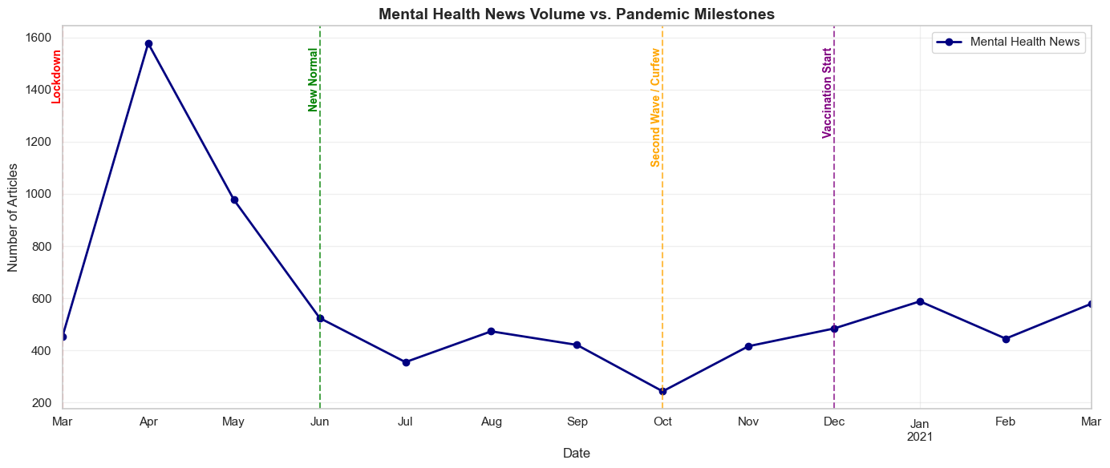
Figure 1: Volume of mental health plot
To contextualize the corpus beyond pure temporal volume, an analysis of the publishing sources was conducted. The following plot analyzes the distribution of the top five publishers. This plot allows for a comparative analysis on how different publishers engaged with the topic.
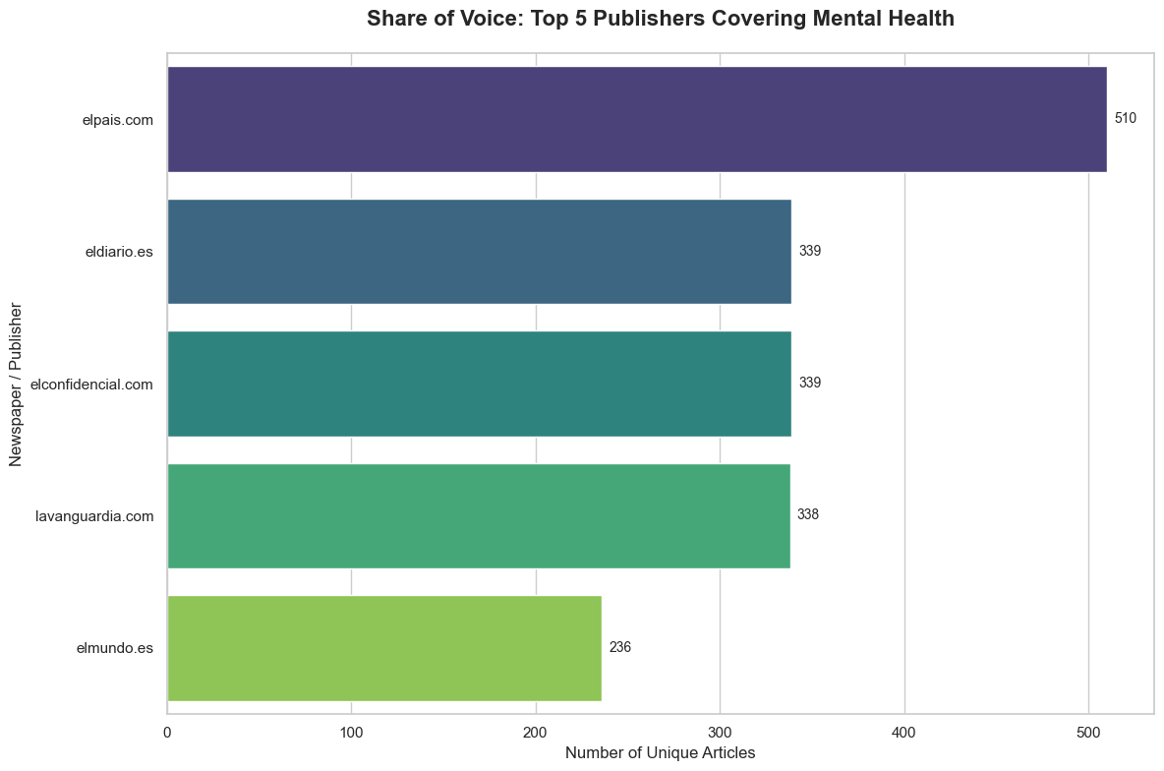
Figure 2: Share of Voice Distribution
As shown in Figure 2, the Share of Voice (SoV) distribution reveals that mental health coverage was driven by a mix of traditional media and digital-native platforms. The legacy newspaper El País has the highest SoV with 510 unique articles. The following publishers, El Diarío, El Confidencial and La Vanguardia have very similar SoV with 339, 339 and 338 unique articles respectively. The temporary inactivity of La Vanguardia during two months due to instability issues may have resulted in a higher volume if the publisher had been available. The combined SoV for these five publishers accounts for over 80% of the entire corpus (1,762 unique articles out of a total of 2,156), which suggests that mental health was a cross-ideological priority during this period and not exclusive of a single editorial ideology.
These top 5 publishers account for over 80% of the entire corpus (1,762 out of 2,156 articles), which suggests that mental health was a cross-ideological priority during this period and not exclusive of a single editorial ideology.
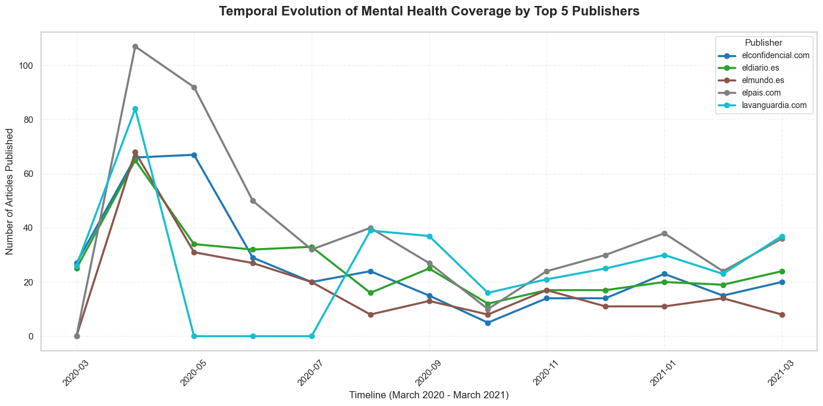
Figure 3: Temporal Evolution of Mental Health Coverage
Figure 3 presents the temporal engagement of the top five publishers. The simultaneous outbreak of the top publishers in March to April 2020 suggests that mental health was a salient topic for all of them. El País published more articles during this period. The temporary absence of La Vanguardia between May to July 2020 is due to a harvesting issue.
The keyword frequency distribution (Figure 4) identifies that terms representing immediate emotional responses—miedo (fear) and ansiedad (anxiety)—dominate the early stages of the corpus. When the two orthographic variants of stress (estrés and estres) are normalized, stress becomes the highest-volume keyword overall. This frequency distribution is compatible with a corpus describing emotional reactions to an exceptional situation and validates the selection of the terms for the extraction of the embeddings.
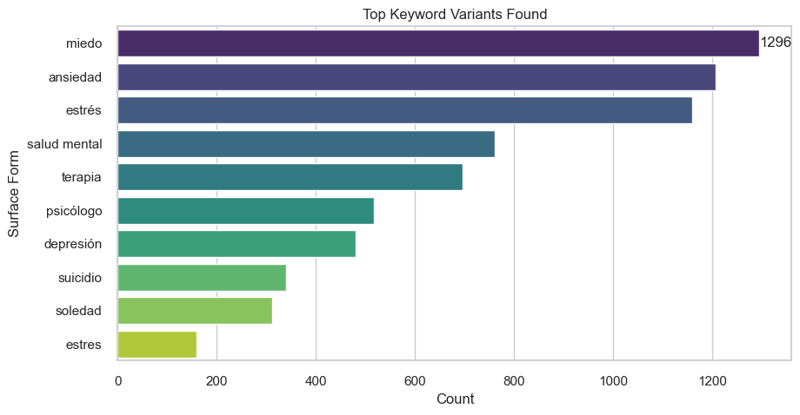
Figure 4: Distribution of mental health keyword frequencies across the corpus (unnormalized).

4.2. Technique Comparison and Analytical Configuration
Before presenting longitudinal results, we perform a quantitative comparison of the various analytical choices made in the methodology (Section 3) in order to identify the best configuration for this study. It was argued in the introduction that extracting true longitudinal patterns of semantic change requires careful choice of text representation. In this section, we compare three core architectural and geometric choices: (i) whether domain adaptation contributes to the analysis of frames. (DAPT vs. Baseline); (ii) which layer suits best for our study. (Last4_concat vs. Penultimate); and (iii) whether to correct for geometric anisotropy (Raw vs. Corrected)
This step is necessary to ensure that the longitudinal patterns observed in the subsequent sections reflect genuine sociological shifts in media discourse, rather than mathematical artifacts introduced by the embedding architecture.

4.2.1. Domain Adaptation
First, we compare whether the DAPT procedure is of value for this study. The baseline Spanish BERT model was pretrained on a large and diverse corpus of general text in Spanish. However, the meanings of words in specialized corpora (e.g., news articles about the pandemic) may take on shades of meaning that are specific to that domain and were not captured during the pretraining of the general model. We perform the DAPT procedure in order to give the model the opportunity to learn this domain-specific information about word meaning, while retaining the knowledge about the structure of the Spanish language that it has already learned. To quantify the impact of Domain-Adaptive Pretraining, we compared the geometry of the embeddings generated by the standard Baseline model versus our DAPT model.
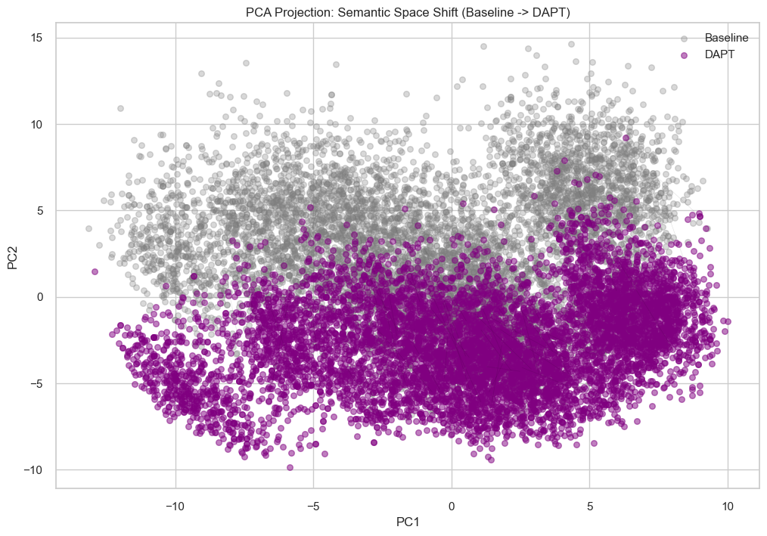
Figure 5: PCA Projection Baseline vs DAPT
Figure 5 represents the semantic shift. The separation between the baseline model and the DAPT demonstrates that the DAPT process successfully altered the vector space representation, adapting it to the specific context of the pandemic. Furthermore, an analysis of the row-wise cosine similarities yielded an average of ~0․86‚ showing that while Spanish structures were preserved‚ the model successfully learned a meaningful amount of semantic information about the crisis.

4.2.2. Layer Extraction
The second methodological choice pertains to which layer extraction approach to use. As described in methodology section (3․2․2)‚ there are two possibilities: last4_concat and penultimate. The first method is the aggregation of the last 4 layers of the transformer network‚ and is found to encode the more fine-grained information. The second strategy utilizes the penultimate layer and is generally understood to capture more general information. To determine which configuration to use, both strategies were evaluated.
The intrinsic dimensionality (k) of the semantic subspace shows a very large difference between the two strategies (Figure 6)
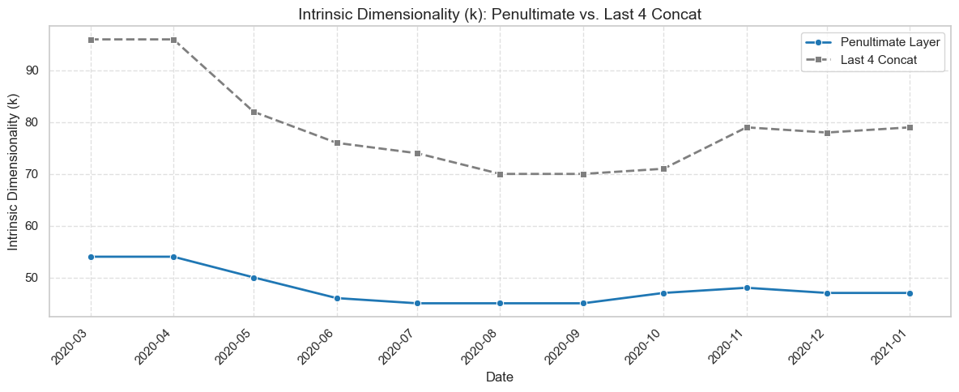
Figure 6: Intrinsic dimensionality (k) over time: layer strategies comparison.
While both are consistent in capturing a reduction in the dimensionality of the semantic subspace over time, the last4_concat layer (gray, doted) consistently returns higher k values (mean k ≈ 79) compared to the penultimate layer (blue, solid; mean k ≈ 47). While the last4_concat layer is capturing more of the syntactic context (i.e., a richer meaning), it also has a lot of representational noise, which is not ideal for longitudinal tracking. This higher dimensionality observed is between layers is expected as the penultimate layer strategy relies on a single hidden state with a fixed dimensionality (d = 768). Contrary, the last4_concat layer strategy concatenates the output of the final four layers, resulting in a much higher dimensionality (d = 3072).
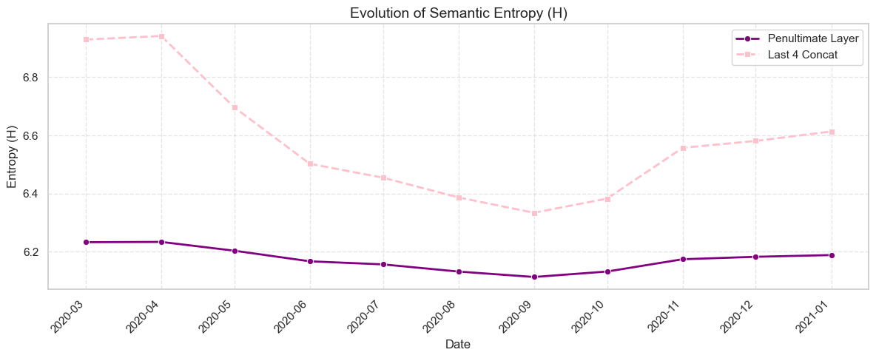
Figure 7: Semantic Entropy over time.
The impact of this structural noise becomes evident when observing the semantic entropy illustration (Figure 7). While both capture general decline in discourse ambiguity over time, they exhibit different evolutionary patterns. The last4_concat exhibits greater instability, particularly during the initial months of the pandemic. In contrast, the penultimate layer, provides a stable and interpretable trajectory, filtering out the syntactic noise generated by the aggregation of layers that captured superficial syntactic shits in news reporting rather than deep semantic changes.
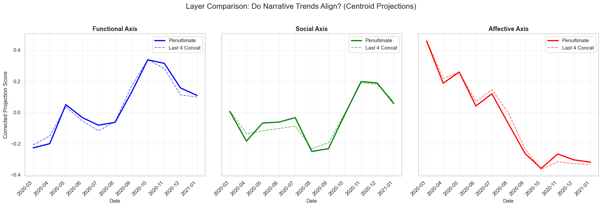
Figure 8: Anchor Projection Comparison Centroid.
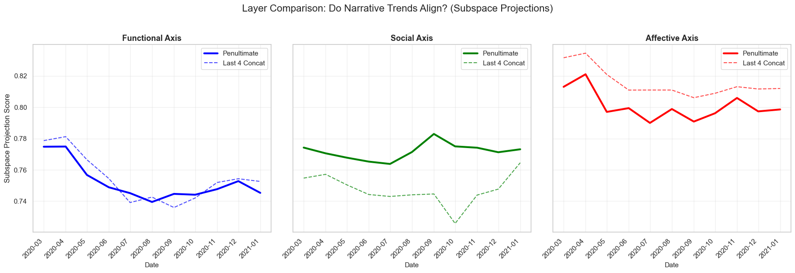
Figure 9: Anchor Projection Comparison Subspace.
To finalize the layer selection, the narrative consistency between the two strategies was evaluated. This step also serves as an empirical demonstration of one of the core premises of this thesis: the structural limitations of centroid-based representations.
When evaluating the semantic frames using traditional centroid projections (Figure 8) the trends of both layer strategies are practically identical. The centroid, being a simple mean vector, smooths out representational variations, falsely suggesting that both layers capture the exact same framing dynamics. This illusion is supported by near-perfect Pearson correlations between the two layers across all axes (e.g., r = 0.995 on the affective axis. See appendix G for complete correlation table).
However, when the full geometric structure is evaluated using Subspace-based Anchor Projection (Figure 9), the hidden instability of the last4_concat layer is exposed. Subspace-based projections additionally reveal that the choice of layer extraction does not only affect noise levels but also the models sensitivity to specific semantic domains. While the penultimate layer maintains a coherent temporal narrative, the subspace projections of the last4_concat layer reveals severe structural distortions. Interestingly both layers follow similar patterns in the functional axis, however, in the Social dimension, the last4_concat subspace exhibits erratic structural collapses, most notably during the Second Wave (September–October 2020). This geometric collapse perfectly aligns with the anomalous entropy spike and SVD instability documented in the previous section. Lastly, in the affective axis the concatenated strategy consistently shows higher projection values.
This quantitative divergence definitively confirms the penultimate layer as the most geometrically robust extraction strategy. While concatenating the final layers (last4_concat) captures highly localized syntactic information, it introduces severe structural noise that distorts macroscopic semantic trends, a phenomenon well-documented in contextual embedding literature (Ethayarajh, 2019). Furthermore, this comparison empirically validates the necessity of subspace modeling: relying solely on traditional centroids would have masked this structural noise, falsely equating a stable semantic space with a highly unstable one, leading to fundamentally flawed narrative interpretations.

4.2.3. Geometry Correction
The last choice pertains to the geometry in which the embedding is found․ Contextualized embeddings are known to be anisotropic (i․e․‚ vectors concentrate on a small cone), which can have an adverse effect on cosine similarity scores․ But a centering technique (subtracting the global mean vector) was also considered as a potential solution․
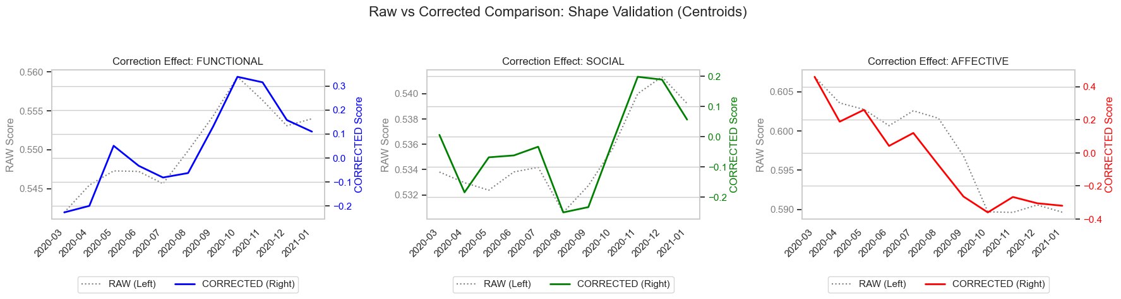
Figure 10: Anchor Projection Comparison Subspace.
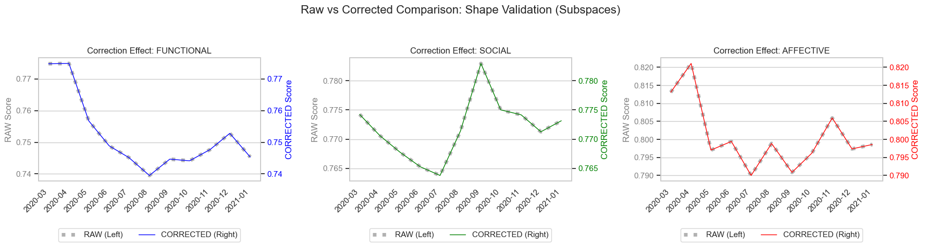
Figure 11: Anchor Projection Comparison Subspace.
Traditional Centroid Projections (Figure 10): The most notable impact of anisotropy correction on the centroid projections is the scale of the absolute scores. Given that the correction re-centers the entire semantic space so that its origin now lies at the center of the data cloud, the magnitude of the corrected scores are drastically different from the raw scores (corrected scores now center around 0). Although the trends of the raw and corrected scores over time are very highly correlated, the drastic shift in scale shows that centroid measures (which are measures of distance from the origin) are very sensitive and vulnerable to global directional noise.
Subspace-based Anchor Projection (Figure 11): there is a critical mathematical advantage. Unlike centroids, the absolute values and the time-series trajectory of the subspace projections are mathematically identical for the RAW and CORRECTED conditions (the two lines are perfectly superimposed). This is because SVD operates on the principle axes of variance (not the distance from the origin) and hence is mathematically immune to anisotropic noise.
This comparison has two critical implications. Firstly, it demonstrates that the centering procedure successfully cleans the vector space mathematically, but leaves the content of the narrative untouched. Secondly‚ it offers empirical mathematical evidence that the subspace method is superior to centroids because‚ while centroids are contaminated by anisotropic noise‚ the geometric structure of semantic subspaces are untouched and invariant․

4.2.4. Analytical Configuration
The cumulative advantages of the selected analytical configuration are definitively demonstrated by examining the relationship between intrinsic dimensionality (k) and semantic entropy (H) across all temporal windows. This scatterplot reveals how the model translates information (entropy) into structure (dimensions).
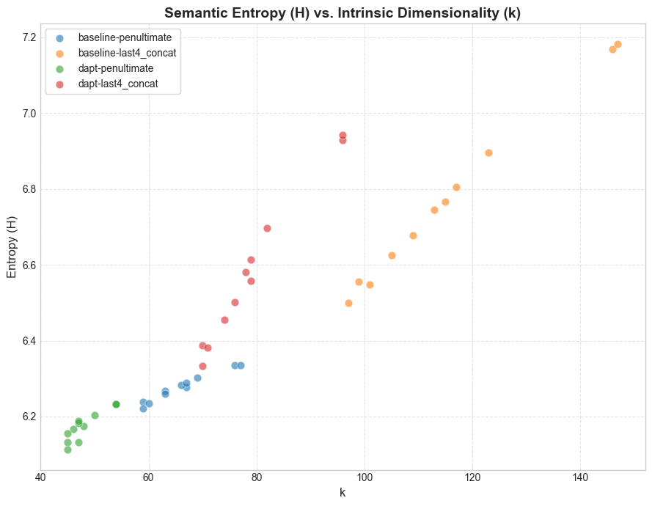
Figure 12: Intrinsic Dimensionality (k) vs. Entropy (H).
In this distribution, each data point represents a specific time period for a given configuration. These results reveal a striking geometric divergence: (i) baseline and Last4_Concat (Orange and Red): This configuration has a high number of dimensions and high entropy․ We observe a predominantly linear relationship with a very steep slope․ In these cases‚ we can observe how every increment of semantic entropy is translated into an increment of extracted dimensions (k): a large semantic space‚ increased in entropy, the model cannot map on its own‚ explaining the high dimensions (up to k ≈ 140) and previous noise behavior; (ii) in this DAPT-penultimate configuration (green cluster)‚ the relationship is different․ The slope is steep at low entropy but is quadratically shaped and concave․ Low entropy creates a "dimensionality ceiling"‚ separating lower and upper parts of the model's dimensions as the entropy rises․ Instead of the dimensionality ceiling‚ the model reaches semantic saturation‚ as more categories are integrated into a stable k-dimensional space (where k≈45-55)․
This positioning provides two critical geometric guarantees for the longitudinal analysis. First, parsimony and semantic focus: the low entropy and intrinsic dimensionality of the model indicates that the framework effectively captures the semantic core of mental health frames without fitting syntactic noise․ Second‚ temporal stability: the extremely tight clustering of the dapt-penultimate points illustrates that the mathematical properties of the subspace remain stable throughout the year‚ even while other configurations suffer significant fluctuations as seen in other configurations.
As shown through systematic validation of dimensionality‚ drift sensitivity‚ narrative similarity and robustness against anisotropic noise‚ the DAPT model‚ penultimate layer‚ and corrected embedding geometry is the optimal analytical configuration for extracting meaning from data․

4.3. Framing Metrics
Having established the optimal analytical configuration (DAPT + Penultimate + Corrected), this last part of the results section explores the actual diachronic evolution of the mental health discourse structure. To do so, we rely on two structural indicators that can be used as proxies for (i) the pace of meaning change (Semantic Drift), and (ii) the structural uncertainty or fuzziness of the discourse (Shannon Entropy) at different points in time.
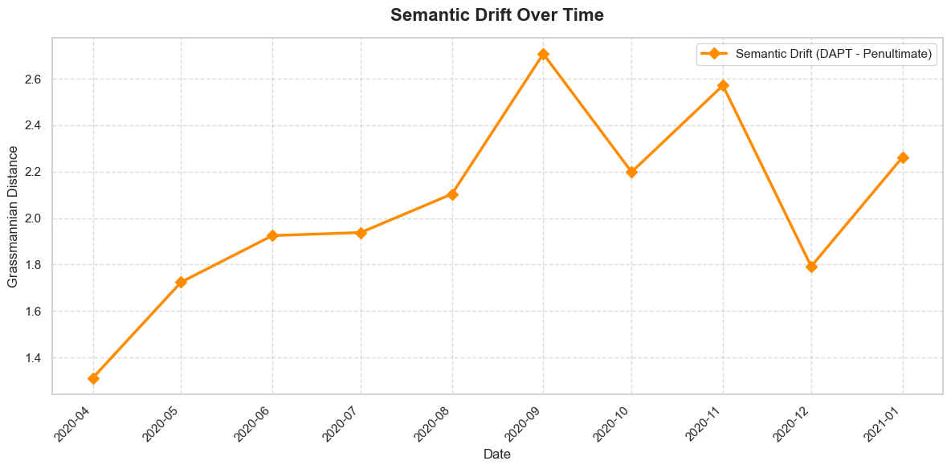
Figure 13: Semantic Drift Over Time
Semantic Drift (D) is measured as the Grassmannian distance between the previous and current month’s subspace. It indexes the amount of change in the structural meaning of the mental health discourse from month to month. Figure 13 displays the monthly values of drift across the observed time frame. As shown, the diachronic change in the discourse structure is not monotonous. Although we expected a single spike at the beginning of the crisis, the lowest value of drift occurs between March and April 2020. Conversely, the rate of structural change keeps growing all through spring and summer, with a large peak in September 2020. This huge jump in the meaning of the discourse precisely matches the end of the “New Normal” and the beginning of the Second Wave, when children returned to school, partial confinements were implemented in different regions, and a plethora of new policies were enacted. The following peak, in November 2020, also captures the turbulence of the fall. These dynamics partly qualify hypothesis H2: instead of displaying a maximum only at the start of the lockdown, the most dramatic shifts in meaning appear when society was obliged to go back from the summer to the harsh conditions of the pandemic.
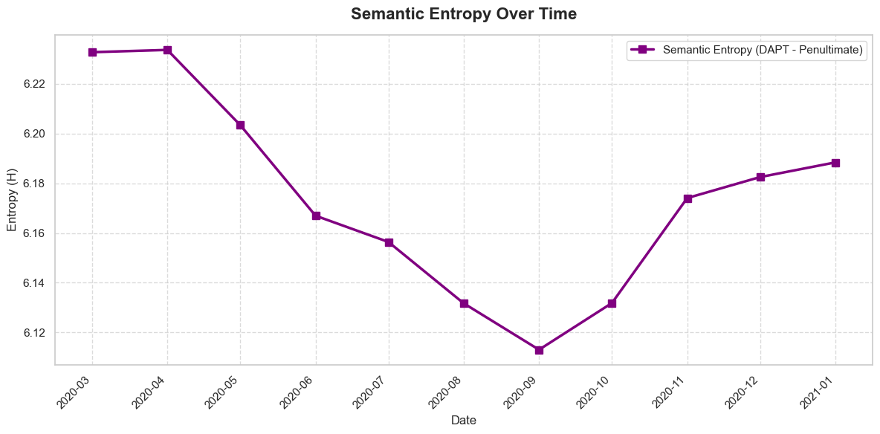
Figure 14: Semantic Entropy Over Time
The temporal trajectory of semantic entropy (Figure 14) reveals a clear U-shaped pattern that confirms hypothesis H3. The highest entropy values were reached during the National Lockdown of March to April 2020․ During the initial shock phase of the lockdown in March to April 2020‚ commentary in the media on mental health became more ambiguous․ The entropy dropped steadily through the second summer of the pandemic‚ reaching its minimum in September 2020․ This is partially due to the normalization of the discourse‚ as the media slowly understood the nature of the crisis and converged on a more limited and standardized vocabulary of mental health․ Normalization of discourse was not strictly monotonic‚ which we can see in the October 2020 entropy curve following the same trend as the October 2020 semantic drift peak․ It then increases until January 2021․ The chronic aspect of the pandemic‚ the exhaustion phenomenon of the Second and Third Waves and vaccine issues produced new complexity and multiple new framing in the public opinion discourse associated with the pandemic․

4.4. Anchor Projections
For a detailed breakdown of the semantic axes, including formal definitions and illustrative keyword examples, please refer to Appendix J.
While semantic drift and entropy capture the magnitude and stability of structural change, anchor projections quantify the directional orientation of the discourse. By projecting the temporal subspaces onto the predefined semantic axes (affective, social, and functional), we can observe the diachronic relevance of each the journalistic frames.
Analyzing the subspace projections using the optimal, noise-free configuration (DAPT + Penultimate + Corrected), three distinct evolutionary phases are observed across the three dimensions:
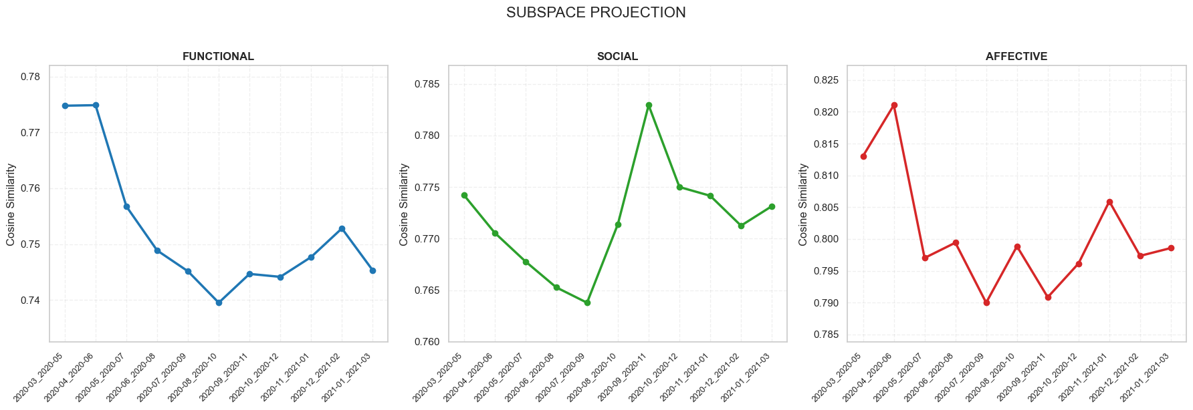
Figure 15: Subspace Projection Across Three Dimensions
The Affective Dimension (Crisis & Emotion): The affective anchor projection corroborates the emotional history of the pandemic. The affective projection reaches its overall maximum during the first National Lockdown (March to June 2020), which supports our initial assumption that the early coverage of the pandemic was extremely emotionally and psychologically charged (e.g., fear, panic, trauma) due to the extraordinary social disruption. After a massive drop in summer 2020, the affective frame shows volatile peaks during autumn and winter, which captures the emergence of “pandemic fatigue” and the emotional dimension of the second and third waves.
The Social Dimension (Isolation & Community): This dimension shows the most significant change in structure throughout the whole dataset. It is relatively important during the first confinement, but it reaches its lowest level during the summer 2020, a period in which public life partially resumed and discourse shifted away from social constraint. However, starting in September 2020, the social dimension surges to an extraordinary peak that persists through November 2020. This aligns perfectly with the Second Wave and the period of “Return to School/Work.” This was a time in which the media discourse became heavily focused on the social: the social distancing measures, the blame to social interactions as responsible for the contagion, and the social tension derived from the selective confinements.
The Functional Dimension (Institutions & Healthcare): Contrary to a simple linear progression, the functional framing, which captures institutional, medical, and systemic language, displays a distinct U-shaped trajectory. It begins exceptionally high during the initial State of Alarm (March–May 2020), capturing the massive governmental and systemic healthcare response to the hospital collapses. After a pronounced dip during the "New Normal" summer, the functional projection steadily climbs back up from October 2020 through early 2021. This resurgence indicates a structural reframing in the later stages of the crisis, as the discourse became heavily institutionalized once again to discuss vaccine rollouts, systemic protocols, and sustained public health management.

4.5. Trajectory Projections
To further illustrate the relationship between the frames, trajectory projections of dimensions are created. Using the corrected geometric space, which we have established is robust to anisotropic noise, each point in time is a point on the plot, and describes the evolution of the discourse over time.
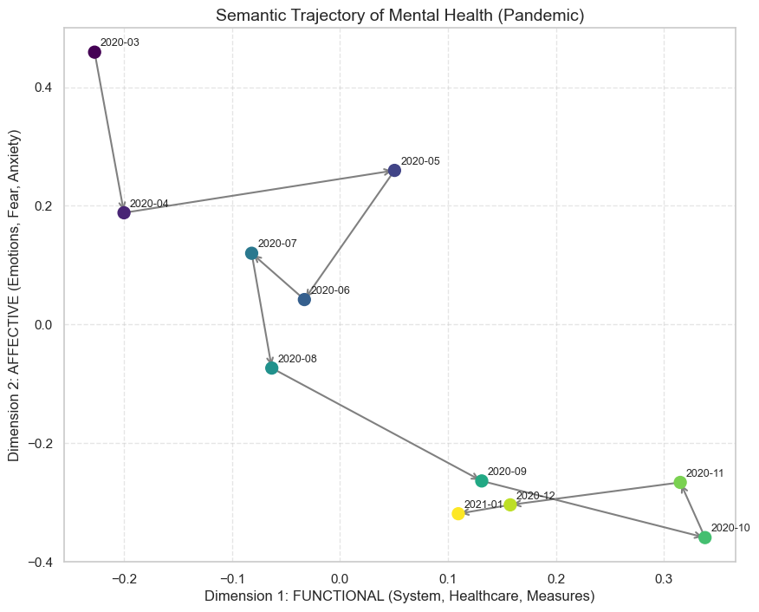
Figure 16: Semantic Trajectory Plot: Functional vs Affective.
Analyzing the Functional-Affective trajectory (Figure 16), a clear rotational pattern emerges. The early temporal windows (March–May 2020) cluster tightly in the high-affective, low-functional quadrant, visually capturing the emotion-dominated nature of the lockdown-era discourse. As the pandemic progressed, the trajectory migrated progressively toward the high-functional, low-affective region.
This can be seen as a visualization of the overarching result that we have seen in the corpus, the shift in language from the crisis/emotion to the institutional/functional. Moreover, the loops in the trajectory, such as the trajectory moving towards more affective languages during the peak of the Second Wave in autumn 2020, demonstrate the sensitivity of the subspace method for the given context, and that the shift in media discourse framing is not a one-way change but a dynamic social process responding to the social reality.

5. Discussion

5.1. The Temporal Narrative
The empirical results of this study reveal that the media framing of mental health during the COVID-19 pandemic was not a static phenomenon, but a highly dynamic and iterative narrative. By mapping the diachronic evolution of the discourse, we can identify a clear trajectory from acute emotional crisis to structural institutionalization.
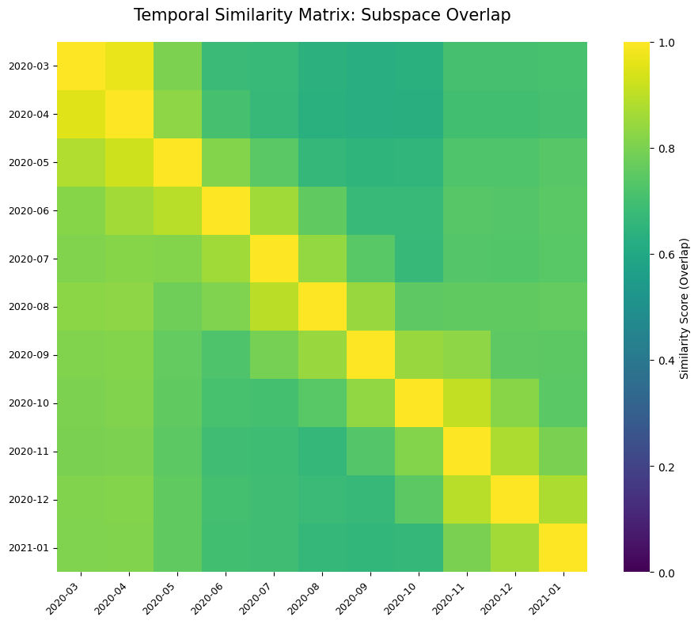
Figure 17: Subspace Similarity Matrix.
As visualized in the Subspace Similarity Matrix (Figure 17), which computes the overall structural similarity across temporal windows‚ the COVID-19 discourse can be further segmented into distinct narrative epochs:
The Shock Phase (Spring 2020): With high semantic entropy and overwhelming Affective projection‚ the first lockdown discourse was reactionary‚ with mental health framed as an acute‚ individualized emotional trauma (fear‚ anxiety) caused by the COVID-19 virus as an unprecedented threat to individual well-being․
The Social Peak (Autumn 2020): During Second Wave‚ however‚ the Social catalog was at its highest all-time level․ This was because of the abrupt end of temporary relief‚ not because of a summer story․ The media turned its entire attention to social consequences‚ community friction‚ localized lockdowns‚ and the breakdown of social norms․ As normalization was interrupted‚ the public‚ as a whole‚ showed signs of high levels of anxiety․
Institutionalization and Pandemic Fatigue (Autumn 2020 - Early 2021): Lastly‚ with the coming of the Second and the Third Wave‚ we can see a branching point in the storyline‚ where the Functional dimension became predominant‚ and this leads us to suggest that the storyline can be characterized by the institutionalization of the issue․ Towards the end of the period‚ mental health during the pandemic was treated as a public health issue that required medical and governmental responses․

5.2. Methodological Contributions
Aside from the sociological insights that this dissertation provides, it also contributes to the computational literature on semantic framing and LLMs in three ways. First, it shows that mean vectors are not only vulnerable to anisotropic noise but are also blind to the stability of the semantic space they operate in. This exposes the theoretical and empirical risks of making longitudinal inferences based on centroids alone, which may equate extremely chaotic semantic fields with very stable ones. Second, it demonstrates that semantic subspaces produced through SVD are not only capable of picking up the most important dimensions of variation in the data, but are also geometrically invariant under anisotropy correction. Third, it shows that the penultimate layer of a DAPT is the most reliable, efficient, and pure way to represent words over time for longitudinal NLP research in media studies.
This study empirically demonstrated that subspace-based anchor projections are mathematical invariants under anisotropic correction (centering)․ While this is sufficient to support our theory‚ future work should show robustness across a variety of transformer architectures (RoBERTa‚ GPT-4) and linguistic distributions to build confidence in this result․ If this property holds universally‚ then subspace modeling is the natural successor to centroid-based methods for diachronic NLP problems‚ as it avoids geometric "cone" effects․

5.3. Limitations
While this methodology provides a robust framework for semantic tracking, several limitations must be acknowledged.
This analysis only holds for the corpus of Spanish newspaper articles we gathered in the period of interest. The exact trajectories we observed might not be the same for other cultures, languages, or in social media where the discourse follows different patterns.
We are using the carefully selected seed words to define the anchor dimensions (Affective, Social, and Functional) that proxy for the main framing axes of the discourse. Although we validated the resulting axes by projecting the subspace, they are still just a proxy, capturing the main macro-frames of the discourse but perhaps missing more micro-frames at lower levels of granularity.
We only tracked the discourse until early 2021, meaning that the last stages of the pandemic (mass vaccination and “the end” of the pandemic) are not covered in this dataset, and the ultimate normalization of the discourse of mental health remains to be seen. A related constrain concerns timescale of the methodology itself. As discussed in section 2.4, Hamilton et al. (2016) validate their methodology using 2 centuries of historical data. This thesis, however, is limited to one year of data, whether the same regularities are detectable over a single year of data is not something Hamilton et al. address directly. This thesis proceeds on the assumption that the logic and methodology still applies at shorter timescales, a question that future work with greater corpus could address.

6. Conclusion
This thesis set out to computationally map how the Spanish print media framed mental health during the disruptive timeline of the COVID-19 pandemic. By rejecting traditional, static keyword tracking in favor of advanced, diachronic contextual embeddings and semantic subspace modeling, this study successfully quantified the structural evolution of public discourse. The results provide a coherent temporal account of framing dynamics that aligns seamlessly with both the sociopolitical milestones of the pandemic and prior empirical literature on crisis communication.
The empirical implementation of this thesis has provided evidence for most of the hypotheses guiding this research. Firstly, the framing of mental health by the Spanish press is shown to be non-static and has evolved throughout the pandemic, from an initial framing characterized by high emotional arousals, to a focus on social isolation and finally to an institutionalized-systemic framing (H1). Secondly, the results show how the rate of semantic change increases during the most relevant socio-political events, such as the Lockdown, the beginning of the New Normal or the Second Wave. This means that the structural evolution of news frames can be linked to the real-world events (H2). Thirdly, although the semantic uncertainty of news language has generally decreased as the language became more standardized throughout summer 2020, the length of the crisis has introduced new degrees of uncertainty during the First and Second Waves. This has revealed a non-linear but rather a U-shaped curve of news normalization (H3). Finally, it has been found how Domain-Adapted Pre-Training (DAPT) has offered a mathematically and contextually better geometric space for diachronic analysis, which has proven to be a necessary step for any diachronic analysis. Nevertheless, it has preserved perfectly the overall trends of the news narrative (H4).
Apart from the theoretical implications and methodological validation, these results also present practical relevance to media practice and health communication. On the one hand, they illustrate the impact of automatically generated frames used by the media, especially the dominant affective-crisis frame in the initial stages of the pandemic that might have had an effect on the public opinion and aggravated collective anxiety. On the other hand, the presence of a positive transition to functional framing in the later periods shows the possibility of a positive and functional public agenda that might be achieved by sustained media and institutional reporting. The slight decrease observed in the Second Wave, however, indicates that the framing is not a one-way evolutionary process.
Future studies can expand the time period to be able to identify the complete normalization of the agenda for the full span of the pandemic (until 2022). The vaccination process would also be a key aspect to explore in relation to the framing of mental health, and the methodology presented in this study can be extended to other languages, or complemented with social media posts to offer a broader, cross-linguistic view of the news media ecosystem. Finally, this study has shown the potential of Natural Language Processing tools for social sciences, not only to represent the way that the media talks about a crisis, but also the way society speaks about its own mental health.

7. References
Bojanowski, P., Grave, E., Joulin, A., & Mikolov, T. (2017). Enriching word vectors with subword information. Transactions of the Association for Computational Linguistics, 5, 135–146. https://doi.org/10.1162/tacl_a_00051
Busemeyer, J. R., & Bruza, P. D. (2012). Quantum models of cognition and decision. Cambridge University Press.
Cañete, J., Chaperon, G., Fuentes, R., Ho, J.-H., Kang, H., & Pérez, J. (2020). SPANISH PRE-TRAINED BERT MODEL AND EVALUATION DATA. https://users.dcc.uchile.cl/~jperez/papers/pml4dc2020.pdf
Carrasco, J. P., Saucier, A.-M., & Whitley, R. (2023). Spanish media coverage of youth mental health issues during the COVID-19 pandemic. BMC Psychiatry, 23(1). https://doi.org/10.1186/s12888-023-05054-7
Entman, R. M. (1993). Framing: Toward clarification of a fractured paradigm. Journal of Communication, 43(4), 51–58. https://doi.org/10.1111/j.1460-2466.1993.tb01304.x
Ethayarajh, K. (2019). How contextual are contextualized word representations? Comparing the geometry of BERT, ELMo, and GPT-2 embeddings. Proceedings of the 2019 Conference on Empirical Methods in Natural Language Processing, 55–65. https://arxiv.org/abs/1909.00512
Fauconnier, G., & Turner, M. (2003). Conceptual blending, form and meaning. Recherches en Communication, 19, 57–86.
Fillmore, C. J. (1982). Frame semantics. In The Linguistic Society of Korea (Ed.), Linguistics in the morning calm (pp. 111–137). Hanshin Publishing Company.
Gunnell, D., & Biddle, L. (2020). Suicide and the media: reporting could cost lives. BMJ, m870. https://doi.org/10.1136/bmj.m870
Gunnell, D., Appleby, L., Arensman, E., Hawton, K., John, A., Kapur, N., Khan, M., O'Connor, R. C., & Pirkis, J. (2020). Suicide risk and prevention during the COVID-19 pandemic. The Lancet Psychiatry, 7(6), 468–471. https://doi.org/10.1016/s2215-0366(20)30171-1
Gutiérrez-Fandiño, A., Armengol-Estapé, J., Pàmies, M., Llop-Palao, J., Silveira-Ocampo, J., Carrino, C. P., Gonzalez-Agirre, A., Armentano-Oller, C., Rodriguez-Penagos, C., & Villegas, M. (2021). Spanish language models (arXiv:2107.07253). arXiv. https://arxiv.org/abs/2107.07253
Gururangan, S., Marasović, A., Swayamdipta, S., Lo, K., Beltagy, I., Downey, D., & Smith, N. A. (2020). Don't stop pretraining: Adapt language models to domains and tasks. Proceedings of the 58th Annual Meeting of the Association for Computational Linguistics, 8342–8360. https://arxiv.org/abs/2004.10964
Hamilton, W. L., Leskovec, J., & Jurafsky, D. (2016). Diachronic word embeddings reveal statistical laws of semantic change. Proceedings of the 54th Annual Meeting of the Association for Computational Linguistics, 1489–1501. 10.18653/v1/P16-1141
Instituto Nacional de Estadística. (2021). Encuesta europea de salud en España. https://www.ine.es/ss/Satellite?L=es_ES&c=INECifrasINE_C&cid=1259953225445&p=1254735116567&pagename=ProductosYServicios%2FINECifrasINE_C%2FPYSDetalleCifrasINE
Kutuzov, A., Øvrelid, L., Szymanski, T., & Velldal, E. (2018). Diachronic word embeddings and semantic shifts: A survey. Proceedings of the 27th International Conference on Computational Linguistics, 1384–1397. https://aclanthology.org/C18-1117/
Martínez-Mingo, A., Jorge-Botana, G., Martínez-Huertas, J. A., & Olmos, R. (2023). Quantum projections on conceptual subspaces. Cognitive Systems Research, 82, 101154. https://doi.org/10.1016/j.cogsys.2023.101154
Mu, J., Bhat, S., & Viswanath, P. (2017). All-but-the-top: Simple and effective postprocessing for word representations. arXiv. https://arxiv.org/abs/1702.01417
Olivas Osuna, J. J., Jorge-Botana, G., Martínez-Huertas, J. A., Olmos Albacete, R., & Martínez-Mingo, A. (2023). Quantifying the ideational context: Political frames, meaning trajectories and punctuated equilibria in Spanish mainstream press during the Catalan nationalist challenge. Political Research Exchange, 5(1), 2287036.
SciPy. (2025). scipy.linalg.svd. SciPy v1.15.2 Manual. https://docs.scipy.org/doc//scipy-1.15.2/reference/generated/scipy.linalg.svd.html
Tversky, A. (1977). Features of similarity. Psychological Review, 84(4), 327–352. https://doi.org/10.1037/0033-295X.84.4.327
World Health Organization. (2020, October 5). COVID-19 disrupting mental health services in most countries, WHO survey. https://www.who.int/news/item/05-10-2020-covid-19-disrupting-mental-health-services-in-most-countries-who-survey

Appendix A: Summary of Terms and Abbreviations
Abbreviation | Definition
WHO | World Health Organization
INE | Instituto Nacional de Estadística
GDELT | Global Database of Events, Language, and Tone
BERT | Bidirectional Encoder Representations from Transformers
DAPT | Domain-Adaptive Pretraining
NLP | Natural Language Processing
NLU | Natural Language Understanding
PCA | Principal Component Analysis
SVD | Singular Value Decomposition
TAPT | Task-Adaptive Pretraining
SoV | Share of Voice

Appendix B: Media List
Publisher | Platform | Type | Editorial Stance
El País | Legacy Newspaper | National | Center left
El Mundo | Legacy Newspaper | National | Center right
ABC | Legacy Newspaper | National | Right wing
El Diario | Digital-native | Digital | Left wing
Europapress | Legacy Agency | Digital | Neutral
Publico | Digital-native | Digital | Left wing
La Vanguardia | Legacy Newspaper | National | Center / Liberal/ Moderate Catalanism
El Confidencial | Digital-native | Digital | Center right/ economic liberalism
20 Minutos | Legacy Newspaper | Digital | Neutral / Generalist

Appendix C: Phase 1 Data Harvesting Keywords

COVID-19 Filter Keywords
The following keywords were used to filter COVID-19 related articles during Phase 1:
- covid, coronavirus, pandemia.

Mental Health Filter Keywords
The following keywords were used to filter mental health-related articles from the COVID-19 corpus:
- salud mental, ansiedad, depresion, estrés, suicidio, psicologo, terapia, autolesion, trastorno mental, psiquiatra, psiquiatria, bienestar emocional, salud emocional.

Appendix D: Phase 2 Embedding Extraction Keywords
The following 13 normalized keywords were used for contextual embedding extraction in Phase 2:
- salud mental, ansiedad, depresion, estres, suicidio, soledad, miedo, psicosis, psicologo, terapia, autolesion, trastorno mental, psiquiatria.
Note: orthographic variants (estrés/estres, depresión/depresion, psicólogo/psicologo, autolesión/autolesion, psiquiatría/psiquiatria) were normalized to a single canonical form before extraction.

Appendix E: Tversky's Cognitive Psychology and Violations of Classical Geometry
In traditional geometric models of semantics, concepts are represented as single points and similarity is measured by standard distance metrics. Tversky (1977) demonstrated that human similarity judgements frequently violate classical geometry. Subspace-based models are designed to account for these cognitive behaviors:
- Asymmetry: Classical distance is symmetric (distance from A to B equals distance from B to A), but human similarity judgements are directional. People may judge "North Korea is similar to China" differently from "China is similar to North Korea," because the more prominent entity serves as the referent, shifting which features are diagnostic.
- Triangle Inequality: A fundamental rule of metric spaces states that distance(A,C) ≤ distance(A,B) + distance(B,C). Cognitive similarity violates this property. Jamaica may be judged similar to Cuba (geographically) and Cuba similar to Russia (politically), but Russia is not similar to Jamaica.
- Diagnosticity: In traditional vector models, all features have fixed weights. Tversky's diagnosticity principle holds that humans dynamically shift the weight of features depending on context and task. For example, the concept "immigration" projects onto entirely different subspaces depending on whether it is framed through security (diagnostic features: crime, borders), economic (features: labor, growth), or humanitarian (features: refugees, human rights) lenses.

Appendix F: Layer Comparison Drift Plot.
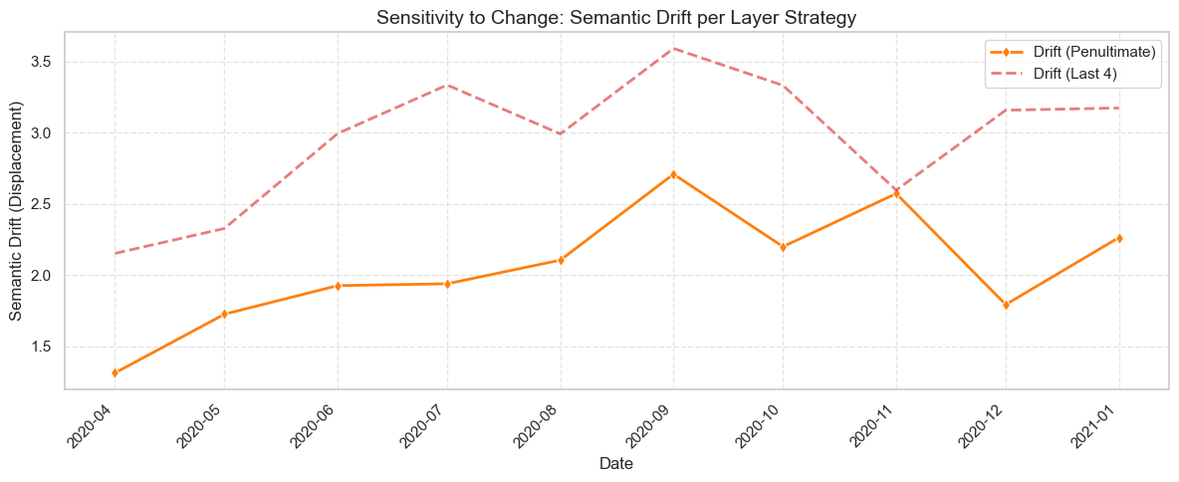
This plot compares the drift for each of the analyzed layer strategies in section 4.2.2.

Appendix G: Correlation Table between Centroids and Subspaces for 2 Layer Strategies
We calculated the correlation between the centroid_penultimate vs centroid_last4_concat.
Equally the correlation was computed for the subspaces. (subspace_penultimate vs subspace_last4_concat).
For both correlations calculations the model variant selected was DAPT.
Centroids Correlation (Social): 0.975
Subspace Correlation (Social): -0.068
========================================
Centroids Correlation (Affective): 0.995
Subspace Correlation (Affective): 0.874
========================================
Centroids Correlation (Functional): 0.987
Subspace Correlation (Functional): 0.940

Appendix H: Supplementary Semantic Trajectories
While Section 4.5 details the primary functional-affective evolution of the discourse, the semantic subspace methodology allows for the visualization of all possible dimensional pairings. This appendix provides the supplementary 2D trajectory projections, offering a comprehensive view of how the social dimension co-evolved with functional and affective framings.
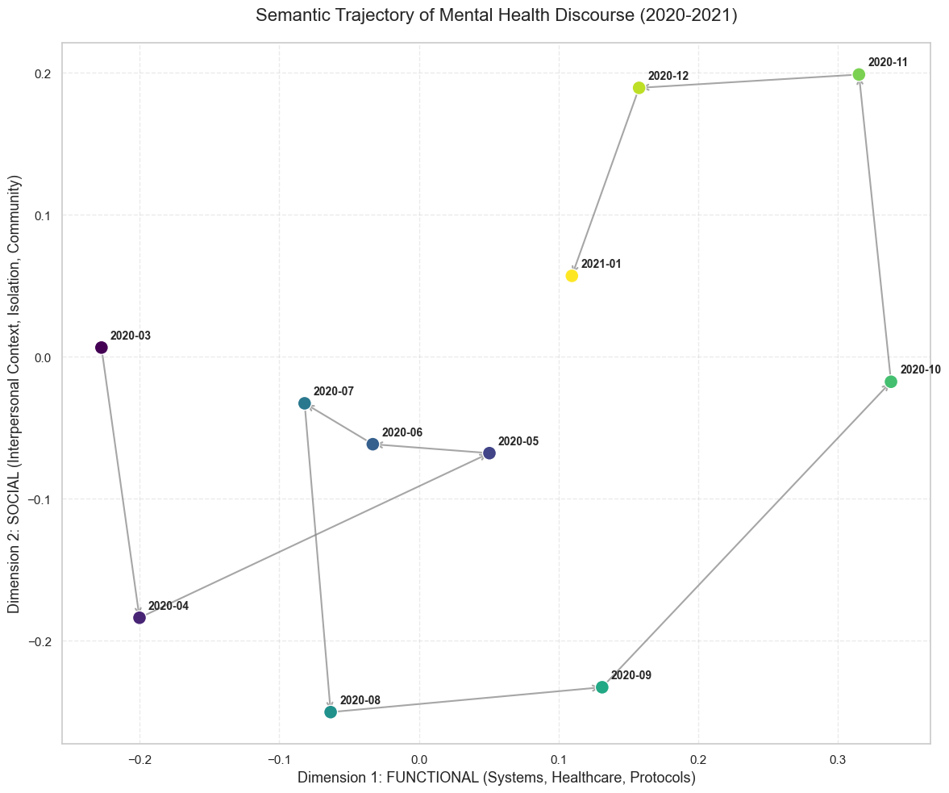
Functional vs. Social

Social vs Affective
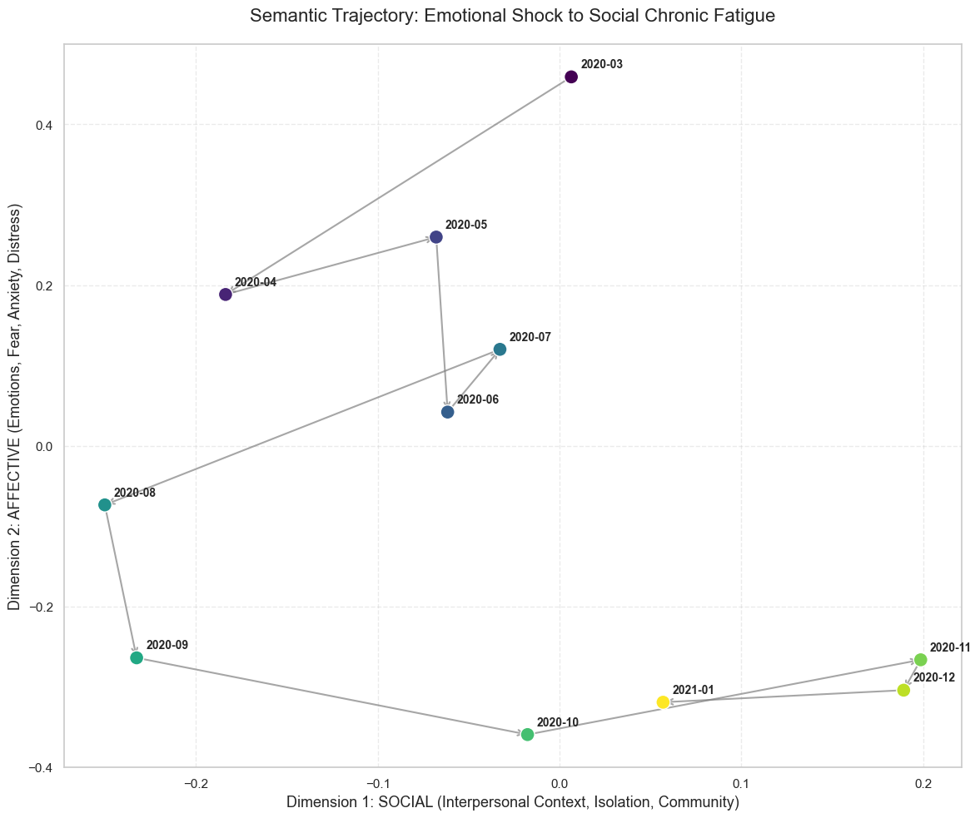

Appendix I: Media List Rolling Window
The following table displays the count of each aggregated window, the number of occurrences and number of documents.
window_start | window_end | n_occurrences | n_documents | valid
2020-03 | 2020-05 | 3007 | 801 | True
2020-04 | 2020-06 | 3074 | 869 | True
2020-05 | 2020-07 | 1852 | 549 | True
2020-06 | 2020-08 | 1348 | 434 | True
2020-07 | 2020-09 | 1249 | 410 | True
2020-08 | 2020-10 | 1137 | 353 | True
2020-09 | 2020-11 | 1080 | 328 | True
2020-10 | 2020-12 | 1143 | 312 | True
2020-11 | 2021-01 | 1488 | 386 | True
2020-12 | 2021-02 | 1517 | 388 | True
2021-01 | 2021-03 | 1612 | 423 | True

Appendix J: Anchors List Definitions
Here include definition of each of the definitions of the anchors.

Semantic Dimensions Definitions
Dimension | Conceptual Description | Spanish Anchor Terms (Keywords)
Functional (Funcional) | Day-to-day operations and formal resources. Covers health services (psychological/psychiatric), clinical interventions, access to care, daily routines, and the professional impact of the pandemic (e.g., furlough/ERTE, remote work) as a functional burden. | psicólogo, psiquiatra, terapia, consulta, atención primaria, salud pública, intervención, tratamiento, medicación, ansiolítico, antidepresivo, diagnóstico, seguimiento, teleterapia, línea, protocolo, recursos, saturación, rutina, hábitos, teletrabajo, ERTE, desempleo, precariedad, conciliación, carga mental.
Social (Social) | Interpersonal relationships and community context. Focuses on the collective impact of the pandemic, including social isolation, domestic cohabitation, social support networks, family dynamics, and the presence of domestic conflict or violence. | aislamiento, soledad, confinamiento, convivencia, familia, pareja, hijos, mayores, apoyo, red social, amigos, comunidad, solidaridad, violencia, maltrato, conflicto, cuidadores, duelo, despedida, luto.
Affective (Afectiva) | Emotional states and psychological symptoms. Captures the internal subjective experience, including manifestations of anxiety, fear, depression, trauma-related symptoms, sleep disturbances, and acute emotional crises. | salud mental, ansiedad, miedo, angustia, pánico, incertidumbre, estrés, nerviosismo, depresión, tristeza, desánimo, apatía, desesperanza, culpa, insomnio, pesadillas, fatiga, irritabilidad, trauma, postraumático, crisis, suicidio, autolesión, ideación.

Contextualized Anchors (Examples)
The following table illustrates how specific anchors were contextualized to ground the semantic subspaces in the COVID-19 news discourse.
Dimension | Spanish Anchor | English Translation | Contextual Usage (Example)
Functional | Saturación | Saturation | "Healthcare saturation delays appointments and worsens distress."
Functional | ERTE | Furlough | "The ERTE generated economic uncertainty and stress in many families."
Functional | Rutina | Routine | "Recovering a daily routine improves functioning and mood."
Functional | Terapia | Therapy | "Online therapy expanded to maintain psychological care."
Social | Aislamiento | Isolation | "Prolonged social isolation affects mood and motivation."
Social | Convivencia | Cohabitation | "Forced cohabitation can increase arguments and daily stress."
Social | Conflicto | Conflict | "Domestic conflicts are aggravated when there are no escape spaces."
Social | Duelo | Grief | "Grief is complicated when one cannot say goodbye to loved ones."
Affective | Miedo | Fear | "Fear of contagion conditions daily life and social relationships."
Affective | Pánico | Panic | "Some people suffer panic when hearing about symptoms or reading new figures."
Affective | Angustia | Anguish | "Anguish is reflected in physical symptoms and repetitive thoughts."
Affective | Incertidumbre | Uncertainty | "Uncertainty about the future increases psychological tension."

Invariant under orthogonal rotations: meaning or semantic representation of an object (or concept) remains constant regardless of its orientation, pose, or coordinate system mapping.

