Task 1 — Responsive Portfolio Website
InternSpark Internship — Task Documentation
Task | 1 — Portfolio Website
Technologies | HTML5, CSS3, JavaScript, Bootstrap
Hosted platform | GitHub Pages

1. Objective
Create a responsive personal portfolio website with a modern interface and sections for introduction, skills, projects and contact.

2. Implementation
The repository contains the portfolio HTML and CSS implementation. The live page is deployed through GitHub Pages.

3. Features
Responsive layout, navigation, hero section, skills section, projects section, contact section and mobile-friendly navigation.

Relevant Code Snippet
<!-- index.html: main portfolio structure -->
<nav class="navbar navbar-expand-lg fixed-top">
<div class="container">
<a class="navbar-brand" href="#home">amtul</a>
<div class="collapse navbar-collapse" id="menu">
<ul class="navbar-nav ms-auto">
<li class="nav-item"><a class="nav-link" href="#home">Home</a></li>
<li class="nav-item"><a class="nav-link" href="#skills">Skills</a></li>
<li class="nav-item"><a class="nav-link" href="#projects">Projects</a></li>
<li class="nav-item"><a class="nav-link" href="#contact">Contact</a></li>
</ul>
</div>
</div>
</nav>

Screenshots / Visual Evidence
The following screenshots are the actual project screenshots captured during completion of this task.
Screenshot 1
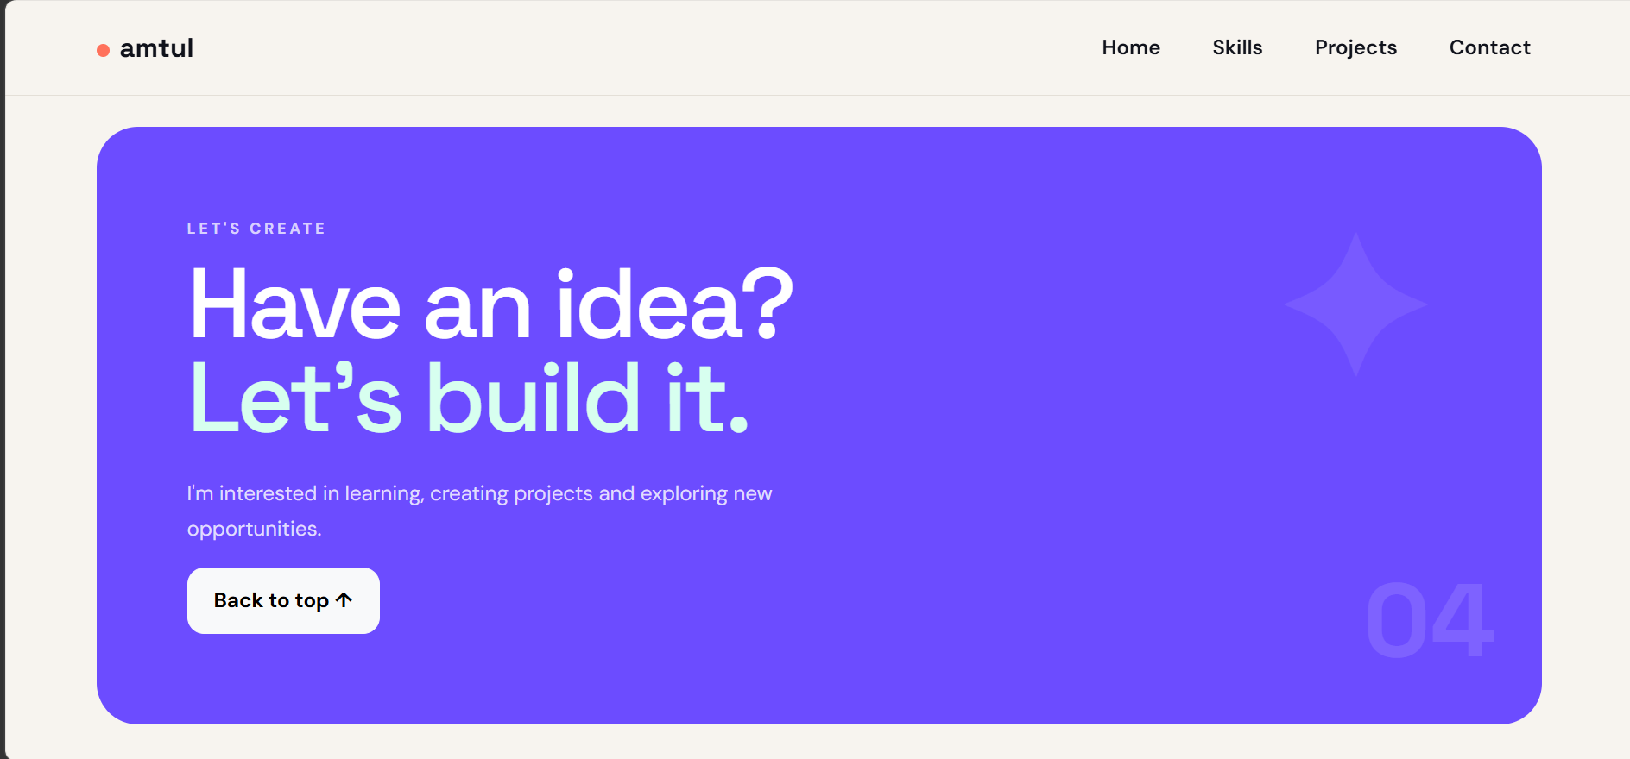
Screenshot 2
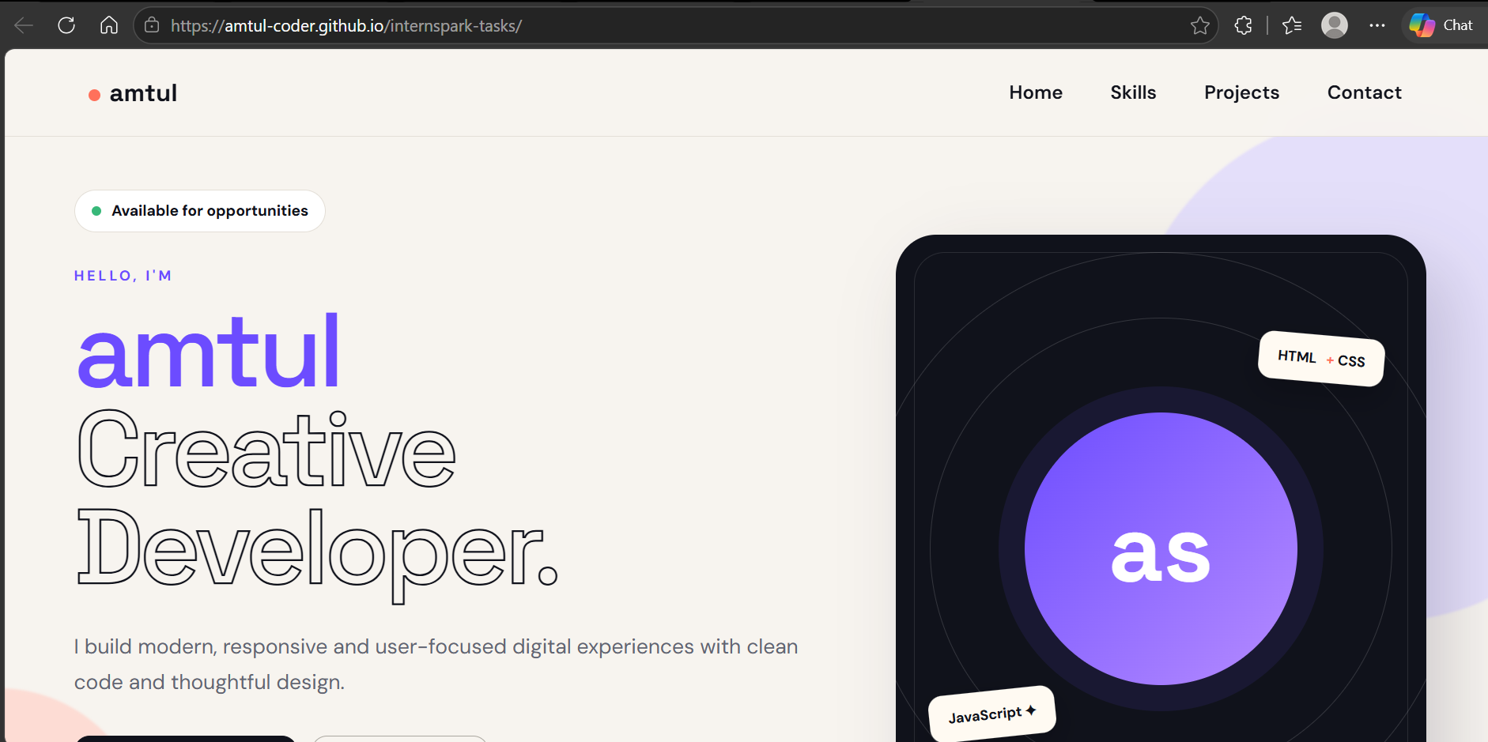
Screenshot 3
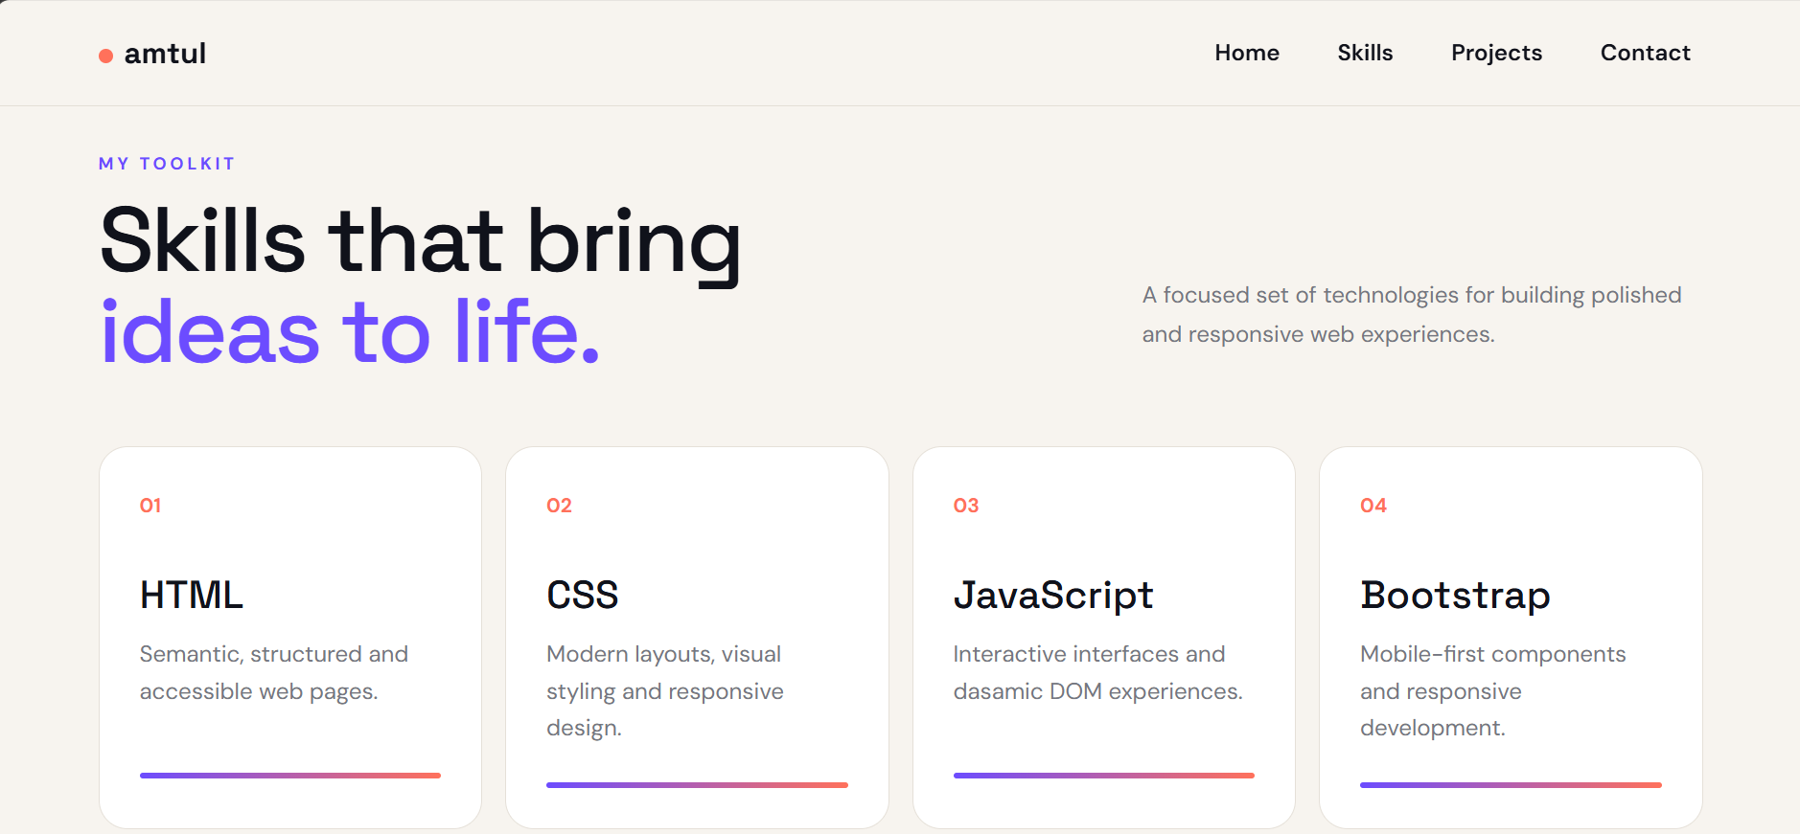

Hosted Live Project
https://amtul-coder.github.io/internspark-tasks/

GitHub Source Repository
https://github.com/amtul-coder/internspark-tasks

Requirements / Evidence
• Responsive portfolio interface
• HTML/CSS implementation
• Skills and projects sections
• Hosted GitHub Pages version
• Screenshots and source-code reference

Conclusion
Task 1 was completed as a responsive personal portfolio website using HTML, CSS, Bootstrap and JavaScript. The hosted project, repository and screenshots provide the required evidence.

