Task 2 — NeonCalc JavaScript Mini Project
InternSpark Internship — Task Documentation
Task | 2 — JavaScript Mini Project
Technologies | HTML5, CSS3, JavaScript
Design | Neon / magenta theme

1. Objective
Build a mini interactive JavaScript application using DOM manipulation.

2. Implementation
The calculator uses HTML for controls and display, CSS for the responsive neon/magenta interface, and JavaScript for calculator state, event handling and arithmetic logic.

3. Features
Addition, subtraction, multiplication, division, decimal calculations, percentage, delete, clear, division-by-zero handling and keyboard input.

Relevant Code Snippet
// script.js: calculator state and calculation logic
let current = "0";
let previous = "";
let operator = null;
function calculate() {
if (!operator || previous === "") return;
const a = Number(previous);
const b = Number(current);
let result;
if (operator === "/" && b === 0) {
current = "Error";
expression.textContent = "Cannot divide by zero";
return;
}
switch (operator) {
case "+": result = a + b; break;
case "-": result = a - b; break;
case "*": result = a * b; break;
case "/": result = a / b; break;
}
current = String(result);
}

Screenshots / Visual Evidence
The following screenshots are the actual project screenshots captured during completion of this task.
Screenshot 1
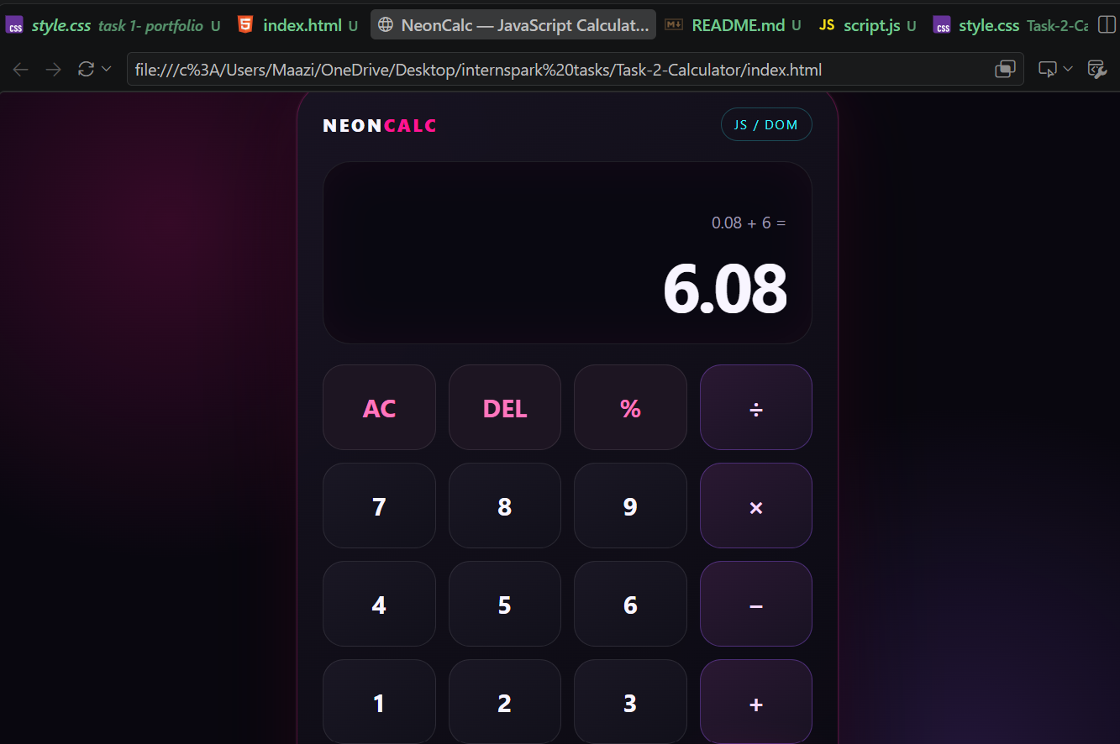
Screenshot 2
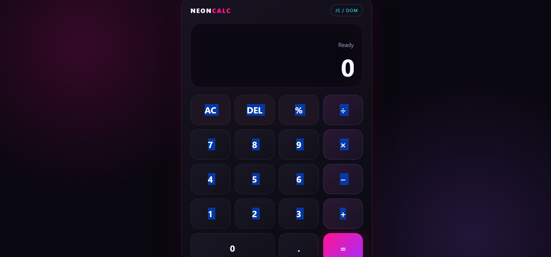
Screenshot 3


Hosted Live Project
https://amtul-coder.github.io/internspark-tasks/Task-2-Calculator/

GitHub Source Repository
https://github.com/amtul-coder/internspark-tasks

Requirements / Evidence
• Interactive JavaScript calculator
• DOM manipulation and event handling
• Arithmetic operations
• Delete, clear and percentage controls
• Keyboard support
• Responsive neon/magenta UI

Conclusion
Task 2 was completed as an interactive JavaScript calculator using DOM manipulation and event handling. The calculator includes the required arithmetic controls, error handling, keyboard support and responsive neon/magenta design.

