Task 3 — BookFinder REST API Project
InternSpark Internship — Task Documentation
Task | 3 — Public REST API Project
API | Open Library Search API
Technologies | HTML5, CSS3, JavaScript, Fetch API, DOM manipulation
Theme | Neon green and dark red

1. Objective
Use a public REST API to fetch and display data dynamically on the page.

2. API Used
Open Library Search API: https://openlibrary.org/search.json

3. Implementation
The application sends a search request with Fetch API, receives JSON data, and renders book cards dynamically. It includes loading and error states and a search feature.

4. Short API Write-up
Open Library provides searchable bibliographic data. The application requests results with fetch(), reads the JSON response, and updates the DOM with book title, author, publication year and cover information.

Relevant Code Snippet
// script.js: REST API + Fetch API
const API = "https://openlibrary.org/search.json";
async function searchBooks(q) {
q = q.trim();
if (!q) {
error("Please enter a book title, author, or topic.");
return;
}
loading();
try {
const r = await fetch(`${API}?q=${encodeURIComponent(q)}&limit=20`);
if (!r.ok) throw new Error();
const data = await r.json();
render(data.docs || []);
} catch (e) {
error("Unable to load books right now. Please check your connection and try again.");
}
}

Screenshots / Visual Evidence
The following screenshots are the actual project screenshots captured during completion of this task.
Screenshot 1
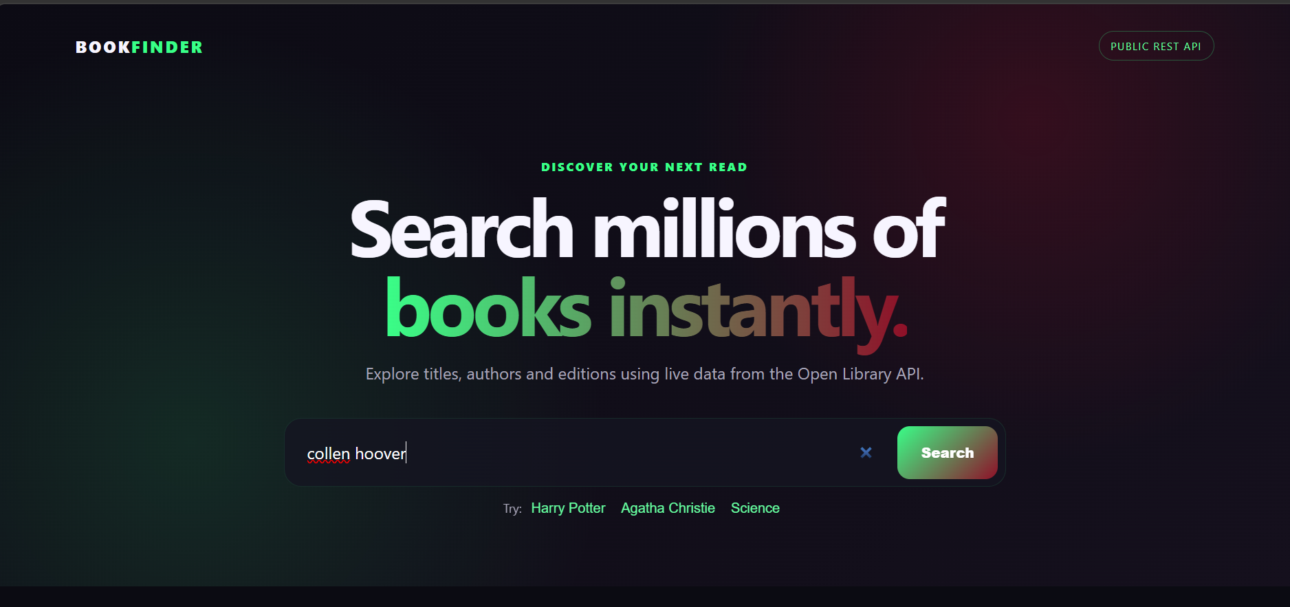
Screenshot 2
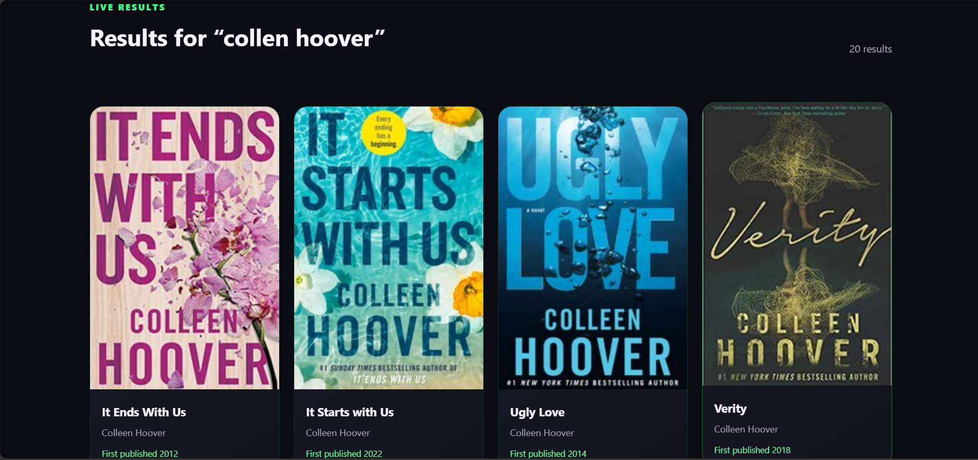

Hosted Live Project
https://amtul-coder.github.io/internspark-tasks/Task-3-BookFinder/

GitHub Source Repository
https://github.com/amtul-coder/internspark-tasks

Requirements / Evidence
• Public REST API
• Fetch API integration
• Dynamic API data rendering
• Loading state
• Error state
• Search feature
• Responsive dark red/neon green UI

Conclusion
Task 3 was completed as a dynamic BookFinder application using the Open Library Search API and Fetch API. It includes dynamic results, loading/error states, search functionality and the requested dark red/neon green visual theme.

