TASK 1 – RESPONSIVE PORTFOLIO WEBSITE
InternSpark Internship Project Report
Project | Responsive Personal Portfolio Website
Task | Task 1
Technologies | HTML5, CSS3, JavaScript, Bootstrap
Hosted Website | https://amtul-coder.github.io/internspark-tasks/
GitHub Repository | https://github.com/amtul-coder/internspark-tasks

1. Project Objective
The objective of this task was to design and develop a responsive personal portfolio website that presents a professional introduction, technical skills, selected projects, and a clear contact section. The website was designed to provide a clean user experience across desktop and smaller screen sizes while maintaining a consistent visual identity.

2. Project Overview
The completed portfolio uses a modern, minimal visual style with a light background, strong typography, purple accent colours, rounded cards, and contrasting dark project sections. The page is organized into clear navigation sections so visitors can quickly move between Home, Skills, Projects, and Contact content.

3. Main Sections Implemented
Home / Hero: Introduces the portfolio owner with a short professional description and visual technology illustration.
Skills: Presents the main toolkit, including HTML, CSS, JavaScript, and Bootstrap, using structured cards.
Projects: Displays project-oriented content in visually distinct cards with a purpose-focused presentation.
Contact / CTA: Provides a prominent call-to-action section encouraging visitors to connect or explore opportunities.
Responsive Layout: Uses responsive web styling so the layout adapts to different screen sizes.

4. Technologies Used
Technology | Purpose
HTML5 | Semantic structure and page content.
CSS3 | Layout, typography, colours, cards, spacing, and responsive styling.
JavaScript | Client-side interaction and dynamic behaviour where required.
Bootstrap | Responsive/mobile-first components and layout support.

5. Design Rationale
The design combines a neutral light background with purple, coral, and soft pastel accents to create a modern and creative portfolio identity. Large headings establish visual hierarchy, while rounded cards and generous spacing improve readability. The dark project area creates contrast between sections and gives the project showcase a stronger visual focus. Navigation is kept simple so users can move directly to the most important sections.

6. Screenshots of Completed Website
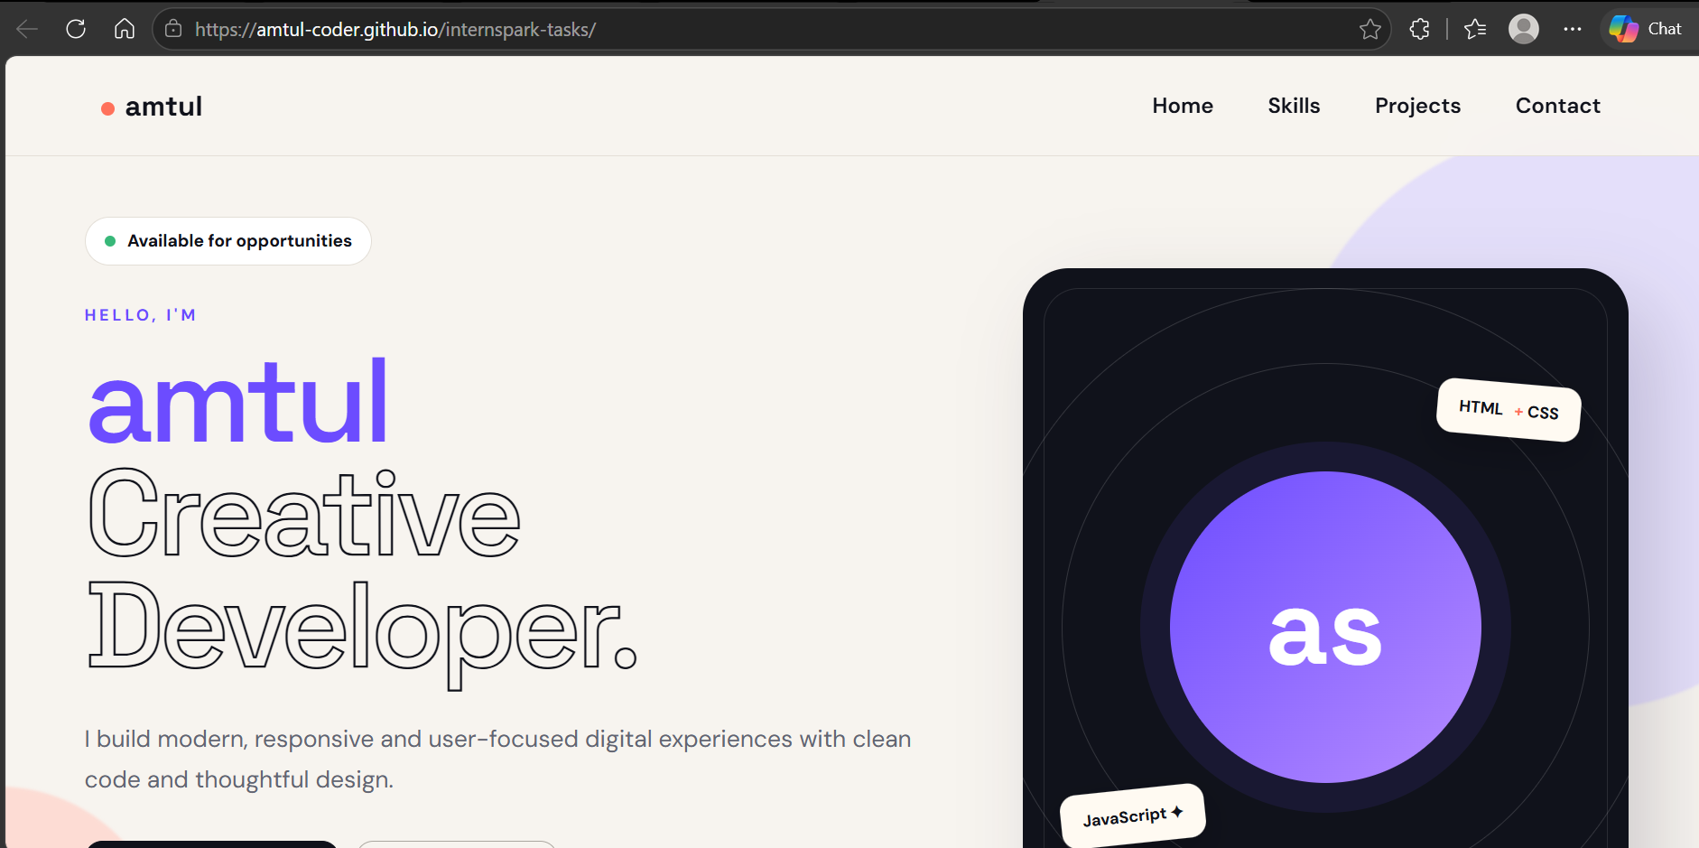
Figure 1. Home / Hero section
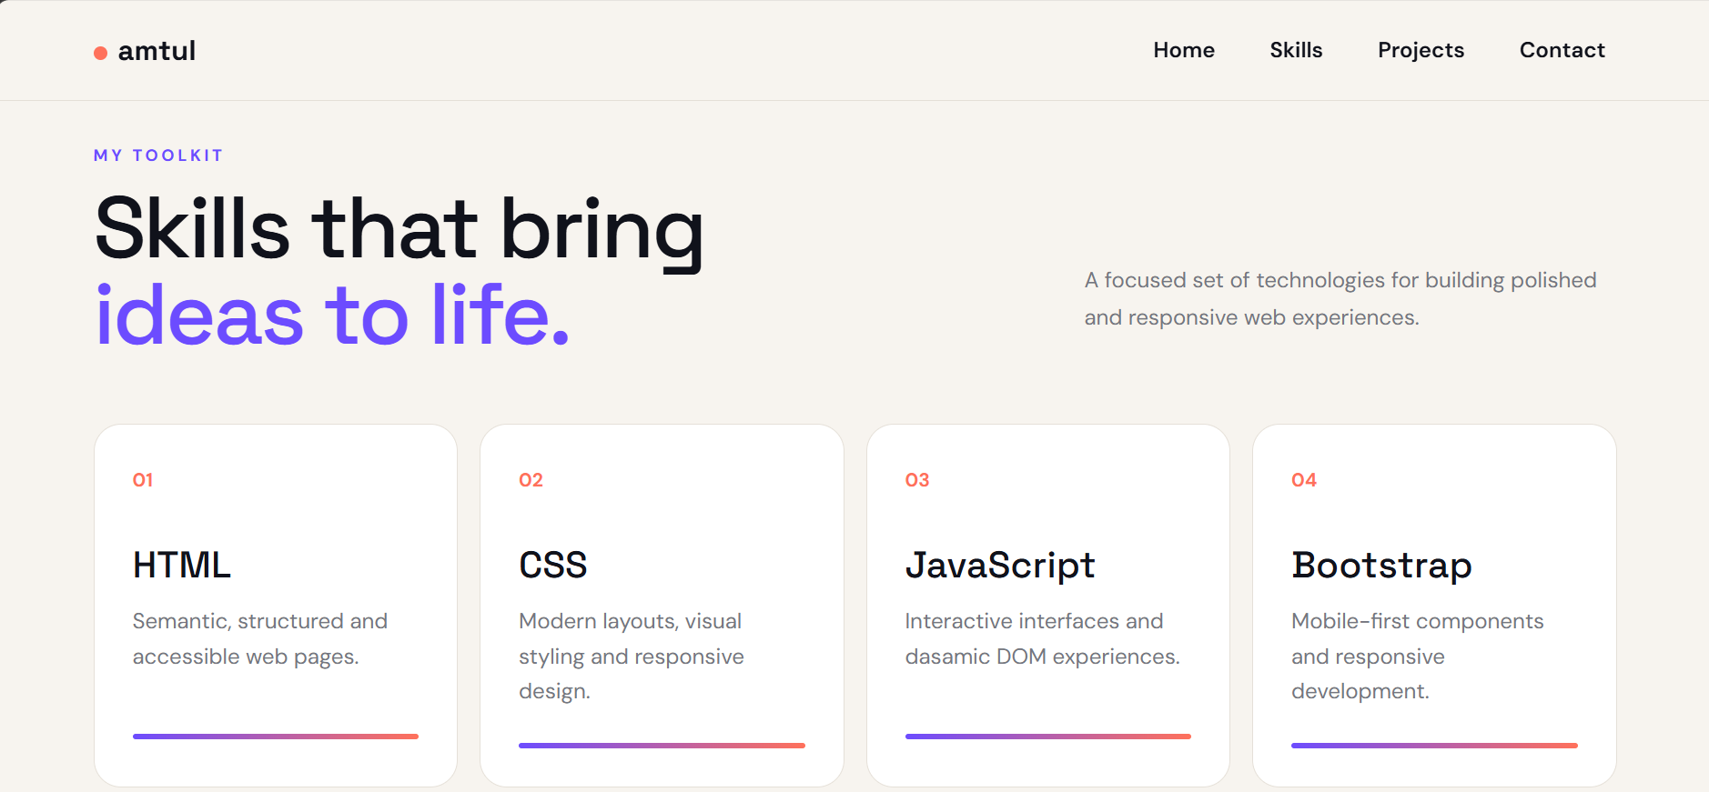
Figure 2. Skills section
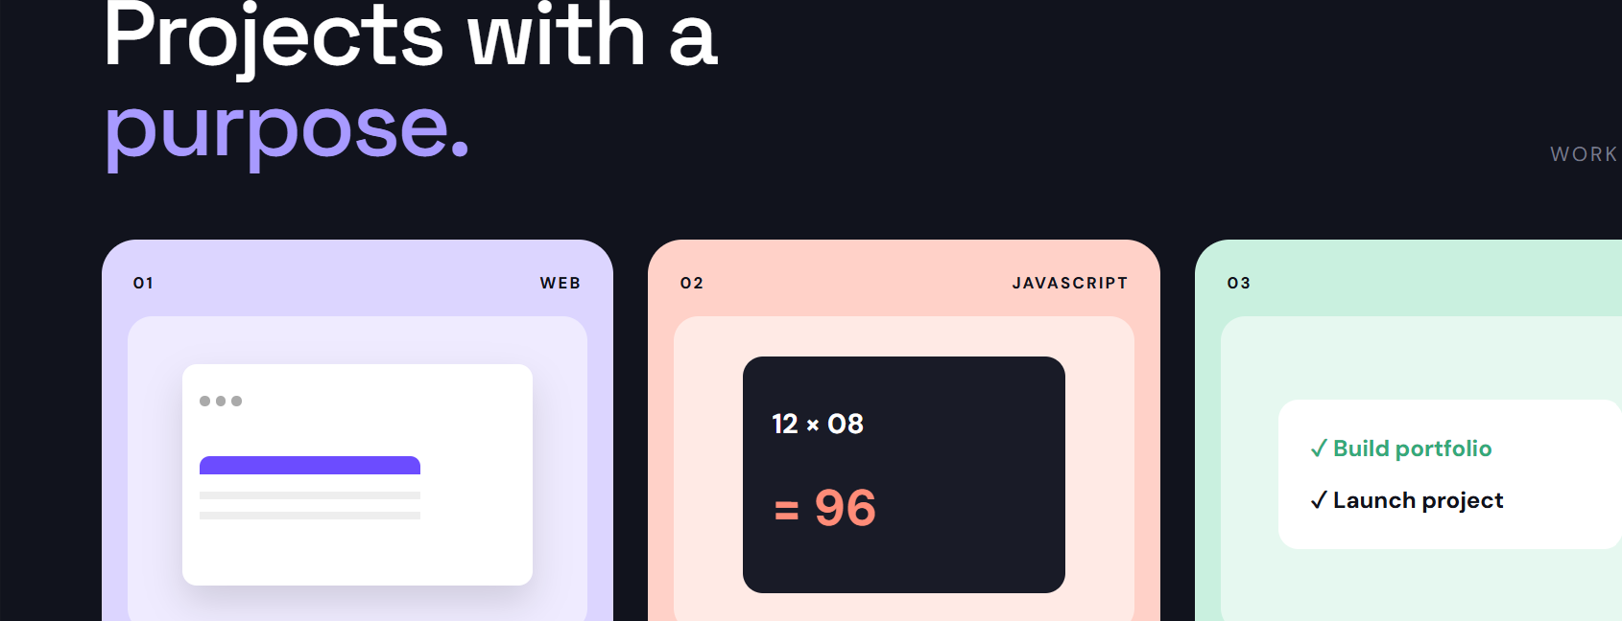
Figure 3. Projects section
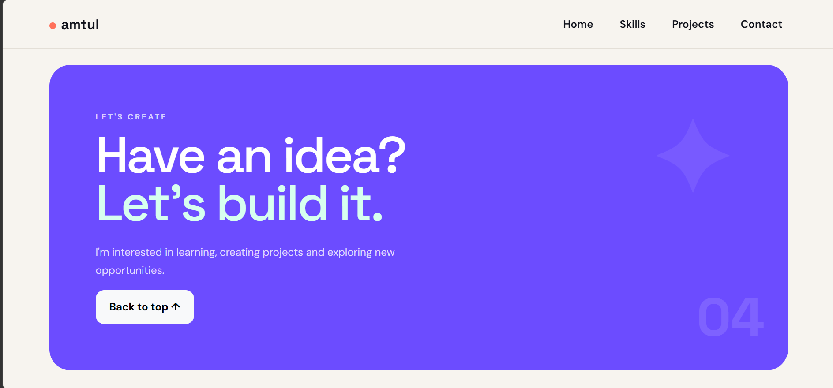
Figure 4. Contact / Call-to-action section

7. Testing and Verification
- Verified that the portfolio loads correctly through the deployed GitHub Pages URL.
- Checked navigation between the major sections of the page.
- Checked visual consistency of typography, spacing, cards, and colour accents.
- Verified that the main content sections are visible and readable in the deployed version.

8. Deliverables
- Responsive portfolio website source files.
- HTML and CSS implementation files.
- README documentation.
- Deployed GitHub Pages website.
- GitHub repository containing the project.
- Screenshots documenting the completed design.

9. Links
Live Website: https://amtul-coder.github.io/internspark-tasks/
GitHub Repository: https://github.com/amtul-coder/internspark-tasks

10. Conclusion
Task 1 was completed as a responsive personal portfolio website with a consistent visual theme and clearly structured content. The final implementation demonstrates the use of front-end technologies to create a professional, accessible, and visually engaging web page. The project has been uploaded to GitHub and deployed using GitHub Pages for online access.

