System Prototype and Evaluation Plan

# Project Description

The system was designed to provide kindergarten children with an interactive way of understanding a written story. The users targeted by this application are children with ages from 5 to 6. The system was thought so that would it helps them to better understand the message of the story, to make more correlations with the real world and expend their knowledge and vocabulary.

# Requirements Summary

The main requirements of the system are to have the children understand the story, expand their vocabulary and learn grammatical constructions explained in context and also to provide some mathematical activity.

The understanding of the story should be done in an interactive way so that the children remain engaged with the application. The new words should be explained in order for the children to be able to understand them and the grammatical constructions should be done using words from the story. In what concerns the mathematical activity, this needs to be done considering the children abilities and understanding capabilities.

Besides the main functional requirements of the application, we also have the usability requirements. Given that the system is indented to be used by children, it should be attractive and have appealing images and colors, enough to engage them but not to disturb them and make them unable to focus. The system should also provide intuitive navigation and since the children to no know how to read, the use of icons and signs that can be related to real life object is recommended.

Another usability criterion that should be accomplished is the consistency of actions across the application. If a certain action is done is a particular way somewhere is the application, it should be done the same way always in order for the children to learn faster and get familiar with the application more quickly. Also feedback should be always provided for actions done by users in order for them to know that the system is processing their request.

# System Prototype

Our prototype combines aspects from the design alternatives which we provided on the previous stage. We chose the best ideas from each of them, in order to obtain the best solution for our system. Starting from the story of Marin Sorescu, the game will include grammar, vocabulary and mathematics activities. However, the prototype covers only one of these activities, the grammar one, because the others will be developed in a similar way. Therefore, we considered that it will be enough for the evaluation.

When the application is opened, the following window will appear:

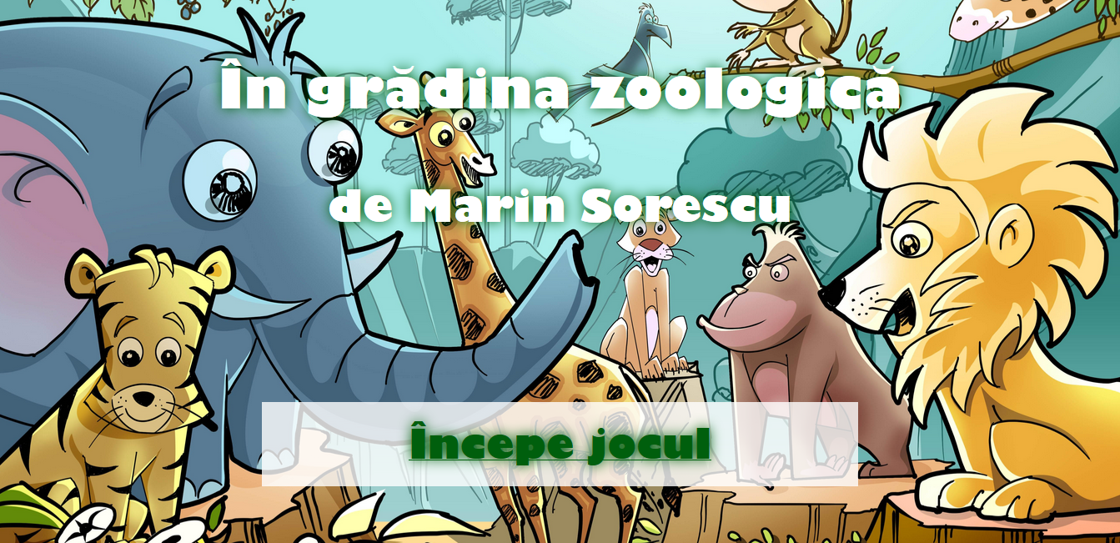

The background image is suggestive for the story that the game follows, containing cartoon animals. When the cursor is hover the title or the author, a log message containing that information is displayed. These messages will be replaced with ones in audio format, during the implementation stage. The same will happen when the cursor hovers over the start button. Besides this, the button will be lit green and the pointer cursor changes into a hand sign, in order to convince the users to click on it. This can be seen in the picture below.

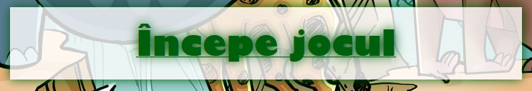

After the start button is clicked, the page corresponding to the first game will open:

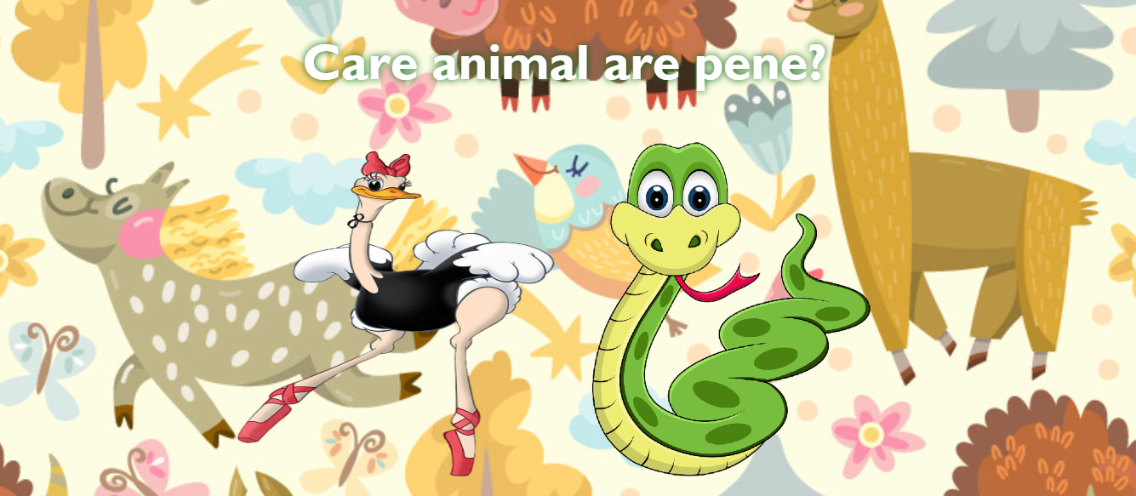

Following the same scenario as first page, log messages will be used for the question from the top of the page and for the story of each animal. The user will answer the question by clicking on one from the two displayed animals. After each answer, a feedback will be given, letting the user know if his answer was correct or wrong. Depending on the answer, a button will appear on the screen:

prototype4.png

It gives to the user the chance to try again to answer the question, if the answer was wrong, or to go to the next question, if the answer was correct. The “try again” button gives the possibility to repeat the question and the story of the animals, in order to find the correct answer.

We chose this prototype because it gives the users the chance to interact with the system, fact that is helpful for us for the evaluation step. When presenting it to the users, we can observe how it is perceived and if it is used properly. The requirements and the usability criteria are more visible than in the case of static prototypes, so it can be observed easier if the system respects them or not. It facilitates the customer's decision when determining whether some changes are needed. One disadvantage of the prototype is the fact that information is provided in text format only. In this case, the children would need the assistance of an adult, in order to understand the game’s questions. They cannot interact with it by themselves.

During the development of our prototype, the requirements and the usability criteria did not change. We found a manner to cover all the things which we have established in the previous stages, so altering the requirements or the usability criteria was not necessary.

# Evaluation plan

For the evaluation of our system we will consider the following evaluation types:

* Heuristic evaluation
* Real users evaluation
* Accessibility evaluation

We consider these three approaches of evaluation to provide us with sufficient feedback in order to verify our understanding of domain and of the user needs.

## Heuristic evaluation

The heuristic evaluation will be conducted by the expert user during lecture hours. The expert user will be able to evaluation both functional requirements that were initially set by them but also usability requirements. The user has the knowledge to decide if the application is suited to be used by the real users or changed should be made to the application.

**+ provide a list of checks from us?**

## Real users evaluation

The evaluation done by the real users will provide us with valuable information about how our system will actually be used. Also we will be able to analyze how they are interacting with the application and from this learn if they are using featured that we provided and if so if they are cleared enough to be used correctly.

The best suited environment for this evaluation to be done should be in a place familiar to the users, like the kindergarten. Besides us, they should also be accompanied by a familiar figure, like the kindergarten teacher, that can encourage them to use the application.

We would like for the children to evaluate the application in pairs, in order for them to overcome shyness and to be more open in describing their actions. By using pairs of two children, we provide them the right environment for them to exchange between themselves the role of the teacher and the role of the pupil. By explaining one to another how they should use the application, we gather information about how our system is perceived by the user, and if it is designed in such a way that the user can understand its purpose.

**+ More?**

## Accessibility evaluation

Since accessibility is very important in today’s society, we want to also integrate it into our system. The accessibility will be evaluated with an automatic tool that provides us with information about the **?** percetange of our application that is accessible, what is used correctly in order to provide the best accessibility and what not**?**

Although these tools are very useful, human evaluation is also needed to determine if the system is accessible. For example, an automatic tool will check if the images have an alternative text, but will not guarantee that the provided text is relevant for the image. Therefore, the Web Content Accessibility Guidelines, provided by WCAG, will be used for evaluation. Following this set of checklists will ensure in a greater extent that content is accessible to all user groups.