# Part 1 – Understanding the problem

## Introduction

Over the past few years, influence of technology upon children and education has been immense. Great education is now available through educational applications. Applications, either used on mobile devices or on desktop, are making things easier for children to understand. Books are often found tiring for children while replacing them with colorful pages and moving animations can make learning a fun experience.

To continue with, there are a couple of benefits for using educational applications. First, software applications in school can make children more interactive and activate better engagement between teachers and children. Also, applications promote entertainment. Lessons transforming to games can change the face of education, so that children will enable a kind of interest in learning.

Moreover, the use of educational applications can make children tech-savvy. Applications familiarize children with basic facets of tablets, smartphones or desktop computers. Regular use of learning applications makes children confident when handling similar technology tools as well as gadgets.

## Overview

It is a known fact that children’s literature helps a young child make sense of what it is to be human and helps them understand the world around them. The fairy tale genre provides ways for children to receive important messages. Although there are some themes in fairy tales that are unrealistic, the overall effect is positive and offers fundamental elements for children’s development.

Fairy tales have a powerful impact on development of both a young reader and a learner of a foreign language or mother tongue.

Currently, there are a couple of traditional ways to teach children fairy tales. The most obvious one is to read them stories, explain words, concepts, extract together the lessons learned. In addition, the use of audio books can be efficient too. However, there exists other innovative ways to teach children and arose their interest. A handful example would be the use of applications, which refresh the classic fairy tales by setting them in modern times.

Following the discussion with our client and considering multiple fairy tales proposals, we decided to build an interactive application, using “In grădina zoologică”, written by Marin Sorescu. Teaching children stories needs a new approach, and we firmly believe that the magic of this story, put in interactive illustrations, would be a learning experience for young children. The application will have two main purposes, getting to know the fairy tale and introduce children to one of these domains: mathematics, grammar, zoology.

## Users

The main users of the system will be pre-school children around the ages of 5-6 years. At these ages, they do not have much knowledge regarding language concepts such as grammar or even mathematics. They might know how to count to let’s say until 20, but most often than not, they do not understand what 5 means. Moreover, they may be familiar with animals that are surrounding them on the usual (cats, dogs, maybe even cows and chickens), that they or their grandparents might have at home, but the exotic or unreachable animals on the daily basis may be hard to recognize or remember. Grammar is another alien concept for the users but through the system, they might remember and understand the difference between words that define an object (e.g. nouns) and words that describe an object (e. g. adjectives).

However, the most important attribute of this kind of users is that they understand and learn very quickly and very easily, especially if the “lecture” is interactive and they are involved in the process of learning.

## Task Analysis

The most important characteristics of the tasks that are currently performed in order to achieved the goal of reading a story and providing useful information to the children from its content are efficiency and complexity.

The fact that these tasks involve more than one or two children of 5-6 years old implies an increase in the complexity and a decrease in the efficiency of the tasks and by doing so increases the duration until the initial goal is met. Having to coordinate more children at once can be difficult and can result in doing the same tasks multiple times until the goal of that task is completed or even not achieving the goal of some tasks at all.

One of the most complex and time consuming task that usually needs to be performed in parallel with almost every other task is that the teacher has to constantly make sure that the children are focused on the story, which can be hard if they only listen to the teacher and do not have any visual representations that could make easier for them to follow of the storyline.

Because the actions are taking place in a familiar environment, if the goal that is trying to be reached, in this case reading a story, does not seem interesting enough for a child, he or she can easily find something else to do, since they already know what else is available.

In addition, children respond in different ways when being presented to the same environment. For example, some children respond well in an environment that is soothing and calming, but other children may thrive in an environment that has a lot of hustle. Unfortunately, the teacher has the possibility to provide only one unique environment for all children.

During out visit to the kindergarten, we noticed the classrooms have vividly colored walls, dancing letters and some of them charming cartoon animals. This bright, cheerful look has become a familiar sight in classrooms, but it might not be the best environment for a child. Some studies have shown that when kindergartens are taught in highly decorated classrooms, they can be more distracted, their gazes can be more likely to wander off tasks.

The current system can be described as followed, using task analysis. Read a story to children can be split in five big steps from the teacher’s role perspective, having the last one optional:

* Decide to read
* Decide domain (nature, science, languages)
* Prepare story
* Read story
* Explain story moral.

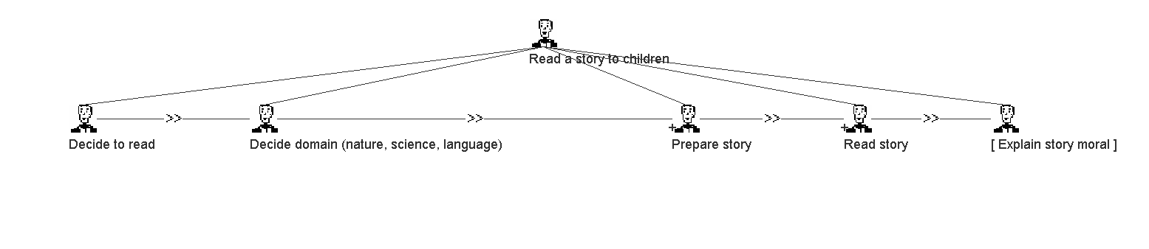

All tasks need to be executed sequentially. Two of them: prepare story and read story can be further detailed into subtasks, as follows:

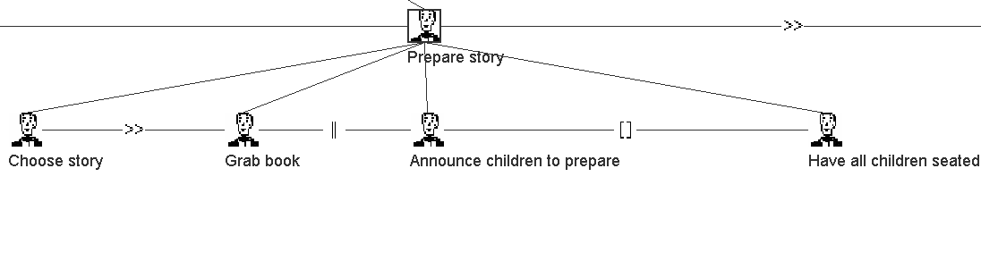

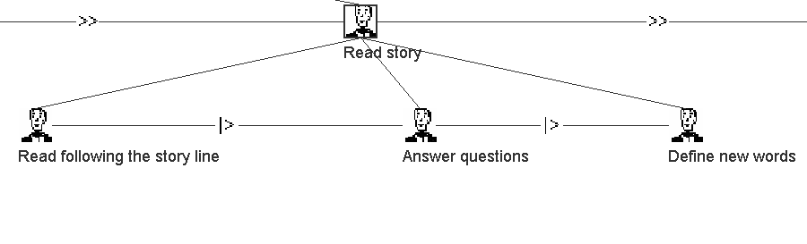

From the child’s role perspective, it can be split into three steps:

* Prepare for story
* Listen to story
* Ask questions

The first step needs to be finished before any other can begin. The last two steps can be done in parallel, the last one also being optional.

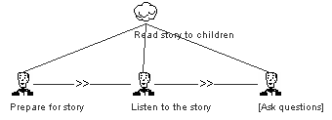

In the current situation, most of the tasks have to be made sequentially, there can be lots of interruptions and because of the nature of the major task, the actual story reading, when children need to keep their focus on the words of the teacher, they can get easily distracted.

A system that presents a story in an interactive way can bring benefits in multiple moments from the current process of reading a story. First, because the technology is something new, that kindergarten children do not interact with in the classroom, it is easier to keep their focus and interest in what there are doing, rather than going and play with something familiar in the middle of the activity. This helps with the efficiency of the tasks, since the teacher will not need so often to stop from a task over and over again. Another benefit of the system is the graphical interface that transposes the story into something more real. It is easier for the children to follow the story and associate all the new words with physical representations. Answering the questions of children and helping them getting familiar with the system is still a task for the teacher but after all children are familiar on how to use the application, it will be very interesting for them to discover themselves all what it can offer.

A system that would present the story to the children can be described as follows, using task analysis:

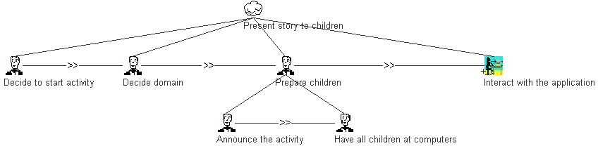

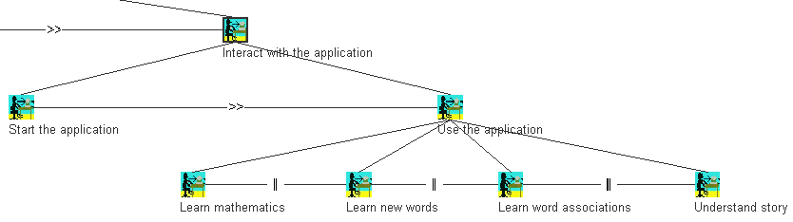

From the teacher’s role perspective we have the following model:

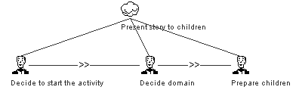

From the child’s role perspective we have the following model:

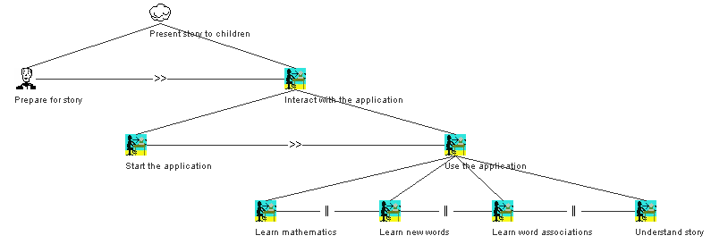

By looking at the models from the current situations and the ones involving a system we can observe a shift of parts of the responsibilities for achieving the main goal from teacher to children.

## Existing system

The first systems that were interactive (to a certain extent) for children were illustrated books that allowed the parents or tutors to show them parts of the stories while they were reading to the children. This however, quickly became an uninteresting practice for the young people mainly because they were not actively involved in the story and the learning process. There are some hybrids between coloring books and illustrated books that allow children to color maybe the main character or other parts, but this is almost an insignificant difference from the previous systems. Other relatively interactive books are designed to ask children questions and give answers through riddles or moving parts of the pages.

However, as the technology advanced, publishing houses started to create audio version of the stories and add them to the books. This made it easier for children to learn how to read and for parents, such that they no longer needed to read the stories themselves. Nowadays the publishing houses are coming up with many creative ideas such as adding little toys to books or making the pages create sounds.

Moreover, the technology involved in teaching young children has progressed a lot more mainly in the latest years when many mobile and desktop applications have been designed for this purpose.

Advantages for these systems include mainly the fact that the users do not need any kind of computer or smart device to use them or even internet connection, and maybe the most important fact is that they require a significantly less amount of money to buy. However, having that these systems are “static” (they cannot be updated and/or improved), children can get easily bored and forget about them.

Leaving aside actual computer games, these applications are designed to have children interact with them and let them also play small games while learning new concepts or deeply understand other concepts that they have been memorizing. They are easily accessible in diverse application stores across different platforms or are even simple websites, and usually they are free. However, the costs involved in getting these applications are a lot larger than buying books, since there is a need for a computer, tablet or smartphone. Nevertheless, children are more excited, involved and learn faster through these kinds of applications.

## Social and technical system at intersection

The application will be used by kindergarten children. Although it is meant to be used in kindergarten, offering support for a lesson, it can be used at home too. To run the application, a computer with an operating system installed, will be necessary. Connection to the Internet will not be required. At least for the first time the application will be used on a computer, a storage device containing the application must be used. If the application will be saved in the computer, the storage device will not be required anymore. Once the application is started, the children will be able to use the system by themselves, without needing the help of an adult. The adults, teachers or parents, can supervise the process of learning, to ensure the children are paying attention and are involved; but they will not have to help the kids to use the application.

When is used during lessons, in kindergarten, the teacher can coordinate the activity. In this case, a projector can be used in order to involve all the children in the activity. When children will use the application individually, both in class and at home, they will not need extra hardware.

## Usability

The design must be attractive, having appealing images and colors. The colors are important because they have an impact in the level of satisfaction. The children enjoy colorful layouts instead of grey or pale ones.

Also, because kindergarten children do not know how to read, they must be guided by images or intuitive signs and icons. The system should be easy to understand and children must be able to use it independently, without the help of an adult.

Regarding operability, the interface elements should be consistent. Similar actions, on different phases of the application, must be completed in the same way. This consistence of the interface elements is important in order for the children to learn faster the steps needed to perform a certain operation. The application must also provide feedback for all clickable surfaces and, to be clear what surfaces is a clickable, the pointer cursor must be used when interacting with them.

The system, also, must be easy to learn. After a few uses, the children should decrease the time spent for completion a task. The more time spent at a task, the less efficient the system will be. Also there should not be more than two steps in opening the system. After it is once shown to them, the children should be able to do it themselves.

Because there is also a need for the children to understand the whole story presented and not only the concepts it contains, the application should follow the storyline.

All the usability criteria that is targeted will be evaluated by using manual and automatic (end-to-end) testing, beta testing and also by analyzing the feedback gathered from the users, both children and supervisors.

## Conclusion

The information learnt about the users, the environment in which the application will be used and the importance of specific tasks to be made with the least amount of effort changed both the initial idea of the design of the system and also the tasks that it needs to be able to perform.

The first information that the users of the systems are 5 to 6 years old children did not provide sufficient information about the their ability of performing certain tasks or their knowledge in different fields since no member of the team has specialized knowledge in this area. Initial assumptions were changed after further research. The research was needed in order to find information that will eventually let us understand what the users can actually do, how granular and introductory the presented information must be and how they are able to perform the tasks they are given. Being only 5 or 6 years old, the information must be presented to users using common concepts that they might have already encounter in daily life. The same kind of information must be presented in the same way in order for them to distinguish a pattern that will eventually do the action they want and they should not be overwhelmed with too much information or choices of action at once.

More information about the environment in which the application will be used, changed both the initial ideas about the architecture of the application and about the complexity of the application. After knowing that the application must be able to be used without the internet, we knew that we cannot use, for example, existing animations from the internet without providing them offline, but we also need to consider that by providing them offline, the size of the application increases a lot, and so the application might not be usable on the computers the users have available.

The last but not the least, the fact the there are some tasks that should be done with the least amount of effort made us realize for example that we cannot deliver the final application in any format, but it needs to be delivered in such a way that the children will find it easy to start and be able to do it themselves after it is shown to them once.