Evaluating Multi-Agent Workflow Architectures for Enterprise AI Tasks: A Comparative Study Using Gemini and n8n

Author: Muawia Ali
Affiliation: Independent Researcher
Date: June 2026

Table of Contents
Abstract 5
1 Introduction 5
2 Related Work 7
3 Methodology 9
3.1 Research Design 9
3.2 Experimental Environment 9
3.3 Workflow Architectures 9
3.3.1 Basic Agent 9
3.3.2 Planner Executor 9
3.3.3 Planner Executor Reviewer 10
3.4 Workflow Implementation 10
3.5 Dataset Construction 12
3.5.1 Knowledge 12
3.5.2 Reasoning 12
3.5.3 Coding 12
3.6 Difficulty Classification 12
3.7 Experimental Procedure 13
3.7.1 Pilot Phase 13
3.7.2 Main Experiment 13
3.8 Data Collection 13
3.9 Data Preparation 13
3.10 Evaluation Metrics 14
3.11 Statistical Analysis 14
3.12 Reproducibility 14
4 Results 15
4.1 Overview 15
4.2 Workflow Performance 15
4.3 Performance by Task Category 16
4.4 Performance by Task Difficulty 17
4.5 Workflow Improvement 18
4.6 Key Findings 19
5 Discussion 20
5.1 Overview 20
5.2 Impact of Multi-Agent Architectures 20
5.3 Why Reasoning Tasks Benefited the Most 20
5.4 Limited Gains for Coding Tasks 21
5.5 Task Difficulty and Workflow Design 21
5.6 Consistency and Reliability 22
5.7 Practical Implications 22
5.8 Summary 22
6 Threats to Validity 23
6.1 Overview 23
6.2 Model Dependency 23
6.3 Dataset Size 23
6.4 Task Selection Bias 23
6.5 Confidence as an Evaluation Metric 24
6.6 Reviewer-Generated Quality Scores 24
6.7 Workflow Implementation 24
6.8 Enterprise Generalization 24
6.9 Internal Validity 25
6.10 Summary 25
7 Future Work 25
7.1 Overview 25
7.2 Evaluation Across Multiple Models 25
7.3 Larger Task Datasets 26
7.4 Human Evaluation 26
7.5 Cost and Performance Analysis 26
7.6 Advanced Multi-Agent Architectures 27
7.7 Real Enterprise Deployments 27
7.8 Long-Term Research Direction 27
7.9 Summary 27
8 Conclusion 28
8.1 Overview 28
8.2 Main Findings 28
8.3 Research Contribution 28
8.4 Practical Implications 29
8.5 Final Remarks 29
References 30

Abstract
The growing adoption of large language models has increased interest in agentic AI systems that organize tasks through multiple specialized agents. While planning, execution, and review-based workflows are widely used in practice, limited empirical evidence exists regarding their effectiveness when compared under controlled conditions.
This study investigates the impact of workflow architecture on enterprise-oriented AI task performance. Three workflow architectures were evaluated using the same underlying language model, dataset, and execution environment: Basic Agent, Planner Executor, and Planner Executor Reviewer. The experiment was implemented using Google Gemini-3.1-flash-lite and the n8n workflow automation platform. A dataset of 30 enterprise-oriented tasks covering Knowledge, Reasoning, and Coding domains was constructed and executed across all workflow architectures, resulting in 90 experimental runs.
Performance was evaluated using workflow confidence scores, task category analysis, task difficulty analysis, and comparative improvement relative to a single-agent baseline. The results indicate that workflow architecture has a measurable effect on both performance and consistency. The Planner Executor workflow improved overall confidence by 3.16% compared with the Basic Agent baseline, while the Planner Executor Reviewer workflow achieved an improvement of 3.89%. The largest gains were observed in Reasoning tasks and Hard tasks, where multi-agent workflows improved performance by more than 10% relative to the baseline. In addition, multi-agent workflows demonstrated substantially lower variance, indicating more consistent behavior across diverse task types.
The findings suggest that workflow orchestration can improve AI system effectiveness without changing the underlying language model. The study contributes empirical evidence supporting the use of planning and review mechanisms in enterprise AI workflows and provides a reproducible framework for future research on agentic AI architectures.
Keywords: Agentic AI, Multi-Agent Systems, Workflow Orchestration, Enterprise Automation, Gemini, n8n, AI Agents, Task Planning, AI Evaluation.

Introduction
The rapid adoption of large language models (LLMs) has transformed how organizations approach automation, knowledge management, software development, and decision support. Modern AI systems are increasingly capable of performing tasks that traditionally required human expertise, enabling businesses to automate complex workflows and improve operational efficiency.
Despite these advances, most enterprise AI applications continue to rely on a single-agent interaction model in which one language model receives a prompt and produces a response. While this approach is effective for many tasks, it may struggle when problems require multi-step reasoning, planning, verification, or decision-making. As task complexity increases, single-agent systems can become less reliable and may produce inconsistent results.
To address these limitations, researchers and practitioners have begun exploring Agentic AI architectures. Rather than relying on a single model invocation, agentic systems decompose tasks into multiple stages performed by specialized agents. Examples include planning agents that create execution strategies, executor agents that perform task-specific actions, and reviewer agents that evaluate and refine outputs before final delivery. Such architectures aim to improve reasoning quality, reduce errors, and increase overall system reliability.
The growing popularity of workflow orchestration platforms such as n8n has made it easier to implement and deploy multi-agent systems in enterprise environments. Organizations can now design workflows that combine planning, execution, and review stages while using the same underlying language model. However, despite the increasing adoption of these architectures, empirical evidence regarding their effectiveness remains limited. Many claims about multi-agent systems are based on anecdotal observations, demonstrations, or small-scale examples rather than controlled experimental evaluations.
This creates an important research question: Does workflow architecture itself improve AI system performance when the underlying language model remains unchanged?
To investigate this question, this study evaluates three workflow architectures using the same language model, dataset, and execution environment:
- Basic Agent
- Planner Executor
- Planner Executor Reviewer
The experiment was conducted using Google Gemini-3.1-flash-lite and n8n and involved a dataset of 30 enterprise-oriented tasks spanning knowledge, reasoning, and coding domains. Each task was executed using all three workflow architectures, resulting in 90 experimental runs. Performance was evaluated using workflow confidence scores, category-specific analysis, difficulty-level analysis, and improvement relative to a single-agent baseline.
The results demonstrate that workflow architecture has a measurable impact on AI system performance. Multi-agent workflows consistently achieved higher confidence scores and greater consistency than the single-agent approach. The largest improvements were observed in reasoning-intensive and difficult tasks, where planning and review mechanisms provided substantial benefits.
The primary contributions of this study are as follows:
- It provides an empirical comparison of three commonly used agentic workflow architectures.
- It evaluates workflow performance using a controlled experimental design in which the underlying language model remains constant.
- It analyzes workflow behavior across different task categories and difficulty levels.
- It demonstrates the practical value of planning and review mechanisms for enterprise-oriented AI tasks.
- It provides a reproducible experimental framework that can be extended by future researchers.
The remainder of this paper is organized as follows. Section 2 reviews related work on agentic AI systems and multi-agent architectures. Section 3 describes the research methodology and experimental design. Section 4 presents the experimental results. Section 5 discusses the findings and their implications. Section 6 outlines threats to validity. Section 7 presents future research directions. Finally, Section 8 concludes the paper.

Related Work
The increasing capabilities of large language models (LLMs) have led to growing interest in agentic AI systems and multi-agent architectures. Rather than relying on a single model invocation, these systems decompose tasks into multiple stages involving planning, execution, reflection, verification, and collaboration. Researchers and practitioners have proposed a variety of approaches aimed at improving reasoning quality, reliability, and task performance through workflow orchestration.
One important line of research focuses on reasoning enhancement through structured problem decomposition. Techniques such as Chain-of-Thought prompting (Wei et al., 2022) demonstrated that explicitly generating intermediate reasoning steps can significantly improve performance on complex reasoning tasks. Subsequent work such as ReAct (Yao et al., 2023) further combined reasoning and action, enabling language models to solve tasks in a more structured manner. These approaches showed that breaking complex tasks into intermediate steps can improve both reasoning quality and task completion performance.
Recent studies have explored agent-based architectures such as AutoGen (Wu et al., 2023) and CrewAI (Moura, 2024), in which multiple specialized agents collaborate to solve tasks. These systems often assign different responsibilities to individual agents, such as planning, execution, evaluation, or critique. Multi-agent approaches have been applied to software engineering, decision support, research assistance, and autonomous task execution. The underlying motivation is that specialization may improve performance compared with a single agent attempting to perform all functions simultaneously.
Another related research direction involves self-reflection and response verification. Approaches such as Reflexion (Shinn et al., 2023) demonstrated that language models can improve performance through iterative self-critique and refinement.
Several studies have shown that language models can improve output quality when provided opportunities to review, critique, or revise their own responses. Reflection-based workflows attempt to identify errors, inconsistencies, or missing information before producing a final answer. These approaches share similarities with reviewer-based architectures in which an additional agent evaluates the quality of generated outputs.
The emergence of workflow orchestration frameworks has further accelerated the adoption of
agentic AI systems. Platforms such as LangChain (Chase, 2023), LangGraph (LangChain Inc.,
2024), AutoGen (Wu et al., 2023), CrewAI (Moura, 2024), and n8n provide mechanisms for
coordinating multiple agents and managing complex execution flows. These tools have enabled practitioners to implement increasingly sophisticated AI workflows for enterprise automation and business process support.
Despite the rapid growth of agentic AI systems, empirical evaluation remains relatively limited. Many published examples focus on demonstrating capabilities rather than conducting controlled comparisons between workflow architectures. In many cases, improvements are attributed to larger models, different prompts, or changes in execution environments, making it difficult to isolate the impact of workflow design itself.
This study contributes to the existing literature by providing a controlled comparison of three workflow architectures while holding the underlying language model, dataset, and execution environment constant. By evaluating Basic Agent, Planner Executor, and Planner Executor Reviewer architectures under identical conditions, the study aims to provide empirical evidence regarding the practical impact of workflow orchestration on enterprise-oriented AI tasks.
The findings complement existing research on reasoning enhancement, multi-agent collaboration, and self-reflective AI systems by demonstrating that workflow architecture alone can influence confidence, consistency, and performance outcomes. As organizations increasingly deploy agentic AI systems in production environments, understanding these architectural effects becomes increasingly important for both researchers and practitioners.

Methodology

Research Design

This study evaluates the effectiveness of different Agentic AI workflow architectures for enterprise-oriented tasks. The objective is to determine whether multi-agent workflows improve performance, confidence, and consistency compared with a traditional single-agent approach.
A comparative experimental design was used to evaluate three workflow architectures under identical conditions.

Experimental Environment
The workflows were implemented using n8n and executed using Google Gemini-3.1-flash-lite as the underlying large language model.
All workflow executions used:
- The same task dataset
- The same workflow infrastructure
- The same execution environment
- The same evaluation process
This ensured that differences in performance could be attributed primarily to workflow architecture rather than environmental factors.

Workflow Architectures

Basic Agent
The Basic Agent workflow consists of a single AI agent that receives a task prompt and generates a direct response.
Workflow:
Task → Agent → Response

Planner Executor
The Planner Executor workflow separates planning from execution.
Workflow:
Task → Planner → Execution Plan → Executor → Response
The Planner Agent generates a structured plan which is then executed by the Executor Agent.

Planner Executor Reviewer
The Planner Executor Reviewer workflow introduces an additional review stage.
Workflow:
Task → Planner → Executor → Reviewer → Final Response
The Reviewer Agent evaluates the generated response and assigns a quality score.

Workflow Implementation
The evaluated workflow architectures were implemented using the n8n workflow automation platform and stored as reusable workflow definitions in JSON format.
Each workflow was designed to execute the same task while introducing different levels of orchestration:
- Basic Agent: A single-agent workflow in which the language model receives the task prompt and directly generates a response.
- Planner Executor: A two-stage workflow in which a planning agent first creates an execution strategy, followed by an executor agent that generates the final response based on the generated plan.
- Planner Executor Reviewer: A three-stage workflow consisting of a planning agent, an executor agent, and a reviewer agent. The reviewer evaluates the executor output, provides quality assessment, and may refine the final response before completion.
The workflow definitions were implemented as n8n JSON workflows and maintained in the project repository to support reproducibility and future experimentation. The workflow files are available in the accompanying research repository under the workflows directory.
To provide additional transparency regarding the experimental implementation, Figures 1–3 present the actual n8n workflow configurations used during the study.
The Basic Agent workflow represents the baseline architecture. A task prompt is submitted directly to a Gemini-powered AI agent, which generates a response without intermediate planning or review stages. The generated output is parsed and stored for subsequent analysis.
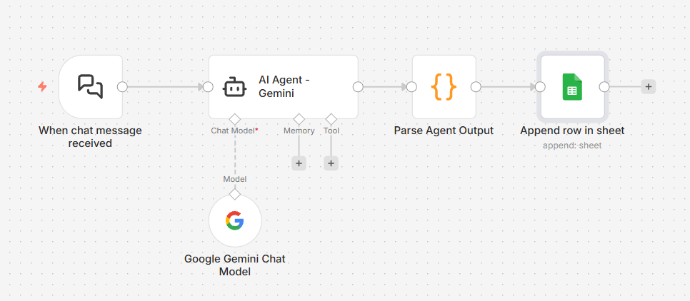Figure 1. Basic Agent workflow implemented in n8n.
The Planner Executor workflow introduces a dedicated planning stage before response generation. The planner agent first creates an execution strategy, which is then passed to an executor agent responsible for producing the final answer.
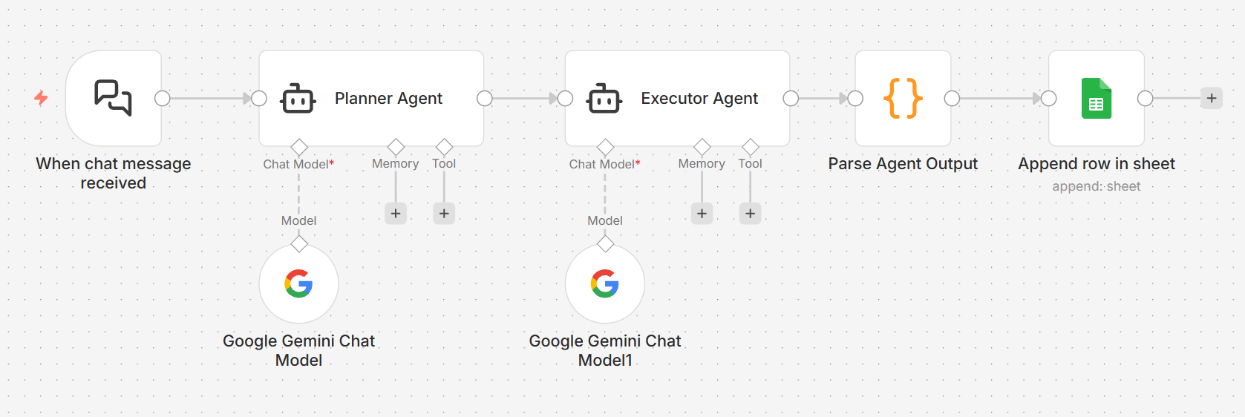Figure 2. Planner Executor workflow implemented in n8n.
The Planner Executor Reviewer workflow extends the architecture by introducing a reviewer agent. After planning and execution are completed, the reviewer evaluates the generated response, assigns quality-related assessments, and produces a refined final output before the results are recorded.
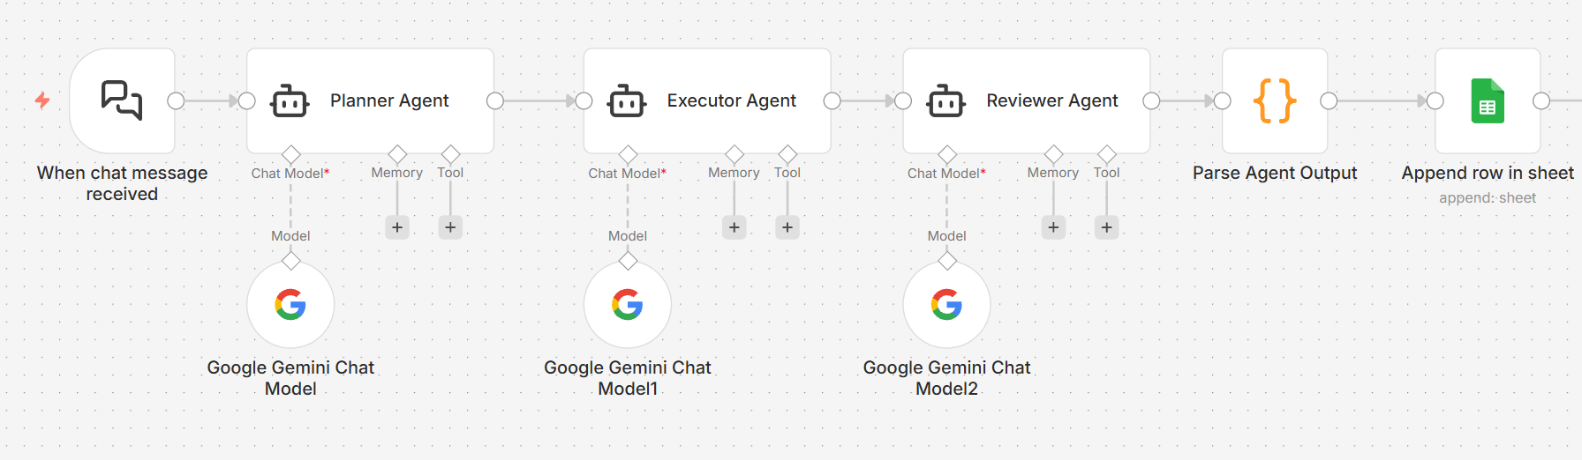Figure 3. Planner Executor Reviewer workflow implemented in n8n.
The complete workflow definitions used in this experiment are available in JSON format within the accompanying public repository. Providing the workflow implementations supports reproducibility and enables future researchers to replicate or extend the experiment.

Dataset Construction
A custom dataset of 30 enterprise-oriented tasks was created for the experiment.
Tasks were designed to represent realistic business and technical scenarios.
The dataset contained 30 tasks distributed equally across the three categories, including 10 Knowledge tasks, 10 Reasoning tasks, and 10 Coding tasks. The balanced category distribution was intended to reduce evaluation bias and provide comparable coverage of different enterprise-oriented task types.
The dataset was divided into three categories:

Knowledge
Tasks requiring factual understanding, comparison, explanation, or summarization.

Reasoning
Tasks requiring analysis, planning, decision-making, or multi-step problem solving.

Coding
Tasks requiring software development, scripting, debugging, or technical implementation.

Difficulty Classification
Each task was assigned a difficulty level:
- Easy
- Medium
- Hard
Difficulty levels were determined based on the expected cognitive complexity and number of reasoning steps required to complete the task.

Experimental Procedure
Each task was executed on all three workflow architectures.
The experiment consisted of:

Pilot Phase
- 9 pilot executions
- Used for workflow validation and debugging

Main Experiment
- 30 tasks
- 3 workflow architectures per task
- Total executions: 90
The pilot runs were excluded from the final analysis.

Data Collection
Workflow outputs were automatically logged using Google Sheets integration.
Collected data included:
- workflow_type
- task prompt
- response
- execution summary
- confidence score
- quality score (Reviewer workflow only)
The exported results were stored as CSV files and later merged with task metadata.

Data Preparation
The final analysis dataset was created through the following process:
- Remove pilot executions.
- Retain only main experiment runs.
- Match task prompts to the task dataset.
- Assign verified task identifiers.
- Add category metadata.
- Add difficulty metadata.
- Generate the final analysis dataset.
The resulting dataset contained:
- 90 workflow executions
- 30 unique tasks
- 3 workflow architectures

Evaluation Metrics
The primary evaluation metric was confidence score.
Confidence scores were analyzed across:
- Workflow architecture
- Task category
- Difficulty level
For the Planner Executor Reviewer workflow, reviewer-generated quality scores were also recorded.
Additional evaluation metrics included:
- Average confidence
- Minimum confidence
- Maximum confidence
- Standard deviation
- Percentage improvement over baseline

Statistical Analysis
The analysis was conducted using Microsoft Excel, including pivot tables, descriptive statistics, and comparative analysis techniques.
Pivot tables and descriptive statistics were used to evaluate:
- Workflow performance.
- Category-specific performance.
- Difficulty-specific performance.
- Improvement relative to the Basic Agent baseline.
Visualizations were generated to summarize experimental findings.

Reproducibility
All datasets, workflow definitions, analysis files, figures, and documentation are maintained within the project repository.
Version-controlled artifacts allow future researchers to reproduce the experiment and verify the reported results.

Results

Overview
The experiment evaluated three agentic workflow architectures across a dataset of 30 enterprise-oriented tasks. Each task was executed using three different workflow configurations, resulting in a total of 90 experimental runs.
The evaluated workflow architectures were:
- Basic Agent
- Planner Executor
- Planner Executor Reviewer
The analysis focused on workflow confidence, task category performance, task difficulty performance, and workflow improvement relative to the Basic Agent baseline.

Workflow Performance
The first objective of the study was to compare overall workflow performance.
The Basic Agent workflow achieved an average confidence score of 0.950. The Planner Executor workflow improved the average confidence score to 0.980, while the Planner Executor Reviewer workflow achieved the highest average confidence score of 0.987.
In addition to achieving the highest confidence score, the Planner Executor Reviewer workflow demonstrated significantly greater consistency across tasks. Both multi-agent workflows produced substantially lower standard deviation values compared with the Basic Agent workflow, indicating more stable behavior across diverse task types.
One notable observation was the presence of a single outlier in the Basic Agent workflow. During the task "Analyze employee feedback and identify major organizational themes," the workflow returned a confidence score of 0.0, which contributed to the higher variance observed in the single-agent architecture.
Overall, the results suggest that introducing planning and review stages improves both confidence and consistency.

Table 1. Overall Performance of Workflow Architectures
Workflow | Average of confidence | StdDev of confidence
Basic Agent | 0.950 | 0.181
Planner Executor | 0.979 | 0.025
Planner Executor Reviewer | 0.986 | 0.025
Table 1 summarizes the overall performance of the three workflow architectures.
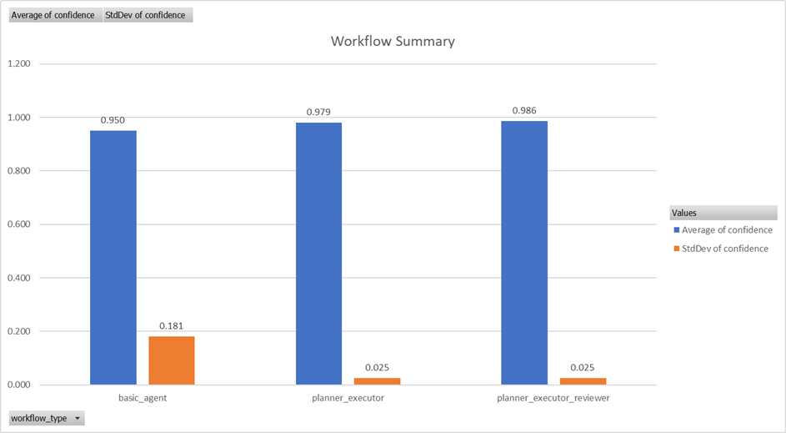
Figure 4. Average confidence and standard deviation across workflow architectures.

Performance by Task Category
Task performance varied across the three task categories.
Coding tasks achieved the highest confidence scores across all workflow architectures. Confidence scores remained near 1.0 regardless of workflow design, suggesting that the underlying model was already highly effective at solving coding-oriented tasks.
Knowledge tasks showed moderate improvements as workflow complexity increased. The Planner Executor Reviewer workflow achieved the highest confidence score within this category, indicating that review and refinement contributed to improved response quality.
The largest differences appeared in Reasoning tasks. The Basic Agent workflow achieved an average confidence score of 0.880, while the Planner Executor and Planner Executor Reviewer workflows achieved 0.968 and 0.979 respectively.
These findings suggest that multi-agent orchestration provides the greatest benefit when solving tasks that require planning, analysis, and multi-step reasoning.
Table 2. Workflow Performance by Task Category
Workflows | Coding | Knowledge | Reasoning
Basic Agent | 0.995 | 0.975 | 0.880
Planner Executor | 0.994 | 0.980 | 0.968
Planner Executor Reviewer | 0.989 | 0.993 | 0.979
Table 2 presents the average confidence scores achieved by each workflow across the Knowledge, Reasoning, and Coding task categories.
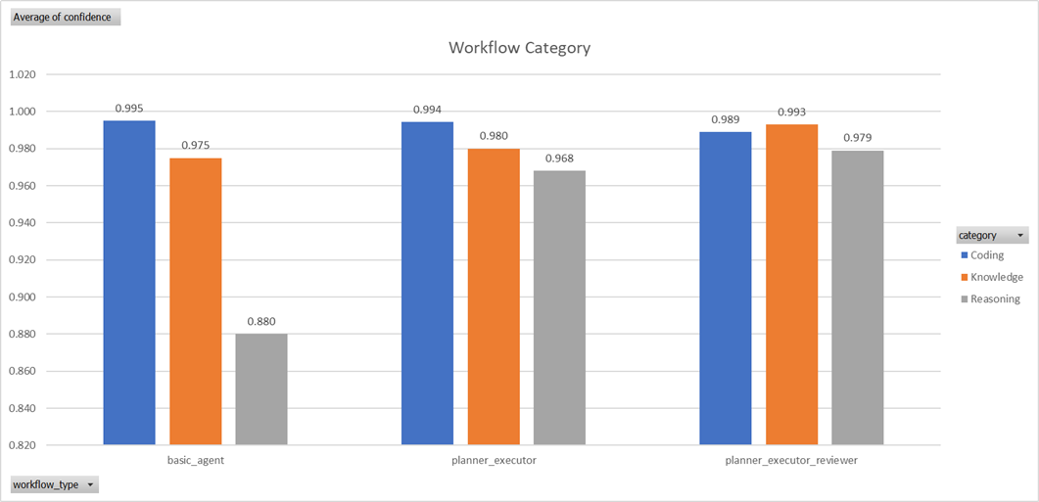
Figure 5. Workflow performance across task categories.

Performance by Task Difficulty
Performance was also analyzed according to task difficulty.
Easy and Medium tasks produced consistently high confidence scores across all workflow architectures. Differences between workflows were relatively small for these tasks.
In contrast, Hard tasks revealed substantial differences between architectures. The Basic Agent workflow achieved an average confidence score of 0.896, while Planner Executor increased confidence to 0.980 and Planner Executor Reviewer further improved confidence to 0.987.
This pattern indicates that workflow architecture becomes increasingly important as task complexity grows.
The results suggest that planning and review mechanisms help reduce uncertainty when addressing difficult or cognitively demanding tasks.
Table 3. Workflow Performance by Task Difficulty
Workflows | Easy | Medium | Hard
Basic Agent | 0.9857 | 0.9864 | 0.8958
Planner Executor | 0.9786 | 0.9818 | 0.9800
Planner Executor Reviewer | 0.9900 | 0.9845 | 0.9873
Table 3 compares workflow performance across Easy, Medium, and Hard tasks.
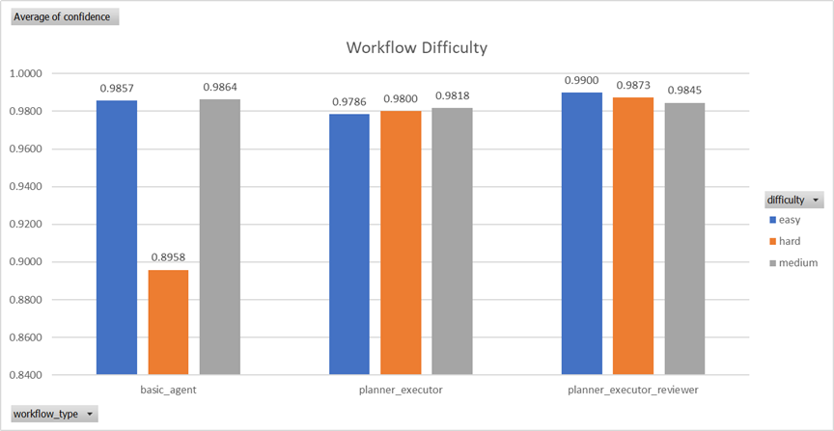
Figure 6. Workflow performance across difficulty levels.

Workflow Improvement
To quantify the benefits of multi-agent architectures, workflow performance was compared against the Basic Agent baseline.
The Planner Executor workflow improved overall confidence by approximately 3.16%, while the Planner Executor Reviewer workflow improved overall confidence by approximately 3.89%.
The largest gains were observed in Reasoning tasks. Relative to the Basic Agent workflow, Planner Executor improved performance by approximately 10.0%, while Planner Executor Reviewer improved performance by approximately 11.25%.
Similarly, Hard tasks showed improvements of approximately 9.38% and 10.16% for Planner Executor and Planner Executor Reviewer respectively.
These results indicate that multi-agent architectures provide their greatest value in scenarios requiring deeper reasoning and greater task complexity.
Table 4. Percentage Improvement Relative to the Basic Agent Baseline
Metric | PE Improvement over Basic | PER Improvement over Basic
Overall | 3.16% | 3.89%
Reasoning | 10.00% | 11.25%
Hard Tasks | 9.38% | 10.16%
Table 4 reports the relative improvement achieved by the Planner Executor (PE) and Planner Executor Reviewer (PER) workflows compared with the Basic Agent baseline.
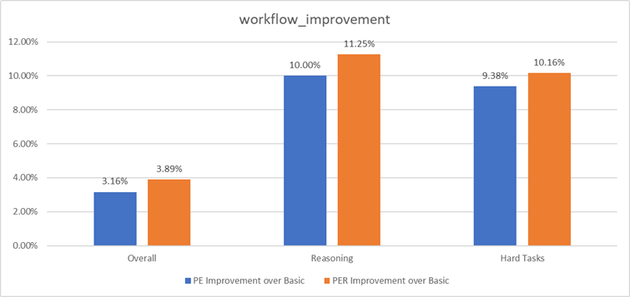
Figure 7. Percentage improvement relative to the Basic Agent baseline.

Key Findings
The experiment produced four primary findings.
First, multi-agent workflows consistently outperformed the single-agent baseline.
Second, the Planner Executor Reviewer workflow achieved the highest overall confidence and the most consistent performance.
Third, Reasoning tasks benefited the most from workflow decomposition and review.
Finally, the performance advantage of multi-agent architectures increased as task difficulty increased.
Taken together, these findings support the hypothesis that agentic workflow architectures can improve the effectiveness and reliability of enterprise-oriented AI systems.

Discussion

Overview
The purpose of this study was to evaluate whether multi-agent workflow architectures improve the performance of enterprise-oriented AI systems compared with a traditional single-agent approach.
The experimental results indicate that workflow architecture has a measurable impact on both confidence and consistency. While all workflows performed well across many tasks, the benefits of multi-agent orchestration became increasingly apparent as task complexity increased.

Impact of Multi-Agent Architectures
The overall results show that both multi-agent workflows outperformed the Basic Agent baseline.
The Planner Executor workflow increased average confidence from 0.950 to 0.980, while the Planner Executor Reviewer workflow achieved the highest average confidence score of 0.987.
Although the overall improvement appears modest, the results suggest that introducing planning and review stages can improve workflow reliability without requiring changes to the underlying language model.
This finding is important because it demonstrates that workflow design itself can influence performance, even when all workflows use the same AI model.

Why Reasoning Tasks Benefited the Most
The largest performance gains were observed in Reasoning tasks.
The Basic Agent workflow achieved an average confidence score of 0.880, compared with 0.968 for Planner Executor and 0.979 for Planner Executor Reviewer.
This result is consistent with the nature of reasoning problems. Unlike factual or coding tasks, reasoning tasks often require:
- Problem decomposition
- Intermediate planning
- Evaluation of alternatives
- Multi-step decision making
A single agent must perform all of these activities simultaneously.
In contrast, the Planner Executor architecture separates planning from execution, reducing cognitive load and encouraging more structured problem solving. The addition of a Reviewer Agent provides a further validation step, helping identify weaknesses before producing a final response.
These findings suggest that multi-agent workflows are particularly valuable when tasks require structured reasoning rather than simple information retrieval.

Limited Gains for Coding Tasks
Coding tasks showed only minor differences between workflow architectures.
Confidence scores remained close to 1.0 across all workflows, including the Basic Agent configuration.
One possible explanation is that modern large language models already perform strongly on many coding-related tasks. As a result, there is less opportunity for workflow orchestration to produce noticeable improvements.
This finding suggests that the value of multi-agent systems may depend on task type. For tasks where the underlying model already performs exceptionally well, additional workflow complexity may provide limited benefit.

Task Difficulty and Workflow Design
The influence of workflow architecture became more apparent as task difficulty increased.
For Hard tasks, the Basic Agent workflow achieved an average confidence score of 0.896. Planner Executor increased this value to 0.980, while Planner Executor Reviewer achieved 0.987.
These results indicate that planning and review mechanisms become increasingly important when solving complex tasks.
The findings support the idea that workflow orchestration helps manage uncertainty and reduces the likelihood of incomplete reasoning when task requirements become more demanding.

Consistency and Reliability
In addition to higher confidence scores, the multi-agent workflows demonstrated substantially lower variance.
Both Planner Executor and Planner Executor Reviewer achieved standard deviation values of approximately 0.025, compared with 0.181 for the Basic Agent workflow.
This difference suggests that multi-agent workflows produce more predictable behavior across diverse tasks.
From an enterprise perspective, consistency is often as important as average performance. Organizations typically prefer systems that produce stable results across different scenarios rather than systems that occasionally achieve high performance but exhibit greater variability.
Therefore, the reduction in variance observed in the multi-agent workflows may represent a meaningful practical advantage.

Practical Implications
The results have several implications for organizations adopting AI-powered automation.
For relatively simple tasks, a single-agent workflow may be sufficient and more cost-effective.
However, for tasks involving planning, analysis, decision-making, or complex reasoning, multi-agent architectures appear to offer measurable advantages.
The findings suggest that organizations can improve workflow performance without necessarily upgrading to a more powerful model. Instead, performance gains may be achieved through better orchestration of existing models.
This observation is particularly relevant for enterprise environments where cost, reliability, and scalability are important considerations.

Summary
The experimental results indicate that workflow architecture plays an important role in AI system performance.
While all workflows performed well overall, multi-agent architectures consistently achieved higher confidence and greater stability. The greatest benefits were observed in reasoning-intensive and difficult tasks, where planning and review mechanisms provided substantial improvements over the single-agent baseline.
These findings support the use of agentic workflow architectures as a practical strategy for improving enterprise AI systems without requiring changes to the underlying language model.

Threats to Validity

Overview
As with any experimental study, several factors may influence the interpretation and generalizability of the results. This section discusses the primary limitations of the experiment and identifies potential threats to validity.

Model Dependency
All workflow architectures were evaluated using the same underlying language model.
The experiment was conducted using Google Gemini-3.1-flash-lite as the execution model for all workflows. While this approach ensured fairness across workflow comparisons, the results may not fully generalize to other large language models such as GPT-4, Claude, or future generations of AI systems.
Different models may respond differently to planning, execution, and review stages, which could influence the magnitude of the observed improvements.

Dataset Size
The study used a dataset consisting of 30 enterprise-oriented tasks.
Although the dataset was intentionally designed to cover multiple categories and difficulty levels, it remains relatively small compared with large-scale benchmark datasets commonly used in AI evaluation.
A larger dataset could provide additional evidence regarding the consistency and robustness of the findings.

Task Selection Bias
The task dataset was manually created and categorized by the researcher.
While effort was made to include realistic enterprise scenarios covering knowledge, reasoning, and coding tasks, the selection process may introduce bias regarding task type, complexity, and expected outcomes.
Different task sets may produce different performance patterns.

Confidence as an Evaluation Metric
The primary metric used in this study was workflow confidence.
Although confidence provides a useful indicator of workflow behavior, it does not directly measure factual correctness or objective task success.
A highly confident response may still contain errors, while a lower-confidence response may be correct.
Future studies could incorporate additional evaluation methods such as expert review, automated benchmarks, or task-specific success criteria.

Reviewer-Generated Quality Scores
Quality scores were only available for the Planner Executor Reviewer workflow.
As a result, quality scores could not be directly compared across all three workflow architectures.
The reviewer-generated scores were used primarily to evaluate the behavior of the Planner Executor Reviewer workflow rather than as a universal comparison metric.
Future work may include external evaluators or independent scoring mechanisms to enable broader comparisons.

Workflow Implementation
The workflows were implemented using n8n and a specific orchestration design.
Alternative implementations of planner, executor, or reviewer architectures may produce different results.
Therefore, the findings should be interpreted as evidence regarding the evaluated workflow implementations rather than definitive conclusions about all possible agentic architectures.

Enterprise Generalization
The experiment focused on enterprise-oriented tasks.
Although many of the evaluated scenarios reflect realistic business use cases, the results may not generalize to other domains such as healthcare, education, scientific research, or highly specialized industrial applications.
Additional studies are required to validate the findings across different environments and task domains.

Internal Validity
Several measures were taken to improve internal validity.
All workflow architectures:
- Used the same language model
- Received the same task prompts
- Operated within the same execution environment
- Followed the same data collection process
These controls help reduce experimental bias and support the fairness of the workflow comparison.

Summary
Despite these limitations, the study provides useful evidence regarding the impact of workflow architecture on AI system performance. The controlled comparison of three agentic workflow designs demonstrates that planning and review mechanisms can improve confidence, consistency, and performance, particularly for reasoning-intensive and difficult tasks.
Future studies using larger datasets, additional language models, and independent evaluation methods would help strengthen and extend these findings.

Future Work

Overview
This study provides an initial evaluation of agentic workflow architectures using a controlled experimental design. While the results demonstrate measurable benefits of planning and review mechanisms, several opportunities exist for extending and strengthening the research.

Evaluation Across Multiple Models
The current experiment was conducted using a single underlying language model.
Future research should evaluate the same workflow architectures using additional models such as:
- OpenAI GPT-4o
- Anthropic Claude
- Future Gemini versions
- Open-source models
Comparing workflow behavior across different models would improve the generalizability of the findings and help determine whether the observed improvements are architecture-dependent or model-dependent.

Larger Task Datasets
The experiment used a dataset of 30 enterprise-oriented tasks.
Future studies should expand the dataset to include:
- Hundreds of tasks
- Additional business domains
- Industry-specific scenarios
- Real-world enterprise workflows
Larger datasets would improve statistical confidence and provide a broader evaluation of workflow performance.

Human Evaluation
The current study primarily relied on confidence scores and reviewer-generated assessments.
Future research could incorporate:
- Human experts
- Domain specialists
- Independent evaluators
Human evaluation would provide additional evidence regarding response quality, usefulness, and practical applicability.

Cost and Performance Analysis
This study focused on workflow effectiveness rather than operational cost.
Future work should investigate:
- Token consumption
- API cost
- Execution time
- Workflow latency
Understanding the trade-off between performance improvements and operational costs would be valuable for enterprise adoption.

Advanced Multi-Agent Architectures
Only three workflow architectures were evaluated.
Future studies could investigate more sophisticated designs, including:
- Multi-reviewer systems
- Collaborative agent teams
- Reflection-based agents
- Self-correcting workflows
- Hierarchical planning architectures
These approaches may provide additional improvements for complex reasoning tasks.

Real Enterprise Deployments
The experiment was conducted in a controlled environment using benchmark-style tasks.
Future research should evaluate the workflows within real organizational environments where tasks involve:
- Business processes
- Knowledge management
- Customer support
- Software development teams
- Decision-support systems
Such studies would provide stronger evidence regarding practical enterprise impact.

Long-Term Research Direction
A promising direction for future work is the development of adaptive agentic systems that dynamically select workflow architectures based on task complexity.
Rather than using a fixed workflow for all tasks, future systems could automatically determine whether a task requires a single agent, planning stage, review stage, or a more advanced multi-agent configuration.
This approach could improve both efficiency and performance while reducing operational costs.

Summary
The findings of this study suggest that workflow architecture plays an important role in AI system performance. Future research should expand the scope of evaluation through larger datasets, multiple language models, human assessment, and real-world enterprise deployments to better understand the capabilities and limitations of agentic AI systems.

Conclusion

Overview
This study investigated the impact of agentic workflow architectures on enterprise-oriented AI tasks.
Three workflow configurations were evaluated:
- Basic Agent
- Planner Executor
- Planner Executor Reviewer
Using a dataset of 30 enterprise-oriented tasks and 90 experimental runs, the study compared workflow performance across multiple task categories and difficulty levels.

Main Findings
The results demonstrated that workflow architecture influences both confidence and consistency.
The Planner Executor workflow improved overall confidence compared with the Basic Agent baseline, while the Planner Executor Reviewer workflow achieved the highest overall performance.
The most significant improvements were observed in:
- Reasoning tasks
- Hard tasks
These task types benefited substantially from planning, task decomposition, and review mechanisms.
In contrast, coding tasks showed only minor differences between workflows, suggesting that the underlying language model already performed strongly in this domain.

Research Contribution
The study provides empirical evidence that multi-agent workflow orchestration can improve AI system performance without changing the underlying language model.
The findings suggest that workflow design itself is an important factor in enterprise AI systems.
Rather than relying solely on larger or more expensive models, organizations may achieve measurable performance gains through improved orchestration strategies.

Practical Implications
For simple tasks, a single-agent workflow may provide sufficient performance with lower implementation complexity.
However, for reasoning-intensive and difficult tasks, multi-agent architectures demonstrated clear advantages in both confidence and consistency.
These findings indicate that planning and review mechanisms can be valuable components of enterprise AI workflows.

Final Remarks
The results support the hypothesis that agentic workflow architectures improve the effectiveness of enterprise-oriented AI systems.
While additional research is needed to validate the findings across larger datasets and different language models, the experiment demonstrates that multi-agent orchestration represents a practical and effective approach for enhancing AI workflow performance.

References
Chase, H. (2023). LangChain: Building applications with large language models. Retrieved from https://github.com/langchain-ai/langchain
LangChain Inc. (2024). LangGraph Documentation. Retrieved from https://langchain-ai.github.io/langgraph/
Moura, J. (2024). CrewAI: Framework for orchestrating role-playing autonomous AI agents. Retrieved from https://github.com/crewAIInc/crewAI
Shinn, N., Cassano, F., Labash, B., Gopinath, A., Narasimhan, K., & Yao, S. (2023). Reflexion: Language agents with verbal reinforcement learning. arXiv:2303.11366.
Wei, J., Wang, X., Schuurmans, D., Bosma, M., Xia, F., Chi, E., Le, Q., & Zhou, D. (2022). Chain-of-Thought Prompting Elicits Reasoning in Large Language Models. Proceedings of NeurIPS 2022.
Wu, Q., Bansal, G., Zhang, J., Wu, Y., Li, B., Zhu, E., Jiang, L., Zhang, X., Wang, C., & others. (2023). AutoGen: Enabling Next-Gen LLM Applications via Multi-Agent Conversation. arXiv:2308.08155.
Yao, S., Zhao, J., Yu, D., Du, N., Shafran, I., Narasimhan, K., & Cao, Y. (2023). ReAct: Synergizing Reasoning and Acting in Language Models. International Conference on Learning Representations (ICLR).
Google. (2024). Gemini Technical Report. Google DeepMind.
n8n GmbH. (2025). n8n Workflow Automation Platform Documentation. Retrieved from https://docs.n8n.io/
OpenAI. (2023). GPT-4 Technical Report. arXiv:2303.08774.
Anthropic. (2024). Claude 3 Model Card. Anthropic Research.

