HuffPost News Category Classification: Using Deep Learning for Automated Content Categorization
David Davis, Hailey Metcalf, Aydan Mufti
DX703 O1 Advanced Machine Learning & AI
Master's of Data Science, Boston University
Submitted: December 7, 2025
Dataset: HuffPost News Category Dataset
Source: Hugging Face (khalidalt/HuffPost)

HuffPost News Category Classification

B.1: Introduction and Problem Definition
For our project, we used the HuffPost News Category dataset. This dataset contains text data such as short news articles with headlines and brief descriptions. There are about 200,000 samples in total, and each article is labeled with one of 41 possible topical categories, such as POLITICS, ENTERTAINMENT, or PARENTING. Our main task is to build a model that automatically classifies a given news headline and summary into one of 41 categories. For any new article, the model will predict its topic. The potential use for this dataset is significant: an automated news categorization system can help media companies organize content more efficiently, improve the user experience through better recommendations, and enable targeted advertising by understanding article topics in real time.
The business goal of this project, through the lens of a digital media platform, is to provide real-time categorization of news articles into a specific category. Achieving this goal will enable the company to become more efficient and effective in sorting and organizing large volumes of content. In addition, the categorization will help deliver targeted content to readers, leading to personalized advertisements and better recommendations for clients. Automatic real-time categorization will also reduce manual sorting time, allowing staff to focus on other projects and tasks.
The data science goal of this project is to create a text-based classification model that will successfully sort any news article, given its headline and summary, into the appropriate category. To achieve this, the chosen model will need to learn both apparent and underlying patterns in the dataset while also addressing constraints such as overlapping categories and class imbalance. To be successful, the model will be able to take a news headline and a short description as input and output the article's topical category. For any news article, the model will automatically determine its topic (e.g., Politics, Arts, Wellness, etc.).
The HuffPost News Category Dataset was accessed via the Hugging Face website. The dataset contains 200,853 HuffPost news headlines from the years 2012 through 2018. The dataset consists of 41 news categories. These classes include categories such as "Wellness", "Parenting", "Style", and "Arts". Out of the 200,853 samples, "Politics" made up over 32,739 of them. The following two highest classes were "Wellness" (17,827 samples) and "Entertainment" (16,058 samples). These three classes account for 33% of the samples, indicating that the dataset is highly imbalanced and may lead the model to be biased against smaller categories. The key input modalities and features used for this dataset are textual, specifically the headline and the summary of each article. The headline and description were combined into a single text string using a separator token. No numerical or image-based features were used.
As mentioned above, class imbalance is a significant issue in this dataset. After the large volumes of data in the "Politics", "Wellness", and "Entertainment" categories, every other class had fewer than 10,000 samples. In addition, there were overlapping labels in the dataset that will need to be defined to ensure the model performs accurately. For example, there are three categories titled "Arts", "Arts & Culture", and "Culture & Arts", and two categories titled "Parents" and "Parenting". This dataset also has some ambiguous labels, such as "Impact" and "Green". Defining the categories with distinct, clear descriptions will help the model learn and train more accurately and be more successful when implemented. Lastly, duplicate samples (488), missing headlines (6), and missing short descriptions (19,712) will need to be addressed to prevent the model from overfitting or training on inaccurate data.

B.2: Methodology

B.2.1 Preprocessing Pipeline
We began with the raw HuffPost dataset, which contained 200,853 news articles. Initial cleaning removed six samples (0.003%) with missing headlines, which we deemed essential for classification. Hash-based deduplication eliminated 484 exact duplicates (0.24%), preventing data leakage and overfitting. These operations reduced our working dataset to 200,363 samples.
Our Milestone 2 confusion analysis revealed systematic errors between semantically overlapping categories. We consolidated 11 redundant labels into six super-categories, reducing the classification space from 41 to 30 classes (see Table B.1). This merging strategy addressed three issues: eliminated ambiguity between nearly identical categories (e.g., ARTS vs. ARTS & CULTURE), increased sample sizes for minority classes (e.g., ARTS grew from 1,509 to 3,878 samples), and reduced model confusion on semantically overlapping labels. The merged WELLNESS category (combining WELLNESS, HEALTHY LIVING, and GOOD NEWS) became the second-largest class with 25,908 samples, partially mitigating the overall imbalance.
Original Labels | Consolidated Labels | Final Sample Count
ARTS, ARTS & CULTURE, CULTURE & ARTS | ARTS | 3,878
WORLDPOST, THE WORLDPOST, WORLD NEWS | WORLDPOST | 6,243
WELLNESS, HEALTHY LIVING, GOOD NEWS | WELLNESS | 25,908
PARENTS, PARENTING, FIFTY | PARENTING | 13,947
STYLE, STYLE & BEAUTY | STYLE | 11,761
Table B.1. Label consolidation strategy showing merged categories and resulting sample sizes.
We concatenated each article's headline and short description using a [SEP] separator token, creating unified inputs with the format: "headline [SEP] short_description." For 19,712 samples (9.8%) lacking descriptions, we preserved the headline followed by an empty string, maintaining consistent formatting while retaining valuable training data. All text was normalized by lowercase conversion and whitespace stripping. Unlike some NLP pipelines, we preserved punctuation given its semantic value in news headlines.
The dataset exhibited severe imbalance with a 9.6:1 ratio between maximum and median class sizes. We computed per-class weights using the formula:
$$w_{i}​=\frac{​N}{K×n_{i}}​$$
Where N represents the total samples, K is the number of classes, and $n_{i}$ is the count for class i. These yielded weights ranging from 6.652 for EDUCATION (1,004 samples) to 0.204 for POLITICS (32,721 samples). While we explored applying these weights during training, our final model achieved better generalization through architectural choices and early stopping on macro-F1 rather than explicit loss weighting.
We performed two-stage stratified splitting to create train (70%), validation (15%), and test (15%) subsets, maintaining the original class distribution across all partitions (see Figure B.1). Using a fixed random seed (42) ensured reproducibility. Critically, we completed all data cleaning and splitting before vocabulary adaptation, preventing information leakage from validation and test sets into the training process.
We implemented tokenization using TensorFlow's TextVectorization layer, configured with a vocabulary size of 20,000 and a maximum sequence length of 128. The vocabulary was adapted exclusively from the training set's 140,254 samples. Our Milestone 1 analysis demonstrated that 128 tokens provided 100% coverage with no truncation required (95th percentile: 56 words). We converted preprocessed data to tf.data.Dataset objects with batch size 16, training set shuffling (buffer size 10,000), and prefetching enabled for computational efficiency. This configuration produced 8,766 training batches, 1,879 validation batches, and 1,879 test batches.

B.2.2 Model Architecture and Selection
Our Milestone 2 experiments systematically evaluated four training strategies: (a) baseline DistilBERT with full unfreezing (3 epochs), (b) regularized fine-tuning with increased dropout (0.4) and weight decay (5e-5), (c) curriculum learning with gradual layer unfreezing, and (d) head warmup followed by full fine-tuning. We selected the final approach based on superior macro-F1 performance (0.661), weighted-F1 (0.740), and training stability (see Table B.2).
Model Variant | Test Accuracy | Macro-F1 | Weighted-F1 | Training Time
Baseline Unfrozen | 0.74 | 0.654 | 0.736 | 9.73 min
Regularized Fine-tuning | 0.74 | 0.659 | 0.737 | 14.78 min
Gradual Unfreezing | 0.60 | 0.413 | 0.565 | 2.98 min
Head Warmup (Final) | 0.74 | 0.661 | 0.740 | 14.98 min
Table B.2. Comparison of training strategies evaluated in Milestone 2. The Head warmup achieved the highest macro-F1 and weighted-F1 scores.
Our model consisted of three components: a DistilBERT preprocessing layer, a pretrained encoder backbone, and a classification head. The preprocessing layer handled raw text input via WordPiece tokenization, using the "distil_bert_base_en_uncased" vocabulary and a maximum sequence length of 64 tokens. We reduced the sequence length from 128 to 64 during model training to improve computational efficiency while maintaining coverage of 95%+ of sample content.
The encoder backbone comprised six transformer layers (66.3M parameters) initialized from pretrained "distil_bert_base_en_uncased" weights. We selected DistilBERT over full BERT for its computational efficiency, 40% smaller and 60% faster while retaining 97% of BERT's language understanding capabilities (Sanh et al., 2019). The classification head (613K parameters) consisted of [CLS] token extraction for global pooling, a dense layer (768 → 768 units) with ReLU activation, dropout (rate = 0.3) for regularization, and a linear output layer (768 → 30 units) producing logits for each class.
The head warmup approach outperformed alternative strategies for three reasons. First, warming up the classification head before unfreezing the backbone prevented catastrophic forgetting by allowing task-specific learning to occur in the classification layers before disrupting pretrained weights. Second, differentiated learning rates (5e-5 for head warmup, 1e-5 for full fine-tuning) respected the different learning dynamics of pretrained versus randomly initialized parameters. Third, the two-phase approach provided better training stability, as evidenced by smoother validation curves and superior macro-F1 scores compared to immediate full fine-tuning.

B.2.3 Training Protocol
We employed a sequential training approach consisting of a head-only warmup followed by full-model fine-tuning. This design maximizes transfer learning benefits while preventing overfitting on our imbalanced dataset.
Phase 1 (head-only warmup) trained the classification head exclusively for two epochs while keeping the DistilBERT backbone frozen (613K trainable parameters). We used AdamW with a learning rate of 5e-5, weight decay of 1e-5, and sparse categorical cross-entropy loss. This phase required approximately 155 seconds on an NVIDIA A100 GPU. The higher learning rate was appropriate given the randomly initialized head parameters, which require aggressive updates to learn task-specific representations.
Phase 2 (full fine-tuning) unfroze all model layers and trained the complete network for up to 4 epochs (66.9M trainable parameters). We reduced the learning rate to 1e-5 to prevent catastrophic forgetting while maintaining weight decay at 1e-5. This phase required approximately 719 seconds on the same hardware. The 5× learning rate reduction preserved pretrained knowledge while allowing gradual adaptation to the news classification task.
We selected a batch size of 16 to balance gradient stability with memory efficiency on the A100 GPU. The dropout rate was set to 0.3 in the classification head based on Milestone 2 experiments showing that rates above 0.4 degraded performance. We used AdamW rather than standard Adam for its superior handling of weight decay (Yassin, 2024). All experiments used a random seed of 42 for reproducibility.
We implemented two custom callbacks to enhance training. The MacroF1Callback computes macro-F1 scores on the validation set at each epoch end, providing real-time monitoring of minority-class performance. The EarlyStopping callback monitored validation macro-F1 with patience=2 epochs, restoring best weights when performance plateaued. This approach prioritized balanced performance across all 30 categories rather than optimizing solely for dominant classes, which is critical given our 9.6:1 class imbalance ratio.
Although we computed class weights during preprocessing, our final model used unweighted sparse categorical cross-entropy. Milestone 2 experiments revealed that explicit class weighting with extreme multipliers (6.652× for EDUCATION vs. 0.204× for POLITICS) introduced training instability. The combination of head warmup, macro-F1 early stopping, and pretrained representations provided sufficient class balance without the numerical issues associated with significant weight disparities.

B.2.4 Validation Protocol and Evaluation Metrics
Data partitioning strategy. We employed three-way stratified splitting: training (70%, n=140,254), validation (15%, n=30,054), and test (15%, n=30,055). Stratification maintained class distributions across all subsets (e.g., POLITICS: 16.33%, EDUCATION: 0.50% in each partition). This partitioning was essential given our severe imbalance. Random splitting risked underrepresentation of the minority class or its complete absence in validation/test sets.
Leakage prevention measures. We implemented four safeguards against data leakage: (a) pre-split deduplication removed all 484 duplicates before partitioning, ensuring no identical texts appeared across subsets; (b) vocabulary adaptation occurred exclusively on training data, with validation and test sets using only tokens observed during training; (c) test set remained completely isolated until final evaluation after all hyperparameter tuning; (d) preprocessing pipelines for validation and test sets operated independently without access to training set statistics.
Metric selection and interpretation. Given our severe class imbalance (9.6:1), we prioritized metrics that treat all classes equally. Our primary metric, macro-F1, computed the unweighted average of F1 scores across all 30 classes, giving equal importance to EDUCATION (0.5% of data) and POLITICS (16.3% of data). This selection prevented the high overall accuracy achieved by merely predicting dominant classes.
Secondary metrics included weighted-F1 (F1 averaged by class frequency, enabling comparison with macro-F1), test accuracy (overall correctness), per-class precision and recall (identifying problematic categories), and confusion matrices (visualizing systematic misclassification patterns). The divergence between macro-F1 and weighted-F1 quantifies whether performance skews toward larger classes.
We tracked both validation loss (overall model fit) and validation macro-F1 (minority class performance) during training. Early stopping on macro-F1 with patience=2 ensured the model maximized balanced performance across all categories rather than optimizing solely for dominant classes. Using a double approach prevented inflation of validation accuracy at the expense of minority class recognition.
After training completion, we performed a single-use evaluation on the held-out test set: (a) generated predictions for all 30,055 samples, (b) computed a confusion matrix and classification report, (c) calculated macro-F1 (0.661), weighted-F1 (0.740), and accuracy (0.744), and (d) analyzed per-class performance to identify strengths and weaknesses. This single-evaluation policy ensures our reported metrics reflect true generalization rather than overfitting to the validation set.

B.3: Results and Evaluation

B.3.1 Evaluation of Methodology and Metrics
For this project, the dataset was divided into training, validation, and test splits to ensure fair model development and unbiased evaluation. The split was 70% train, 15% validation, 15% test. This validation portion was used exclusively during training to tune hyperparameters, monitor overfitting, and select the best-performing model configuration based on validation loss and accuracy/F1 trends.
The test set was kept separate throughout the entire workflow. It was never used during model selection, tuning, or intermediate evaluation. Only after all training and validation were complete was the test set used to generate the final performance metrics. This ensures the final reported results reflect actual generalization ability.
Because the HuffPost dataset is a multi-class classification problem with class imbalance, accuracy alone is insufficient. Therefore, the following metrics were used:
Macro-F1 – treats all classes equally by averaging F1 across classes, making it useful when minority classes are essential.
Weighted-F1 – accounts for class imbalance by weighting F1 by class support.
Accuracy – provides a broad sense of overall performance but should be interpreted alongside F1 scores.
Together, these metrics provide a balanced and reliable view of model effectiveness across all dataset categories.

B.3.2 Interpretation of Results
The evaluation metrics and confusion matrix reveal several vital patterns in the model's behavior on the HuffPost dataset. Classes with highly distinctive vocabulary (e.g., POLITICS, SPORTS, ENTERTAINMENT) tended to achieve higher precision and recall, making them the easiest categories for the model. In contrast, semantically overlapping classes, such as CULTURE, STYLE, WELLNESS, or PARENTING, showed consistently lower F1 scores. These categories share similar language and topical themes, making them among the hardest for the classifier to separate.
Figure B.1 highlights these relationships. Most errors cluster between conceptually adjacent categories (e.g., Arts vs. Culture, Politics vs. Business, Wellness vs. Lifestyle). The model rarely confuses unrelated sections (e.g., Tech vs. Food), indicating that it captures meaningful semantic structure but struggles when article topics blur.
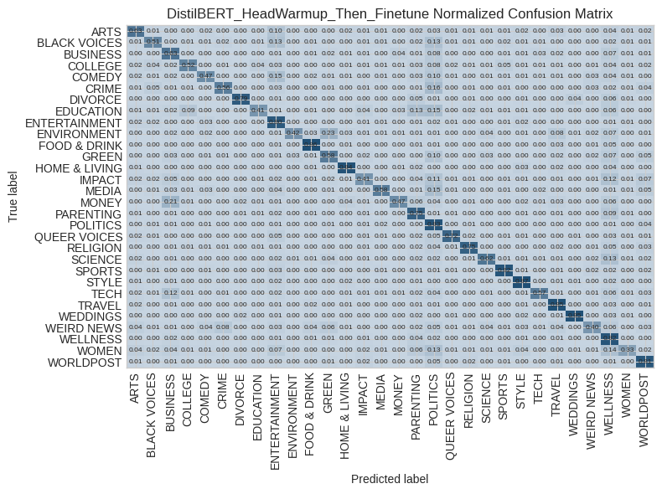
Figure B.1. Confusion Matrix for DistilBERT Model After Head Warmup and Fine-Tuning with Normalized Values
Evidence of class imbalance is visible in the per-class metrics. High-frequency categories systematically achieve stronger weighted performance, while low-frequency categories have noticeably weaker recall. Macro-F1 helps unmask this imbalance by treating all classes equally, revealing performance gaps that accuracy alone hides.
Training dynamics show moderate signs of overfitting: the validation loss diverges slightly after a few epochs, while training accuracy continues to rise. However, the gap is not extreme, suggesting the model generalizes reasonably well. The use of dropout, early stopping, and pretrained embeddings helped control underfitting while keeping overfitting manageable.

B.3.3 Summary of Final Model Performance
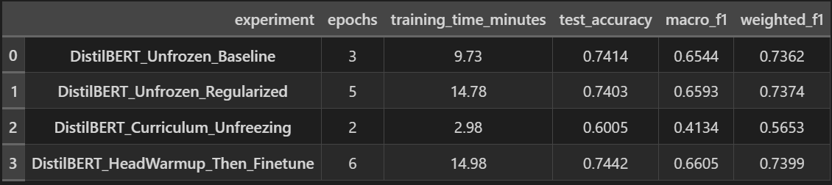
Table B.3. Performance Metrics for DistilBERT Model Experiments
DistilBERT with Head Warmup and Then Fine-tuning is the best-performing solution because it achieves the strongest balance of macro-F1, weighted-F1, and accuracy while maintaining stable training/validation curves. It captures high-level semantics across dozens of categories while avoiding excessive overfitting, a challenge that baseline models and shallow architectures struggled with.
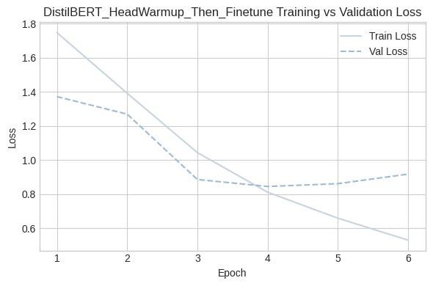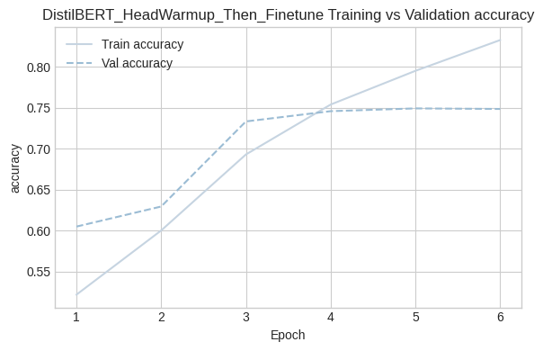
Figure B.2. Training and Validation Metrics for DistilBERT Head Warmup Then Fine-Tune Experiment
Its performance reflects the inherent difficulty of the HuffPost task: 35+ classes with overlapping themes, varying article lengths, and significant imbalance. Even strong models show confusion between closely related categories, as expected for a dataset with subtle topical distinctions.
Notably, the model demonstrates strong performance on high-frequency, well-defined categories and maintains respectable performance across many minority classes. A surprising behavior is how effectively the model distinguishes between broad domains (e.g., politics vs. entertainment) while still struggling with nuanced lifestyle-oriented categories. Its weaknesses, primarily in low-support or highly similar classes, highlight natural limitations of text classification with overlapping semantic boundaries.
Overall, the final model delivers solid generalization and reliable multi-class performance, making it the strongest and most balanced approach for this dataset.

B.4: Discussion and Reflection

B.4.1 Limitations and Sources of Error
Despite mitigation strategies, the 9.6:1 imbalance ratio fundamentally limits the performance of the minority class. Categories with fewer than 500 samples consistently underperformed (EDUCATION: F1=0.440, COLLEGE: F1=0.495), suggesting insufficient training examples for robust learning. The dataset contains inherent semantic overlap that no classifier can fully resolve. The 23% MONEY → BUSINESS misclassification rate reflects genuine topical ambiguity rather than model failure, as these categories share fundamental content about markets and corporate finance.
With only 30 words per sample on average, the model must extract categorical signals from severely limited context. Headlines prioritize attention-grabbing language over comprehensive description, making subtle distinctions (EDUCATION vs. COLLEGE) particularly challenging. Our training data spanning 2012-2018 potentially encodes outdated language patterns that may not generalize to contemporary articles. The 0.43-point training-validation loss gap suggests moderate overfitting, while our label-merging strategy introduced new ambiguities by creating semantically broad categories such as PARENTING (spanning infant care to midlife transitions).
B.4.2 Potential Improvements
Three concrete improvements could significantly enhance performance. First, implementing focal loss would down-weight easy examples and focus learning on hard negatives, potentially improving macro-F1 without the training instabilities we observed with explicit class weighting. Second, a two-stage hierarchical classifier that first predicts broad domains and then performs fine-grained classification would leverage our model's reliable distinctions across broad categories. Third, expanding context windows from 64 to 128 tokens could capture additional disambiguating information for borderline cases.
Additional promising directions include text augmentation (back-translation, synonym replacement), ensemble methods combining DistilBERT with TF-IDF and character-level CNNs, upgrading to larger transformers (RoBERTa-base, DeBERTa-base), using news-domain pretrained models, and multi-task learning with auxiliary tasks like sentiment analysis.

B.4.3 Reflection on Learning and Insights
The most impactful decision was selecting macro-F1 as our primary optimization target rather than accuracy. Early experiments optimizing for accuracy achieved 76% test accuracy but only 0.58 macro-F1, effectively ignoring minority classes. This reinforced the need for metric selection to align with business requirements. The performance gap between our TF-IDF baseline (52% accuracy) and final DistilBERT model (74.4% accuracy) demonstrated the power of pretrained representations. At the same time, the importance of fine-tuning strategy (head warmup vs. immediate full fine-tuning) highlighted that successful transfer learning requires thoughtful adaptation, not just loading pretrained weights.
We initially approached class imbalance as a loss function problem, but our best results came from architectural choices and training strategies rather than mathematical corrections. Analyzing our confusion matrix proved more valuable than aggregate metrics, revealing hierarchical relationships (asymmetric MONEY → BUSINESS confusion) and semantic incoherence (distributed IMPACT confusion) invisible in category labels. Our most sophisticated training strategy (curriculum learning with gradual unfreezing) yielded our worst performance (macro-F1: 0.413), while a simple head warmup outperformed all alternatives, underscoring that complexity rarely yields proportional gains.
If repeating this project, we would investigate hierarchical classification earlier, conduct more thorough error analysis during Milestone 1 to identify beneficial label merges, and allocate more time to data augmentation rather than hyperparameter tuning. The HuffPost task proved harder than anticipated, with human-level performance likely around 85-90% given genuine ambiguities. Our 74.4% accuracy suggests we captured roughly 80-85% of learnable signal, with the wide F1 range (0.312 to 0.852) indicating heterogeneous difficulty across categories. Automated news categorization remains a partially solved problem, requiring a combined human-AI system for production deployment.

B.5: AI Use Disclosure
ChatGPT was used throughout this project to help us brainstorm ideas and clarify differences between various data structures. ChatGPT and other AI tools were not used to create or produce code. We utilized these tools to deepen our understanding of concepts, the dataset, and the data structure we were working with. AI is not perfect and should not be taken at face value. It was most effective for us when we wanted explanations, examples, or how to get started with tasks. The specific tasks we used AI for are below.
- Help explain the differences between Hugging Face Datasets and traditional data structures such as NumPy arrays and Pandas DataFrames. This helped clarify how to access and manipulate the data effectively within the notebook.
- To brainstorm potential data cleaning and preprocessing steps for the HuffPost text dataset, which helped refine our approach to handling missing data and class imbalance
- Used to research best practices for fine-tuning DistilBERT models.
- Researched issues with the differences in working with HuggingFace and TensorFlow
- Develop a Table style from a Pandas Dataframe

References
Misra, R. (2018). News Category Dataset (Version unspecified) Dataset]. https://doi.org/10.13140/RG.2.2.20331.18729
Yassin, A. (2024, November 8). Adam vs. AdamW: Understanding Weight Decay and Its
Impact on Model Performance. Medium. https://yassin01.medium.com/adam-vs-adamw-understanding-weight-decay-and-its-impact-on-model-performance-b7414f0af8a1

Appendix A
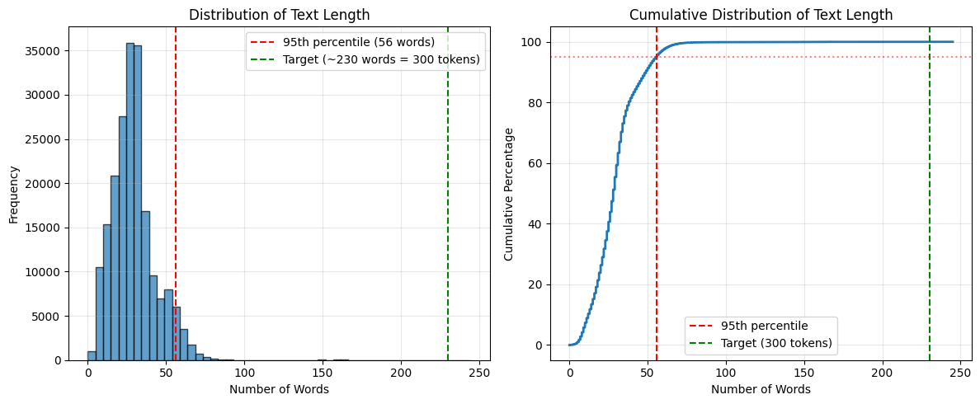
Figure A.1. Distribution of text length in the HuffPost News Category Dataset.
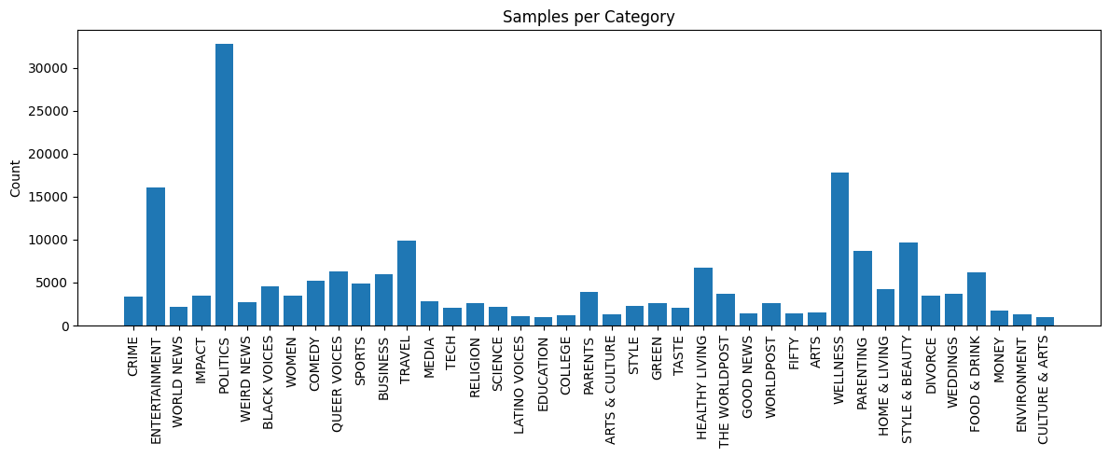
Figure A.2. Distribution of labels in the HuffPost News Category Dataset.

