See Example Projects/Concepts – Bookmark manager, Local Storage, Flexbox

1. UI Design

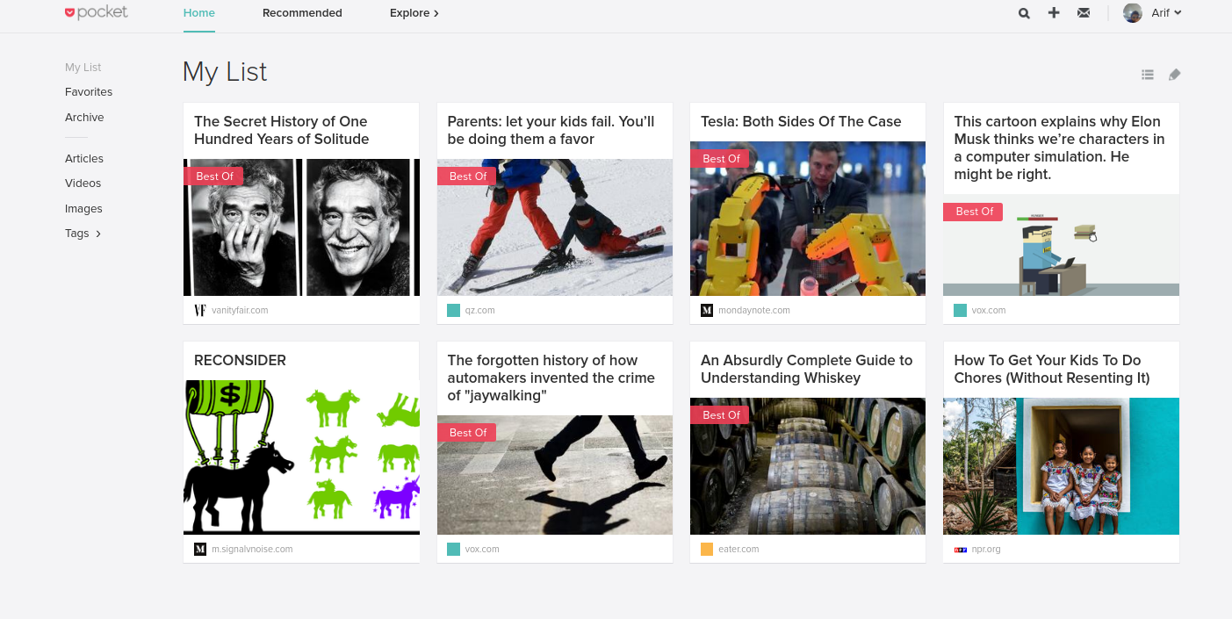

2. Add bookmark
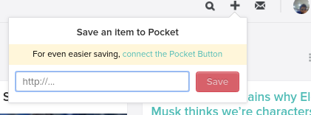


3. Delete bookmark

1. Show the delete option when hovered over the bookmark thumbnail

4. Toggle bookmark View
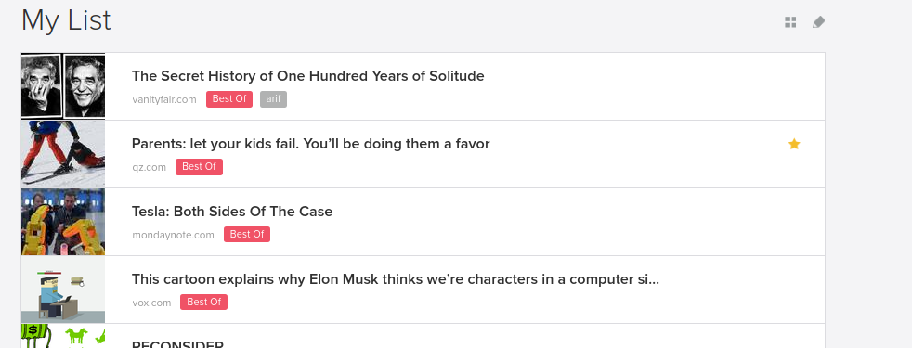

5. Filter Bookmarks By Tag Name

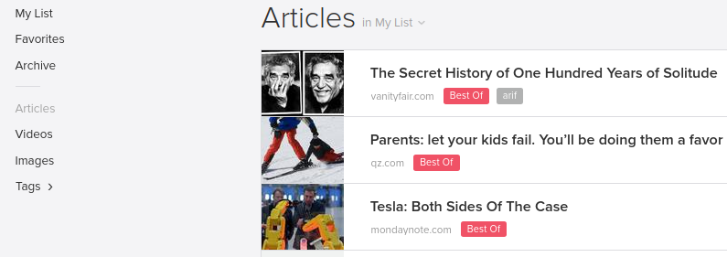

6. Edit Bookmark Tag

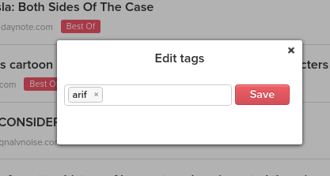

7. Dynamically render unique tag names in the sidebar when bookmark tags are added or modified

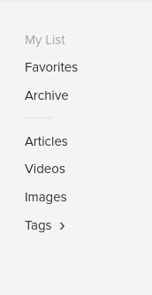

8. Search Bookmark

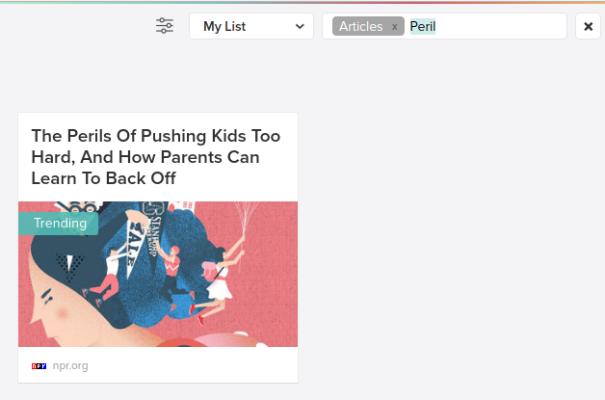

9. Sort Bookmark
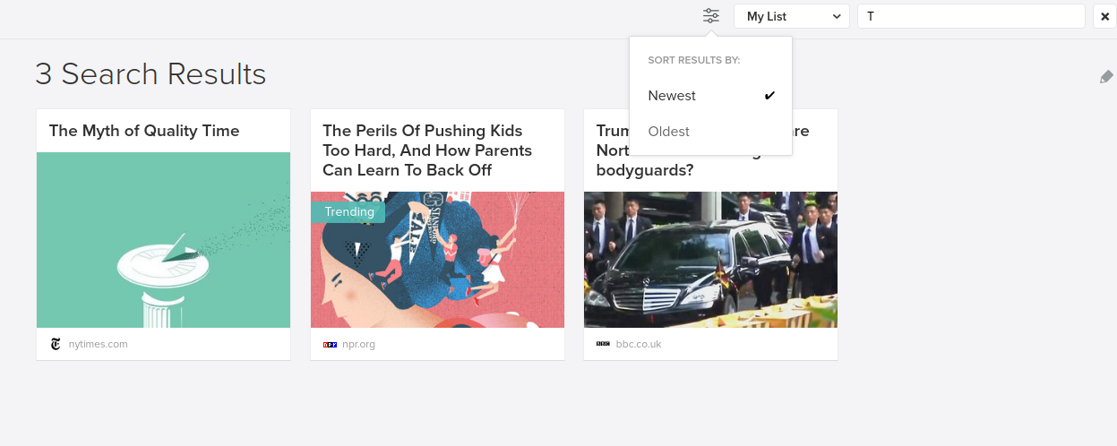

10. Bulk Edit

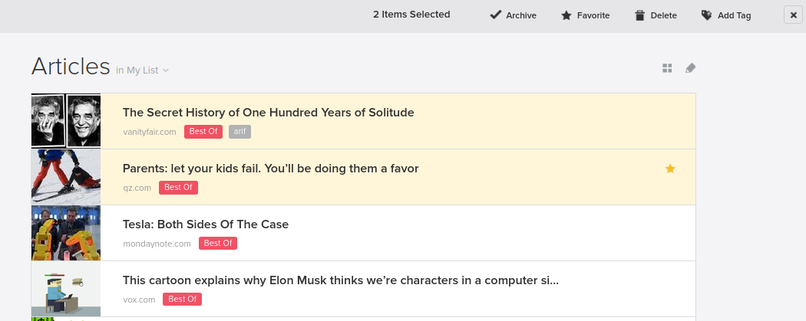
10.1 Bulk edit bookmark tags
10.2 Bulk delete bookmarks

11. Bug –After filtering user is unable to edit the bookmarks
- this is happening because the filtered bookmark list used to render the ui is not the same as the original bookmarkList. The indexes of the filtered list and the original list does not match. We need to have a index property on each bookmark object which will map to the data-index property of the rendered list items

[Resolved] – included a global counter which increments on each bookmark creation and assign that as bookmark index

