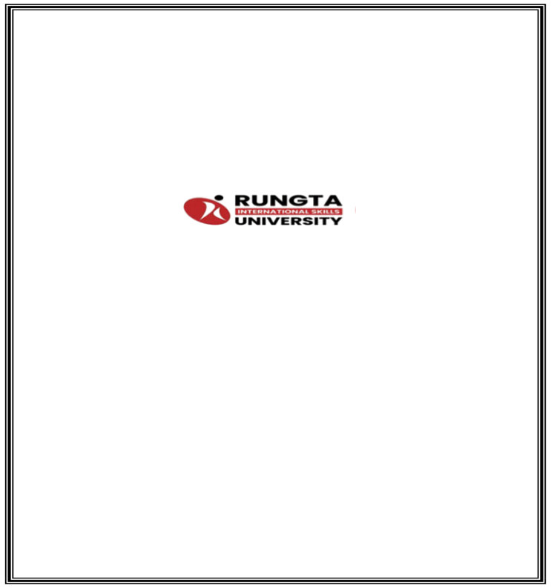
Project

Interim

Report

On

Smart

Home

Automation

System

(
Using

Core

Java

&

OOP

Concepts)

RU-100-01-00012

Object

Oriented

Programming

with

Java

SESSION:

2025-26

Submitted

By

Ujjawal Gupta

RU-25-11549

Under

the

Guidance

of

Mr.

Harsh

Multani

SCHOOL

OF

INFORMATION

TECHNOLOGY

RUNGTA

INTERNATIONAL

SKILLS

UNIVERSITY

BHILAI,

CG

(
April

2026)

TABLE

Serial No. | Title | Pg no.
1 | Abstract | 1
2 | Introduction | 2
3 | Objectives | 3
4 | Scope | 4
5 | SYSTEM REQUIREMENTS | 5
6 | METHODOLOGY | 7
7 | FLOW CHAT | 8
8 | IMPLEMENTATION | 9
9 | Future Enhancements | 10
10 | Gantt Chart | 11
11 | Conclusion | 12
12 | Reference | 13

Abstract

The Smart Home Automation System is a console-based application developed using Core Java and Object-Oriented Programming (OOP) concepts. The project is designed to simulate a basic smart home environment where users can control household devices such as lights and fans through a centralized system.
This project is needed to demonstrate how modern smart home technologies improve convenience, energy efficiency, and control over daily household operations. It also helps in understanding how real-world systems can be designed using programming concepts, especially OOP principles like inheritance, polymorphism, encapsulation, and method overriding.
The system allows users to perform essential operations such as turning devices ON and OFF and checking their current status. It manages multiple devices efficiently by using a common interface, making the system simple, flexible, and easy to extend. The design ensures code reusability and scalability, allowing future enhancements such as adding more devices or integrating advanced features.

Introduction

The Smart Home Automation System is a console-based application developed using Core Java and Object-Oriented Programming (OOP) concepts. The primary objective of this project is to simulate the functioning of smart home technology by enabling users to control various household devices, such as lights and fans, through a centralized system.
In the modern era, smart home systems have gained significant importance due to their ability to provide convenience, energy efficiency, and enhanced control over household appliances. This project aims to replicate a simplified version of such systems, where multiple devices can be managed efficiently using a single interface. The system is designed using a base class called Device and derived classes such as Light and Fan, which inherit common properties and behaviors while also offering flexibility for future expansion.
The application allows users to perform basic operations such as turning devices ON and OFF and checking their current status. It utilizes key OOP concepts, including inheritance, polymorphism, encapsulation, and method overriding, to ensure a structured, modular, and reusable design. These principles help in improving code maintainability and scalability.
Furthermore, the system can be extended by incorporating additional devices such as AC and TV, as well as advanced features like scheduling and automation. Overall, this project provides a clear understanding of how real-world systems can be modeled using OOP principles and serves as a strong foundation for developing more advanced and intelligent home automation systems.

Objectives

The main objectives of the Smart Home Automation System project are:

- To design and develop a smart home automation system using Object-Oriented Programming (OOP) concepts such as inheritance and polymorphism, ensuring a structured and efficient approach to problem-solving.
- To create a base class (Device) and multiple derived classes (such as Light, Fan, etc.) to represent different home appliances, thereby demonstrating the concept of class hierarchy.
- To control and manage multiple devices efficiently through common methods like turnOn() and turnOff(), reducing code duplication and improving maintainability.
- To implement polymorphism by using a single reference variable to handle different types of devices, enabling flexibility and scalability in the system.
- To simulate a real-world smart home environment in a simplified console-based application, providing a practical understanding of automation systems.
- To apply key OOP concepts such as encapsulation, inheritance, polymorphism, and method overriding in a real-world scenario.
- To improve code reusability, modularity, and readability through proper class design and logical structuring of the program.
- To develop a system that can be easily extended by adding new devices or features without affecting the existing code.
- To reduce manual effort in controlling devices by providing a centralized and automated system.
- To build a strong foundation for developing advanced applications such as IoT-based smart home systems in the future.

Scope

The Smart Home Automation System is designed to provide a basic framework for controlling and managing household devices in a small-scale home environment. It focuses on devices such as lights and fans, allowing users to perform operations like turning them ON and OFF and monitoring their current status through a centralized console-based system. The project primarily emphasizes the application of Object-Oriented Programming (OOP) concepts to model real-world scenarios in a simple and understandable way.
The scope of the current system is limited to a standalone application without real-time connectivity or external integration. It operates locally and does not include advanced features such as remote access, automation based on sensors, or data storage. The main purpose at this stage is to demonstrate core functionalities and provide a clear understanding of system design using classes, objects, inheritance, and polymorphism.
Despite its simplicity, the project has a wide scope for future enhancements. It can be extended by incorporating a Graphical User Interface (GUI) using Java Swing or JavaFX to improve user interaction and usability. Integration with a database (such as MySQL or SQLite) can allow storage of device data, user preferences, and usage history. Furthermore, the system can be upgraded to support Internet of Things (IoT) technologies, enabling remote control of devices through the internet using hardware components like Arduino or Raspberry Pi.
Additional features such as automation and scheduling can be implemented to allow devices to operate automatically based on time, environmental conditions, or user-defined rules. The system can also be expanded into a mobile or web-based application, making it accessible from anywhere. Security features, user authentication, and energy monitoring can further enhance the system’s capabilities.
In conclusion, while the current project is limited to a basic implementation, it serves as a strong foundation that can be scaled into a fully functional, intelligent, and real-world smart home automation system with advanced technologies and features

SYSTEM REQUIREMENTS

The system requirements for this project are minimal because the Smart Home Automation System is a simple console-based Java application. Since the project is developed using Object-Oriented Programming (OOP) concepts in Java, it can run on any system that supports the Java platform. The project does not require high-end hardware or specialized software tools, making it easy to develop, test, and execute on a basic computer system.
For hardware requirements, a computer or laptop with at least an Intel/AMD processor, 2 GB RAM or more, and sufficient storage space is enough to run the program smoothly. Basic input and output devices such as a keyboard and monitor are required for writing, compiling, and executing the program.
For software requirements, the system should have an operating system such as Windows, Linux, or macOS. The main requirement is the Java Development Kit (JDK), which provides the necessary tools such as the compiler and runtime environment to develop and run Java programs. Any code editor or Integrated Development Environment (IDE) such as Visual Studio Code, Eclipse, IntelliJ IDEA, or NetBeans can be used to write, edit, and manage the source code. The system should also include a command prompt/terminal or IDE console to compile and execute the program.
The project does not require any external database, internet connection, or third-party libraries, as all operations are performed within the program using basic Java methods and logic. However, future enhancements may include database integration or IoT-based connectivity. Overall, the system requirements are simple, cost-effective, and easily accessible, making the project suitable for academic learning and practical implementation.

METHODOLOGY

The methodology of this project is based on the step-by-step design and implementation of a Smart Home Automation System using Object-Oriented Programming (OOP) in Java. The project follows a structured development approach in which real-world home devices are first analyzed and then modeled into a software system using classes and methods.
The first step in the methodology is the identification of the main requirements of the system. The project needs to perform basic operations such as turning devices ON, turning them OFF, and displaying their current status. These requirements are carefully analyzed to ensure that the system behaves like a simplified real-world smart home environment.
The second step is the design of the system using a base class called Device. In this step, common attributes such as device name and device status (ON/OFF) are defined. These variables are declared private to ensure encapsulation and to protect the internal state of each device object.
The third step is the creation of derived classes such as Light and Fan. These classes extend the Device class and inherit its properties and methods. This demonstrates the concept of inheritance and allows code reusability. If required, methods can be overridden to provide specific behavior for each device.
The fourth step is the implementation of methods such as turnOn() and turnOff(). These methods are responsible for changing the state of the device and displaying appropriate output messages. This step ensures that each device responds correctly to user commands.
The fifth step is the application of polymorphism. A common reference of type Device is used to handle different objects like Light and Fan. This allows the same methods to work for multiple device types, making the system flexible and scalable.
The sixth step is the management of multiple devices using an array or collection. All device objects are stored in a single structure, which makes it easy to perform operations on all devices using loops. This reduces code repetition and improves efficiency.
The seventh step is testing and validation of the system. In this stage, device objects are created in the main method, and operations such as turning devices ON and OFF are performed. The output is checked to ensure that all devices respond correctly and display accurate status messages.
The final step in the methodology is result observation and analysis. The output of the program is verified to confirm that the system works as expected. Through this methodology, the project is developed in a systematic manner, ensuring proper class design, correct implementation of OOP concepts, and successful simulation of a smart home automation system.

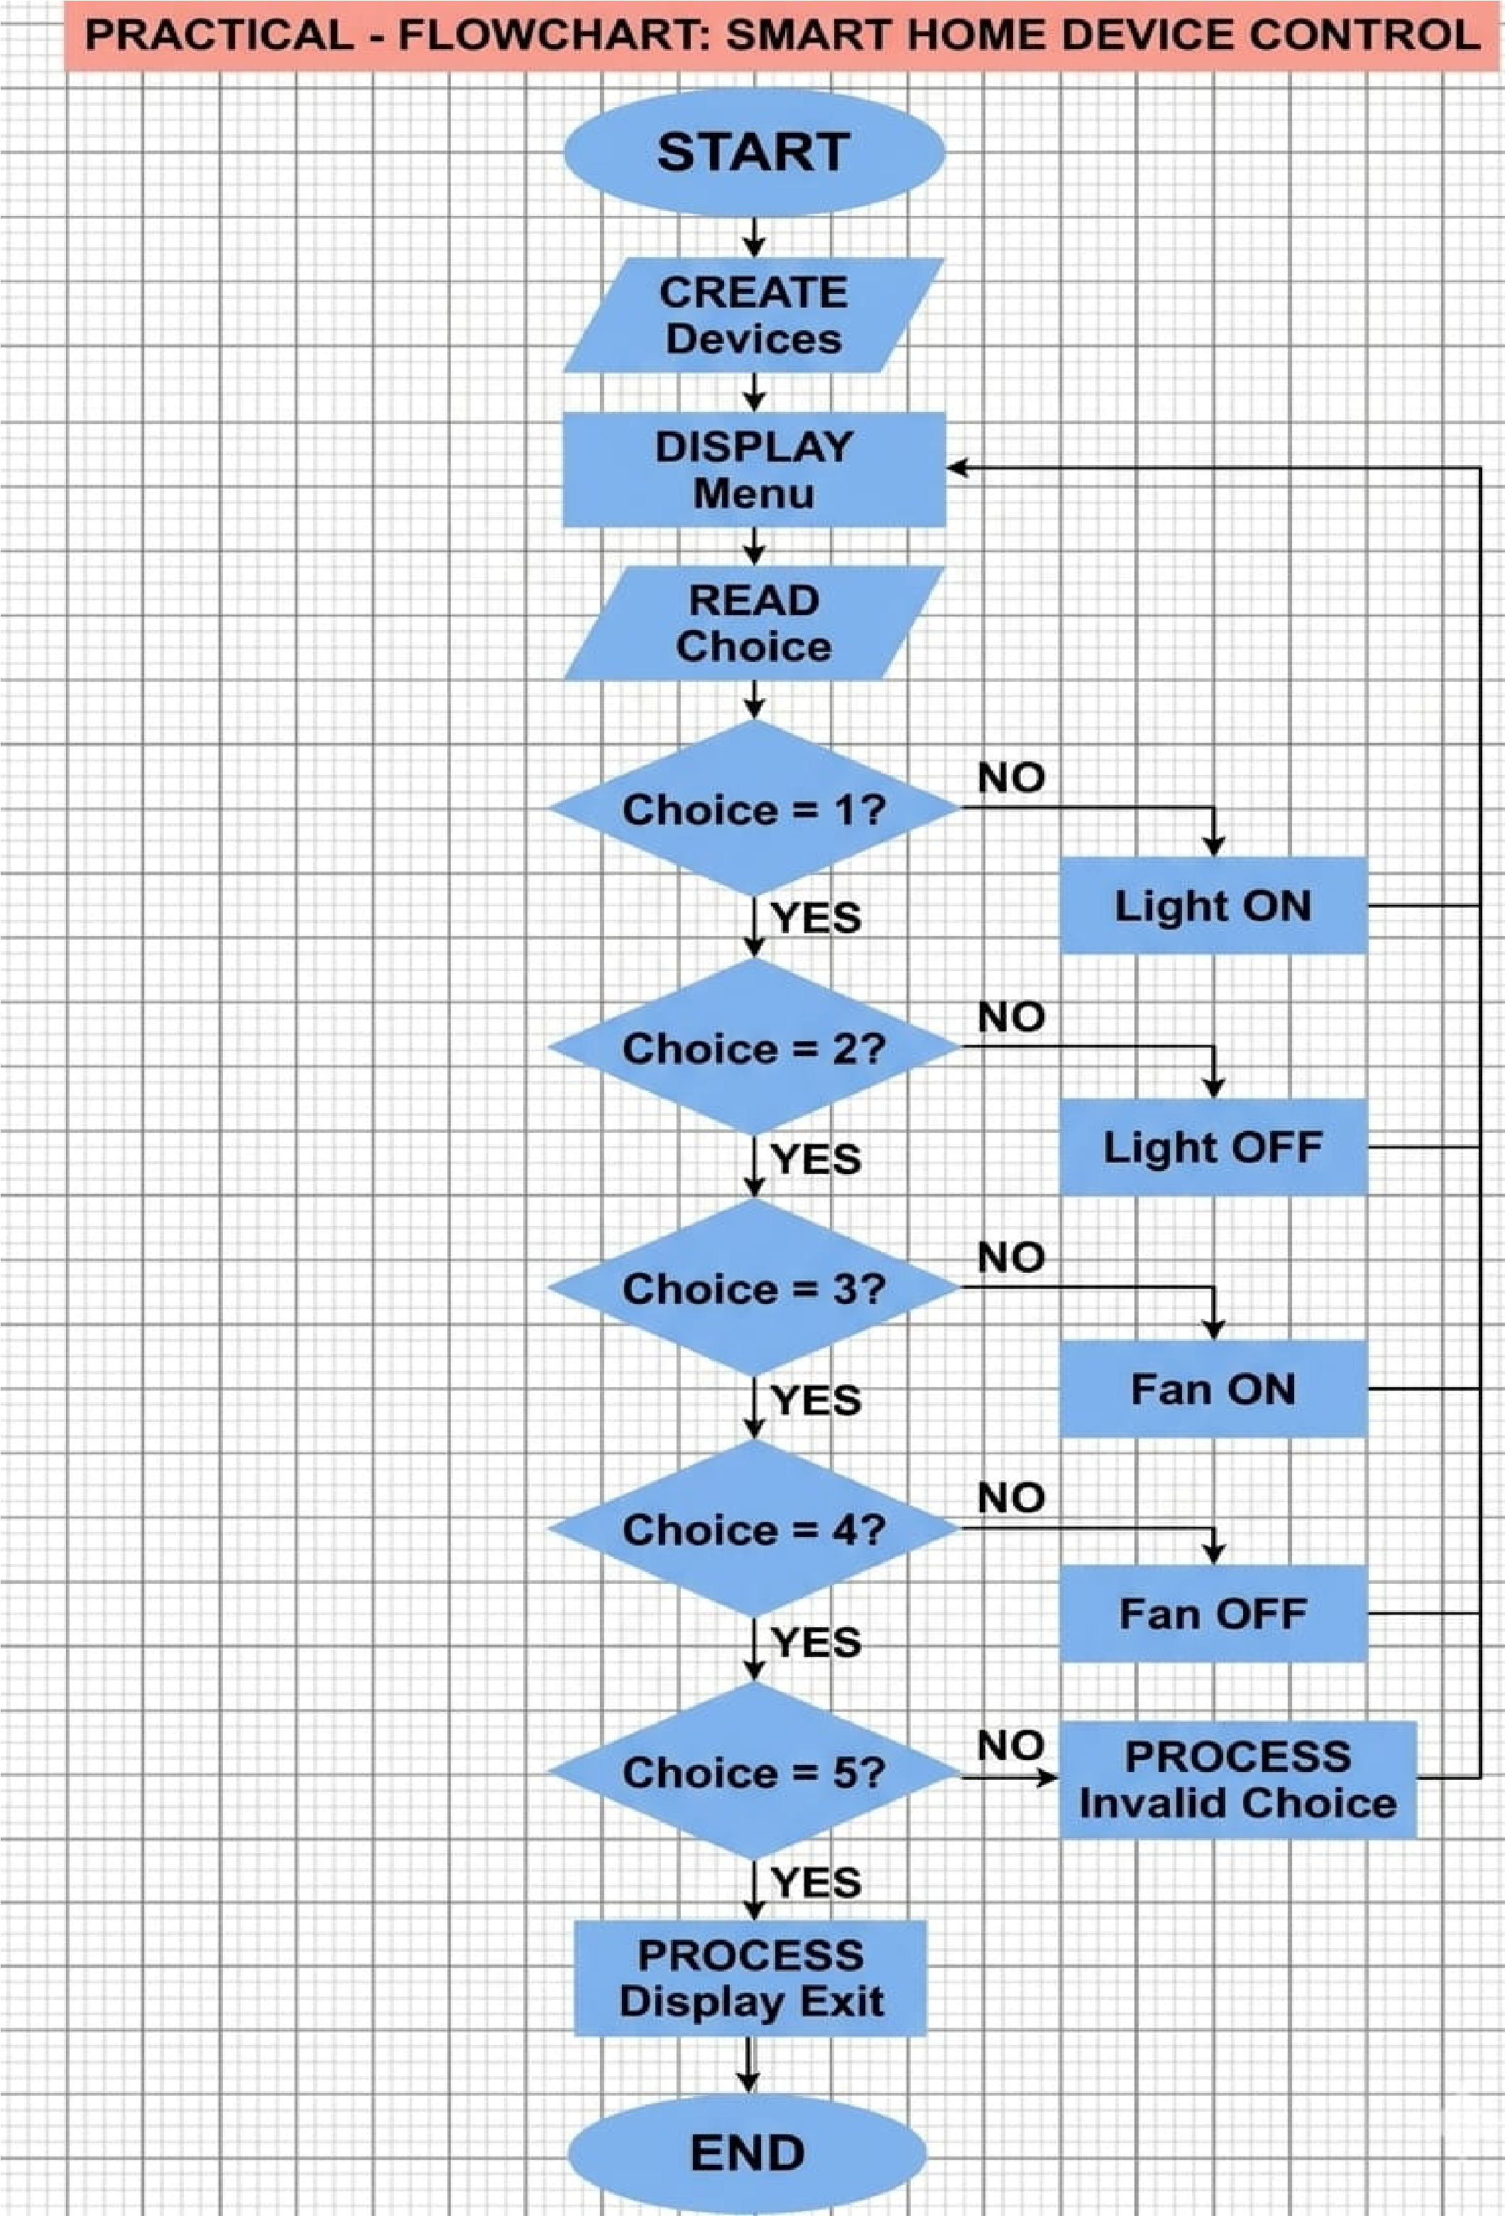

IMPLEMENTATION

The implementation of this project is based on the use of a main class that controls the overall execution of the program and a base class called Device along with its derived classes such as Light and Fan, which handle all device-related operations. The central logic of the project is organized within these classes so that the functionality remains structured, reusable, and easy to maintain.
The Device class is responsible for storing the common properties of all devices and performing basic operations. It includes variables such as device name and device status (ON/OFF). These variables are declared private to ensure encapsulation and protect the internal state of the object. The class also provides methods like turnOn() and turnOff() to control the device state.
Derived classes such as Light and Fan extend the Device class and inherit its properties and methods. This allows code reuse and demonstrates the concept of inheritance. If required, these classes can override methods to provide device-specific behavior, making the system flexible and extensible.
When a device is turned ON, the system updates its status and displays a message indicating that the device is active. Similarly, when a device is turned OFF, the system updates the status and displays the appropriate message. This ensures that each device responds correctly to control operations.
Another important part of the implementation is the use of polymorphism. A common reference of type Device is used to handle objects of different device types. This allows the same methods to operate on multiple devices, simplifying the code and improving scalability.
The main class is used to test and demonstrate the working of the system. It creates multiple device objects and stores them in an array or collection. Using loops, the program performs operations such as turning all devices ON and OFF. This approach reduces code repetition and makes the system efficient.

Sample Input/Output
In this project, no keyboard-based input is strictly required, as device operations are demonstrated through method calls within the program. The output is displayed in the terminal after executing different operations.
Sample Output 1:

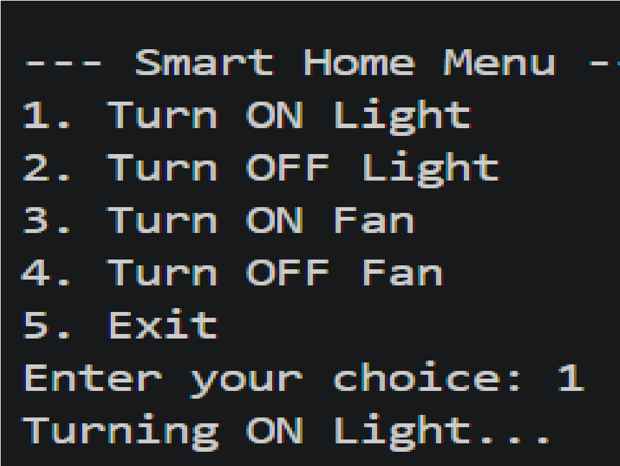

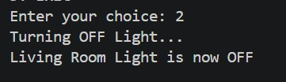

Sample Output 2:

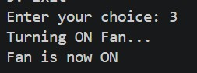

Sample Output 3:
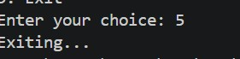

This output shows that when devices are turned ON, their status changes accordingly and is displayed to the user. Similarly, when devices are turned OFF, the system updates and displays their status. This confirms that the system successfully controls and manages multiple devices.

Future Enhancements
Although the current project successfully implements the basic functionality of controlling home devices such as lights and fans, there are many improvements that can be made in the future to enhance its functionality, usability, and real-world applicability. At present, the system is console-based and mainly focuses on demonstrating core object-oriented programming concepts like inheritance and polymorphism. Future enhancements can make the system more advanced, interactive, and closer to real smart home applications.
One major improvement would be the addition of a Graphical User Interface (GUI) using Java Swing or JavaFX. This would allow users to control devices using buttons, switches, and visual panels instead of typing commands in the console. A GUI-based system would be more user-friendly and visually appealing, making it easier for non-technical users to operate.
Another possible enhancement is the addition of more smart devices such as air conditioners, televisions, smart doors, and security cameras. This would make the system more comprehensive and realistic. The system can also be extended to include room-based control, where users can manage devices in different rooms like the bedroom, kitchen, and living room separately.
The project can also be upgraded by integrating a database system to store device status, user preferences, and usage history. This would allow users to track and manage their devices more efficiently. Additionally, features like device scheduling can be added, enabling automatic ON/OFF operations at specific times, which is very useful in real-world scenarios.
In the future, the system can be expanded into a mobile application or a web-based application, allowing users to control their home devices remotely through smartphones or the internet. Integration with IoT (Internet of Things) technology can make the system capable of controlling real hardware devices instead of just simulation.

Additional features such as voice control, energy consumption monitoring, security alerts, and automation rules (e.g., turning lights on automatically at night) can also be included. Thus, while the present project is simple and educational, it has a wide future scope and can be developed into a fully functional smart home automation system.

Gantt Chart
Planning & Structure
A Gantt chart is an important project management tool that helps in organizing and scheduling different tasks involved in the development of the Smart Home Automation System. It divides the entire project into smaller phases such as planning, design, coding, testing, and documentation. Each task is assigned a specific time period, which makes the development process more systematic and easy to manage.
In this project, the work begins with understanding the requirements and designing the class structure, followed by writing the code using object-oriented principles. After implementation, the system is tested to ensure correct functionality, and finally, the project report is prepared.
Task | Duration | Start Day | End Day | Description
Requirement Analysis | 1 Day | Day 1 | Day 1 | Understanding project goals and features
System Design | 1 Day | Day 2 | Day 2 | Creating class structure (Device, Light, Fan)
Coding  (Implementation) | 2 Days | Day 3 | Day 4 | Writing Java code using OOP concepts
Testing &  Debugging | 1 Day | Day 5 | Day 5 | Checking errors and verifying output
Documentation  (Report Writing) | 1 Day | Day 6 | Day 6 | Preparing project report
Final Review & Submission | 1 Day | Day 7 | Day 7 | Final checking and submission

Conclusion
The Smart Home Automation System project successfully demonstrates the application of core Object-Oriented Programming (OOP) concepts in Java, such as classes, objects, inheritance, polymorphism, and encapsulation. The system provides a simple yet effective way to simulate the control of home devices like lights and fans through a menu-driven interface.
Through this project, a clear understanding of how real-world systems can be modeled using programming concepts has been achieved. The use of a base Device class and its derived classes ensures code reusability, modularity, and better organization. The implementation also shows how multiple devices can be managed efficiently using a common interface.
Although the current system is console-based, it serves as a strong foundation for developing more advanced smart home applications. Overall, the project is functional, easy to understand, and useful for learning and applying OOP principles

REFERENCE

- H. Schildt, Java: The Complete Reference, 11th ed. New York: McGraw-Hill, 2018.

- Oracle, “System (Java Platform SE),” Oracle Documentation.
[Online]. Available:

https://docs.oracle.com/javase/8/docs/api/java/lang/System.html?

- Oracle, “Classes and Objects,” The Java™ Tutorials. [Online]. Available:

https://docs.oracle.com/javase/tutorial/java/javaOO/index.html?

