**1. Install Git :**

Windows : *git bash : https://gitforwindows.org/*

Ubuntu : *sudo apt-get install git-core*

RedHat : *sudo yum install git-core*

**2. Config Set :**

Set a Git username:

*git config --global user.name "Ethans Institute"*

*git config --global user.email "deepak.kumar@ethans.com"*

*ls*

**3. Need HELP?**

Open the help page in browser or in console

*git help <verb>*

*git <verb> --help*

**4. Initialize a repository from existing code.**

*mkdir LearnGit*

*cd LearnGit*

*git init* (will create .git directory which makes the LearnGit directory a tracked Repo)

*touch .project*

*touch test.pyc*

*touch calc.py*

*git status* (will show the untracked file before git commit)

*touch .gitignore* (to block some files in repo to not get commited to remote repo)

*vi .gitignore* (and add the files to be ignored)

.project

*.pyc

*git status* (will not show the files included in .gitignore)

**5. Basic WorkFlow**

Working Dir Staging Area .git Dir(Repo)

| | |

|<---------------------Checkout the Project-----------------------|

| | |

|---------------Stage Fixes---------->| |

| | |

| |------------Commit------->|

Add File to staging area

*git add .gitignore*

*git add calc.py*

Remove File to staging Area

*git reset calc.py* (bring back calc.py to untracked stage)

*git reset* (will bring all staged file to untracked)

**6. Our First Commit**

*git add -A* (add All file to staging area)

*git commit -m "Initial Commit"*

*git status*

*git log*

**7. Cloning a Remote Repo**

*mkdir RemoteRepo*

*cd RemoteRepo*

*git clone git@github.com: deepak2717/MyScripts.git .*

**8. Viewing Information about remote repository**

*git remote -v*

---------Note-----------

git pull does a git fetch followed by a git merge

You can do a git fetch at any time to update your remote-tracking branches under refs/remotes/<remote>/.

This operation never changes any of your own local branches under refs/heads, and is safe to do without changing your working copy

A git pull is what you would do to bring a local branch up-to-date with its remote version, while also updating your other remote-tracking branches

-------------------------

*git branch -a*

**9. create a .gitignore and calc.py in the cloned repo.**

*touch .gitignore*

*touch calc.py*

write a code in calc.py

def add(x,y):

pass

def subtract(x,y):

pass

def multiply(x,y):

pass

def divide(x,y):

pass

def square(x,y):

pass

*git add -A*

make change in the calc.py

def multiply(x,y):

return x*y

*git diff* (show the changes made in the files)

*git status* (show the modified state)

*git add -A* (all the chnages in file)

**10. Pushing the changes**

we should always pull first then push when there is parallel development is going on

*git pull origin master*

From github.com:deepak2717/MyScripts

* branch master -> FETCH_HEAD

Already up to date.

*git remote add origin git@github.com:deepak2717/MyScripts.git* (its get added when clone is done, if remote is not added we can use this command)

*git push -u origin master*

Counting objects: 4, done.

Delta compression using up to 4 threads.

Compressing objects: 100% (3/3), done.

Writing objects: 100% (4/4), 407 bytes | 203.00 KiB/s, done.

Total 4 (delta 1), reused 0 (delta 0)

remote: Resolving deltas: 100% (1/1), completed with 1 local object.

To github.com:deepak2717/MyScripts.git

7257f74..6c795bb master -> master

Branch 'master' set up to track remote branch 'master' from 'origin'.

**11. Common Work Flow :**

a) Create a branch from desired feature

*git branch calc-divide* (creates the branch from master)

*git branch* (check the branch)

*git checkout calc-divide* ( move from master to the created branch)

b) Make changes to the calc.py in divide function

def divide(x,y):

return x/y

*git status* ( show the modified state in branch)

*git add -A*

*git commit -m “Divide Function”* ( only changed in the local branch, it has no effect in the local master and remote repository)

c) After commit push branch to remote

*git push -u origin master*

*git branch -a*

d) Merge a Branch

*git checkout master* ( switch to master as branch need to be merged with master)

*git pull origin master* (a good practice, to pull any new changes from remote to local, in our case we had not made any changes)

*git branch –merged* ( It shows with what all branched you have merged till now)

*git merge calc-divide*

*git push origin master*

**12. Deleting a Branch**

*git branch –merged* (to check the branch is merged with master, so we can delete the branch now)

*git branch -d calc-divide* (delete the branch calc-divide locally, not from the remote)

*git branch -a* (we can see the calc-divide branch is still in remote)

*git push origin –delete calc-divide* (delete the branch from remote)

**13. Merge Vs Rebase**

**Merge :**

Merging is nice because it’s a non-destructive operation. The existing branches are not changed in any way. This avoids all of the potential pitfalls of rebasing

git checkout feature

git merge master

OR

git merge feature master

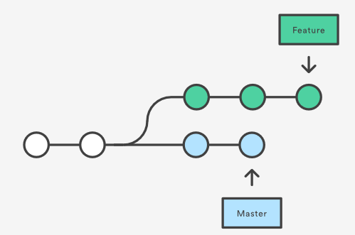

After Merge :

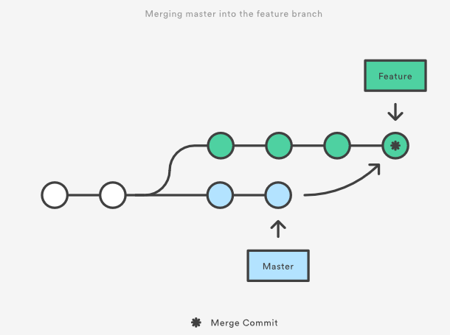

**REBASE**

As an alternative to merging, you can rebase the feature branch onto master branch using the following commands:

git checkout feature

git rebase master

The major benefit of rebasing is that you get a much cleaner project history. First, it eliminates the unnecessary merge commits required by git merge.

Second, as you can see in the below diagram, rebasing also results in a perfectly linear project history—you can follow the tip of feature all the way to the beginning of the project without any forks

