1. CRUD USER API Create API endpoints to Create/Read/Update/Delete (CRUD) User

Create a User POST
http://localhost:3000/api/auth/register { "userEmail": "testuser@example.com","firstName": "Test","lastName": "User","password": "password123","isActive": true }

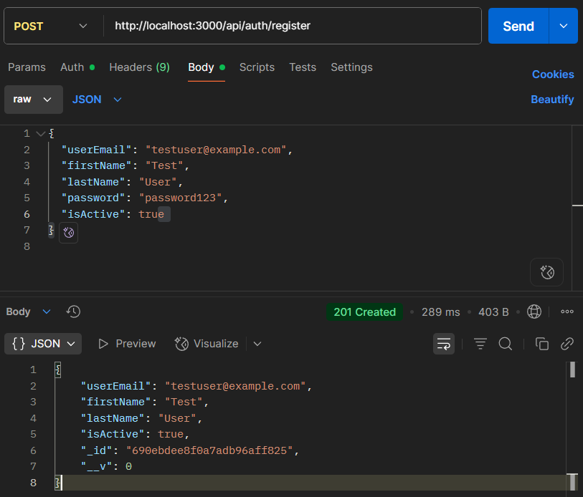

Login POST

http://localhost:3000/api/auth/login { "userEmail": "testuser@example.com", "password": "password123"}

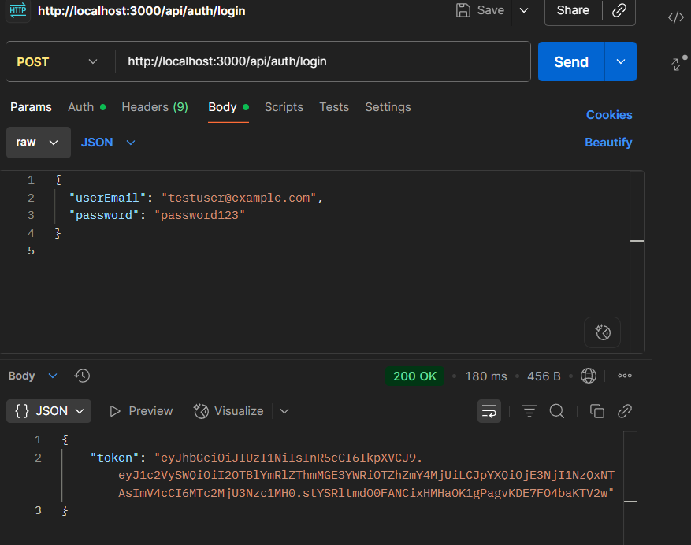
Read GET

http://localhost:3000/api/users

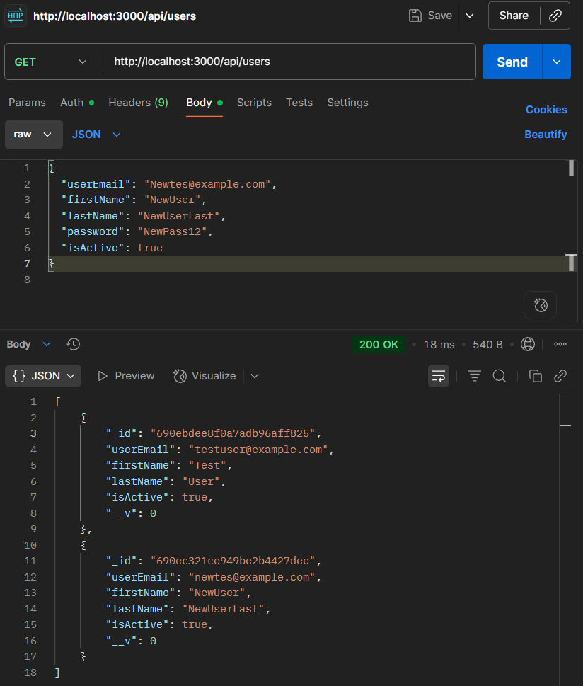

Update PUT

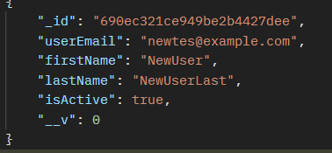

_id : 690ec321ce949be2b4427dee

http://localhost:3000/api/users/690ec321ce949be2b4427dee { "firstName": "NewUserUpdated", "isActive":false}

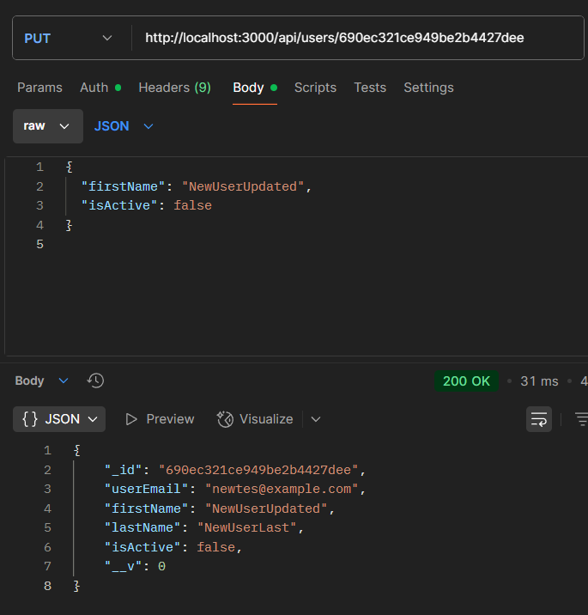

Delete DELETE

http://localhost:3000/api/users/690ebdee8f0a7adb96aff825

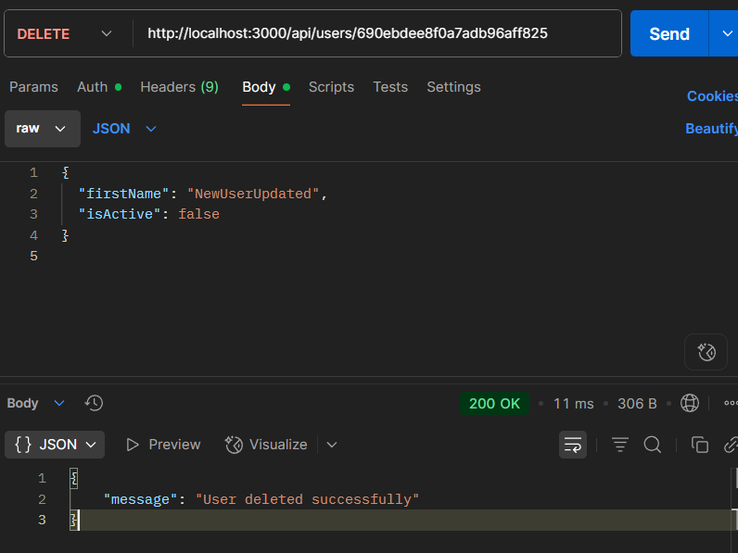

Code :

models/User.js

const mongoose = require('mongoose');

const userSchema = new mongoose.Schema({
userEmail: { type: String, required: true, unique: true, lowercase: true, trim: true },
firstName: { type: String, required: true, trim: true },
lastName: { type: String, required: true, trim: true },
isActive: { type: Boolean, default: true },
password: { type: String, required: true }
});

userSchema.set('toJSON', {
transform: (doc, ret) => {
delete ret.password;
return ret;
}
});

const User = mongoose.model('User', userSchema);
module.exports = User;

routes/users.js

const express = require('express');
const router = express.Router();
const User = require('../models/User');

// Create a new user

router.post('/', async (req, res) => {
try {
const user = new User(req.body);
await user.save();
res.status(201).json(user);
} catch (error) {
res.status(400).json({ error: error.message });
}
});

// Get all users
router.get('/', async (req, res) => {
try {
const users = await User.find();
res.json(users);
} catch (error) {
res.status(500).json({ error: error.message });
}
});

// Get a user by ID

router.get('/:id', async (req, res) => {
try {
const user = await User.findById(req.params.id);
if (!user) return res.status(404).json({ error: 'User not found' });
res.json(user);
} catch (error) {
res.status(500).json({ error: error.message });
}
});

// Update

router.put('/:id', async (req, res) => {
try {
const user = await User.findByIdAndUpdate(req.params.id, req.body, { new: true, runValidators: true });
if (!user) return res.status(404).json({ error: 'User not found' });
res.json(user);
} catch (error) {
res.status(400).json({ error: error.message });
}
});

// Delete

router.delete('/:id', async (req, res) => {
try {
const user = await User.findByIdAndDelete(req.params.id);
if (!user) return res.status(404).json({ error: 'User not found' });
res.json({ message: 'User deleted successfully' });
} catch (error) {
res.status(500).json({ error: error.message });
}
});

module.exports = router;

routes/auth.js

const express = require('express');
const bcrypt = require('bcryptjs');
const jwt = require('jsonwebtoken');
const User = require('../models/User');
const router = express.Router();
const JWT_SECRET = process.env.JWT_SECRET;

// Register
router.post('/register', async (req, res) => {
try {
const { userEmail, firstName, lastName, password, isActive } = req.body;
const existingUser = await User.findOne({ userEmail });
if (existingUser) {
return res.status(400).json({ message: 'Email already registered.' });
}
const hashedPassword = await bcrypt.hash(password, 10);
const user = new User({
userEmail,
firstName,
lastName,
isActive, // Optional, defaults to true if not provided
password: hashedPassword
});
await user.save();
const { password: _, ...userWithoutPassword } = user.toObject();
res.status(201).json(userWithoutPassword);
} catch (error) {
res.status(500).json({ message: error.message });
}
});

// Login
router.post('/login', async (req, res) => {
try {
const { email, password } = req.body;
const user = await User.findOne({ email });
if (!user) {
return res.status(401).json({ message: 'Invalid credentials' });
}
const valid = await bcrypt.compare(password, user.password);
if (!valid) {
return res.status(401).json({ message: 'Invalid credentials' });
}
const token = jwt.sign(
{ userId: user._id, email: user.email },
JWT_SECRET,
{ expiresIn: '1h' }
);
res.json({ token });
} catch (error) {
res.status(500).json({ message: error.message });
}
});

module.exports = router;

Main

app1.js

require('dotenv').config();
const express = require('express');
const mongoose = require('mongoose');
const cors = require('cors');
const usersRouter = require('./routes/users');
const authRoutes = require('./routes/auth');

const app = express();
const port = process.env.PORT || 3000;

app.use(cors());
app.use(express.json());

// Connect to MongoDB
mongoose.connect('mongodb://127.0.0.1:27017/ScratchCardDB', {
useNewUrlParser: true,
useUnifiedTopology: true
})
.then(() => console.log('MongoDB connected successfully'))
.catch((err) => console.log('MongoDB connection error:', err));

app.use('/api/auth', authRoutes);
app.use('/api/users', usersRouter);

app.get('/', (req, res) => {
res.send('Hello World!');
});

app.listen(port, () => {
console.log(`Server is running on port ${port}`);
});

Conclusion : CRUD operation are successfully completed

