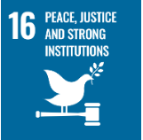
SDG – 16: Peace, Justice and Strong Institutions

Dashboard regarding SDG - 16 | Count
SDG 16 Related Publications (2024-25) | 26
Cumulative SDG 16 Related Publications | 41
Field-Weighted Citation Impact (FWCI) | 0.85
Citation Count | 76
Major Events Aligned with SDG 16 | 13
Various Outreach Programmes, and Other Academic/Professional Activities | 25

Kalinga University, Raipur, is committed to promoting peaceful, inclusive and just societies by strengthening institutional accountability, transparency, ethical governance and respect for human rights. The University actively contributes to SDG 16 through its Faculty of Law, Legal Aid Cell, Internal Complaints Committee (ICC), Anti-Ragging Committee, Grievance Redressal Cell and various student welfare initiatives. These institutional mechanisms ensure access to justice, protect individual rights, promote gender equality and provide a safe, inclusive and discrimination-free campus environment.
The University conducts legal awareness programmes, workshops, seminars, awareness campaigns and community outreach activities to educate students and local communities about constitutional values, fundamental rights, legal responsibilities and social justice. Through NSS, the Department of Students' Welfare (DSW) and student-led initiatives, the University encourages civic responsibility, peaceful coexistence, democratic participation and ethical leadership.
Furthermore, Kalinga University promotes transparent administrative practices, responsible decision-making and effective grievance redressal mechanisms to ensure institutional integrity and accountability. By integrating legal education, community engagement and good governance practices, the University strives to develop socially responsible citizens and contribute towards building peaceful, inclusive and sustainable communities in alignment with United Nations Sustainable Development Goal 16.

16.1 Research on Peace and Justice
Kalinga University promotes research on peace, justice, human rights, constitutional values, social inclusion and good governance through its Faculty of Law and interdisciplinary research initiatives. Faculty members and scholars undertake research addressing legal reforms, gender justice, access to justice, human rights protection, conflict resolution and social equity. Through research publications, seminars, conferences and community engagement, the University contributes to strengthening legal awareness, promoting peaceful coexistence and supporting transparent, accountable and inclusive institutions in alignment with SDG 16.
16.1.1 Peace, Justice and Strong Institutions: Citescore
Kalinga University actively contributes to SDG 16 through research focusing on peace, justice, human rights, good governance and strong institutions. The University has published 41 cumulative research papers, receiving a total of 76 citations, reflecting the research impact and scholarly contributions in this area. These publications promote legal awareness, social justice, institutional accountability, transparency and inclusive development, supporting the University's commitment to the United Nations Sustainable Development Goal 16.
16.1.2 Peace, Justice and Strong Institutions: FWCI
University demonstrates its research contribution to SDG 16 through 41 publications addressing peace, justice, human rights, good governance and institutional accountability. These publications have achieved a Field-Weighted Citation Impact (FWCI) of 0.85, indicating their citation performance relative to the global average in corresponding research fields. This research contributes to advancing legal awareness, social equity, transparency and inclusive institutional development.

16.1.3 Peace, Justice and Strong Institutions: Publications
Kalinga University has demonstrated consistent growth in research publications aligned with SDG 16: Peace, Justice and Strong Institutions. As illustrated in the graph, the University recorded no aligned publications in 2021 and 2022, followed by 7 papers in 2023 and 4 papers in 2024. A significant increase was observed in 2025, with 22 research publications, representing the highest annual contribution. In 2026, the University recorded 9 publications. These research contributions reflect growing academic engagement in areas such as human rights, social justice, legal reforms, good governance, institutional accountability and peaceful societies.

Figure: Year-wise Research Papers aligned with SDG 16
Graph: Year-wise Research Publications Related to SDG 16: Peace, Justice and Strong Institutions (2021–2026)

16.2 University Governance Measures
16.2.1 Elected Representation 2025
Kalinga University has implemented a Policy for Students' Council to promote student participation, leadership development, representation, communication and responsible engagement in institutional activities. The Council provides a structured platform for students to express suggestions and concerns and actively participate in academic, cultural, sports, technical, social, sustainability, community-service and student-welfare initiatives.
The Council is constituted through election, nomination, selection or a combination of these methods, as approved by the competent authority, ensuring appropriate student representation. Representatives must fulfil prescribed eligibility criteria, including satisfactory academic performance, attendance, discipline and conduct.
The Council facilitates teamwork, peer engagement and constructive communication between students and university authorities. Periodic meetings are conducted, with proper records of agendas, attendance, minutes, suggestions and action-taken reports. Student welfare concerns are communicated to appropriate authorities, while formal grievances are referred to designated grievance redressal mechanisms and statutory committees.
A Faculty Advisor or Student Council Coordinator guides and monitors its functioning. All activities require prior university approval and follow prescribed financial procedures.
Through this initiative, Kalinga University promotes student empowerment, democratic participation, transparency, accountability and responsible leadership, contributing to SDG 16: Peace, Justice and Strong Institutions.

Student Council Policy:
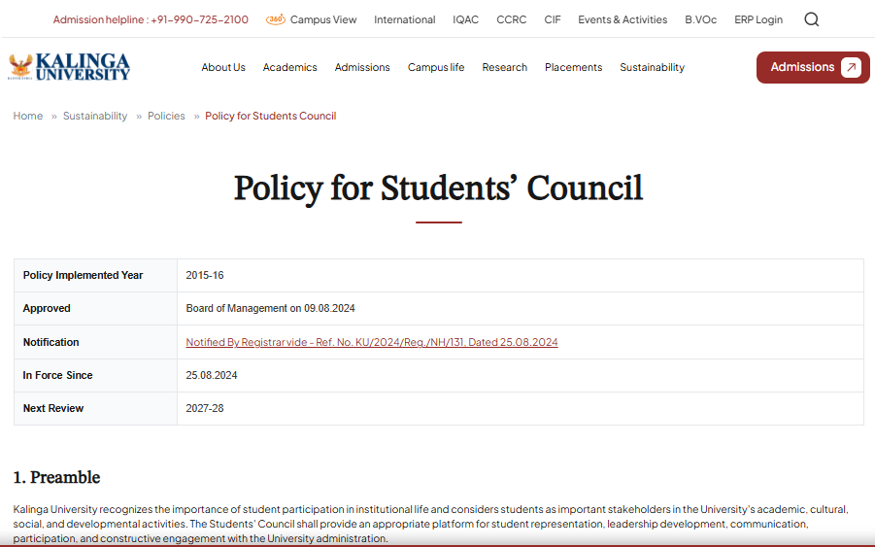
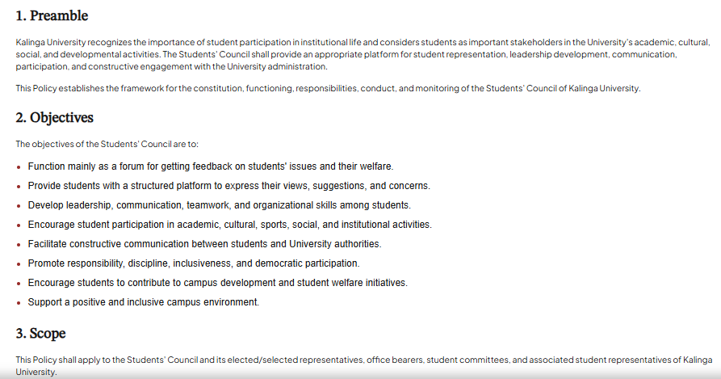
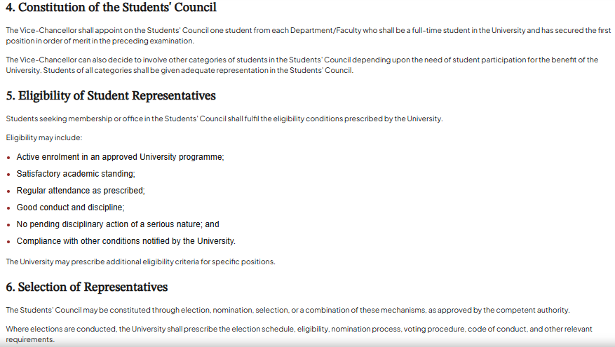
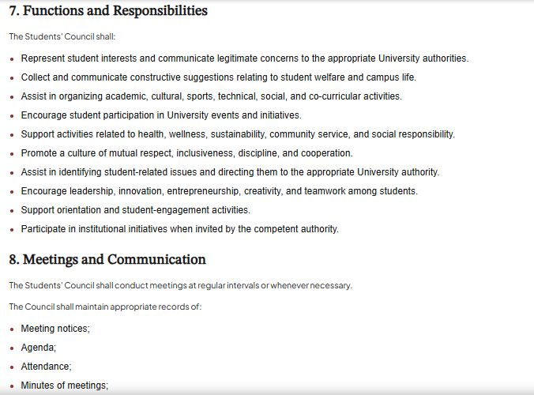
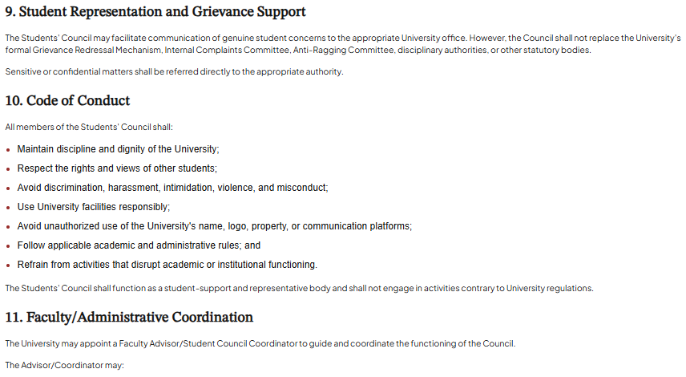

16.2.2 Students’ Union 2025
Kalinga University does not have a formal Students' Union; however, it has an officially approved Students' Council Policy to promote student representation, leadership and participatory governance. The Council facilitates student engagement in academic, cultural, sports, technical, social and community-service activities. It communicates student suggestions and welfare concerns to university authorities. Guided by a Faculty Advisor/Coordinator, the Council promotes inclusivity, discipline, transparency, accountability and responsible leadership, contributing to SDG 16: Peace, Justice and Strong Institutions.

16.2.3 Identify and Engage With Local Stakeholders 2025
Kalinga University is committed to promoting sustainable development, inclusive economic growth, community engagement and meaningful partnerships through its Policy for Identification and Engagement with Local Stakeholders. The policy provides a structured framework for identifying, connecting and collaborating with relevant local stakeholders to strengthen institutional and community relationships.
The University engages with diverse stakeholders, including local communities, government bodies, industries, employers, NGOs, civil society organisations, alumni, local entrepreneurs, farmers and community-based organisations. These collaborations aim to create mutually beneficial opportunities for knowledge sharing, skill development, internships, employment, entrepreneurship, research and community development.
Through its various academic departments, schools, Placement and Training Cell, Alumni Cell, Extension and Outreach units, and IQAC, the University facilitates stakeholder consultations, collaborative activities, capacity-building programmes and community outreach initiatives. These engagements provide students with practical exposure, industry-oriented skills and opportunities for professional development while addressing local and regional needs.
The Deans, Heads of Departments, faculty members and concerned administrative units are responsible for stakeholder mapping, consultation, engagement, documentation and periodic review to ensure effective implementation of the policy.
Through this systematic approach, Kalinga University strengthens university–community partnerships, promotes employability and entrepreneurship, supports local economic development and contributes to achieving the United Nations Sustainable Development Goals (SDGs) through inclusive and sustainable stakeholder engagement.

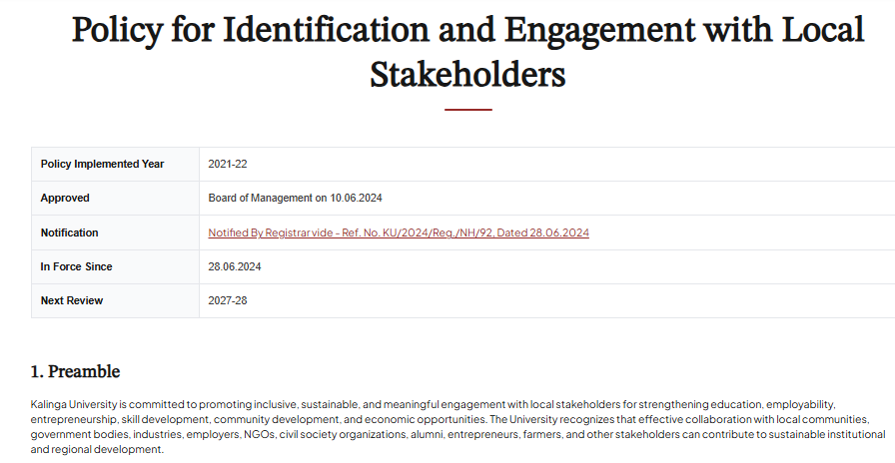

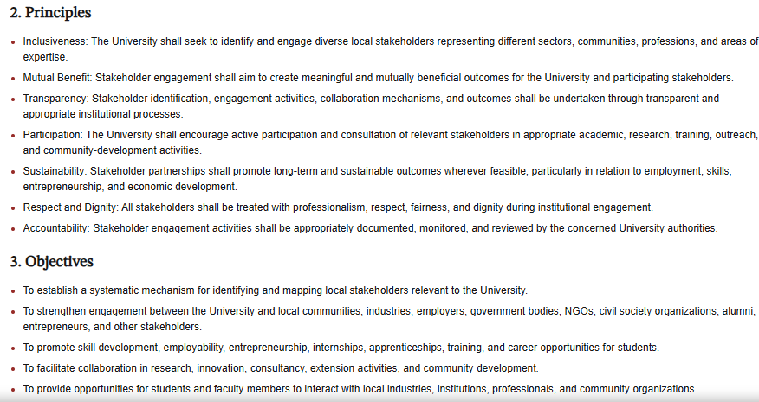
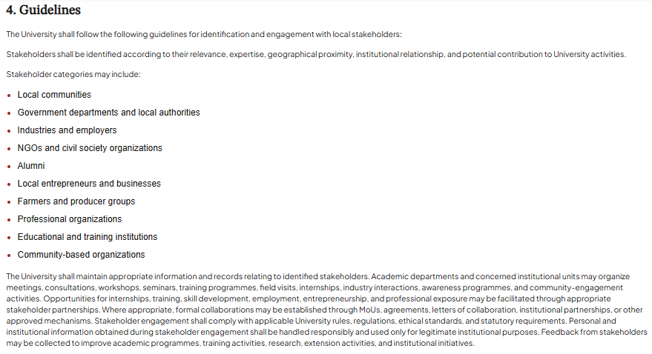
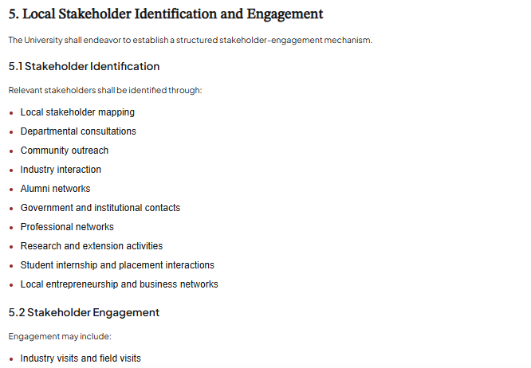

16.2.4 Participatory Bodies for Stakeholder Engagement 2025
Kalinga University promotes active stakeholder participation through various institutional bodies, departments and outreach units to strengthen university–community relationships and encourage inclusive development. The National Service Scheme (NSS) Unit, Department of Students' Welfare (DSW), Young Indians (YI), Alumni Cell, Placement and Training Cell, IQAC and academic departments across all eight Schools actively engage students, faculty members, local communities and external stakeholders.
These participatory bodies organise awareness programmes, workshops, seminars, skill-development activities, community outreach initiatives and collaborative events focusing on social responsibility, digital literacy, civic awareness, employability, entrepreneurship, environmental sustainability and community welfare. They also facilitate interaction with government organisations, industries, NGOs, alumni and local community groups to address regional needs and promote mutually beneficial partnerships.
During the academic year 2025, several initiatives were undertaken to encourage stakeholder involvement, strengthen community participation and provide students with opportunities for experiential learning, leadership development and social engagement. These activities reflect the University's commitment to participatory governance and sustainable development.
Media Coverage Web Page Link: https://kalingauniversity.ac.in/media
List of Events:
Sl. No. | Event Title | Date | Organizing Department | Number of Participants | Outcome
1 | Observance of Constitution Killing Day (Samvidhan Hatya Diwas) & 50th Anniversary of the Emergency | 25.06.25 | “Sahitya Academy, Chhattisgarh Culture Council” | 10 | Participants gained historical and political awareness about the Emergency and its impact on Indian democracy.  Students experienced civic learning through visual exhibitions and inspiring speeches.  Strengthened commitment among youth to uphold constitutional values and democratic principles.
2 | International Yoga Day 2025 | 21.06.25 | Department of Education & NSS Unit | 81 | Enhanced public awareness of yoga, improved physical and mental well-being, and harmony with nature through yogic practices. Promoted healthy lifestyles, environmental consciousness, and sustainable living practices, contributing to individual wellness and environmental protection.
3 | Jashn-e-Zindagi | 31.05.2025 | “Shri Davara University”  In Association with“News 18 Madhyapradesh Chhattisgarh” | 20 | The event witnessed of students, faculty, families, and general public, demonstrating community support for the cause.  Informative messages and visuals during the event helped educate attendees on cancer prevention, detection, and available treatment options.  Students actively participated in organizing and attending the event, showing increased interest in taking part in future social initiatives.
4 | Gram Sabha (Labour Day) under Unnat Bharat Abhiyan | 01.05.2025 | DSW/NSS/SPORTS | 11 | Strengthened relationship between university and village community.  Villagers expressed keen interest in future training and awareness programs.  Identified 3 key areas for follow-up: skill training, health awareness, and school infrastructure.
5 | Meeting in Jila Panchayat | 20.03.2025 | Jila pancahayat”  In Association with  “Swatch Baharat Abhiyaan” | 10 | ODF स्थिरता सुनिश्चित होगी  ग्राम में ठोस एवं तरल अपशिष्ट प्रबंधन प्रणाली विकसित होगी  प्लास्टिक मुक्त गांव की दिशा में महत्वपूर्ण कदम बढ़ेंगे  सामुदायिक सहभागिता और जागरूकता बढ़ेगी
6 | “Viksit Bharat Young Leader Dialogue 2025 organized by the Ministry of Youth and Sports Affairs” | 11.1.2025  to  12.1.2025 | Ministry of Youth and Sports Affairs | 02 | Enhanced public awareness of yoga, improved physical and mental well-being, and harmony with nature through yogic practices. Promoted healthy lifestyles, environmental consciousness, and sustainable living practices, contributing to individual wellness and environmental protection.
7 | Street Play “Clean Chhattisgarh – Good Governance of Government” | 16.12.2024 | NSS Unit, Kalinga University | 40 | The program successfully educated the audience about the significance of cleanliness as a cornerstone of good governance.  The street play inspired behavioral change among the community members, encouraging them to adopt clean and hygienic practices.  It strengthened public awareness about the Chhattisgarh government’s commitment to cleanliness and its role in promoting sustainable development.  NSS volunteers gained valuable experience in teamwork, public speaking, and social engagement, reinforcing their role as agents of change.
8 | Constitution Day Celebration”  Commemorating 75 Years of Indian Constitution and the Way Forward | 26.11.2024 | Faculty of Law, Kalinga University  in association with  Pro Bono Club, Ministry of Law and Justice  and NSS, Kalinga University | 159 | Enhanced understanding of the Indian Constitution, its history, values, and democratic principles among students and faculty. Honoured national leaders, strengthened constitutional awareness, encouraged responsible democratic participation, and connected theoretical knowledge with the practical application of constitutional law.
9 | Tree Plantation on “EK PED MAA K NAAM" | 12.10.2024  &  13.10.2024 | NSS & DSW, Kalinga University, Raipur | 50 | The plantation drive concluded successfully with the students gaining valuable insights into environmental stewardship. The saplings planted will contribute to the sustainability of the university campus, and this activity serves as a step forward in the NSS's commitment to environmental conservation.
10 | Tree Plantation Drive | 20.07.2024 | NSS Unit of Kalinga University | 26 | The Tree Plantation Drive successfully promoted environmental conservation, community involvement, and educational enrichment, aligning with Kalinga University's mission of fostering academic growth and community engagement.
11 | राज्य स्तरीय एक दिवसीय महिला कार्यक्रम अधिकारी प्रशिक्षण कार्यशाला | 10.07.2024 | छत्तीसगढ़ शासन उच्च शिक्षा विभाग | 265 | The state-level one-day women program officer training workshop, "Naari Shakti se Jal Shakti," was a significant step towards empowering women in water conservation and management. The workshop successfully raised awareness, developed skills, and encouraged active participation of women in addressing water-related issues. The positive outcomes and feedback highlight the need for continued efforts in this direction to ensure sustainable water management practices led by empowered women.
12 | Yuva Utsav 3.O | 20.09.2024 | YI & CII | 193 | Yuva Utsav 3.0 was an impactful platform for engaging Chhattisgarh’s youth in discussions on entrepreneurship, technology, and leadership, driving forward the vision of a self-reliant and developed India by 2047. The event successfully combined knowledge-sharing sessions with entertainment, leaving participants inspired and motivated to contribute to India's growth journey.  The CII and Yi's initiative, along with the active participation of state leaders and industry experts, highlights the critical role of youth in shaping the future of the country.
13 | Marathon ‘Run for Mann’ | 09.03.2025 | Bharat Rising  &  CII | 55 | Participants gained a better understanding of the importance of regular exercise and a healthy lifestyle.  A large number of students enthusiastically took part, fostering a sense of teamwork and sportsmanship.  The event successfully brought together students, officials, and the local community, strengthening social connections.  The inspiring address by the Raipur Collector boosted morale and motivated participants to prioritize health and fitness.  The event was well-planned, ensuring smooth logistics, timely execution, and a memorable experience for all involved.

Program Highlights and Event Reports:
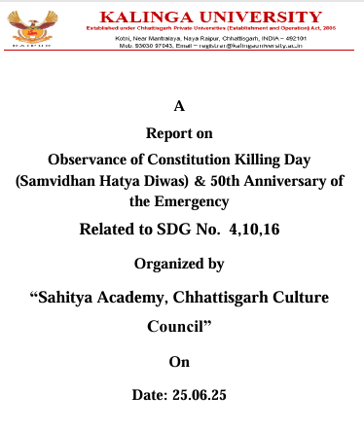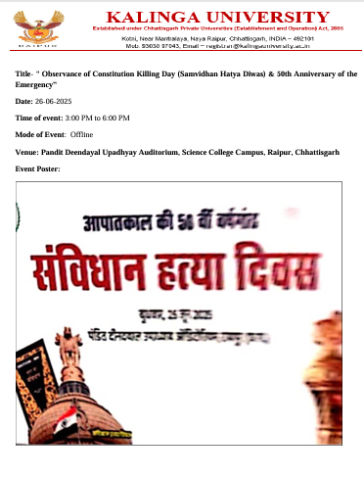
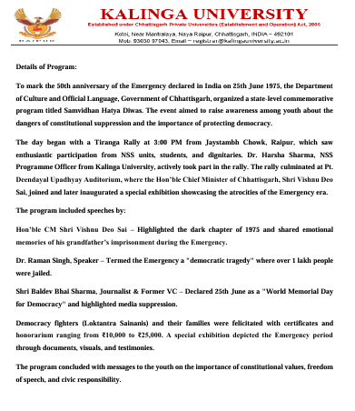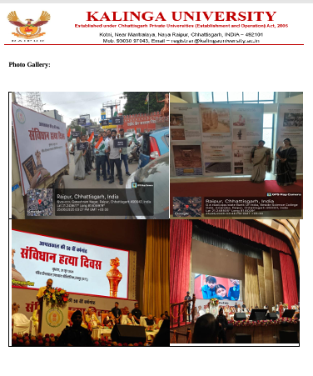
Observance of Constitution Killing Day (Samvidhan Hatya Diwas) & 50th Anniversary of the Emergency, 25.06.25

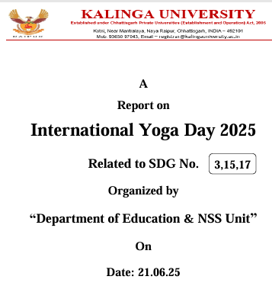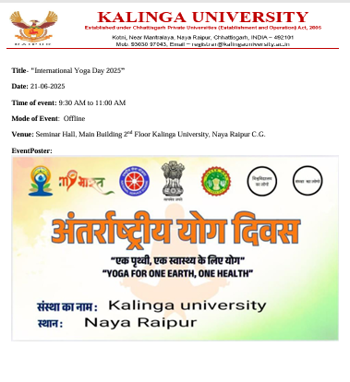
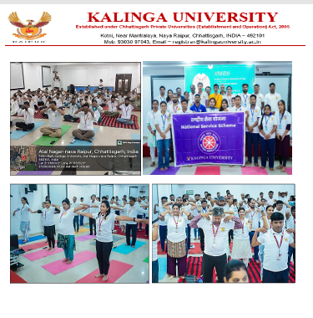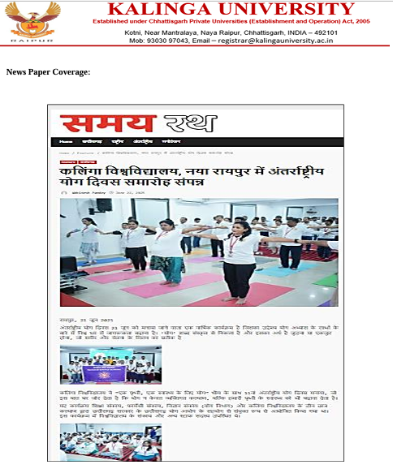
International Yoga Day 2025, 21.06.2025

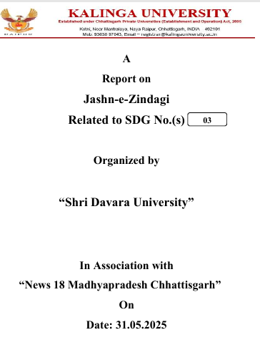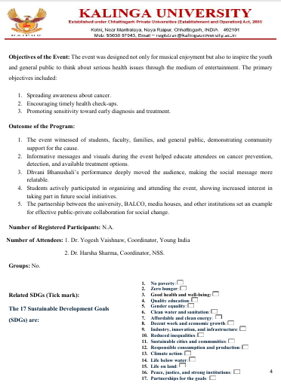
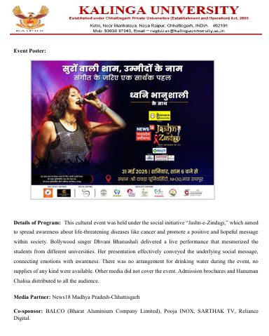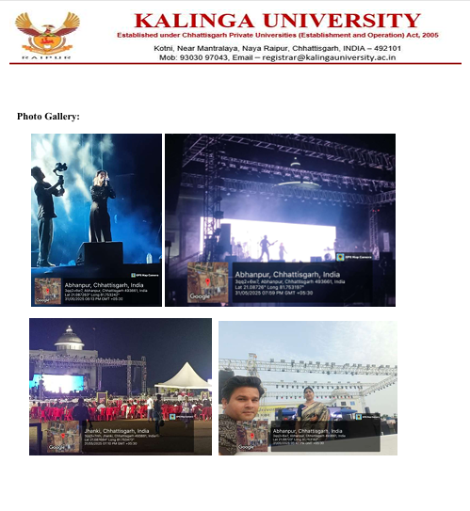
Jashn-e-Zindagi, 31.05.2025

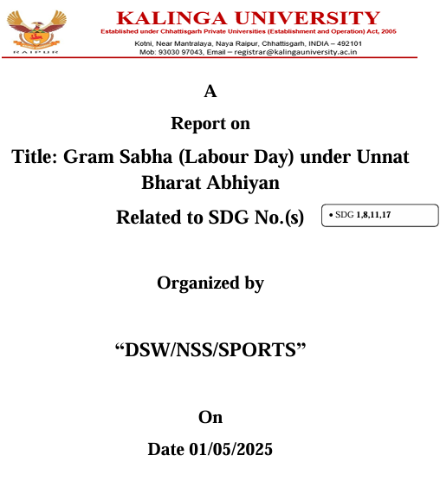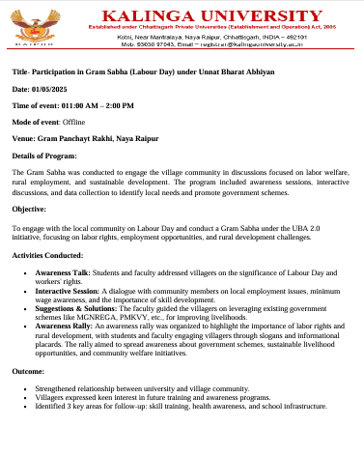
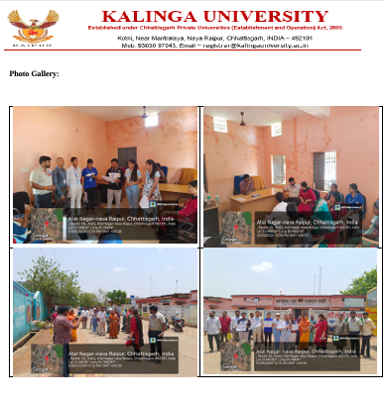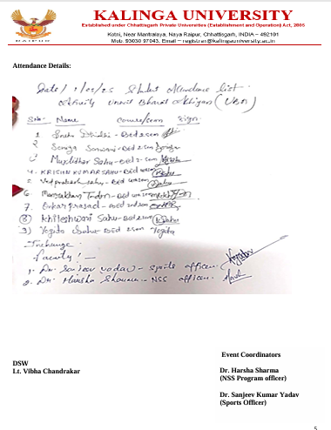

Gram Sabha (Labour Day) under Unnat Bharat Abhiyan, 01.05.2025

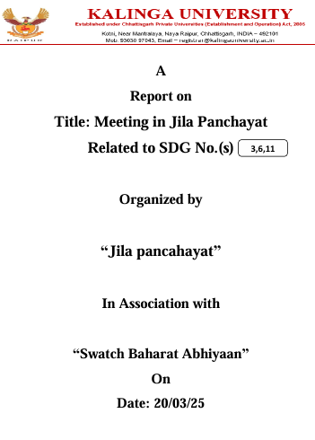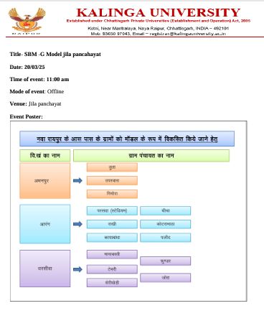
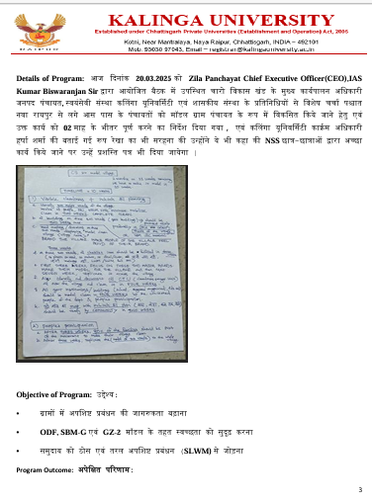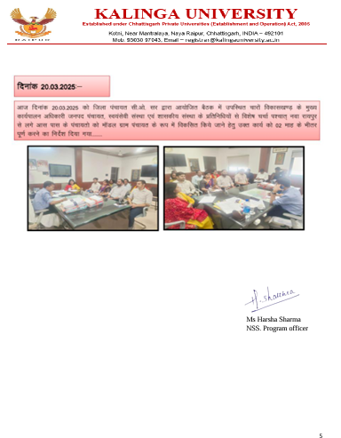
Meeting in Jila Panchayat, 20.03.2025

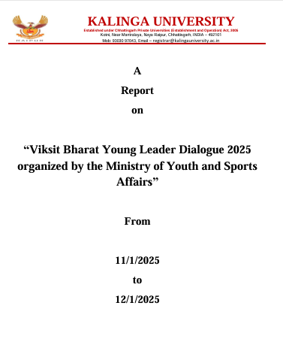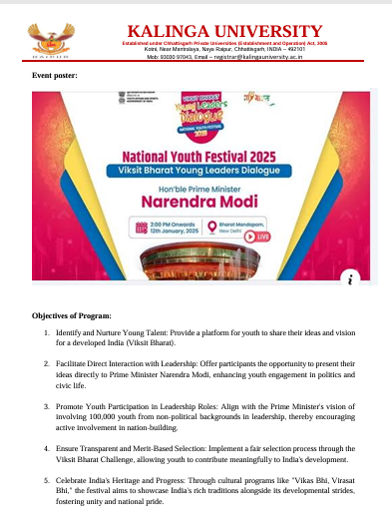
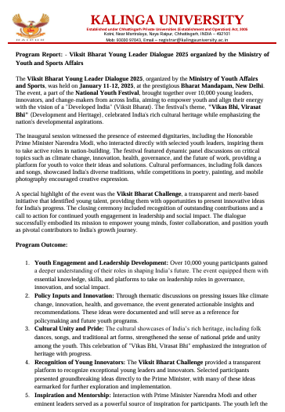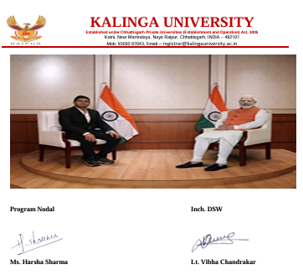
“Viksit Bharat Young Leader Dialogue 2025 organized by the Ministry of Youth and Sports Affairs” 11 & 12.01.2025

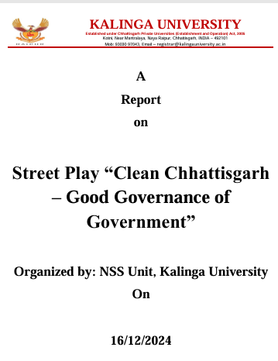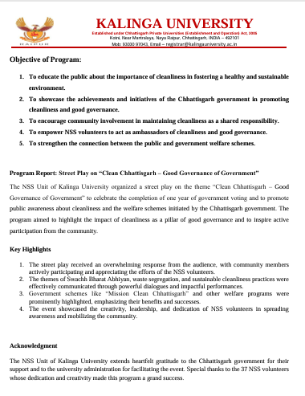
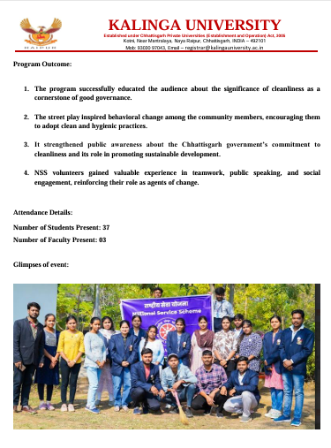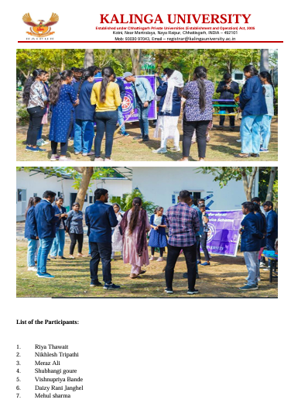
Street Play “Clean Chhattisgarh – Good Governance of Government”, 16.12.2024

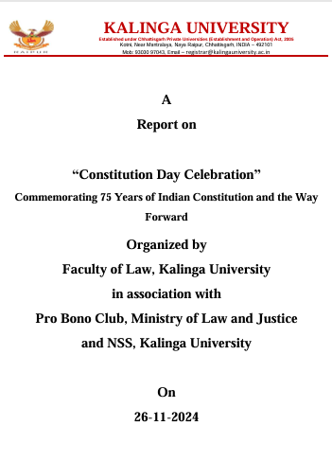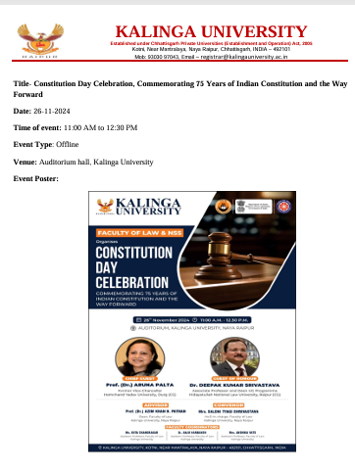
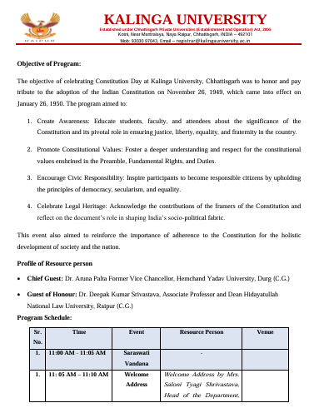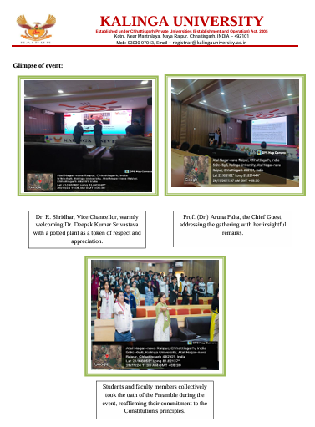
Constitution Day Celebration”
Commemorating 75 Years of Indian Constitution and the Way Forward, 26.11.2024

16.2.5 University Principles on Corruption and Bribery 2025
Kalinga University upholds a zero-tolerance approach towards corruption, bribery, fraud and unethical practices. The University's Code of Conduct is applicable to the Vice-Chancellor, Registrar, Chief Finance Officer (CFO), Controller of Examinations (COE), all teaching and non-teaching employees, and students. It emphasises honesty, integrity, transparency, accountability and fairness in all academic, administrative and financial activities. All members are expected to avoid bribery, conflicts of interest, undue influence, favouritism and misuse of institutional authority or resources. The University promotes ethical decision-making, responsible governance and compliance with applicable laws, policies and institutional regulations to ensure a fair, transparent and accountable environment, in alignment with SDG 16.
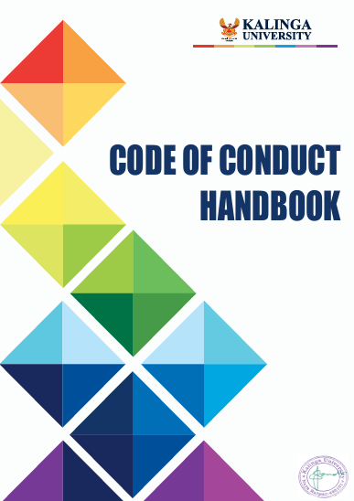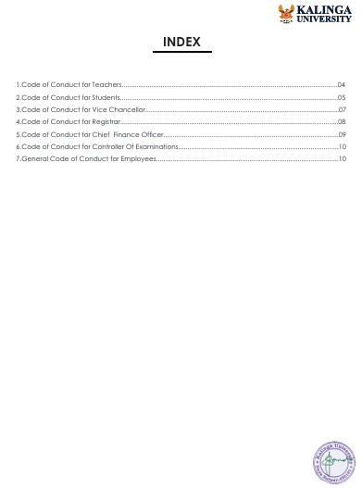
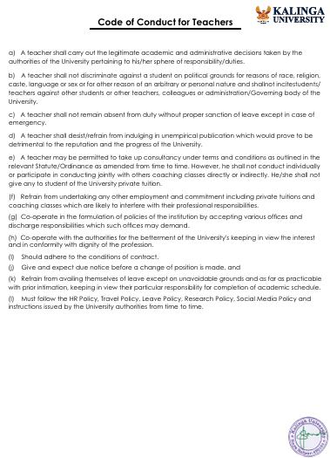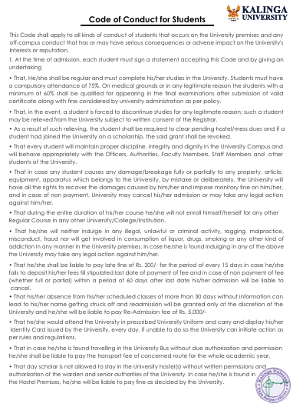

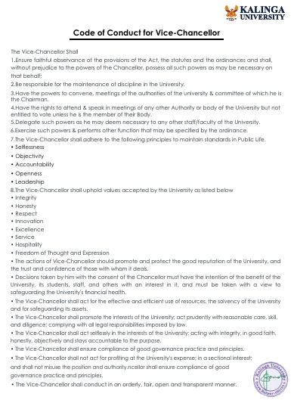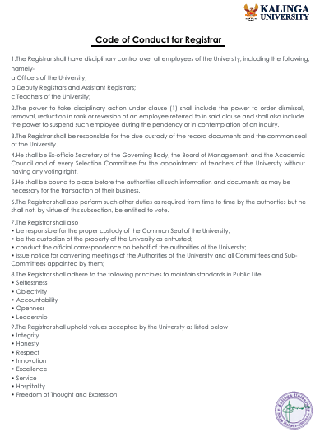
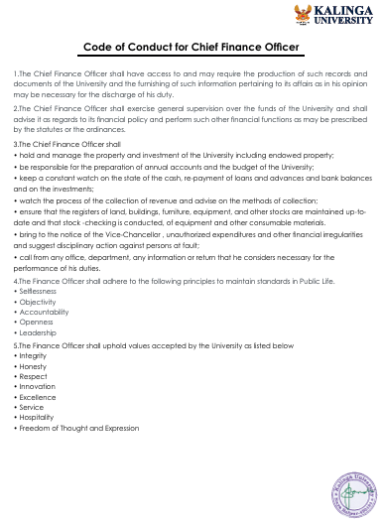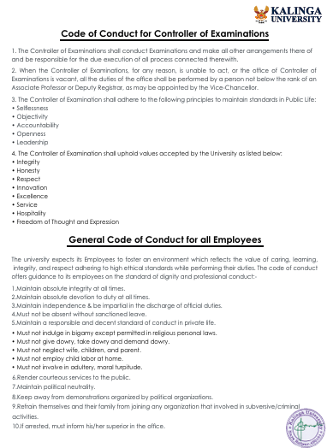

16.2.6 Academic Freedom Policy
Kalinga University promotes academic freedom as an essential foundation of quality education, research excellence and intellectual independence. The University's Academic Freedom Policy encourages faculty members, researchers and students to engage in independent teaching, learning, research, critical thinking, academic discussions, debates and knowledge sharing while maintaining ethical and professional standards. The University supports intellectual exploration through conferences, seminars, workshops, research programmes and publication opportunities. This policy fosters innovation, knowledge creation, responsible academic participation and institutional development, contributing to SDG 16: Peace, Justice and Strong Institutions.

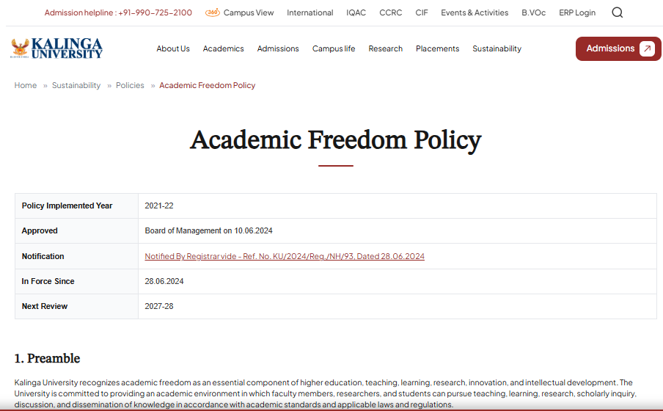
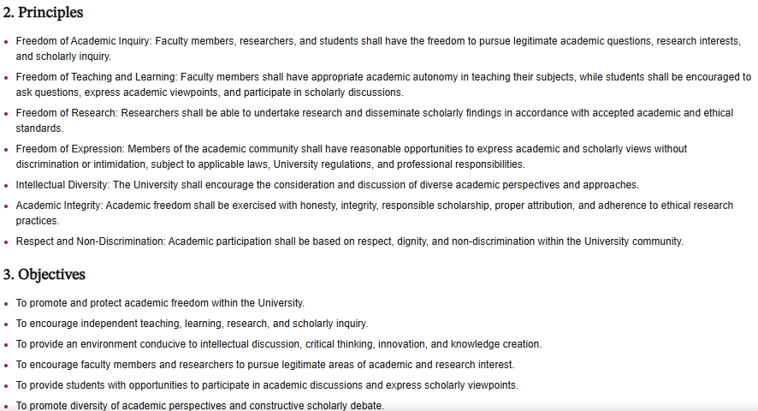

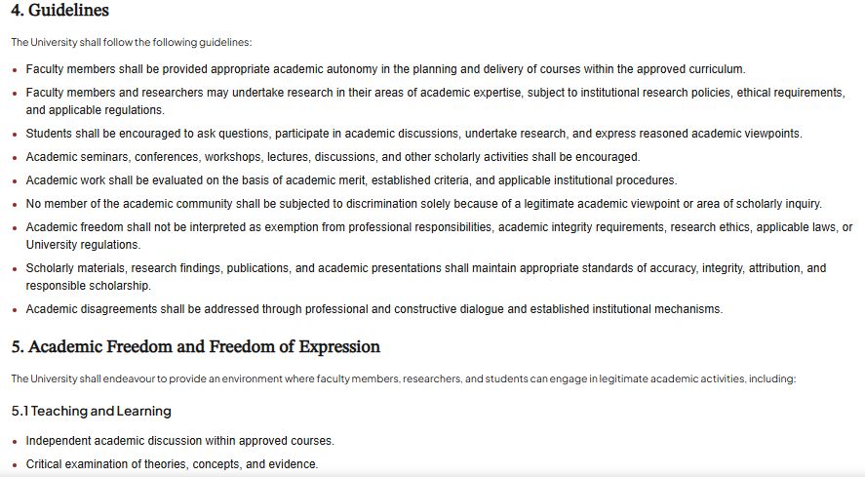
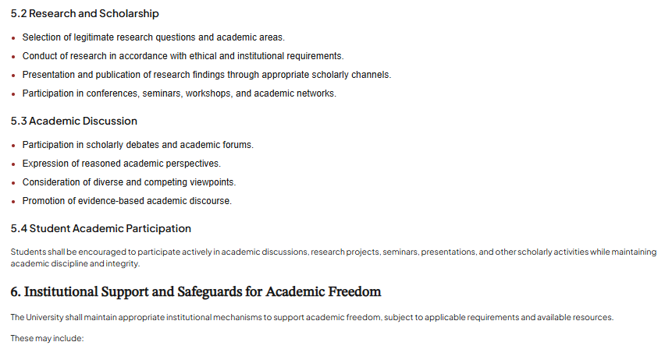

16.2.7 Publish Financial Data
Kalinga University promotes financial transparency, accountability and responsible resource management through the preparation and maintenance of audited financial statements, balance sheets and income-expenditure reports. Regular statutory audits ensure financial accuracy, regulatory compliance and appropriate utilisation of institutional resources. Relevant financial information is shared with stakeholders through appropriate institutional channels, including the official website, wherever applicable. These practices strengthen ethical financial management, institutional integrity and good governance, contributing to SDG 16: Peace, Justice and Strong Institutions.
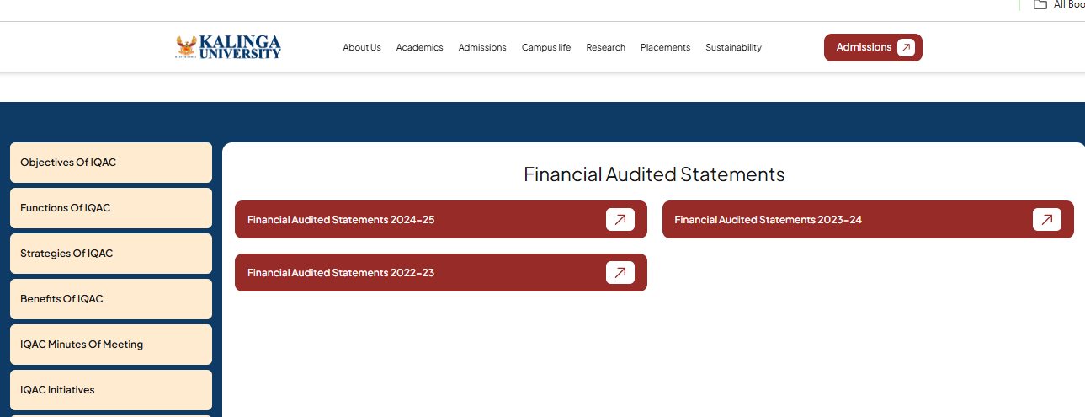
16.3 Working with Government
Kalinga University actively collaborates with various government departments, ministries, statutory bodies and public institutions to promote education, research, innovation and sustainable development. The University participates in and organises government-supported initiatives, programmes, workshops, seminars, training sessions, awareness campaigns and community outreach activities. Through these collaborations, the University contributes to skill development, environmental sustainability, social welfare, digital literacy, entrepreneurship and public awareness. Faculty members and students actively engage in government-led initiatives, strengthening institutional partnerships and community participation. These collaborative efforts support regional development, public welfare and the achievement of SDG 16: Peace, Justice and Strong Institutions.
16.3.1 Provide Expert Advice to Government
Kalinga University actively contributes to SDG 16.3.1 through collaboration with government departments and local authorities by conducting community-oriented extension activities, awareness campaigns, health initiatives, blood donation drives, surveys and environmental programmes, including tree plantation. Through NSS, Young Indians (YI), DSW and various academic departments, the University engages students and faculty in public welfare initiatives. These partnerships promote civic responsibility, social justice, community well-being and sustainable development while strengthening University–Government collaboration and institutional engagement.

16.3.2 Policy- and Lawmakers Outreach and Education
Kalinga University promotes meaningful engagement with policymakers, legislators, government officials and public institutions through its Policy on Engagement, Outreach and Education for Policymakers and Legislators. The University facilitates knowledge exchange through research dissemination, policy dialogues, seminars, conferences, workshops, expert interactions and capacity-building programmes. These initiatives encourage evidence-based decision-making, public awareness and informed understanding of governance and societal issues. All engagements follow a non-partisan, academically responsible approach, focusing on education, research, knowledge sharing and sustainable development.
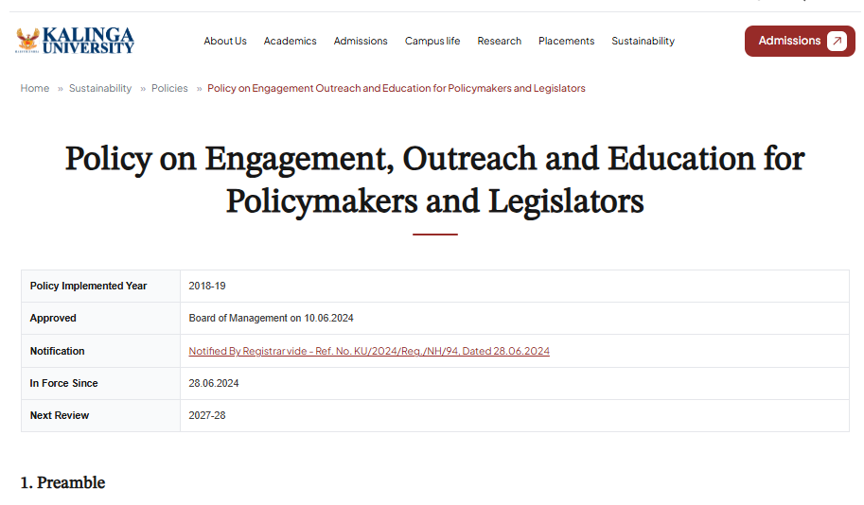
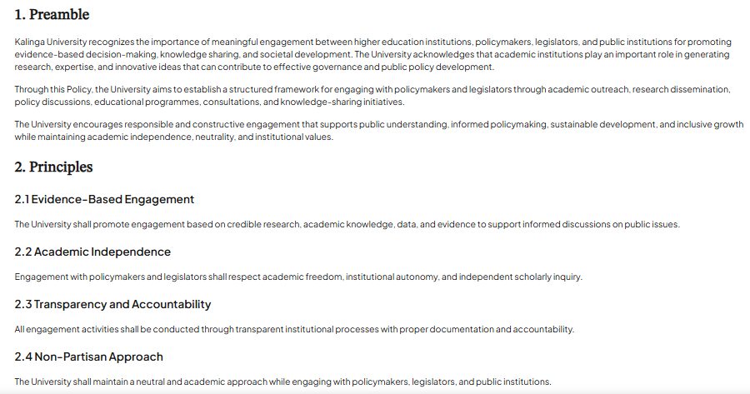

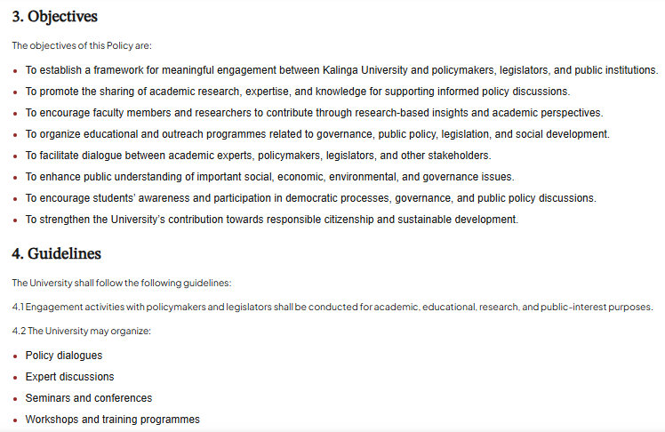
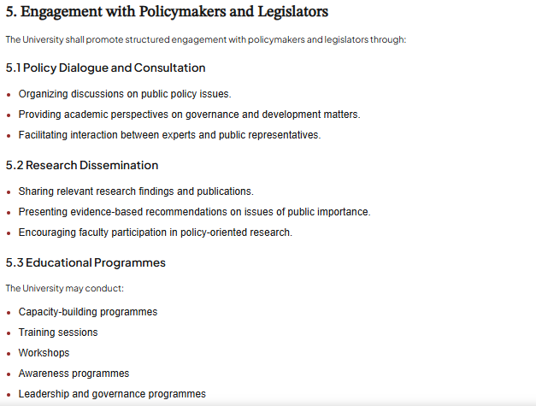

16.3.3 Participation in Government Research
Kalinga University encourages faculty members and researchers to actively participate in government-funded research projects and initiatives supported by various national and state-level agencies, including DST, AICTE, ICSSR, DBT, CSIR, BIRAC, CGCOST, NABARD, Chhattisgarh Tourism Department, Ministry of Law and Justice, Ministry of Earth Sciences, Chhattisgarh Environment Conservation Board (CECB), Watershed Development Component (WDC), Chhattisgarh Regional Science Centre, Unnat Bharat Abhiyan, NITI Aayog and other public funding organisations.
Through its Research and Development Cell, the University promotes research collaboration, innovation, knowledge creation and interdisciplinary studies addressing national and societal challenges. It facilitates research proposals, funding applications, grant management, financial documentation and compliance with relevant funding guidelines. These collaborations strengthen academia–government partnerships, encourage evidence-based research and contribute to national development, technological advancement, environmental sustainability and SDG 16: Peace, Justice and Strong Institutions.
Funds Received from Government Organisations
S. No. | Project Title | Name of the Principal Investigator/ Co Investigator (if applicable) | Name of the Funding agency | Department | Year of Award | Funds provided (INR)
1 | Conference on Chhattisgarh @2047: Transforming Education through Sustainability, Inclusion, Innovation & IKS | Dr. Shraddha Verma | NIEPA | Education | 08.12.2025 | 300000
2 | : छत्तीसगढ़ में कौशल विकास योजनाओं का मूल्यांकन एवं नीतिगत सुझाव | Dr. Praveen Kumar Yadaw | NITI Aayog, Chhattisgarh | Technology | 09.12.2025 | 500000
3 | Fiscal Strengthening and Revenue Augmentation Strategies: A Strategic Study on Enhancing the Economic Position of Chhattisgarh | Dr. Chandra Bhooshan Singh | NITI Aayog, Chhattisgarh | C&M | 09.12.2025 | 350000
4 | Data Empowerment for local innovation and entrepreneurship | Dr. Vijayalaxmi Biradar | IIIT Hyderabad | Technology & IQAC | 19.11.2025 | 100000
5 | Enhancing Livelihoods through Affordable Mushroom Cultivation, seeks to empower the community of Palaud | Dr. Sushma Dubey | Unnat Bharat Abhiyan | Science | 17.02.2025 | 92,000
6 | Bootcamp on Innovation & Entrepreneurship | Dr. Vijayalaxmi Biradar | Unnat Bharat Abhiyan | Technology & IQAC | 22.08.2025 | 100000
7 | Production of Banana stem yarn from Banana fiber, an innovation in Handloom industry | Dr. Vijayalaxmi Biradar | Unnat Bharat Abhiyan | Technology & IQAC | 17.02.2025 | 97000
8 | Envirothon & Painting Competition on 16 September Ozone Layer Protection Day | Manoj Kumar Nigam | CG Environment Protection Board | Technology | 28.08.2025 | 40000
9 | SciSustain 2025: Fostering Sustainable Development Through Interdisciplinary Scientific Research | Dr. Rupesh Thakur | CSIR | Science | 08.09.2025 | 40000
10 | Formulation, development, and characterization of ready-to-use nutraceutical soft beverage of Curcuma angustifolia (Tikhur) powder. | Dr. Sandip Tiwari  Dr. Sandeep Mishra  Ms. Rajni Yadav  Mr. Saurabh Sharma | State Planning Commission CG | Pharmacy | Jul-24 | 438000
11 | Production of lotus Yarn from lotus fiber as an aquafiber, an innovation in Handloom industry | Dr. Vineeta Diwan | Unnat Bharat Abhiyan | Arts & Humanities | 06.06.2024 | 97000
12 | Innovative Education Strategies: NEP 2020 in Chhattisgarh & Beyond | Dr. Shraddha Verma | ICSSR - International Seminar | Education | 05.06.2024 | 300000
13 | 5 days residential Inspire Science Camp for mentoring Top 1% rank holder students which would help us to track talented students in near future for the admission at KU under UG program. | Dr. Renuka Sahu | INSPIRE Science Camp | Science | Accepted by DST on 09.05.2024 | 1002500
14 | Women leadership in Stem | Dr. Vijayalaxmi Biradar | BIRAC STEM | Technology |  | 1211304
  Accepted on 09.05.2024
15 | Best out of Waste | Dr. Vijayalaxmi Biradar & Dr. Sanyogita Shahi | Chhattisgarh Regional Science Center | Technology | Accepted on 18.04.2024 | 48900
16 | Best out of Waste | Dr. Vijayalaxmi Biradar & Dr. Sanyogita Shahi | Chhattisgarh Regional Science Center | Technology and Science | 2023 | 47700
17 | Scientific Toy | Dr. Vijayalaxmi Biradar & Dr. Sanyogita Shahi | Chhattisgarh Regional Science Center | Technology and Science | 2023 | 47700
18 | Wonder of Electronics | Dr. Vijayalaxmi Biradar & Dr. Sanyogita Shahi | Chhattisgarh Regional Science Center | Technology and Science | 2023 | 68700
19 | Drone Workshop | Dr. Vijayalaxmi Biradar & | Chhattisgarh Regional Science Center | Technology | 2023 | 79000
20 | Robotics Workshop | Dr. Sanyogita Shahi | Chhattisgarh Regional Science Center | Science | 2023 | 50000
21 | Hands on Training workshop on portable microscope. | Dr. Vijayalaxmi Biradar | Chhattisgarh Regional Science Center | Technology | 2023 | 54500
22 | Website Updation | Dr. Vijayalaxmi Biradar & Mr. Anup Kumar Jana | CGCOST | Technology | 2023 | 78000
23 | Status of Environment and Related Issues to conduct a certificate course in Waste Optimisation Professional | Dr. Manoj Singh | Chhattisgarh Environment Conservation Board | Science | 2023 | 1150000
24 | AICTE-AQIS Conference | Dr. Biswas & Dr.G.V.V. Rao | AICTE | Science | 2023 | 221700
25 | Training on MS Office | Dr. Vijayalaxmi Biradar | Labour Department, Govt. of Chhattisgarh | Technology | 2023 | 50000
26 | International Conference on Climate Change Sustainable Development and Smart Agriculture (ICSSA-2023) | Dr. Manoj Singh | NABARD | Science | 2023 | 100000
27 | National Conference on Climate Change: Suggestion and recommendations for fostering adaptation and resilience | Dr. Ajay Kumar Harit | NABARD | Science | 2023 | 100000
28 | World Wetlands Day Celebration | Dr. Manoj Singh | Office of Forest Divisional Officers General Forest Division Mahasamund CG | Science | 2023 | 55000
29 | Debate/Group Discussion competetion for selecting students for phase 1 youth parliament on Life program | Dr. Manoj Singh | Chhattisgarh Environment Conservation Board | Science | 2023 | 50000
30 | Envirothon: Trash to Treasure | Dr. Manoj Singh | Chhattisgarh Environment Conservation Board (CECB) | Science | 2023 | 50000
31 | Water and Groundwater examination | Dr. Ajay Kumar Harit | Chhattisgarh State Watershed Management Agency (CGSWMA) | Science | 2023 | 200000
32 | Water and Groundwater examination | Dr. Manoj Singh | Watershed Development Component (WDC) | Science | 2023 | 200000
33 | International Conference | Dr. Manoj Singh | Chhattisgarh Environment Conservation Board (CECB) | Science | 2023 | 40000
34 | National Conference on Climate Change Sustainable Development and Smart Agriculture (NCSSA-2023) | Dr. Manoj Singh | Ministry of Earth Science | Science | 2023 | 200000
35 | Envirothon | Dr. Manoj Singh | Chhattisgarh Environment Conservation Board (CECB) | Science | 2023 | 25000
36 | MS office Training | Dr. Vijayalaxmi Biradar | Labour Department, Government of Chhattisgarh | Technology | 2023 | 61000

16.3.4 Neutral Platform to Discuss Issues
Kalinga University provides an inclusive and neutral platform for constructive discussions on social, legal, academic and policy-related issues. Through seminars, conferences, panel discussions, workshops and awareness programmes, the University encourages meaningful interaction among students, faculty members, government representatives, industry experts and civil society organisations. These activities promote open dialogue on peace, justice, governance, gender equality, human rights and sustainable development. The University encourages evidence-based discussions, mutual respect, diverse perspectives and informed decision-making, strengthening institutional transparency, social responsibility and SDG 16: Peace, Justice and Strong Institutions.

16.4 Proportion of Graduates in Law and Civil Enforcement

16.4.1 Indicator: Proportion of Graduates in Law

Data Collected | Definition | Count
Number of graduates | This is the total headcount number of graduates at all levels from your institution in year 2025. | 1881
Number of graduates from law and enforcement related courses | This is the headcount number of graduates at all levels from your institution from law and enforcement related courses in year 2025. | 247

Details of Various Outreach Programmes, and Other Academic/Professional Activities Conducted During the Academic Session 2024–25.
List of Activities:
Sl. No. | Faculty / Department | Date of Event | Event Category | Title of the Event | Aligned SDG Goal(s) | Remarks
1 | Faculty of Law | 17.08.2024 | Competition / Moot Court | National Moot Court Competition | SDG 4, SDG 16 | Legal education and justice
2 | Faculty of Science | 13.09.2024 | Workshop / Training | Workshop on Fingerprint Development | SDG 4, SDG 16 | Forensic learning and justice
3 | Faculty of Law | 17.09.2024 | Career Guidance | Career Counselling Session on UPSC and Judiciary | SDG 4, SDG 8, SDG 16 | Career development and public justice services
4 | Faculty of Pharmacy | 19.09.2024 | Awareness / Patient Safety | Building ADR Reporting Culture for Patient Safety | SDG 3, SDG 16 | Patient safety and responsible systems
5 | Faculty of Science | 20.09.2024 | Hands-on Training | Fingerprint Forensics: Hand on Training in Latent Print Development | SDG 4, SDG 16 | Forensic skills and justice
6 | Faculty of Law | 28.09.2024 | Capacity Building | Capacity Building Program on “Constitutional Values and Ethics Inside the Classroom” | SDG 4, SDG 16 | Ethics, citizenship and justice
7 | Faculty of C & M | 28.09.2024 | Workshop | Workshop on “GST” | SDG 4, SDG 8, SDG 16 | Financial and regulatory literacy
8 | Faculty of Law | 08.10.2024 | Competition / Debate | Intra Debate Competition, 2024 | SDG 4, SDG 16 | Critical thinking and civic/legal awareness
9 | Faculty of Law | 05.10.2024 to 14.10.2024 | Certificate Course | Two-Week Advanced Certificate Course on “Understanding New Criminal Laws: A Focus on New Legislative Changes” | SDG 4, SDG 16 | Legal education and justice
10 | CTCD | 19.10.2024 | Training / Quality Assurance | Quality Assurance in HEIs: NAAC, NBA, CO/PO Mapping | SDG 4, SDG 16 | Quality education and institutional governance
11 | Faculty of Law | 24.10.2024 to 26.10.2024 | Certificate Course | Three Days Online Certificate Course on “Contract Drafting” | SDG 4, SDG 16 | Legal skills and justice
12 | Faculty of Law | 26/11/2024 | Day Celebration / Awareness | Commemorating 75 years of Indian Constitution and the way forward Constitution Day Celebration | SDG 16 | Constitutional values and institutions
13 | IQAC | 22/11/2024-23/11/2024 | Symposium / Sustainability | ESG & Sustainability Symposium | SDG 12, SDG 13, SDG 16, SDG 17 | Sustainability, governance and partnerships
14 | Faculty of Law | 11.01.2025 and 12.01.2025 | Certificate Course | Two week online certificate course on Legal journalism | SDG 4, SDG 16 | Legal/media education
15 | Faculty of Science | 16.01.2025 | Guest Lecture | Guest lecture on “The Science of Justice-Forensic Breakthrough” | SDG 4, SDG 16 | Forensic science and justice
16 | Faculty of Law | 18.01.2025 and 19.01.2025 | Certificate Course | Law-Two week online certificate course on Legal journalism | SDG 4, SDG 16 | Legal/media education
17 | Faculty of Commerce and Management | 31.01.2025 | Guest Lecture | Guest Lecture under Amartya Sen Chair | SDG 4, SDG 10, SDG 16 | Education, inclusion and social development
18 | Faculty of Law | 11.01.2025 to 02.02.2025 | Certification / Capacity Building | Trainers' Training Certification Course on POSH Act, 2013 | SDG 5, SDG 16 | Gender safety and institutional justice
19 | Faculty of Law | 12/02/2025 to 13/02/2025 | Competition / Moot Court | Intra Moot Court Competition | SDG 4, SDG 16 | Legal education and justice
20 | Faculty of Arts and Humanities | 21.02.2025 | Guest Lecture / Economic Awareness | Guest Lecture on “Health of State Finances with a Focus on Union Budget 2025-26” | SDG 4, SDG 8, SDG 16 | Economic and governance literacy
21 | Faculty of A & H | 24.02.2025 | Field Visit / Civic Learning | Visit to Collectorate | SDG 4, SDG 16 | Civic and governance learning
22 | Faculty of Law | 28/02/2025 to 01/03/2025 | Global Conference | Two-Days Global Conference On “RECENT TRENDS IN LAW, ARBITRATION, MEDIATION, ECONOMY AND SOCIETY” | SDG 16, SDG 17 | Justice, governance and collaboration
23 | Faculty of Law | 20.03.2025 | Competition / Client Counselling | Client Counselling Competition, 2025 on Contract Law | SDG 4, SDG 16 | Legal education and access to justice
24 | Faculty of Law | 14.04.2025 | Competition / Quiz | Online Quiz Competition on “The Constitution of India: Foundation, Rights and Governance” | SDG 4, SDG 16 | Constitutional literacy and governance
25 | Faculty of Law | 11.04.2025 to 19.04.2025 | Certification Course | Advanced Certification Course | SDG 4, SDG 16 | Advanced professional/legal education

