ASSIGNMENT 3_4

1. Answer

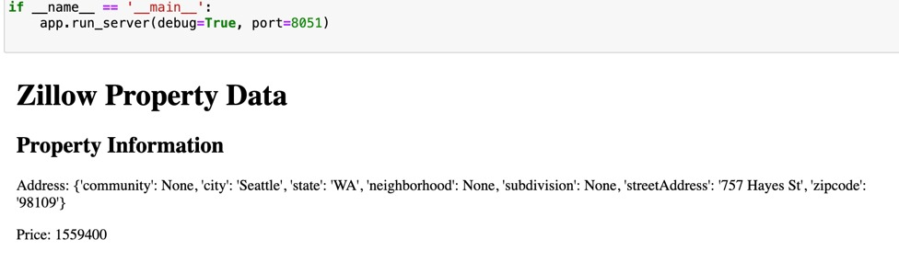

2.

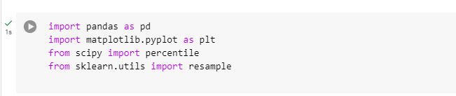

2.a)

2.b)

2.c)

