“SMART INVENTORY MANAGEMENT SYSTEM”
A Project Report Submitted in partial fulfillment of the requirements for the award of the degree of
BACHELOR OF TECHNOLOGY
in
DEPARTMENT OF COMPUTER SCIENCE ENGINEERING
&
DEPARTMENT OF COMPUTER SCIENCE AND INFORMATION TECHNOLOGY
By
KUNAMANENI BHAVANA 2520030003
ALLURU AMULYA 2520030032
METUKU NIHAL 2520030124
Under the Esteemed Guidance of
Dr. S. Spandana
Assistant Professor
Department of Computer Science and Engineering
K L (Deemed to be) University



DECLARATION
We hereby declare that the project report entitled “InRetail – Smart Inventory Management System” is a record of the work carried out by KUNAMANENI BHAVANA (2520030003), ALLURU AMULYA (2520030032), and METUKU NIHAL (2520030124), in partial fulfillment of the requirements for the award of the Bachelor of Technology degree. The work presented in this report is based on the project implementation and study undertaken by our team.
We further declare that this report describes the current project version and that its technical details have been prepared with reference to the supplied source code, configuration files, entity models, API controller, database reference script, and README. Implemented functionality is distinguished from proposed future enhancements.
KUNAMANENI BHAVANA -2520030003
ALLURU AMULYA- 2520030032
METUKU NIHAL- 2520030124

CERTIFICATE
This is to certify that the project report entitled “InRetail – Smart Inventory Management System” is a bonafide work carried out and submitted by KUNAMANENI BHAVANA, ALLURU AMULYA, and METUKU NIHAL in partial fulfillment of the requirements for the award of the degree of Bachelor of Technology at K L (Deemed to be) University.
The report presents a database-oriented retail inventory application comprising a web interface, Spring Boot REST services, and a MySQL relational database. The project work has been prepared in accordance with the academic requirements of the programme.
Signature of the Guide
Signature of the Course Coordinator Signature of the HOD

ACKNOWLEDGEMENT
We express our sincere gratitude to everyone who supported and encouraged us during the development of InRetail – Smart Inventory Management System. The completion of this project has been possible through the guidance, feedback, and cooperation of our faculty members, colleagues, and family members.
We are especially thankful to our project guide, Dr. S. Spandana, Assistant Professor, Department of Computer Science and Engineering, for valuable guidance, suggestions, and encouragement throughout the project. Her feedback helped us approach the problem systematically and improve the organization of the project work and its documentation.
We express our gratitude to the Head of the Department, course coordinator, and faculty members of the Department of Computer Science Engineering and the Department of Computer Science and Information Technology for providing the academic environment and facilities required to complete this work.
We also thank the teaching and non-teaching staff members, classmates, and friends who offered suggestions and assistance during the development and review process. Finally, we are grateful to our parents and family members for their patience, motivation, and continued support.
KUNAMANENI BHAVANA ALLURU AMULYA METUKU NIHAL

ABSTRACT
InRetail – Smart Inventory Management System is a database-driven web application designed to help retail operators organize product information, monitor stock availability, record stock changes, maintain supplier contacts, and review customer orders through a unified workspace. Retail inventory is dynamic: products are received, issued, sold, and replenished continuously. When product details and stock quantities are maintained in disconnected files or manual registers, it becomes difficult to determine current availability, identify products that require replenishment, and trace how inventory levels changed over time.
The project addresses this operational problem through a layered application built with Java 17, Spring Boot, Spring Data JPA, MySQL, HTML, CSS, and JavaScript. The browser-based interface provides dashboard, product catalogue, stock control, order centre, supplier directory, reports, and settings views. The backend exposes REST endpoints under the /api path and uses repository interfaces to persist domain entities in a relational database. MySQL stores products, suppliers, customer orders, and stock movement records.
The product catalogue stores a unique stock-keeping unit (SKU), product name, category, current quantity, reorder point, unit price, and optional expiry date. Product records can be created, viewed, edited, searched by name or SKU, and deleted. Inventory control supports stock-IN and stock-OUT operations. Each accepted adjustment updates the product quantity and creates a corresponding stock movement record containing the product reference, movement type, quantity, note, and timestamp. Stock-out operations are checked against available quantity so that the balance cannot become negative through the provided stock endpoint.
The dashboard converts stored information into operational indicators. It presents recorded order value, number of orders, low-stock and out-of-stock counts, and the number of products. It also identifies products that need attention according to their reorder point. The reporting view summarizes inventory valuation using current quantity multiplied by unit price and groups stock quantities by category. The order centre lists customer orders with order number, customer name, amount, status, and date. The supplier area stores supplier name, contact person, email, telephone number, and address.
The project uses a relational database model because products, suppliers, orders, and stock movements represent structured business information. Spring Data JPA maps Java entity classes to database tables and manages persistence through repository interfaces. Hibernate schema update is configured so that the application can create or update the mapped tables during startup. A reference SQL file documents the expected table structure and useful queries for low-stock identification, inventory valuation, movement history, and category summaries.
InRetail is intended to demonstrate how database concepts can be applied to a practical retail problem. It brings key inventory information into a single interface, reduces repeated manual calculations, and preserves a history of stock adjustments. The current version is a focused inventory-management foundation rather than a complete enterprise resource planning system. It does not claim to provide AI-based demand forecasting, integrated payment processing, user authentication, barcode scanning, or automated supplier purchasing. Such capabilities can be considered in later versions after the core data model and operational workflows are extended.
Overall, InRetail provides a structured foundation for retail inventory visibility and control. Its main contribution is the connection between a product's current stock balance and a traceable movement history, supported by a relational database and REST-based application architecture. The project demonstrates database modelling, entity relationships, CRUD operations, validation, API development, frontend integration, and the use of SQL for operational reporting.

INDEX
Chapter | Title | Contents
1 | Introduction | Background, problem statement, scope, objectives, importance, target users
2 | System Requirements | Hardware, software, development tools and frameworks
3 | Technology Stack | Frontend, backend, database, JPA, configuration and version control
4 | System Architecture | Layered architecture, data flow, API layer and deployment design
5 | Design | Database schema, ER model, interface design and data dictionary
6 | Implementation | Modules, frontend logic, REST API integration and persistence
7 | Features | Dashboard, products, inventory, orders, suppliers and reports
8 | Testing | Test strategy, API checks, integration cases and test records
9 | Deployment | Prerequisites, database configuration, startup and hosting considerations
10 | Challenges & Limitations | Development considerations, mitigations and current boundaries
11 | Future Enhancements | Forecasting, alerts, purchasing, security and scalability
12 | Conclusion | Summary, achievements, learning outcomes and final observations
13 | References | Technical documentation and learning resources
14 | Appendices | API reference, SQL examples, setup guide and user guide

CHAPTER 1 – INTRODUCTION

1.1 Background of the Project
Retail businesses manage a wide variety of products, each with its own SKU, category, unit price, available quantity, and replenishment requirement. Even a small store may handle hundreds of product records and frequent changes in stock. As the number of items and transactions grows, keeping an accurate view of inventory becomes a daily operational responsibility. A delayed update can cause a product to appear available when it is not, while an unnoticed low balance can interrupt order fulfilment and customer service.
Many small and medium retail operations begin with notebooks, spreadsheets, or independent point-of-sale records. These approaches can be useful at a small scale, but they often separate product information from stock movement history and supplier details. Staff may need to calculate current balances manually, search multiple sheets to find an SKU, or compare purchase and issue records to understand why a quantity changed. Manual reconciliation consumes time and makes it harder to maintain consistent information.
Database management systems provide a structured way to store related information and retrieve it through queries. A relational database can represent products, suppliers, orders, and stock movements as connected entities. Primary keys identify records, unique constraints prevent duplicate SKU values, and foreign keys connect a stock movement to the product whose quantity it affects. Such a structure supports reliable retrieval, reporting, and traceability.
InRetail applies these database principles to a practical retail inventory scenario. The application offers a browser-based workspace backed by a Spring Boot server and MySQL. The product catalogue captures the key attributes needed to identify and value inventory. Stock control records incoming and outgoing adjustments. Supplier and order views provide additional context around the retail operation, while dashboard and report views present summarized information.
The current project is intentionally focused on the inventory data lifecycle. It provides the essential operations required to create and maintain product records, adjust stock, view recent movement history, and inspect orders and suppliers. It is not presented as a complete accounting or sales transaction platform. The available customer order data contains order-level totals and statuses, but the current schema does not contain individual order line items or a complete sales ledger.
From an academic perspective, the project demonstrates the use of Java classes as database entities, Spring Data JPA repositories as the persistence layer, REST controllers as the application interface, and HTML/CSS/JavaScript as the presentation layer. It also illustrates how a database-backed dashboard can calculate useful indicators from stored records rather than relying entirely on static page content.

1.2 Problem Statement
The central problem addressed by InRetail is the difficulty of maintaining a clear, consistent, and traceable view of retail inventory when product details and stock updates are managed through disconnected or manual processes. A store operator needs to know what products exist, how many units are available, which products are approaching a reorder threshold, and how recent stock changes occurred. Without a centralized data source, these questions may require repeated manual checks and calculations.
Product identification is one part of the problem. Similar product names, inconsistent descriptions, and duplicate records can make it difficult to identify the correct item. A unique SKU provides a stable identifier that can be used in searches and updates. The current product model therefore stores SKU as a required, unique field along with name, category, current stock, reorder point, unit price, and optional expiry date.
Stock accuracy is another major concern. A quantity may increase when goods are received and decrease when goods are issued or sold. If the system stores only the latest balance, staff may not be able to determine when or why the value changed. If each change is recorded without updating the product balance, the displayed availability can become inconsistent. InRetail addresses this by coupling a stock adjustment with a movement record that references the affected product.
Replenishment decisions also require timely visibility. A product with a quantity at or below its reorder point should be reviewed. A product with zero units is unavailable and may require immediate action. When these states are not highlighted, replenishment can be delayed. The dashboard and inventory views classify stock health from the current quantity and configured reorder point so that products needing attention can be identified quickly.
Retail information is not limited to product and stock records. Supplier contact information and customer order summaries are also useful for day-to-day coordination. If supplier details are kept separately, staff may spend additional time locating contact information. If orders are not presented in a common register, it can be difficult to review order values and statuses. InRetail includes supplier records and customer order listings as connected operational views.
The project therefore aims to provide a single application in which core inventory information is stored in a relational database and exposed through clear workflows. The intended outcome is better visibility, fewer repetitive manual calculations, and a traceable record of stock changes. Advanced procurement, sales line-item processing, authentication, and forecasting remain outside the implemented scope.

1.3 Scope of the Project
The scope of InRetail covers a database-backed web application for basic retail inventory administration. The application is designed for a store administrator or inventory operator who needs to maintain product details, monitor quantities, record stock movements, review suppliers, and inspect customer orders. The scope includes the user interface, backend APIs, relational persistence, seed data, and operational reports derived from stored records.
The product management scope includes creating a product with SKU, name, category, current stock, reorder point, unit price, and optional expiry date. Existing product records can be retrieved, searched by name or SKU, updated, and deleted through the API. The frontend presents product cards and supports product creation and editing through a form. Product filters distinguish healthy, low-stock, and out-of-stock records.
The inventory scope includes recording stock received and stock issued. A stock-IN event increases the current quantity; a stock-OUT event decreases it. The backend validates that the quantity is greater than zero, accepts only IN or OUT as the movement type, and rejects an outgoing quantity that exceeds the available balance. The movement record stores a reference to the product, movement type, quantity, optional note, and creation time. The inventory view displays recent movement history.
The supplier scope includes storing supplier name, contact person, email, phone, and address. The current interface supports adding supplier information and displaying registered partners. It does not include a full supplier purchase-order lifecycle, supplier rating, contract management, or automated email integration.
The customer-order scope includes listing order number, customer name, total amount, status, and order date. These records provide a summary of orders for the dashboard and order centre. The current application does not expose a full order creation, editing, fulfilment, returns, shipment tracking, or order-item management workflow in the inspected backend.
The reporting scope includes totals derived from current records: recorded order value, order count, active product count, stock status counts, inventory valuation, total units on hand, and category-level stock distribution. The dashboard includes a monthly revenue visualization in the interface design; the project README identifies that chart as illustrative until dated sales line-item data is added. It must not be interpreted as verified time-series sales analysis.
The technical scope includes Java 17 or newer, Maven, Spring Boot, Spring Data JPA, MySQL Connector/J, validation annotations, and a static frontend served by the Spring Boot application. The application uses a MySQL database named inretail_db and listens on port 8080 by default. JPA schema update is configured for the current development setup.
User registration, role-based authorization, online payments, barcode scanning, AI forecasting, automatic purchase orders, multi-branch inventory, and mobile applications are not part of the current implementation. They are discussed only as possible future enhancements.

1.4 Objectives of the Project
The primary objective is to design and implement a centralized inventory-management application that stores retail product and operational information in a relational database and makes it accessible through a simple web interface. The system should help an administrator understand the current stock position and perform common inventory maintenance tasks without repeatedly editing separate spreadsheets.
A key database objective is to represent the core retail entities in a structured manner. Product records require a stable primary key and a unique SKU. Supplier and order records need their own identifiers and descriptive attributes. Stock movement records need a foreign-key relationship to the product being adjusted. This model supports meaningful queries and preserves the relationship between a product and its movement history.
A functional objective is to provide complete product CRUD operations. Users should be able to add a product, retrieve product records, search using product name or SKU, edit the details of an existing product, and remove a product when appropriate. Input validation should prevent blank required fields and the database should enforce the uniqueness of SKU.
Another objective is to make stock adjustments explicit. The system should support stock received and stock issued, validate positive quantities, prevent stock from becoming negative through the stock adjustment endpoint, and record the movement details. By keeping movement history, the application makes stock changes easier to review and audit.
The dashboard objective is to summarize the current state of the database. It should show recorded order revenue, total orders, products needing attention, and active product count. Stock-health indicators should distinguish healthy items, low-stock items, and out-of-stock items using the configured reorder point and current quantity.
The reporting objective is to provide simple calculations useful to retail operators. Inventory valuation should be calculated as the sum of current stock multiplied by unit price. Category summaries should group product quantities by category. Recent stock movement records should be available for inspection.
The usability objective is to organize the interface into recognizable work areas: dashboard, product catalogue, stock control, order centre, suppliers, reports, and settings. Consistent navigation, readable tables, forms, status badges, and responsive styling help users move between the main tasks.
The learning objective is to demonstrate the integration of database design, Java object modelling, Spring Boot REST APIs, repository-based persistence, frontend development, and project configuration.

1.5 Importance of the Application
Inventory visibility is important because stock availability affects customer experience, order fulfilment, and purchasing decisions. A store that cannot identify low-stock products promptly may lose sales or make emergency purchases. A centralized dashboard makes stock conditions easier to inspect and provides a common view for the person responsible for inventory.
The application is important from a data organization perspective. Product attributes are stored in one structured record rather than being repeated across multiple worksheets. A unique SKU helps distinguish products even when names are similar. Required fields and database constraints improve consistency and reduce the risk of duplicate product identifiers.
The movement ledger adds value beyond a simple quantity field. A current balance answers how much stock is available, while a movement record helps explain how the balance changed. This distinction is fundamental to inventory management. The relationship between stock_movements and products allows recent stock changes to be displayed with the associated product name and other details.
The reporting functions support quick operational decisions. Inventory valuation gives an estimate of the value represented by current stock based on unit prices. Category summaries show how units are distributed across product groups. Low-stock and out-of-stock indicators direct attention toward products that may need replenishment. These calculations are simple, explainable, and based on stored data.
The supplier directory is useful because replenishment requires access to partner contact details. Although the current project does not automate purchase orders, it keeps basic supplier information in the same application. The order register also gives an administrator a concise view of customer order values and statuses.
The application has educational importance because it demonstrates how a real business problem can be represented as database entities and operations. Students can observe the interaction between a browser form, a REST endpoint, a controller, a repository, an entity, and a MySQL table.
The design provides a foundation for extension. A future version can add detailed order items, purchase orders, sales transactions, user accounts, audit permissions, barcode input, notifications, and demand analysis. Each extension would require additional requirements, schema changes, and testing.

1.6 Target Users / Audience
The primary target user is a store administrator or inventory manager who is responsible for maintaining product information and monitoring stock levels. This user can review the dashboard, add or update products, search by SKU or name, record stock movements, and inspect recent changes.
Inventory staff are another intended audience. Their main interest is accurate stock adjustment. The stock control workflow is designed around two explicit movement types: IN for goods received and OUT for goods issued. The note field can capture a short reason such as a purchase receipt, sale, or manual adjustment. The movement history gives staff a record to review after a quantity change.
Retail operations personnel may use the order centre to inspect customer order references, customer names, order totals, statuses, and dates. In the current version, the order view is primarily read-oriented. It is not a complete order processing console, so users should not assume that the interface performs shipping, invoicing, or payment collection.
Purchasing or store-support personnel may use the supplier directory to find contact details for registered suppliers. The system stores supplier name, contact person, email, phone, and address. Since automated procurement is not implemented, users still make purchasing decisions and coordinate orders outside the application.
Project evaluators, faculty members, and developers are also an audience for this report. They can use the documentation to understand the data model, REST API design, technology choices, setup steps, current limitations, and possible extensions.

CHAPTER 2 – SYSTEM REQUIREMENTS

2.1 Hardware Requirements
InRetail is a web application whose development environment runs a Java backend, a MySQL database, and a browser-based frontend. The hardware requirements are modest for local development and demonstration. Actual production sizing depends on data volume, number of simultaneous users, query patterns, and the hosting environment; no capacity benchmark is claimed by the current project.
2.1.1 Development Machine. A laptop or desktop with a modern dual-core or quad-core processor is suitable for editing the source, running Maven, starting Spring Boot, and hosting MySQL locally. An Intel Core i5 or AMD Ryzen 5 class processor or equivalent is a practical recommendation. A minimum of 8 GB RAM is suitable for basic development, while 16 GB provides more comfortable operation when the IDE, database service, browser, and terminal are open together.
An SSD is recommended because it reduces project loading and database startup time. Sufficient free disk space should be available for the project source, Maven dependencies, MySQL data files, logs, screenshots, and generated documentation. A stable internet connection is useful for downloading Maven dependencies and accessing technical documentation, although the application itself can run locally after dependencies are available.
2.1.2 Server and Database Environment. During local development, Spring Boot and MySQL may run on the same computer. The application uses port 8080 by default and connects to MySQL on localhost port 3306. The database URL includes createDatabaseIfNotExist=true, so the database can be created by the JDBC connection when the configured MySQL user has the necessary privileges. The README also provides an optional SQL command to create inretail_db manually.
The database host must have adequate storage for product, supplier, order, and stock movement records. Backups should be kept separately from the active database. For a demonstration, a small set of seed records is sufficient to populate the dashboard and show product status categories. For a production deployment, backup frequency and retention should be selected according to business requirements.
2.1.3 End-User Devices. Users access the application through a modern desktop or laptop browser. The interface is built with standard HTML, CSS, and JavaScript and is intended to adapt to common screen sizes. A keyboard and pointing device are useful for entering product details and navigating tables. A smartphone or tablet may be used where the responsive layout is suitable, but device-specific usability should be verified before relying on it for routine operations.
2.1.4 Demonstration Requirements. A project demonstration machine should have Java 17 or newer, Maven 3.8 or newer, MySQL Server 8 or newer, and a modern browser. The database username and password in application.properties must match the local MySQL installation. The backend should be started before opening the browser at http://localhost:8080. The team should verify that sample products, supplier information, orders, and stock movements appear as expected.

2.2 Software Requirements
2.2.1 Operating System and Runtime. The project can be developed on Windows, Linux, or macOS where Java 17, Maven, and MySQL are supported. The Java runtime executes the Spring Boot application. Maven resolves project dependencies, compiles the code, and runs the application through the Spring Boot Maven plugin.
2.2.2 Frontend Software. The frontend consists of static HTML, CSS, and JavaScript files located under src/main/resources/static. The index.html file defines the application shell and page containers. styles.css controls layout, typography, cards, tables, modals, and responsive presentation. app.js loads data from the backend API, renders the different views, and submits product and stock forms. The static resources are served by Spring Boot, so a separate frontend development server is not required for the supplied build.
2.2.3 Backend Software. The backend uses Spring Boot 3.4.5 with the Spring Web starter to expose REST endpoints. InventoryController is mapped under /api and handles product, supplier, order, movement, and dashboard requests. Spring Boot provides application startup and embedded web-server integration. The application listens on port 8080 unless the configuration is changed.
2.2.4 Database Software. MySQL Server is the relational database used by the project. MySQL Connector/J provides the JDBC driver. Spring Data JPA and Hibernate map Java entity classes to relational tables and manage persistence. The application configuration specifies the inretail_db database and sets spring.jpa.hibernate.ddl-auto=update for the current development setup.
2.2.5 Validation and Persistence Libraries. The project includes spring-boot-starter-validation and uses Jakarta validation annotations such as @NotBlank on required product fields. Spring Data JPA repositories provide standard database operations and a derived search method for matching product names or SKUs without case sensitivity. These components reduce repetitive SQL and mapping code.
2.2.6 Browser and Development Tools. A current browser such as Chrome, Edge, or Firefox can be used to run the interface and inspect network requests. IntelliJ IDEA, Eclipse, or Visual Studio Code can be used to edit Java and frontend files. A terminal is required to execute Maven commands. Browser developer tools help inspect the console, network responses, layout, and client-side errors.
2.2.7 Testing and Verification Tools. API requests can be tested with Postman, Insomnia, curl, or a browser for GET endpoints. Testing should cover successful operations as well as invalid input, missing identifiers, duplicate SKU values, insufficient stock, and database connection failures. The supplied source does not include a recorded automated test suite, so test outcomes should be documented only after they are executed.
2.2.8 Configuration Files. pom.xml defines the Maven coordinates, Spring Boot parent version, Java version, and dependencies. application.properties defines the application name, port, JDBC URL, username, password placeholder, driver, Hibernate schema behavior, SQL logging option, dialect, and date serialization setting. schema-reference.sql documents the logical table layout and sample reporting queries.

2.3 Development Tools and Frameworks
2.3.1 Java 17. Java is the implementation language for the backend. The project uses classes to represent products, suppliers, customer orders, and stock movements. Java's type system and object-oriented structure make it possible to define fields, constructors, getters, setters, and relationships that JPA can map to database tables.
2.3.2 Spring Boot. Spring Boot simplifies application configuration and startup. The main InventoryApplication class is the entry point. Component scanning discovers controllers, repositories, configuration classes, and entity definitions. The web starter provides REST support, while the JPA starter integrates Hibernate and repository infrastructure.
2.3.3 Spring Web and REST Controllers. InventoryController uses annotations such as @RestController, @RequestMapping, @GetMapping, @PostMapping, @PutMapping, and @DeleteMapping. These annotations map HTTP requests to Java methods. JSON request bodies and JSON responses provide a simple communication contract between the browser and server.
2.3.4 Spring Data JPA. Repository interfaces extend JpaRepository for the Product, Supplier, CustomerOrder, and StockMovement entities. The framework supplies common operations such as findAll, findById, save, deleteById, and count. A derived method in ProductRepository supports case-insensitive search by name or SKU. StockMovementRepository provides a method to retrieve the latest twenty movements.
2.3.5 Hibernate ORM. Hibernate implements the object-relational mapping layer used by Spring Data JPA. Entity annotations define table names, primary keys, generated identifiers, column constraints, and relationships. The application sets ddl-auto to update, allowing Hibernate to create or update mapped tables during startup. For a production system, controlled schema migrations are preferable to automatic schema updates.
2.3.6 MySQL and JDBC. MySQL stores the persistent records. The JDBC URL points to the inretail_db schema on the local database server. MySQL Connector/J supplies the driver required by the application. The database is configured with a username and a password placeholder that must be replaced locally and must not be committed with real credentials.
2.3.7 HTML, CSS, and JavaScript. The browser interface uses native web technologies. HTML defines navigation, content areas, forms, and modal dialogs. CSS provides the visual design, including dashboard cards, status badges, responsive grids, and tables. JavaScript fetches backend resources, updates the page, filters products, submits forms, and displays feedback messages.
2.3.8 Maven. Maven manages the Java build lifecycle and project dependencies. The project can be launched with mvn spring-boot:run from the project directory. Maven can also compile and package the application. The supplied README identifies Java 17+, Maven 3.8+, and MySQL 8+ as the recommended environment.
2.3.9 Seed Data. DataSeeder is a Spring configuration class that registers a CommandLineRunner. On application startup, it inserts sample products if the product table is empty, inserts a sample supplier if the supplier table is empty, and inserts sample customer orders if the order table is empty. This allows the dashboard to show representative records during an initial demonstration. Seed data is demonstration content and should not be treated as real store transactions.
2.3.10 Technology-Stack Summary. The current implementation uses Java 17, Spring Boot 3.4.5, Spring Web, Spring Data JPA, Hibernate, Jakarta Validation, MySQL Connector/J, MySQL, Maven, HTML, CSS, and JavaScript. It does not use React, Node.js, Express, MongoDB, Cashfree, Socket.IO, or face-recognition libraries.

CHAPTER 3 – TECHNOLOGY STACK

3.1 Front-End Technology
The frontend is the presentation layer through which an administrator interacts with InRetail. It is implemented using static HTML, CSS, and JavaScript and is stored in Spring Boot's static resource directory. This arrangement keeps the browser assets in the same deployable application as the backend and avoids a separate frontend build pipeline in the supplied project.
3.1.1 HTML Structure. index.html defines the document title, viewport settings, stylesheet link, and application shell. The shell contains a sidebar with navigation options, a top bar with search and notification controls, a page heading, a page content container, and a footer. Modal dialogs provide forms for product details and stock adjustments. The page loads app.js after the HTML structure is defined.
3.1.2 CSS Styling. styles.css controls the visual appearance of the application. It defines the sidebar, navigation states, dashboard metrics, product cards, tables, supplier cards, modal windows, buttons, status badges, and responsive layouts. A consistent visual system helps users distinguish navigation, primary actions, data summaries, and attention states.
3.1.3 JavaScript Rendering. app.js maintains arrays for products, suppliers, orders, and movements. The refresh function requests these resources from the backend and then renders the selected page. A page-selection function updates the active navigation item, page title, explanatory text, and visible content. Rendering functions are provided for the dashboard, product catalogue, inventory, orders, suppliers, reports, and settings.
3.1.4 API Requests. The frontend uses the Fetch API to call endpoints under /api. The shared request helper sends HTTP requests and parses JSON responses. The refresh process loads product, supplier, order, and movement data. When an operation succeeds, the frontend refreshes the relevant data and updates the displayed view. When a request fails, the interface displays a toast-style message.
3.1.5 Product Forms. The product modal collects SKU, name, category, current stock, reorder point, unit price, and expiry date. The form is used for both new product creation and editing an existing product. The backend validation and database constraints remain important because client-side checks can be bypassed.
3.1.6 Stock Movement Form. The stock modal collects movement type, quantity, and a note. The movement type is selected as stock received (IN) or stock issued (OUT). The browser sends the selected operation to the product stock endpoint. The backend is responsible for enforcing quantity and balance rules.
3.1.7 Product Filtering and Search. The product catalogue supports filters for all products, healthy products, low-stock products, and out-of-stock products. The backend supports an optional search parameter on GET /api/products. Filtering and search reduce the time required to locate a record in a larger catalogue.
3.1.8 Responsive Presentation. The interface uses CSS layout techniques to organize content into grids and panels. The design is intended to remain readable across common desktop and smaller browser widths. Before deployment on a wide range of devices, the team should verify forms, tables, modal dimensions, and navigation behavior at target screen sizes.

3.2 Back-End Technology
The backend is responsible for receiving requests, validating input, applying inventory rules, interacting with repositories, and returning JSON responses. It is implemented in Java using Spring Boot. The controller layer is organized around the /api path and delegates persistence operations to Spring Data JPA repositories.
3.2.1 Main Application Class. InventoryApplication is the Spring Boot entry point. It starts the application context, configures component scanning, and launches the embedded web server. During startup, Spring discovers the controller, repository interfaces, entity classes, and the DataSeeder configuration.
3.2.2 REST Controller. InventoryController exposes endpoints for products, stock changes, suppliers, orders, stock movements, and dashboard summaries. It receives HTTP requests and uses the relevant repository to read or persist data. The controller returns entity objects or collections that Spring serializes as JSON.
3.2.3 Product Operations. GET /api/products retrieves all product records. When the optional search parameter is provided, the controller calls a repository method that searches product name or SKU without case sensitivity. POST /api/products creates a new product and clears any client-supplied identifier before saving. PUT /api/products/{id} locates an existing product and updates its fields. DELETE /api/products/{id} removes a product by identifier.
3.2.4 Stock Adjustment Logic. POST /api/products/{id}/stock locates the product, reads the movement type, quantity, and note from the request body, and validates the operation. Quantity must be greater than zero. For OUT, the controller checks that enough stock is available before subtracting. For IN, the quantity is added. Any type other than IN or OUT is rejected. A StockMovement entity is then saved and the updated product is persisted.
3.2.5 Supplier and Order Operations. GET /api/suppliers lists supplier records and POST /api/suppliers creates a supplier record. GET /api/orders retrieves customer orders. The current controller does not expose update or delete operations for suppliers and does not provide full create/update/delete operations for customer orders.
3.2.6 Movement History. GET /api/movements returns the latest twenty stock movement records ordered by creation time. The movement entity has a many-to-one relationship with Product, allowing the response to include information about the product associated with the movement.
3.2.7 Dashboard Aggregation. GET /api/dashboard reads product and order data and calculates summary values. It counts low-stock products where current stock is greater than zero and less than or equal to the reorder point. It counts out-of-stock products where current stock is zero. It sums order totals to calculate recorded order value, reports the order count and product count, and returns products requiring attention.
3.2.8 Error Responses. The controller uses ResponseStatusException for cases such as a missing product, invalid movement quantity, insufficient stock, or unsupported movement type. These exceptions allow the server to return appropriate HTTP error statuses.

3.3 Database Technology
MySQL is the relational database used by the current project. It stores the records required by the product catalogue, supplier directory, customer order register, and stock movement history. The schema-reference.sql file documents the logical table structure and example SQL queries. Hibernate maps the Java entities to database tables through JPA annotations.
3.3.1 Database Configuration. application.properties configures the JDBC URL, username, password, driver class, Hibernate dialect, and schema update behavior. The default database is inretail_db. The JDBC URL includes a parameter to create the database if it does not already exist, provided the configured database user has permission.
3.3.2 Entity Mapping. Product maps to the products table. Supplier maps to suppliers. CustomerOrder maps to customer_orders. StockMovement maps to stock_movements. Each entity uses an auto-generated Long identifier as its primary key. Product SKU is required and unique. Required fields are marked with non-null column constraints where specified in the entity classes.
3.3.3 Primary Keys and Unique Constraints. The id field in each entity uniquely identifies a row. The Product entity additionally marks SKU as unique and non-null. This prevents two product rows from using the same SKU at the database level. The application should handle constraint violations gracefully so users receive a useful message when a duplicate SKU is submitted.
3.3.4 Foreign-Key Relationship. StockMovement contains a @ManyToOne relationship with Product and uses a product_id join column. The relationship expresses that many movement records can refer to one product. It provides a direct way to retrieve the product associated with a movement and is the key relationship in the current schema.
3.3.5 Repository Layer. ProductRepository, SupplierRepository, CustomerOrderRepository, and StockMovementRepository extend Spring Data JPA repository interfaces. They provide common CRUD and query operations without requiring handwritten SQL for every action. Derived query methods are used for product search and for retrieving the latest movement records.
3.3.6 Data Initialization. DataSeeder inserts a small sample dataset only when the relevant tables are empty. Product examples cover multiple categories and stock states, including low-stock and zero-stock products. A supplier and several customer orders are also inserted. This gives the application meaningful data for a first-run demonstration.
3.3.7 Data Integrity Considerations. Product quantities should remain non-negative, movement quantities should be positive, and every movement should reference a valid product. The controller enforces the stock-out balance check in the normal stock adjustment endpoint. For stronger reliability under concurrent updates, a production version should use database transactions and appropriate locking or atomic update strategies.
3.3.8 Schema Evolution. Hibernate's update mode is convenient during development because mapped entity changes can be reflected in the schema. In a production environment, explicit migration tools and versioned migration scripts are preferable. They make schema changes reviewable, repeatable, and safer to apply across multiple environments.

3.4 Build, Configuration and Version Control
The supplied project includes a Maven build definition and a README with setup instructions. Git can be used to track changes to Java source, frontend assets, database reference scripts, and documentation. A shared remote repository can support team collaboration and code review. The supplied ZIP does not establish a remote repository URL, so no repository address is asserted in this report.
Configuration values such as database username and password are environment-specific. The supplied application.properties contains a placeholder password that must be replaced for local execution. A safer deployment approach is to externalize credentials through environment variables or a secret-management facility and keep real credentials out of source control.
The project can be started with mvn spring-boot:run from the root directory. Maven resolves dependencies, compiles the code, and starts Spring Boot. Once startup completes, the application is available at http://localhost:8080. If the database connection fails, the operator should verify that MySQL is running, the database credentials are correct, and port 3306 is accessible.

CHAPTER 4 – SYSTEM ARCHITECTURE
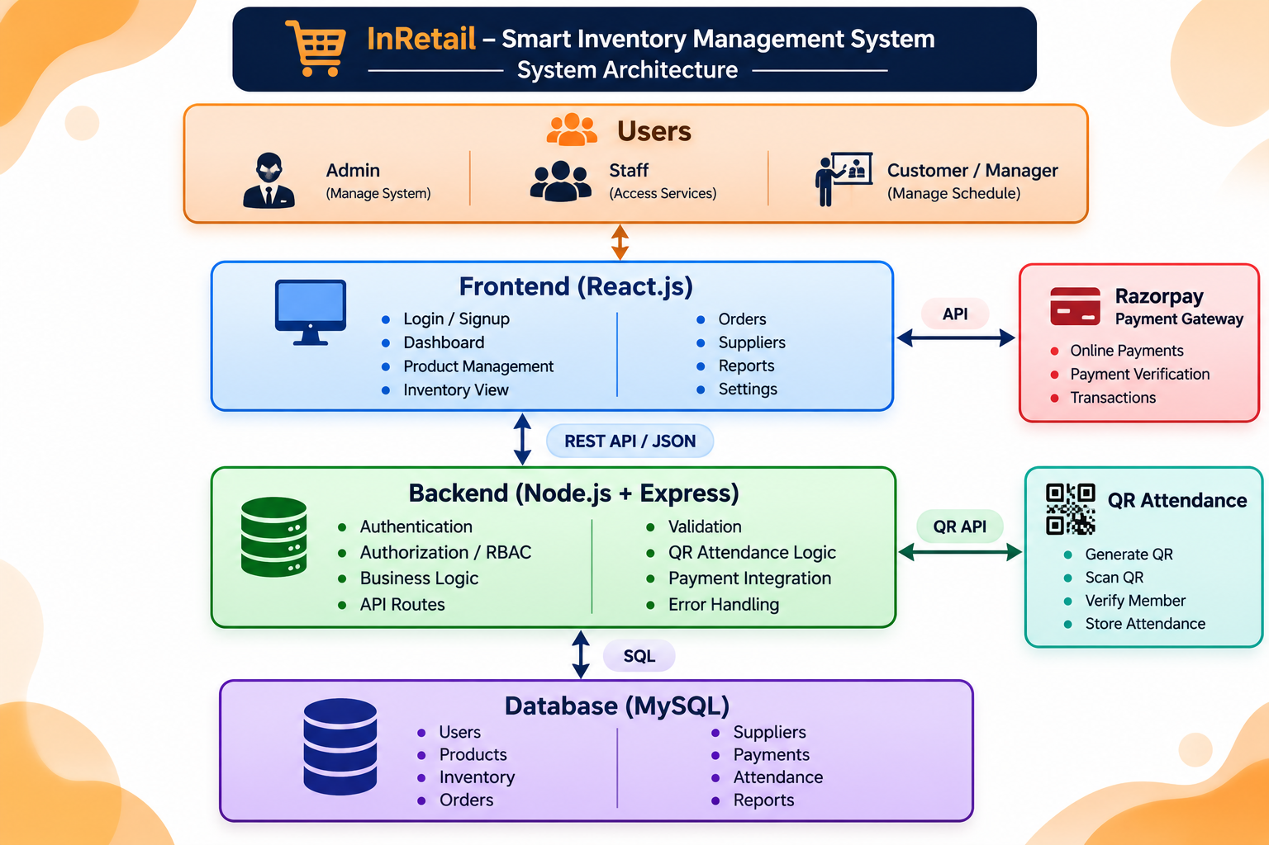

4.1 High-Level Architecture
InRetail follows a layered architecture in which a browser-based presentation layer communicates with a Spring Boot REST backend, and the backend persists data in MySQL. The main flow is: Administrator Browser → HTML/CSS/JavaScript Interface → HTTP REST API → Spring Boot Controller → Spring Data JPA Repository → Hibernate/JDBC → MySQL Database. The response follows the reverse path and is rendered by the browser.
4.1.1 User Layer. The intended user is a store administrator or inventory operator. The user opens the application in a browser and selects a workspace area such as Dashboard, Products, Inventory, Orders, Suppliers, Reports, or Settings. The current implementation does not include a complete login or role-based access module; the interface should therefore be treated as a prototype workspace rather than a secured multi-user deployment.
4.1.2 Presentation Layer. Static resources are located in src/main/resources/static. index.html provides the application shell, styles.css defines the visual design, and app.js handles navigation, data retrieval, filtering, forms, and rendering. Spring Boot serves these files alongside the REST API.
4.1.3 Application Layer. InventoryController defines the API routes and business operations. It uses repository interfaces to retrieve and persist entities. The controller contains the current stock adjustment rules and dashboard aggregation logic. Spring Boot manages dependency injection and application startup.
4.1.4 Persistence Layer. Spring Data JPA repository interfaces provide access to entity records. Hibernate maps entity objects to relational rows and uses the MySQL JDBC driver to communicate with the database. This separation keeps HTTP request handling distinct from low-level database access.
4.1.5 Database Layer. MySQL stores products, suppliers, customer orders, and stock movements. The product table contains catalogue and stock fields. The stock_movements table contains a product reference and movement details. Supplier and customer order tables store the contact and order summary data needed by their views.

4.2 Description of Each Layer
4.2.1 Presentation Layer – Static Web Interface. The browser layer is responsible for displaying data and collecting user input. The page navigation changes the active workspace without requiring a full page reload. Data is requested from the backend through fetch calls. Product and stock forms submit JSON to the corresponding API endpoints. The frontend then refreshes data to reflect the persisted result.
4.2.1.1 Dashboard Navigation. The sidebar exposes the major application areas. When a user selects a page, JavaScript updates the active navigation item, page title, subtitle, and page content. This gives the application a single-page interaction style while keeping the source implementation in plain JavaScript.
4.2.2 Application Layer – Spring Boot. The application layer receives HTTP requests, maps them to controller methods, validates selected entity fields, applies business rules, and calls repositories. The controller is the boundary between the browser and the persistence layer. Keeping the API paths consistent makes the interface easier to maintain.
4.2.2.1 REST API Layer. REST endpoints use HTTP methods to represent operations. GET retrieves information, POST creates records or performs a stock adjustment, PUT updates a product, and DELETE removes a product. JSON is used for request and response bodies. The /api prefix groups the application endpoints.
4.2.2.2 Validation and Error Handling. Product fields such as SKU, name, and category are marked as non-blank. The stock controller checks quantity, movement type, and available balance. Missing product identifiers return a not-found response. Invalid operations return a bad-request response. These checks protect the normal API workflow, although additional validation and centralized error formatting can improve the user experience.
4.2.3 Database Layer – MySQL. The database stores normalized business records in separate tables. Primary keys identify rows, and the stock movement foreign key connects the movement ledger to the product catalogue. JPA entities describe this structure in Java, while Hibernate handles SQL generation and mapping.
4.2.3.1 Database Communication. A controller invokes a repository method. Spring Data JPA creates the required persistence operation, Hibernate translates it into SQL, and the MySQL driver sends it to the database. The resulting row data is mapped back into Java entity objects and serialized by Spring as JSON when returned by the controller.
4.2.3.2 Relationship Flow. A product can have multiple stock movements. Each movement belongs to one product through the product_id foreign key. This one-to-many conceptual relationship supports movement history and allows the interface to show the product name alongside the movement type and quantity.
4.2.4 Business Logic Layer. Business logic includes product updates, search, stock adjustment, stock status classification, inventory valuation, and dashboard aggregation. The current implementation keeps much of this logic in the controller and frontend rendering functions. As the project grows, dedicated service classes can centralize these rules and make them easier to test.
4.2.5 Request and Response Flow. When the dashboard opens, the browser requests products, suppliers, orders, and movements. The backend reads the relevant tables and returns JSON. JavaScript calculates or displays summary values and renders the page. When a stock movement is submitted, the browser posts the movement details, the controller validates and saves the operation, and the updated product is returned. The frontend refreshes the relevant records so the new balance and movement appear.
4.2.6 Security Considerations. The current supplied project does not implement authentication and authorization. CORS is enabled on the controller, but CORS is not an authentication mechanism. A real deployment should add user identity, role permissions, protected endpoints, secure credential handling, HTTPS, audit attribution, and input validation appropriate to the business context.

4.3 Deployment Architecture
4.3.1 Local Deployment. The simplest deployment is a local environment in which MySQL runs as a database service and Spring Boot runs as a Java process on port 8080. The browser connects to the application through localhost. This arrangement is appropriate for development and controlled demonstrations.
4.3.2 Server Deployment. A hosted environment can run the Spring Boot application on a virtual machine or container and connect it to a managed or separately hosted MySQL database. The application should be configured with the correct JDBC URL, database credentials, port, and environment-specific settings. The current source does not include a cloud deployment manifest, so cloud hosting is a proposed deployment option rather than an implemented capability.
4.3.3 Environment Configuration. Database credentials should be externalized and protected. The database should be provisioned with a least-privilege account rather than a shared root account. The application port and database endpoint should be documented for the deployment environment. A production profile can disable verbose SQL logging and apply stricter connection and security settings.
4.3.4 Build and Release. Maven can compile and package the application into an executable artifact. A release process should include source review, compilation, dependency checks, database backup, configuration verification, and smoke testing. The same artifact should be promoted between environments with configuration supplied externally.
4.3.5 Monitoring and Backup. A production environment should monitor application health, database availability, error rates, disk usage, and response times. MySQL backups should be scheduled and restore procedures tested. Logs should capture operational errors without exposing passwords or other sensitive values.
4.3.6 Scalability. If the number of products or users grows, database indexes should be selected according to query patterns. Pagination can be added to list endpoints. Frequently requested dashboard summaries can be optimized or cached after correctness requirements are established. Horizontal scaling would require an external database and careful management of application configuration.

CHAPTER 5 – DESIGN

5.1 Design Overview
The design of InRetail is centered on a small set of clearly defined entities and operational workflows. The product catalogue is the central data area because stock status, inventory value, and stock movements all depend on product records. Supplier and customer order information provide supporting operational context. The user interface organizes these data areas into separate pages while keeping a consistent visual language.
The database design follows a relational approach. Each main entity has a generated primary key. Required attributes are represented by non-null fields where appropriate. Product SKU is unique because it acts as the business identifier used by staff to locate a product. Stock movements use a foreign key to refer to the product they affect.
5.2 ER Diagram / Database Schema. The conceptual relationship is PRODUCTS (1) to STOCK_MOVEMENTS (many). SUPPLIERS and CUSTOMER_ORDERS are separate operational tables in the current version. The schema reference lists products, suppliers, customer_orders, and stock_movements. No direct supplier-to-product or order-to-product relationship is implemented in the supplied model.

5.3 Database Tables and Data Dictionary
5.3.1 Products Table. The products table stores id, sku, name, category, current_stock, reorder_point, unit_price, and expiry_date. The id field is the primary key. SKU is non-null and unique. The current_stock value represents the latest known quantity. The reorder_point is the threshold used to classify low-stock products. Unit price is used by inventory valuation calculations. Expiry date is optional.
5.3.2 Suppliers Table. The suppliers table stores id, name, contact_person, email, phone, and address. The supplier name is required. Other contact fields may be left empty. The current implementation uses this table as a directory and does not define purchase-order or product-supply junction tables.
5.3.3 Customer Orders Table. The customer_orders table stores id, order_number, customer_name, total_amount, status, and order_date. These fields support the order listing and order-value aggregation. The current schema does not include a separate order_items table, so product-level sales analysis cannot be derived from the order table alone.
5.3.4 Stock Movements Table. The stock_movements table stores id, product_id, movement_type, quantity, note, and created_at. The product_id column references products.id. Movement type is represented as a string with accepted values IN and OUT in the controller. Quantity records the magnitude of the movement; the type determines whether the current balance increases or decreases.

5.4 User Interface Design
The dashboard uses metric cards to display recorded revenue, order count, products needing attention, and active product count. Additional panels summarize inventory valuation and stock health. A priority-attention table lists products that may need replenishment. The dashboard is intended to make important values visible without requiring users to open each record.
The product catalogue uses product cards and filters. Each card displays SKU, name, category, unit price, current stock, and stock status. Actions allow the user to edit product details, open stock movement controls, or delete a product. The product form groups the required fields and uses appropriate input types for numeric values and dates.
The inventory page focuses on warehouse stock visibility. It shows units on hand, healthy product count, low-stock alerts, and out-of-stock count. A table lists products and allows stock adjustment. A recent movement table provides a short ledger view. The current API limits the movement list to the latest twenty records.
The order centre presents order statistics and a register of customer orders. Supplier cards display contact information and provide convenient email or phone actions based on stored values. The reports page summarizes recorded order value, inventory valuation, attention counts, total orders, and category stock distribution.
5.5 Design Principles. The application uses clear navigation, consistent labels, recognizable status badges, and a limited set of primary actions. The design separates product master data from stock transactions so that a user can edit product attributes without losing the concept of a movement history. The interface should communicate that a stock movement changes the quantity, while product editing changes the stored catalogue attributes.

CHAPTER 6 – IMPLEMENTATION

6.1 Module-Wise Implementation
6.1.1 Application Initialization. InventoryApplication starts the Spring Boot application. During startup, Spring configures the web server, JPA, repositories, and application components. DataSeeder runs after the application context is created and inserts demonstration records only when the corresponding tables are empty.
6.1.2 Product Management Module. Product.java defines the product entity and maps it to the products table. ProductRepository provides standard persistence operations and a search method for product name or SKU. InventoryController exposes create, read, update, and delete endpoints. The frontend uses the product form for creation and editing and refreshes the catalogue after a successful request.
6.1.3 Inventory Module. The stock adjustment endpoint receives the product identifier and a JSON body containing type, quantity, and note. It loads the product, validates the movement, updates current stock, saves a StockMovement entity, and persists the product. The frontend opens a modal for the movement details and refreshes the inventory page after the request completes.
6.1.4 Supplier Module. Supplier.java defines the supplier entity. SupplierRepository provides persistence operations. The controller exposes supplier listing and creation. The supplier page displays registered contacts in cards. The current project does not expose supplier update or delete endpoints.
6.1.5 Customer Order Module. CustomerOrder.java maps order number, customer name, total amount, status, and order date. CustomerOrderRepository supports retrieval and counting. The controller exposes a GET endpoint that returns all orders. The dashboard calculates recorded order value by summing totalAmount across the returned order records.
6.1.6 Dashboard and Reports Module. The dashboard endpoint calculates revenue, order count, low-stock count, out-of-stock count, active product count, and the products needing attention. The frontend adds further presentation such as inventory valuation and stock distribution by category. Inventory valuation is calculated from currentStock multiplied by unitPrice for each product.
6.1.7 Stock Movement Repository. StockMovementRepository includes a derived query to retrieve the top twenty records ordered by createdAt descending. This supports a compact recent-activity view without loading the complete movement ledger. A later version can provide pagination and date filters.

6.2 Front-End Logic and State Handling
The frontend uses JavaScript variables to hold the currently loaded product, supplier, order, and movement arrays. A refresh operation requests the API resources and stores the returned values. The selected page determines which rendering function is invoked. When users change pages, the navigation state and page headings are updated.
The product page applies a selected filter to the product array. The available categories are All, Healthy, Low stock, and Out of stock. A healthy product has stock greater than its reorder point. A low-stock product has a positive quantity at or below the reorder point. An out-of-stock product has zero quantity. The dashboard's attention list combines low-stock and out-of-stock products.
The frontend uses modal forms for product and stock operations. Form submission serializes values into JSON and sends them to the backend. The browser can provide basic validation through required fields and numeric input constraints. The backend remains the authoritative layer for required values, duplicate identifiers, and stock movement rules.
Toast messages communicate success or failure to the user. A successful request is followed by data refresh so the interface reflects the latest server state. A failed request displays an error message and should not be represented as a successful update. This pattern helps keep the displayed data aligned with persisted records.
The current project uses a straightforward client-side rendering approach rather than a dedicated state-management framework. For the present scope, the approach keeps the frontend compact. If the number of pages and interactions increases, the team can introduce reusable modules, centralized API functions, and more formal state handling.

6.3 API Integration
The frontend and backend communicate through JSON-based HTTP requests. The main endpoints are grouped under /api. Product retrieval uses GET /api/products. Product creation uses POST /api/products. Product update uses PUT /api/products/{id}. Product deletion uses DELETE /api/products/{id}. Stock changes use POST /api/products/{id}/stock. Supplier, order, movement, and dashboard data are retrieved through their corresponding endpoints.
The request helper in the frontend centralizes fetch handling. It sends the selected method and request body, checks whether the response is successful, and parses the returned JSON. A shared helper avoids repeating low-level request code in every rendering function. The API contract should remain consistent as additional features are introduced.
API validation is important because requests can originate from tools other than the browser. For example, a user can call the stock endpoint directly with Postman. The controller therefore validates quantity and movement type on the server. It also checks available stock before processing an OUT movement. The project can be strengthened by validating all numeric product fields and returning structured validation messages.

6.4 Authentication and Authorization
The supplied InRetail source does not include a login, user entity, password hashing, JWT authentication, or role-based authorization. The current interface displays an administrator workspace but this label is part of the presentation and should not be interpreted as proof of an authenticated session. Before exposing the application to a public network, authentication and authorization must be implemented on the server.

CHAPTER 7 – FEATURES

7.1 List of Main Features
The main features of InRetail are organized around the retail inventory lifecycle. The dashboard presents a summary of store activity. Product management maintains the catalogue. Inventory control updates quantities and records movements. The order centre lists customer order summaries. Supplier management stores partner contacts. Reports calculate useful inventory and order indicators.
7.1.1 Dashboard Overview. The dashboard presents recorded revenue, order count, low-stock and out-of-stock count, and active product count. It also highlights products that require attention. The figures are generated from database-backed records, except for any visual trend chart explicitly marked as illustrative in the project README.
7.1.2 Product Catalogue. The catalogue displays products with SKU, name, category, unit price, current quantity, and stock status. Users can add a product, edit details, delete a product, and filter the list by stock health. The backend supports search by product name or SKU.
7.1.3 Stock Control. The stock control view displays total units on hand and counts of healthy, low-stock, and out-of-stock products. Users can select a product and record stock received or stock issued. The backend records the movement and updates the product balance.
7.1.4 Supplier Directory. The supplier page displays supplier name, contact person, email, phone, and address. The current interface supports adding supplier information and listing saved suppliers. Contact actions can open the user's email application or copy a phone number where browser permissions allow.
7.1.5 Customer Order Centre. The order page lists order number, customer name, total amount, status, and date. Summary counts show the distribution of orders by selected statuses. These records support basic order visibility but do not provide detailed fulfilment actions.
7.1.6 Reports and Insights. The reports page calculates inventory valuation, recorded order value, products needing attention, total orders, total units on hand, and category-level stock distribution. These values help the operator understand the current stock position and order summary.
7.1.7 Settings Workspace. The interface includes a settings navigation area. The supplied source presents a workspace settings view; it does not establish a full configuration-management backend. Any preferences shown by the page should be understood within the limits of the current frontend implementation.

7.2 How Each Feature Works
Product creation begins when the user opens the Add product form and enters the SKU, name, category, stock quantity, reorder point, unit price, and optional expiry date. The browser sends the values to POST /api/products. The controller clears the id and saves the entity through ProductRepository. The newly created product is returned and the frontend refreshes the catalogue.
Product editing follows a similar flow. The frontend loads the existing values into the form and sends an update request to PUT /api/products/{id}. The controller locates the existing row, updates its fields, and saves it. If the identifier does not exist, the API returns a not-found response. The unique SKU constraint prevents two products from sharing the same SKU.
Stock receipt is recorded as an IN movement. The controller adds the submitted quantity to the existing currentStock value and stores a movement row. Stock issue is recorded as OUT. The controller first checks that the product has enough units; if not, the operation is rejected. The quantity is then subtracted and a movement record is saved.
Stock status is calculated from currentStock and reorderPoint. If currentStock is zero, the product is out of stock. If currentStock is greater than zero but less than or equal to reorderPoint, the product is low stock. If currentStock is greater than reorderPoint, the product is considered healthy. This classification is used in the product and inventory views.
Inventory valuation is calculated by multiplying each product's current quantity by its unit price and summing the results. The calculation provides an estimated value of current stock at the stored unit prices. It should not be interpreted as an audited accounting valuation because the current model does not include purchase cost history, tax, discounts, or valuation methods such as FIFO.
Recorded order value is calculated by summing the totalAmount field for the customer order records. The result is a simple total of the order values stored in the database. The current project does not include a detailed sales ledger or payment settlement data, so the figure should be labelled as recorded order value rather than verified cash revenue.

CHAPTER 8 – TESTING

8.1 Testing Objectives
Testing is required to confirm that the frontend, backend, and database work together as expected. The main objectives are to verify that product records can be created and retrieved, product search returns appropriate matches, updates persist correctly, stock adjustments follow the business rules, supplier and order records can be listed, and dashboard values reflect the stored data.
Testing should cover both normal and abnormal conditions. A successful stock-IN operation should increase the product balance and create a movement record. A successful stock-OUT operation should decrease the balance and create a movement record. An attempt to issue more stock than is available should be rejected without reducing the quantity. Zero or negative movement quantities should also be rejected.
Testing should verify database persistence by restarting the application and checking that saved records remain available. It should also verify relationships by retrieving stock movements and confirming that each movement is associated with the correct product. Error cases such as a missing product identifier, duplicate SKU, malformed JSON, or unavailable database should be examined.
8.1.1 Testing Approach. The recommended approach combines unit-level checks of business rules, API tests of controller endpoints, integration tests involving MySQL, and browser-based user journey tests. The current project package does not include a dedicated automated test suite in the supplied file list; the cases below are a test plan and should be marked as passed only after execution.

8.2 API Testing
API testing can be performed using Postman or curl. Each endpoint should be tested with a valid request and with invalid values. The response status, response body, and resulting database state should be inspected. The API paths are stable reference points for repeatable tests.
8.2.1 Product Retrieval. Send GET /api/products and confirm that the response is a JSON array. If seed data has been inserted, the array should contain the sample products. Send GET /api/products?search=USB and verify that matching product names or SKUs are returned without case sensitivity.
8.2.2 Product Creation. Send POST /api/products with a unique SKU and all required fields. Verify that the response contains a generated id and that the record appears in subsequent GET requests. Repeat the request with the same SKU and confirm that the unique constraint rejects the duplicate. Also test blank SKU, name, or category values.
8.2.3 Product Update and Delete. Send PUT /api/products/{id} with modified product fields and verify that the changes persist. Use an unknown identifier and confirm a not-found response. Send DELETE /api/products/{id} and confirm that the product is no longer returned. If the product has stock movement references, verify the database's foreign-key behavior before relying on deletion in a production workflow.
8.2.4 Stock-IN. Send POST /api/products/{id}/stock with type IN, a positive quantity, and a note. Verify that currentStock increases by the requested amount and a movement record is created with type IN.
8.2.5 Stock-OUT. Send the same endpoint with type OUT and a quantity not greater than current stock. Verify that currentStock decreases and the movement record stores the submitted quantity and note. Attempt to issue more than the available stock and verify that the request is rejected.
8.2.6 Supplier and Order Retrieval. Send GET /api/suppliers and GET /api/orders and confirm that the records are returned. Send POST /api/suppliers with a valid supplier object and verify that the new supplier appears in the list.
8.2.7 Dashboard and Movement History. Send GET /api/dashboard and compare its summary values with direct database counts and sums. Send GET /api/movements and verify that no more than the latest twenty records are returned in descending creation-time order.

8.3 Integration Testing
Integration testing checks whether the browser, API, repositories, and database operate as a single application. A typical user journey begins by opening the dashboard, navigating to the product catalogue, adding a product, recording a stock receipt, recording a stock issue, and checking the updated balance and movement history.
The product form should be tested in both create and edit modes. The browser should send the expected JSON fields and refresh the view after a successful response. If the backend rejects a duplicate SKU or invalid field, the user should receive an error message and the page should not display an unsaved record as if it were persisted.
The stock modal should be tested for both movement types. The test should compare the product balance before and after the operation and verify the corresponding stock_movements row. The recent movement list should show the correct product, movement type, quantity, note, and timestamp.
The dashboard should be tested after inserting and changing sample records. Low-stock and out-of-stock counts should match the product data. Inventory valuation should equal the sum of quantity multiplied by unit price for all products. Recorded order value should equal the sum of the customer order totals.
8.3.1 Browser Compatibility. The interface should be checked in current versions of common browsers. Testing should include navigation, modal open and close actions, form submission, table rendering, search, filters, and responsive layout. Any browser-specific issue should be recorded with the browser version and reproduction steps.
8.3.2 Database Restart Test. After creating or updating records, stop and restart the application and confirm that the data remains in MySQL. This test distinguishes persistent database storage from temporary browser state.

8.4 Tools Used and Test Case Register
Postman or an equivalent HTTP client is suitable for endpoint-level testing. Browser developer tools can inspect network requests and JavaScript errors. MySQL Workbench or the MySQL command-line client can inspect table rows and execute verification queries. Maven is used to compile and launch the backend.
Test results should be recorded with a test identifier, precondition, request or user action, expected result, actual result, and status. The table below is a test plan; the result column is intentionally left as “To be executed” because source inspection alone does not prove that a test has been run.

CHAPTER 9 – DEPLOYMENT

9.1 Deployment Requirements
The supplied project is designed to run as a Spring Boot application with a MySQL database. The required software includes Java 17 or newer, Maven 3.8 or newer, MySQL Server 8 or newer, and a modern browser. The project can be opened in a Java IDE or run from a terminal.
9.1.1 Pre-Deployment Preparation. Extract the project ZIP into a working directory. Confirm that pom.xml is present at the root. Install the required Java and Maven versions and ensure that MySQL Server is running. Review application.properties and replace the password placeholder with the local database password. Do not use a privileged database account for a public production service.
Before the demonstration, verify that port 8080 is available. If another service uses the port, change server.port in the configuration or stop the conflicting service. Confirm that the JDBC URL points to the correct MySQL host and schema. Ensure that the application can connect to the database before opening the browser.

9.2 Environment Configuration
9.2.1 Backend Configuration. The application name is configured as InRetail Inventory Management. The server port is 8080. The datasource URL points to localhost:3306/inretail_db and includes createDatabaseIfNotExist=true. The username defaults to root in the sample configuration, and the password must be replaced with a local value. The MySQL driver is com.mysql.cj.jdbc.Driver.
9.2.2 JPA Configuration. Hibernate schema generation is set to update. SQL logging is disabled by default. The MySQL dialect is configured, and Jackson is configured to serialize date/time values in a readable non-timestamp form. These settings are appropriate for the supplied local project; production settings should be reviewed before deployment.
9.2.3 Database Preparation. The README provides an optional SQL command to create the database: CREATE DATABASE inretail_db;. The schema-reference.sql file also includes a database creation statement and a logical description of the four tables. In the current configuration, Hibernate can create or update the mapped tables when the application starts.
9.2.4 Secrets and Configuration Safety. Real database passwords should not be committed to source control. A production deployment should use environment variables, a protected configuration store, or the hosting platform's secret manager. The database account should have only the permissions required by the application.

9.3 Hosting and Startup
9.3.1 Local Startup. Open a terminal in the project root and execute mvn spring-boot:run. Maven resolves dependencies and starts the application. Wait for the Spring Boot startup message and confirm that no database connection error is reported. Then open http://localhost:8080 in a modern browser.
9.3.2 Initial Data. On the first run, DataSeeder inserts sample products, one supplier, and sample customer orders if the relevant tables are empty. If the tables already contain records, the seeder does not replace them. For a clean demonstration, use a separate demonstration database or carefully reset sample data before the presentation.
9.3.3 Post-Startup Verification. Open the dashboard and confirm that the product and order summaries appear. Open the product catalogue and inspect sample product records. Record a stock-IN movement and verify the balance. Record a valid stock-OUT movement and inspect the movement history. Test an invalid stock-out quantity to confirm that the backend rejects it.
9.3.4 Production Hosting Considerations. A production deployment should use HTTPS through a reverse proxy or hosting platform, a managed or secured MySQL instance, protected credentials, backups, monitoring, and authentication. The current source does not include a Dockerfile, cloud infrastructure definition, or CI/CD workflow. These should be added as part of a separate deployment task rather than claimed as existing features.

CHAPTER 10 – CHALLENGES AND LIMITATIONS

10.1 Development Considerations
10.1.1 Keeping Stock Values Consistent. The most important inventory rule is that the product balance and movement history must remain consistent. A stock receipt increases the quantity and a stock issue decreases it. The controller validates positive quantities and checks for sufficient stock before an OUT movement. This protects the normal API flow from accidental negative balances.
10.1.2 Duplicate Product Identification. Products require a unique SKU so that users can distinguish catalogue entries. The Product entity marks SKU as unique and non-null. The frontend should provide a clear message if the database rejects a duplicate. A future improvement can check SKU availability before submission, while retaining the database constraint as the final safeguard.
10.1.3 Relational Mapping. The stock movement entity references Product through a many-to-one relationship. This makes it possible to retrieve the product associated with each movement. Care is required when deleting products that have movement history. A production policy should decide whether to prevent deletion, archive the product, or preserve historical records through a soft-delete approach.
10.1.4 Dashboard Accuracy. Dashboard values should be calculated from the database and should use clearly defined meanings. Inventory value is based on current quantity multiplied by unit price. Recorded order value is the sum of order totals. It is not necessarily equal to recognized revenue or collected payments. Labels should communicate these distinctions to avoid misleading users.
10.1.5 Data Seeding. Seed data helps demonstrate the application immediately after setup. The seeder checks whether each table is empty before inserting sample records. However, seed data is not a substitute for realistic production data management. The demonstration team should distinguish sample records from actual business information.

10.2 Solutions and Good Practices
The project uses separate entity classes and repository interfaces to keep data modelling and persistence operations organized. The controller provides API endpoints rather than placing database access in the browser. This separation improves maintainability and provides a clear boundary for validation.
The stock adjustment workflow uses explicit movement types and records each accepted change. The movement note gives the operator a place to record a short reason. The product quantity is updated in the backend, so the browser does not calculate and persist the balance independently.
The application uses JPA validation annotations and database constraints for required product fields and unique SKU. These protections should be supplemented with validation for numeric ranges, consistent error responses, and tests for edge cases.
The README provides setup instructions and lists the required Java, Maven, and MySQL versions. The schema reference provides useful SQL examples. Keeping these documents aligned with the source code makes it easier for another developer or evaluator to run the project.

10.3 Current Limitations or Known Boundaries
The current version does not include authentication or authorization. The interface's administrator label is visual only. The backend endpoints are not protected by a user login system. This is a significant limitation for any deployment beyond a controlled demonstration and should be addressed before real store data is used.
The product model stores a current quantity but does not implement a full purchase receiving document, sales transaction, return, transfer, or stock reservation workflow. Stock adjustments are recorded through the manual IN/OUT endpoint. A more complete system should link movements to source documents and user identities.
The supplier module supports listing and creation but not full editing, deletion, supplier purchase orders, or delivery tracking. The order module is currently read-oriented and contains order-level summary fields. It does not include order line items, product allocation, shipping events, returns, or payment status.
The monthly revenue chart in the supplied interface is illustrative until dated sales line-item data is added, as stated in the README. The current order model supports an aggregate of order totals but does not provide the detailed date and product information required for reliable monthly sales analytics.
The project does not implement a trained AI forecasting model. It also does not implement automatic reorder recommendations based on statistical demand, barcode scanning, payment gateway integration, notifications, or multi-store synchronization. These are potential future enhancements, not current capabilities.
The movement endpoint returns only the latest twenty records. Pagination, filtering by product, movement type, or date range, and export facilities are not currently part of the inspected API. The current application is a focused project prototype and a foundation for further development, not a fully featured enterprise inventory platform.
CHAPTER 11 – FUTURE ENHANCEMENTS

11.1 Planned Features
11.1.1 User Authentication and Roles. A future version should introduce user accounts and secure login. Roles such as Administrator, Inventory Staff, and Read-Only Manager can determine which operations a user may perform. Authorization must be enforced on the server for every protected endpoint, not only by hiding buttons in the frontend. Passwords should be stored using a strong password-hashing algorithm and sessions should use secure token or session management.
11.1.2 Purchase Orders and Receiving. The supplier module can be extended with purchase orders that identify the supplier, requested products, quantities, expected delivery date, and status. When goods are received, the system can create a receiving record and generate stock-IN movements linked to that document. This would provide a stronger connection between supplier activity and inventory changes.
11.1.3 Sales Order Line Items. Customer orders can be extended with an order_items table containing product reference, quantity, unit price, and line total. When an order is confirmed, the application can validate availability and create corresponding stock-OUT movements. This would allow product-level sales analysis and improve the accuracy of revenue reports.
11.1.4 Reorder Alerts. A configurable alert mechanism can notify authorized staff when a product reaches its reorder point. Alerts could appear in the dashboard, be sent by email, or be delivered through an internal notification centre. The system should avoid repeated alerts for the same unresolved condition and should record when an alert is acknowledged.
11.1.5 Expiry Monitoring. The Product entity already contains an optional expiryDate field. A future enhancement can use this field to identify products approaching expiry, show days remaining, and filter expired items. Expiry alerts should be configurable and should distinguish items that are expired from those that are approaching the date.

11.2 Possible Integrations and Optimizations
11.2.1 Barcode or QR Scanning. A browser camera or handheld scanner can be used to capture product SKUs and speed up stock operations. The scanned value should be resolved against the product catalogue before an adjustment is submitted. The server must continue to validate product identity and quantity even when scanning is used.
11.2.2 Demand Forecasting. A forecasting module could estimate future demand using dated sales line items, historical stock-outs, seasonality, and promotional information. A useful forecast requires sufficiently complete historical data. The current order summary model does not provide enough detail for a reliable trained forecasting model, so sales line-item capture should be implemented first.
11.2.3 Multi-Store Inventory. A branch or warehouse entity could be introduced to track stock at different locations. Product quantities would then be associated with a location, and transfer movements would move stock between locations. This would require additional constraints and reporting to prevent the same quantity from being counted in two places.
11.2.4 Advanced Reports. Future reports can include stock turnover, days of inventory on hand, ageing, purchase history, supplier lead time, product profitability, and sales trends. These measures require additional data such as dated sales, purchase costs, and receiving records. Reports should show the time period and calculation method used.
11.2.5 API Pagination and Search. As the number of products and movements grows, list endpoints should support pagination, sorting, and filters. Database indexes can be added for frequently searched fields such as SKU, name, order number, and movement creation time. Query plans should be reviewed using realistic data volumes.
11.2.6 Automated Testing and CI/CD. Unit tests can cover stock movement rules and dashboard calculations. Integration tests can run against a test database. A CI pipeline can compile the project, execute tests, and package the application for release. Deployment should be repeatable and should include a database migration process.

11.3 Security, Reliability, and Scalability
Security improvements should include authenticated access, role-based permissions, HTTPS, protected secrets, request validation, rate limiting, and audit logs. Each stock adjustment should record who performed it and when. Sensitive database credentials should be managed outside the source repository.
Reliability improvements should include transaction management around stock balance updates and movement creation. If one part of the operation fails, the database should not be left with a changed quantity but no corresponding movement record. Concurrency control should prevent two simultaneous stock-out requests from both consuming the same available units.
Scalability improvements can include connection-pool tuning, query optimization, pagination, caching of selected dashboard aggregates, and separation of application and database hosting. Any optimization should be guided by measurement rather than assumption. Monitoring should record response time, error rates, database availability, and resource use.

CHAPTER 12 – CONCLUSION

12.1 Summary of the Project
InRetail – Smart Inventory Management System was developed as a database-driven application to organize core retail inventory information. It addresses the need for a centralized view of products, current stock, stock movements, suppliers, and customer order summaries. The system combines a browser interface, REST backend, and MySQL persistence in a compact full-stack architecture.
The product catalogue stores the information needed to identify and value each item. The stock control module records incoming and outgoing quantities and preserves movement history. The supplier directory keeps basic supplier contact information. The order centre lists order summaries. The dashboard and reports present calculated indicators that help an administrator understand the current state of inventory.
12.1.1 Main Purpose. The main purpose is to reduce dependence on scattered manual records and make inventory information easier to retrieve and maintain. The system provides a single workspace in which a user can inspect product status, perform stock adjustments, and review recent activity.
12.1.2 Major Modules. The main modules are Dashboard, Product Catalogue, Inventory Control, Order Centre, Supplier Directory, Reports, and Settings. The backend supports product CRUD operations, stock adjustments, supplier creation and retrieval, order retrieval, movement history, and dashboard aggregation.
12.1.3 Technology Used. The backend uses Java 17 and Spring Boot 3.4.5. Spring Web exposes REST endpoints. Spring Data JPA and Hibernate map entities to MySQL tables. MySQL Connector/J provides database connectivity. The frontend uses HTML, CSS, and JavaScript and is served from the Spring Boot static resource directory. Maven manages the build and dependencies.

12.2 What Was Achieved
The project establishes a relational data model for products, suppliers, customer orders, and stock movements. It uses generated identifiers for primary keys, a unique constraint for product SKU, and a many-to-one relationship from stock movements to products. These structures support data retrieval and preserve the link between stock changes and the affected product.
The project provides REST endpoints for the main product lifecycle. A product can be created, retrieved, searched, updated, and deleted. Stock can be received or issued through a dedicated endpoint. The backend validates movement type and quantity and checks that sufficient stock is available before an OUT operation is accepted.
The dashboard aggregates database records into useful indicators. It reports order totals, order count, low-stock count, out-of-stock count, and active product count. The reports view calculates inventory value and category stock distribution. The current implementation demonstrates how operational summaries can be generated from relational data.
The frontend provides a unified interface for the main workflows. It uses navigation, product cards, tables, modal forms, status badges, and feedback messages. The interface is connected to the backend through HTTP requests and refreshes its data after successful operations.
The project also includes sample data initialization and setup documentation. DataSeeder makes the first-run demonstration easier by inserting representative products, a supplier, and customer orders when the relevant tables are empty. The README and schema reference provide setup and query guidance.

12.3 Skills Learned During Development
The project provides practical experience in requirement analysis and converting a business problem into a set of data entities and workflows. It demonstrates how to identify the core records needed by an application and how to define relationships between them.
Database skills include relational modelling, primary and foreign keys, unique constraints, field mapping, query design, aggregate calculations, and data integrity considerations. The project also demonstrates how an ORM maps Java objects to database rows.
Backend development skills include Spring Boot application configuration, REST controller design, HTTP method mapping, JSON request and response handling, dependency injection, repository usage, and exception handling. The stock adjustment workflow illustrates the translation of a business rule into server-side validation.
Frontend skills include HTML page structure, CSS layout, JavaScript event handling, fetch-based API communication, form submission, filtering, rendering, and user feedback. The integration between the static frontend and backend API demonstrates a complete request-response cycle.
Testing and debugging skills include checking API responses, inspecting browser network requests, reviewing database rows, validating error cases, and reproducing configuration problems. Maven and project configuration skills support repeatable local execution.

12.4 Limitations and Future Work
The current version is a focused inventory management prototype. It does not provide secure user authentication, role-based access, detailed sales line items, purchase orders, payment processing, barcode scanning, or AI-based forecasting. The monthly revenue chart is illustrative until detailed dated sales data is available. The movement history endpoint returns only the latest twenty records.
Future development should prioritize security, transaction safety, purchase and sales workflows, and more complete reporting. Adding user attribution to stock movements would improve accountability. Adding order items and purchase receiving would connect inventory changes to business documents. Reorder alerts and expiry monitoring would provide more proactive inventory support.

12.5 Final Conclusion
In conclusion, InRetail demonstrates how a relational database and a web application can be combined to solve a practical retail inventory problem. The system organizes product details, current quantities, movement records, supplier contacts, and customer order summaries. It provides CRUD operations, stock adjustment rules, dashboard calculations, and reporting views through a clear layered architecture.
The project achieves its core objective of providing a centralized foundation for inventory visibility and stock control. Its design is intentionally extensible: additional modules can be introduced without abandoning the existing relational model. With further work on authentication, transaction handling, procurement, sales detail, alerts, and analytics, InRetail can evolve into a more comprehensive retail operations platform.

CHAPTER 13 – REFERENCES

13.1 Technical References
The following official documentation and technical resources are relevant to the technologies used in the current project. They are listed as references for framework behavior, setup, persistence, and database concepts. The project implementation should be evaluated against the versions specified in pom.xml and the local MySQL environment.
1. Spring Boot Reference Documentation – https://docs.spring.io/spring-boot/ .
2. Spring Framework Reference Documentation – https://docs.spring.io/spring-framework/reference/ .
3. Spring Data JPA Reference Documentation – https://docs.spring.io/spring-data/jpa/reference/ .
4. Hibernate ORM User Guide – https://hibernate.org/orm/documentation/ .
5. MySQL Reference Manual – https://dev.mysql.com/doc/ .
6. Maven Documentation – https://maven.apache.org/guides/ .
7. Java Documentation – https://docs.oracle.com/en/java/ .
8. MDN Web Docs: HTML, CSS, and JavaScript – https://developer.mozilla.org/ .
9. MySQL Connector/J Developer Guide – https://dev.mysql.com/doc/connector-j/en/ .
10. Jakarta Bean Validation documentation – https://jakarta.ee/specifications/bean-validation/ .

CHAPTER 14 – APPENDICES

APPENDIX A – API REFERENCE
The following endpoint summary reflects the routes exposed by InventoryController in the supplied project. The examples are representative request shapes; actual response fields follow the Java entity properties and Spring JSON serialization.
GET /api/products – retrieves all products. Optional query parameter: search. When search is present, product name and SKU are searched without case sensitivity.
POST /api/products – creates a product. Required fields include sku, name, and category. Other fields include currentStock, reorderPoint, unitPrice, and expiryDate.
PUT /api/products/{id} – updates an existing product. The identifier must refer to an existing product.
DELETE /api/products/{id} – deletes a product by identifier.
POST /api/products/{id}/stock – records a stock movement. Example body: { "type": "IN", "quantity": 10, "note": "Purchase received" }. The type must be IN or OUT and quantity must be greater than zero.
GET /api/suppliers – retrieves supplier records.
POST /api/suppliers – creates a supplier record using name, contactPerson, email, phone, and address.
GET /api/orders – retrieves customer order records.
GET /api/movements – retrieves the latest twenty stock movements ordered by creation time.
GET /api/dashboard – returns summary values including totalRevenue, totalOrders, lowStockItems, outOfStockItems, activeProducts, and productsNeedingAttention.

APPENDIX B – DATABASE TABLE SUMMARY
PRODUCTS: id (primary key), sku (unique and required), name (required), category (required), current_stock, reorder_point, unit_price, expiry_date.
SUPPLIERS: id (primary key), name (required), contact_person, email, phone, address.
CUSTOMER_ORDERS: id (primary key), order_number, customer_name, total_amount, status, order_date.
STOCK_MOVEMENTS: id (primary key), product_id (foreign key referencing products.id), movement_type, quantity, note, created_at.
The current schema contains a direct foreign-key relationship from stock_movements to products. The supplied entity model does not define a direct relationship between suppliers and products or between customer orders and products.

APPENDIX C – SAMPLE SQL QUERIES
1. Identify products at or below their reorder point: SELECT * FROM products WHERE current_stock <= reorder_point;
2. Identify products with no available stock: SELECT * FROM products WHERE current_stock = 0;
3. Calculate inventory valuation: SELECT SUM(current_stock * unit_price) AS inventory_value FROM products;
4. Review stock movement history with product names: SELECT p.name, m.movement_type, m.quantity, m.created_at FROM stock_movements m JOIN products p ON p.id = m.product_id ORDER BY m.created_at DESC;
5. Summarize stock by category: SELECT category, SUM(current_stock) AS units FROM products GROUP BY category;
6. Count products by stock status: SELECT CASE WHEN current_stock = 0 THEN 'OUT OF STOCK' WHEN current_stock <= reorder_point THEN 'LOW STOCK' ELSE 'HEALTHY' END AS stock_status, COUNT(*) AS product_count FROM products GROUP BY stock_status;
7. List the most recent stock movements: SELECT * FROM stock_movements ORDER BY created_at DESC LIMIT 20;
8. Calculate total recorded order value: SELECT SUM(total_amount) AS recorded_order_value FROM customer_orders;

APPENDIX D – INSTALLATION AND SETUP GUIDE
Step 1: Extract the InRetail project ZIP into a local working folder.
Step 2: Install Java 17 or newer and Maven 3.8 or newer. Verify the installation using java -version and mvn -version.
Step 3: Install and start MySQL Server 8 or newer. Confirm that the MySQL service is running and that the configured user can create or access databases.
Step 4: Open src/main/resources/application.properties. Replace YOUR_MYSQL_PASSWORD with the correct local password. Change the username if the local MySQL account is not root.
Step 5: Optionally create the database manually by executing CREATE DATABASE inretail_db; in MySQL. The JDBC URL is also configured to create the database if it does not exist and the account has permission.
Step 6: Open a terminal in the project root, where pom.xml is located, and execute mvn spring-boot:run.
Step 7: Wait for Spring Boot to start and check the terminal for database or port errors.
Step 8: Open http://localhost:8080 in a modern browser. The application should display the InRetail workspace.
Step 9: Verify the dashboard, product catalogue, stock control, order centre, suppliers, and reports. Sample records are inserted automatically when the relevant tables are empty.
Troubleshooting: If the page cannot connect, confirm that the backend is running and port 8080 is free. If database startup fails, verify MySQL service status, JDBC URL, username, password, and database permissions. If the dashboard is empty, inspect whether the seeder ran and whether the application is connected to the intended database.

APPENDIX E – USER GUIDE
Dashboard: Open the application to view summary cards and products needing attention. Use the navigation menu to move between the application areas.
Product catalogue: Open Products and choose Add product. Enter a unique SKU, product name, category, stock quantity, reorder point, and unit price. Add an expiry date only when it is relevant. Save the form to create the record. Use Edit details to update an existing product. Use the filters to view all, healthy, low-stock, or out-of-stock products.
Stock control: Open Inventory or use the Stock movement action for a product. Select Stock received (IN) to increase stock or Stock issued (OUT) to decrease stock. Enter a positive quantity and a short note. Save the movement. If the requested OUT quantity is greater than the available balance, the backend rejects the operation.
Orders: Open Order centre to review the order number, customer, order value, status, and date. This view is read-oriented in the current version.
Suppliers: Open Suppliers to view the supplier directory. Use Add supplier to enter a company name and optional contact details. The page displays the stored supplier information.
Reports: Open Insights & reports to view inventory valuation, recorded order value, products needing attention, total orders, and category stock distribution. Interpret recorded order value as the sum of stored order totals, not as verified payment settlement.
Settings: Open Settings to inspect the available workspace settings interface. The current project does not provide a comprehensive server-side configuration or account-management module.

APPENDIX F – TEST CASE REGISTER
The following test register is a verification template. Execute each case against the running application, record the actual result, attach relevant screenshots or API responses, and update the status column. No test is marked as passed solely because the corresponding source code exists.

APPENDIX I – GLOSSARY
Term | Meaning
API | Application Programming Interface; the contract through which the frontend communicates with backend operations.
CRUD | Create, Read, Update, and Delete operations used to maintain records.
Entity | A Java class mapped by JPA to a relational database table.
Foreign Key | A column that references a key in another table and represents a relationship between records.
Hibernate | The object-relational mapping implementation used by the JPA layer.
HTTP | The request-response protocol used by the browser and REST backend.
Inventory Valuation | An estimate calculated as current stock multiplied by unit price and summed across products.
JPA | Java Persistence API; the standard used to map Java objects to relational data.
JDBC | Java Database Connectivity; the interface used by Java applications to communicate with relational databases.
Maven | A build and dependency management tool used by the Java project.
MySQL | The relational database management system used to store InRetail records.
Primary Key | A field that uniquely identifies a row in a table.
Reorder Point | A configured stock threshold used to identify products that need replenishment attention.
REST | An architectural style commonly used to expose resources through HTTP endpoints.
SKU | Stock Keeping Unit; a unique product identifier used by the catalogue.
Spring Boot | A Java framework used to configure and run the backend application.
Spring Data JPA | A Spring module that provides repository abstractions for persistence.
Stock Movement | A recorded stock-IN or stock-OUT adjustment associated with a product.

SUPPLEMENTARY TECHNICAL DISCUSSION

1. Inventory data as a business resource
Inventory data is more than a list of item names and quantities. It represents the store's ability to fulfil demand, plan replenishment, and understand the resources held in stock. A product catalogue therefore needs stable identification, descriptive classification, and measurable quantity and value fields. InRetail uses SKU as the business identifier because names can be similar or may change over time. A stable identifier helps the operator search for a product, distinguish variants, and avoid accidental duplication.
The currentStock field represents the latest quantity known to the application. It is useful for quick display and stock-status calculations, but it should be understood as a current balance rather than a complete explanation of all inventory activity. That explanation is provided by the stock movement ledger. The combination of a current balance and movement records is a common pattern in inventory systems because it supports both fast operational reads and retrospective review.
The reorderPoint field adds a basic business rule to the product record. It allows the application to classify items by their current availability relative to a threshold chosen by the store. The threshold is not a forecast by itself; it is a configured value. Its usefulness depends on the store maintaining sensible thresholds and reviewing them as demand and supplier lead times change. A later version could calculate suggested thresholds from sales history, but that would require additional data.

2. Product master data management
Product master data describes the items that the store handles. InRetail stores SKU, name, category, current stock, reorder point, unit price, and optional expiry date. These fields support the current screens and calculations. SKU is unique and required, while name and category are also required. The application uses a generated numeric identifier as the database primary key, separating internal row identity from the human-readable SKU.
Separating the generated id from the SKU is useful because the database can retain a stable internal reference even if a business identifier needs to be corrected. The unique constraint on SKU prevents duplicate values. In a larger deployment, additional validation could normalize whitespace, enforce a standard SKU format, or prevent case-only duplicates according to the business rules. Such decisions should be made consistently at both the API and database levels.
The optional expiryDate field makes the product model suitable for recording an expiry date when relevant. However, storing a date does not automatically provide expiry alerts or expiry-based stock handling. Those functions would require queries for approaching dates, a user interface for review, and business rules for expired items. The current project should therefore describe expiry date as a supported product attribute rather than an implemented expiry management module.

3. Stock balance lifecycle
A stock balance changes when items enter or leave the store's available inventory. InRetail represents these events using two movement types. IN increases the balance and OUT decreases it. The quantity field stores a positive magnitude, while the movement type determines the direction of the change. This is easier to interpret than storing a signed quantity without an explicit movement label.
The stock adjustment endpoint first locates the product. If the product identifier does not exist, the request is rejected. The controller reads the movement type, quantity, and note. It checks that quantity is greater than zero and that the movement type is one of the accepted values. For an OUT movement, it checks the available balance before subtracting. For an IN movement, it adds the quantity.
After applying the movement rule, the controller saves a StockMovement record and saves the updated Product. This approach links the operational change to a historical record. For stronger consistency, both writes should be protected by a database transaction. Transaction handling is especially important if the database experiences an error after one write but before the other. The current implementation demonstrates the intended workflow, while transaction annotations and concurrency control are appropriate reliability improvements.

4. Stock movement history and auditability
The stock_movements table is the historical record of stock adjustments. Each row contains a generated id, product_id, movement_type, quantity, note, and created_at timestamp. The foreign key allows the movement to be associated with a product. A movement note can capture a short explanation, such as purchase receipt, issue to customer, correction, or another operational reason.
The current movement API returns the latest twenty records ordered by creation time. This is sufficient for a compact recent-activity panel and a small demonstration dataset. A larger store would need pagination and filters. Common filters could include product SKU, date range, movement type, or note keyword. Export to CSV could also help staff reconcile activity with external records.
An audit-ready design would additionally store the user who performed the movement, the source document, the previous balance, and the resulting balance. These attributes are not present in the current model and should not be implied by the existing history. They are recommended enhancements for accountability and investigation of discrepancies.

5. Relational integrity and constraints
Relational integrity helps ensure that records remain meaningful as the application changes. Primary keys identify rows, unique constraints prevent duplicate business identifiers, and foreign keys prevent orphan movement rows. InRetail uses generated primary keys for its entities and a foreign-key association from stock_movements to products. The product SKU field is marked non-null and unique.
Column nullability communicates which values are essential. The Product entity marks SKU, name, and category as required. The Supplier entity requires a name. The CustomerOrder entity requires order number, customer name, total amount, status, and order date. The StockMovement entity requires a product, movement type, quantity, and creation time. Optional contact and note fields can remain empty where appropriate.
Additional database constraints could improve safety. Quantities and reorder points should be non-negative, unit prices and order totals should follow a non-negative rule, and movement quantities should be positive. Some of these rules can be expressed with check constraints in MySQL, while others are enforced in service logic. A production schema should document the chosen enforcement location so that database and application behavior do not conflict.

6. Database normalization considerations
The current design separates products, suppliers, customer orders, and stock movements into distinct tables. This avoids storing all operational information in a single wide table and keeps each entity's attributes grouped with the entity they describe. Stock movements refer to products through a foreign key instead of repeating every product attribute in each movement row.
The supplier directory is independent in the current schema. There is no supplier_id column in Product and no purchase-order table connecting suppliers to products. This is a deliberate description of the current implementation, not a claim that supplier relationships are fully modelled. If the business needs to identify which supplier provides each product, a supplier-product relationship or purchase-order line model should be introduced.
Customer orders are also stored as summary records. There is no order_items table connecting orders to individual products. Consequently, the current schema can calculate total order value but cannot reliably answer which products contributed to a particular order or how many units of each product were sold. Adding order lines would improve normalization of order details and unlock product-level sales analytics.

7. Dashboard metric definitions
Dashboard metrics should have precise definitions so that users interpret them consistently. Active products currently represents the number of product rows returned from the product repository. It does not indicate that a product has been sold recently or is enabled through a separate active flag. If the business later requires discontinued products, an explicit product status field should be added.
Low-stock items are products whose currentStock is greater than zero and less than or equal to reorderPoint. Out-of-stock items have currentStock equal to zero. Products needing attention include products whose currentStock is less than or equal to reorderPoint. The frontend may combine low and out-of-stock products in the same attention list.
Inventory valuation is calculated by summing currentStock multiplied by unitPrice for each product. This is a simple indicative measure based on the stored unit price. It does not account for purchase cost, landed cost, tax, discount, currency conversion, or accounting valuation methods. A report should label it as an estimated inventory value unless the underlying price semantics are formally defined.
Recorded order value is calculated by summing totalAmount across customer_orders. It is a total of stored order amounts, not necessarily net sales, paid revenue, or cash received. Orders may have statuses that indicate different fulfilment states, and the current model does not include payment settlement fields. Clear labels avoid confusing an operational summary with a financial statement.

8. Data seeding and demonstration readiness
The DataSeeder configuration class registers a CommandLineRunner that inserts sample data when the relevant tables are empty. It adds a small collection of products across categories such as electronics, apparel, accessories, beauty, footwear, and home. The sample quantities intentionally include healthy, low-stock, and out-of-stock conditions so that the user interface can demonstrate the stock status indicators.
The seeder also inserts a supplier record and several customer orders when those tables contain no rows. This makes the supplier directory and order centre useful immediately after first startup. The sample records are demonstration fixtures. They should be clearly identified as sample data during a presentation and removed or replaced before the application is used for real store operations.
Because the seeder checks each table independently, a partially populated database may receive seed rows for an empty table while retaining records in another table. This behavior is useful during development but should be considered when preparing repeatable demonstrations. A dedicated reset script or separate demonstration database can provide more predictable setup.

9. API design and HTTP semantics
The REST API groups endpoints under the /api prefix. GET requests retrieve resources, POST requests create resources or perform a stock adjustment, PUT updates a product, and DELETE removes a product. This mapping makes the API relatively easy to inspect using a browser or API client. The frontend uses JSON for request bodies and consumes JSON responses.
The product search endpoint accepts an optional search parameter. When the parameter is non-empty, the controller delegates to a repository method that searches product name or SKU using case-insensitive matching. This approach keeps search logic in the persistence layer and avoids downloading the entire product list for every search operation.
The stock adjustment endpoint is action-oriented because it performs a business operation that changes the balance and creates a movement record. It accepts a JSON map with type, quantity, and note. A more strongly typed request DTO could make the contract clearer and allow validation annotations for movement type and quantity. The response could also return a dedicated result object with the updated product and movement record.

10. Error handling and validation
Validation is important because the backend can receive requests from the browser, API clients, or other services. The Product entity uses @NotBlank for required text fields and non-null database columns for important values. The stock endpoint checks quantity and movement type in the controller and raises an HTTP error when the request is invalid.
Missing product identifiers are handled through a not-found response. Insufficient stock and invalid movement details are treated as bad requests. These responses allow the frontend to show feedback instead of silently changing the display. A centralized exception handler could standardize the JSON error format and include a stable error code for each validation problem.
Further validation should cover negative current stock, negative reorder points, negative unit prices, malformed expiry dates, excessive text length, invalid email addresses, and duplicate supplier or order identifiers if uniqueness is required. Validation rules should be documented and tested at the API boundary.

11. Concurrency and transaction safety
Inventory systems can receive simultaneous requests. For example, two staff members may attempt to issue units from the same product at nearly the same time. If both requests read the same starting quantity before either saves the result, the final balance may not reflect both operations correctly. This is a concurrency problem that becomes more important as multiple users are introduced.
A production implementation can use transaction boundaries and optimistic or pessimistic locking. Optimistic locking can add a version field to Product and reject conflicting updates. Pessimistic locking can lock a product row while the movement is being applied. An atomic database update with a condition that checks the available quantity is another possible approach.
The stock balance update and movement insert should be committed as one transaction. If either operation fails, both should roll back. The current controller demonstrates the sequence of operations but does not explicitly declare a transaction boundary in the inspected source. This is therefore a recommended improvement, not an implemented guarantee.

12. Performance and query efficiency
The current project uses repository methods that retrieve all products, suppliers, and orders for several views. This is straightforward for a small demonstration dataset. As data volume grows, loading every row for each refresh may increase response time and memory use. Pagination and server-side filtering would reduce the amount of data transferred.
Indexes should be selected based on real query patterns. The unique SKU constraint provides an index for SKU lookup in most MySQL configurations. Additional indexes may be useful for product name, category, movement creation time, order date, or order status. Indexes add write overhead, so they should be introduced after query patterns and execution plans are reviewed.
Dashboard aggregation currently reads product and order collections and computes several values in application code. A larger dataset may benefit from database-side aggregate queries. If summaries are cached, the system must define when cached values are invalidated after a product or order change. Correctness should be maintained before introducing performance optimizations.

13. User experience and accessibility
The interface organizes common tasks into a persistent sidebar and a main content area. Page titles and subtitles help identify the current workspace. Cards summarize important metrics, tables present detailed records, and status badges visually distinguish stock conditions. Modals keep product and movement forms close to the page where the user needs them.
Forms should have visible labels, understandable validation messages, and clear focus behavior. Colour should not be the only method of communicating stock status; labels such as Healthy, Low stock, and Out of stock should remain visible. Keyboard navigation and adequate contrast should be reviewed when the interface is evaluated for accessibility.
Responsive layouts are useful when staff access the application from different screen sizes. Tables may require horizontal scrolling on narrow devices, while modal forms should remain usable without clipping. These behaviors should be tested in the browsers and screen sizes used by the intended audience.

14. Operational data governance
Even a small inventory application should define who is allowed to enter and change information, how errors are corrected, and how long historical records are retained. InRetail currently does not include authenticated user accounts, so it cannot attribute changes to individual staff members. A future audit model should capture user identity and operation context.
Data quality depends on consistent SKU formats, meaningful category names, accurate quantities, and maintained reorder points. Duplicate categories or inconsistent spelling can make category reports less useful. A category master table and controlled selection list could improve consistency if the catalogue expands.
Backup and restore procedures should be documented before real business data is stored. A backup is useful only if it can be restored and verified. The database should be backed up on a schedule appropriate to the business, and the restore process should be tested in a separate environment.

15. Project boundary and implementation honesty
The report distinguishes implemented functions from future proposals. Product CRUD, product search, stock IN/OUT adjustment, supplier listing and creation, order listing, recent movement retrieval, and dashboard aggregation are represented in the supplied backend. The static interface provides corresponding views and forms. These are the core claims made about the current project.
Some visual elements may be present in the dashboard design without having a complete data model behind them. In particular, the README identifies the monthly revenue graph as illustrative until dated sales line-item data is added. It would be misleading to present this chart as a live, historically accurate revenue analysis.
Similarly, the presence of an expiryDate field does not establish automated expiry alerts; supplier contact information does not establish automated procurement; and an administrator-themed interface does not establish authentication. Keeping these distinctions clear makes the project documentation technically credible and helps evaluators understand both the delivered scope and the development roadmap.

SUPPLEMENTARY REFERENCE TABLES

Technology and responsibility mapping
Technology / Component | Role in InRetail | Project location / evidence
Java 17 | Backend programming language | pom.xml; Java source files
Spring Boot 3.4.5 | Application framework and startup | pom.xml; InventoryApplication.java
Spring Web | REST controller support | pom.xml; InventoryController.java
Spring Data JPA | Repository-based persistence | pom.xml; repository interfaces
Hibernate | ORM and schema mapping | JPA configuration in application.properties
MySQL | Relational database | application.properties; schema-reference.sql
MySQL Connector/J | JDBC database driver | pom.xml
Jakarta Validation | Required-field validation | Product.java; controller
HTML / CSS / JavaScript | Browser interface | static/index.html, styles.css, app.js
Maven | Build and dependency management | pom.xml; README.md

Business rule summary
Rule | Current behavior | Related component
SKU uniqueness | Product SKU is required and unique | Product entity / products table
Product required fields | SKU, name, and category cannot be blank | Product entity validation
Stock-IN | Adds a positive quantity to current stock | InventoryController
Stock-OUT | Subtracts only when sufficient stock exists | InventoryController
Movement type | Only IN and OUT are accepted | InventoryController
Movement quantity | Must be greater than zero | InventoryController
Low-stock status | Positive stock at or below reorder point | Dashboard / frontend
Out-of-stock status | Current stock equals zero | Dashboard / frontend
Inventory value | Sum of current stock × unit price | Frontend reports
Movement list | Latest 20 records by creation time | StockMovementRepository

Project file map
File / Directory | Purpose
pom.xml | Maven project definition and dependencies
InventoryApplication.java | Spring Boot entry point
config/DataSeeder.java | Initial demonstration data
controller/InventoryController.java | REST API and current business rules
model/Product.java | Product entity
model/Supplier.java | Supplier entity
model/CustomerOrder.java | Customer order entity
model/StockMovement.java | Stock movement entity and product relationship
repository/ProductRepository.java | Product persistence and search
repository/SupplierRepository.java | Supplier persistence
repository/CustomerOrderRepository.java | Order persistence
repository/StockMovementRepository.java | Recent movement retrieval
application.properties | Server and MySQL/JPA configuration
schema-reference.sql | Logical schema and example SQL
static/index.html | Frontend structure
static/styles.css | Frontend styling
static/app.js | Frontend API integration and rendering
README.md | Project overview and run instructions

Appendices:
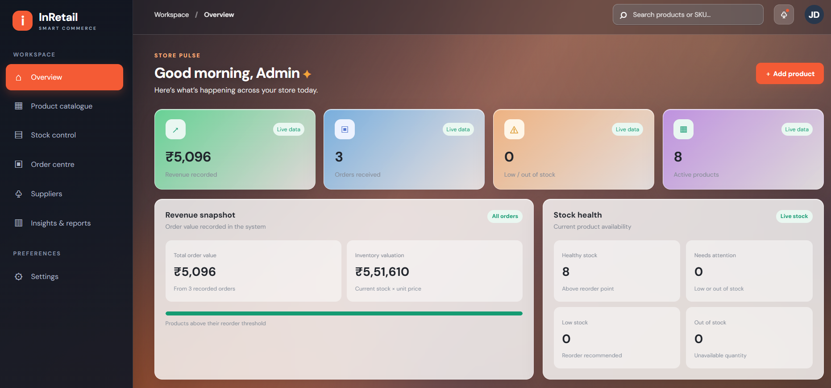
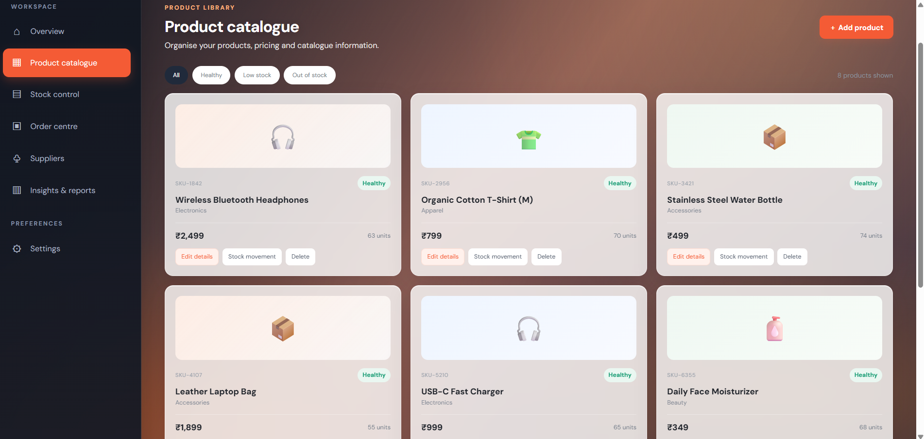
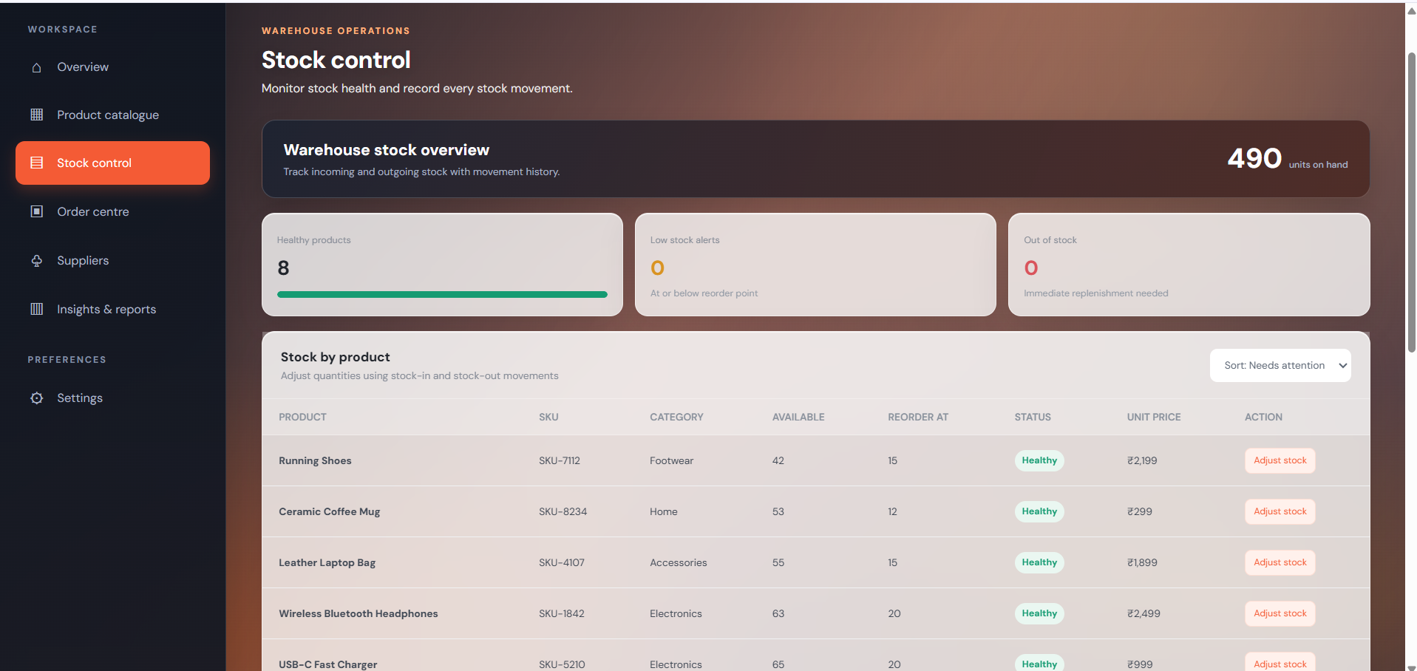
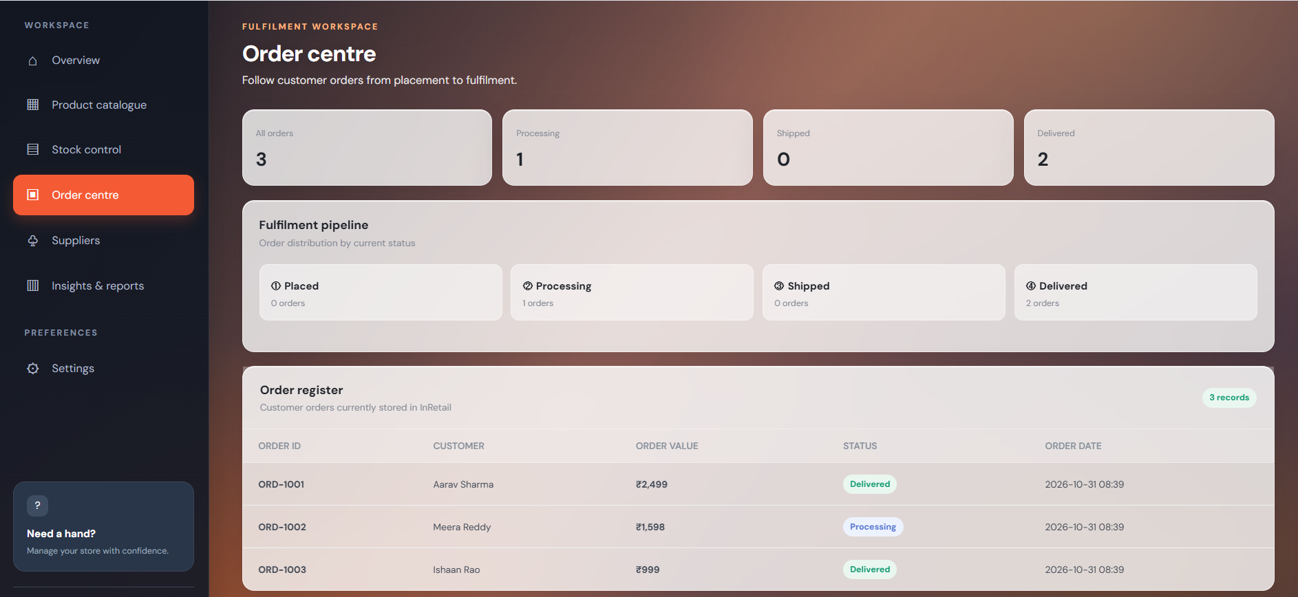
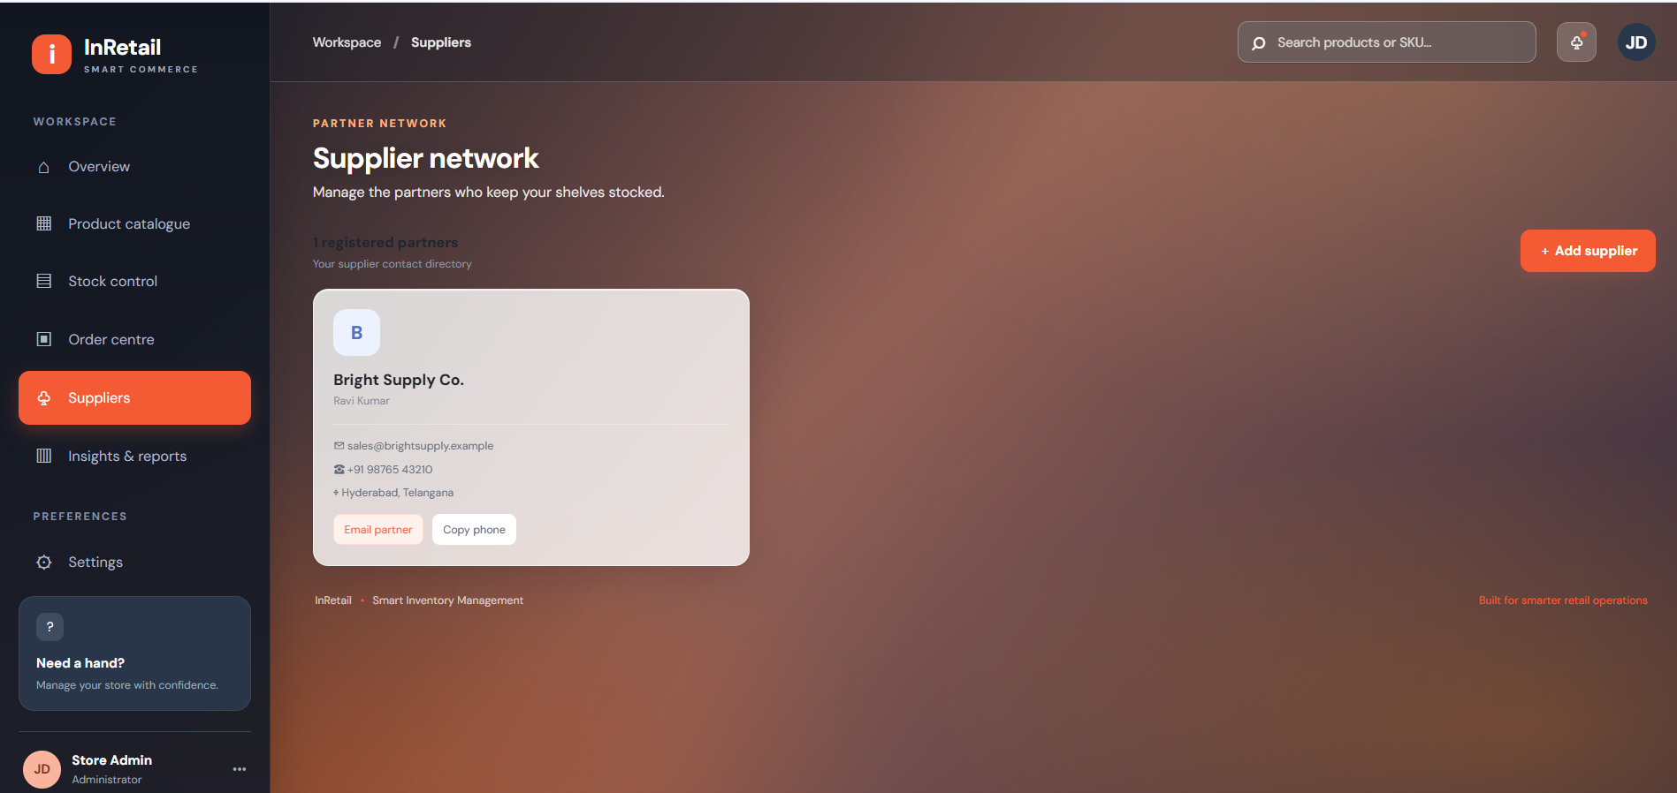
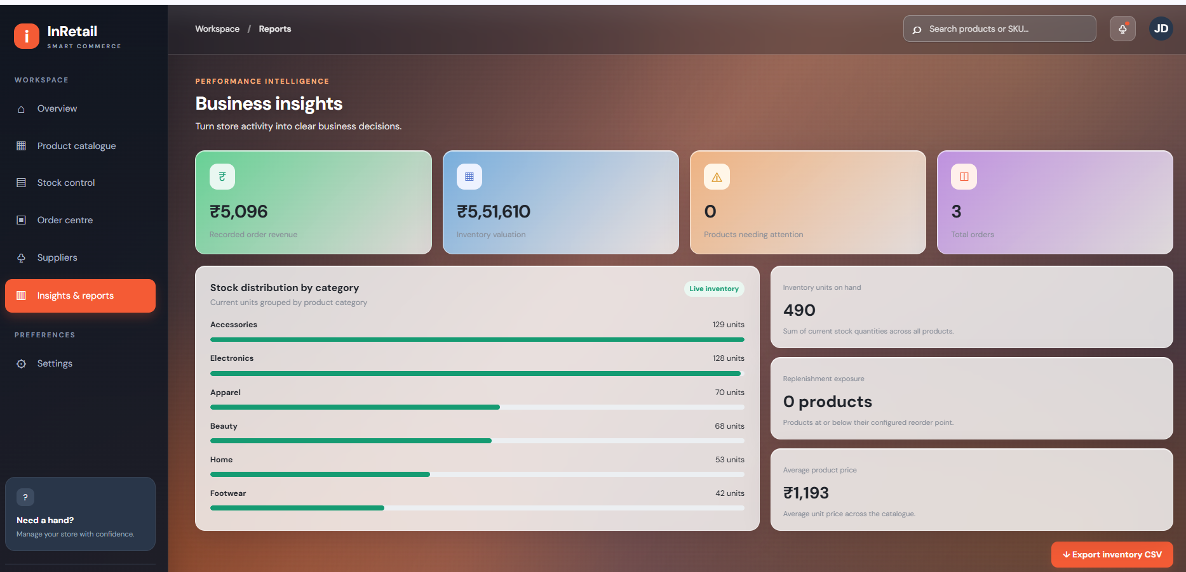
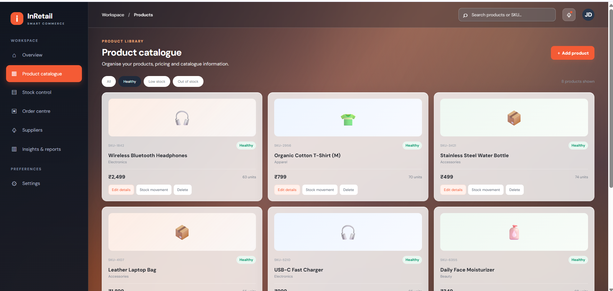

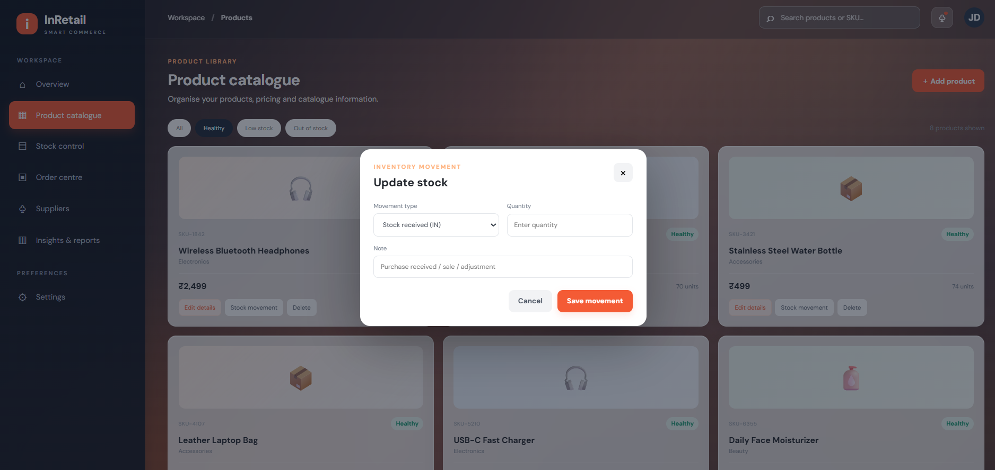

Geo Tag Photos


