Data Storytelling Project: COVID-19 and the Global Economy
Programme: CentraleDigitalLab — Data Storytelling
Deadline: October 21, 2026 (dashboard and 20-minute oral presentation)
Document status: Final implementation, updated 20 October 2026. This version replaces the earlier planning draft.
Repository: github.com/amulyaambati6/covid-economic-impact-dashboard
Live dashboard: [add the Streamlit Community Cloud URL]

1. Project Overview

Research question
How did the COVID-19 pandemic impact the global economy?

Project objective
To explore the impact of the COVID-19 pandemic on the economy through data analysis and an interactive dashboard, comparing seven countries and stating clearly what the data can and cannot show.

Main deliverable
A multi-page interactive dashboard built in Python with Streamlit and Plotly, published on Streamlit Community Cloud. The brief suggests Plotly Dash; Streamlit was approved as an alternative, and every chart in the dashboard is an interactive Plotly figure.

Team roles and contributions
Team member | Role | Contribution in the final project
Othmane | Data | Data collection and preparation: cleaning scripts for the stringency, cases and deaths, and World Bank datasets; the merge script; the processed datasets.
Sara | Analysis | Exploratory data analysis notebook organised around the five themes; statistical summaries and the first findings summary.
Saad | Dashboard development | First Streamlit dashboard: page structure, data loading, interactive filters and the analysis sections.
Amulya | Visualisation and integration | Project set-up and raw data; visual design and CSS; homepage illustration; multi-page structure; consistent charts; statistical corrections; tests; documentation; deployment.
All members reviewed the findings and prepared the presentation. Please confirm the contribution descriptions before submission.

2. Final Scope
The project compares seven countries rather than estimating a single global figure, because the datasets are country-level. Every finding therefore describes these seven countries, not the whole world economy; the dashboard states this on every page.
- Economic indicators: 2018–2024 (2018–2019 serve as the pre-pandemic baseline).
- Pandemic and policy indicators: 2020–2022, the period every source covers (the stringency index ends in December 2022).

3. Indicators Used
Indicator | Measure | Use in the dashboard
GDP growth | Annual % change in real GDP | Contraction in 2020, rebound, and recovery of the GDP level
Unemployment | % of labour force (modelled ILO estimate) | 2019–2020 change and return to the pre-pandemic rate
Inflation | Annual % change in consumer prices | Timing and size of the 2021–2023 price surge
COVID-19 cases and deaths | New cases and deaths per million, monthly totals | Timing and reported severity of the pandemic
Government stringency | Oxford index 0–100 (weighted; vaccinated and non-vaccinated) | Strictness of restrictions; rules by vaccination status

4. Country Selection
The seven countries represent different regions, economic structures, and levels of development. Status: final; data coverage was checked and is complete for all seven.
Country | Reason for selection
United States | A major global economy; a large, service-oriented economy.
India | A large emerging economy with a diverse labour market and a large population.
France | A Western European perspective on economic performance and government restrictions.
China | A major manufacturing and exporting economy.
Brazil | A South American perspective on pandemic and economic trends.
Germany | A major European industrial and export-oriented economy.
Rwanda | An African perspective and a comparison with larger, more industrialised economies.

5. Research Objectives and Where They Are Answered
Objective | Dashboard page
Examine changes in GDP growth before, during, and after the main pandemic period | Economic Growth
Analyse changes in unemployment and inflation | Labour Market; Inflation
Compare economic trends across the seven countries | Country Comparisons
Explore how cases, deaths, and restrictions coincided with economic changes | Pandemic & Policy Response
Identify similarities and differences in economic recovery | Economic Growth (recovery section); Labour Market; Key Findings
The analysis identifies patterns and associations; it does not assume that the pandemic or restrictions alone caused the economic outcomes.

6. Datasets and Data Sources
Dataset | Source | Years used | Frequency
GDP growth (annual %), NY.GDP.MKTP.KD.ZG | World Bank World Development Indicators | 2018–2024 | Annual
Unemployment (% of labour force), SL.UEM.TOTL.ZS | World Bank World Development Indicators | 2018–2024 | Annual
Inflation, consumer prices (annual %), FP.CPI.TOTL.ZG | World Bank World Development Indicators | 2018–2024 | Annual
Daily new cases and deaths per million | WHO via Our World in Data | 2020–2022 | Daily, summed to months
COVID-19 Stringency Index | Oxford COVID-19 Government Response Tracker via Our World in Data | 2020–2022 | Daily, averaged to months
The World Bank files were last updated on 8 October 2026. Raw downloads are kept unchanged in data/raw/. The optional excess-mortality extension from the planning stage was not included.

7. Data Cleaning and Processing
Each source has its own cleaning script in src/data/, followed by a merge script:
- Columns, units, and date ranges are checked; data are filtered to the seven countries by ISO-3 code.
- Duplicates and impossible values are removed or set to missing; missing values are never treated as zero.
- Daily cases and deaths are summed into monthly totals; the stringency index is averaged (it is a level, not a flow). A month with fewer than 15 observed days is left missing.
- The monthly and annual tables are merged over the period every dataset covers (2020–2022). Yearly values are only built from complete years.
- Each script writes a quality report. Rebuilding all processed files from the raw downloads gives values identical to the files the dashboard uses (verified on 20 October 2026).

8. Methodology
- Own-normal comparison: each economic indicator is compared with the country's 2018–2019 average; differences are in percentage points (pp). This lets fast- and slow-growing economies be compared fairly.
- GDP index and trend benchmark: annual real growth is compounded from 2019 = 100. The benchmark continues each country's 2018–2019 growth rate. It is illustrative, not an estimate of GDP lost to COVID-19.
- Medians summarise the seven countries, so one extreme country does not dominate.
- Correlations: Spearman rank correlations on 21 country-years (2020–2022), shown with Bonferroni-adjusted p-values and recalculated within each single year to detect timing effects.

9. Dashboard Architecture
Page | What it shows
Home | The research question, the virus-and-globe illustration, and six cards that open the research pages.
Economic Growth | GDP growth by year, the 2020 shortfall against each country's normal, and the recovery of the GDP level against the pre-COVID trend.
Labour Market | Unemployment by year, the 2019–2020 change, and whether each country returned to its 2019 rate.
Inflation | Inflation by year, 2022 against each country's normal, and peak versus latest rates.
Pandemic & Policy Response | Cases and deaths (log, linear, or per-country scale), stringency lines and heatmap, rules by vaccination status, and links with the economy.
Country Comparisons | Ranking on any indicator and year, a summary table of headline measures, and 2020 deaths against the GDP shortfall.
Key Findings | Headline results for all seven countries, calculated live, and the assessment of data sufficiency.
Full report; About & methods | All pages on one scrolling page; sources, methods, and limitations.

Technical structure
- Stack: Python 3.12, Streamlit, Plotly, pandas, SciPy; deployed on Streamlit Community Cloud.
- Code: one module per page in pages/; shared calculations in src/analysis/; data loading in src/data/; chart builders, colours, and page layout in src/visualizations/.
- Filters: country and year-range filters in the sidebar apply to every research page and are kept when moving between pages.
- Quality assurance: 37 automated tests check that every page renders, that the filters work, that country colours stay fixed, that the processed data are complete, and that the published findings match the data.

10. Visualisation Choices
Question | Chart | Why
How did an indicator change over time? | Line chart, one line per country, 2020–2021 shaded | Shows timing and direction; shading marks the shock years
Which country was most affected relative to its normal? | Sorted horizontal bar chart with labelled values | Easy ranking; positive and negative values on one axis
Has the economy recovered its size? | Small multiples: one panel per country, actual vs trend | Avoids 14 overlapping lines; each country compared with itself
How did reported cases evolve? | Line chart on a log scale (linear and per-country options) | Values differ by several orders of magnitude between countries
When were restrictions strictest? | Heatmap of month by country | Shows waves of restrictions across 36 months at once
Did deaths track the economic loss? | Scatter plot with log x-axis and rank correlation | Tests the relationship directly; one point per country
Each country keeps the same colour and marker on every chart and after filtering. The palette is colour-blind-safe (Okabe–Ito), and every line has at least 3:1 contrast. Charts have descriptive titles, labelled axes with units, and short notes; pie charts and 3-D effects were avoided.

11. Visual Design

Concept: an editorial research dashboard
The design aims to look like a polished university research publication rather than a generic template: memorable on the homepage, and quiet and data-focused on the analytical pages.
- Palette: warm cream/ivory background (#FBF7F1), restrained blush accents (#F5EAE5, rose #A8445F) and dark navy text (#1C2B44). All text colours meet WCAG AA contrast.
- Typography: a serif (Source Serif 4) for page titles and research questions; a readable sans-serif (Inter) for data, labels, and navigation.
- Homepage: a hand-drawn-style COVID-19 virus overlapping a globe, drawn as lightweight inline SVG. Six navigation cards surround it: Economic Growth, Labour Market, Inflation, Pandemic & Policy Response, Country Comparisons, and Key Findings. Hovering the virus highlights the cards and their connecting lines; the cards are always visible and also work by click, touch, and keyboard. Animation stops when the computer asks for reduced motion.
- Analytical pages: a consistent layout of page title, one-sentence research question, short description, KPI cards, a main chart with a key-insights panel, supporting charts, and an interpretation-notes box with the limitations.

Design mockup (concept reference)
The mockup below was the visual reference used to develop the design. It is a concept image: its numbers are illustrative and it is not the implemented interface.
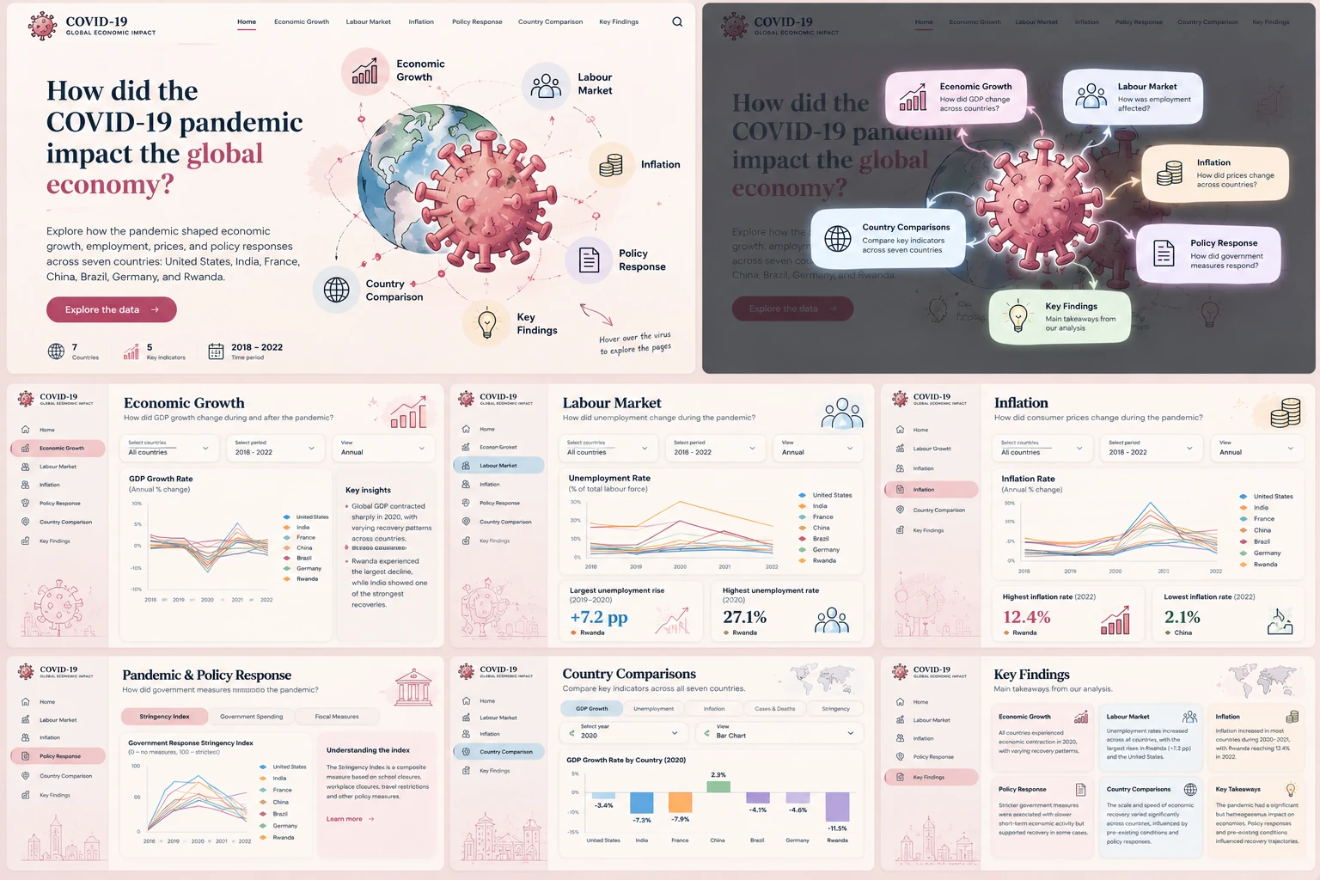
Figure 1. Design mockup used as the visual reference (concept, not the implemented dashboard; its values are not real data).

Implemented dashboard
Screenshots of the implemented dashboard, taken on 20 October 2026 from the running application with all seven countries selected.
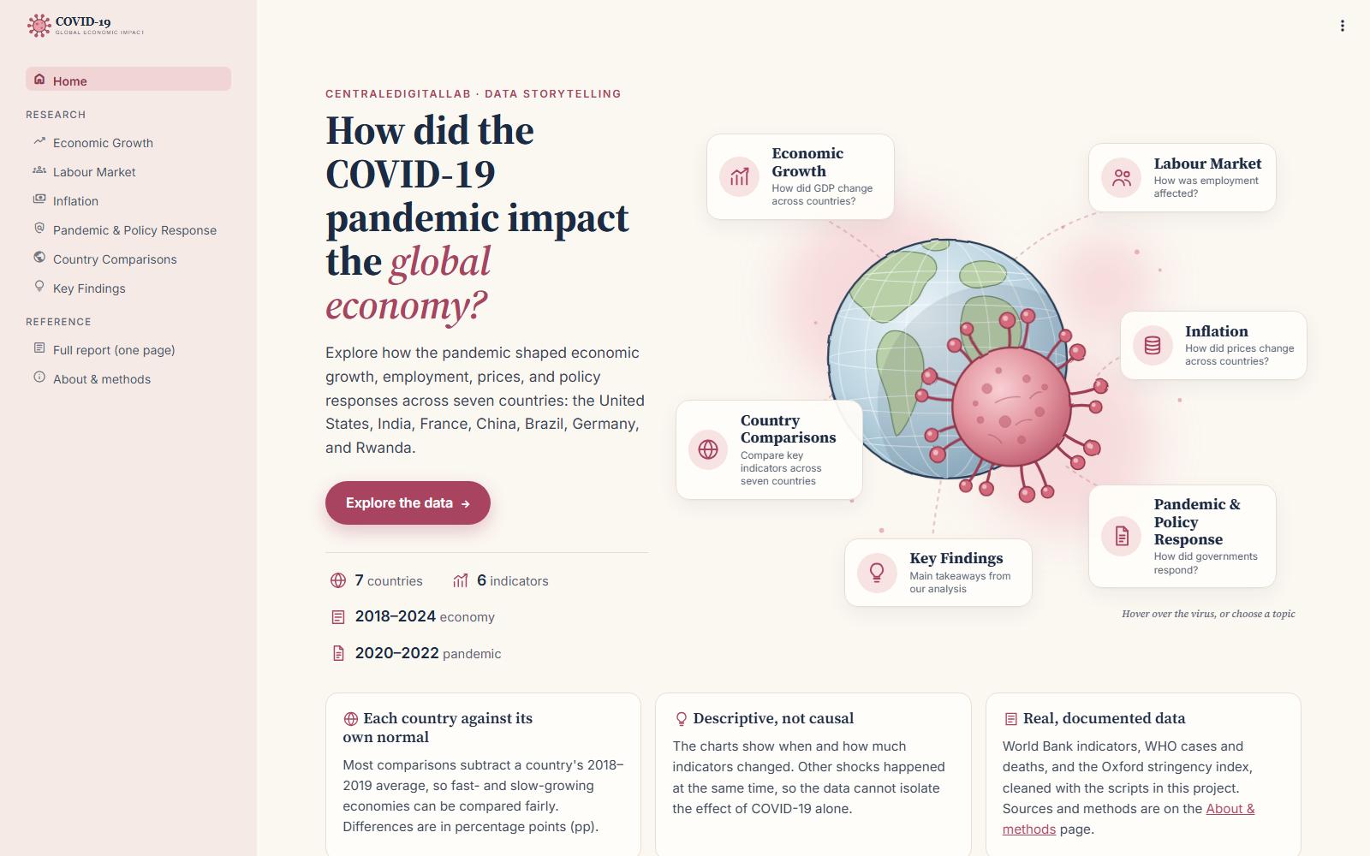
Figure 2. Implemented homepage: research question, virus-and-globe illustration, and navigation cards.
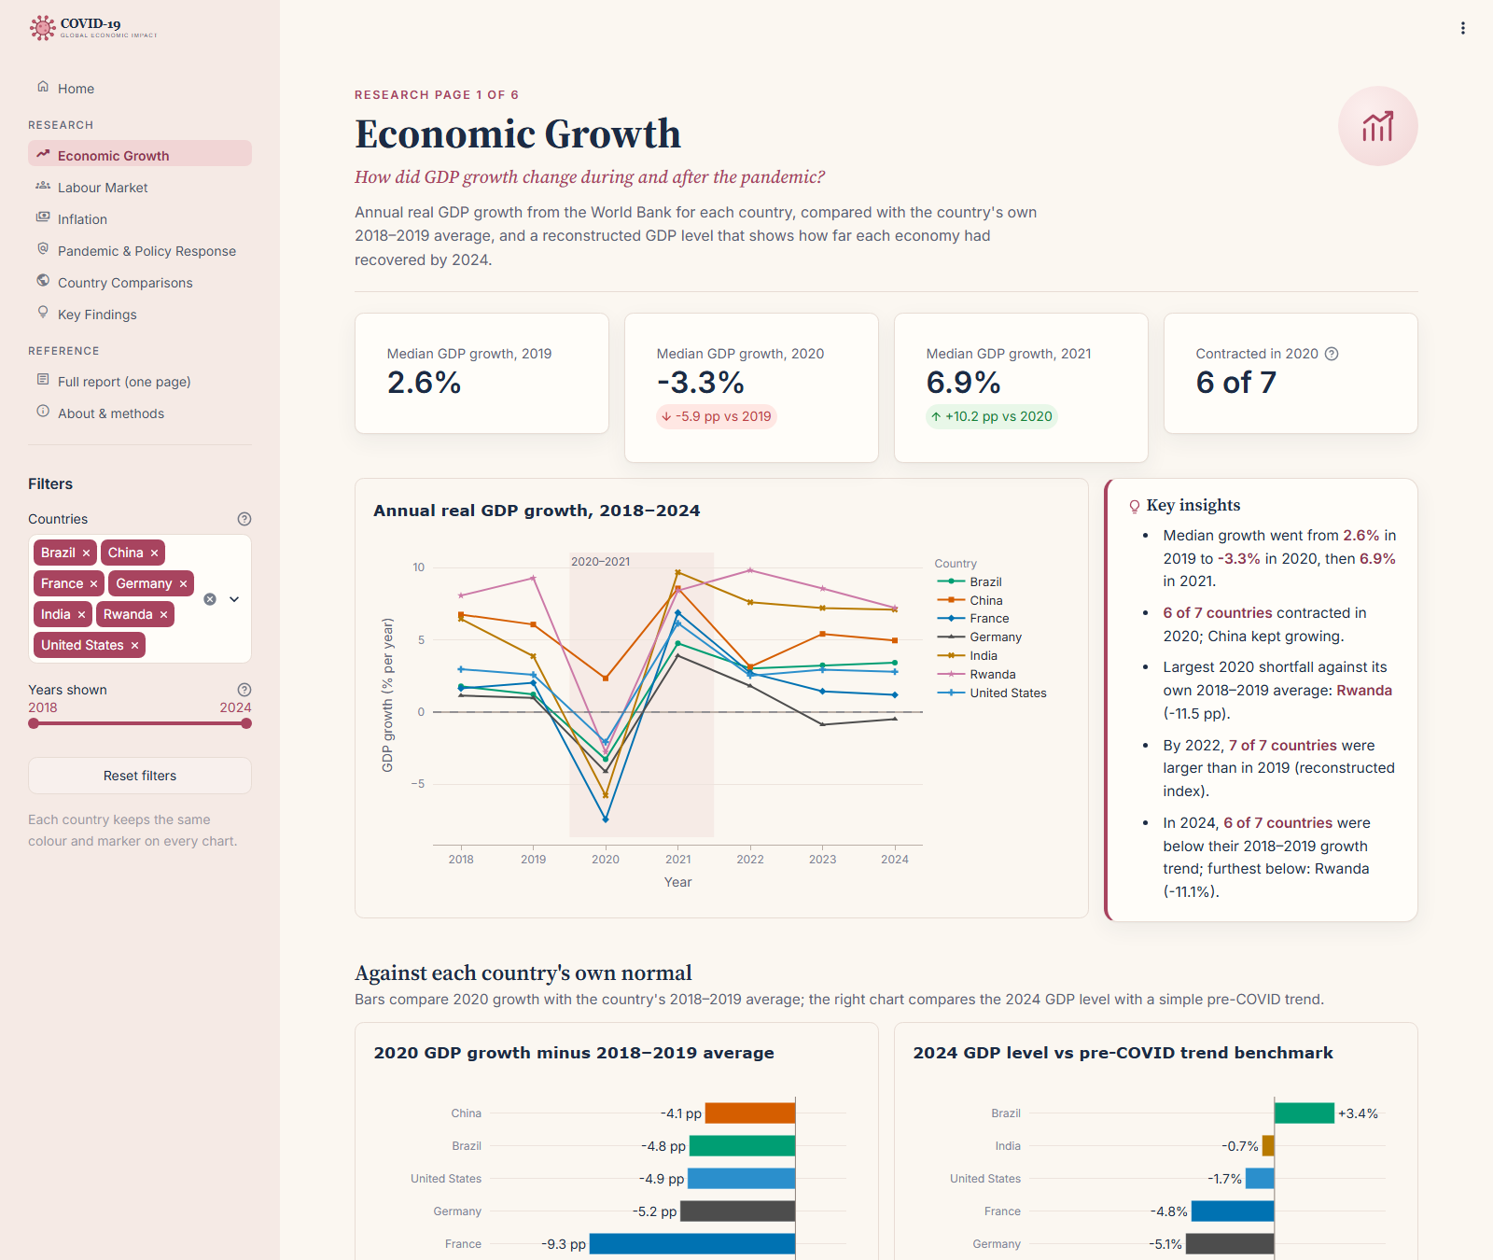
Figure 3. Economic Growth page: KPI cards, GDP growth by country, key insights, and comparisons with each country's normal.
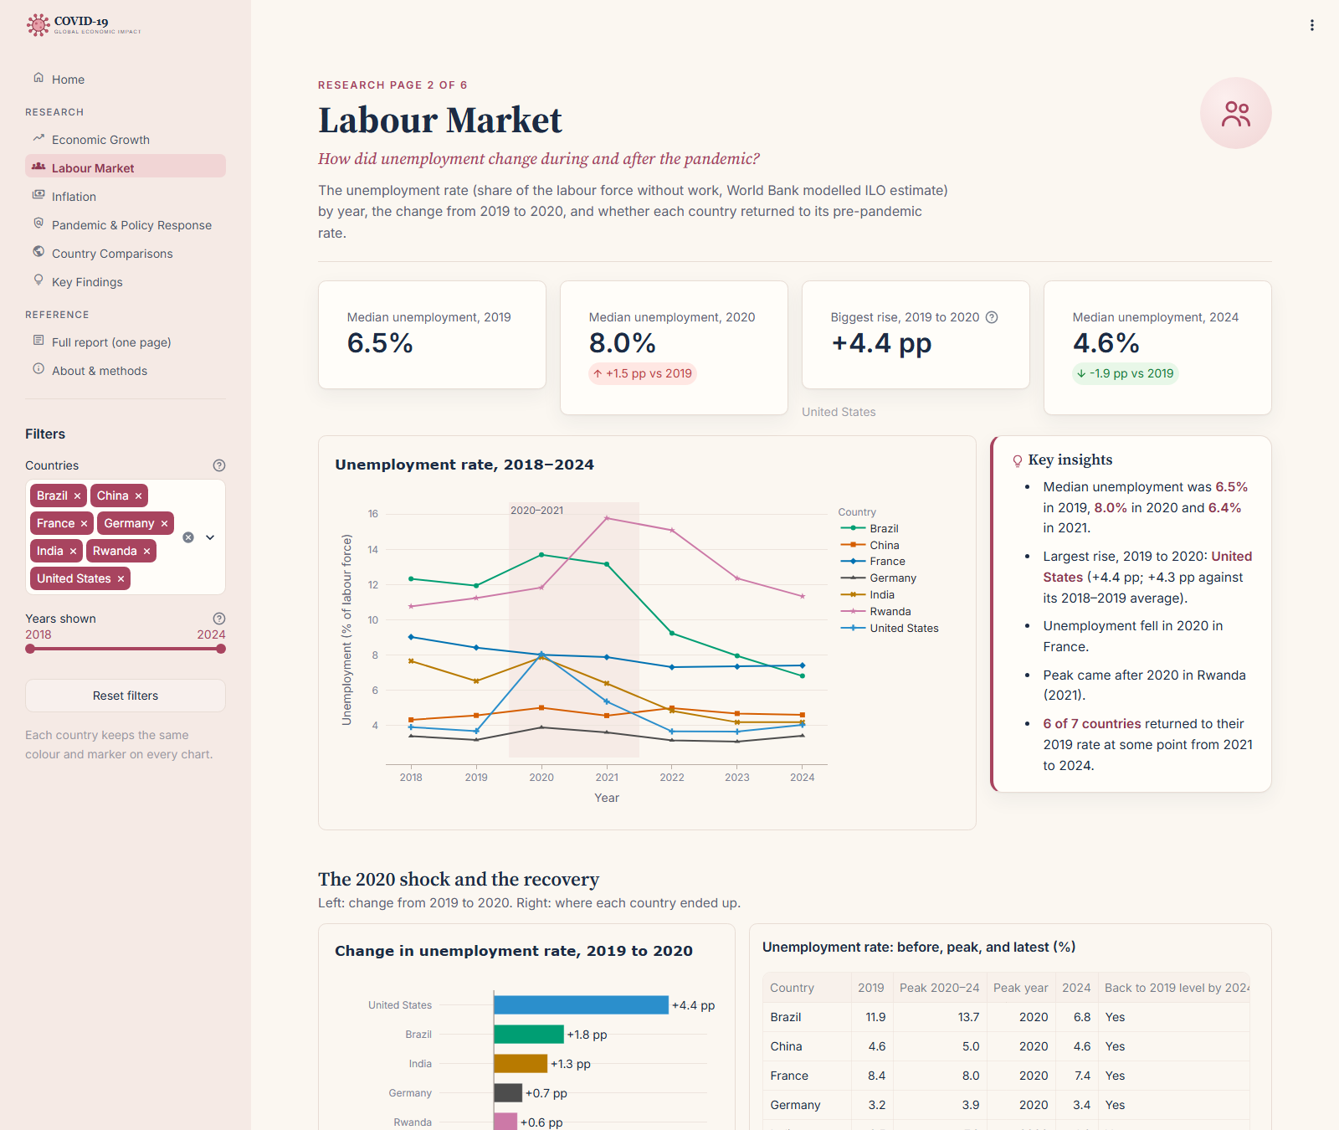
Figure 4. Labour Market page.
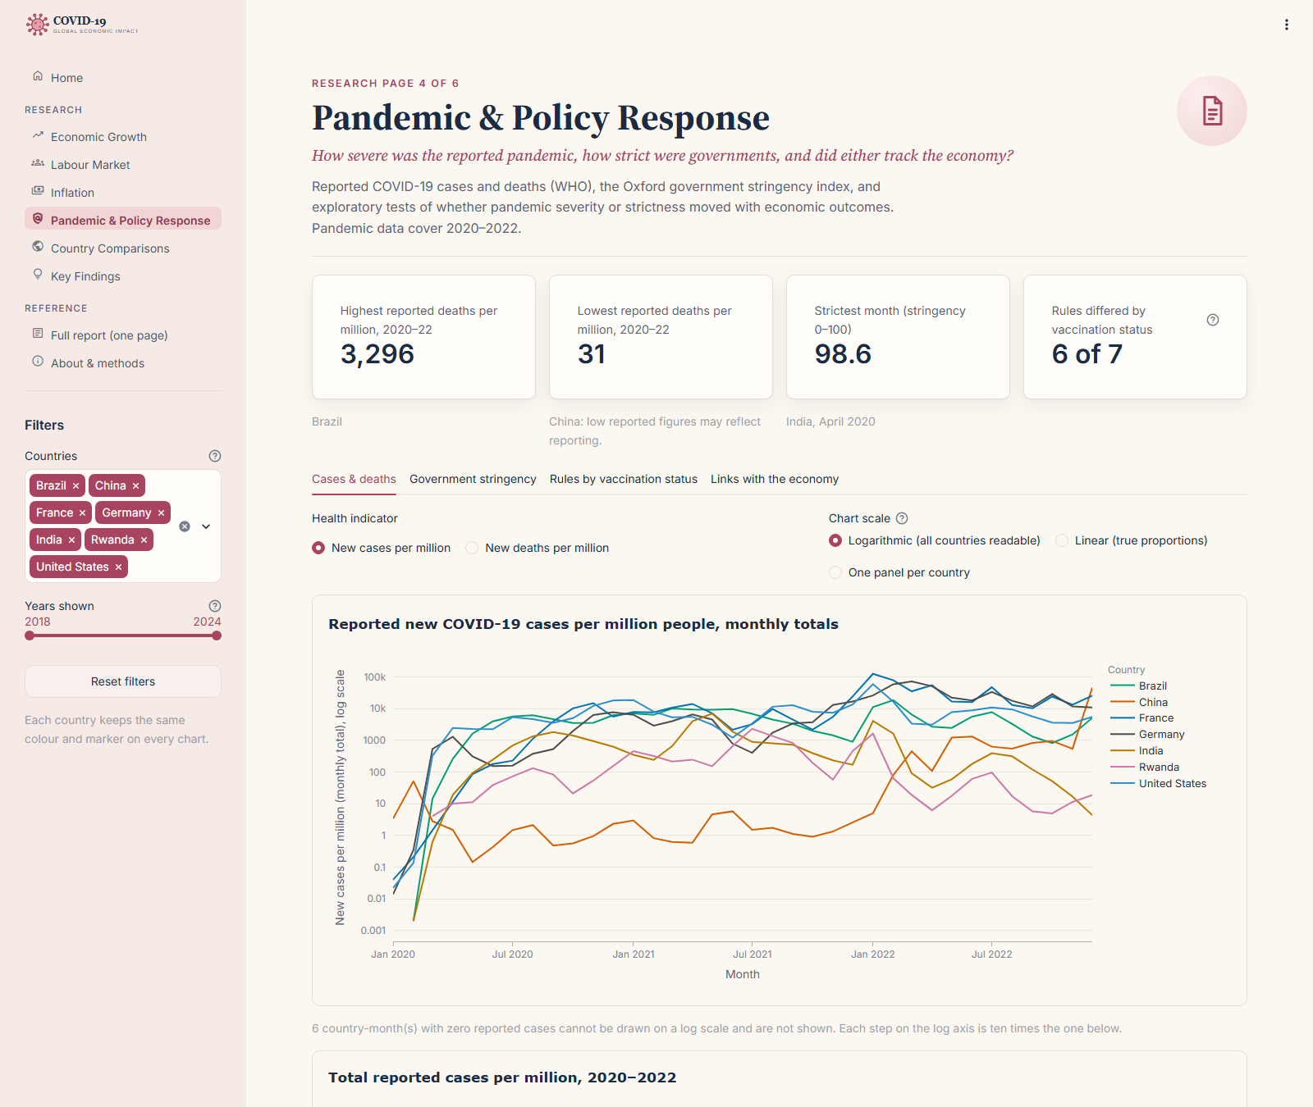
Figure 5. Pandemic & Policy Response page: reported cases per million on a log scale.
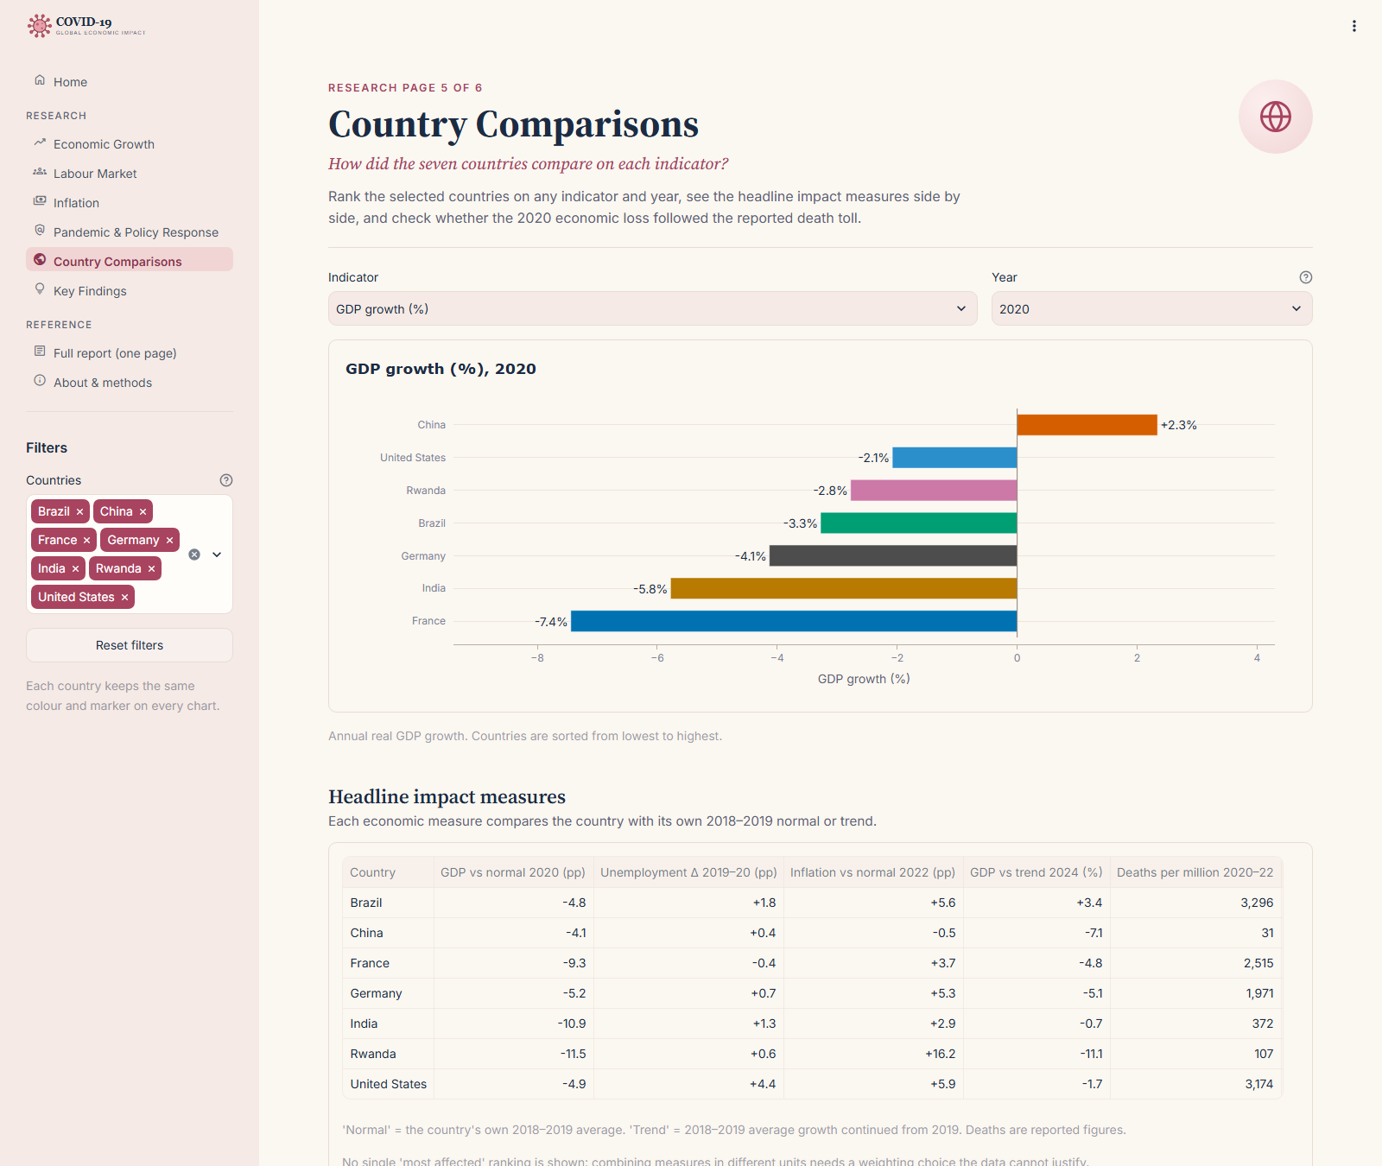
Figure 6. Country Comparisons page: ranking on a chosen indicator and year.
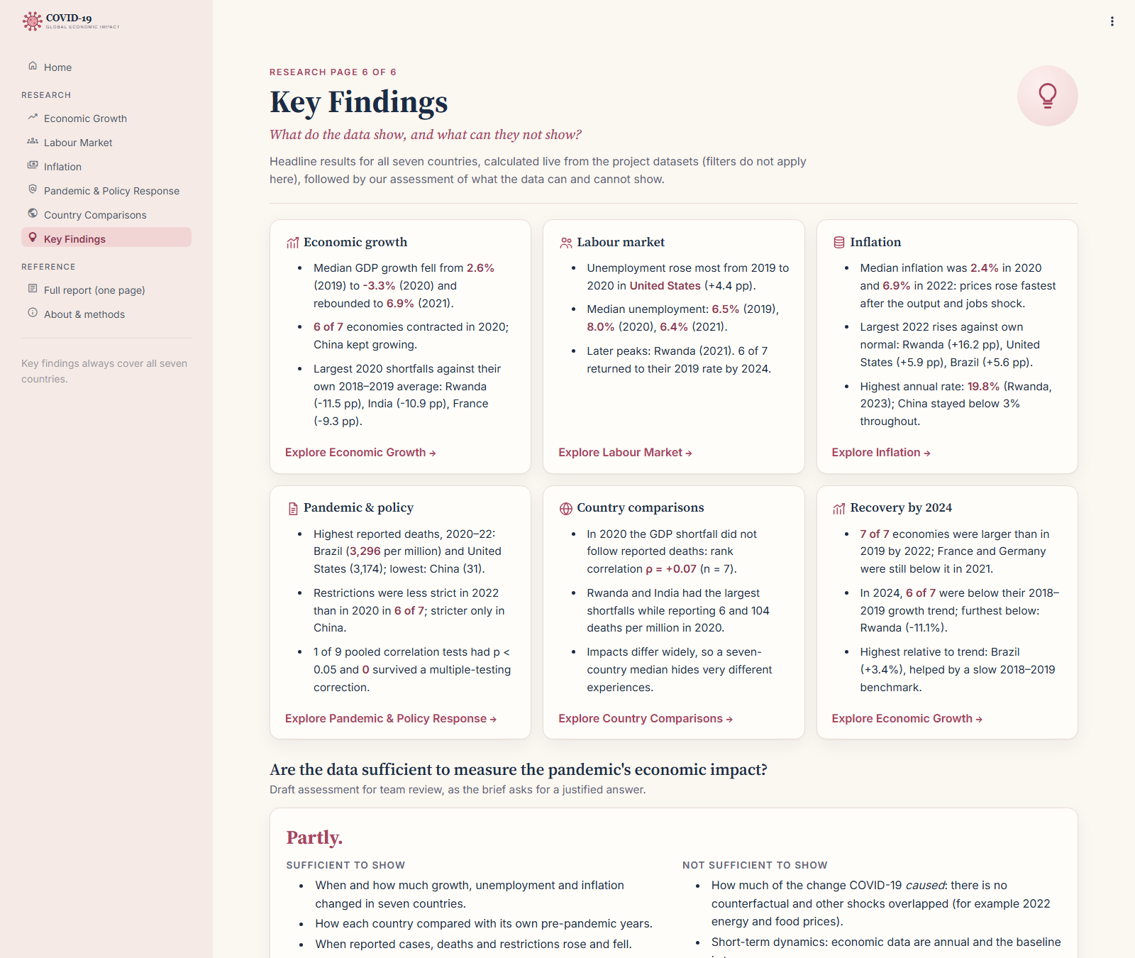
Figure 7. Key Findings page: headline results calculated live from the data.

12. Key Findings
All figures describe the seven countries and were recalculated from the processed data; they are checked automatically by the project's tests.

Economic growth
- Median GDP growth fell from 2.6% in 2019 to −3.3% in 2020 and rebounded to 6.9% in 2021.
- 6 of 7 economies contracted in 2020; China kept growing (+2.3%, down from 6.1% in 2019).
- Against their own 2018–2019 average, the largest 2020 shortfalls were in Rwanda (−11.5 pp), India (−10.9 pp), and France (−9.3 pp).

Labour market
- Unemployment rose most in the United States, from 3.7% to 8.1% (+4.4 pp), followed by Brazil (+1.8 pp) and India (+1.3 pp); it fell in France.
- Median unemployment was 6.5% in 2019, 8.0% in 2020, and 6.4% in 2021; Rwanda peaked later (15.8% in 2021).

Inflation
- Median inflation was 2.4% in 2020 and 6.9% in 2022: prices rose fastest after the output and jobs shock, not during it.
- The largest 2022 rises against each country's normal were in Rwanda (+16.2 pp), the United States (+5.9 pp), and Brazil (+5.6 pp). The highest rate was 19.8% (Rwanda, 2023); China stayed below 3% throughout.

Pandemic and policy
- Reported deaths over 2020–2022 were highest in Brazil (3,296 per million) and the United States (3,174), and lowest in China (31) and Rwanda (107).
- Restrictions were less strict in 2022 than in 2020 in 6 of 7 countries; they rose only in China (average 68.3 to 77.6).
- The 2020 economic loss did not follow reported deaths (rank correlation +0.07, 7 countries). Of 9 pooled correlation tests, one had p < 0.05 (stringency vs inflation), and none remained significant after the Bonferroni correction. That association reverses within single years, so it reflects timing (restrictions eased in 2022 as inflation peaked), not cause.

Recovery
- All 7 economies were larger than in 2019 by 2022; France and Germany were still below their 2019 size in 2021.
- In 2024, 6 of 7 were below their 2018–2019 growth trend; the furthest below was Rwanda (−11.1%), and Brazil was above it (+3.4%).
- Unemployment returned to its 2019 rate by 2024 in 6 of 7 countries (all except Rwanda).

13. Critical Analysis: Are the Data Sufficient?
Answer: partly. (Draft for team agreement.)
Sufficient to show: when and how much growth, unemployment, and inflation changed in the seven countries; how each country compared with its own pre-pandemic years; and when reported cases, deaths, and restrictions rose and fell.
Not sufficient to show: how much of the change COVID-19 caused, because there is no counterfactual and other shocks overlapped (for example 2022 energy and food prices); short-term dynamics, because the economic data are annual and the baseline is two years; and a global picture, because seven countries are a purposive sample and reported health data differ in quality.
Strategy: compare each country with its own normal, combine several indicators, show timing alongside pandemic and policy data, and state the limitations next to every chart.

14. Limitations and Interpretation
- Seven countries cannot represent every economy; findings compare the chosen sample.
- The baseline (2018–2019) is only two years; one unusual year, such as Rwanda's −0.3% inflation in 2018, changes a country's results.
- Annual economic indicators do not capture short-term changes within the pandemic.
- Reported cases and deaths depend on testing and registration and may differ from actual infections and deaths.
- The stringency index measures government rules, not compliance or effectiveness.
- Unemployment is a modelled estimate and captures labour-market stress less fully in economies with large informal sectors.
- Correlations use at most 21 country-years; observations from the same country are not independent and several tests are run at once.
- Economic changes also reflect supply-chain disruptions, fiscal and monetary policy, energy prices, and trade, so the analysis identifies associations, not causes.

15. Deployment and Reproducibility
- Hosting: Streamlit Community Cloud, deployed from the GitHub repository (branch main, entrypoint app.py, Python 3.12). Each push to main redeploys the app.
- Live URL: [add the Streamlit Community Cloud URL]
- Run locally: conda activate covid-dashboard, then python -m pip install -r requirements.txt, then streamlit run app.py.
- Tests: python -m unittest discover -s tests (37 tests).
- Rebuild the data: the commands are in the README; they regenerate the processed files from the raw downloads.

Optional extensions
- MySQL database (bonus challenge): not implemented. It is optional in the brief; the dashboard reads the processed CSV files directly.
- Excess mortality: considered at the planning stage; not included.

