For SICK dataset:

1. Extract zip and go to ‘acl_long_2018/sick_model/linear_bilstm’ folder.
2. Download SICK dataset.
   1. Link: <http://alt.qcri.org/semeval2014/task1/index.php?id=data-and-tools>
   2. Files to download: TestData (including gold scores), TrainingData, TrialData
3. Download Glove embeddings.
   1. <https://nlp.stanford.edu/projects/glove/>
   2. Common Crawl (840B)
4. Change ‘–glove’ argument in config.py to point to the location of downloaded Glove embeddings.
5. Change path of following in preprocess-sick.py to point to downloaded train, trial and test datasets, respectively:
   1. file0 ---- location of train dataset file
   2. file1 ---- location of trial dataset file
   3. file2 ---- location of test dataset file
6. Go to folder ‘acl_long_2018/sick_model/linear_bilstm/scripts’ and run command:
   1. python preprocess-sick.py.
   2. If the command runs successfully, then you should see the output as follows:

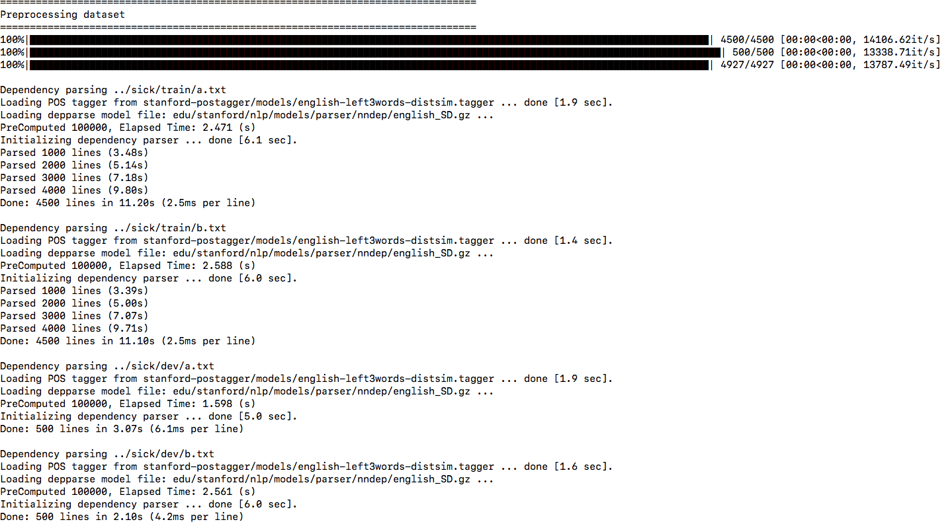

1. Go to folder ‘acl_long_2018/sick_model/linear_bilstm’’ and run command:
   1. python main.py
   2. If the command runs successfully, then you should see the output as follows:

