Alert to Warning:

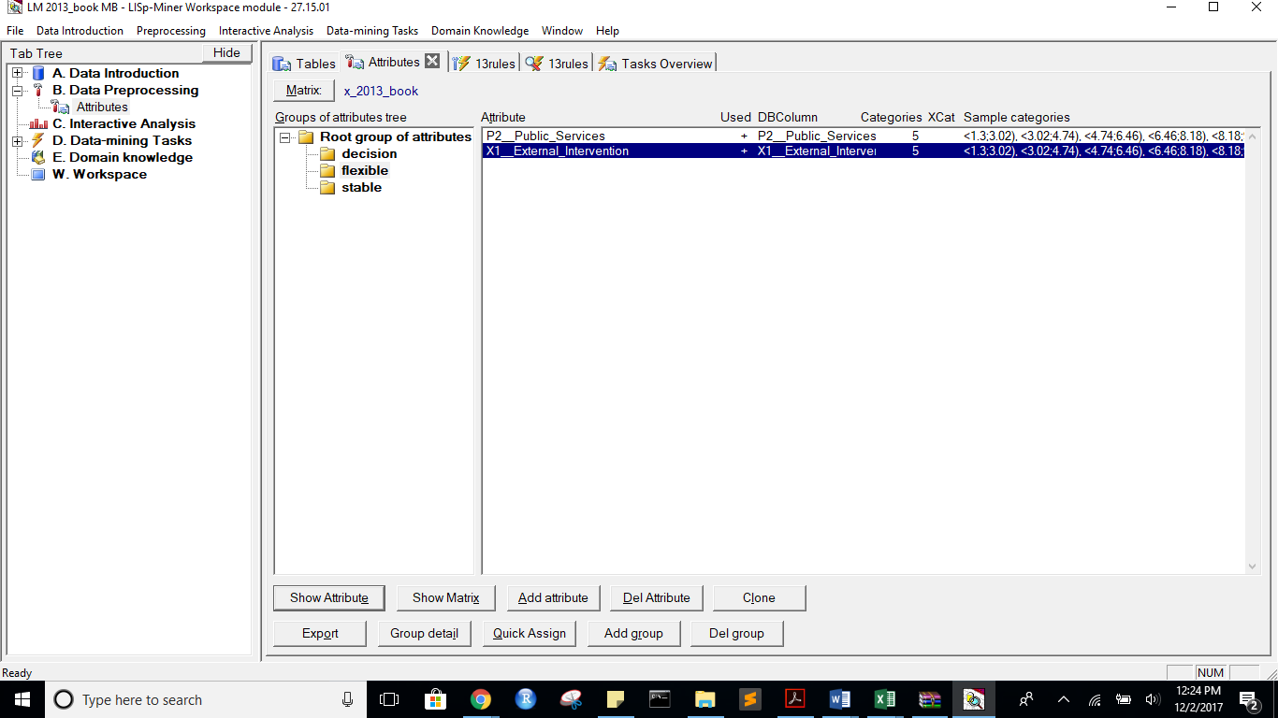

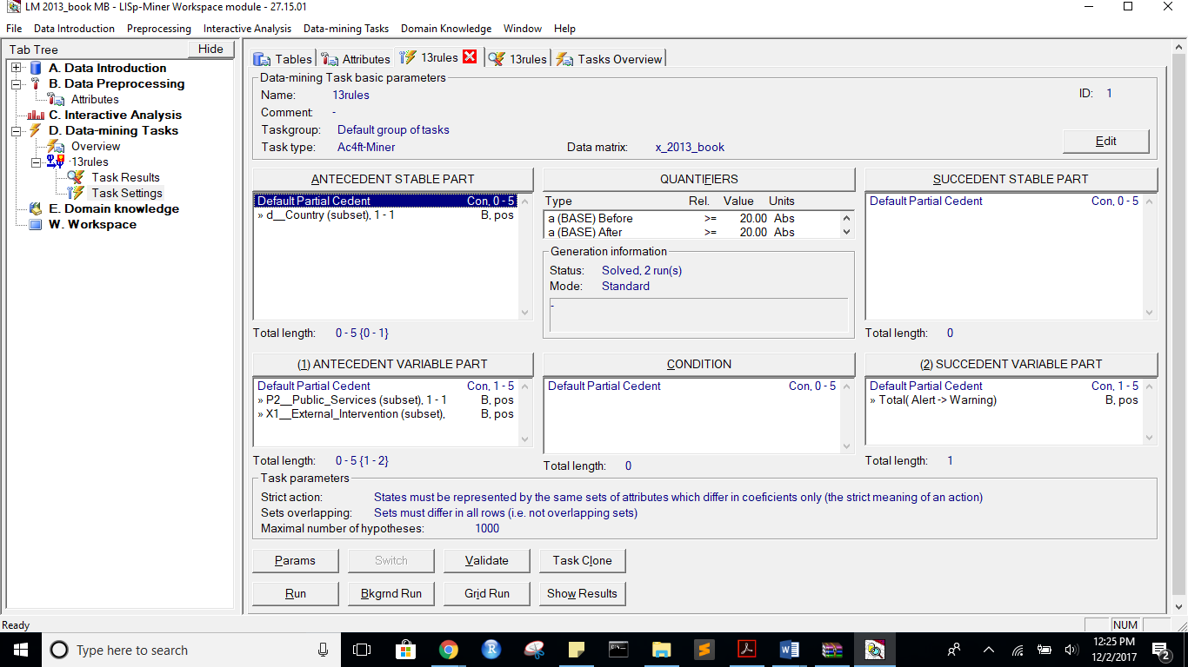

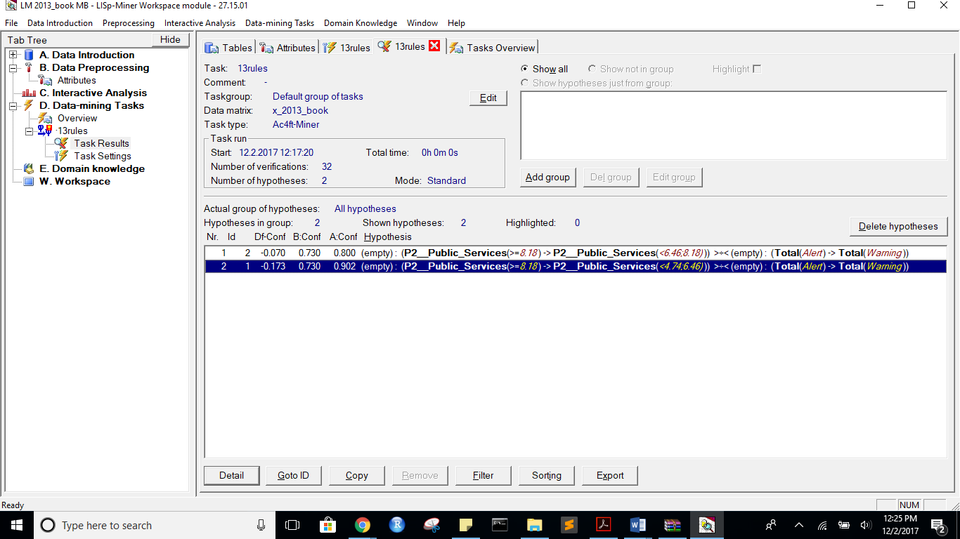

state before:

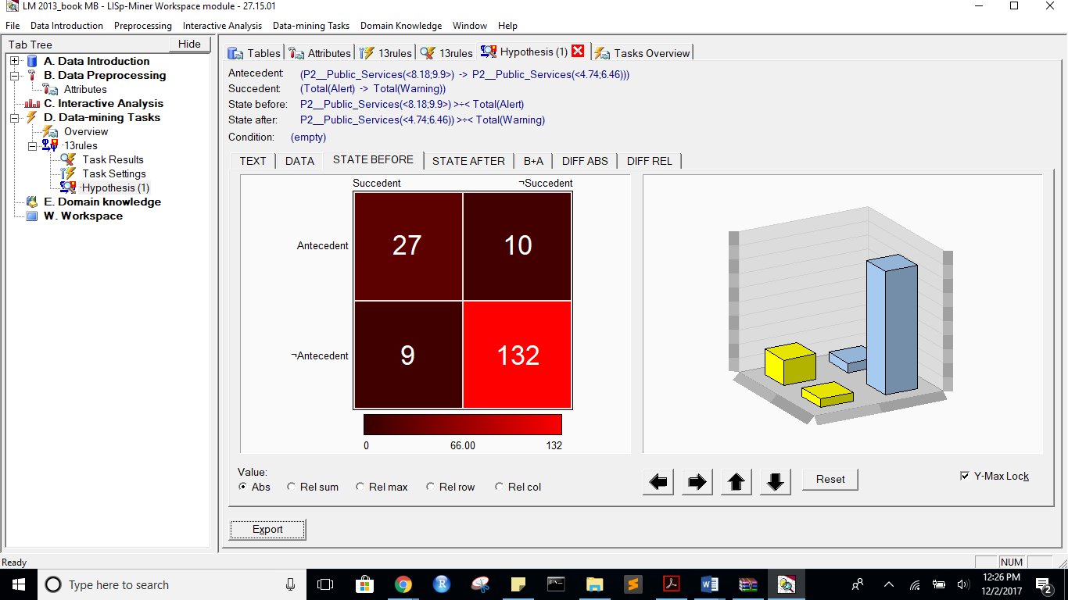

after:

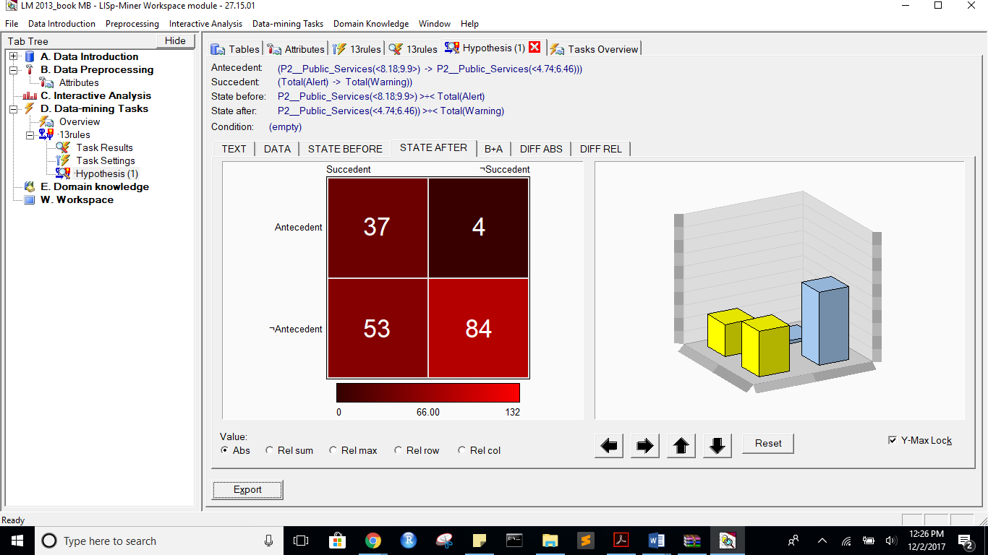

B+A:

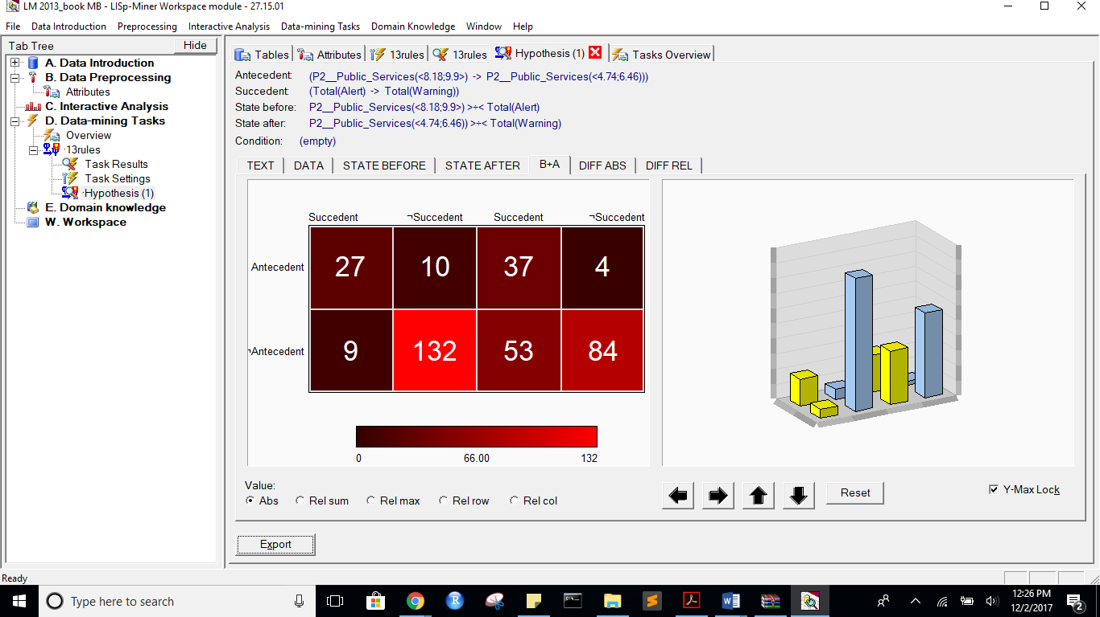

DIFF ABS:

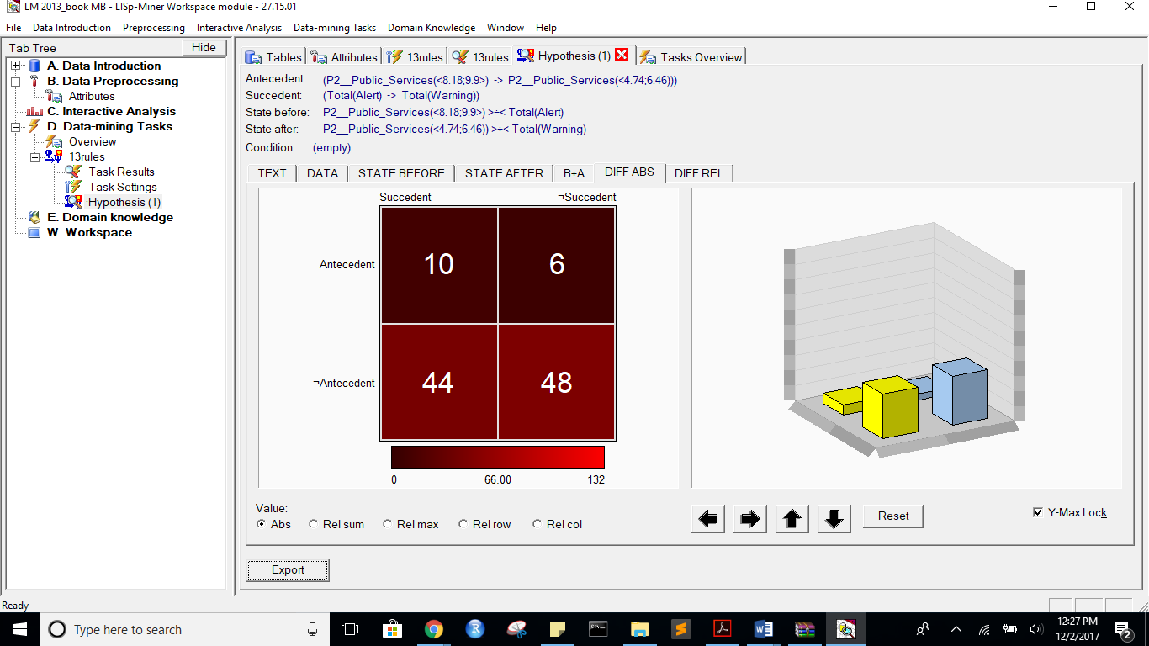

DIFF REL:

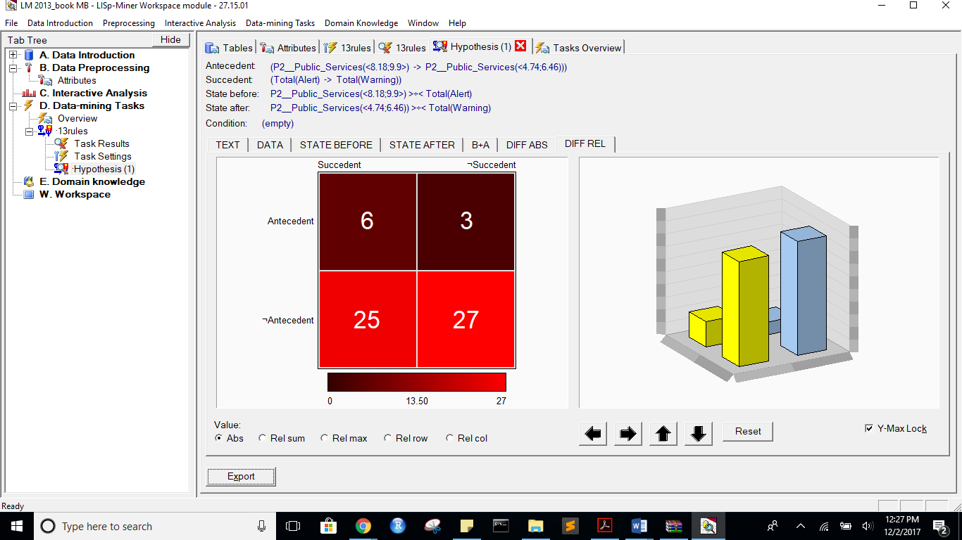

rules:

Task name: 13rules

Task description: -

Date of output: 2.12.2017

Survey of antecedent attributes

Group Name Description

Default Partial Cedent d__Country (subset), 1 - 1 -

Survey of variable antecedent attributes

Group Name Description

Default Partial Cedent P2__Public_Services (subset), 1 - 1 -

Default Partial Cedent X1__External_Intervention (subset), 1 - 1 -

Survey of succedent attributes

Group Name Description

Survey of variable sukcedent attributes

Group Name Description

Default Partial Cedent Total( Alert -> Warning) -

Survey of Action4ft-Quantifiers

a-frequency Before >= 20.00 Absolute number

a-frequency After >= 20.00 Absolute number

Task parameters

The comparison of the first set versus the second set

Sets must differ in all rows (i.e. not overlapping sets)

Nr. Hypothesis D%-Sum Df-Conf Df-AFUI Df-FUE Df-Avg R-Conf R-DFUI R-FUE R-Avg H-Conf H-DFUI H-FUE H-Avg B:a B:b B:c B:d B:r B:n B:Conf B:DConf B:EConf B:Supp B:Cmplt B:AvgDf B:Lift B:LBound B:UBound B:ELBound B:EUBound B:DLBound B:DUBound B:Fisher B:Chi-Sq B:bMean B:bVAR B:bStDev B:P(>=90%) B:P(>=95%) A:a A:b A:c A:d A:r A:n A:Conf A:DConf A:EConf A:Supp A:Cmplt A:AvgDf A:Lift A:LBound A:UBound A:ELBound A:EUBound A:DLBound A:DUBound A:Fisher A:Chi-Sq A:bMean A:bVAR A:bStDev A:P(>=90%) A:P(>=95%)

2 (P2__Public_Services(<8.18;9.9>) -> P2__Public_Services(<6.46;8.18))) >÷< (Total(Alert) -> Total(Warning)) 0.62 -0.0702702703 0.2982967279 0.2808988764 2.0258858859 0.9121621622 2.0333850932 1.4587155963 4.4795749948 1.0962962963 2.0333850932 1.4587155963 4.4795749948 27 10 9 132 37 178 0.7297297297 0.5869565217 0.893258427 0.1516853933 0.75 2.6081081081 3.6081081081 0.9992796789 0.0027458517 0.6743081202 0.4179435017 0.9999999958 0.0000000283 0 80.5504458609 0.7179487179 0.7179487179 0.0711509586 0.0009228786 0.0000016653 28 7 62 81 35 178 0.8 0.2886597938 0.6123595506 0.1573033708 0.3111111111 0.5822222222 1.5822222222 0.9800097664 0.0551828499 1 0 1 0 0.0000761474 15.103910433 0.7837837838 0.7837837838 0.0667806236 0.0235095363 0.0003346085

1 (P2__Public_Services(<8.18;9.9>) -> P2__Public_Services(<4.74;6.46))) >÷< (Total(Alert) -> Total(Warning)) 0.61 -0.1727092947 0.1933395005 0.2134831461 1.8232842599 0.8086194302 1.491186839 1.3140495868 3.3231764223 1.2366757001 1.491186839 1.3140495868 3.3231764223 27 10 9 132 37 178 0.7297297297 0.5869565217 0.893258427 0.1516853933 0.75 2.6081081081 3.6081081081 0.9992796789 0.0027458517 0.6743081202 0.4179435017 0.9999999958 0.0000000283 0 80.5504458609 0.7179487179 0.7179487179 0.0711509586 0.0009228786 0.0000016653 37 4 53 84 41 178 0.9024390244 0.3936170213 0.6797752809 0.2078651685 0.4111111111 0.7848238482 1.7848238482 0.6084289922 0.5969015998 1 0 1 0 0.0000000017 33.5573387426 0.8837209302 0.8837209302 0.0483261288 0.412104059 0.0572779282

*** End of list ***

Alert to Warning with more Attributes:

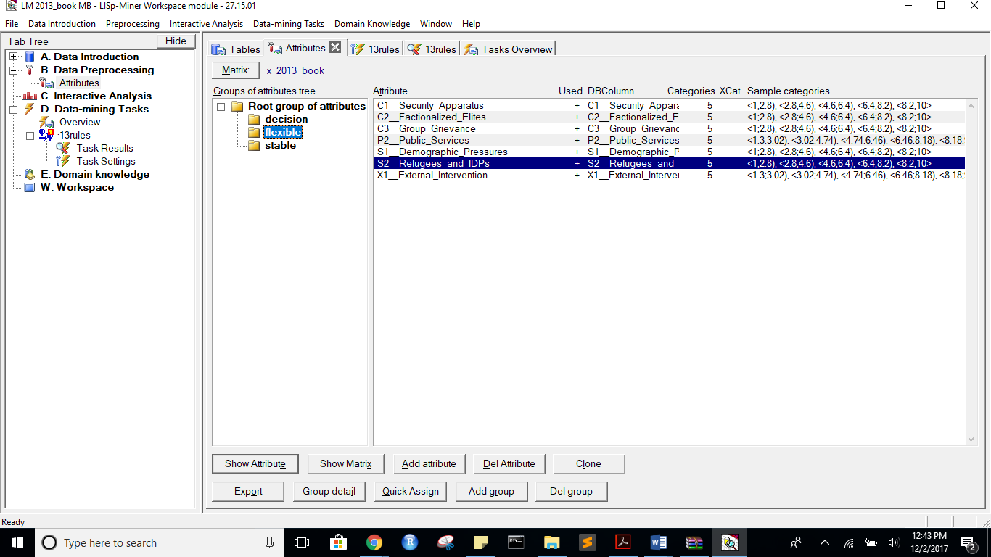

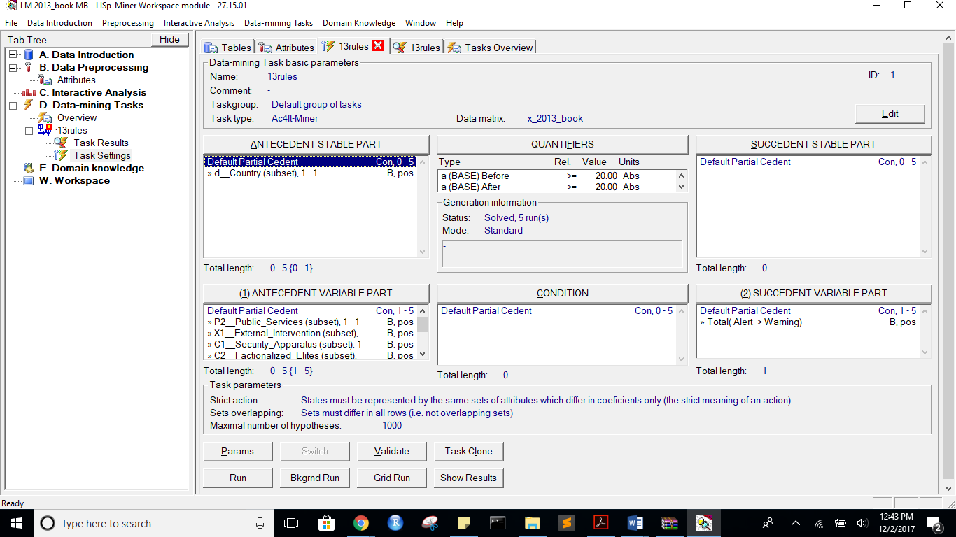

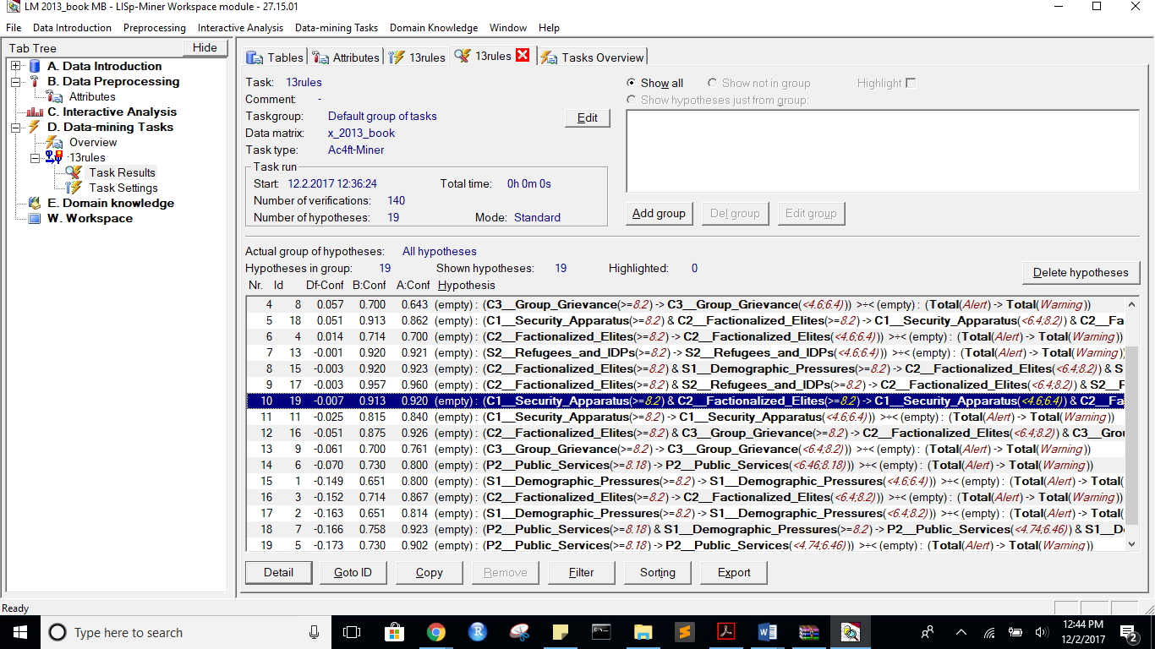

before:

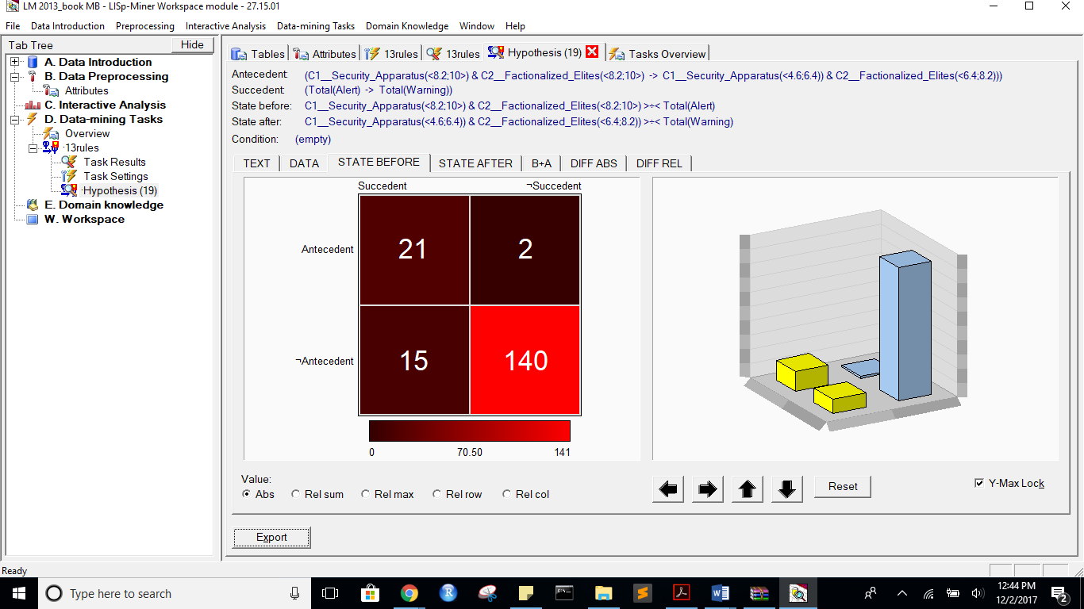

After:

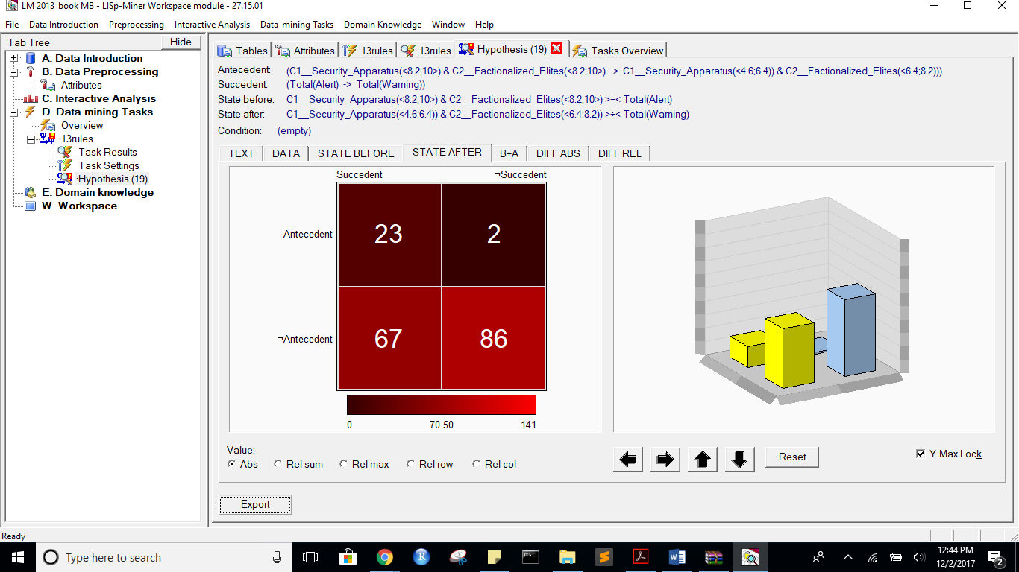

B+A:

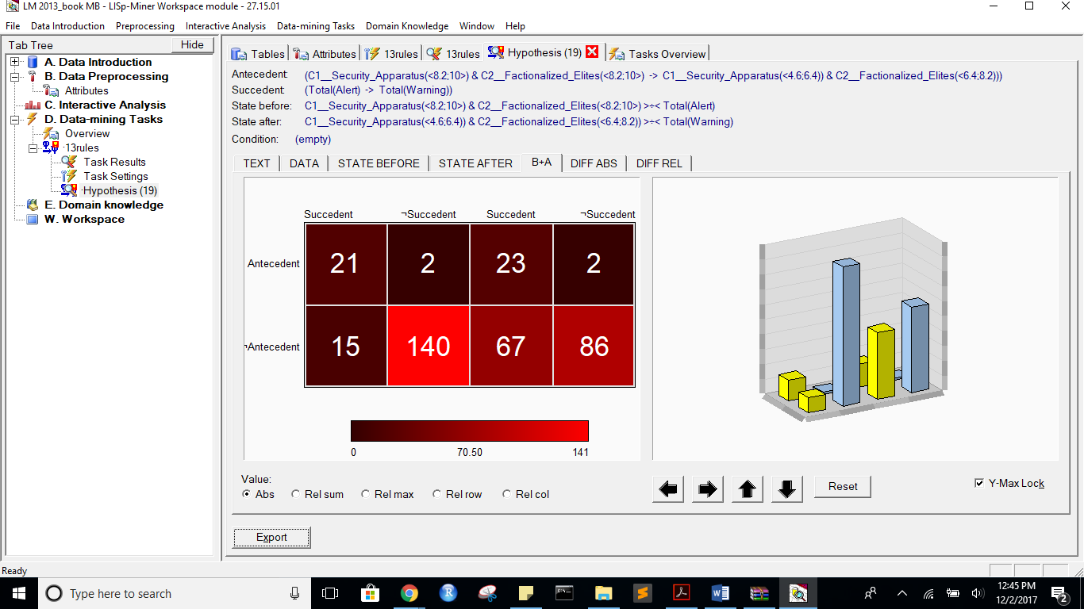

DIFF ABS:

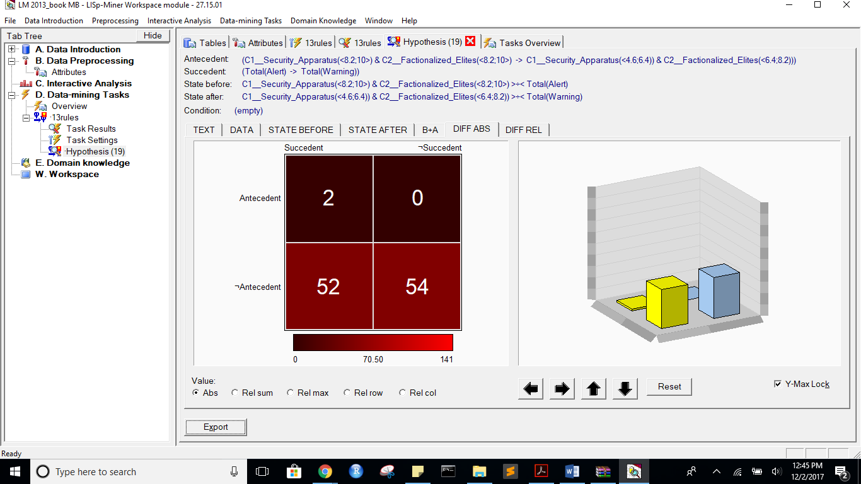

DIFF REL:

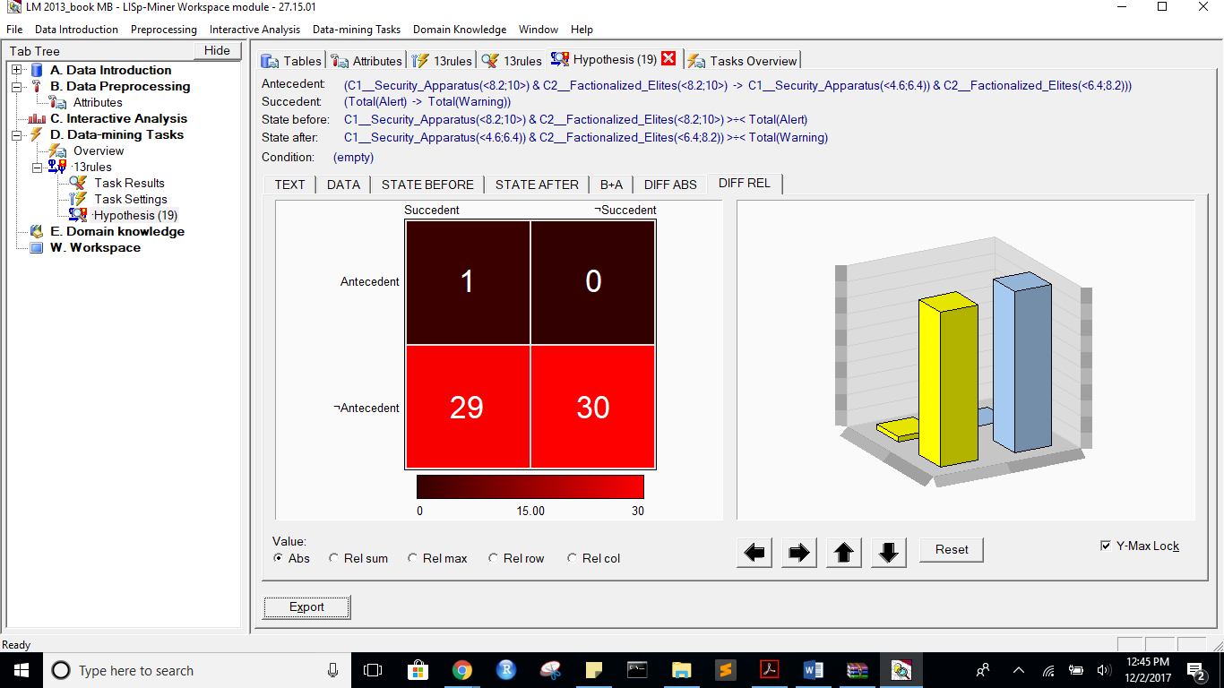

ActionRUles:  
Task name: 13rules

Task description: -

Date of output: 2.12.2017

Survey of antecedent attributes

Group Name Description

Default Partial Cedent d__Country (subset), 1 - 1 -

Survey of variable antecedent attributes

Group Name Description

Default Partial Cedent P2__Public_Services (subset), 1 - 1 -

Default Partial Cedent X1__External_Intervention (subset), 1 - 1 -

Default Partial Cedent C1__Security_Apparatus (subset), 1 - 1 -

Default Partial Cedent C2__Factionalized_Elites (subset), 1 - 1 -

Default Partial Cedent C3__Group_Grievance (subset), 1 - 1 -

Default Partial Cedent S1__Demographic_Pressures (subset), 1 - 1 -

Default Partial Cedent S2__Refugees_and_IDPs (subset), 1 - 1 -

Survey of succedent attributes

Group Name Description

Survey of variable sukcedent attributes

Group Name Description

Default Partial Cedent Total( Alert -> Warning) -

Survey of Action4ft-Quantifiers

a-frequency Before >= 20.00 Absolute number

a-frequency After >= 20.00 Absolute number

Task parameters

The comparison of the first set versus the second set

Sets must differ in all rows (i.e. not overlapping sets)

Nr. Hypothesis D%-Sum Df-Conf Df-AFUI Df-FUE Df-Avg R-Conf R-DFUI R-FUE R-Avg H-Conf H-DFUI H-FUE H-Avg B:a B:b B:c B:d B:r B:n B:Conf B:DConf B:EConf B:Supp B:Cmplt B:AvgDf B:Lift B:LBound B:UBound B:ELBound B:EUBound B:DLBound B:DUBound B:Fisher B:Chi-Sq B:bMean B:bVAR B:bStDev B:P(>=90%) B:P(>=95%) A:a A:b A:c A:d A:r A:n A:Conf A:DConf A:EConf A:Supp A:Cmplt A:AvgDf A:Lift A:LBound A:UBound A:ELBound A:EUBound A:DLBound A:DUBound A:Fisher A:Chi-Sq A:bMean A:bVAR A:bStDev A:P(>=90%) A:P(>=95%)

12 (S2__Refugees_and_IDPs(<8.2;10>) -> S2__Refugees_and_IDPs(<2.8;4.6))) >÷< (Total(Alert) -> Total(Warning)) 0.75 0.295 0.3671679198 0.3651685393 3.3127777778 1.472 2.5421052632 1.6632653061 15.0305882353 1.472 2.5421052632 1.6632653061 15.0305882353 23 2 13 140 25 178 0.92 0.6052631579 0.9157303371 0.1292134831 0.6388888889 3.5488888889 4.5488888889 0.5370940501 0.7287940935 0.2905614278 0.7922119314 0.9999997449 0.0000016263 0 92.8683097569 0.8888888889 0.8888888889 0.0593913871 0.4894947323 0.1386323979 25 15 65 73 40 178 0.625 0.2380952381 0.5505617978 0.1404494382 0.2777777778 0.2361111111 1.2361111111 0.9999994072 0.0000034806 1 0 1 0 0.0619406808 2.9416675816 0.619047619 0.619047619 0.0740564939 0.0000008816 0

14 (S2__Refugees_and_IDPs(<8.2;10>) -> S2__Refugees_and_IDPs(<6.4;8.2))) >÷< (Total(Alert) -> Total(Warning)) 0.72 0.2443243243 0.3601651187 0.3483146067 3.2125525526 1.3616 2.4694736842 1.6138613861 10.5516071429 1.3616 2.4694736842 1.6138613861 10.5516071429 23 2 13 140 25 178 0.92 0.6052631579 0.9157303371 0.1292134831 0.6388888889 3.5488888889 4.5488888889 0.5370940501 0.7287940935 0.2905614278 0.7922119314 0.9999997449 0.0000016263 0 92.8683097569 0.8888888889 0.8888888889 0.0593913871 0.4894947323 0.1386323979 25 12 65 76 37 178 0.6756756757 0.2450980392 0.5674157303 0.1404494382 0.2777777778 0.3363363363 1.3363363363 0.9999650857 0.0001679037 1 0 1 0 0.0156699032 5.4039339146 0.6666666667 0.6666666667 0.0745355992 0.0000482136 0.0000000202

10 (C1__Security_Apparatus(<8.2;10>) -> C1__Security_Apparatus(<6.4;8.2))) >÷< (Total(Alert) -> Total(Warning)) 0.69 0.0600978337 0.1482358513 0.2471910112 2.5361441106 1.0796296296 1.3817073171 1.3826086957 6.1478329393 1.0796296296 1.3817073171 1.3826086957 6.1478329393 22 5 14 137 27 178 0.8148148148 0.5365853659 0.893258427 0.1235955056 0.6111111111 3.0288065844 4.0288065844 0.9529431066 0.1265574483 0.6743081202 0.4179435017 0.9999999997 0.0000000027 0 74.0225525612 0.7931034483 0.7931034483 0.0739572779 0.0550069963 0.002268705 40 13 50 75 53 178 0.7547169811 0.3883495146 0.6460674157 0.2247191011 0.4444444444 0.4926624738 1.4926624738 0.9994517322 0.0017919209 1 0 1 0 0.0000116298 18.7346102535 0.7454545455 0.7454545455 0.0582102203 0.0006726379 0.0000002955

8 (C3__Group_Grievance(<8.2;10>) -> C3__Group_Grievance(<4.6;6.4))) >÷< (Total(Alert) -> Total(Warning)) 0.73 0.0571428571 0.1393939394 0.2808988764 2.1896825397 1.0888888889 1.4259259259 1.4807692308 9.067251462 1.0888888889 1.4259259259 1.4807692308 9.067251462 21 9 15 133 30 178 0.7 0.4666666667 0.8651685393 0.1179775281 0.5833333333 2.4611111111 3.4611111111 0.9995456449 0.002019829 0.9478570364 0.0813549153 1 0 0 55.4059161274 0.6875 0.6875 0.080687153 0.0006109052 0.0000016374 36 20 54 68 56 178 0.6428571429 0.3272727273 0.5842696629 0.202247191 0.4 0.2714285714 1.2714285714 0.9999999592 0.0000002178 1 0 1 0 0.0099375456 6.1562912497 0.6379310345 0.6379310345 0.0625686104 0.0000000585 0

18 (C1__Security_Apparatus(<8.2;10>) & C2__Factionalized_Elites(<8.2;10>) -> C1__Security_Apparatus(<6.4;8.2)) & C2__Factionalized_Elites(<6.4;8.2))) >÷< (Total(Alert) -> Total(Warning)) 0.62 0.0509745127 0.2866741321 0.2921348315 2.8095119107 1.0591304348 2.0778947368 1.4770642202 4.985231569 1.0591304348 2.0778947368 1.4770642202 4.985231569 21 2 15 140 23 178 0.9130434783 0.5526315789 0.904494382 0.1179775281 0.5833333333 3.5144927536 4.5144927536 0.5919567312 0.6848733113 0.4834625774 0.6157437281 0.9999999954 0.0000000361 0 82.7095391423 0.88 0.88 0.0637302005 0.4357262546 0.1159446076 25 4 65 84 29 178 0.8620689655 0.2659574468 0.6123595506 0.1404494382 0.2777777778 0.7049808429 1.7049808429 0.8415559161 0.328952035 1 0 1 0 0.0000164979 17.6094665704 0.8387096774 0.8387096774 0.0650182076 0.1754949311 0.0156355239

4 (C2__Factionalized_Elites(<8.2;10>) -> C2__Factionalized_Elites(<4.6;6.4))) >÷< (Total(Alert) -> Total(Warning)) 0.71 0.0142857143 0.4128787879 0.3370786517 2.1473015873 1.0204081633 2.9464285714 1.6 6.5854665566 1.0204081633 2.9464285714 1.6 6.5854665566 30 12 6 130 42 178 0.7142857143 0.625 0.8988764045 0.1685393258 0.8333333333 2.5317460317 3.5317460317 0.99984511 0.0006236563 0.5820564983 0.5165374226 0.9999999354 0.0000003745 0 89.3274253363 0.7045454545 0.7045454545 0.0680132597 0.0002017681 0.0000001079 21 9 69 79 30 178 0.7 0.2121212121 0.5617977528 0.1179775281 0.2333333333 0.3844444444 1.3844444444 0.9995456449 0.002019829 1 0 1 0 0.0156893414 5.4538923014 0.6875 0.6875 0.080687153 0.0006109052 0.0000016374

13 (S2__Refugees_and_IDPs(<8.2;10>) -> S2__Refugees_and_IDPs(<4.6;6.4))) >÷< (Total(Alert) -> Total(Warning)) 0.63 -0.0010526316 0.2289190719 0.2415730337 2.727251462 0.9988571429 1.6082706767 1.3583333333 4.3192882562 1.0011441648 1.6082706767 1.3583333333 4.3192882562 23 2 13 140 25 178 0.92 0.6052631579 0.9157303371 0.1292134831 0.6388888889 3.5488888889 4.5488888889 0.5370940501 0.7287940935 0.2905614278 0.7922119314 0.9999997449 0.0000016263 0 92.8683097569 0.8888888889 0.8888888889 0.0593913871 0.4894947323 0.1386323979 35 3 55 85 38 178 0.9210526316 0.376344086 0.6741573034 0.1966292135 0.3888888889 0.8216374269 1.8216374269 0.4648359773 0.7463302211 1 0 1 0 0.0000000015 33.357679236 0.9 0.9 0.0468521286 0.5562805816 0.1291376569

15 (C2__Factionalized_Elites(<8.2;10>) & S1__Demographic_Pressures(<8.2;10>) -> C2__Factionalized_Elites(<6.4;8.2)) & S1__Demographic_Pressures(<4.6;6.4))) >÷< (Total(Alert) -> Total(Warning)) 0.61 -0.0030769231 0.3443935927 0.297752809 2.7232478632 0.9966666667 2.3201754386 1.4818181818 4.2983436853 1.0033444816 2.3201754386 1.4818181818 4.2983436853 23 2 13 140 25 178 0.92 0.6052631579 0.9157303371 0.1292134831 0.6388888889 3.5488888889 4.5488888889 0.5370940501 0.7287940935 0.2905614278 0.7922119314 0.9999997449 0.0000016263 0 92.8683097569 0.8888888889 0.8888888889 0.0593913871 0.4894947323 0.1386323979 24 2 66 86 26 178 0.9230769231 0.2608695652 0.6179775281 0.1348314607 0.2666666667 0.8256410256 1.8256410256 0.5105052357 0.7487357043 1 0 1 0 0.0000015174 21.2271715127 0.8928571429 0.8928571429 0.0574346001 0.5154188194 0.150494452

17 (C2__Factionalized_Elites(<8.2;10>) & S2__Refugees_and_IDPs(<8.2;10>) -> C2__Factionalized_Elites(<6.4;8.2)) & S2__Refugees_and_IDPs(<4.6;6.4))) >÷< (Total(Alert) -> Total(Warning)) 0.6 -0.0034782609 0.3308583309 0.2921348315 2.8308019324 0.9963768116 2.2545045045 1.4684684685 4.1500021503 1.0036363636 2.2545045045 1.4684684685 4.1500021503 22 1 14 141 23 178 0.9565217391 0.5945945946 0.9157303371 0.1235955056 0.6111111111 3.729468599 4.729468599 0.3151266887 0.9113706188 0.2905614278 0.7922119314 0.9999998371 0.0000010851 0 93.1374206279 0.92 0.92 0.0532049737 0.7075225166 0.3391826135 24 1 66 87 25 178 0.96 0.2637362637 0.6235955056 0.1348314607 0.2666666667 0.8986666667 1.8986666667 0.2712059065 0.9282102012 1 0 1 0 0.000000199 24.0229138443 0.9259259259 0.9259259259 0.0494928226 0.7487350906 0.3758733147

19 (C1__Security_Apparatus(<8.2;10>) & C2__Factionalized_Elites(<8.2;10>) -> C1__Security_Apparatus(<4.6;6.4)) & C2__Factionalized_Elites(<6.4;8.2))) >÷< (Total(Alert) -> Total(Warning)) 0.6 -0.0069565217 0.3026315789 0.2921348315 2.6949371981 0.9924385633 2.2105263158 1.4770642202 4.2882910497 1.0076190476 2.2105263158 1.4770642202 4.2882910497 21 2 15 140 23 178 0.9130434783 0.5526315789 0.904494382 0.1179775281 0.5833333333 3.5144927536 4.5144927536 0.5919567312 0.6848733113 0.4834625774 0.6157437281 0.9999999954 0.0000000361 0 82.7095391423 0.88 0.88 0.0637302005 0.4357262546 0.1159446076 23 2 67 86 25 178 0.92 0.25 0.6123595506 0.1292134831 0.2555555556 0.8195555556 1.8195555556 0.5370940501 0.7287940935 1 0 1 0 0.0000032097 19.9795275632 0.8888888889 0.8888888889 0.0593913871 0.4894947323 0.1386323979

11 (C1__Security_Apparatus(<8.2;10>) -> C1__Security_Apparatus(<4.6;6.4))) >÷< (Total(Alert) -> Total(Warning)) 0.64 -0.0251851852 0.1080139373 0.2078651685 2.367473251 0.9700176367 1.2520325203 1.3032786885 4.5798486659 1.0309090909 1.2520325203 1.3032786885 4.5798486659 22 5 14 137 27 178 0.8148148148 0.5365853659 0.893258427 0.1235955056 0.6111111111 3.0288065844 4.0288065844 0.9529431066 0.1265574483 0.6743081202 0.4179435017 0.9999999997 0.0000000027 0 74.0225525612 0.7931034483 0.7931034483 0.0739572779 0.0550069963 0.002268705 42 8 48 80 50 178 0.84 0.4285714286 0.6853932584 0.2359550562 0.4666666667 0.6613333333 1.6613333333 0.9421327943 0.1221450836 1 0 1 0 0.0000000115 31.1014545455 0.8269230769 0.8269230769 0.0519653916 0.0642950846 0.0008776056

16 (C2__Factionalized_Elites(<8.2;10>) & C3__Group_Grievance(<8.2;10>) -> C2__Factionalized_Elites(<6.4;8.2)) & C3__Group_Grievance(<6.4;8.2))) >÷< (Total(Alert) -> Total(Warning)) 0.61 -0.0509259259 0.266722408 0.2752808989 2.4951131687 0.945 1.9815384615 1.4414414414 4.0015470297 1.0582010582 1.9815384615 1.4414414414 4.0015470297 21 3 15 139 24 178 0.875 0.5384615385 0.8988764045 0.1179775281 0.5833333333 3.3263888889 4.3263888889 0.785737761 0.435726273 0.5820564983 0.5165374226 0.9999999991 0.0000000078 0 77.8163259862 0.8461538462 0.8461538462 0.0694362257 0.2364086732 0.0340906185 25 2 65 86 27 178 0.9259259259 0.2717391304 0.6235955056 0.1404494382 0.2777777778 0.8312757202 1.8312757202 0.4845811417 0.767401052 1 0 1 0 0.0000007093 22.4934902124 0.8965517241 0.8965517241 0.0556017776 0.5406170319 0.1626649193

9 (C3__Group_Grievance(<8.2;10>) -> C3__Group_Grievance(<6.4;8.2))) >÷< (Total(Alert) -> Total(Warning)) 0.62 -0.0608695652 0.1201320132 0.2359550562 1.9562801932 0.92 1.3466666667 1.375 4.8751196172 1.0869565217 1.3466666667 1.375 4.8751196172 21 9 15 133 30 178 0.7 0.4666666667 0.8651685393 0.1179775281 0.5833333333 2.4611111111 3.4611111111 0.9995456449 0.002019829 0.9478570364 0.0813549153 1 0 0 55.4059161274 0.6875 0.6875 0.080687153 0.0006109052 0.0000016374 35 11 55 77 46 178 0.7608695652 0.3465346535 0.6292134831 0.1966292135 0.3888888889 0.5048309179 1.5048309179 0.9984962022 0.0048432033 1 0 1 0 0.0000451567 16.1679750403 0.75 0.75 0.0618589574 0.0018377477 0.0000024622

6 (P2__Public_Services(<8.18;9.9>) -> P2__Public_Services(<6.46;8.18))) >÷< (Total(Alert) -> Total(Warning)) 0.62 -0.0702702703 0.2982967279 0.2808988764 2.0258858859 0.9121621622 2.0333850932 1.4587155963 4.4795749948 1.0962962963 2.0333850932 1.4587155963 4.4795749948 27 10 9 132 37 178 0.7297297297 0.5869565217 0.893258427 0.1516853933 0.75 2.6081081081 3.6081081081 0.9992796789 0.0027458517 0.6743081202 0.4179435017 0.9999999958 0.0000000283 0 80.5504458609 0.7179487179 0.7179487179 0.0711509586 0.0009228786 0.0000016653 28 7 62 81 35 178 0.8 0.2886597938 0.6123595506 0.1573033708 0.3111111111 0.5822222222 1.5822222222 0.9800097664 0.0551828499 1 0 1 0 0.0000761474 15.103910433 0.7837837838 0.7837837838 0.0667806236 0.0235095363 0.0003346085

1 (S1__Demographic_Pressures(<8.2;10>) -> S1__Demographic_Pressures(<4.6;6.4))) >÷< (Total(Alert) -> Total(Warning)) 0.6 -0.1488372093 0.1853832442 0.2247191011 1.6374160207 0.8139534884 1.5098039216 1.347826087 3.8123557607 1.2285714286 1.5098039216 1.347826087 3.8123557607 28 15 8 127 43 178 0.6511627907 0.5490196078 0.8707865169 0.1573033708 0.7777777778 2.2196382429 3.2196382429 0.9999981348 0.0000097956 0.9186450847 0.1220631835 1 0 0 70.8163018498 0.6444444444 0.6444444444 0.0705777096 0.0000026583 0 36 9 54 79 45 178 0.8 0.3636363636 0.6460674157 0.202247191 0.4 0.5822222222 1.5822222222 0.9879698153 0.0319940218 1 0 1 0 0.0000033555 20.8794121668 0.7872340426 0.7872340426 0.0590720966 0.0140266067 0.0000755493

3 (C2__Factionalized_Elites(<8.2;10>) -> C2__Factionalized_Elites(<6.4;8.2))) >÷< (Total(Alert) -> Total(Warning)) 0.6 -0.1523809524 0.0943877551 0.1573033708 1.8176719577 0.8241758242 1.1778846154 1.2121212121 3.5454949615 1.2133333333 1.1778846154 1.2121212121 3.5454949615 30 12 6 130 42 178 0.7142857143 0.625 0.8988764045 0.1685393258 0.8333333333 2.5317460317 3.5317460317 0.99984511 0.0006236563 0.5820564983 0.5165374226 0.9999999354 0.0000003745 0 89.3274253363 0.7045454545 0.7045454545 0.0680132597 0.0002017681 0.0000001079 52 8 38 80 60 178 0.8666666667 0.5306122449 0.7415730337 0.2921348315 0.5777777778 0.7140740741 1.7140740741 0.8583643952 0.2484467139 0.9999999996 0.0000000013 1 0 0 47.1993060549 0.8548387097 0.8548387097 0.0443810145 0.1523168364 0.0031956422

2 (S1__Demographic_Pressures(<8.2;10>) -> S1__Demographic_Pressures(<6.4;8.2))) >÷< (Total(Alert) -> Total(Warning)) 0.6 -0.1627906977 0.1918767507 0.2247191011 1.6098191214 0.8 1.537254902 1.347826087 3.6398305085 1.25 1.537254902 1.347826087 3.6398305085 28 15 8 127 43 178 0.6511627907 0.5490196078 0.8707865169 0.1573033708 0.7777777778 2.2196382429 3.2196382429 0.9999981348 0.0000097956 0.9186450847 0.1220631835 1 0 0 70.8163018498 0.6444444444 0.6444444444 0.0705777096 0.0000026583 0 35 8 55 80 43 178 0.8139534884 0.3571428571 0.6460674157 0.1966292135 0.3888888889 0.6098191214 1.6098191214 0.9756285342 0.0606693516 1 0 1 0 0.0000022235 21.5633683954 0.8 0.8 0.0589767825 0.0280013091 0.0002803617

7 (P2__Public_Services(<8.18;9.9>) & S1__Demographic_Pressures(<8.2;10>) -> P2__Public_Services(<4.74;6.46)) & S1__Demographic_Pressures(<4.6;6.4))) >÷< (Total(Alert) -> Total(Warning)) 0.62 -0.1655011655 0.307312253 0.2752808989 1.9201502202 0.8207070707 2.178030303 1.4454545455 3.3256477822 1.2184615385 2.178030303 1.4454545455 3.3256477822 25 8 11 134 33 178 0.7575757576 0.5681818182 0.893258427 0.1404494382 0.6944444444 2.7457912458 3.7457912458 0.9958656118 0.0141017959 0.6743081202 0.4179435017 0.9999999984 0.0000000117 0 77.4310464202 0.7428571429 0.7428571429 0.0728431359 0.0051311437 0.0000326329 24 2 66 86 26 178 0.9230769231 0.2608695652 0.6179775281 0.1348314607 0.2666666667 0.8256410256 1.8256410256 0.5105052357 0.7487357043 1 0 1 0 0.0000015174 21.2271715127 0.8928571429 0.8928571429 0.0574346001 0.5154188194 0.150494452

5 (P2__Public_Services(<8.18;9.9>) -> P2__Public_Services(<4.74;6.46))) >÷< (Total(Alert) -> Total(Warning)) 0.61 -0.1727092947 0.1933395005 0.2134831461 1.8232842599 0.8086194302 1.491186839 1.3140495868 3.3231764223 1.2366757001 1.491186839 1.3140495868 3.3231764223 27 10 9 132 37 178 0.7297297297 0.5869565217 0.893258427 0.1516853933 0.75 2.6081081081 3.6081081081 0.9992796789 0.0027458517 0.6743081202 0.4179435017 0.9999999958 0.0000000283 0 80.5504458609 0.7179487179 0.7179487179 0.0711509586 0.0009228786 0.0000016653 37 4 53 84 41 178 0.9024390244 0.3936170213 0.6797752809 0.2078651685 0.4111111111 0.7848238482 1.7848238482 0.6084289922 0.5969015998 1 0 1 0 0.0000000017 33.5573387426 0.8837209302 0.8837209302 0.0483261288 0.412104059 0.0572779282

*** End of list ***

Alert to Stable with more Attributes:

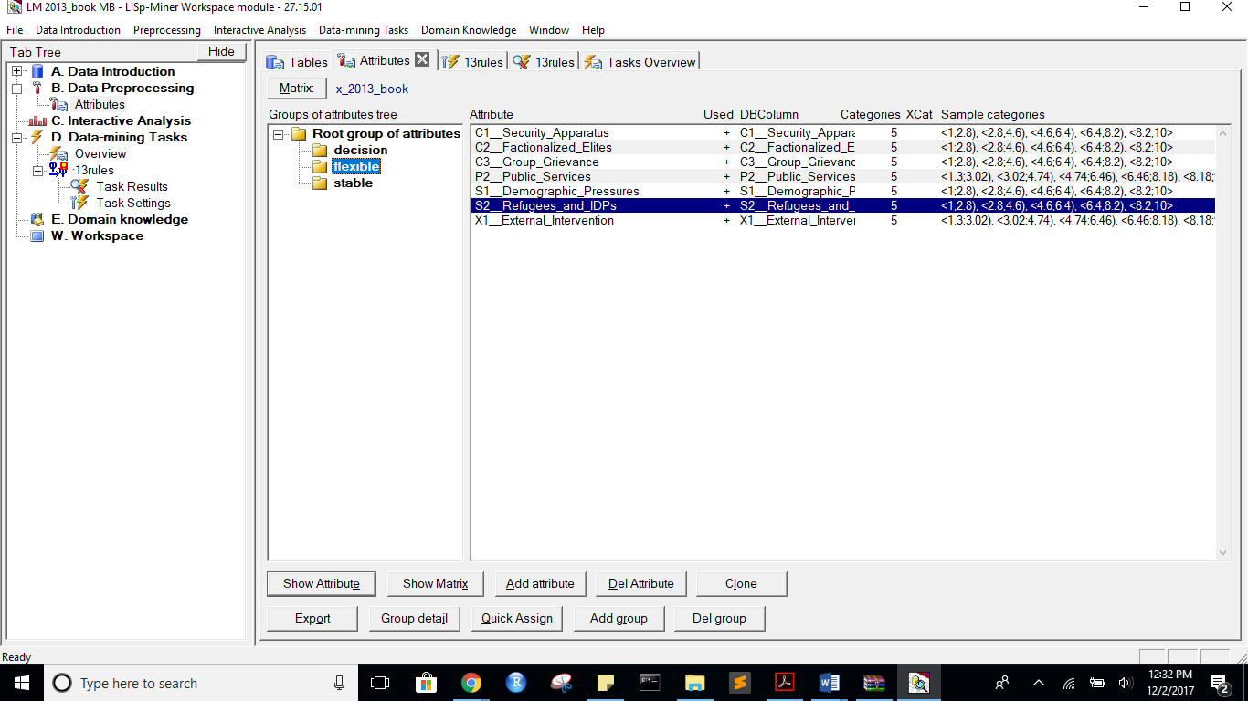

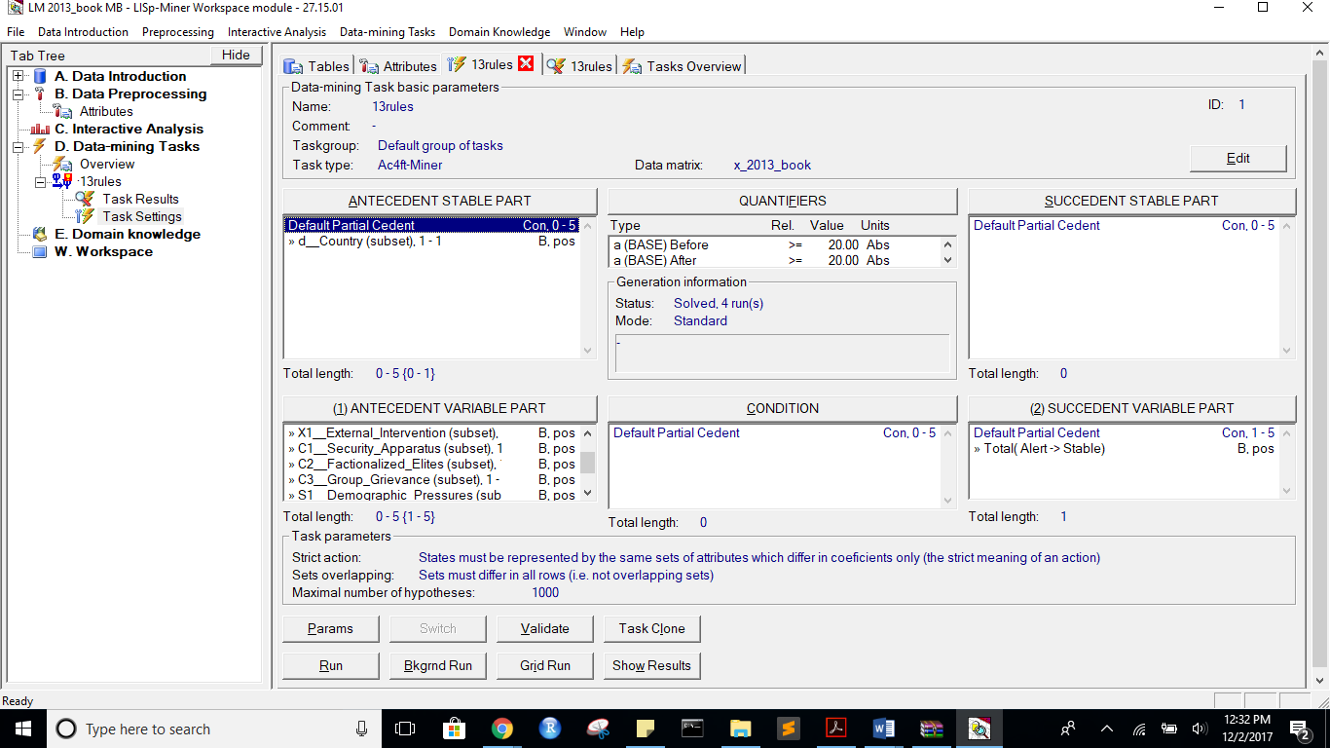

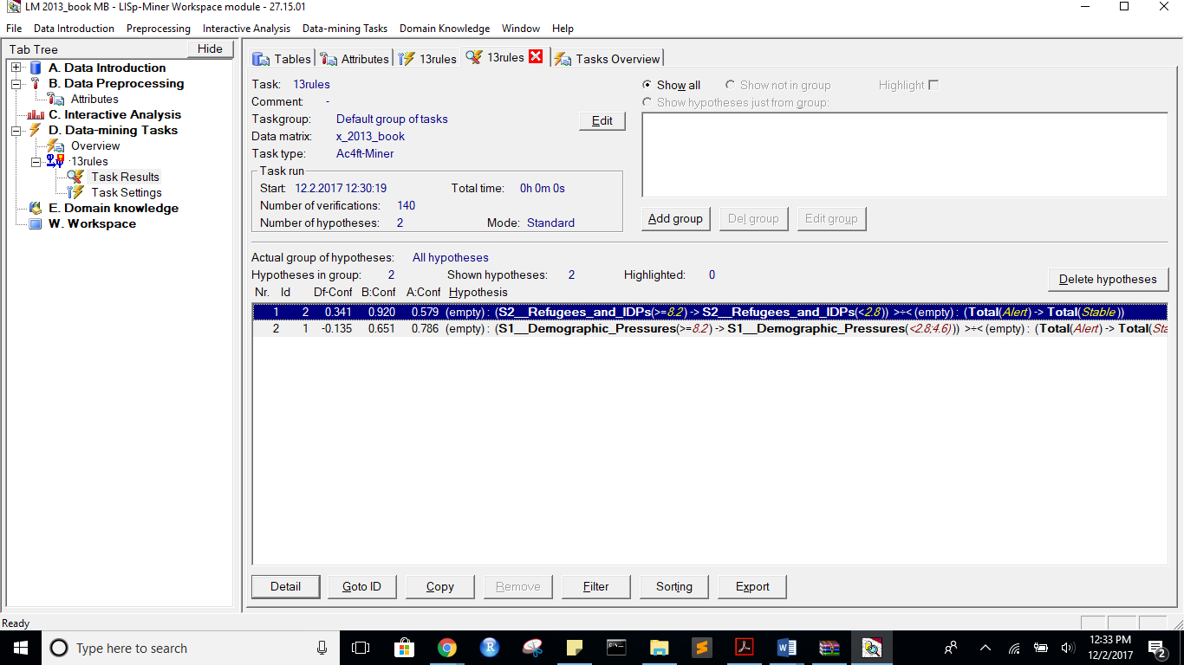

before:

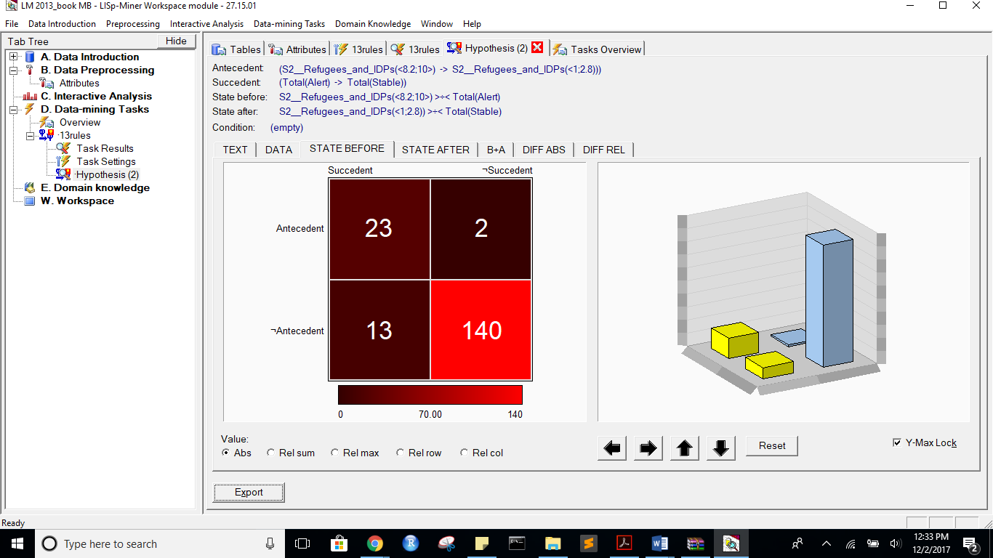

after:

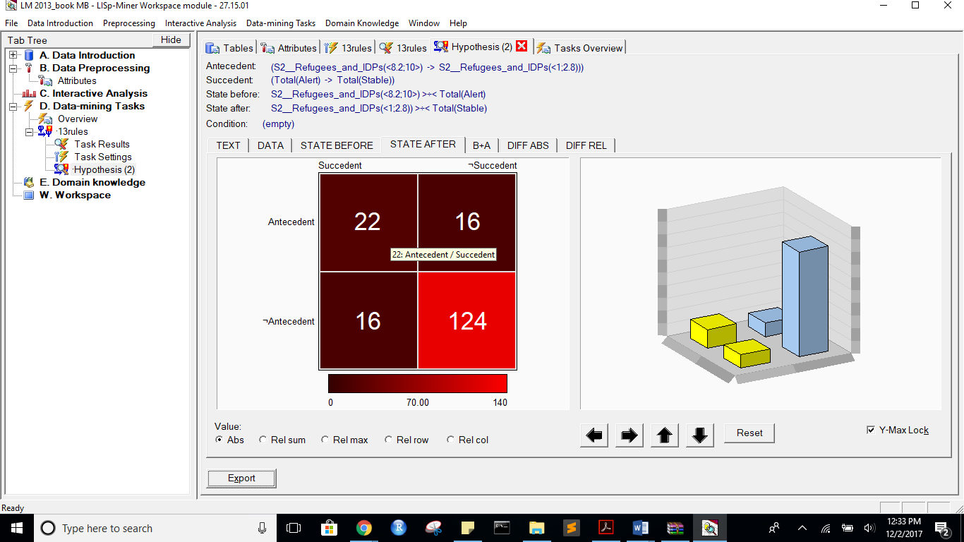

B+A:

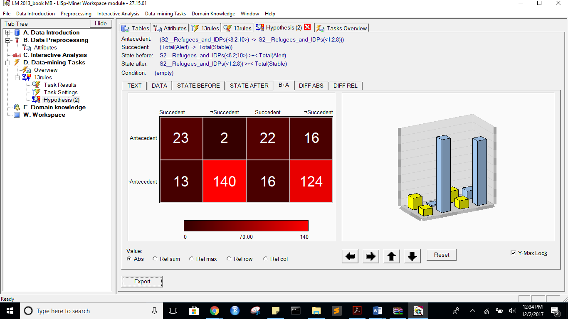

DIFF ABS:

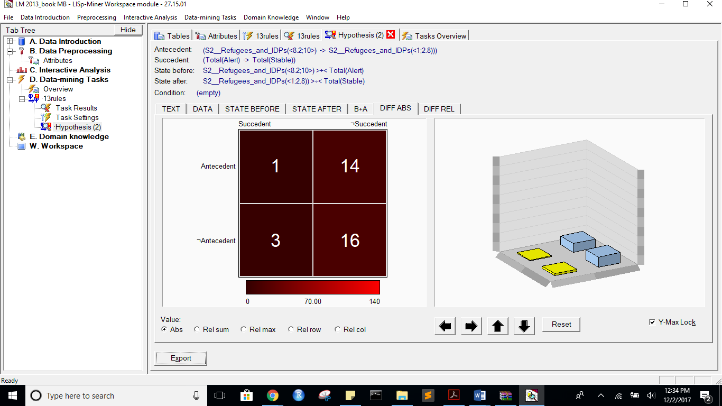

DIFF Rel:

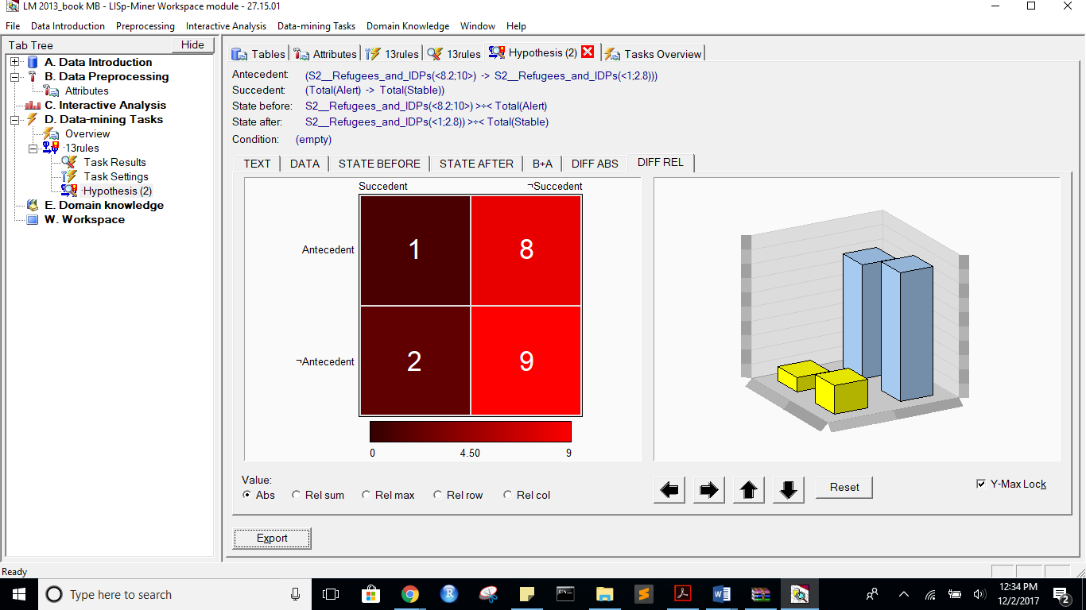

Rules Exported:

Task name: 13rules

Task description: -

Date of output: 2.12.2017

Survey of antecedent attributes

Group Name Description

Default Partial Cedent d__Country (subset), 1 - 1 -

Survey of variable antecedent attributes

Group Name Description

Default Partial Cedent P2__Public_Services (subset), 1 - 1 -

Default Partial Cedent X1__External_Intervention (subset), 1 - 1 -

Default Partial Cedent C1__Security_Apparatus (subset), 1 - 1 -

Default Partial Cedent C2__Factionalized_Elites (subset), 1 - 1 -

Default Partial Cedent C3__Group_Grievance (subset), 1 - 1 -

Default Partial Cedent S1__Demographic_Pressures (subset), 1 - 1 -

Default Partial Cedent S2__Refugees_and_IDPs (subset), 1 - 1 -

Survey of succedent attributes

Group Name Description

Survey of variable sukcedent attributes

Group Name Description

Default Partial Cedent Total( Alert -> Stable) -

Survey of Action4ft-Quantifiers

a-frequency Before >= 20.00 Absolute number

a-frequency After >= 20.00 Absolute number

Task parameters

The comparison of the first set versus the second set

Sets must differ in all rows (i.e. not overlapping sets)

Nr. Hypothesis D%-Sum Df-Conf Df-AFUI Df-FUE Df-Avg R-Conf R-DFUI R-FUE R-Avg H-Conf H-DFUI H-FUE H-Avg B:a B:b B:c B:d B:r B:n B:Conf B:DConf B:EConf B:Supp B:Cmplt B:AvgDf B:Lift B:LBound B:UBound B:ELBound B:EUBound B:DLBound B:DUBound B:Fisher B:Chi-Sq B:bMean B:bVAR B:bStDev B:P(>=90%) B:P(>=95%) A:a A:b A:c A:d A:r A:n A:Conf A:DConf A:EConf A:Supp A:Cmplt A:AvgDf A:Lift A:LBound A:UBound A:ELBound A:EUBound A:DLBound A:DUBound A:Fisher A:Chi-Sq A:bMean A:bVAR A:bStDev A:P(>=90%) A:P(>=95%)

2 (S2__Refugees_and_IDPs(<8.2;10>) -> S2__Refugees_and_IDPs(<1;2.8))) >÷< (Total(Alert) -> Total(Stable)) 0.2 0.3410526316 0.1978557505 0.095505618 1.8369775315 1.5890909091 1.485645933 1.1164383562 2.0730564545 1.5890909091 1.485645933 1.1164383562 2.0730564545 23 2 13 140 25 178 0.92 0.6052631579 0.9157303371 0.1292134831 0.6388888889 3.5488888889 4.5488888889 0.5370940501 0.7287940935 0.2905614278 0.7922119314 0.9999997449 0.0000016263 0 92.8683097569 0.8888888889 0.8888888889 0.0593913871 0.4894947323 0.1386323979 22 16 16 124 38 178 0.5789473684 0.4074074074 0.8202247191 0.1235955056 0.5789473684 1.7119113573 2.7119113573 0.9999999639 0.0000002551 0.9996164189 0.00080435 1 0 0.0000000118 38.4320606026 0.575 0.575 0.0772034057 0.000000058 0

1 (S1__Demographic_Pressures(<8.2;10>) -> S1__Demographic_Pressures(<2.8;4.6))) >÷< (Total(Alert) -> Total(Stable)) 0.16 -0.134551495 0.0490196078 -0.0056179775 -0.4608128849 0.8287526427 1.0980392157 0.9935897436 0.8280838326 1.2066326531 1.0980392157 1.0064516129 1.2076072019 28 15 8 127 43 178 0.6511627907 0.5490196078 0.8707865169 0.1573033708 0.7777777778 2.2196382429 3.2196382429 0.9999981348 0.0000097956 0.9186450847 0.1220631835 1 0 0 70.8163018498 0.6444444444 0.6444444444 0.0705777096 0.0000026583 0 22 6 16 134 28 178 0.7857142857 0.5 0.8764044944 0.1235955056 0.5789473684 2.6804511278 3.6804511278 0.9820933101 0.0550069489 0.8779368165 0.176079924 1 0 0 64.797480845 0.7666666667 0.7666666667 0.0759645267 0.0216167477 0.0004594271

*** End of list ***