2014

Alert to Stable:

flixible attributes:

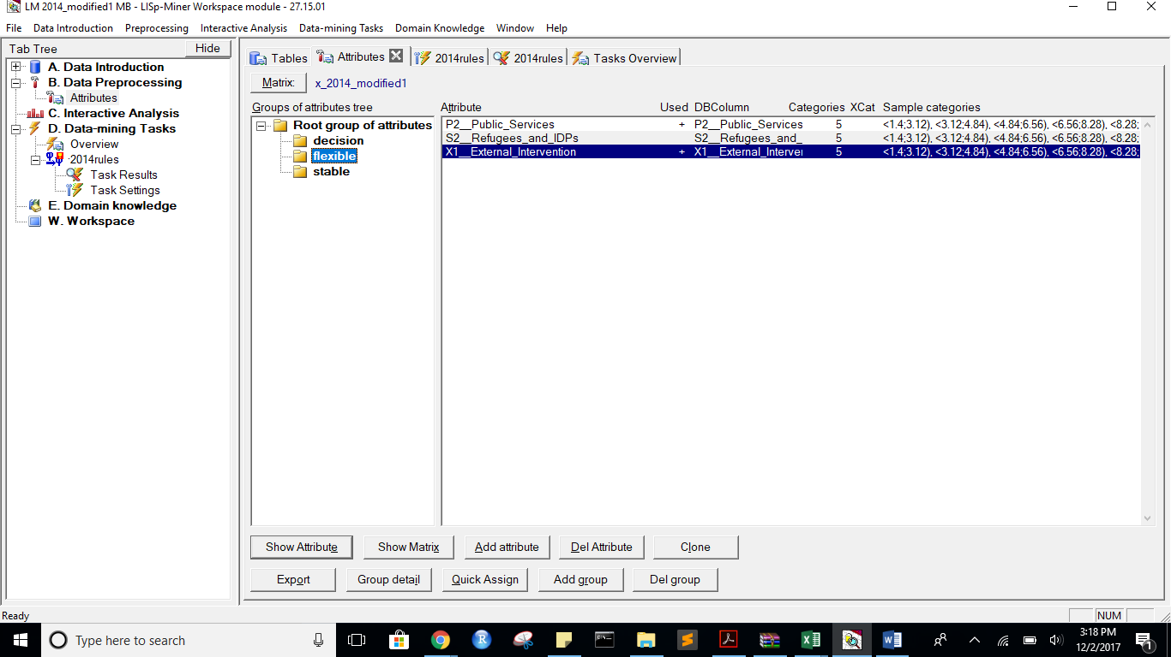

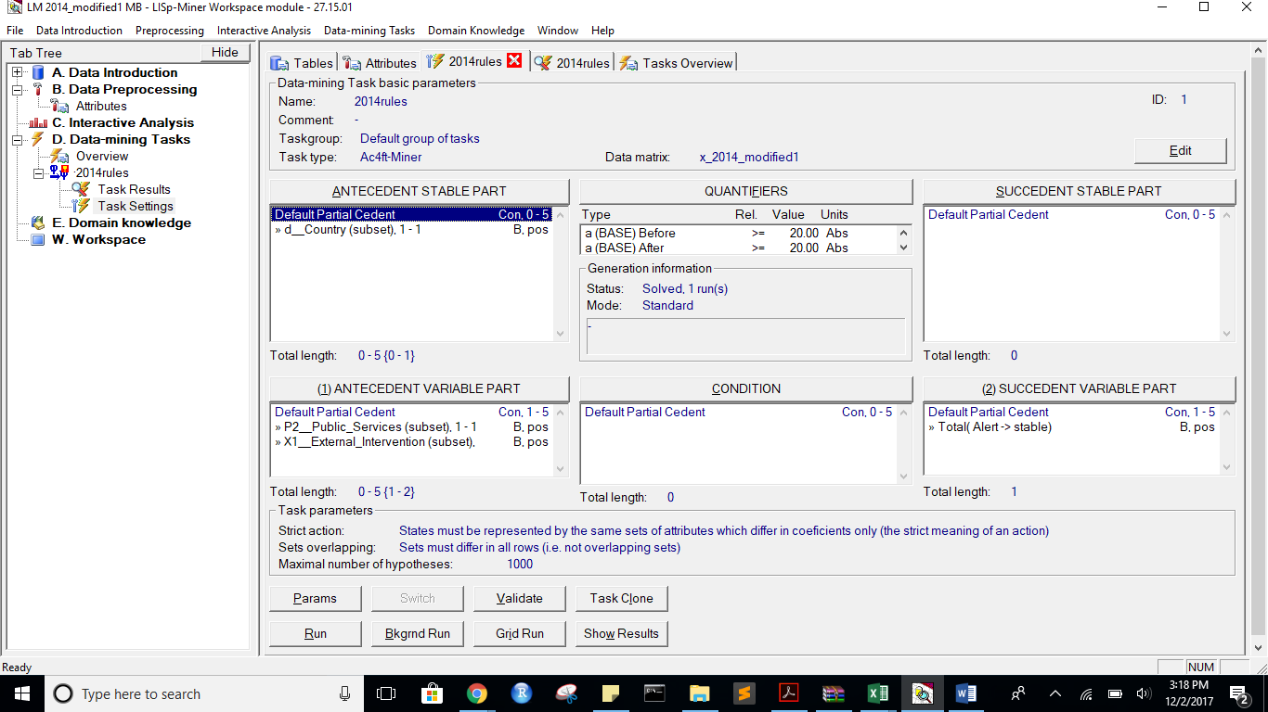

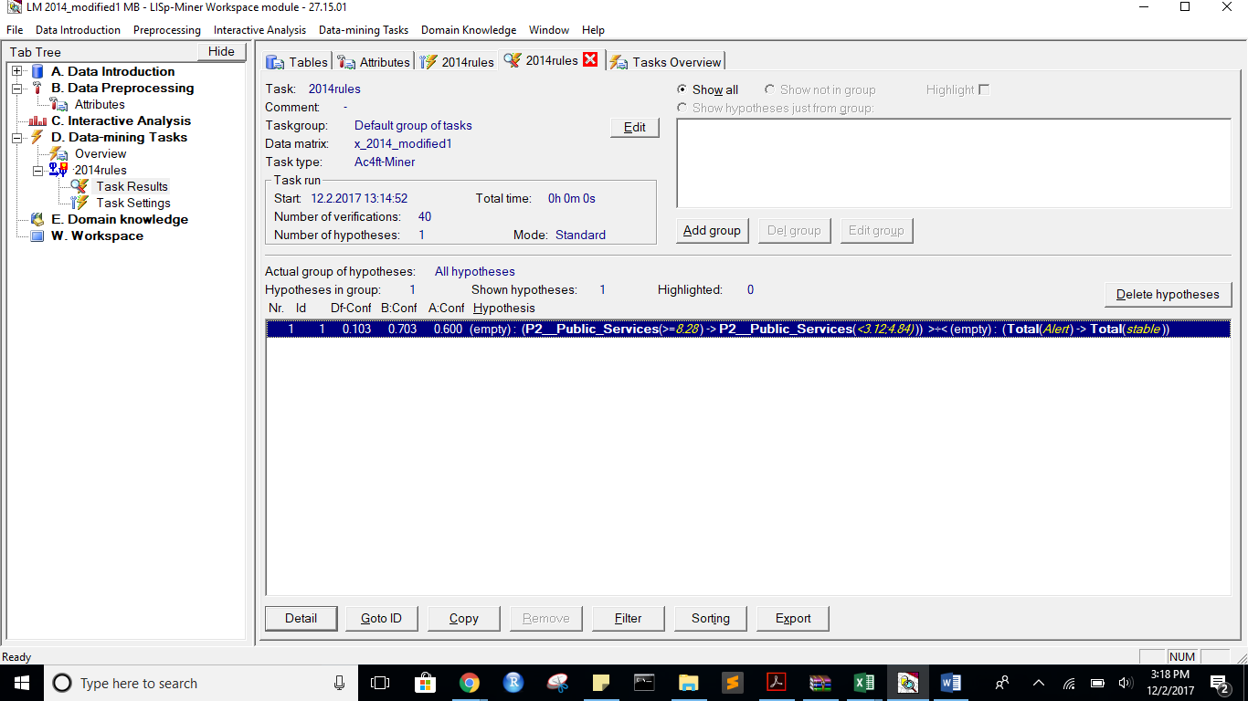

Task name: 2014rules

Task description: -

Date of output: 2.12.2017

Survey of antecedent attributes

Group Name Description

Default Partial Cedent d__Country (subset), 1 - 1 -

Survey of variable antecedent attributes

Group Name Description

Default Partial Cedent P2__Public_Services (subset), 1 - 1 -

Default Partial Cedent X1__External_Intervention (subset), 1 - 1 -

Survey of succedent attributes

Group Name Description

Survey of variable sukcedent attributes

Group Name Description

Default Partial Cedent Total( Alert -> stable) -

Survey of Action4ft-Quantifiers

a-frequency Before >= 20.00 Absolute number

a-frequency After >= 20.00 Absolute number

Task parameters

The comparison of the first set versus the second set

Sets must differ in all rows (i.e. not overlapping sets)

Nr. Hypothesis D%-Sum Df-Conf Df-AFUI Df-FUE Df-Avg R-Conf R-DFUI R-FUE R-Avg H-Conf H-DFUI H-FUE H-Avg B:a B:b B:c B:d B:r B:n B:Conf B:DConf B:EConf B:Supp B:Cmplt B:AvgDf B:Lift B:LBound B:UBound B:ELBound B:EUBound B:DLBound B:DUBound B:Fisher B:Chi-Sq B:bMean B:bVAR B:bStDev B:P(>=90%) B:P(>=95%) A:a A:b A:c A:d A:r A:n A:Conf A:DConf A:EConf A:Supp A:Cmplt A:AvgDf A:Lift A:LBound A:UBound A:ELBound A:EUBound A:DLBound A:DUBound A:Fisher A:Chi-Sq A:bMean A:bVAR A:bStDev A:P(>=90%) A:P(>=95%)

1 (P2__Public_Services(<8.28;10>) -> P2__Public_Services(<3.12;4.84))) >÷< (Total(Alert) -> Total(stable)) 0.15 0.1027027027 0.1815513627 0.0730337079 0.9403937875 1.1711711712 1.4582010582 1.0890410959 1.5409344795 1.1711711712 1.4582010582 1.0890410959 1.5409344795 26 11 8 133 37 178 0.7027027027 0.5777777778 0.893258427 0.1460674157 0.7647058824 2.6788553259 3.6788553259 0.9998320963 0.0007203211 0.6743081202 0.4179435017 0.9999999974 0.0000000184 0 79.1439202031 0.6923076923 0.6923076923 0.0729756383 0.0002231468 0.0000001944 21 14 18 125 35 178 0.6 0.3962264151 0.8202247191 0.1179775281 0.5384615385 1.7384615385 2.7384615385 0.9999995426 0.0000029958 0.9996164189 0.00080435 1 0 0.0000000256 36.9429855148 0.5945945946 0.5945945946 0.0796459043 0.0000007112 0

*** End of list ***

State Before:

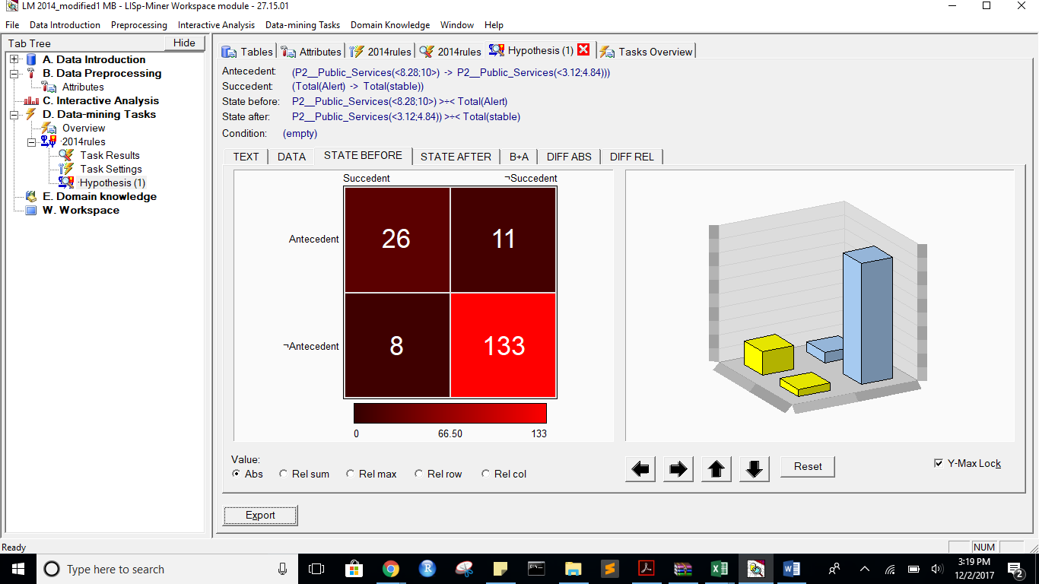

StateAfter:

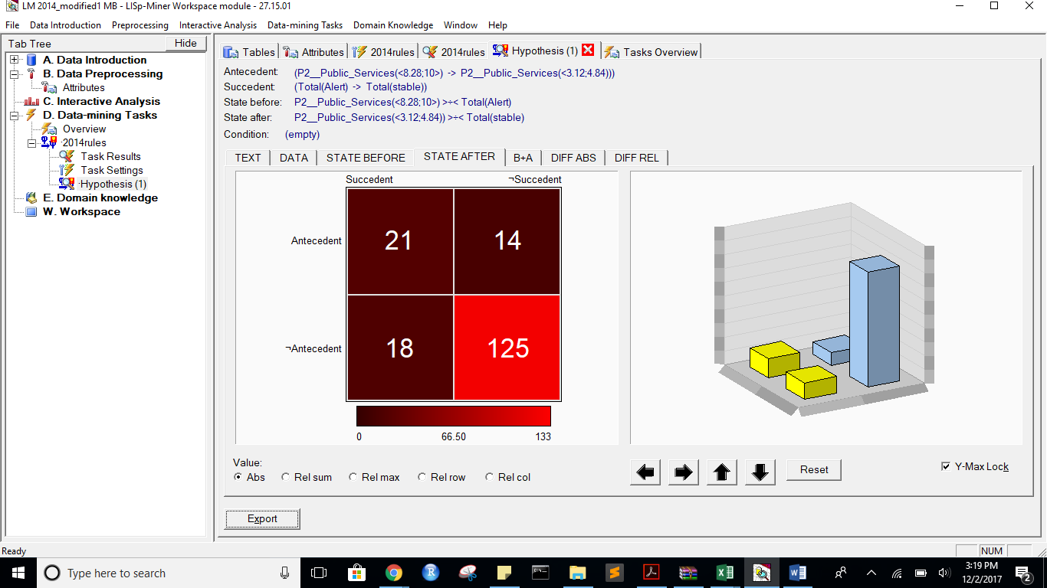

B+A:

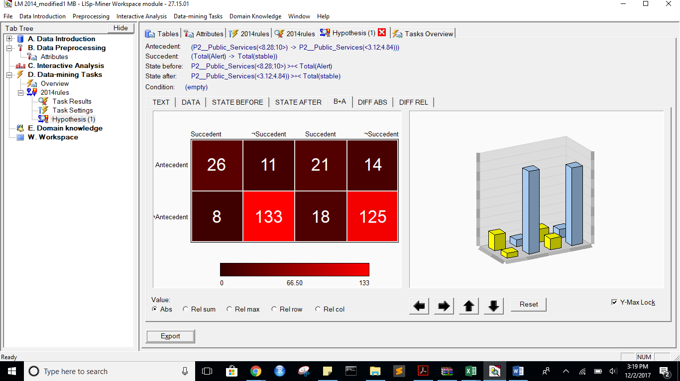

Diff ABS:

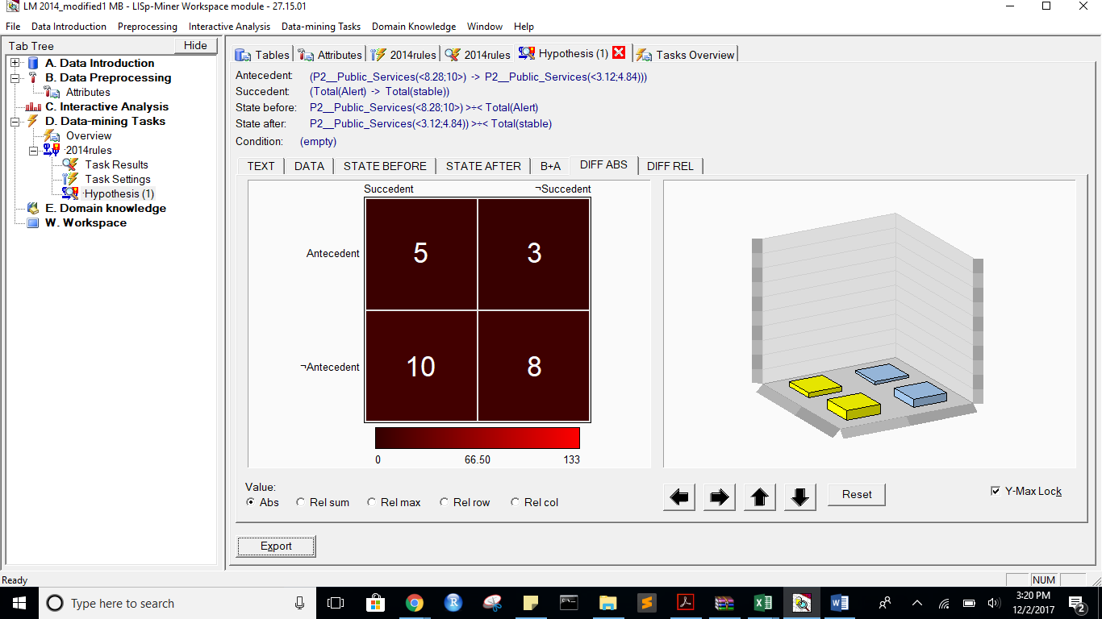

Diff REL:  
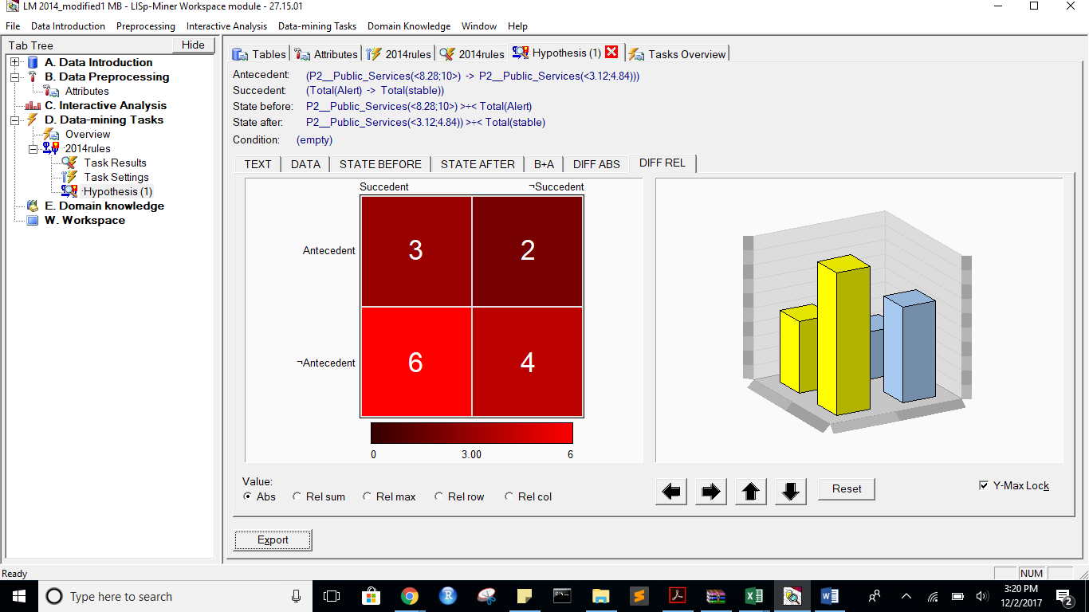

Alert to Warning with same attributes as above:

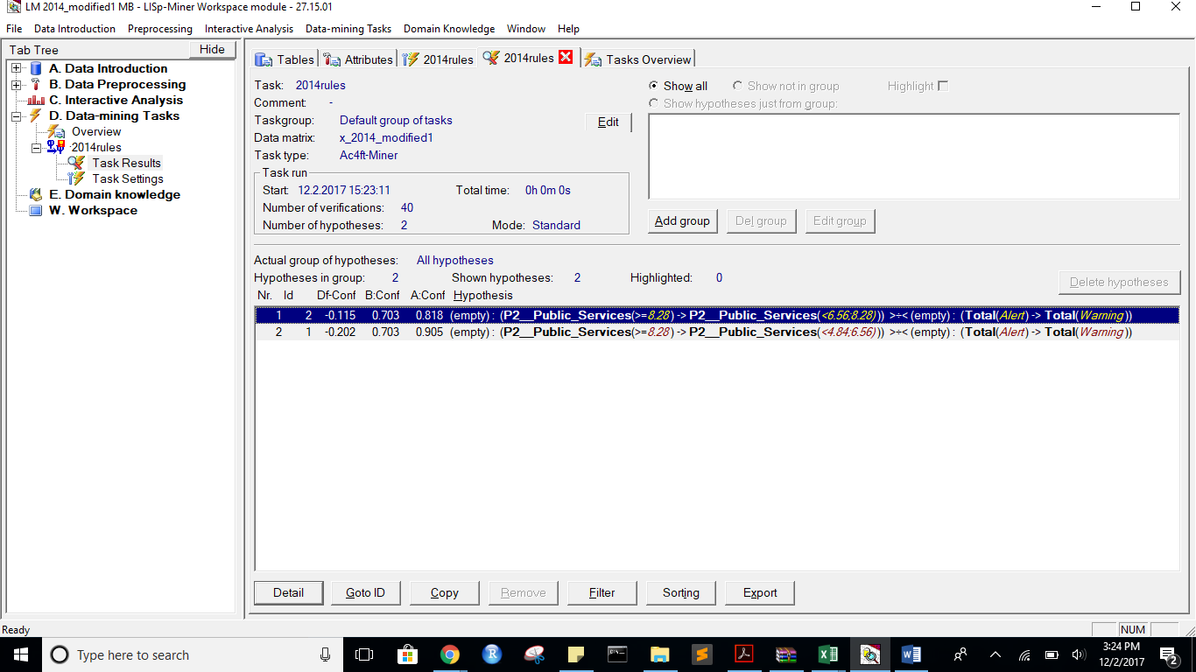

State Before:

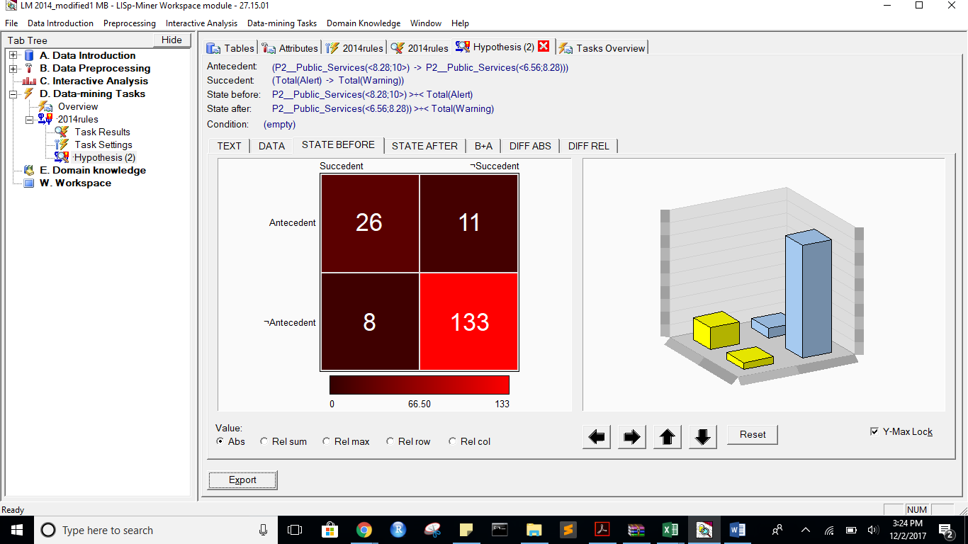

State After:

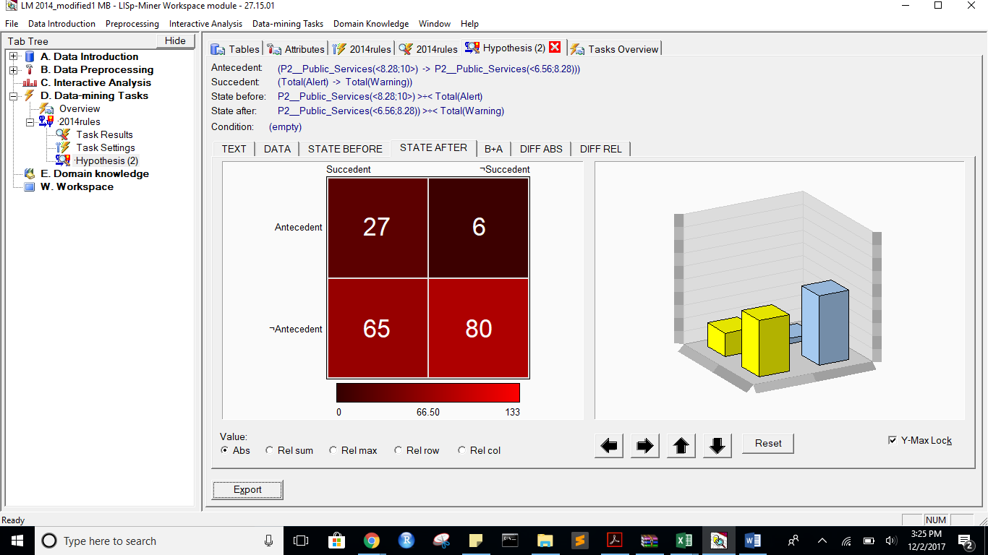

B+A:

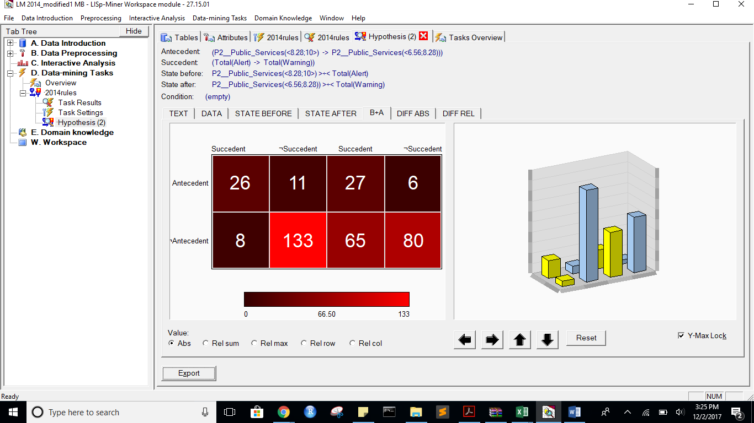

DiffABS:

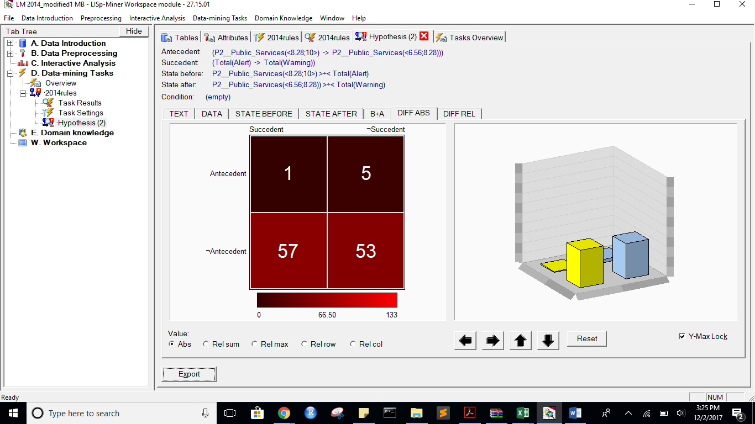

DIFF REL:  
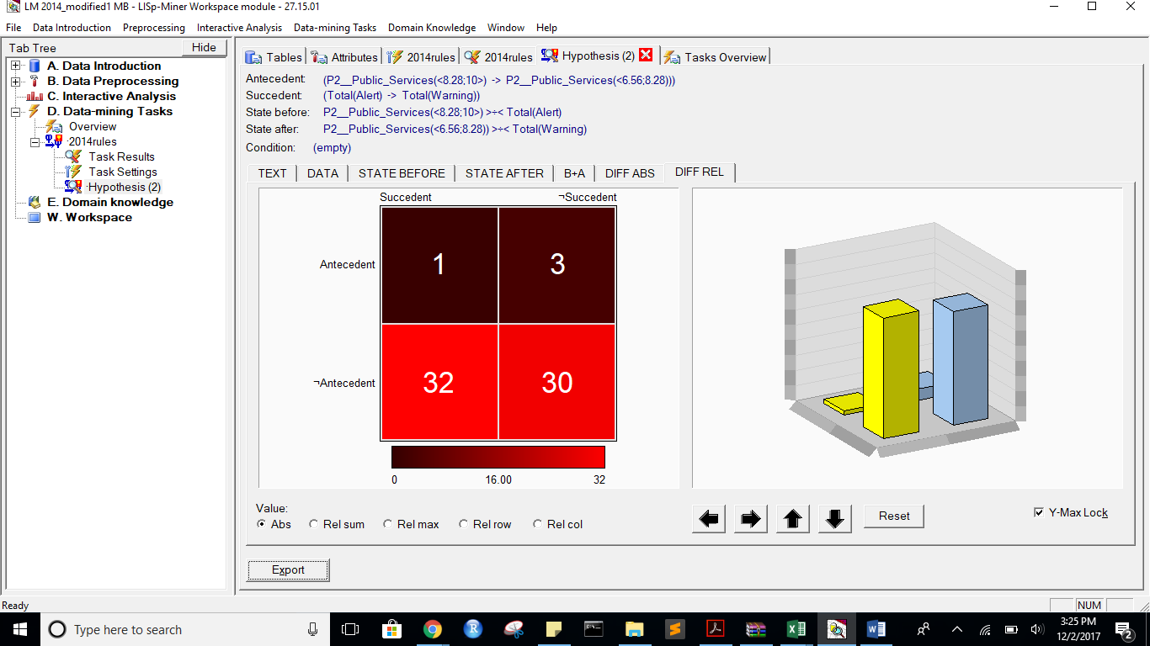

Task name: 2014rules

Task description: -

Date of output: 2.12.2017

Survey of antecedent attributes

Group Name Description

Default Partial Cedent d__Country (subset), 1 - 1 -

Survey of variable antecedent attributes

Group Name Description

Default Partial Cedent P2__Public_Services (subset), 1 - 1 -

Default Partial Cedent X1__External_Intervention (subset), 1 - 1 -

Survey of succedent attributes

Group Name Description

Survey of variable sukcedent attributes

Group Name Description

Default Partial Cedent Total( Alert -> Warning) -

Survey of Action4ft-Quantifiers

a-frequency Before >= 20.00 Absolute number

a-frequency After >= 20.00 Absolute number

Task parameters

The comparison of the first set versus the second set

Sets must differ in all rows (i.e. not overlapping sets)

Nr. Hypothesis D%-Sum Df-Conf Df-AFUI Df-FUE Df-Avg R-Conf R-DFUI R-FUE R-Avg H-Conf H-DFUI H-FUE H-Avg B:a B:b B:c B:d B:r B:n B:Conf B:DConf B:EConf B:Supp B:Cmplt B:AvgDf B:Lift B:LBound B:UBound B:ELBound B:EUBound B:DLBound B:DUBound B:Fisher B:Chi-Sq B:bMean B:bVAR B:bStDev B:P(>=90%) B:P(>=95%) A:a A:b A:c A:d A:r A:n A:Conf A:DConf A:EConf A:Supp A:Cmplt A:AvgDf A:Lift A:LBound A:UBound A:ELBound A:EUBound A:DLBound A:DUBound A:Fisher A:Chi-Sq A:bMean A:bVAR A:bStDev A:P(>=90%) A:P(>=95%)

2 (P2__Public_Services(<8.28;10>) -> P2__Public_Services(<6.56;8.28))) >÷< (Total(Alert) -> Total(Warning)) 0.66 -0.1154791155 0.3022675737 0.2921348315 2.0958513733 0.8588588589 2.0971193416 1.4859813084 4.5949179489 1.1643356643 2.0971193416 1.4859813084 4.5949179489 26 11 8 133 37 178 0.7027027027 0.5777777778 0.893258427 0.1460674157 0.7647058824 2.6788553259 3.6788553259 0.9998320963 0.0007203211 0.6743081202 0.4179435017 0.9999999974 0.0000000184 0 79.1439202031 0.6923076923 0.6923076923 0.0729756383 0.0002231468 0.0000001944 27 6 65 80 33 178 0.8181818182 0.2755102041 0.6011235955 0.1516853933 0.2934782609 0.5830039526 1.5830039526 0.9582961522 0.1061086358 1 0 1 0 0.0000874045 14.7298496629 0.8 0.8 0.0666666667 0.0481443814 0.0012716835

1 (P2__Public_Services(<8.28;10>) -> P2__Public_Services(<4.84;6.56))) >÷< (Total(Alert) -> Total(Warning)) 0.66 -0.2020592021 0.1819444444 0.2191011236 1.9283377276 0.7766714083 1.4596491228 1.325 3.569343786 1.2875457875 1.4596491228 1.325 3.569343786 26 11 8 133 37 178 0.7027027027 0.5777777778 0.893258427 0.1460674157 0.7647058824 2.6788553259 3.6788553259 0.9998320963 0.0007203211 0.6743081202 0.4179435017 0.9999999974 0.0000000184 0 79.1439202031 0.6923076923 0.6923076923 0.0729756383 0.0002231468 0.0000001944 38 4 54 82 42 178 0.9047619048 0.3958333333 0.6741573034 0.2134831461 0.4130434783 0.7505175983 1.7505175983 0.587895933 0.6163539717 1 0 1 0 0.0000000019 33.1239042634 0.8863636364 0.8863636364 0.0473105909 0.4325290412 0.0622586659

*** End of list ***

**ALERT TO STABLE WITH MORE ATTRIBUTES:**

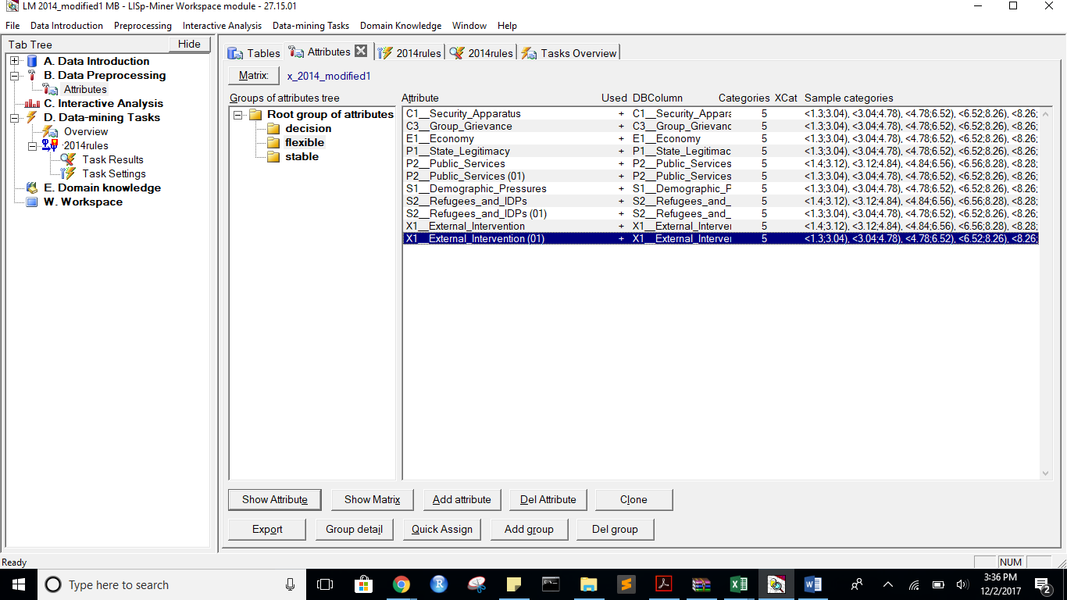

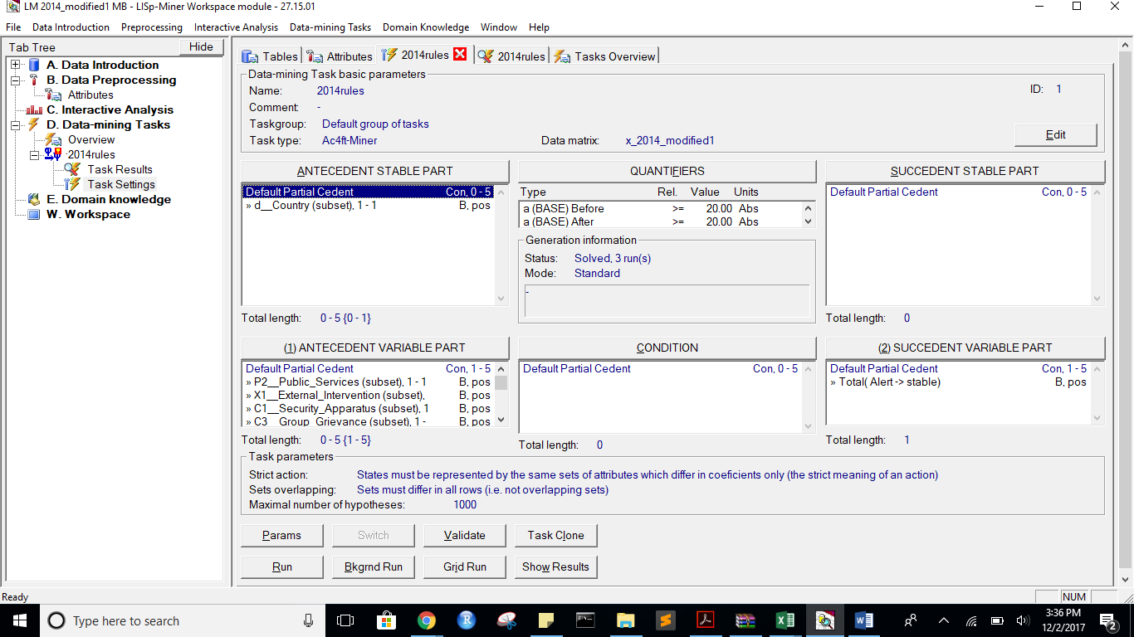

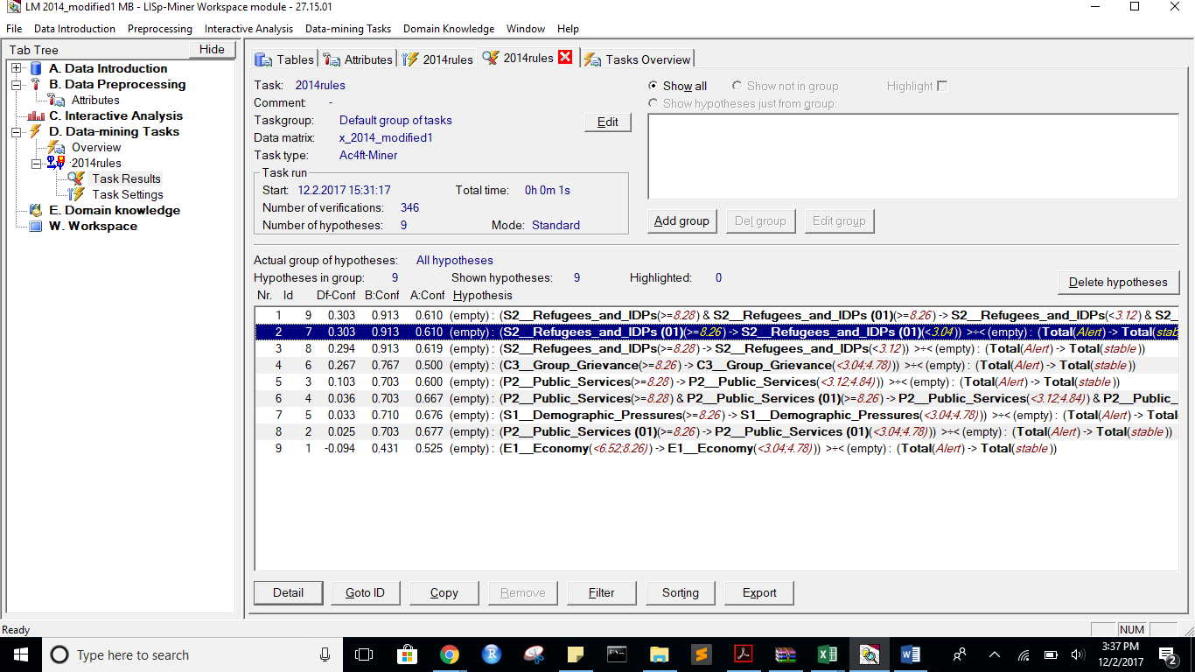

StateBefore:

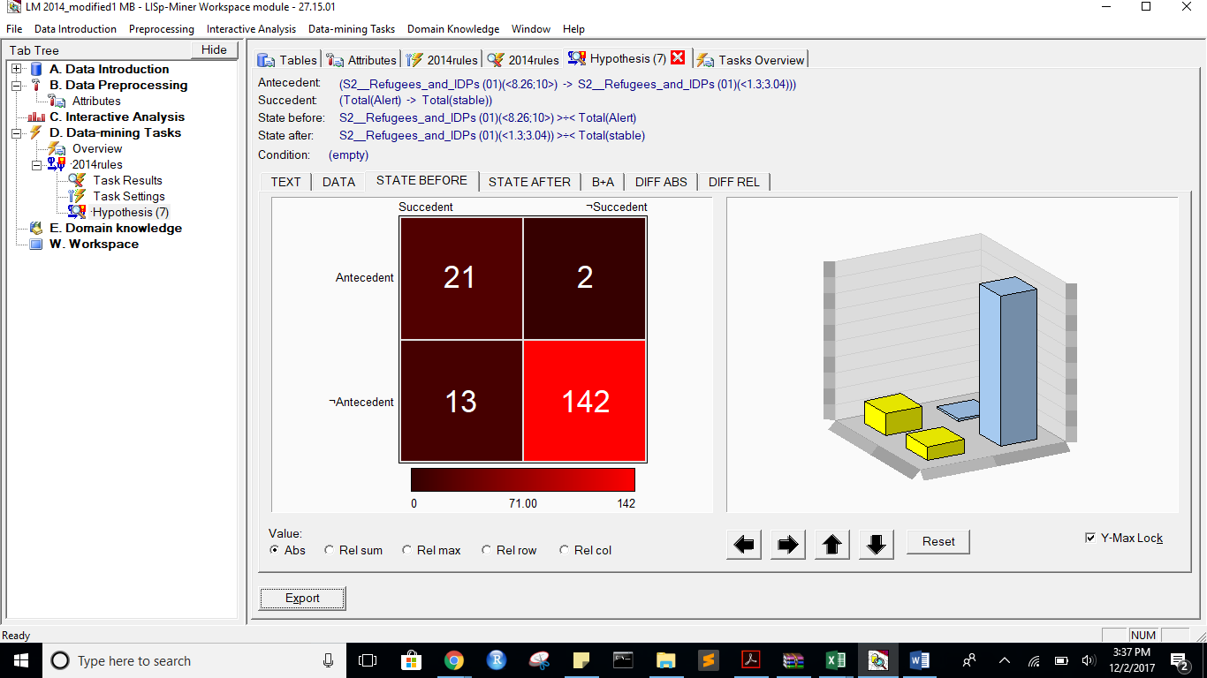

State After:

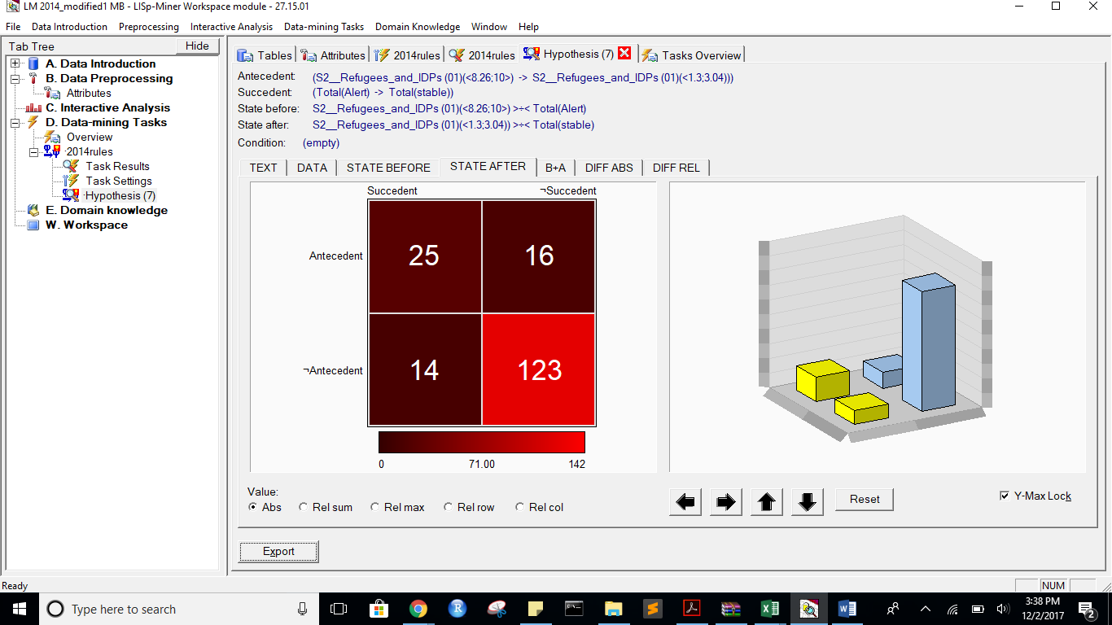

B+A:

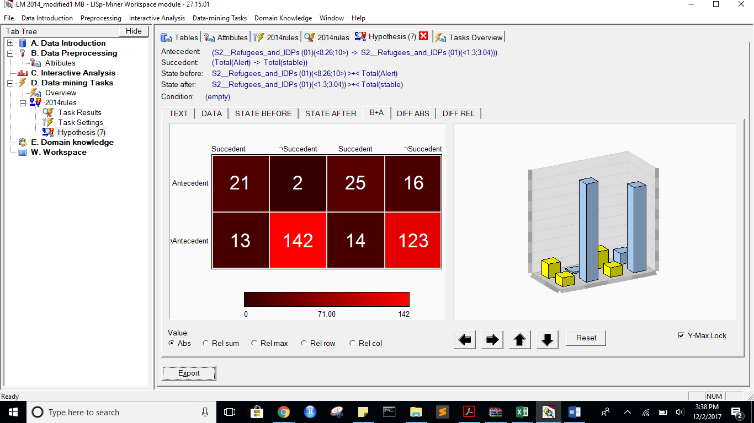

DIFF ABS:

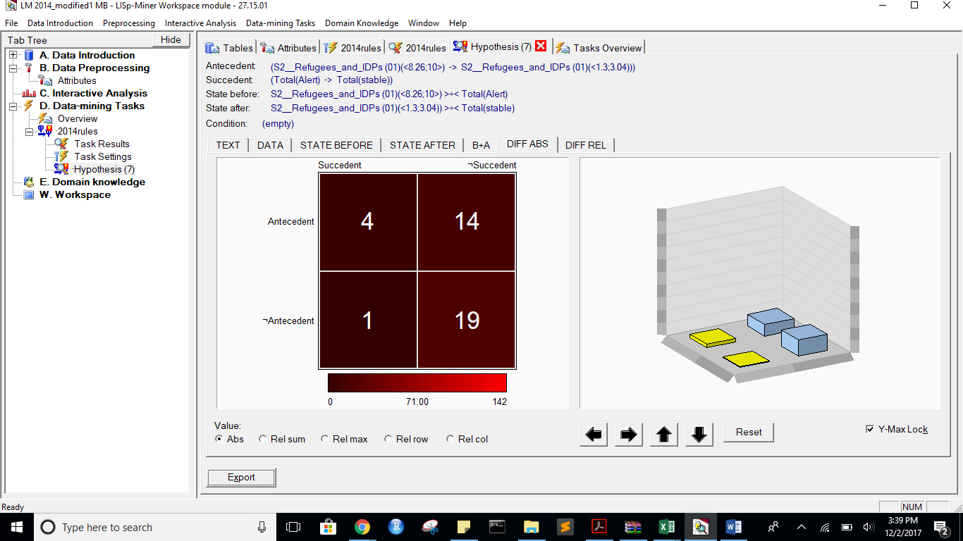

DIFF REL:

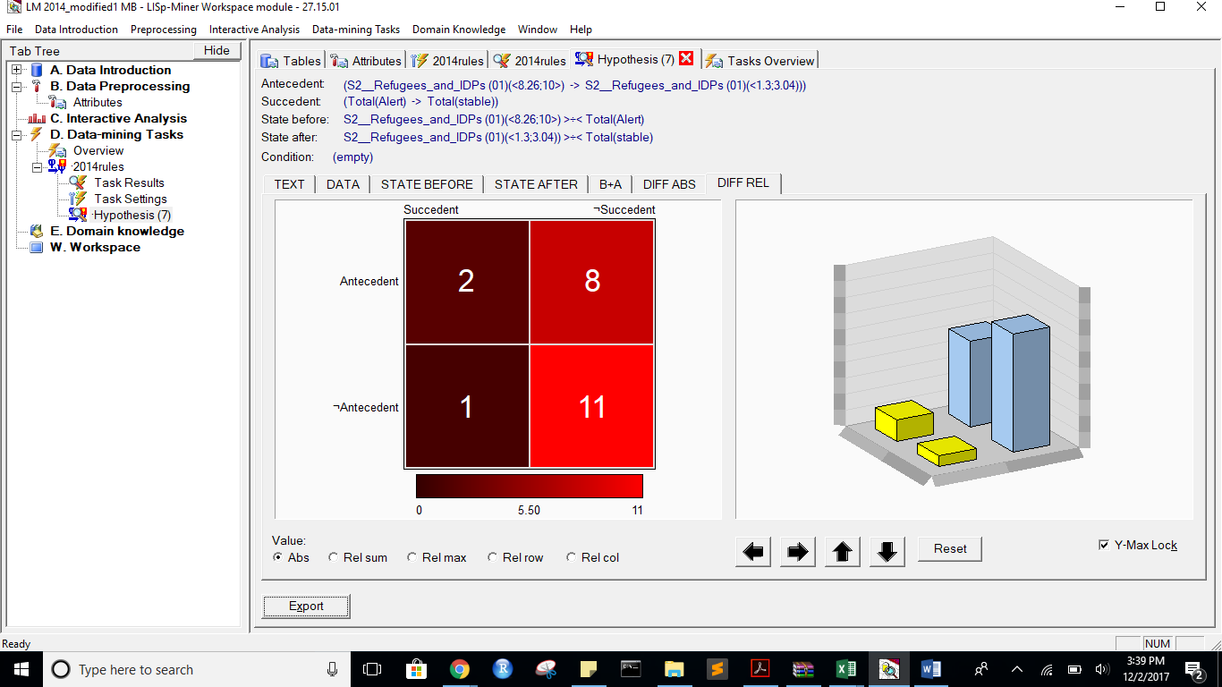

Task name: 2014rules

Task description: -

Date of output: 2.12.2017

Survey of antecedent attributes

Group Name Description

Default Partial Cedent d__Country (subset), 1 - 1 -

Survey of variable antecedent attributes

Group Name Description

Default Partial Cedent P2__Public_Services (subset), 1 - 1 -

Default Partial Cedent X1__External_Intervention (subset), 1 - 1 -

Default Partial Cedent C1__Security_Apparatus (subset), 1 - 1 -

Default Partial Cedent C3__Group_Grievance (subset), 1 - 1 -

Default Partial Cedent E1__Economy (subset), 1 - 1 -

Default Partial Cedent P1__State_Legitimacy (subset), 1 - 1 -

Default Partial Cedent P2__Public_Services#2 (subset), 1 - 1 -

Default Partial Cedent P2__Public_Services (01) (subset), 1 - 1 -

Default Partial Cedent S1__Demographic_Pressures (subset), 1 - 1 -

Default Partial Cedent S2__Refugees_and_IDPs (subset), 1 - 1 -

Default Partial Cedent S2__Refugees_and_IDPs (01) (subset), 1 - 1 -

Default Partial Cedent X1__External_Intervention#2 (subset), 1 - 1 -

Default Partial Cedent X1__External_Intervention (01) (subset), 1 - 1 -

Survey of succedent attributes

Group Name Description

Survey of variable sukcedent attributes

Group Name Description

Default Partial Cedent Total( Alert -> stable) -

Survey of Action4ft-Quantifiers

a-frequency Before >= 20.00 Absolute number

a-frequency After >= 20.00 Absolute number

Task parameters

The comparison of the first set versus the second set

Sets must differ in all rows (i.e. not overlapping sets)

Nr. Hypothesis D%-Sum Df-Conf Df-AFUI Df-FUE Df-Avg R-Conf R-DFUI R-FUE R-Avg H-Conf H-DFUI H-FUE H-Avg B:a B:b B:c B:d B:r B:n B:Conf B:DConf B:EConf B:Supp B:Cmplt B:AvgDf B:Lift B:LBound B:UBound B:ELBound B:EUBound B:DLBound B:DUBound B:Fisher B:Chi-Sq B:bMean B:bVAR B:bStDev B:P(>=90%) B:P(>=95%) A:a A:b A:c A:d A:r A:n A:Conf A:DConf A:EConf A:Supp A:Cmplt A:AvgDf A:Lift A:LBound A:UBound A:ELBound A:EUBound A:DLBound A:DUBound A:Fisher A:Chi-Sq A:bMean A:bVAR A:bStDev A:P(>=90%) A:P(>=95%)

9 (S2__Refugees_and_IDPs(<8.28;10>) & S2__Refugees_and_IDPs (01)(<8.26;10>) -> S2__Refugees_and_IDPs(<1.4;3.12)) & S2__Refugees_and_IDPs (01)(<1.3;3.04))) >÷< (Total(Alert) -> Total(stable)) 0.22 0.3032873807 0.1287878788 0.0842696629 1.9970617825 1.4973913043 1.2833333333 1.1013513514 2.1200637637 1.4973913043 1.2833333333 1.1013513514 2.1200637637 21 2 13 142 23 178 0.9130434783 0.5833333333 0.9157303371 0.1179775281 0.6176470588 3.7800511509 4.7800511509 0.5919567312 0.6848733113 0.2905614278 0.7922119314 0.999999898 0.0000007112 0 89.110302597 0.88 0.88 0.0637302005 0.4357262546 0.1159446076 25 16 14 123 41 178 0.6097560976 0.4545454545 0.8314606742 0.1404494382 0.641025641 1.7829893684 2.7829893684 0.9999998584 0.0000008816 0.9983712863 0.0031827506 1 0 0 47.5149860145 0.6046511628 0.6046511628 0.0737082908 0.0000002156 0

7 (S2__Refugees_and_IDPs (01)(<8.26;10>) -> S2__Refugees_and_IDPs (01)(<1.3;3.04))) >÷< (Total(Alert) -> Total(stable)) 0.22 0.3032873807 0.1287878788 0.0842696629 1.9970617825 1.4973913043 1.2833333333 1.1013513514 2.1200637637 1.4973913043 1.2833333333 1.1013513514 2.1200637637 21 2 13 142 23 178 0.9130434783 0.5833333333 0.9157303371 0.1179775281 0.6176470588 3.7800511509 4.7800511509 0.5919567312 0.6848733113 0.2905614278 0.7922119314 0.999999898 0.0000007112 0 89.110302597 0.88 0.88 0.0637302005 0.4357262546 0.1159446076 25 16 14 123 41 178 0.6097560976 0.4545454545 0.8314606742 0.1404494382 0.641025641 1.7829893684 2.7829893684 0.9999998584 0.0000008816 0.9983712863 0.0031827506 1 0 0 47.5149860145 0.6046511628 0.6046511628 0.0737082908 0.0000002156 0

8 (S2__Refugees_and_IDPs(<8.28;10>) -> S2__Refugees_and_IDPs(<1.4;3.12))) >÷< (Total(Alert) -> Total(stable)) 0.22 0.2939958592 0.1106060606 0.0786516854 1.9546543255 1.474916388 1.233974359 1.0939597315 2.0708106305 1.474916388 1.233974359 1.0939597315 2.0708106305 21 2 13 142 23 178 0.9130434783 0.5833333333 0.9157303371 0.1179775281 0.6176470588 3.7800511509 4.7800511509 0.5919567312 0.6848733113 0.2905614278 0.7922119314 0.999999898 0.0000007112 0 89.110302597 0.88 0.88 0.0637302005 0.4357262546 0.1159446076 26 16 13 123 42 178 0.619047619 0.4727272727 0.8370786517 0.1460674157 0.6666666667 1.8253968254 2.8253968254 0.9999997844 0.0000012914 0.9968172494 0.0059987906 1 0 0 51.3919116807 0.6136363636 0.6136363636 0.0725850883 0.0000003232 0

6 (C3__Group_Grievance(<8.26;10>) -> C3__Group_Grievance(<3.04;4.78))) >÷< (Total(Alert) -> Total(stable)) 0.23 0.2666666667 0.2219925589 0.1179775281 1.7316742081 1.5333333333 1.6548780488 1.1510791367 2.3507058824 1.5333333333 1.6548780488 1.1510791367 2.3507058824 23 7 11 137 30 178 0.7666666667 0.5609756098 0.8988764045 0.1292134831 0.6764705882 3.0137254902 4.0137254902 0.9922163808 0.0258267887 0.5820564983 0.5165374226 0.9999999973 0.0000000207 0 77.3754787876 0.75 0.75 0.0753778361 0.0095879569 0.0001090899 20 20 19 119 40 178 0.5 0.3389830508 0.7808988764 0.1123595506 0.5128205128 1.2820512821 2.2820512821 1 0 0.9999991533 0.0000022334 1 0 0.0000051866 23.7936740908 0.5 0.5 0.0762492852 0 0

3 (P2__Public_Services(<8.28;10>) -> P2__Public_Services(<3.12;4.84))) >÷< (Total(Alert) -> Total(stable)) 0.15 0.1027027027 0.1815513627 0.0730337079 0.9403937875 1.1711711712 1.4582010582 1.0890410959 1.5409344795 1.1711711712 1.4582010582 1.0890410959 1.5409344795 26 11 8 133 37 178 0.7027027027 0.5777777778 0.893258427 0.1460674157 0.7647058824 2.6788553259 3.6788553259 0.9998320963 0.0007203211 0.6743081202 0.4179435017 0.9999999974 0.0000000184 0 79.1439202031 0.6923076923 0.6923076923 0.0729756383 0.0002231468 0.0000001944 21 14 18 125 35 178 0.6 0.3962264151 0.8202247191 0.1179775281 0.5384615385 1.7384615385 2.7384615385 0.9999995426 0.0000029958 0.9996164189 0.00080435 1 0 0.0000000256 36.9429855148 0.5945945946 0.5945945946 0.0796459043 0.0000007112 0

4 (P2__Public_Services(<8.28;10>) & P2__Public_Services (01)(<8.26;10>) -> P2__Public_Services(<3.12;4.84)) & P2__Public_Services (01)(<3.04;4.78))) >÷< (Total(Alert) -> Total(stable)) 0.12 0.036036036 0.1696145125 0.0561797753 0.6361202832 1.0540540541 1.4155555556 1.067114094 1.3114061637 1.0540540541 1.4155555556 1.067114094 1.3114061637 26 11 8 133 37 178 0.7027027027 0.5777777778 0.893258427 0.1460674157 0.7647058824 2.6788553259 3.6788553259 0.9998320963 0.0007203211 0.6743081202 0.4179435017 0.9999999974 0.0000000184 0 79.1439202031 0.6923076923 0.6923076923 0.0729756383 0.0002231468 0.0000001944 20 10 19 129 30 178 0.6666666667 0.4081632653 0.8370786517 0.1123595506 0.5128205128 2.0427350427 3.0427350427 0.9999109221 0.0004543551 0.9968172494 0.0059987906 1 0 0.0000000043 42.2428709839 0.65625 0.65625 0.0826797285 0.0001256063 0.0000001623

5 (S1__Demographic_Pressures(<8.26;10>) -> S1__Demographic_Pressures(<3.04;4.78))) >÷< (Total(Alert) -> Total(stable)) 0.08 0.0332068311 0.051627907 0.0337078652 0.6278888727 1.049088359 1.1122345804 1.0397350993 1.3007878053 1.049088359 1.1122345804 1.0397350993 1.3007878053 22 9 12 135 31 178 0.7096774194 0.511627907 0.8820224719 0.1235955056 0.6470588235 2.715370019 3.715370019 0.9993890975 0.002596208 0.823920076 0.2442029471 1 0 0 65.3489815281 0.696969697 0.696969697 0.0788152976 0.0008094365 0.0000022743 23 11 16 128 34 178 0.6764705882 0.46 0.8483146067 0.1292134831 0.5897435897 2.0874811463 3.0874811463 0.9999338653 0.0003197013 0.9891012997 0.0190760329 1 0 0 51.384408009 0.6666666667 0.6666666667 0.0774984258 0.000091492 0.000000069

2 (P2__Public_Services (01)(<8.26;10>) -> P2__Public_Services (01)(<3.04;4.78))) >÷< (Total(Alert) -> Total(stable)) 0.12 0.0252833479 0.1492063492 0.0505617978 0.5870439115 1.0373230373 1.3481481481 1.06 1.2806390229 1.0373230373 1.3481481481 1.06 1.2806390229 26 11 8 133 37 178 0.7027027027 0.5777777778 0.893258427 0.1460674157 0.7647058824 2.6788553259 3.6788553259 0.9998320963 0.0007203211 0.6743081202 0.4179435017 0.9999999974 0.0000000184 0 79.1439202031 0.6923076923 0.6923076923 0.0729756383 0.0002231468 0.0000001944 21 10 18 129 31 178 0.6774193548 0.4285714286 0.8426966292 0.1179775281 0.5384615385 2.0918114144 3.0918114144 0.9998743944 0.0006109025 0.9940012094 0.0108987003 1 0 0 46.0849610887 0.6666666667 0.6666666667 0.0808452083 0.0001741363 0.000000236

1 (E1__Economy(<6.52;8.26)) -> E1__Economy(<3.04;4.78))) >÷< (Total(Alert) -> Total(stable)) 0.13 -0.093627451 -0.0128626163 -0.0224719101 -0.1377916778 0.8216619981 0.9644746788 0.9716312057 0.9013062363 1.2170454545 1.0368338558 1.0291970803 1.1095008108 22 29 12 115 51 178 0.431372549 0.3492063492 0.7696629213 0.1235955056 0.6470588235 1.2583621684 2.2583621684 1 0 0.999999889 0.0000003112 1 0 0.0000010109 26.7247830685 0.4339622642 0.4339622642 0.0674453163 0 0 21 19 18 120 40 178 0.525 0.3620689655 0.7921348315 0.1179775281 0.5384615385 1.3961538462 2.3961538462 0.9999999998 0.0000000016 0.9999942899 0.0000141429 1 0 0.000000763 28.2174177715 0.5238095238 0.5238095238 0.0761627857 0 0

*** End of list ***

Alert to Warning:

same attributes as above

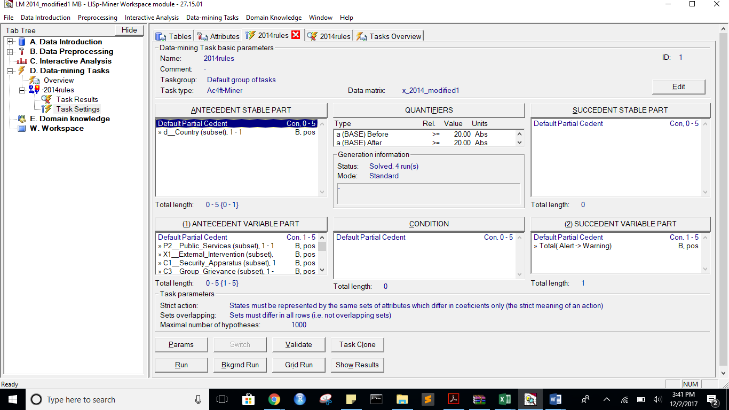

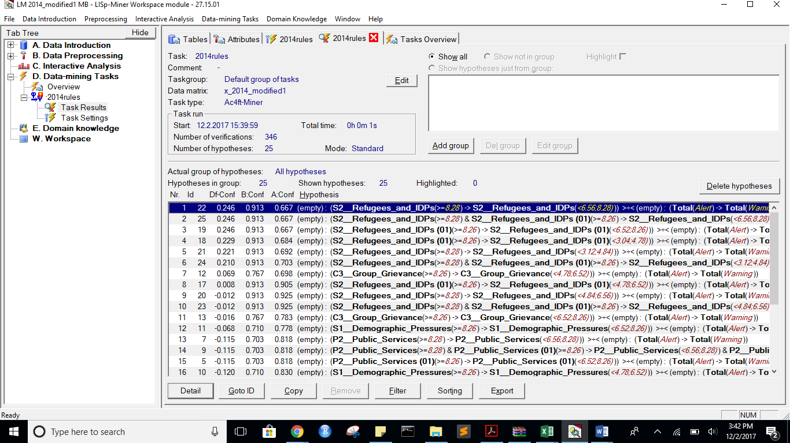

State Before:

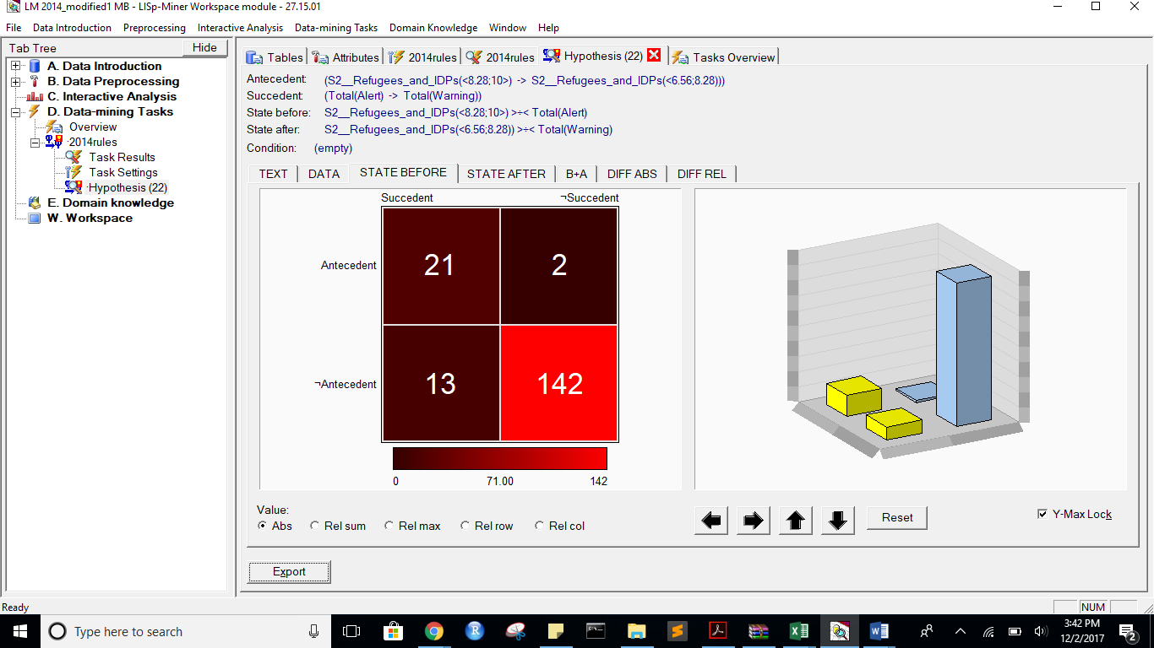

State After:

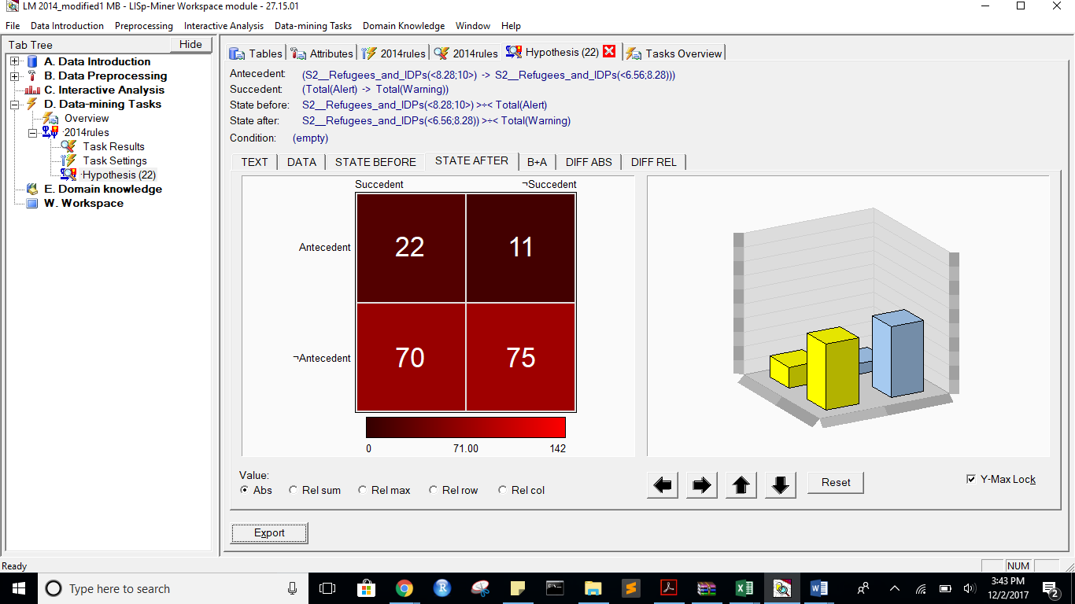

B+A:

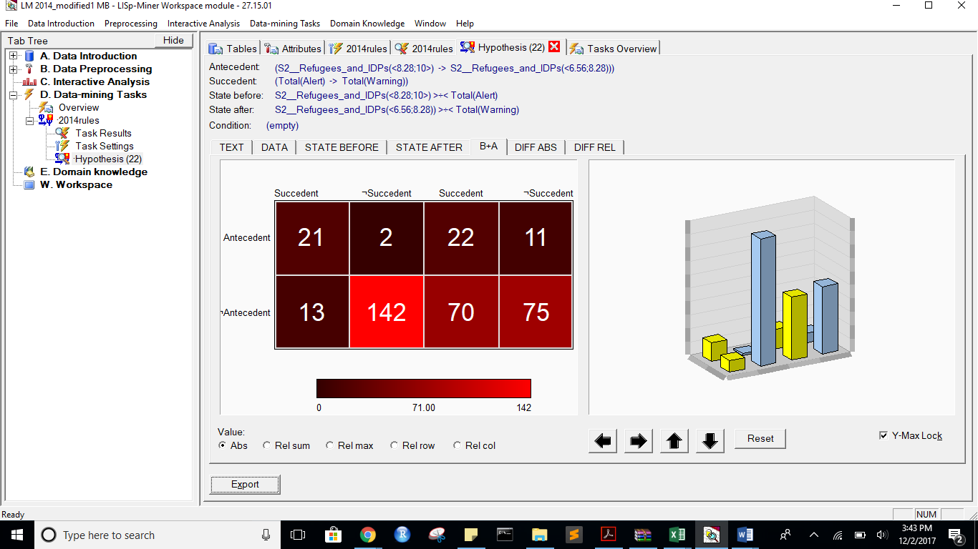

DIFF ABS:

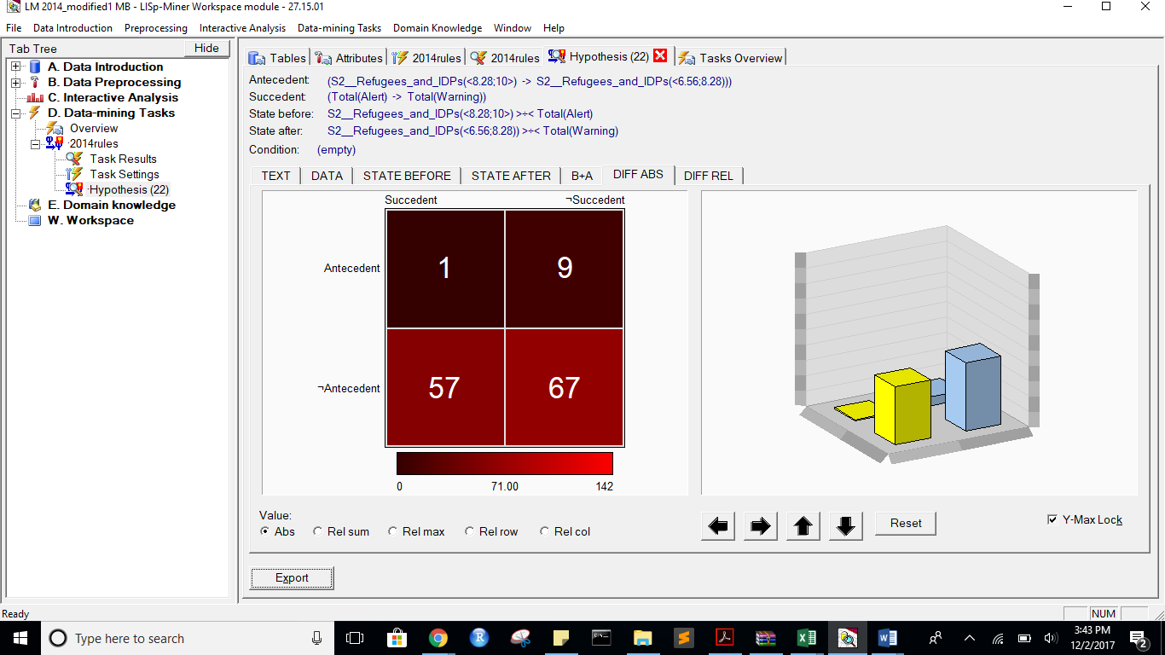

DIFF REL:

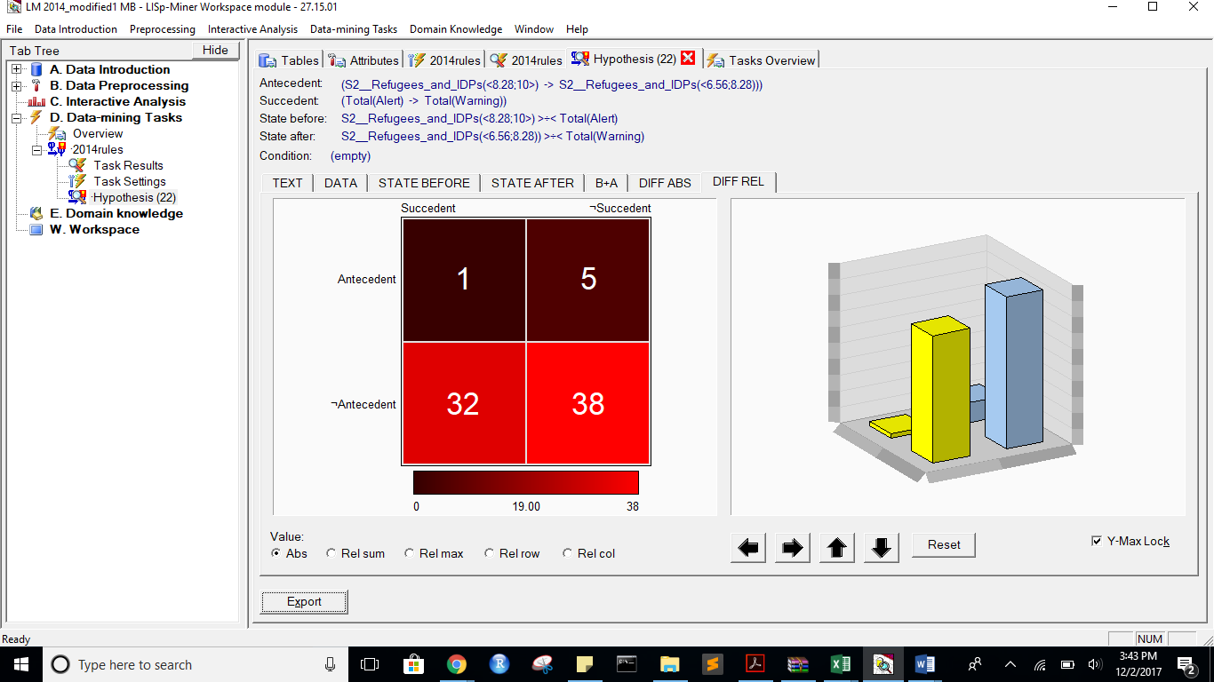

Task name: 2014rules

Task description: -

Date of output: 2.12.2017

Survey of antecedent attributes

Group Name Description

Default Partial Cedent d__Country (subset), 1 - 1 -

Survey of variable antecedent attributes

Group Name Description

Default Partial Cedent P2__Public_Services (subset), 1 - 1 -

Default Partial Cedent X1__External_Intervention (subset), 1 - 1 -

Default Partial Cedent C1__Security_Apparatus (subset), 1 - 1 -

Default Partial Cedent C3__Group_Grievance (subset), 1 - 1 -

Default Partial Cedent E1__Economy (subset), 1 - 1 -

Default Partial Cedent P1__State_Legitimacy (subset), 1 - 1 -

Default Partial Cedent P2__Public_Services#2 (subset), 1 - 1 -

Default Partial Cedent P2__Public_Services (01) (subset), 1 - 1 -

Default Partial Cedent S1__Demographic_Pressures (subset), 1 - 1 -

Default Partial Cedent S2__Refugees_and_IDPs (subset), 1 - 1 -

Default Partial Cedent S2__Refugees_and_IDPs (01) (subset), 1 - 1 -

Default Partial Cedent X1__External_Intervention#2 (subset), 1 - 1 -

Default Partial Cedent X1__External_Intervention (01) (subset), 1 - 1 -

Survey of succedent attributes

Group Name Description

Survey of variable sukcedent attributes

Group Name Description

Default Partial Cedent Total( Alert -> Warning) -

Survey of Action4ft-Quantifiers

a-frequency Before >= 20.00 Absolute number

a-frequency After >= 20.00 Absolute number

Task parameters

The comparison of the first set versus the second set

Sets must differ in all rows (i.e. not overlapping sets)

Nr. Hypothesis D%-Sum Df-Conf Df-AFUI Df-FUE Df-Avg R-Conf R-DFUI R-FUE R-Avg H-Conf H-DFUI H-FUE H-Avg B:a B:b B:c B:d B:r B:n B:Conf B:DConf B:EConf B:Supp B:Cmplt B:AvgDf B:Lift B:LBound B:UBound B:ELBound B:EUBound B:DLBound B:DUBound B:Fisher B:Chi-Sq B:bMean B:bVAR B:bStDev B:P(>=90%) B:P(>=95%) A:a A:b A:c A:d A:r A:n A:Conf A:DConf A:EConf A:Supp A:Cmplt A:AvgDf A:Lift A:LBound A:UBound A:ELBound A:EUBound A:DLBound A:DUBound A:Fisher A:Chi-Sq A:bMean A:bVAR A:bStDev A:P(>=90%) A:P(>=95%)

22 (S2__Refugees_and_IDPs(<8.28;10>) -> S2__Refugees_and_IDPs(<6.56;8.28))) >÷< (Total(Alert) -> Total(Warning)) 0.76 0.2463768116 0.3697411003 0.3707865169 3.4901960784 1.3695652174 2.7310606061 1.6804123711 13.0411764706 1.3695652174 2.7310606061 1.6804123711 13.0411764706 21 2 13 142 23 178 0.9130434783 0.5833333333 0.9157303371 0.1179775281 0.6176470588 3.7800511509 4.7800511509 0.5919567312 0.6848733113 0.2905614278 0.7922119314 0.999999898 0.0000007112 0 89.110302597 0.88 0.88 0.0637302005 0.4357262546 0.1159446076 22 11 70 75 33 178 0.6666666667 0.213592233 0.5449438202 0.1235955056 0.2391304348 0.2898550725 1.2898550725 0.9999529243 0.0002376651 1 0 1 0 0.0423917444 3.6409702126 0.6571428571 0.6571428571 0.0791107035 0.0000661351 0.0000000475

25 (S2__Refugees_and_IDPs(<8.28;10>) & S2__Refugees_and_IDPs (01)(<8.26;10>) -> S2__Refugees_and_IDPs(<6.56;8.28)) & S2__Refugees_and_IDPs (01)(<6.52;8.26))) >÷< (Total(Alert) -> Total(Warning)) 0.76 0.2463768116 0.3697411003 0.3707865169 3.4901960784 1.3695652174 2.7310606061 1.6804123711 13.0411764706 1.3695652174 2.7310606061 1.6804123711 13.0411764706 21 2 13 142 23 178 0.9130434783 0.5833333333 0.9157303371 0.1179775281 0.6176470588 3.7800511509 4.7800511509 0.5919567312 0.6848733113 0.2905614278 0.7922119314 0.999999898 0.0000007112 0 89.110302597 0.88 0.88 0.0637302005 0.4357262546 0.1159446076 22 11 70 75 33 178 0.6666666667 0.213592233 0.5449438202 0.1235955056 0.2391304348 0.2898550725 1.2898550725 0.9999529243 0.0002376651 1 0 1 0 0.0423917444 3.6409702126 0.6571428571 0.6571428571 0.0791107035 0.0000661351 0.0000000475

19 (S2__Refugees_and_IDPs (01)(<8.26;10>) -> S2__Refugees_and_IDPs (01)(<6.52;8.26))) >÷< (Total(Alert) -> Total(Warning)) 0.76 0.2463768116 0.3697411003 0.3707865169 3.4901960784 1.3695652174 2.7310606061 1.6804123711 13.0411764706 1.3695652174 2.7310606061 1.6804123711 13.0411764706 21 2 13 142 23 178 0.9130434783 0.5833333333 0.9157303371 0.1179775281 0.6176470588 3.7800511509 4.7800511509 0.5919567312 0.6848733113 0.2905614278 0.7922119314 0.999999898 0.0000007112 0 89.110302597 0.88 0.88 0.0637302005 0.4357262546 0.1159446076 22 11 70 75 33 178 0.6666666667 0.213592233 0.5449438202 0.1235955056 0.2391304348 0.2898550725 1.2898550725 0.9999529243 0.0002376651 1 0 1 0 0.0423917444 3.6409702126 0.6571428571 0.6571428571 0.0791107035 0.0000661351 0.0000000475

18 (S2__Refugees_and_IDPs (01)(<8.26;10>) -> S2__Refugees_and_IDPs (01)(<3.04;4.78))) >÷< (Total(Alert) -> Total(Warning)) 0.77 0.2288329519 0.3333333333 0.3539325843 3.4562525239 1.3344481605 2.3333333333 1.63 11.6740802328 1.3344481605 2.3333333333 1.63 11.6740802328 21 2 13 142 23 178 0.9130434783 0.5833333333 0.9157303371 0.1179775281 0.6176470588 3.7800511509 4.7800511509 0.5919567312 0.6848733113 0.2905614278 0.7922119314 0.999999898 0.0000007112 0 89.110302597 0.88 0.88 0.0637302005 0.4357262546 0.1159446076 26 12 66 74 38 178 0.6842105263 0.25 0.5617977528 0.1460674157 0.2826086957 0.323798627 1.323798627 0.9999517868 0.0002231454 1 0 1 0 0.0153740798 5.4189475205 0.675 0.675 0.0731478623 0.0000657069 0.0000000289

21 (S2__Refugees_and_IDPs(<8.28;10>) -> S2__Refugees_and_IDPs(<3.12;4.84))) >÷< (Total(Alert) -> Total(Warning)) 0.76 0.220735786 0.3237179487 0.3483146067 3.440586268 1.3188405797 2.2469135802 1.6138613861 11.1353230948 1.3188405797 2.2469135802 1.6138613861 11.1353230948 21 2 13 142 23 178 0.9130434783 0.5833333333 0.9157303371 0.1179775281 0.6176470588 3.7800511509 4.7800511509 0.5919567312 0.6848733113 0.2905614278 0.7922119314 0.999999898 0.0000007112 0 89.110302597 0.88 0.88 0.0637302005 0.4357262546 0.1159446076 27 12 65 74 39 178 0.6923076923 0.2596153846 0.5674157303 0.1516853933 0.2934782609 0.3394648829 1.3394648829 0.9999342936 0.0002931183 1 0 1 0 0.0102030865 6.1567127724 0.6829268293 0.6829268293 0.0718029339 0.0000884483 0.0000000409

24 (S2__Refugees_and_IDPs(<8.28;10>) & S2__Refugees_and_IDPs (01)(<8.26;10>) -> S2__Refugees_and_IDPs(<3.12;4.84)) & S2__Refugees_and_IDPs (01)(<3.04;4.78))) >÷< (Total(Alert) -> Total(Warning)) 0.76 0.2103407756 0.3309061489 0.3483146067 3.4204741826 1.2993311037 2.3108974359 1.6138613861 10.5124951942 1.2993311037 2.3108974359 1.6138613861 10.5124951942 21 2 13 142 23 178 0.9130434783 0.5833333333 0.9157303371 0.1179775281 0.6176470588 3.7800511509 4.7800511509 0.5919567312 0.6848733113 0.2905614278 0.7922119314 0.999999898 0.0000007112 0 89.110302597 0.88 0.88 0.0637302005 0.4357262546 0.1159446076 26 11 66 75 37 178 0.7027027027 0.2524271845 0.5674157303 0.1460674157 0.2826086957 0.3595769683 1.3595769683 0.9998320963 0.0007203211 1 0 1 0 0.0086804754 6.4606426877 0.6923076923 0.6923076923 0.0729756383 0.0002231468 0.0000001944

12 (C3__Group_Grievance(<8.26;10>) -> C3__Group_Grievance(<4.78;6.52))) >÷< (Total(Alert) -> Total(Warning)) 0.76 0.0685534591 0.2183830172 0.297752809 2.6630281973 1.0981981982 1.6374423204 1.4953271028 8.5935236785 1.0981981982 1.6374423204 1.4953271028 8.5935236785 23 7 11 137 30 178 0.7666666667 0.5609756098 0.8988764045 0.1292134831 0.6764705882 3.0137254902 4.0137254902 0.9922163808 0.0258267887 0.5820564983 0.5165374226 0.9999999973 0.0000000207 0 77.3754787876 0.75 0.75 0.0753778361 0.0095879569 0.0001090899 37 16 55 70 53 178 0.6981132075 0.3425925926 0.6011235955 0.2078651685 0.402173913 0.3506972929 1.3506972929 0.9999906973 0.0000394009 1 0 1 0 0.00128844 9.9297899536 0.6909090909 0.6909090909 0.0617532126 0.0000123127 0

17 (S2__Refugees_and_IDPs (01)(<8.26;10>) -> S2__Refugees_and_IDPs (01)(<4.78;6.52))) >÷< (Total(Alert) -> Total(Warning)) 0.68 0.0082815735 0.1875 0.2415730337 3.0295335526 1.0091533181 1.4736842105 1.3583333333 5.0365922921 1.0091533181 1.4736842105 1.3583333333 5.0365922921 21 2 13 142 23 178 0.9130434783 0.5833333333 0.9157303371 0.1179775281 0.6176470588 3.7800511509 4.7800511509 0.5919567312 0.6848733113 0.2905614278 0.7922119314 0.999999898 0.0000007112 0 89.110302597 0.88 0.88 0.0637302005 0.4357262546 0.1159446076 38 4 54 82 42 178 0.9047619048 0.3958333333 0.6741573034 0.2134831461 0.4130434783 0.7505175983 1.7505175983 0.587895933 0.6163539717 1 0 1 0 0.0000000019 33.1239042634 0.8863636364 0.8863636364 0.0473105909 0.4325290412 0.0622586659

20 (S2__Refugees_and_IDPs(<8.28;10>) -> S2__Refugees_and_IDPs(<4.84;6.56))) >÷< (Total(Alert) -> Total(Warning)) 0.67 -0.0119565217 0.1938596491 0.2415730337 2.9903772379 0.9870740306 1.4977477477 1.3583333333 4.7868507348 1.0130952381 1.4977477477 1.3583333333 4.7868507348 21 2 13 142 23 178 0.9130434783 0.5833333333 0.9157303371 0.1179775281 0.6176470588 3.7800511509 4.7800511509 0.5919567312 0.6848733113 0.2905614278 0.7922119314 0.999999898 0.0000007112 0 89.110302597 0.88 0.88 0.0637302005 0.4357262546 0.1159446076 37 3 55 83 40 178 0.925 0.3894736842 0.6741573034 0.2078651685 0.402173913 0.789673913 1.789673913 0.4231306531 0.7771918757 1 0 1 0 0 34.4180186765 0.9047619048 0.9047619048 0.0447649677 0.5969015237 0.147405532

23 (S2__Refugees_and_IDPs(<8.28;10>) & S2__Refugees_and_IDPs (01)(<8.26;10>) -> S2__Refugees_and_IDPs(<4.84;6.56)) & S2__Refugees_and_IDPs (01)(<4.78;6.52))) >÷< (Total(Alert) -> Total(Warning)) 0.67 -0.0119565217 0.1938596491 0.2415730337 2.9903772379 0.9870740306 1.4977477477 1.3583333333 4.7868507348 1.0130952381 1.4977477477 1.3583333333 4.7868507348 21 2 13 142 23 178 0.9130434783 0.5833333333 0.9157303371 0.1179775281 0.6176470588 3.7800511509 4.7800511509 0.5919567312 0.6848733113 0.2905614278 0.7922119314 0.999999898 0.0000007112 0 89.110302597 0.88 0.88 0.0637302005 0.4357262546 0.1159446076 37 3 55 83 40 178 0.925 0.3894736842 0.6741573034 0.2078651685 0.402173913 0.789673913 1.789673913 0.4231306531 0.7771918757 1 0 1 0 0 34.4180186765 0.9047619048 0.9047619048 0.0447649677 0.5969015237 0.147405532

13 (C3__Group_Grievance(<8.26;10>) -> C3__Group_Grievance(<6.52;8.26))) >÷< (Total(Alert) -> Total(Warning)) 0.68 -0.015942029 0.2080344333 0.2696629213 2.4995477964 0.9796296296 1.5894308943 1.4285714286 5.8612528835 1.0207939509 1.5894308943 1.4285714286 5.8612528835 23 7 11 137 30 178 0.7666666667 0.5609756098 0.8988764045 0.1292134831 0.6764705882 3.0137254902 4.0137254902 0.9922163808 0.0258267887 0.5820564983 0.5165374226 0.9999999973 0.0000000207 0 77.3754787876 0.75 0.75 0.0753778361 0.0095879569 0.0001090899 36 10 56 76 46 178 0.7826086957 0.3529411765 0.6292134831 0.202247191 0.3913043478 0.5141776938 1.5141776938 0.9951567967 0.0140265684 1 0 1 0 0.0000202887 17.5436414526 0.7708333333 0.7708333333 0.0600423839 0.0057615614 0.0000158806

11 (S1__Demographic_Pressures(<8.26;10>) -> S1__Demographic_Pressures(<6.52;8.26))) >÷< (Total(Alert) -> Total(Warning)) 0.66 -0.0681003584 0.1684906521 0.2584269663 2.2105391011 0.9124423963 1.4910299003 1.4144144144 5.3787712338 1.095959596 1.4910299003 1.4144144144 5.3787712338 22 9 12 135 31 178 0.7096774194 0.511627907 0.8820224719 0.1235955056 0.6470588235 2.715370019 3.715370019 0.9993890975 0.002596208 0.823920076 0.2442029471 1 0 0 65.3489815281 0.696969697 0.696969697 0.0788152976 0.0008094365 0.0000022743 35 10 57 76 45 178 0.7777777778 0.3431372549 0.6235955056 0.1966292135 0.3804347826 0.5048309179 1.5048309179 0.9959553502 0.0120301847 1 0 1 0 0.000037437 16.4195836744 0.7659574468 0.7659574468 0.0611123686 0.004843222 0.0000127401

7 (P2__Public_Services(<8.28;10>) -> P2__Public_Services(<6.56;8.28))) >÷< (Total(Alert) -> Total(Warning)) 0.66 -0.1154791155 0.3022675737 0.2921348315 2.0958513733 0.8588588589 2.0971193416 1.4859813084 4.5949179489 1.1643356643 2.0971193416 1.4859813084 4.5949179489 26 11 8 133 37 178 0.7027027027 0.5777777778 0.893258427 0.1460674157 0.7647058824 2.6788553259 3.6788553259 0.9998320963 0.0007203211 0.6743081202 0.4179435017 0.9999999974 0.0000000184 0 79.1439202031 0.6923076923 0.6923076923 0.0729756383 0.0002231468 0.0000001944 27 6 65 80 33 178 0.8181818182 0.2755102041 0.6011235955 0.1516853933 0.2934782609 0.5830039526 1.5830039526 0.9582961522 0.1061086358 1 0 1 0 0.0000874045 14.7298496629 0.8 0.8 0.0666666667 0.0481443814 0.0012716835

9 (P2__Public_Services(<8.28;10>) & P2__Public_Services (01)(<8.26;10>) -> P2__Public_Services(<6.56;8.28)) & P2__Public_Services (01)(<6.52;8.26))) >÷< (Total(Alert) -> Total(Warning)) 0.66 -0.1154791155 0.3022675737 0.2921348315 2.0958513733 0.8588588589 2.0971193416 1.4859813084 4.5949179489 1.1643356643 2.0971193416 1.4859813084 4.5949179489 26 11 8 133 37 178 0.7027027027 0.5777777778 0.893258427 0.1460674157 0.7647058824 2.6788553259 3.6788553259 0.9998320963 0.0007203211 0.6743081202 0.4179435017 0.9999999974 0.0000000184 0 79.1439202031 0.6923076923 0.6923076923 0.0729756383 0.0002231468 0.0000001944 27 6 65 80 33 178 0.8181818182 0.2755102041 0.6011235955 0.1516853933 0.2934782609 0.5830039526 1.5830039526 0.9582961522 0.1061086358 1 0 1 0 0.0000874045 14.7298496629 0.8 0.8 0.0666666667 0.0481443814 0.0012716835

5 (P2__Public_Services (01)(<8.26;10>) -> P2__Public_Services (01)(<6.52;8.26))) >÷< (Total(Alert) -> Total(Warning)) 0.66 -0.1154791155 0.3022675737 0.2921348315 2.0958513733 0.8588588589 2.0971193416 1.4859813084 4.5949179489 1.1643356643 2.0971193416 1.4859813084 4.5949179489 26 11 8 133 37 178 0.7027027027 0.5777777778 0.893258427 0.1460674157 0.7647058824 2.6788553259 3.6788553259 0.9998320963 0.0007203211 0.6743081202 0.4179435017 0.9999999974 0.0000000184 0 79.1439202031 0.6923076923 0.6923076923 0.0729756383 0.0002231468 0.0000001944 27 6 65 80 33 178 0.8181818182 0.2755102041 0.6011235955 0.1516853933 0.2934782609 0.5830039526 1.5830039526 0.9582961522 0.1061086358 1 0 1 0 0.0000874045 14.7298496629 0.8 0.8 0.0666666667 0.0481443814 0.0012716835

10 (S1__Demographic_Pressures(<8.26;10>) -> S1__Demographic_Pressures(<4.78;6.52))) >÷< (Total(Alert) -> Total(Warning)) 0.66 -0.1201098147 0.121627907 0.2247191011 2.1099121096 0.8552522746 1.3118664281 1.3418803419 4.4848204591 1.169245648 1.3118664281 1.3418803419 4.4848204591 22 9 12 135 31 178 0.7096774194 0.511627907 0.8820224719 0.1235955056 0.6470588235 2.715370019 3.715370019 0.9993890975 0.002596208 0.823920076 0.2442029471 1 0 0 65.3489815281 0.696969697 0.696969697 0.0788152976 0.0008094365 0.0000022743 39 8 53 78 47 178 0.829787234 0.39 0.6573033708 0.2191011236 0.4239130435 0.6054579093 1.6054579093 0.9588740136 0.09276998 1 0 1 0 0.000000306 25.0440091945 0.8163265306 0.8163265306 0.0547608484 0.0462904616 0.0005537361

16 (P2__Public_Services(<8.28;10>) & P2__Public_Services (01)(<8.26;10>) & S1__Demographic_Pressures(<8.26;10>) -> P2__Public_Services(<4.84;6.56)) & P2__Public_Services (01)(<4.78;6.52)) & S1__Demographic_Pressures(<4.78;6.52))) >÷< (Total(Alert) -> Total(Warning)) 0.66 -0.1236263736 0.2368421053 0.2808988764 2.2996648492 0.8615384615 1.9 1.462962963 4.1611188109 1.1607142857 1.9 1.462962963 4.1611188109 20 6 14 138 26 178 0.7692307692 0.5 0.8876404494 0.1123595506 0.5882352941 3.0271493213 4.0271493213 0.9881312809 0.0398593123 0.7557970529 0.3256918798 1 0 0 65.877009407 0.75 0.75 0.0804084401 0.0146678022 0.0002854441 25 3 67 83 28 178 0.8928571429 0.2631578947 0.606741573 0.1404494382 0.2717391304 0.727484472 1.727484472 0.6945663031 0.5406170777 1 0 1 0 0.0000068992 18.811507776 0.8666666667 0.8666666667 0.0610540627 0.3289520476 0.0547534443

15 (P2__Public_Services(<8.28;10>) & S1__Demographic_Pressures(<8.26;10>) -> P2__Public_Services(<4.84;6.56)) & S1__Demographic_Pressures(<4.78;6.52))) >÷< (Total(Alert) -> Total(Warning)) 0.66 -0.1236263736 0.2368421053 0.2808988764 2.2996648492 0.8615384615 1.9 1.462962963 4.1611188109 1.1607142857 1.9 1.462962963 4.1611188109 20 6 14 138 26 178 0.7692307692 0.5 0.8876404494 0.1123595506 0.5882352941 3.0271493213 4.0271493213 0.9881312809 0.0398593123 0.7557970529 0.3256918798 1 0 0 65.877009407 0.75 0.75 0.0804084401 0.0146678022 0.0002854441 25 3 67 83 28 178 0.8928571429 0.2631578947 0.606741573 0.1404494382 0.2717391304 0.727484472 1.727484472 0.6945663031 0.5406170777 1 0 1 0 0.0000068992 18.811507776 0.8666666667 0.8666666667 0.0610540627 0.3289520476 0.0547534443

14 (P2__Public_Services (01)(<8.26;10>) & S1__Demographic_Pressures(<8.26;10>) -> P2__Public_Services (01)(<4.78;6.52)) & S1__Demographic_Pressures(<4.78;6.52))) >÷< (Total(Alert) -> Total(Warning)) 0.65 -0.1339950372 0.2052631579 0.2640449438 2.2796037392 0.8516483516 1.6964285714 1.4234234234 4.0494511558 1.1741935484 1.6964285714 1.4234234234 4.0494511558 20 6 14 138 26 178 0.7692307692 0.5 0.8876404494 0.1123595506 0.5882352941 3.0271493213 4.0271493213 0.9881312809 0.0398593123 0.7557970529 0.3256918798 1 0 0 65.877009407 0.75 0.75 0.0804084401 0.0146678022 0.0002854441 28 3 64 83 31 178 0.9032258065 0.2947368421 0.6235955056 0.1573033708 0.3043478261 0.747545582 1.747545582 0.6238303786 0.6114143825 1 0 1 0 0.0000008116 22.4403225917 0.8787878788 0.8787878788 0.0559726149 0.3996940906 0.0738055188

3 (P1__State_Legitimacy(<8.26;10>) -> P1__State_Legitimacy(<4.78;6.52))) >÷< (Total(Alert) -> Total(Warning)) 0.65 -0.1596153846 0.1828652253 0.2528089888 1.7222629353 0.794044665 1.5957867018 1.4166666667 4.4482739945 1.259375 1.5957867018 1.4166666667 4.4482739945 24 15 10 129 39 178 0.6153846154 0.4897959184 0.8595505618 0.1348314607 0.7058823529 2.221719457 3.221719457 0.9999996078 0.0000023976 0.9678509945 0.0521429636 1 0 0 58.2055866619 0.6097560976 0.6097560976 0.0752699268 0.0000005928 0 31 9 61 77 40 178 0.775 0.3069306931 0.606741573 0.1741573034 0.3369565217 0.4994565217 1.4994565217 0.9949369463 0.0154953054 1 0 1 0 0.0001572359 13.7684692853 0.7619047619 0.7619047619 0.0649518419 0.0061062986 0.0000261284

2 (P1__State_Legitimacy(<8.26;10>) -> P1__State_Legitimacy(<6.52;8.26))) >÷< (Total(Alert) -> Total(Warning)) 0.64 -0.1846153846 0.0626114523 0.191011236 1.6738933701 0.7692307692 1.146567718 1.2857142857 4.0555196438 1.3 1.146567718 1.2857142857 4.0555196438 24 15 10 129 39 178 0.6153846154 0.4897959184 0.8595505618 0.1348314607 0.7058823529 2.221719457 3.221719457 0.9999996078 0.0000023976 0.9678509945 0.0521429636 1 0 0 58.2055866619 0.6097560976 0.6097560976 0.0752699268 0.0000005928 0 44 11 48 75 55 178 0.8 0.427184466 0.6685393258 0.2471910112 0.4782608696 0.547826087 1.547826087 0.9927150888 0.0188885997 1 0 1 0 0.0000002685 25.553616612 0.7894736842 0.7894736842 0.0535313292 0.0084453131 0.0000172924

4 (P2__Public_Services (01)(<8.26;10>) -> P2__Public_Services (01)(<4.78;6.52))) >÷< (Total(Alert) -> Total(Warning)) 0.65 -0.1909143186 0.1447880871 0.202247191 1.9499006543 0.7863577864 1.3343915344 1.2926829268 3.6749271666 1.271685761 1.3343915344 1.2926829268 3.6749271666 26 11 8 133 37 178 0.7027027027 0.5777777778 0.893258427 0.1460674157 0.7647058824 2.6788553259 3.6788553259 0.9998320963 0.0007203211 0.6743081202 0.4179435017 0.9999999974 0.0000000184 0 79.1439202031 0.6923076923 0.6923076923 0.0729756383 0.0002231468 0.0000001944 42 5 50 81 47 178 0.8936170213 0.4329896907 0.691011236 0.2359550562 0.4565217391 0.7289546716 1.7289546716 0.6714311029 0.5122199768 1 0 1 0 0 36.302537922 0.8775510204 0.8775510204 0.0463584355 0.3469340296 0.0317095154

6 (P2__Public_Services(<8.28;10>) -> P2__Public_Services(<4.84;6.56))) >÷< (Total(Alert) -> Total(Warning)) 0.66 -0.2020592021 0.1819444444 0.2191011236 1.9283377276 0.7766714083 1.4596491228 1.325 3.569343786 1.2875457875 1.4596491228 1.325 3.569343786 26 11 8 133 37 178 0.7027027027 0.5777777778 0.893258427 0.1460674157 0.7647058824 2.6788553259 3.6788553259 0.9998320963 0.0007203211 0.6743081202 0.4179435017 0.9999999974 0.0000000184 0 79.1439202031 0.6923076923 0.6923076923 0.0729756383 0.0002231468 0.0000001944 38 4 54 82 42 178 0.9047619048 0.3958333333 0.6741573034 0.2134831461 0.4130434783 0.7505175983 1.7505175983 0.587895933 0.6163539717 1 0 1 0 0.0000000019 33.1239042634 0.8863636364 0.8863636364 0.0473105909 0.4325290412 0.0622586659

8 (P2__Public_Services(<8.28;10>) & P2__Public_Services (01)(<8.26;10>) -> P2__Public_Services(<4.84;6.56)) & P2__Public_Services (01)(<4.78;6.52))) >÷< (Total(Alert) -> Total(Warning)) 0.66 -0.2020592021 0.1819444444 0.2191011236 1.9283377276 0.7766714083 1.4596491228 1.325 3.569343786 1.2875457875 1.4596491228 1.325 3.569343786 26 11 8 133 37 178 0.7027027027 0.5777777778 0.893258427 0.1460674157 0.7647058824 2.6788553259 3.6788553259 0.9998320963 0.0007203211 0.6743081202 0.4179435017 0.9999999974 0.0000000184 0 79.1439202031 0.6923076923 0.6923076923 0.0729756383 0.0002231468 0.0000001944 38 4 54 82 42 178 0.9047619048 0.3958333333 0.6741573034 0.2134831461 0.4130434783 0.7505175983 1.7505175983 0.587895933 0.6163539717 1 0 1 0 0.0000000019 33.1239042634 0.8863636364 0.8863636364 0.0473105909 0.4325290412 0.0622586659

1 (E1__Economy(<6.52;8.26)) -> E1__Economy(<4.78;6.52))) >÷< (Total(Alert) -> Total(Warning)) 0.65 -0.306332369 -0.0674603175 0.1235955056 0.8310635226 0.5847494553 0.8380952381 1.1913043478 2.9449243074 1.7101341282 1.1931818182 1.1913043478 2.9449243074 22 29 12 115 51 178 0.431372549 0.3492063492 0.7696629213 0.1235955056 0.6470588235 1.2583621684 2.2583621684 1 0 0.999999889 0.0000003112 1 0 0.0000010109 26.7247830685 0.4339622642 0.4339622642 0.0674453163 0 0 45 16 47 70 61 178 0.737704918 0.4166666667 0.6460674157 0.2528089888 0.4891304348 0.4272986458 1.4272986458 0.9999291899 0.0002478154 1 0 1 0 0.0000161675 18.1266013864 0.7301587302 0.7301587302 0.0554846486 0.0000885117 0.0000000065

*** End of list ***