Alert to Stable :

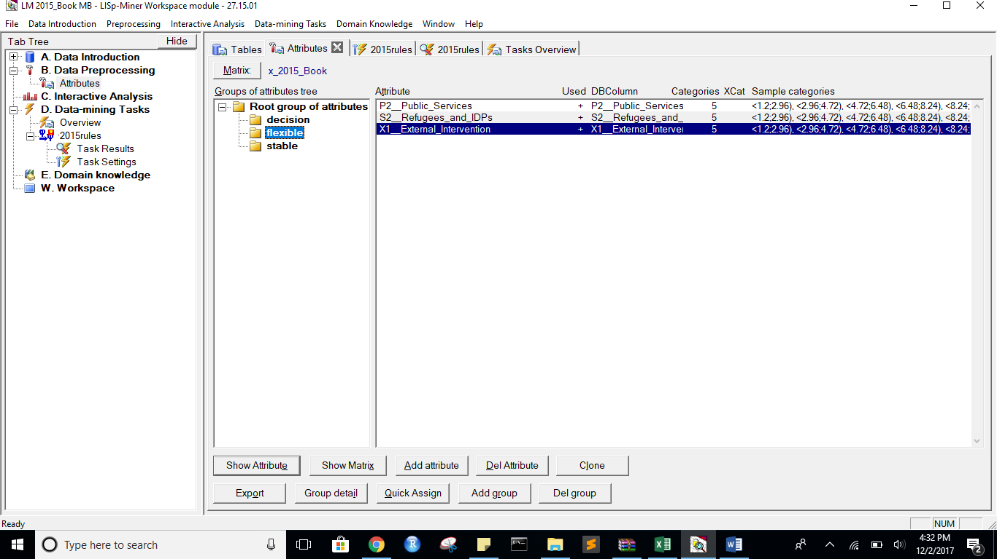

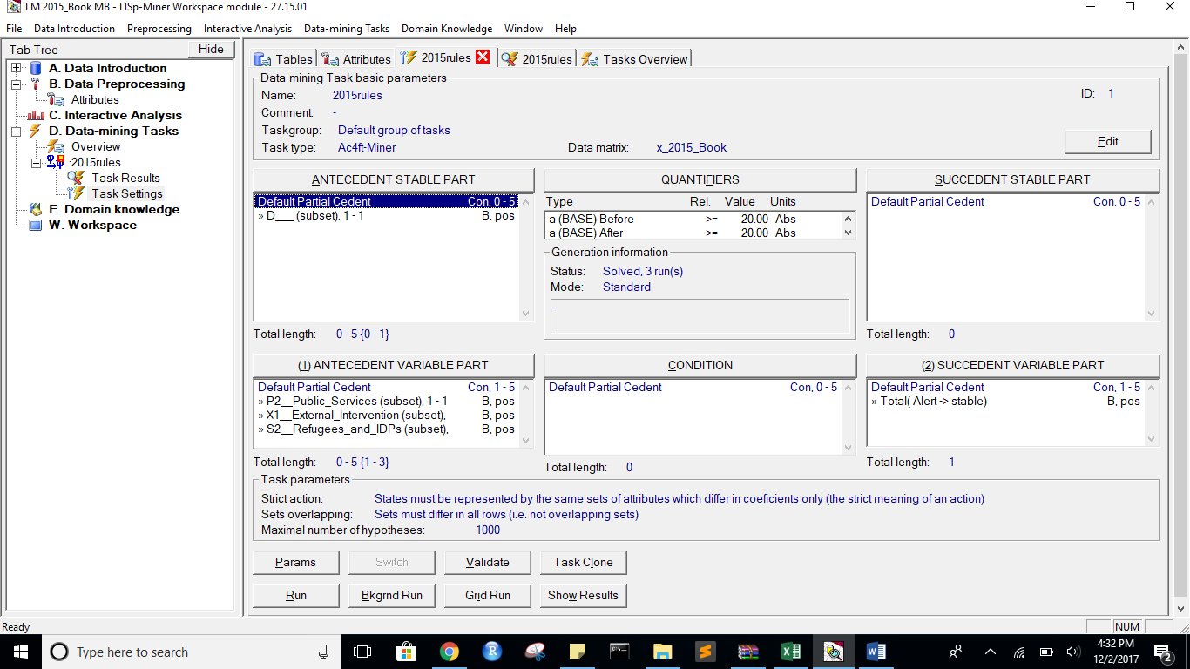

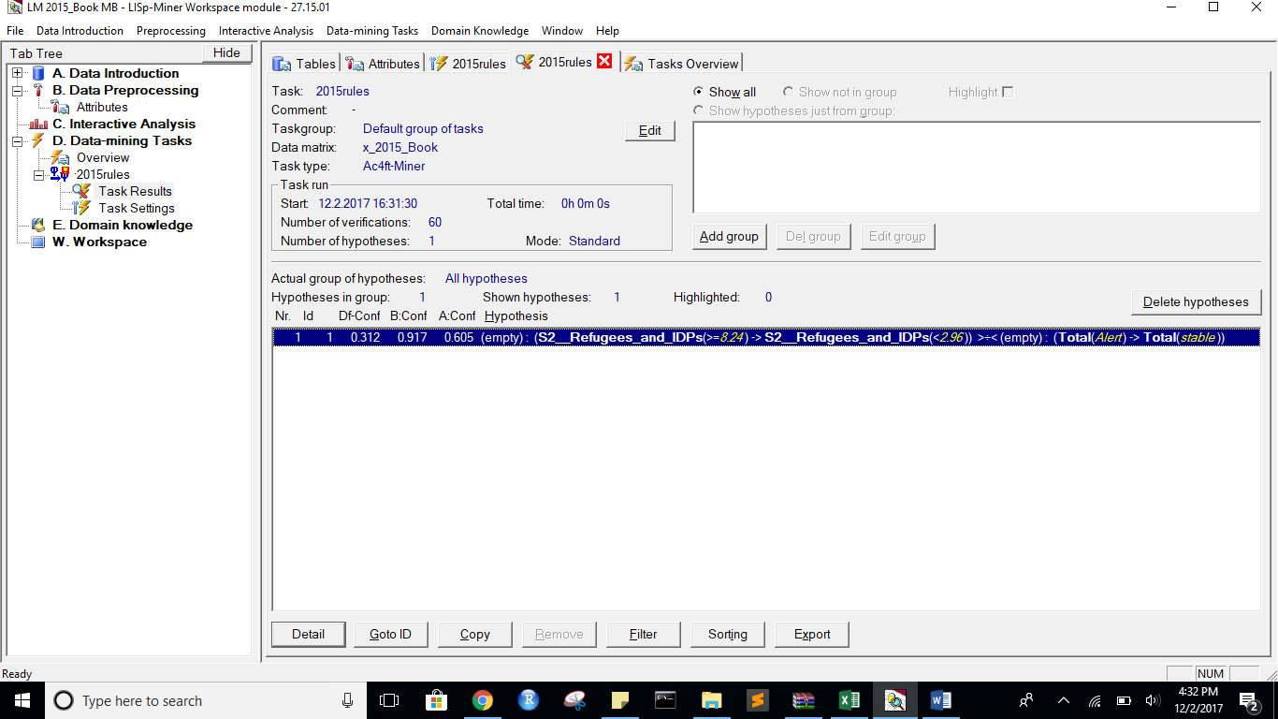

State Before:

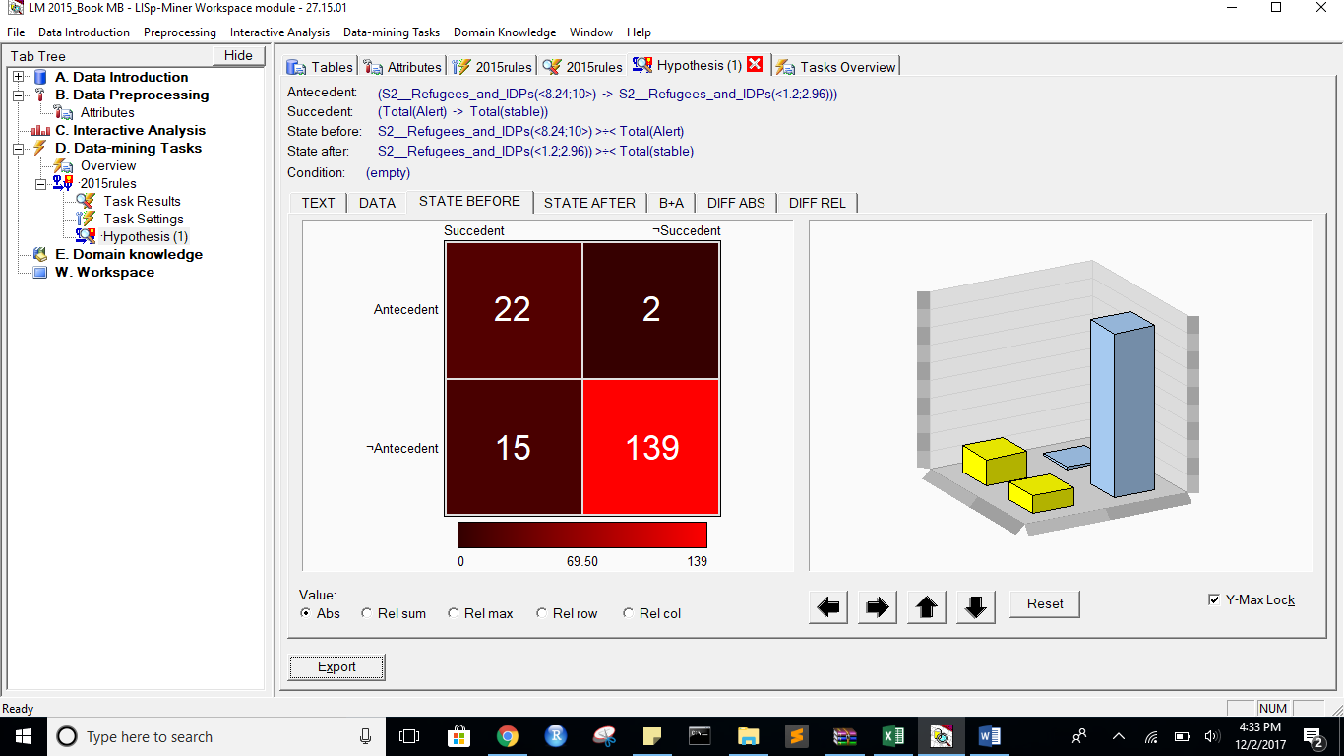

StateAfter:

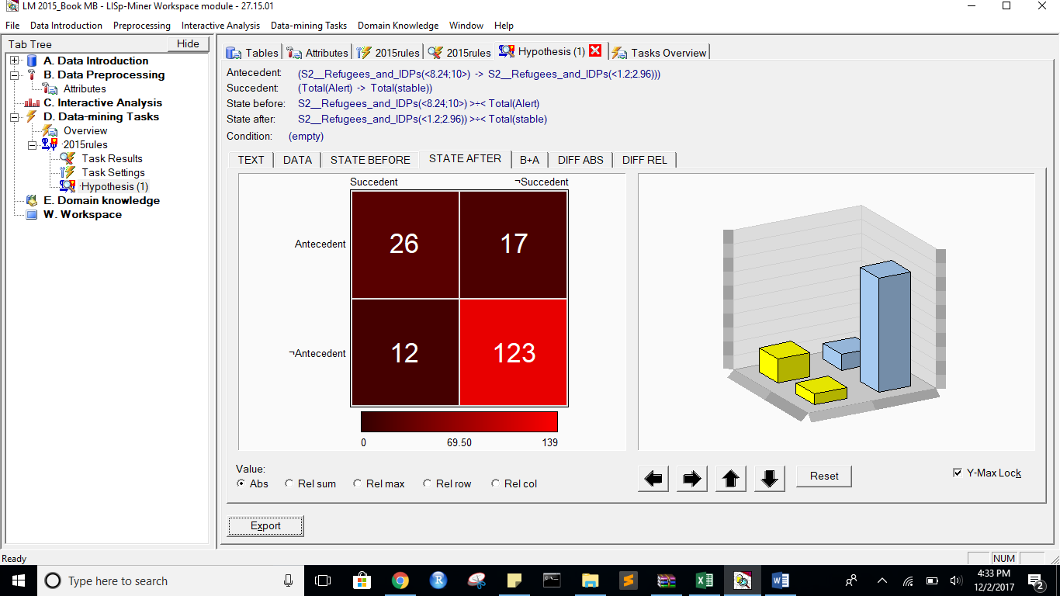

B+A:

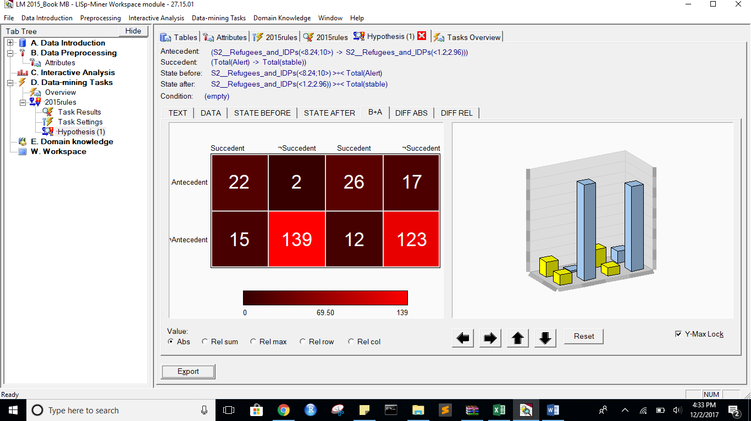

DIFF ABS:

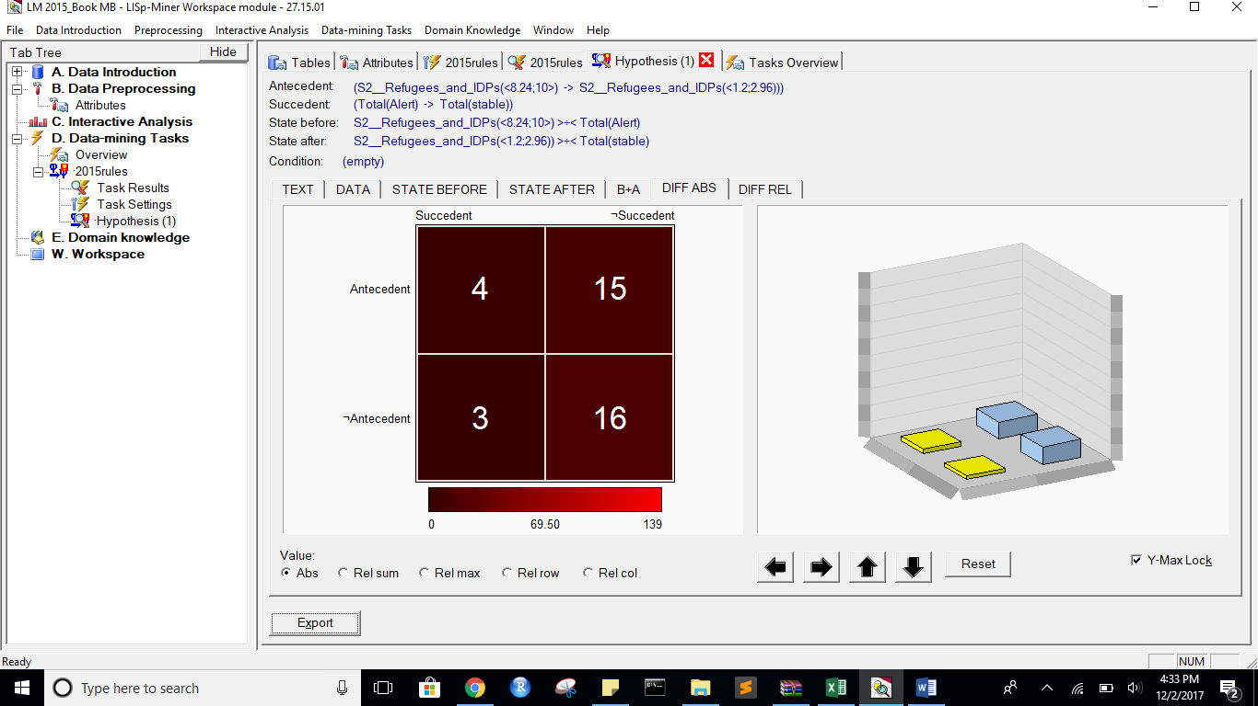

DIFF REL:

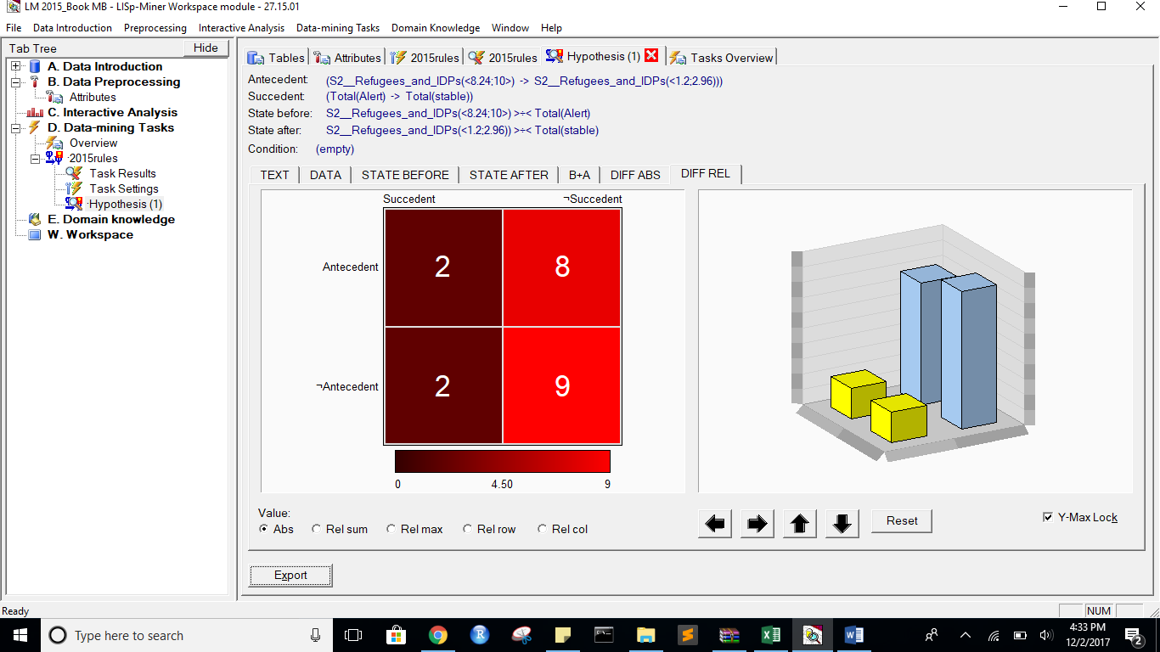

Task name: 2015rules

Task description: -

Date of output: 2.12.2017

Survey of antecedent attributes

Group Name Description

Default Partial Cedent D___ (subset), 1 - 1 -

Survey of variable antecedent attributes

Group Name Description

Default Partial Cedent P2__Public_Services (subset), 1 - 1 -

Default Partial Cedent X1__External_Intervention (subset), 1 - 1 -

Default Partial Cedent S2__Refugees_and_IDPs (subset), 1 - 1 -

Survey of succedent attributes

Group Name Description

Survey of variable sukcedent attributes

Group Name Description

Default Partial Cedent Total( Alert -> stable) -

Survey of Action4ft-Quantifiers

a-frequency Before >= 20.00 Absolute number

a-frequency After >= 20.00 Absolute number

Task parameters

The comparison of the first set versus the second set

Sets must differ in all rows (i.e. not overlapping sets)

Nr. Hypothesis D%-Sum Df-Conf Df-AFUI Df-FUE Df-Avg R-Conf R-DFUI R-FUE R-Avg H-Conf H-DFUI H-FUE H-Avg B:a B:b B:c B:d B:r B:n B:Conf B:DConf B:EConf B:Supp B:Cmplt B:AvgDf B:Lift B:LBound B:UBound B:ELBound B:EUBound B:DLBound B:DUBound B:Fisher B:Chi-Sq B:bMean B:bVAR B:bStDev B:P(>=90%) B:P(>=95%) A:a A:b A:c A:d A:r A:n A:Conf A:DConf A:EConf A:Supp A:Cmplt A:AvgDf A:Lift A:LBound A:UBound A:ELBound A:EUBound A:DLBound A:DUBound A:Fisher A:Chi-Sq A:bMean A:bVAR A:bStDev A:P(>=90%) A:P(>=95%)

1 (S2__Refugees_and_IDPs(<8.24;10>) -> S2__Refugees_and_IDPs(<1.2;2.96))) >÷< (Total(Alert) -> Total(stable)) 0.21 0.3120155039 0.0913752914 0.0674157303 1.5775965684 1.516025641 1.1932938856 1.0805369128 1.8609862367 1.516025641 1.1932938856 1.0805369128 1.8609862367 22 2 15 139 24 178 0.9166666667 0.5641025641 0.904494382 0.1235955056 0.5945945946 3.4099099099 4.4099099099 0.564273727 0.7075230421 0.4834625774 0.6157437281 0.9999999922 0.000000058 0 84.6406411938 0.8846153846 0.8846153846 0.0614850195 0.4629059248 0.1271065152 26 17 12 123 43 178 0.6046511628 0.4727272727 0.8370786517 0.1460674157 0.6842105263 1.8323133415 2.8323133415 0.999999949 0.0000003231 0.9968172494 0.0059987906 1 0 0 51.6665827359 0.6 0.6 0.0722315119 0.0000000782 0

*** End of list ***

Alert to Warning with same flexible attributes as above:

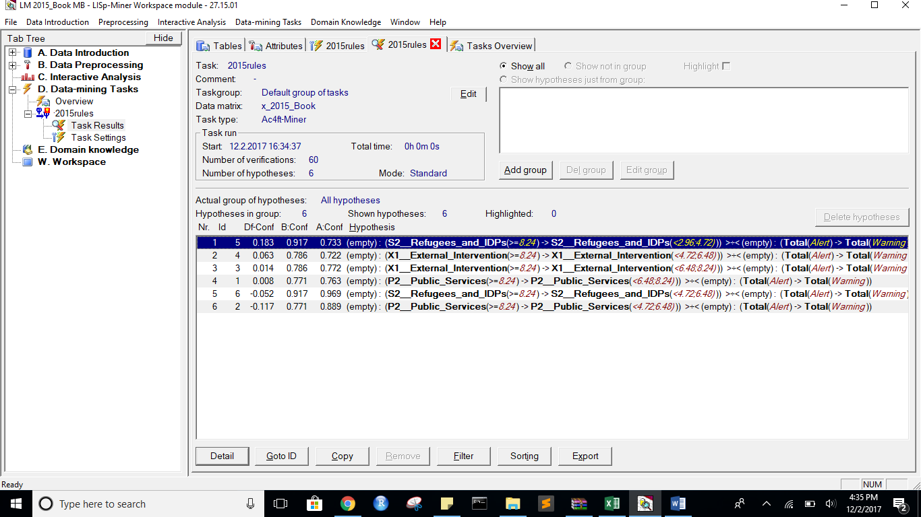

State befpre:

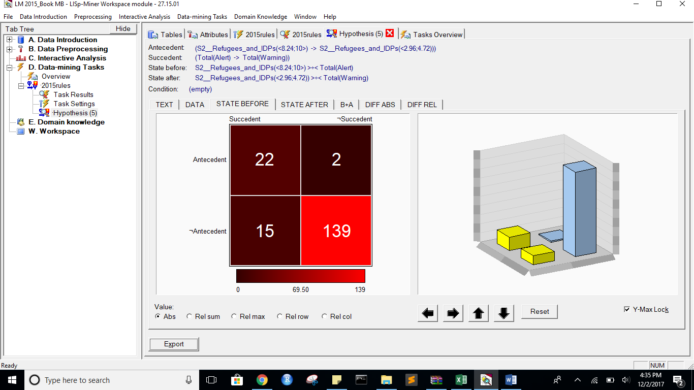

StateAfter:

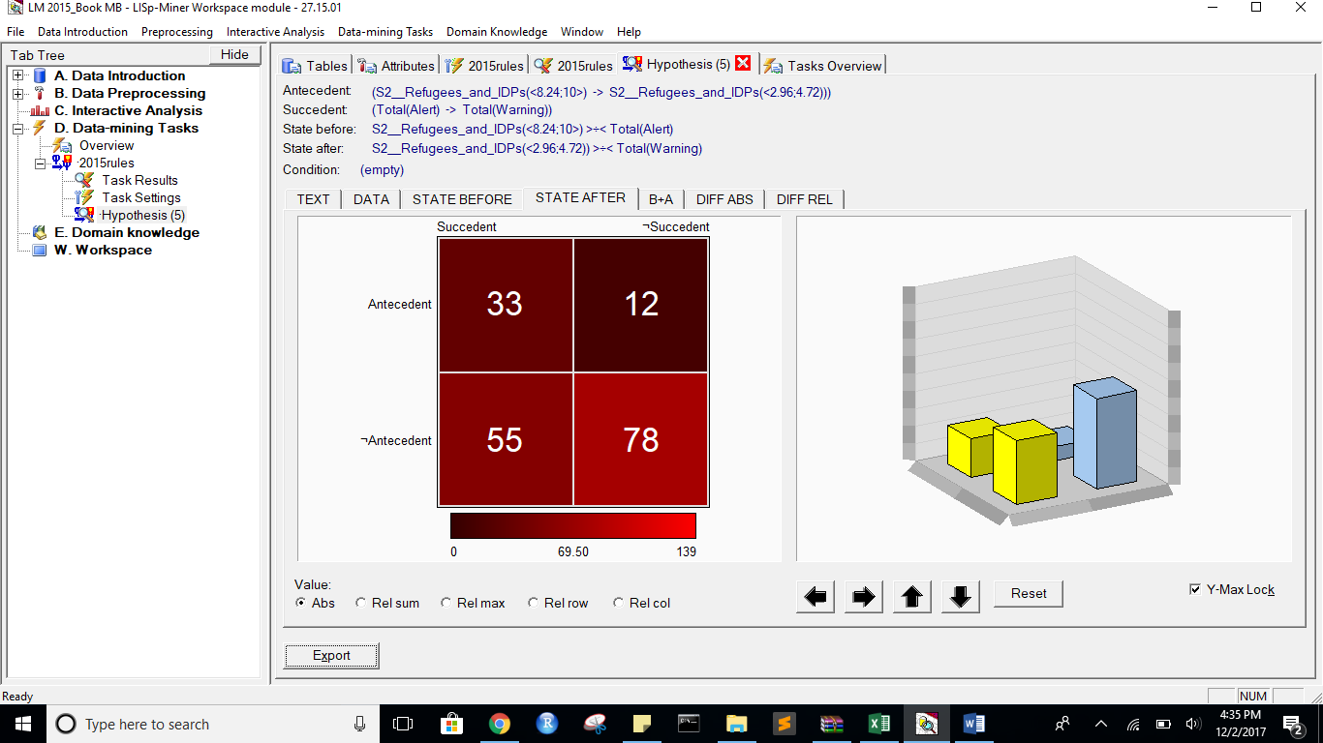

B+A:

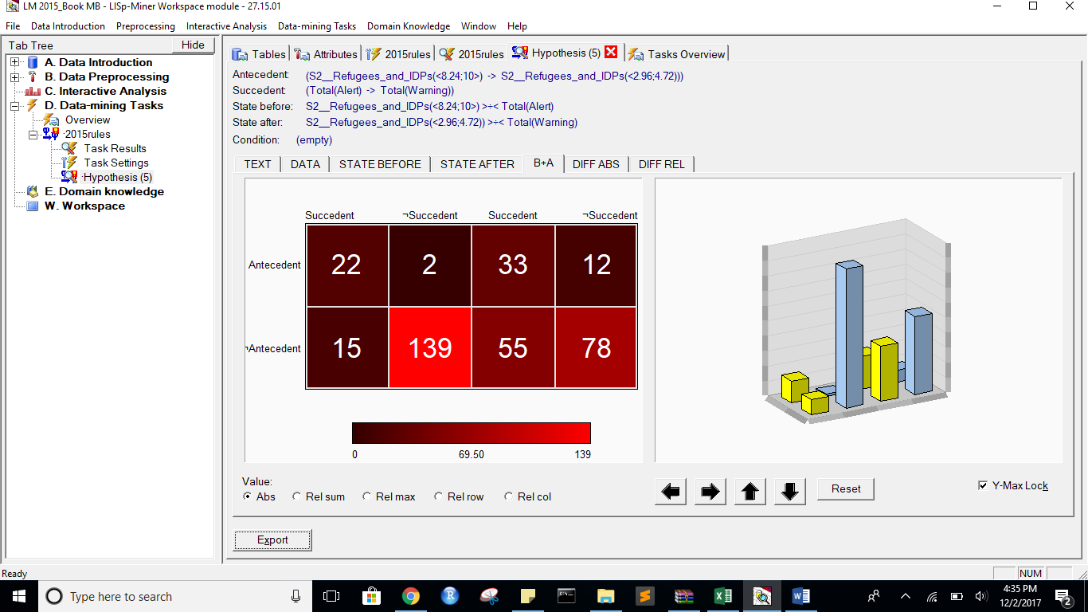

DIFF ABS:

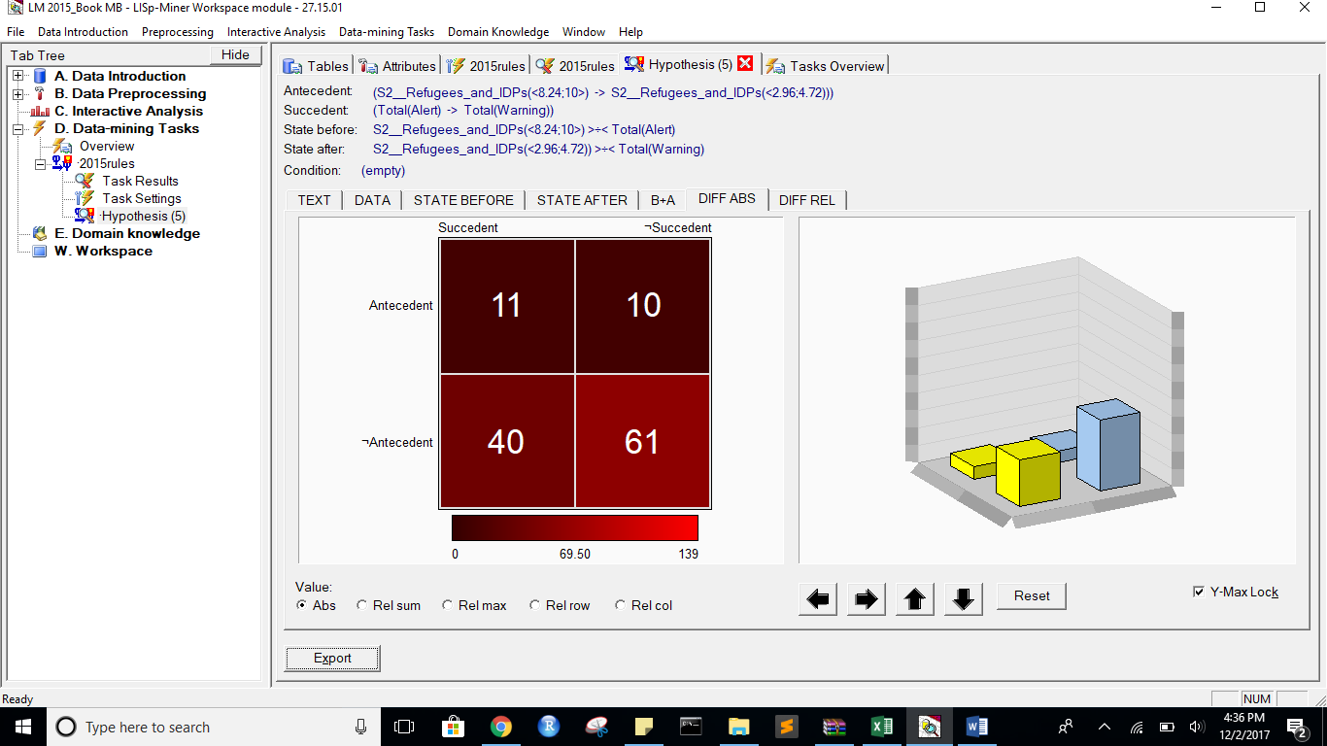

DIFF REL:

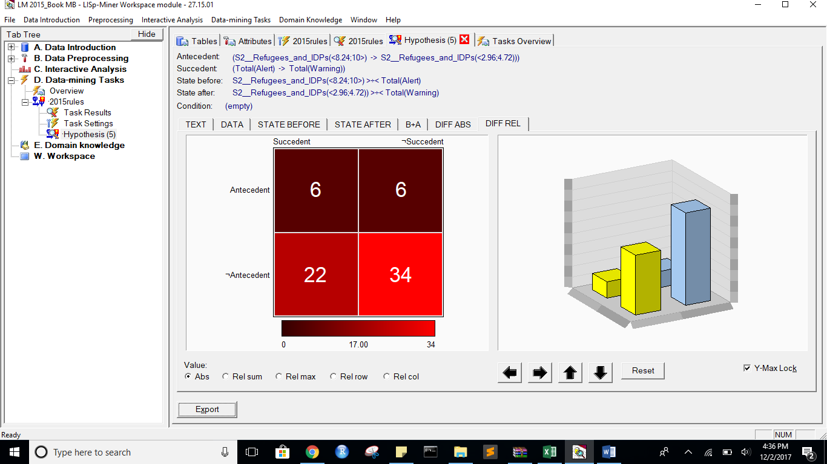

Task name: 2015rules

Task description: -

Date of output: 2.12.2017

Survey of antecedent attributes

Group Name Description

Default Partial Cedent D___ (subset), 1 - 1 -

Survey of variable antecedent attributes

Group Name Description

Default Partial Cedent P2__Public_Services (subset), 1 - 1 -

Default Partial Cedent X1__External_Intervention (subset), 1 - 1 -

Default Partial Cedent S2__Refugees_and_IDPs (subset), 1 - 1 -

Survey of succedent attributes

Group Name Description

Survey of variable sukcedent attributes

Group Name Description

Default Partial Cedent Total( Alert -> Warning) -

Survey of Action4ft-Quantifiers

a-frequency Before >= 20.00 Absolute number

a-frequency After >= 20.00 Absolute number

Task parameters

The comparison of the first set versus the second set

Sets must differ in all rows (i.e. not overlapping sets)

Nr. Hypothesis D%-Sum Df-Conf Df-AFUI Df-FUE Df-Avg R-Conf R-DFUI R-FUE R-Avg H-Conf H-DFUI H-FUE H-Avg B:a B:b B:c B:d B:r B:n B:Conf B:DConf B:EConf B:Supp B:Cmplt B:AvgDf B:Lift B:LBound B:UBound B:ELBound B:EUBound B:DLBound B:DUBound B:Fisher B:Chi-Sq B:bMean B:bVAR B:bStDev B:P(>=90%) B:P(>=95%) A:a A:b A:c A:d A:r A:n A:Conf A:DConf A:EConf A:Supp A:Cmplt A:AvgDf A:Lift A:LBound A:UBound A:ELBound A:EUBound A:DLBound A:DUBound A:Fisher A:Chi-Sq A:bMean A:bVAR A:bStDev A:P(>=90%) A:P(>=95%)

5 (S2__Refugees_and_IDPs(<8.24;10>) -> S2__Refugees_and_IDPs(<2.96;4.72))) >÷< (Total(Alert) -> Total(Warning)) 0.68 0.1833333333 0.2341025641 0.2808988764 2.9265765766 1.25 1.7094017094 1.4504504505 7.0549860205 1.25 1.7094017094 1.4504504505 7.0549860205 22 2 15 139 24 178 0.9166666667 0.5641025641 0.904494382 0.1235955056 0.5945945946 3.4099099099 4.4099099099 0.564273727 0.7075230421 0.4834625774 0.6157437281 0.9999999922 0.000000058 0 84.6406411938 0.8846153846 0.8846153846 0.0614850195 0.4629059248 0.1271065152 33 12 55 78 45 178 0.7333333333 0.33 0.6235955056 0.1853932584 0.375 0.4833333333 1.4833333333 0.9996672945 0.0012214809 1 0 1 0 0.0001721149 13.7567084378 0.7234042553 0.7234042553 0.0645643314 0.0004215859 0.0000002605

4 (X1__External_Intervention(<8.24;10>) -> X1__External_Intervention(<4.72;6.48))) >÷< (Total(Alert) -> Total(Warning)) 0.61 0.0634920635 0.2463217845 0.2865168539 2.3190641941 1.0879120879 1.9284436494 1.4811320755 6.0320516211 1.0879120879 1.9284436494 1.4811320755 6.0320516211 22 6 15 135 28 178 0.7857142857 0.511627907 0.8820224719 0.1235955056 0.5945945946 2.7799227799 3.7799227799 0.9820933101 0.0550069489 0.823920076 0.2442029471 1 0 0 67.3805964019 0.7666666667 0.7666666667 0.0759645267 0.0216167477 0.0004594271 26 10 62 80 36 178 0.7222222222 0.2653061224 0.595505618 0.1460674157 0.2954545455 0.4608585859 1.4608585859 0.9994439111 0.002198411 1 0 1 0 0.001838297 9.3715124642 0.7105263158 0.7105263158 0.0726210167 0.0007203247 0.0000012395

3 (X1__External_Intervention(<8.24;10>) -> X1__External_Intervention(<6.48;8.24))) >÷< (Total(Alert) -> Total(Warning)) 0.65 0.0137844612 0.0759843426 0.202247191 2.2185192712 1.0178571429 1.1744186047 1.2975206612 4.9517374517 1.0178571429 1.1744186047 1.2975206612 4.9517374517 22 6 15 135 28 178 0.7857142857 0.511627907 0.8820224719 0.1235955056 0.5945945946 2.7799227799 3.7799227799 0.9820933101 0.0550069489 0.823920076 0.2442029471 1 0 0 67.3805964019 0.7666666667 0.7666666667 0.0759645267 0.0216167477 0.0004594271 44 13 44 77 57 178 0.7719298246 0.4356435644 0.6797752809 0.2471910112 0.5 0.5614035088 1.5614035088 0.9988025623 0.0035717309 1 0 1 0 0.0000002699 25.8404394825 0.7627118644 0.7627118644 0.0549215313 0.0014348763 0.0000007643

1 (P2__Public_Services(<8.24;10>) -> P2__Public_Services(<6.48;8.24))) >÷< (Total(Alert) -> Total(Warning)) 0.59 0.0082706767 0.3010309278 0.2808988764 2.1675366241 1.0108374384 2.0068965517 1.4545454545 4.9869320523 1.0108374384 2.0068965517 1.4545454545 4.9869320523 27 8 10 133 35 178 0.7714285714 0.6 0.8988764045 0.1516853933 0.7297297297 2.7111969112 3.7111969112 0.9936957838 0.0199902336 0.5820564983 0.5165374226 0.9999999816 0.0000001182 0 84.0343301705 0.7567567568 0.7567567568 0.0695996007 0.0076728385 0.0000534857 29 9 59 81 38 178 0.7631578947 0.2989690722 0.6179775281 0.1629213483 0.3295454545 0.5436602871 1.5436602871 0.9966030849 0.0110749731 1 0 1 0 0.0001521635 13.9627494874 0.75 0.75 0.0676252226 0.0041647353 0.0000162415

6 (S2__Refugees_and_IDPs(<8.24;10>) -> S2__Refugees_and_IDPs(<4.72;6.48))) >÷< (Total(Alert) -> Total(Warning)) 0.58 -0.0520833333 0.2157879574 0.2303370787 2.4503928645 0.9462365591 1.6195202647 1.3416666667 3.5537773154 1.0568181818 1.6195202647 1.3416666667 3.5537773154 22 2 15 139 24 178 0.9166666667 0.5641025641 0.904494382 0.1235955056 0.5945945946 3.4099099099 4.4099099099 0.564273727 0.7075230421 0.4834625774 0.6157437281 0.9999999922 0.000000058 0 84.6406411938 0.8846153846 0.8846153846 0.0614850195 0.4629059248 0.1271065152 31 1 57 89 32 178 0.96875 0.3483146067 0.6741573034 0.1741573034 0.3522727273 0.9595170455 1.9595170455 0.156423374 0.9656631618 1 0 1 0 0 35.120660587 0.9411764706 0.9411764706 0.0397719649 0.8557843175 0.4963498921

2 (P2__Public_Services(<8.24;10>) -> P2__Public_Services(<4.72;6.48))) >÷< (Total(Alert) -> Total(Warning)) 0.57 -0.1174603175 0.252173913 0.2359550562 1.9132171132 0.8678571429 1.725 1.3559322034 3.3975758761 1.1522633745 1.725 1.3559322034 3.3975758761 27 8 10 133 35 178 0.7714285714 0.6 0.8988764045 0.1516853933 0.7297297297 2.7111969112 3.7111969112 0.9936957838 0.0199902336 0.5820564983 0.5165374226 0.9999999816 0.0000001182 0 84.0343301705 0.7567567568 0.7567567568 0.0695996007 0.0076728385 0.0000534857 32 4 56 86 36 178 0.8888888889 0.347826087 0.6629213483 0.1797752809 0.3636363636 0.797979798 1.797979798 0.7107725508 0.4914885946 1 0 1 0 0.0000000441 28.0968811748 0.8684210526 0.8684210526 0.0541285099 0.3094535915 0.0359285374

*** End of list ***

Adding more attributes:

Alert to Stable:

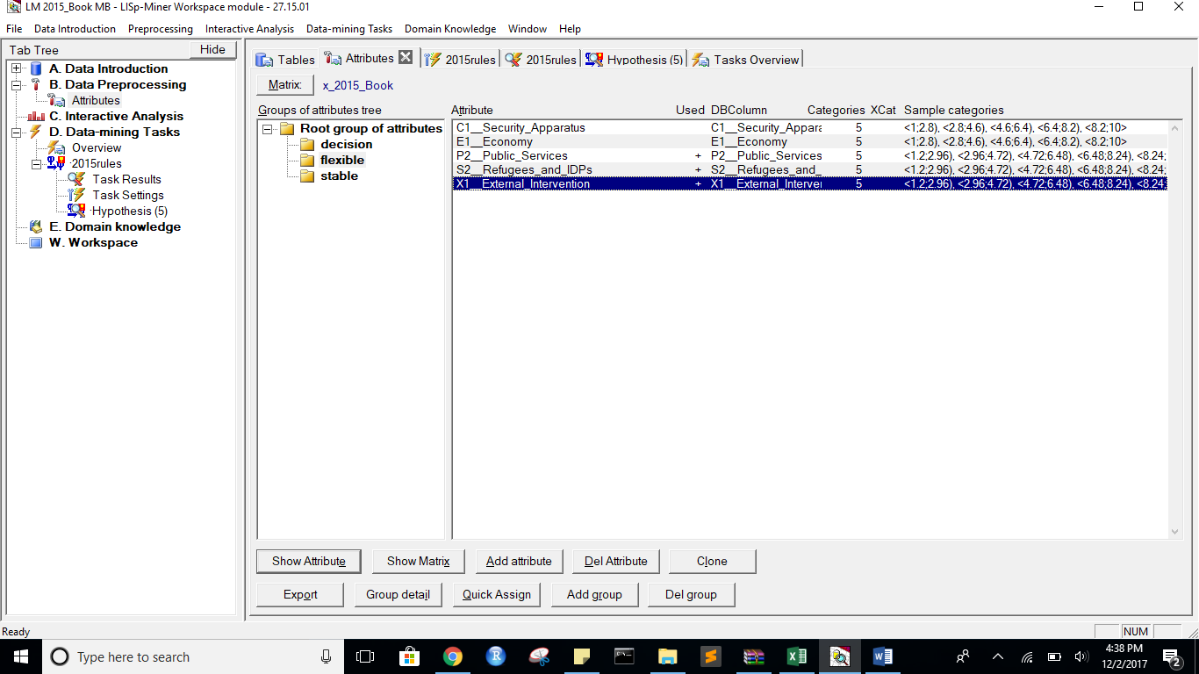

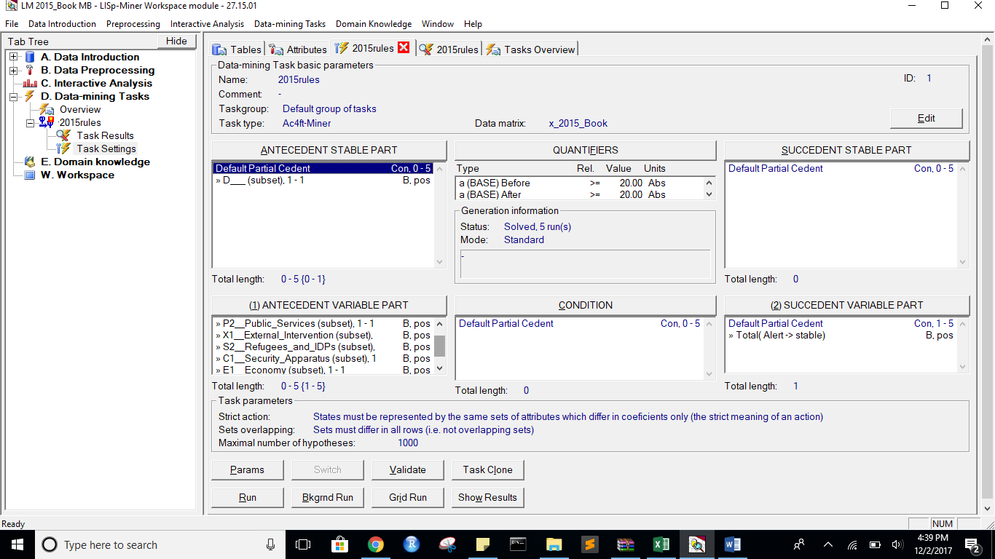

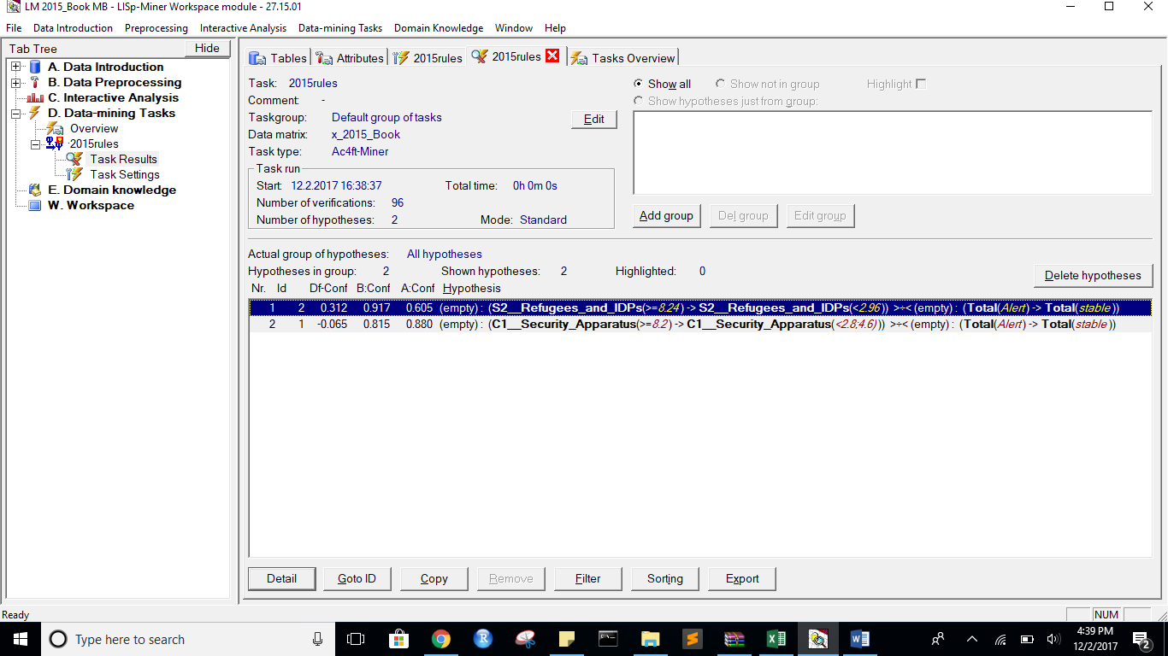

StateBefore:

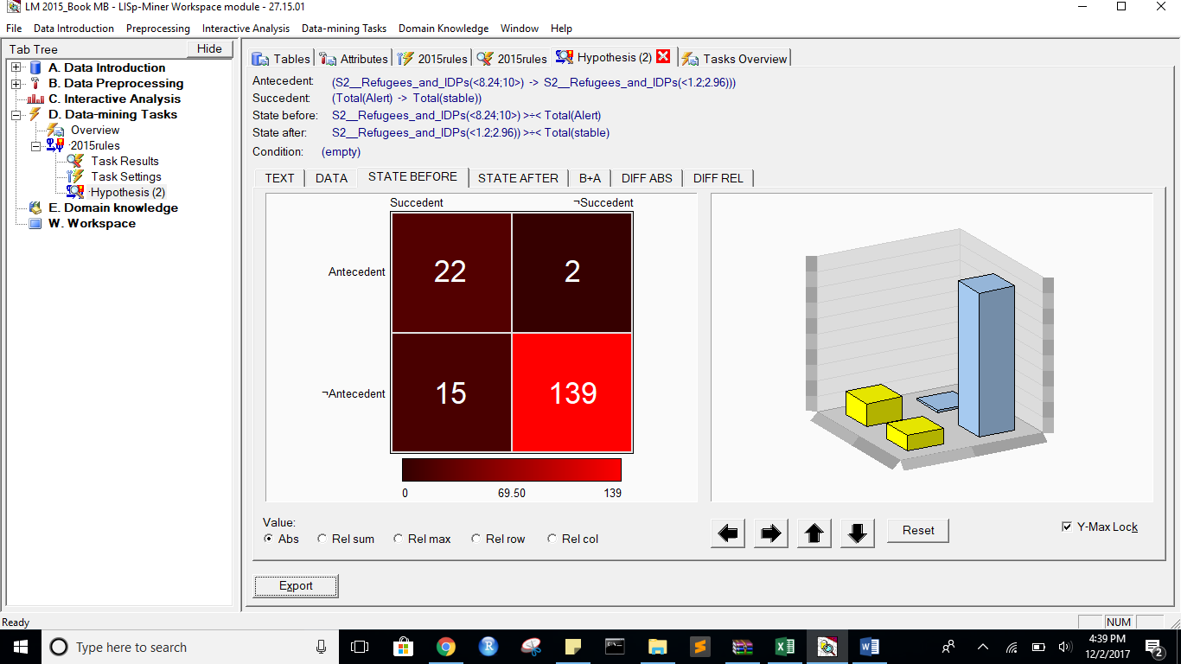

State After:

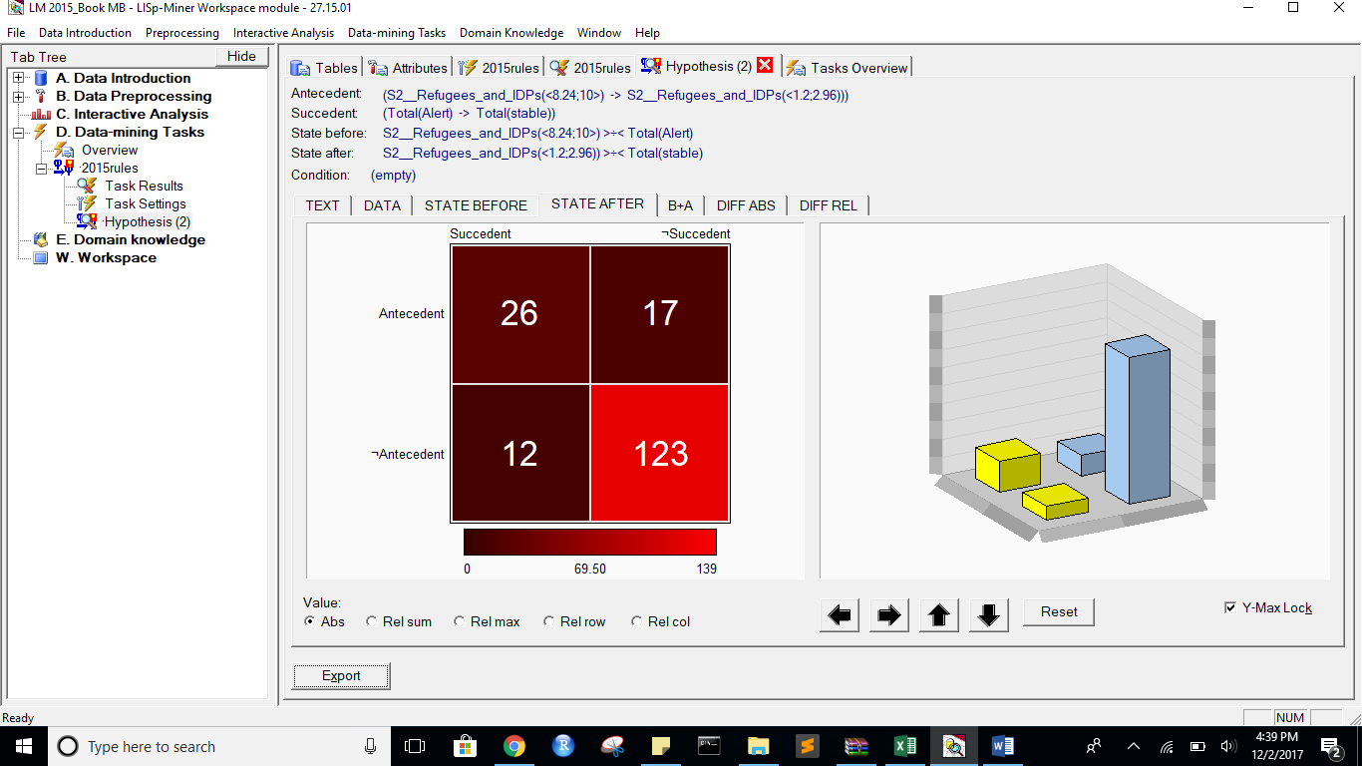

B+A:

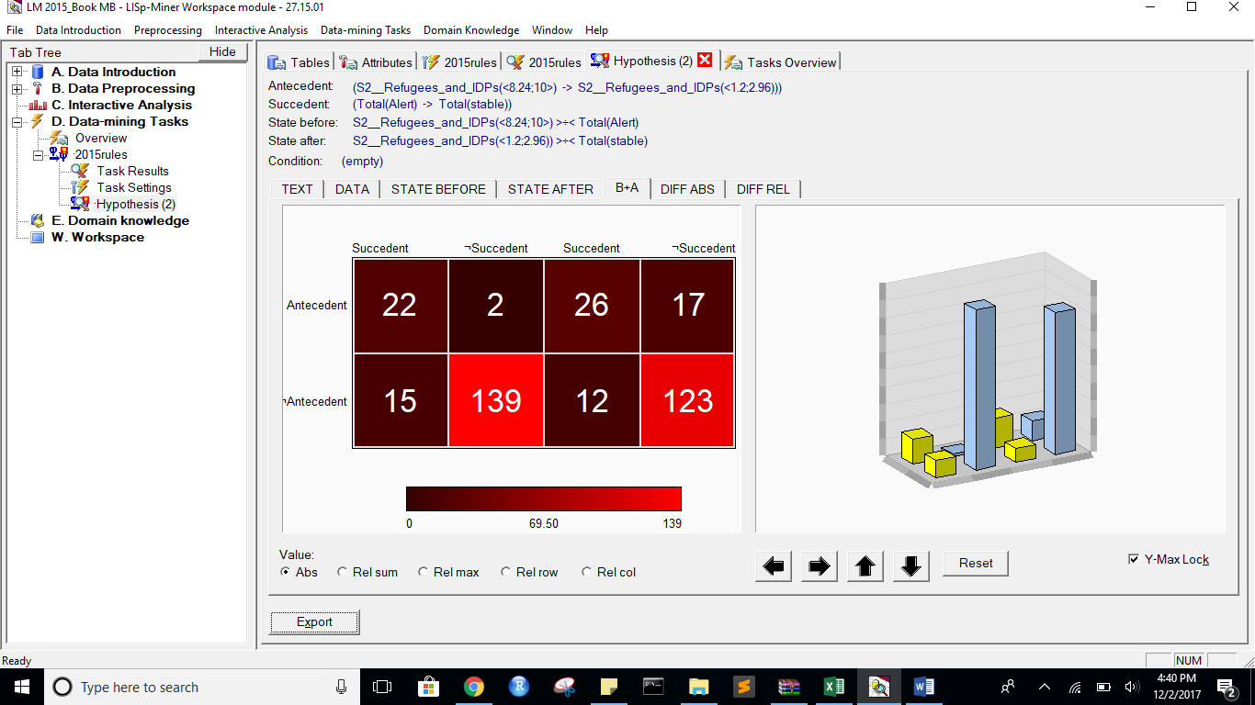

DIFF ABS:

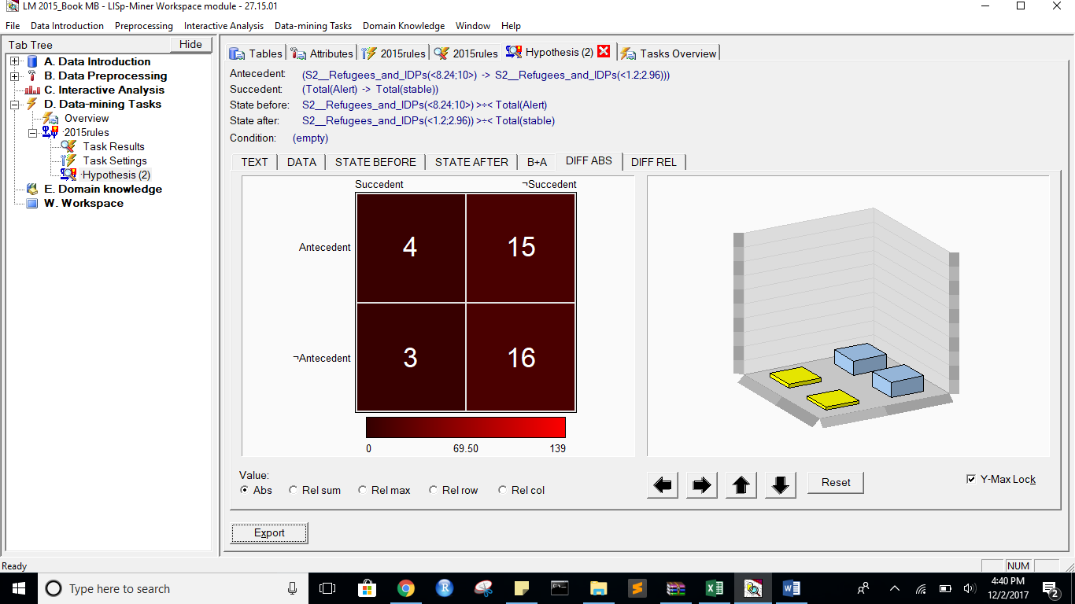

Diff REL:

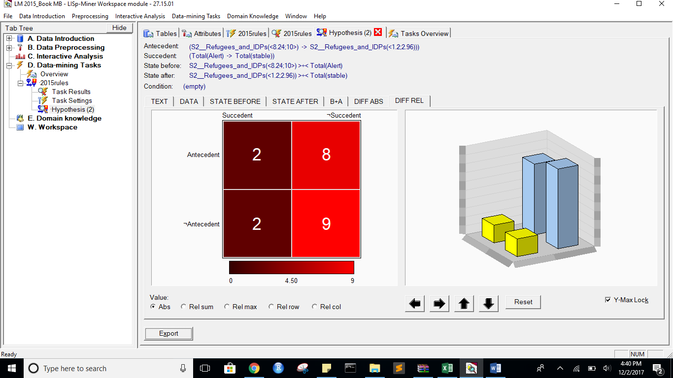

Task name: 2015rules

Task description: -

Date of output: 2.12.2017

Survey of antecedent attributes

Group Name Description

Default Partial Cedent D___ (subset), 1 - 1 -

Survey of variable antecedent attributes

Group Name Description

Default Partial Cedent P2__Public_Services (subset), 1 - 1 -

Default Partial Cedent X1__External_Intervention (subset), 1 - 1 -

Default Partial Cedent S2__Refugees_and_IDPs (subset), 1 - 1 -

Default Partial Cedent C1__Security_Apparatus (subset), 1 - 1 -

Default Partial Cedent E1__Economy (subset), 1 - 1 -

Survey of succedent attributes

Group Name Description

Survey of variable sukcedent attributes

Group Name Description

Default Partial Cedent Total( Alert -> stable) -

Survey of Action4ft-Quantifiers

a-frequency Before >= 20.00 Absolute number

a-frequency After >= 20.00 Absolute number

Task parameters

The comparison of the first set versus the second set

Sets must differ in all rows (i.e. not overlapping sets)

Nr. Hypothesis D%-Sum Df-Conf Df-AFUI Df-FUE Df-Avg R-Conf R-DFUI R-FUE R-Avg H-Conf H-DFUI H-FUE H-Avg B:a B:b B:c B:d B:r B:n B:Conf B:DConf B:EConf B:Supp B:Cmplt B:AvgDf B:Lift B:LBound B:UBound B:ELBound B:EUBound B:DLBound B:DUBound B:Fisher B:Chi-Sq B:bMean B:bVAR B:bStDev B:P(>=90%) B:P(>=95%) A:a A:b A:c A:d A:r A:n A:Conf A:DConf A:EConf A:Supp A:Cmplt A:AvgDf A:Lift A:LBound A:UBound A:ELBound A:EUBound A:DLBound A:DUBound A:Fisher A:Chi-Sq A:bMean A:bVAR A:bStDev A:P(>=90%) A:P(>=95%)

2 (S2__Refugees_and_IDPs(<8.24;10>) -> S2__Refugees_and_IDPs(<1.2;2.96))) >÷< (Total(Alert) -> Total(stable)) 0.21 0.3120155039 0.0913752914 0.0674157303 1.5775965684 1.516025641 1.1932938856 1.0805369128 1.8609862367 1.516025641 1.1932938856 1.0805369128 1.8609862367 22 2 15 139 24 178 0.9166666667 0.5641025641 0.904494382 0.1235955056 0.5945945946 3.4099099099 4.4099099099 0.564273727 0.7075230421 0.4834625774 0.6157437281 0.9999999922 0.000000058 0 84.6406411938 0.8846153846 0.8846153846 0.0614850195 0.4629059248 0.1271065152 26 17 12 123 43 178 0.6046511628 0.4727272727 0.8370786517 0.1460674157 0.6842105263 1.8323133415 2.8323133415 0.999999949 0.0000003231 0.9968172494 0.0059987906 1 0 0 51.6665827359 0.6 0.6 0.0722315119 0.0000000782 0

1 (C1__Security_Apparatus(<8.2;10>) -> C1__Security_Apparatus(<2.8;4.6))) >÷< (Total(Alert) -> Total(stable)) 0.03 -0.0651851852 -0.012775842 -0.0056179775 -0.2021853432 0.9259259259 0.9761904762 0.9937106918 0.9352407026 1.08 1.0243902439 1.0063291139 1.0692434549 22 5 15 136 27 178 0.8148148148 0.5238095238 0.8876404494 0.1235955056 0.5945945946 2.9199199199 3.9199199199 0.9529431066 0.1265574483 0.7557970529 0.3256918798 0.9999999999 0 0 71.2084138998 0.7931034483 0.7931034483 0.0739572779 0.0550069963 0.002268705 22 3 16 137 25 178 0.88 0.5365853659 0.893258427 0.1235955056 0.5789473684 3.1221052632 4.1221052632 0.7635913576 0.4629059499 0.6743081202 0.4179435017 0.9999999997 0.0000000027 0 76.9518781267 0.8518518519 0.8518518519 0.0671353309 0.2590584005 0.0387414148

*** End of list ***

Alert to Warning with same attributes as above:

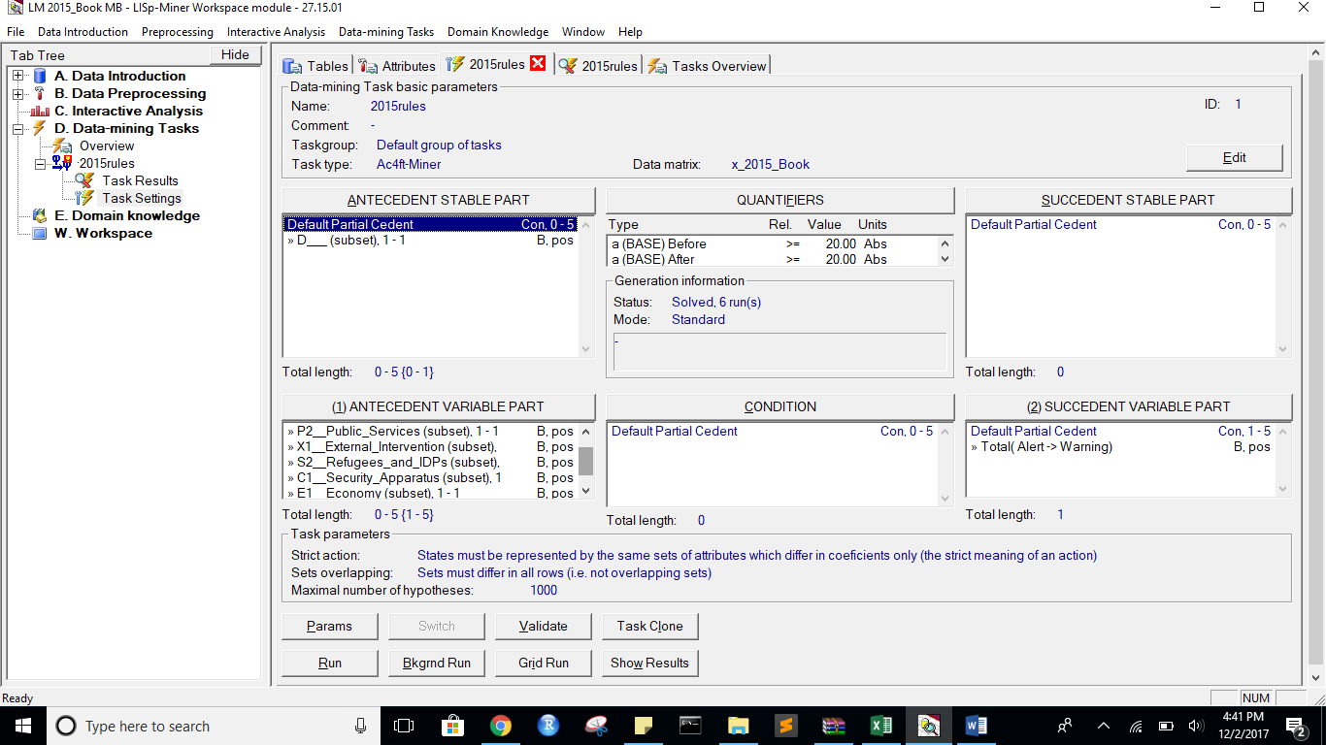

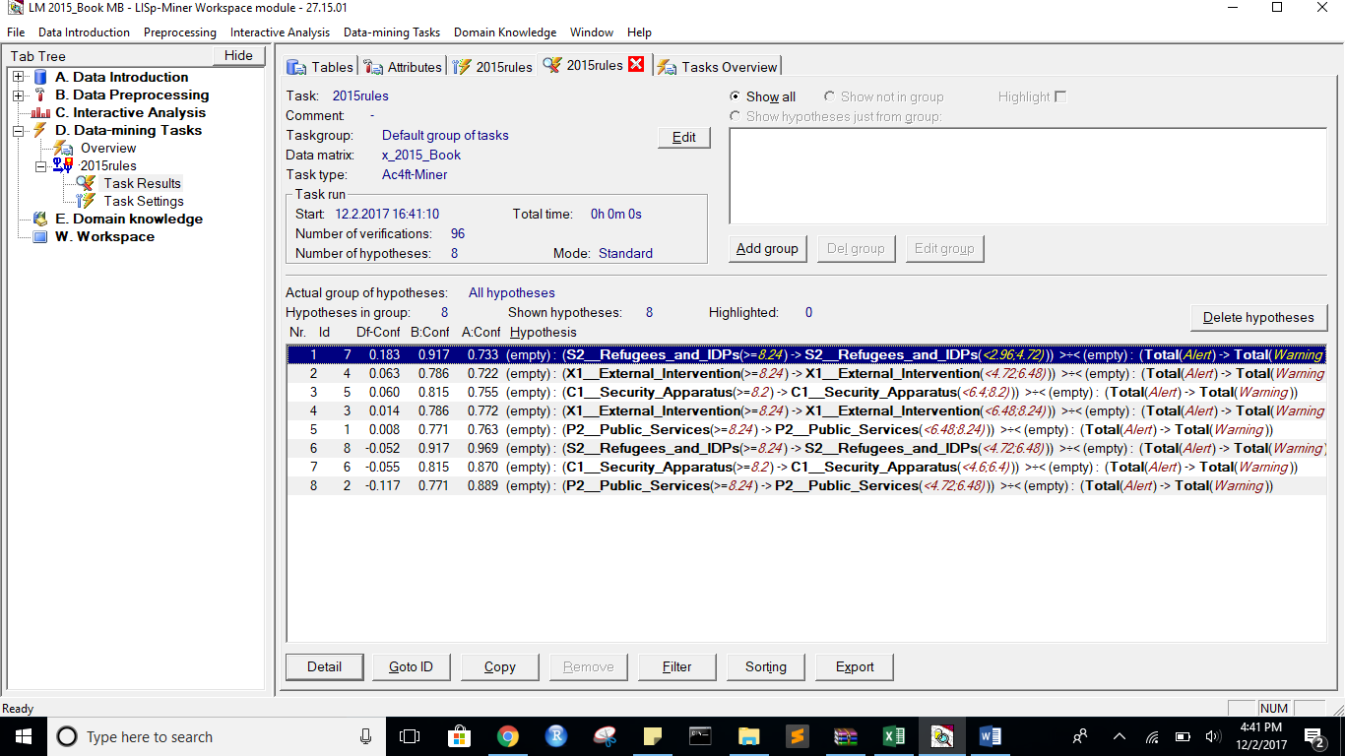

StateBefore:  
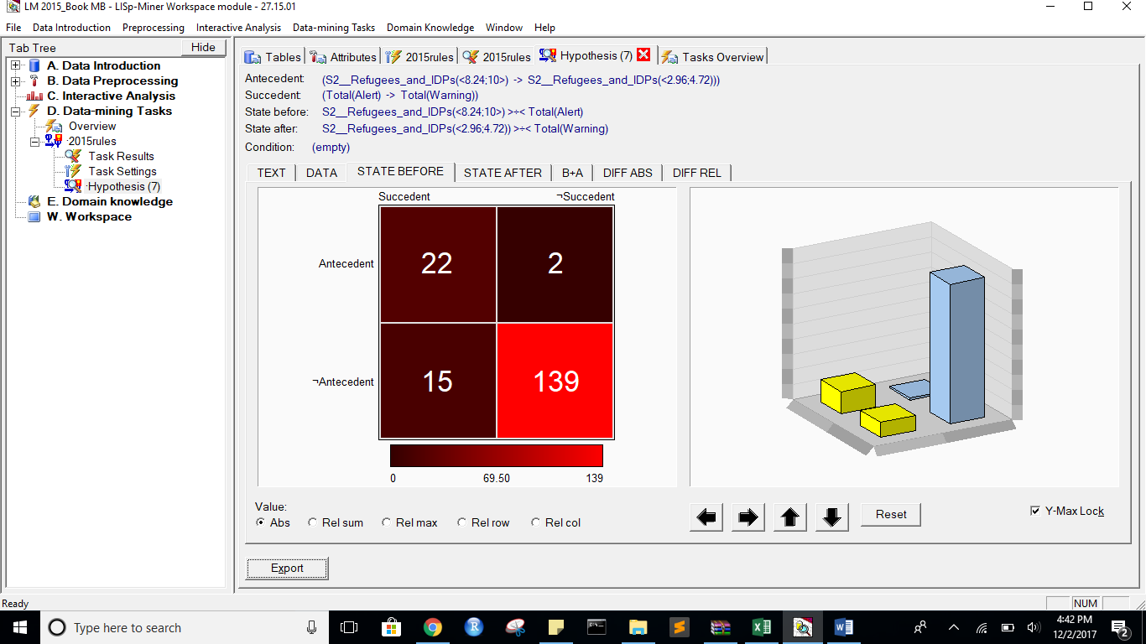

State After:

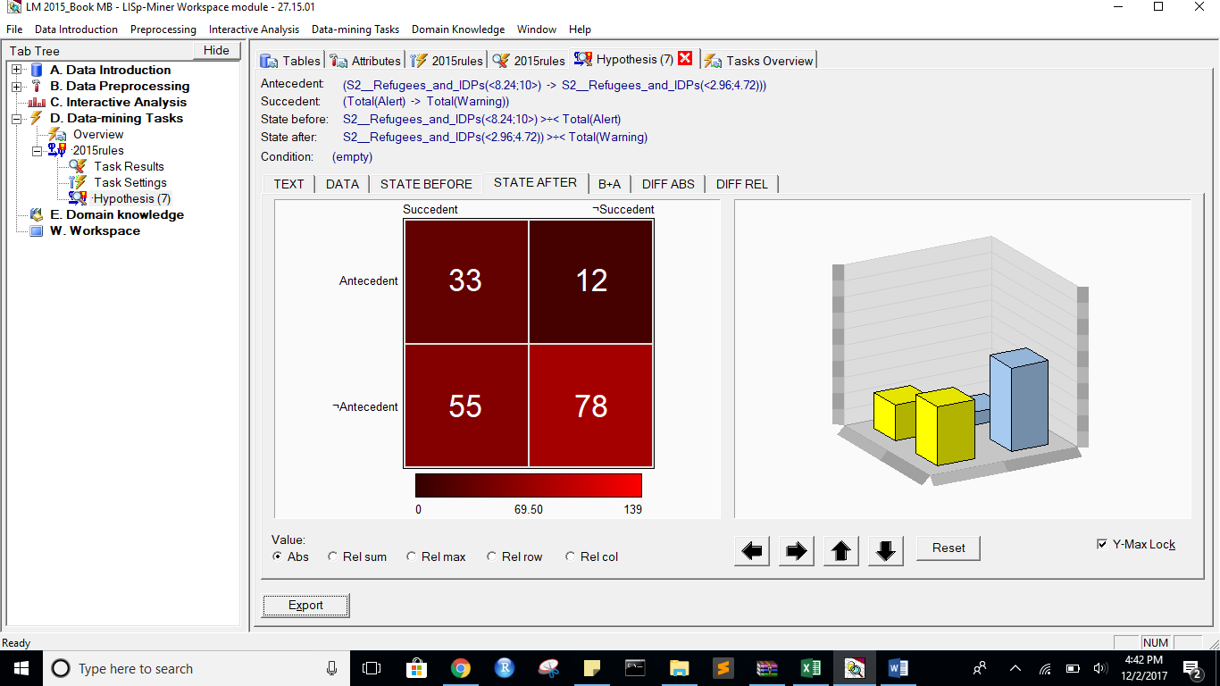

B+A:  
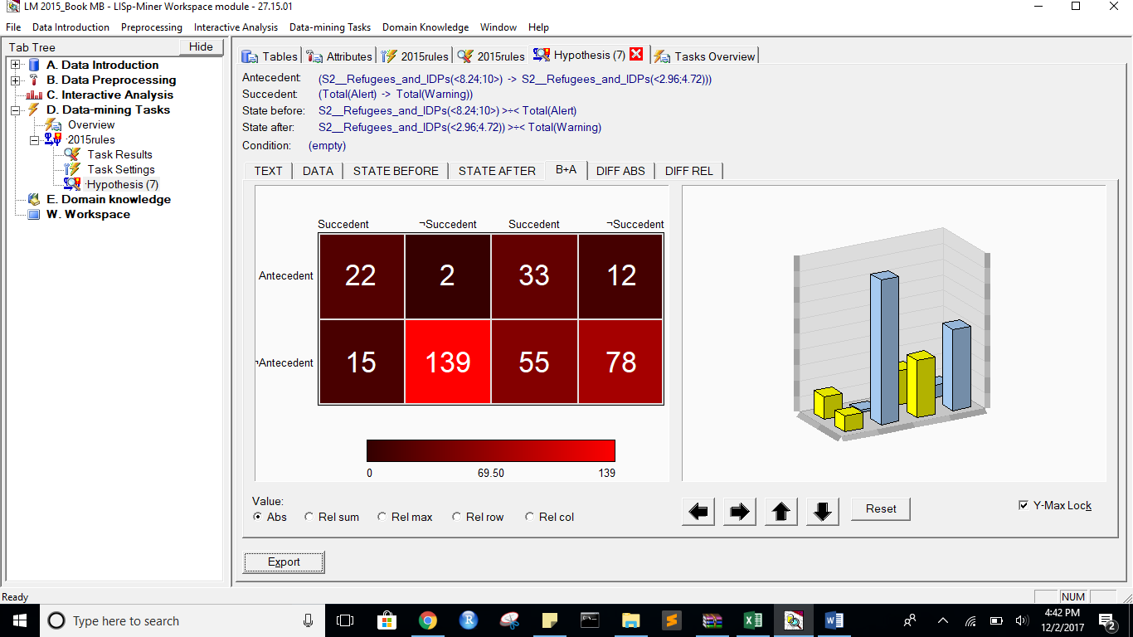

DIFF ABS:

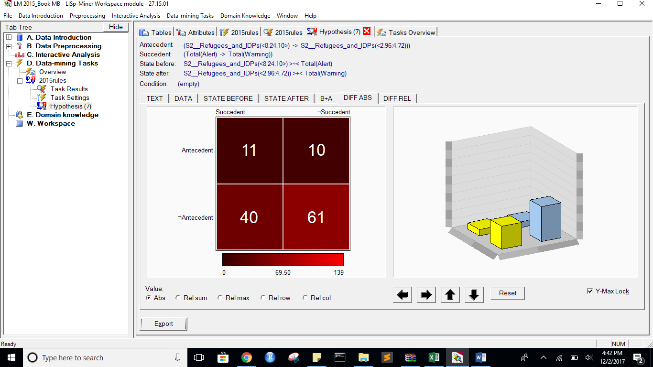

DIFF REL:  
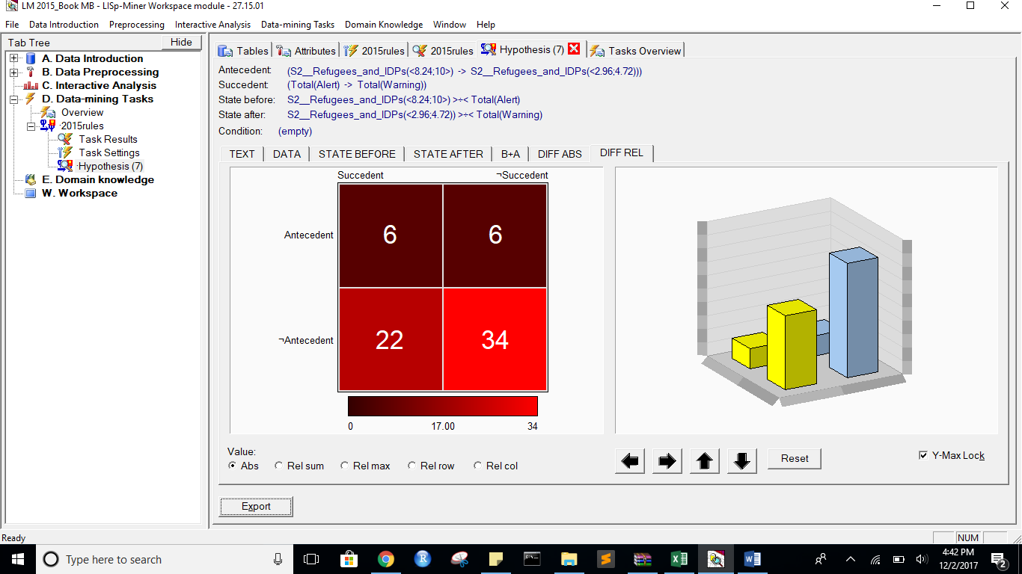

Task name: 2015rules

Task description: -

Date of output: 2.12.2017

Survey of antecedent attributes

Group Name Description

Default Partial Cedent D___ (subset), 1 - 1 -

Survey of variable antecedent attributes

Group Name Description

Default Partial Cedent P2__Public_Services (subset), 1 - 1 -

Default Partial Cedent X1__External_Intervention (subset), 1 - 1 -

Default Partial Cedent S2__Refugees_and_IDPs (subset), 1 - 1 -

Default Partial Cedent C1__Security_Apparatus (subset), 1 - 1 -

Default Partial Cedent E1__Economy (subset), 1 - 1 -

Survey of succedent attributes

Group Name Description

Survey of variable sukcedent attributes

Group Name Description

Default Partial Cedent Total( Alert -> Warning) -

Survey of Action4ft-Quantifiers

a-frequency Before >= 20.00 Absolute number

a-frequency After >= 20.00 Absolute number

Task parameters

The comparison of the first set versus the second set

Sets must differ in all rows (i.e. not overlapping sets)

Nr. Hypothesis D%-Sum Df-Conf Df-AFUI Df-FUE Df-Avg R-Conf R-DFUI R-FUE R-Avg H-Conf H-DFUI H-FUE H-Avg B:a B:b B:c B:d B:r B:n B:Conf B:DConf B:EConf B:Supp B:Cmplt B:AvgDf B:Lift B:LBound B:UBound B:ELBound B:EUBound B:DLBound B:DUBound B:Fisher B:Chi-Sq B:bMean B:bVAR B:bStDev B:P(>=90%) B:P(>=95%) A:a A:b A:c A:d A:r A:n A:Conf A:DConf A:EConf A:Supp A:Cmplt A:AvgDf A:Lift A:LBound A:UBound A:ELBound A:EUBound A:DLBound A:DUBound A:Fisher A:Chi-Sq A:bMean A:bVAR A:bStDev A:P(>=90%) A:P(>=95%)

7 (S2__Refugees_and_IDPs(<8.24;10>) -> S2__Refugees_and_IDPs(<2.96;4.72))) >÷< (Total(Alert) -> Total(Warning)) 0.68 0.1833333333 0.2341025641 0.2808988764 2.9265765766 1.25 1.7094017094 1.4504504505 7.0549860205 1.25 1.7094017094 1.4504504505 7.0549860205 22 2 15 139 24 178 0.9166666667 0.5641025641 0.904494382 0.1235955056 0.5945945946 3.4099099099 4.4099099099 0.564273727 0.7075230421 0.4834625774 0.6157437281 0.9999999922 0.000000058 0 84.6406411938 0.8846153846 0.8846153846 0.0614850195 0.4629059248 0.1271065152 33 12 55 78 45 178 0.7333333333 0.33 0.6235955056 0.1853932584 0.375 0.4833333333 1.4833333333 0.9996672945 0.0012214809 1 0 1 0 0.0001721149 13.7567084378 0.7234042553 0.7234042553 0.0645643314 0.0004215859 0.0000002605

4 (X1__External_Intervention(<8.24;10>) -> X1__External_Intervention(<4.72;6.48))) >÷< (Total(Alert) -> Total(Warning)) 0.61 0.0634920635 0.2463217845 0.2865168539 2.3190641941 1.0879120879 1.9284436494 1.4811320755 6.0320516211 1.0879120879 1.9284436494 1.4811320755 6.0320516211 22 6 15 135 28 178 0.7857142857 0.511627907 0.8820224719 0.1235955056 0.5945945946 2.7799227799 3.7799227799 0.9820933101 0.0550069489 0.823920076 0.2442029471 1 0 0 67.3805964019 0.7666666667 0.7666666667 0.0759645267 0.0216167477 0.0004594271 26 10 62 80 36 178 0.7222222222 0.2653061224 0.595505618 0.1460674157 0.2954545455 0.4608585859 1.4608585859 0.9994439111 0.002198411 1 0 1 0 0.001838297 9.3715124642 0.7105263158 0.7105263158 0.0726210167 0.0007203247 0.0000012395

5 (C1__Security_Apparatus(<8.2;10>) -> C1__Security_Apparatus(<6.4;8.2))) >÷< (Total(Alert) -> Total(Warning)) 0.66 0.0600978337 0.1277699198 0.2303370787 2.393333299 1.0796296296 1.3226190476 1.3504273504 5.5449945059 1.0796296296 1.3226190476 1.3504273504 5.5449945059 22 5 15 136 27 178 0.8148148148 0.5238095238 0.8876404494 0.1235955056 0.5945945946 2.9199199199 3.9199199199 0.9529431066 0.1265574483 0.7557970529 0.3256918798 0.9999999999 0 0 71.2084138998 0.7931034483 0.7931034483 0.0739572779 0.0550069963 0.002268705 40 13 48 77 53 178 0.7547169811 0.396039604 0.6573033708 0.2247191011 0.4545454545 0.5265866209 1.5265866209 0.9994517322 0.0017919209 1 0 1 0 0.000004793 20.4628284353 0.7454545455 0.7454545455 0.0582102203 0.0006726379 0.0000002955

3 (X1__External_Intervention(<8.24;10>) -> X1__External_Intervention(<6.48;8.24))) >÷< (Total(Alert) -> Total(Warning)) 0.65 0.0137844612 0.0759843426 0.202247191 2.2185192712 1.0178571429 1.1744186047 1.2975206612 4.9517374517 1.0178571429 1.1744186047 1.2975206612 4.9517374517 22 6 15 135 28 178 0.7857142857 0.511627907 0.8820224719 0.1235955056 0.5945945946 2.7799227799 3.7799227799 0.9820933101 0.0550069489 0.823920076 0.2442029471 1 0 0 67.3805964019 0.7666666667 0.7666666667 0.0759645267 0.0216167477 0.0004594271 44 13 44 77 57 178 0.7719298246 0.4356435644 0.6797752809 0.2471910112 0.5 0.5614035088 1.5614035088 0.9988025623 0.0035717309 1 0 1 0 0.0000002699 25.8404394825 0.7627118644 0.7627118644 0.0549215313 0.0014348763 0.0000007643

1 (P2__Public_Services(<8.24;10>) -> P2__Public_Services(<6.48;8.24))) >÷< (Total(Alert) -> Total(Warning)) 0.59 0.0082706767 0.3010309278 0.2808988764 2.1675366241 1.0108374384 2.0068965517 1.4545454545 4.9869320523 1.0108374384 2.0068965517 1.4545454545 4.9869320523 27 8 10 133 35 178 0.7714285714 0.6 0.8988764045 0.1516853933 0.7297297297 2.7111969112 3.7111969112 0.9936957838 0.0199902336 0.5820564983 0.5165374226 0.9999999816 0.0000001182 0 84.0343301705 0.7567567568 0.7567567568 0.0695996007 0.0076728385 0.0000534857 29 9 59 81 38 178 0.7631578947 0.2989690722 0.6179775281 0.1629213483 0.3295454545 0.5436602871 1.5436602871 0.9966030849 0.0110749731 1 0 1 0 0.0001521635 13.9627494874 0.75 0.75 0.0676252226 0.0041647353 0.0000162415

8 (S2__Refugees_and_IDPs(<8.24;10>) -> S2__Refugees_and_IDPs(<4.72;6.48))) >÷< (Total(Alert) -> Total(Warning)) 0.58 -0.0520833333 0.2157879574 0.2303370787 2.4503928645 0.9462365591 1.6195202647 1.3416666667 3.5537773154 1.0568181818 1.6195202647 1.3416666667 3.5537773154 22 2 15 139 24 178 0.9166666667 0.5641025641 0.904494382 0.1235955056 0.5945945946 3.4099099099 4.4099099099 0.564273727 0.7075230421 0.4834625774 0.6157437281 0.9999999922 0.000000058 0 84.6406411938 0.8846153846 0.8846153846 0.0614850195 0.4629059248 0.1271065152 31 1 57 89 32 178 0.96875 0.3483146067 0.6741573034 0.1741573034 0.3522727273 0.9595170455 1.9595170455 0.156423374 0.9656631618 1 0 1 0 0 35.120660587 0.9411764706 0.9411764706 0.0397719649 0.8557843175 0.4963498921

6 (C1__Security_Apparatus(<8.2;10>) -> C1__Security_Apparatus(<4.6;6.4))) >÷< (Total(Alert) -> Total(Warning)) 0.59 -0.0547504026 0.0982776089 0.191011236 2.1610266393 0.937037037 1.230952381 1.2741935484 3.8476028111 1.0671936759 1.230952381 1.2741935484 3.8476028111 22 5 15 136 27 178 0.8148148148 0.5238095238 0.8876404494 0.1235955056 0.5945945946 2.9199199199 3.9199199199 0.9529431066 0.1265574483 0.7557970529 0.3256918798 0.9999999999 0 0 71.2084138998 0.7931034483 0.7931034483 0.0739572779 0.0550069963 0.002268705 40 6 48 84 46 178 0.8695652174 0.4255319149 0.6966292135 0.2247191011 0.4545454545 0.7588932806 1.7588932806 0.828115817 0.3103340382 1 0 1 0 0.0000000012 34.9305545574 0.8541666667 0.8541666667 0.0504198641 0.1857292529 0.0084466412

2 (P2__Public_Services(<8.24;10>) -> P2__Public_Services(<4.72;6.48))) >÷< (Total(Alert) -> Total(Warning)) 0.57 -0.1174603175 0.252173913 0.2359550562 1.9132171132 0.8678571429 1.725 1.3559322034 3.3975758761 1.1522633745 1.725 1.3559322034 3.3975758761 27 8 10 133 35 178 0.7714285714 0.6 0.8988764045 0.1516853933 0.7297297297 2.7111969112 3.7111969112 0.9936957838 0.0199902336 0.5820564983 0.5165374226 0.9999999816 0.0000001182 0 84.0343301705 0.7567567568 0.7567567568 0.0695996007 0.0076728385 0.0000534857 32 4 56 86 36 178 0.8888888889 0.347826087 0.6629213483 0.1797752809 0.3636363636 0.797979798 1.797979798 0.7107725508 0.4914885946 1 0 1 0 0.0000000441 28.0968811748 0.8684210526 0.8684210526 0.0541285099 0.3094535915 0.0359285374

*** End of list ***