2016 data:

Alert to Warning

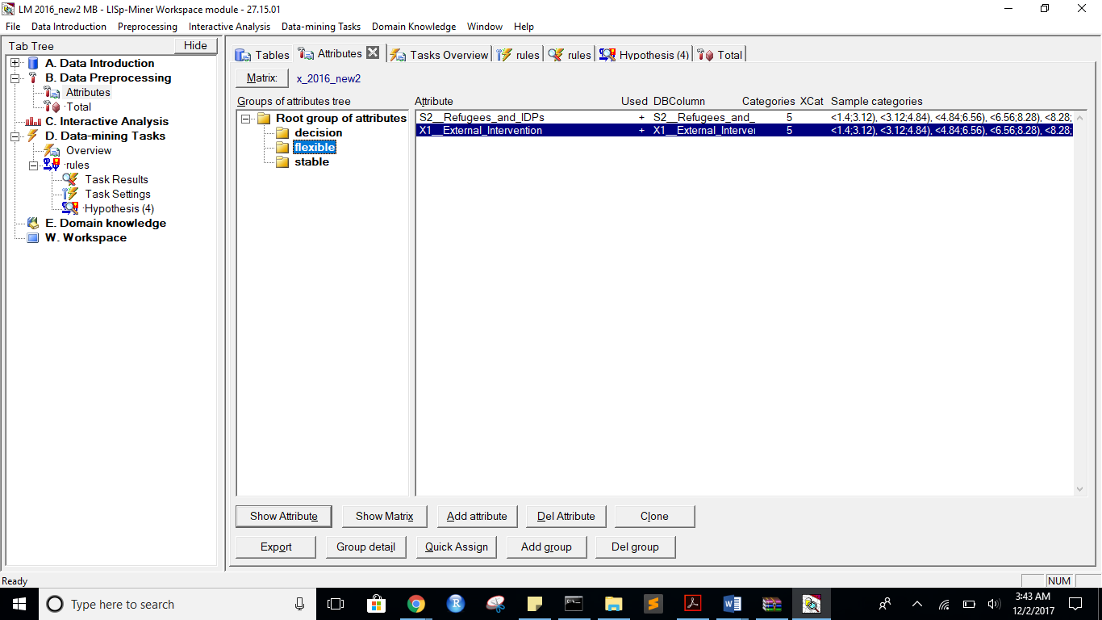

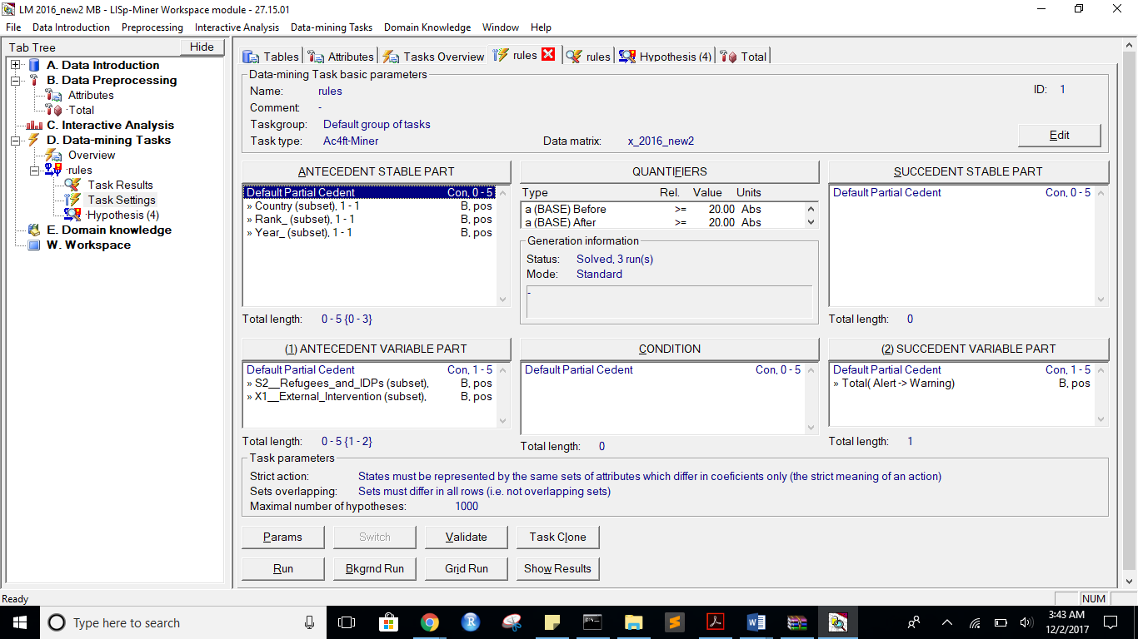

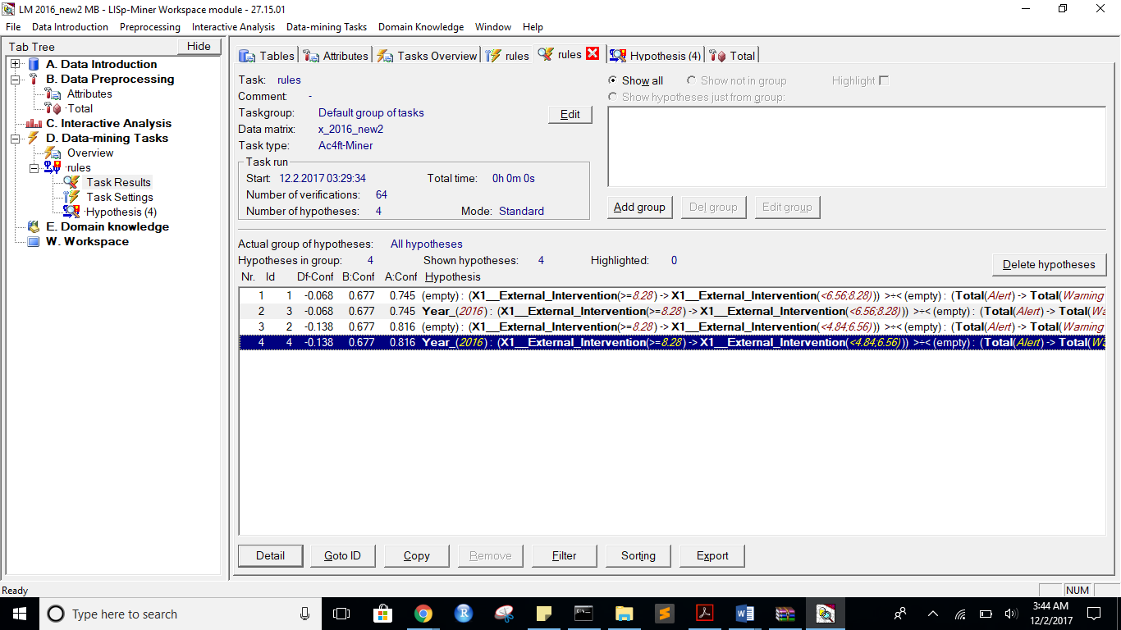

Task name: rules

Task description: -

Date of output: 2.12.2017

Survey of antecedent attributes

Group Name Description

Default Partial Cedent Country (subset), 1 - 1 -

Default Partial Cedent Rank_ (subset), 1 - 1 -

Default Partial Cedent Year_ (subset), 1 - 1 -

Survey of variable antecedent attributes

Group Name Description

Default Partial Cedent S2__Refugees_and_IDPs (subset), 1 - 1 -

Default Partial Cedent X1__External_Intervention (subset), 1 - 1 -

Survey of succedent attributes

Group Name Description

Survey of variable sukcedent attributes

Group Name Description

Default Partial Cedent Total( Alert -> Warning) -

Survey of Action4ft-Quantifiers

a-frequency Before >= 20.00 Absolute number

a-frequency After >= 20.00 Absolute number

Task parameters

The comparison of the first set versus the second set

Sets must differ in all rows (i.e. not overlapping sets)

Nr. Hypothesis D%-Sum Df-Conf Df-AFUI Df-FUE Df-Avg R-Conf R-DFUI R-FUE R-Avg H-Conf H-DFUI H-FUE H-Avg B:a B:b B:c B:d B:r B:n B:Conf B:DConf B:EConf B:Supp B:Cmplt B:AvgDf B:Lift B:LBound B:UBound B:ELBound B:EUBound B:DLBound B:DUBound B:Fisher B:Chi-Sq B:bMean B:bVAR B:bStDev B:P(>=90%) B:P(>=95%) A:a A:b A:c A:d A:r A:n A:Conf A:DConf A:EConf A:Supp A:Cmplt A:AvgDf A:Lift A:LBound A:UBound A:ELBound A:EUBound A:DLBound A:DUBound A:Fisher A:Chi-Sq A:bMean A:bVAR A:bStDev A:P(>=90%) A:P(>=95%)

1 (X1__External_Intervention(<8.28;10>) -> X1__External_Intervention(<6.56;8.28))) >÷< (Total(Alert) -> Total(Warning)) 0.77 -0.0676786844 0.1099137931 0.2865168539 1.8855297175 0.9091680815 1.3355263158 1.51 7.5550546698 1.0999066293 1.3355263158 1.51 7.5550546698 21 10 17 130 31 178 0.6774193548 0.4375 0.8483146067 0.1179775281 0.5526315789 2.1731748727 3.1731748727 0.9998743944 0.0006109025 0.9891012997 0.0190760329 1 0 0 48.1181888229 0.6666666667 0.6666666667 0.0808452083 0.0001741363 0.000000236 38 13 65 62 51 178 0.7450980392 0.3275862069 0.5617977528 0.2134831461 0.3689320388 0.2876451551 1.2876451551 0.9996429297 0.00122615 1 0 1 0 0.0032264986 8.1222536104 0.7358490566 0.7358490566 0.0599961762 0.0004439815 0.000000177

3 Year_(2016) : (X1__External_Intervention(<8.28;10>) -> X1__External_Intervention(<6.56;8.28))) >÷< (Total(Alert) -> Total(Warning)) 0.77 -0.0676786844 0.1099137931 0.2865168539 1.8855297175 0.9091680815 1.3355263158 1.51 7.5550546698 1.0999066293 1.3355263158 1.51 7.5550546698 21 10 17 130 31 178 0.6774193548 0.4375 0.8483146067 0.1179775281 0.5526315789 2.1731748727 3.1731748727 0.9998743944 0.0006109025 0.9891012997 0.0190760329 1 0 0 48.1181888229 0.6666666667 0.6666666667 0.0808452083 0.0001741363 0.000000236 38 13 65 62 51 178 0.7450980392 0.3275862069 0.5617977528 0.2134831461 0.3689320388 0.2876451551 1.2876451551 0.9996429297 0.00122615 1 0 1 0 0.0032264986 8.1222536104 0.7358490566 0.7358490566 0.0599961762 0.0004439815 0.000000177

2 (X1__External_Intervention(<8.28;10>) -> X1__External_Intervention(<4.84;6.56))) >÷< (Total(Alert) -> Total(Warning)) 0.74 -0.1383701188 0.1556818182 0.2921348315 1.7633639376 0.8303850156 1.5524193548 1.5252525253 5.3028718526 1.2042606516 1.5524193548 1.5252525253 5.3028718526 21 10 17 130 31 178 0.6774193548 0.4375 0.8483146067 0.1179775281 0.5526315789 2.1731748727 3.1731748727 0.9998743944 0.0006109025 0.9891012997 0.0190760329 1 0 0 48.1181888229 0.6666666667 0.6666666667 0.0808452083 0.0001741363 0.000000236 31 7 72 68 38 178 0.8157894737 0.2818181818 0.5561797753 0.1741573034 0.3009708738 0.4098109351 1.4098109351 0.9681942702 0.0799545841 1 0 1 0 0.0005629961 11.1434228289 0.8 0.8 0.0624695048 0.0366206709 0.0005951249

4 Year_(2016) : (X1__External_Intervention(<8.28;10>) -> X1__External_Intervention(<4.84;6.56))) >÷< (Total(Alert) -> Total(Warning)) 0.74 -0.1383701188 0.1556818182 0.2921348315 1.7633639376 0.8303850156 1.5524193548 1.5252525253 5.3028718526 1.2042606516 1.5524193548 1.5252525253 5.3028718526 21 10 17 130 31 178 0.6774193548 0.4375 0.8483146067 0.1179775281 0.5526315789 2.1731748727 3.1731748727 0.9998743944 0.0006109025 0.9891012997 0.0190760329 1 0 0 48.1181888229 0.6666666667 0.6666666667 0.0808452083 0.0001741363 0.000000236 31 7 72 68 38 178 0.8157894737 0.2818181818 0.5561797753 0.1741573034 0.3009708738 0.4098109351 1.4098109351 0.9681942702 0.0799545841 1 0 1 0 0.0005629961 11.1434228289 0.8 0.8 0.0624695048 0.0366206709 0.0005951249

*** End of list ***

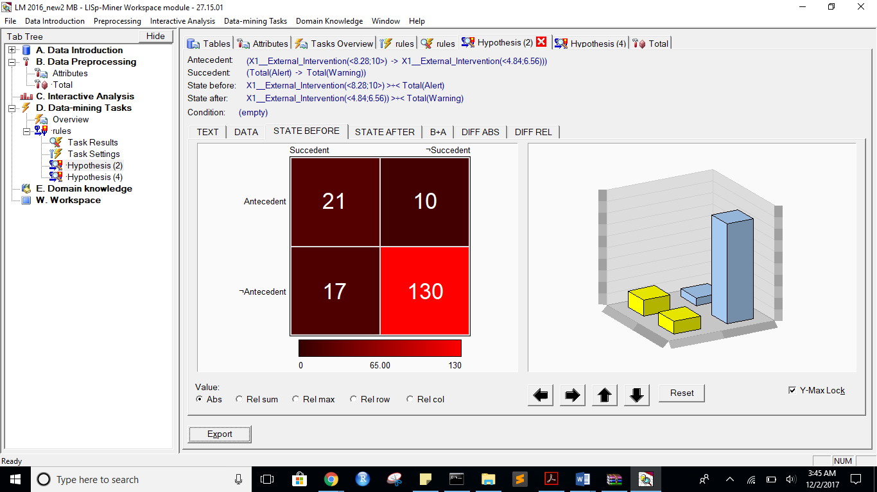

state after:

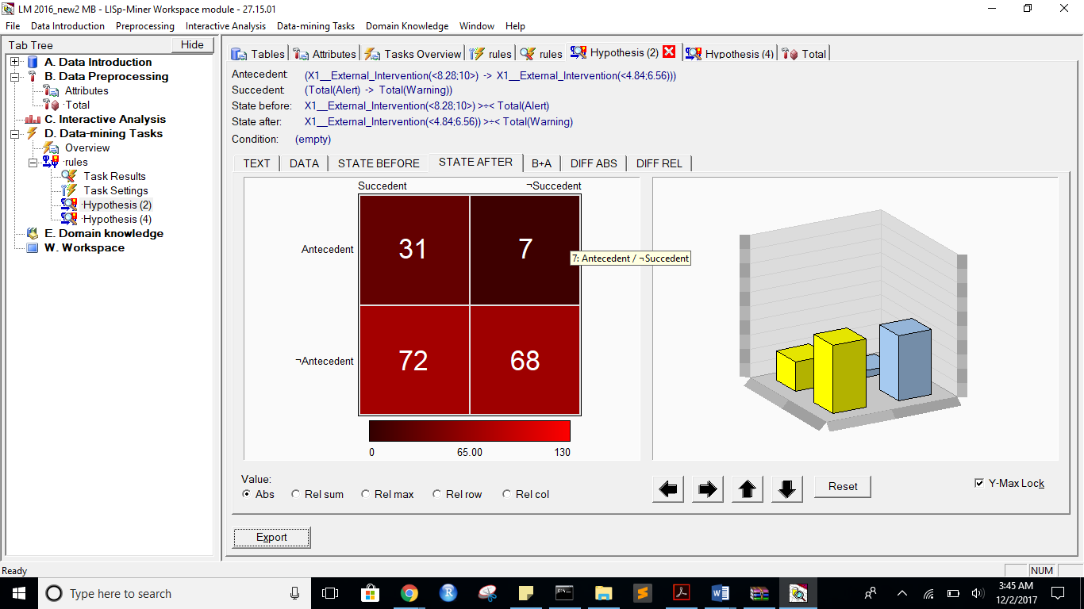

B+A:

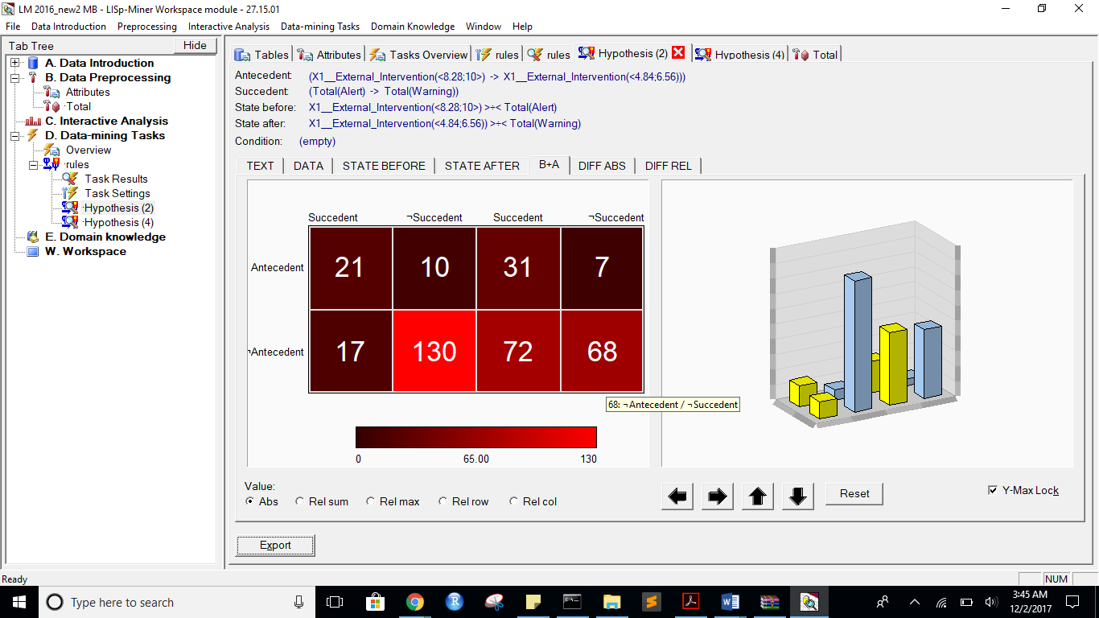

Diff ABS:

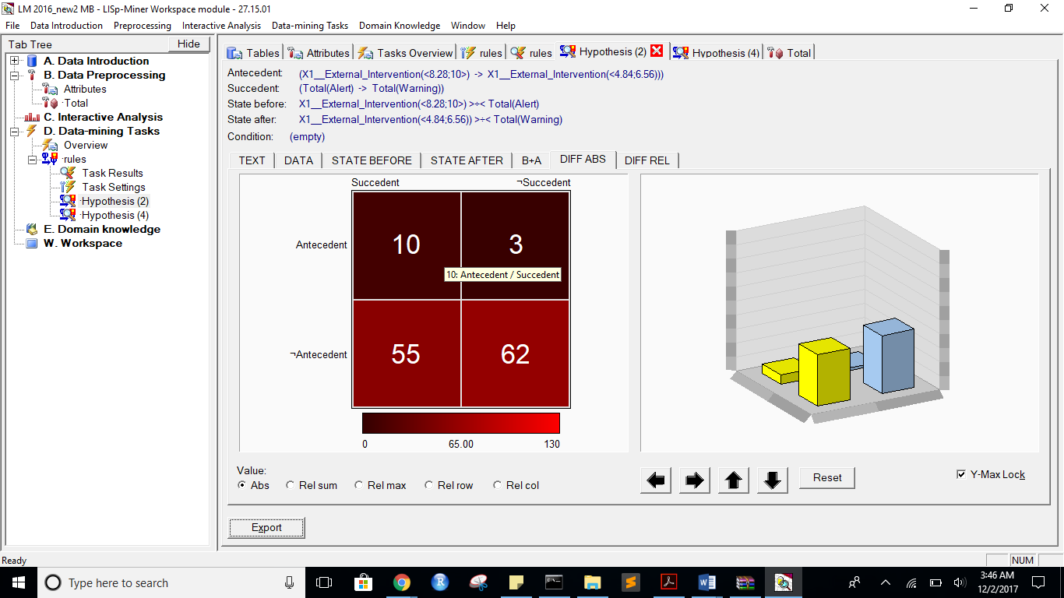

DIFF REL”



2)Alert to Warning with more flexible attributes”

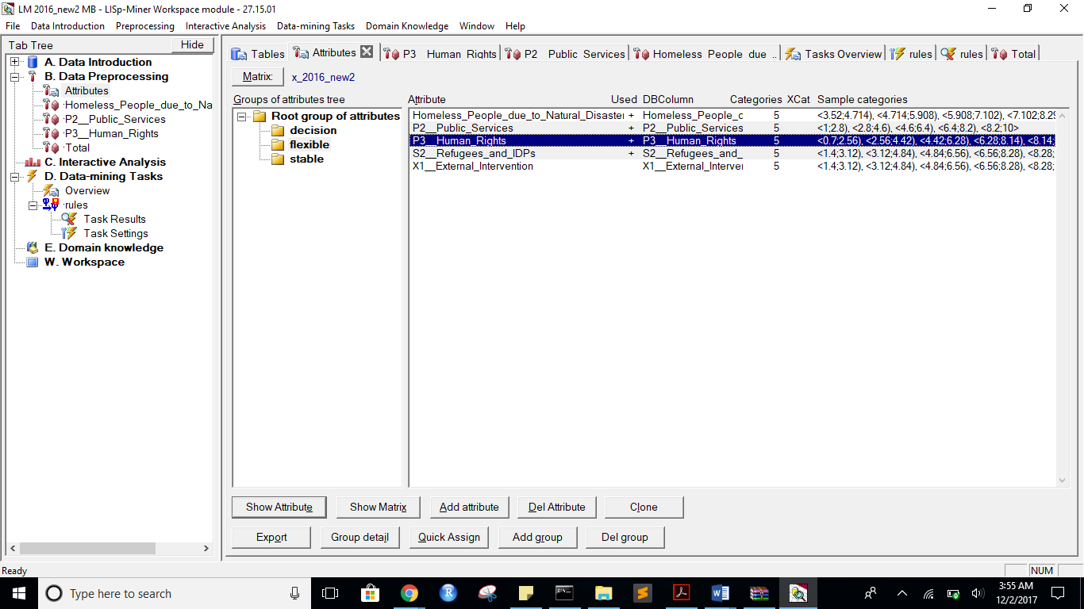

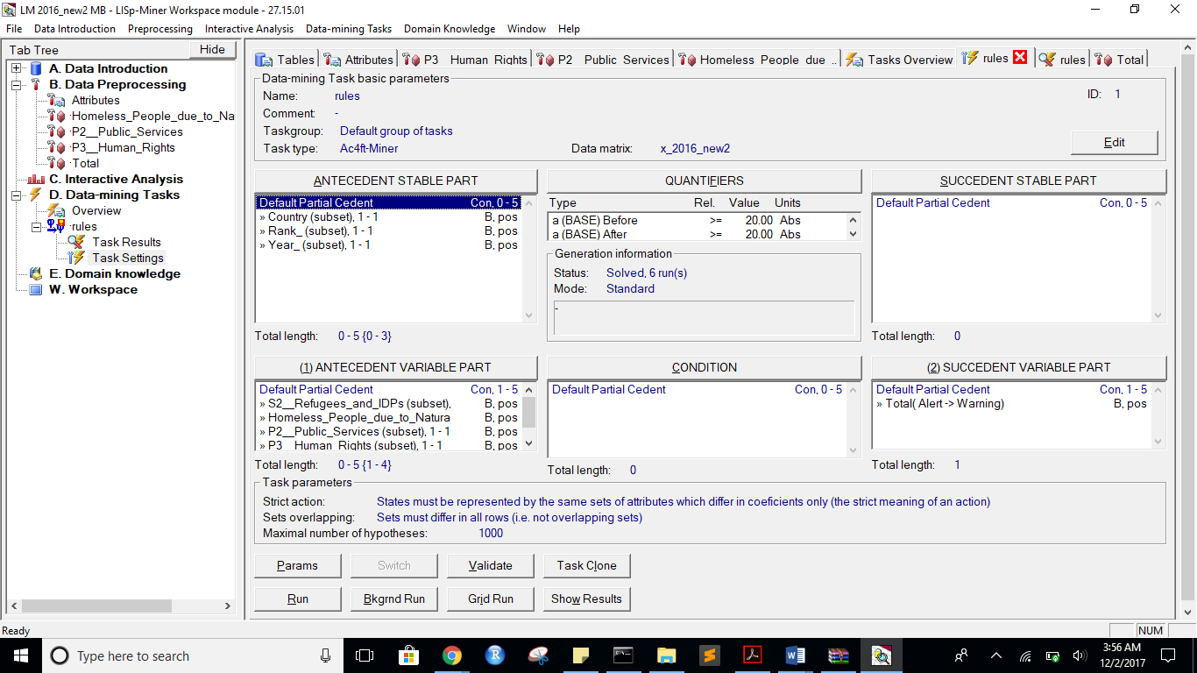

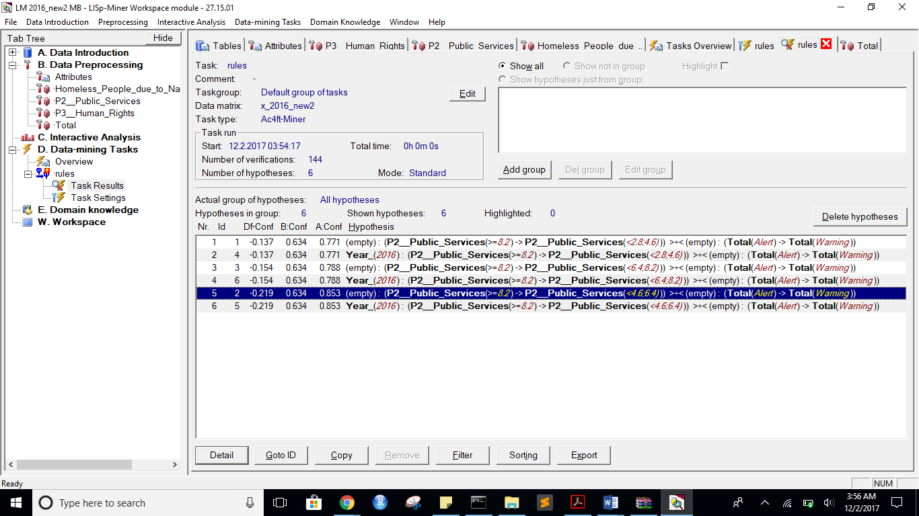

Task name: rules

Task description: -

Date of output: 2.12.2017

Survey of antecedent attributes

Group Name Description

Default Partial Cedent Country (subset), 1 - 1 -

Default Partial Cedent Rank_ (subset), 1 - 1 -

Default Partial Cedent Year_ (subset), 1 - 1 -

Survey of variable antecedent attributes

Group Name Description

Default Partial Cedent S2__Refugees_and_IDPs (subset), 1 - 1 -

Default Partial Cedent Homeless_People_due_to_Natural_Disaster (subset), 1 - 1 -

Default Partial Cedent P2__Public_Services (subset), 1 - 1 -

Default Partial Cedent P3__Human_Rights (subset), 1 - 1 -

Survey of succedent attributes

Group Name Description

Survey of variable sukcedent attributes

Group Name Description

Default Partial Cedent Total( Alert -> Warning) -

Survey of Action4ft-Quantifiers

a-frequency Before >= 20.00 Absolute number

a-frequency After >= 20.00 Absolute number

Task parameters

The comparison of the first set versus the second set

Sets must differ in all rows (i.e. not overlapping sets)

Nr. Hypothesis D%-Sum Df-Conf Df-AFUI Df-FUE Df-Avg R-Conf R-DFUI R-FUE R-Avg H-Conf H-DFUI H-FUE H-Avg B:a B:b B:c B:d B:r B:n B:Conf B:DConf B:EConf B:Supp B:Cmplt B:AvgDf B:Lift B:LBound B:UBound B:ELBound B:EUBound B:DLBound B:DUBound B:Fisher B:Chi-Sq B:bMean B:bVAR B:bStDev B:P(>=90%) B:P(>=95%) A:a A:b A:c A:d A:r A:n A:Conf A:DConf A:EConf A:Supp A:Cmplt A:AvgDf A:Lift A:LBound A:UBound A:ELBound A:EUBound A:DLBound A:DUBound A:Fisher A:Chi-Sq A:bMean A:bVAR A:bStDev A:P(>=90%) A:P(>=95%)

1 (P2__Public_Services(<8.2;10>) -> P2__Public_Services(<2.8;4.6))) >÷< (Total(Alert) -> Total(Warning)) 0.74 -0.13728223 0.2473227945 0.3202247191 1.6373265629 0.8220415537 2.0167714885 1.6063829787 5.9147062942 1.2164835165 2.0167714885 1.6063829787 5.9147062942 26 15 12 125 41 178 0.6341463415 0.4905660377 0.8483146067 0.1460674157 0.6842105263 1.9704749679 2.9704749679 0.9999991184 0.00000498 0.9891012997 0.0190760329 1 0 0 56.1410714788 0.6279069767 0.6279069767 0.0728697164 0.0000012914 0 27 8 76 67 35 178 0.7714285714 0.2432432432 0.5280898876 0.1516853933 0.2621359223 0.333148405 1.333148405 0.9936957838 0.0199902336 1 0 1 0 0.0074028039 6.6405407667 0.7567567568 0.7567567568 0.0695996007 0.0076728385 0.0000534857

4 Year_(2016) : (P2__Public_Services(<8.2;10>) -> P2__Public_Services(<2.8;4.6))) >÷< (Total(Alert) -> Total(Warning)) 0.74 -0.13728223 0.2473227945 0.3202247191 1.6373265629 0.8220415537 2.0167714885 1.6063829787 5.9147062942 1.2164835165 2.0167714885 1.6063829787 5.9147062942 26 15 12 125 41 178 0.6341463415 0.4905660377 0.8483146067 0.1460674157 0.6842105263 1.9704749679 2.9704749679 0.9999991184 0.00000498 0.9891012997 0.0190760329 1 0 0 56.1410714788 0.6279069767 0.6279069767 0.0728697164 0.0000012914 0 27 8 76 67 35 178 0.7714285714 0.2432432432 0.5280898876 0.1516853933 0.2621359223 0.333148405 1.333148405 0.9936957838 0.0199902336 1 0 1 0 0.0074028039 6.6405407667 0.7567567568 0.7567567568 0.0695996007 0.0076728385 0.0000534857

3 (P2__Public_Services(<8.2;10>) -> P2__Public_Services(<6.4;8.2))) >÷< (Total(Alert) -> Total(Warning)) 0.73 -0.1537324464 0.2542024014 0.3202247191 1.6088980335 0.8048780488 2.0754716981 1.6063829787 5.4496699885 1.2424242424 2.0754716981 1.6063829787 5.4496699885 26 15 12 125 41 178 0.6341463415 0.4905660377 0.8483146067 0.1460674157 0.6842105263 1.9704749679 2.9704749679 0.9999991184 0.00000498 0.9891012997 0.0190760329 1 0 0 56.1410714788 0.6279069767 0.6279069767 0.0728697164 0.0000012914 0 26 7 77 68 33 178 0.7878787879 0.2363636364 0.5280898876 0.1460674157 0.2524271845 0.3615769344 1.3615769344 0.9858982041 0.0417038478 1 0 1 0 0.0051573879 7.2734982365 0.7714285714 0.7714285714 0.0699854212 0.0168620332 0.000219529

6 Year_(2016) : (P2__Public_Services(<8.2;10>) -> P2__Public_Services(<6.4;8.2))) >÷< (Total(Alert) -> Total(Warning)) 0.73 -0.1537324464 0.2542024014 0.3202247191 1.6088980335 0.8048780488 2.0754716981 1.6063829787 5.4496699885 1.2424242424 2.0754716981 1.6063829787 5.4496699885 26 15 12 125 41 178 0.6341463415 0.4905660377 0.8483146067 0.1460674157 0.6842105263 1.9704749679 2.9704749679 0.9999991184 0.00000498 0.9891012997 0.0190760329 1 0 0 56.1410714788 0.6279069767 0.6279069767 0.0728697164 0.0000012914 0 26 7 77 68 33 178 0.7878787879 0.2363636364 0.5280898876 0.1460674157 0.2524271845 0.3615769344 1.3615769344 0.9858982041 0.0417038478 1 0 1 0 0.0051573879 7.2734982365 0.7714285714 0.7714285714 0.0699854212 0.0168620332 0.000219529

2 (P2__Public_Services(<8.2;10>) -> P2__Public_Services(<4.6;6.4))) >÷< (Total(Alert) -> Total(Warning)) 0.74 -0.218794835 0.2220475192 0.2921348315 1.4964601192 0.7434819176 1.8269355888 1.5252525253 4.1569899624 1.3450226244 1.8269355888 1.5252525253 4.1569899624 26 15 12 125 41 178 0.6341463415 0.4905660377 0.8483146067 0.1460674157 0.6842105263 1.9704749679 2.9704749679 0.9999991184 0.00000498 0.9891012997 0.0190760329 1 0 0 56.1410714788 0.6279069767 0.6279069767 0.0728697164 0.0000012914 0 29 5 74 70 34 178 0.8529411765 0.2685185185 0.5561797753 0.1629213483 0.2815533981 0.4740148487 1.4740148487 0.8814704409 0.2495917162 1 0 1 0 0.0001840898 12.9686951372 0.8333333333 0.8333333333 0.0612678852 0.1316358428 0.0072517258

5 Year_(2016) : (P2__Public_Services(<8.2;10>) -> P2__Public_Services(<4.6;6.4))) >÷< (Total(Alert) -> Total(Warning)) 0.74 -0.218794835 0.2220475192 0.2921348315 1.4964601192 0.7434819176 1.8269355888 1.5252525253 4.1569899624 1.3450226244 1.8269355888 1.5252525253 4.1569899624 26 15 12 125 41 178 0.6341463415 0.4905660377 0.8483146067 0.1460674157 0.6842105263 1.9704749679 2.9704749679 0.9999991184 0.00000498 0.9891012997 0.0190760329 1 0 0 56.1410714788 0.6279069767 0.6279069767 0.0728697164 0.0000012914 0 29 5 74 70 34 178 0.8529411765 0.2685185185 0.5561797753 0.1629213483 0.2815533981 0.4740148487 1.4740148487 0.8814704409 0.2495917162 1 0 1 0 0.0001840898 12.9686951372 0.8333333333 0.8333333333 0.0612678852 0.1316358428 0.0072517258

*** End of list ***

state before:

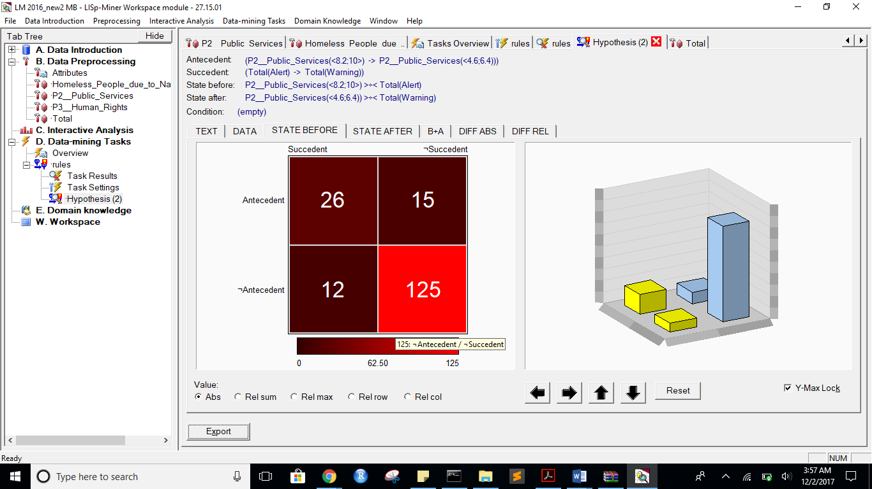

after:

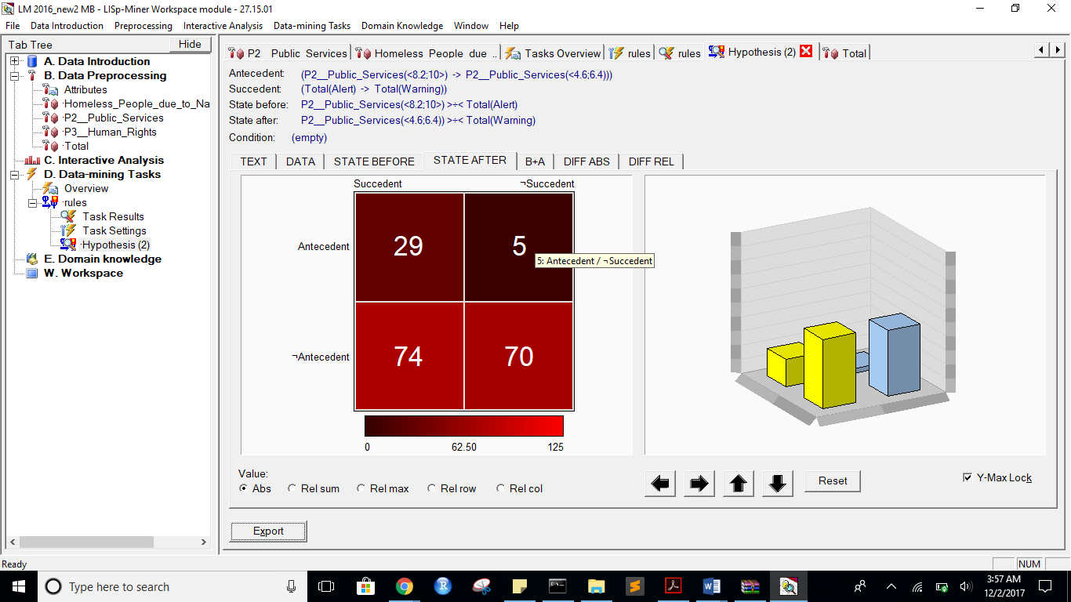

B+A”

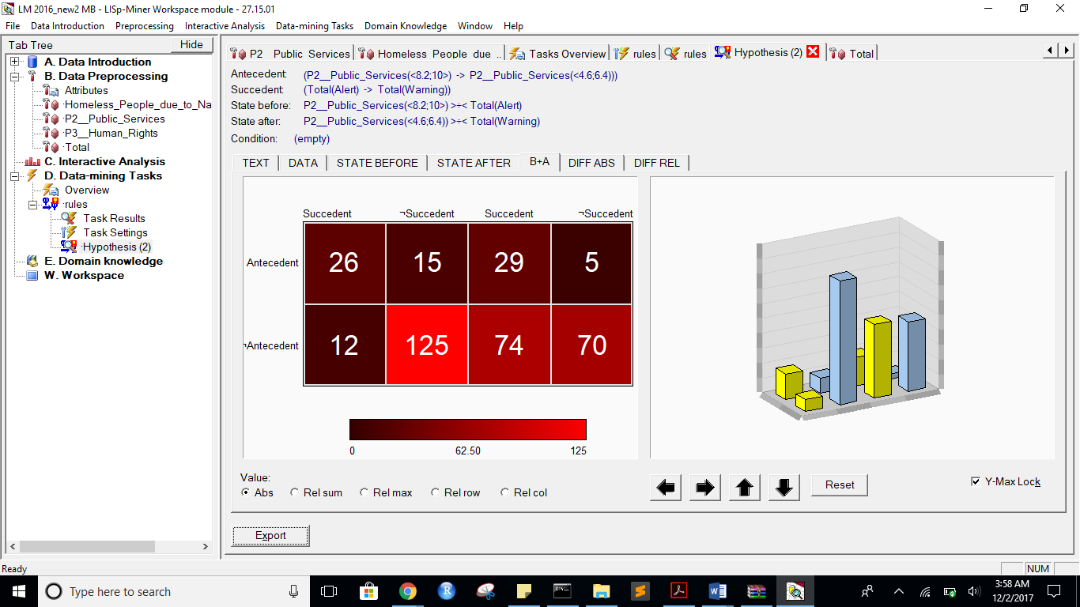

**Diff ABS:**

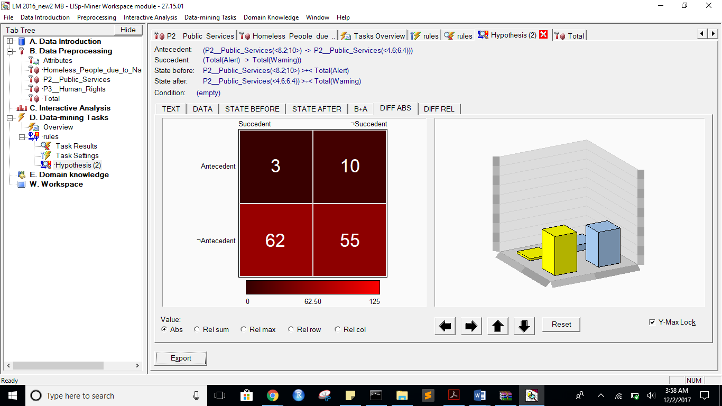

**Diff REL:**

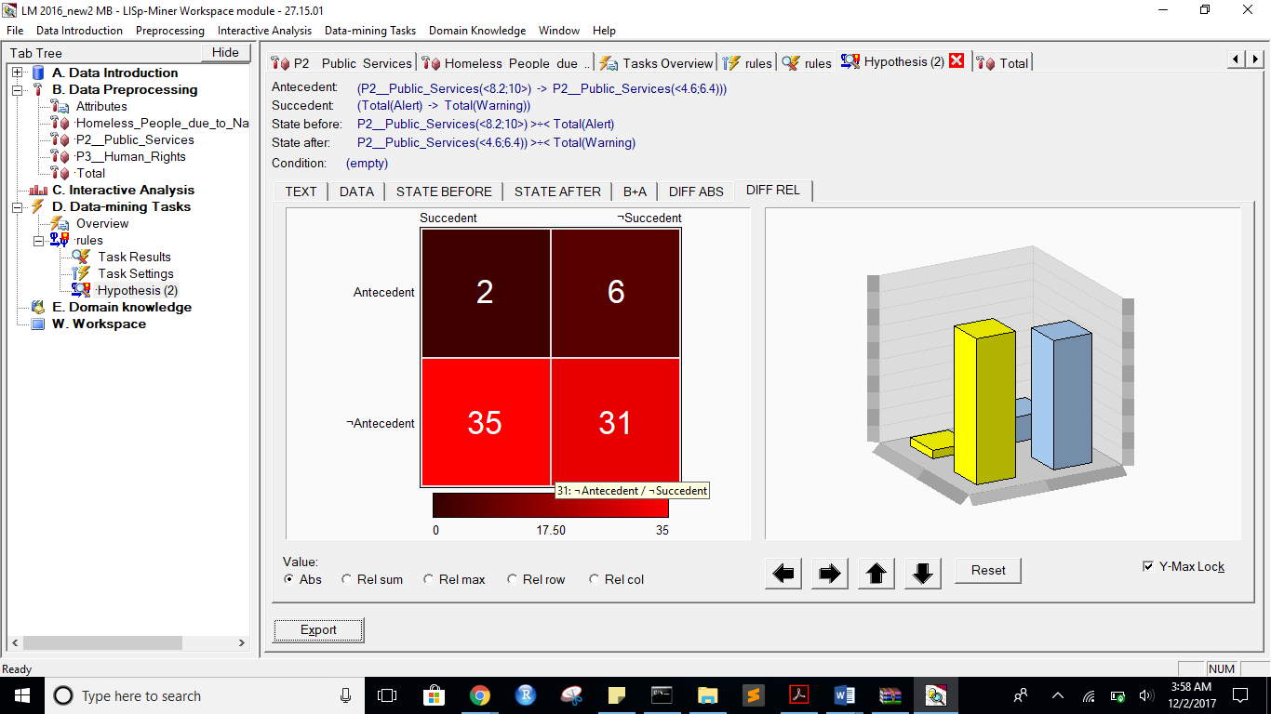

**Alert** to Stable:

same attribues like above,just changed alert to stable

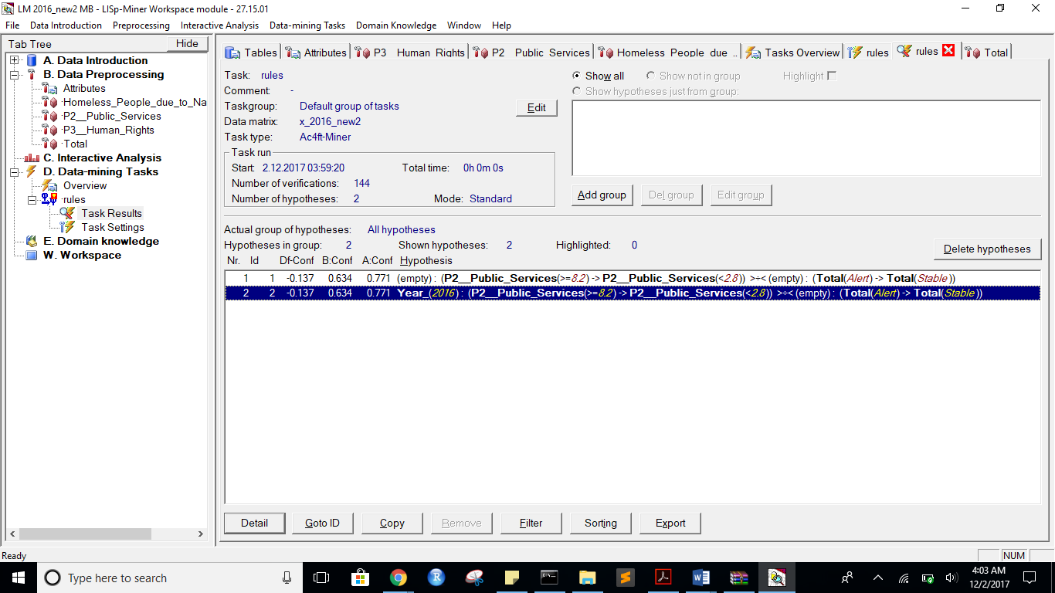

**Before**

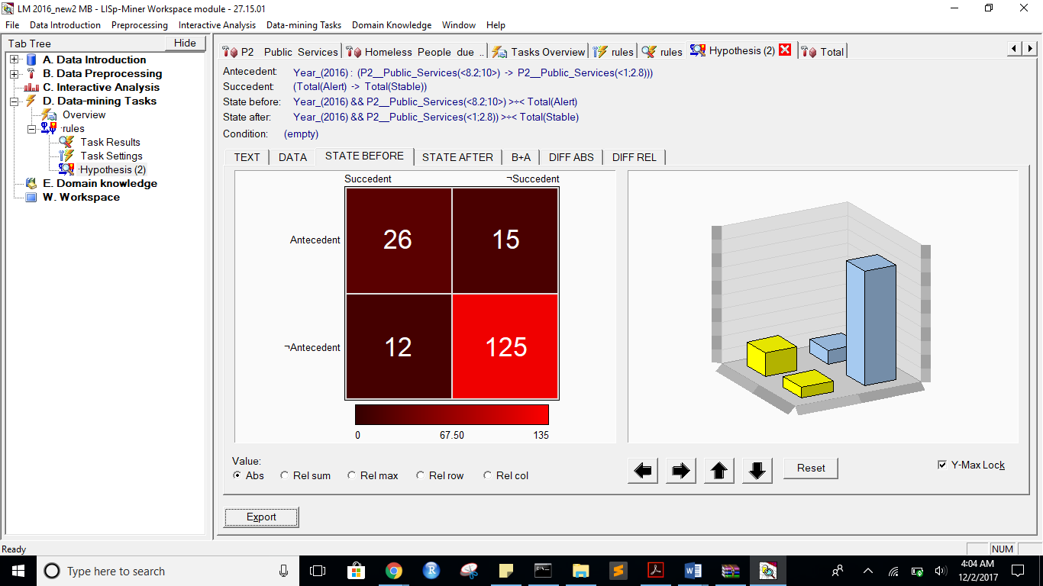

**After:**

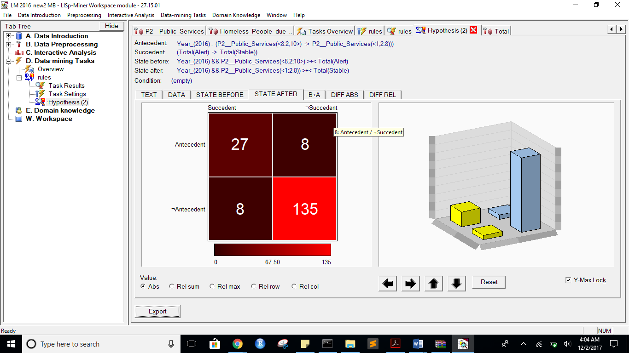

**B+A:**

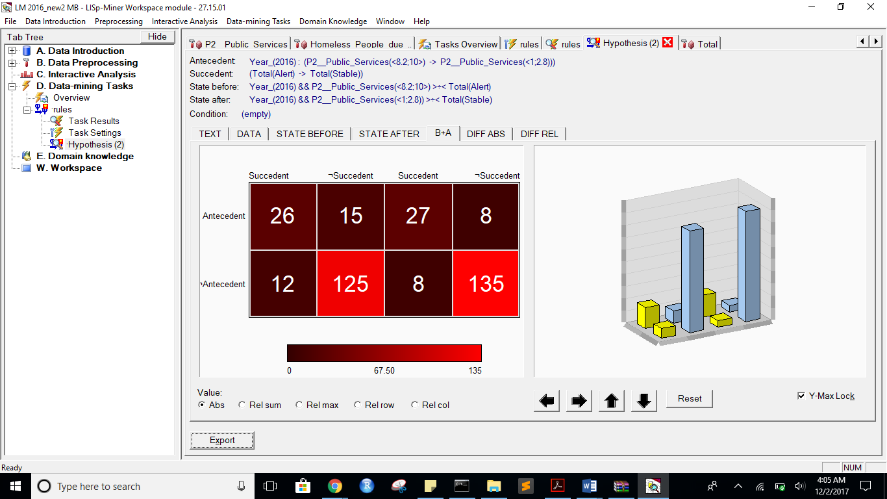

**DIFF ABS:**

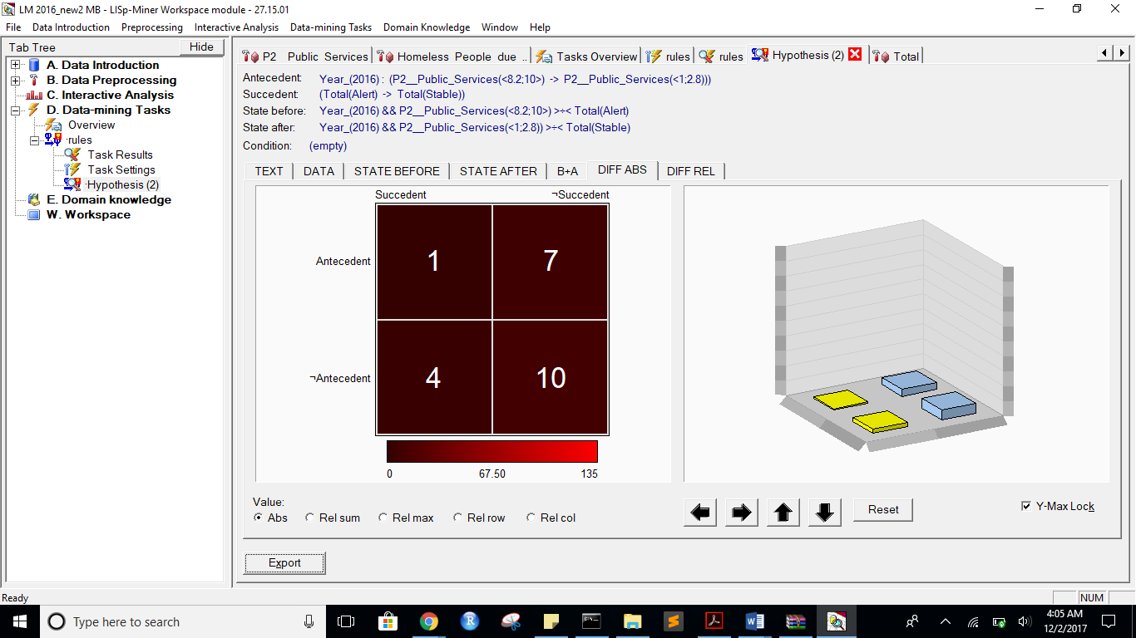

**REL:**

