**Field Service WorkOrder Optimization**

**1.Project Overview**

**1.1 Project Name**

Field Service WorkOrder Optimization

**1.2 Project Description**

The Field Service WorkOrder Optimization project aimed to enhance efficiency of field service operations by implementing a comprehensive Salesforce system.The system integrates various custom objects and automation features to streamline the management of work orders,technicians,and assignments.

**1.3 Objectives**

● Optimization of Work Order Assignment

● Integration with Existing Systems

● User Experience Enhancement

● Reporting and Analytic

**1.4 Outcomes** The project successfully met its objectives, leading to the following outcomes:

● Increased Efficiency

● Improved Technician Productivity

● Enhanced Data Accuracy

● Positive User Feedback

● Better Decision-Making

**2.Implementation Details**

**2.1 Custom Objects Created**

**1. Technician Object**

○ **Purpose**: To store detailed information about technicians.

○ **Data Imported**: Technician details from the Technician.csv file.

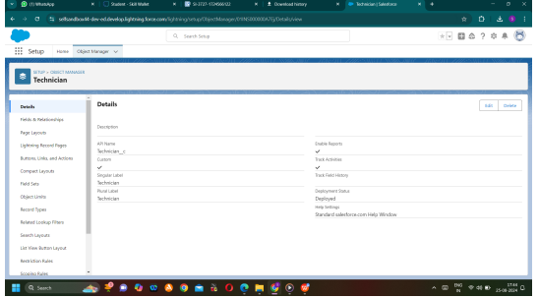

**2. WorkOrder Object**

○ **Purpose:** To manage and track work orders assigned to field technicians.

○ **Fields:** Includes details such as Priority, Service Type, and Location.

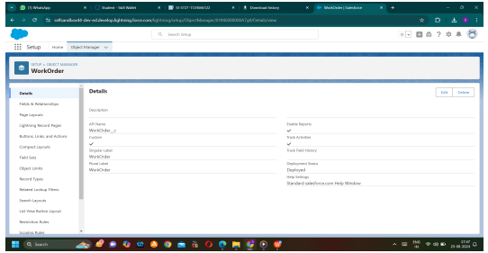

**3. Assignment Object**

○ **Purpose:** To manage the assignment of work orders to technicians.

○ **Fields:** Includes Technician ID, Assignment Date, and Completion Date

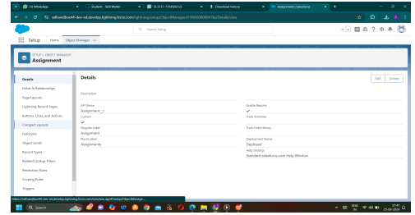

**2.2 Custom Fields and Relationships**

**1. Assignment Object**

○ **Lookup Field**: Created a Lookup field to associate with the WorkOrder object.

○ **Formula Fields**: Added formula fields to calculate dates and statuses based on related records.

**2. WorkOrder Object**

**○ Picklist Values**: Added picklist values for fields like Priority and Service Type.

○ **Formula Fields**: Created formula fields to capture creation dates and status updates.

**2.3 Tabs and Navigation**

● **Custom Tabs**: Created a tab for the Assignment object.

● **Navigation:** Added relevant items (Home, WorkOrder, Technician, Assignment, Reports, Dashboard) to the Lightning App.

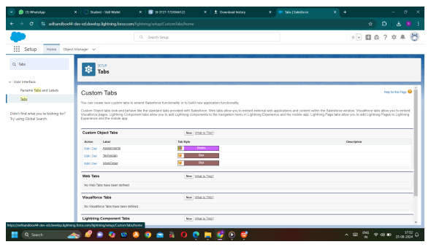

**2.4 Lightning App Creation**

● **App Name:** Field Service WorkOrder Optimization

● **Navigation Items:** Included Home, WorkOrder, Technician, Assignment, Reports, and Dashboard.

● **User Profiles:** Assigned access to the System Administrator profile for visibility.

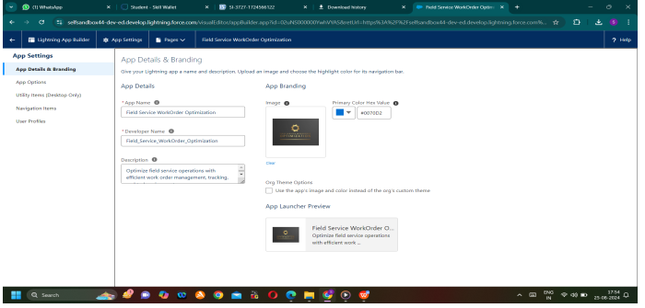

**3.Fields & Relationship**

● Creating Lookup Field In Assignment Object(WorkOrder, Technician ID) And Formula field(Assignment Date,Completion Date).

● Manage Your Picklist Values(Location, Priority,Service Type) in WorkOrder Object

● Creating Formula Field In WorkOrder Object(Date) 4. User Profiles and Permissions

**4.1 Technician Profile**

● **Permissions:** Provided Read-Only access to Technician, WorkOrder, and Assignment objects.

● **Field-Level Security:** Enabled visibility for critical fields such as Status in the WorkOrder object.

**4.2 User Creation**

● **User Details:** Created a user with the profile of Technician, including personal details and Salesforce Platform license.

**5.Apex Trigger**

Use Salesforce Developer Console or Salesforce CLI to deploy the following Apex classes and triggers:

- Apex Classes:

•WorkOrderClass,

•AssigningEmailClass

•CompletionMail Class

•RecordDeletion Class

•Schedule Class

- Apex Triggers:

•WorkOrderTrigger,

•Assignment Trigger

**6.Reports & Dashboards**

Salesforce Reports and Dashboards are powerful tools that empower users to visualize and analyze data within he Salesforce platform. They play a crucial role in providing insights, monitoring performance, and making informed business decisions.

**Create Reports**

● Create a report with report type: “Assignment with WorkOrder ID”.

● Create a report with report type: “WorkOrders Status Reports”

● Create a report with report type: “Technician and Assignment Details Reports”.

**Create Dashboards**

**7. Project Summary**

The Field Service WorkOrder Optimization project successfully established a Salesforce system tailored for efficient field service management. By integrating custom objects, automating processes, and providing valuable insights, the project has enhanced operational efficiency and customer satisfaction