Exercise
- Git Setup https://confluence.atlassian.
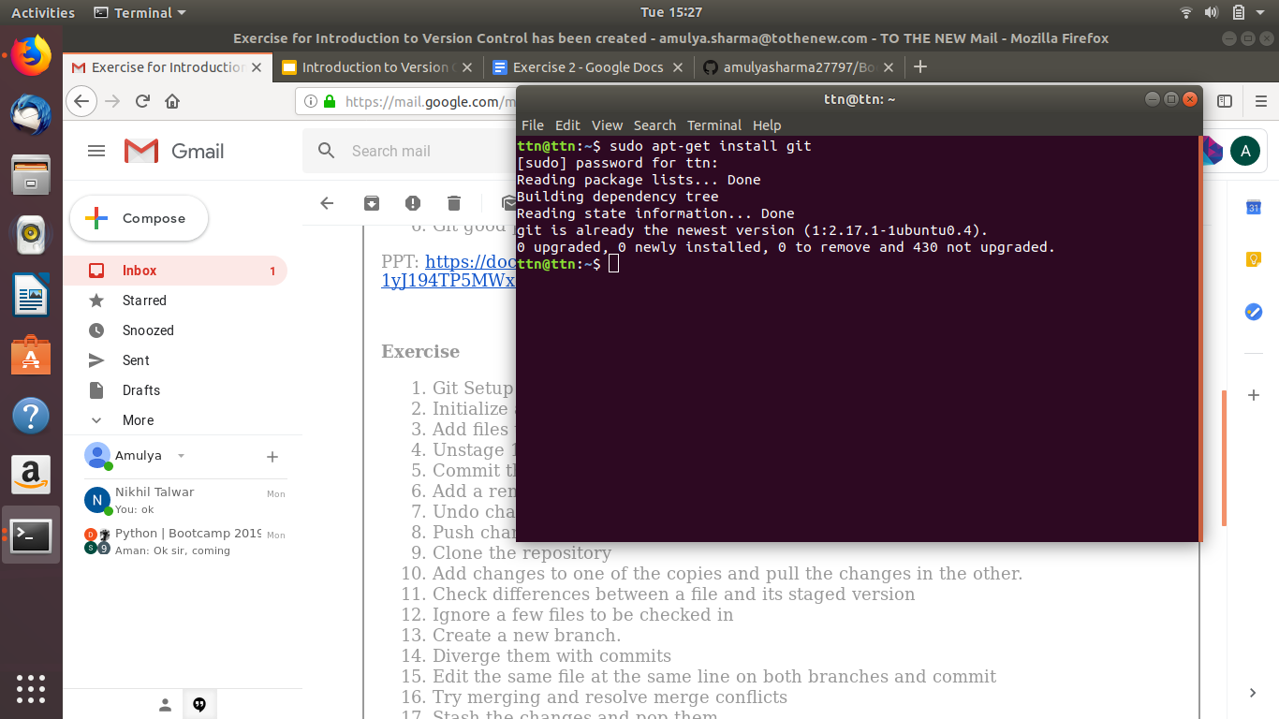
- Initialize a Git Repository
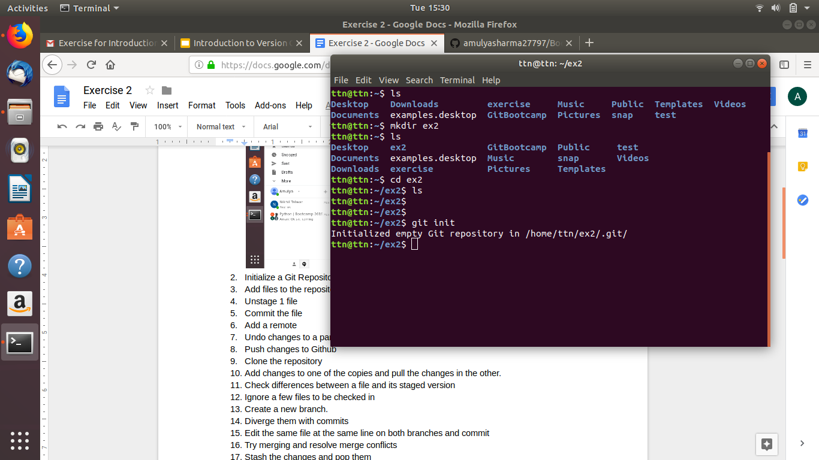
- Add files to the repository
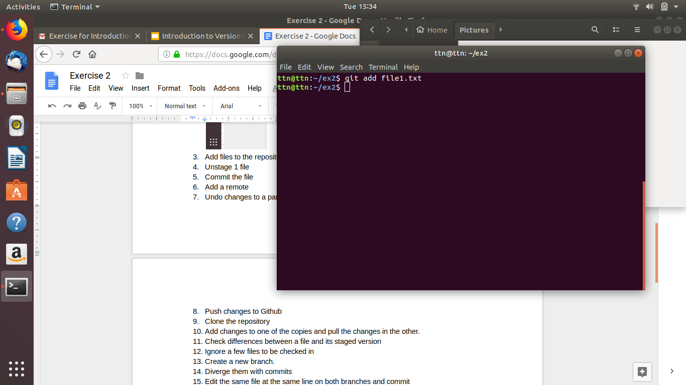
- Unstage 1 file
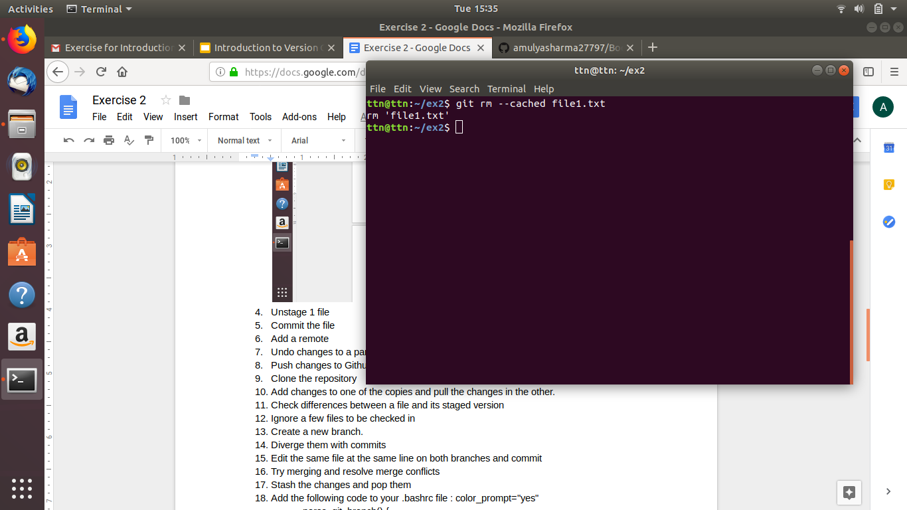
- Commit the file
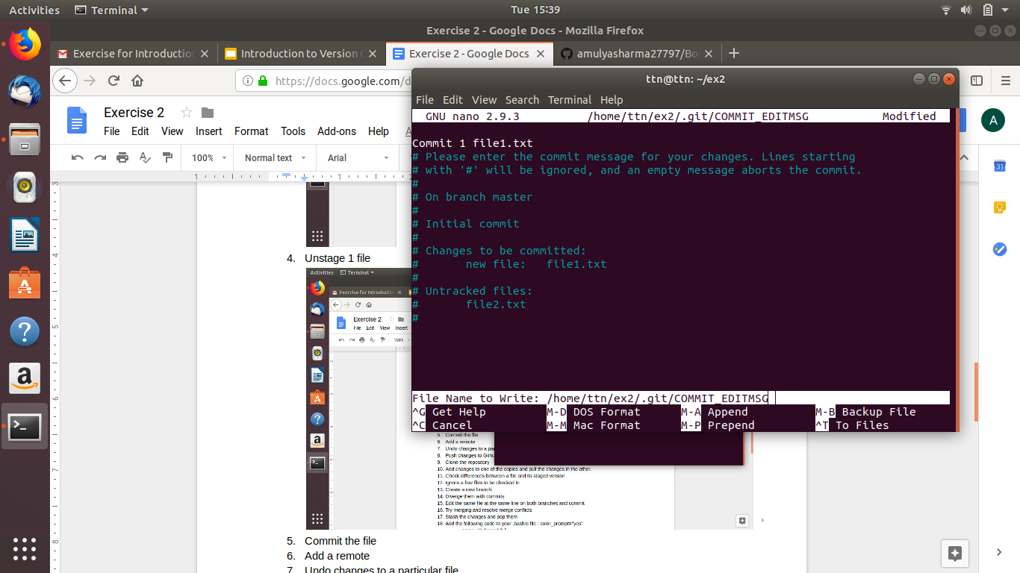
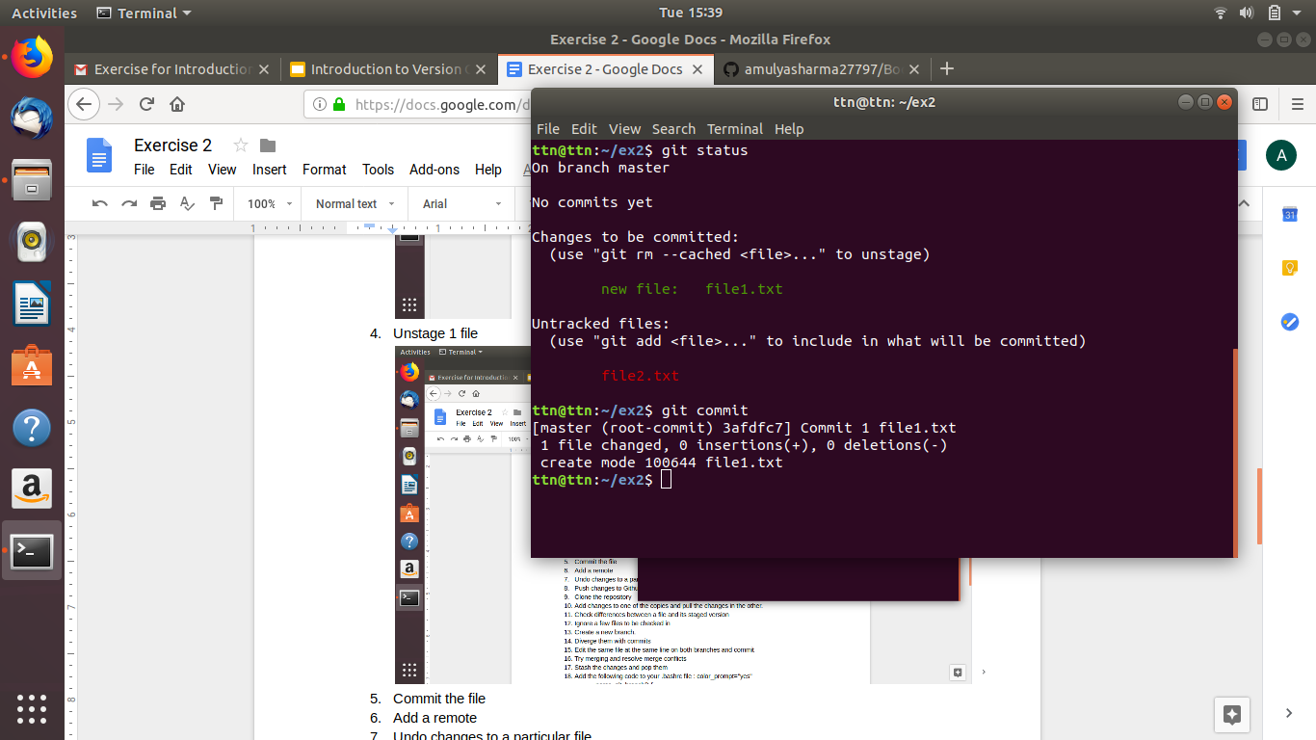
- Add a remote
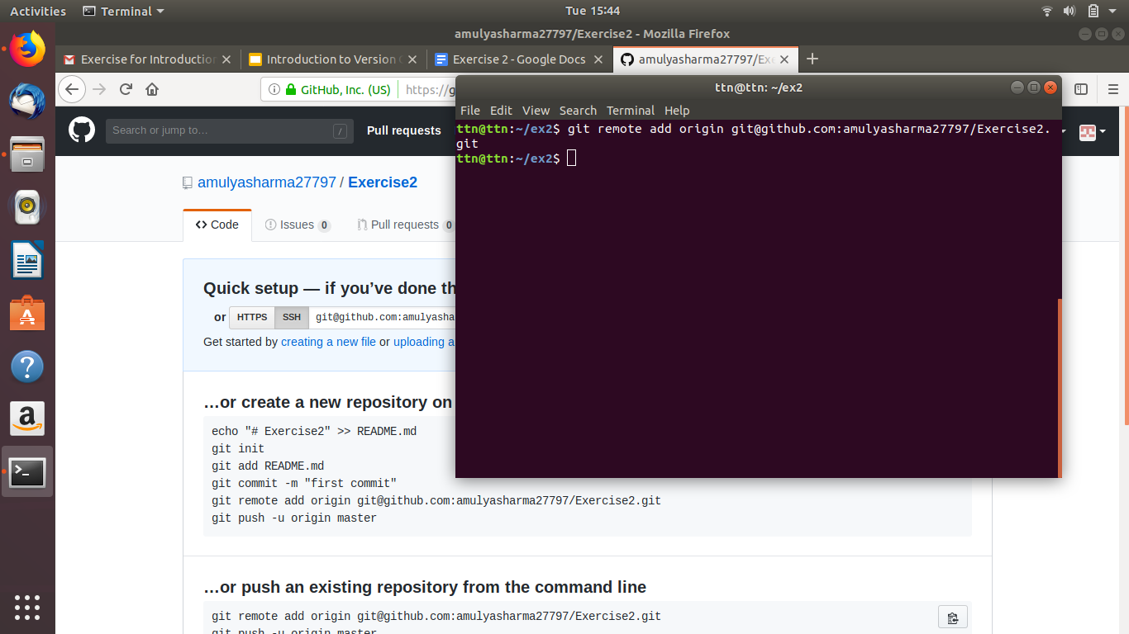
- Undo changes to a particular file
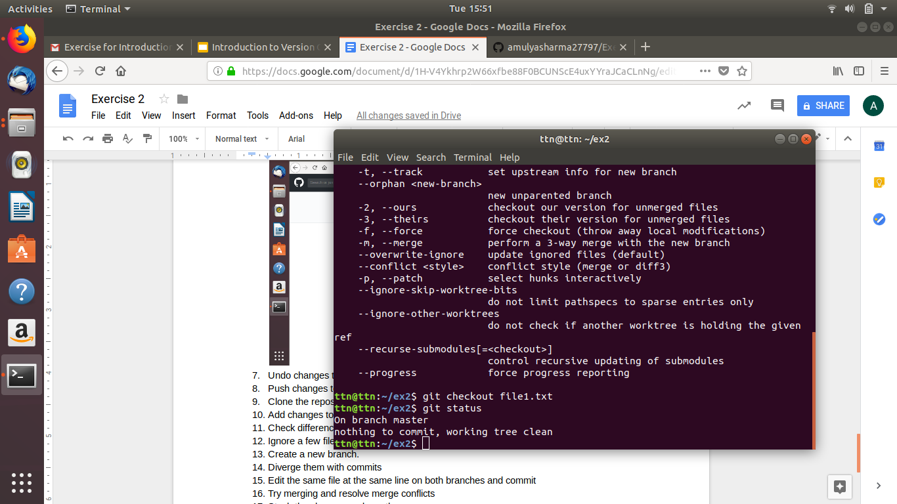
- Push changes to Github
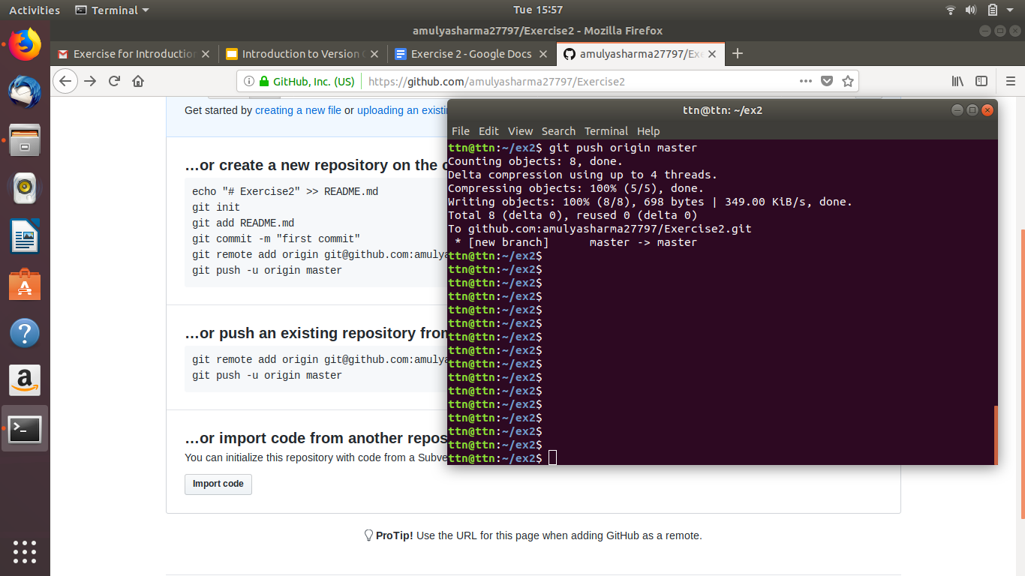
- Clone the repository
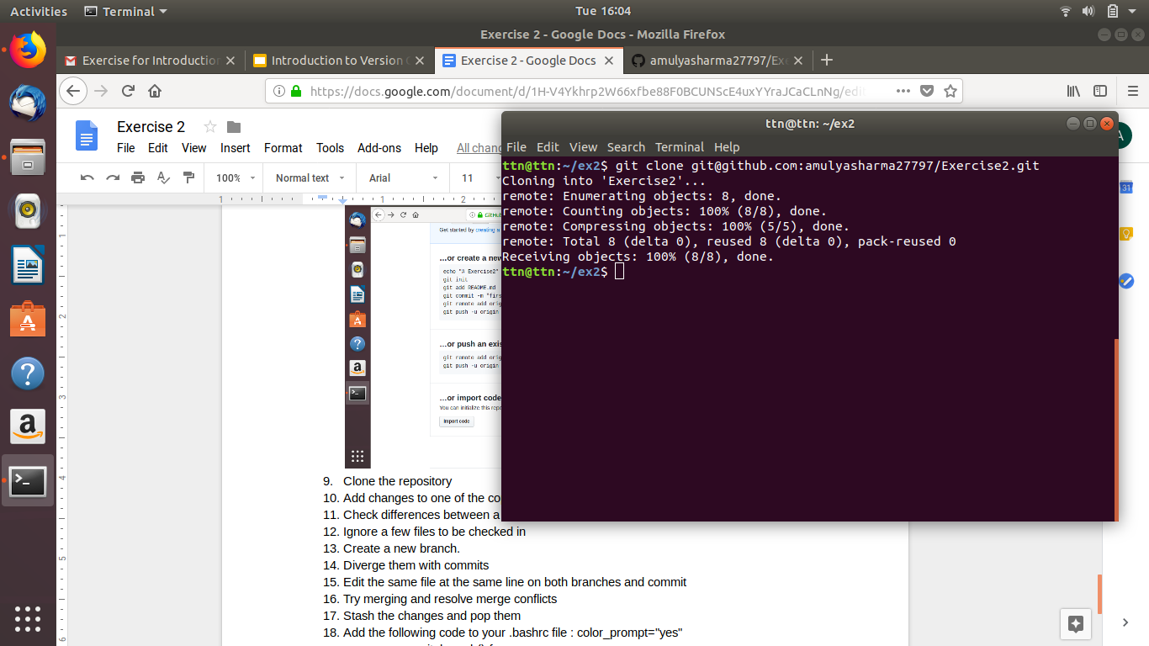
- Add changes to one of the copies and pull the changes in the other.
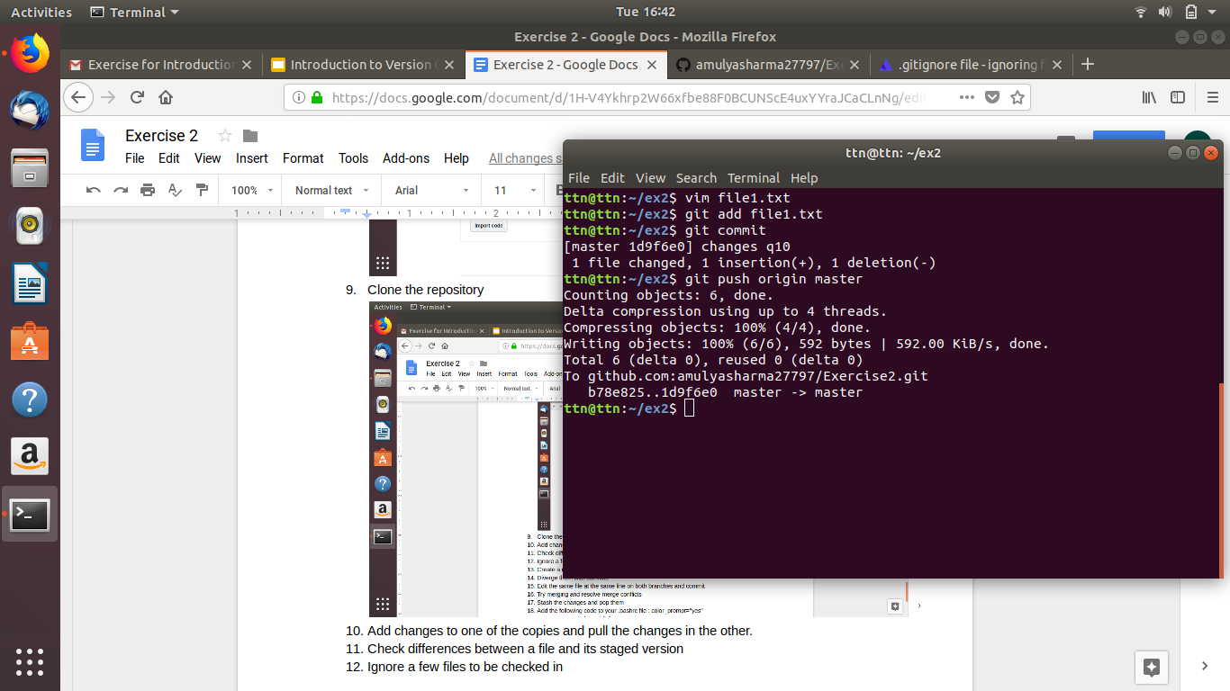
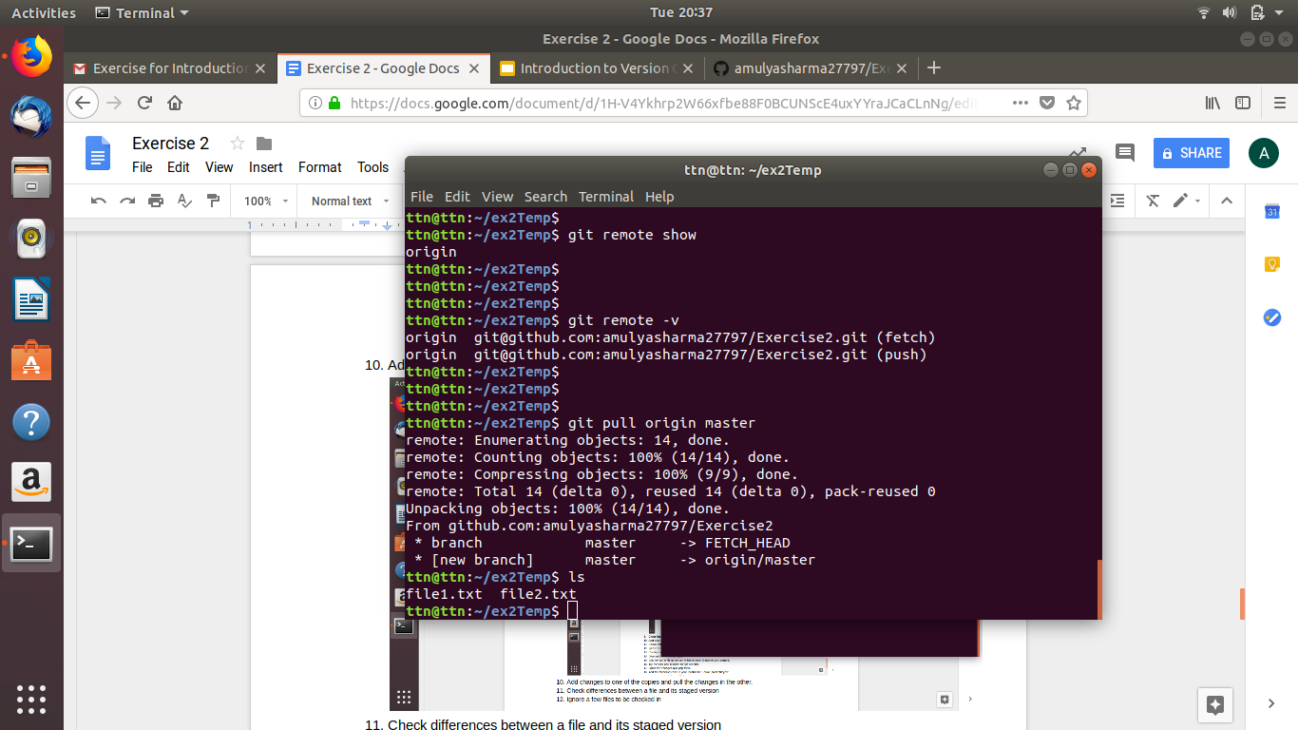
- Check differences between a file and its staged version
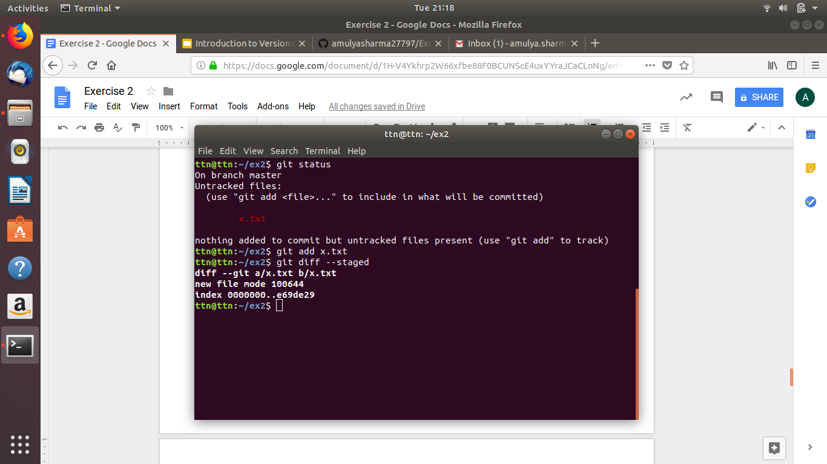
- Ignore a few files to be checked in
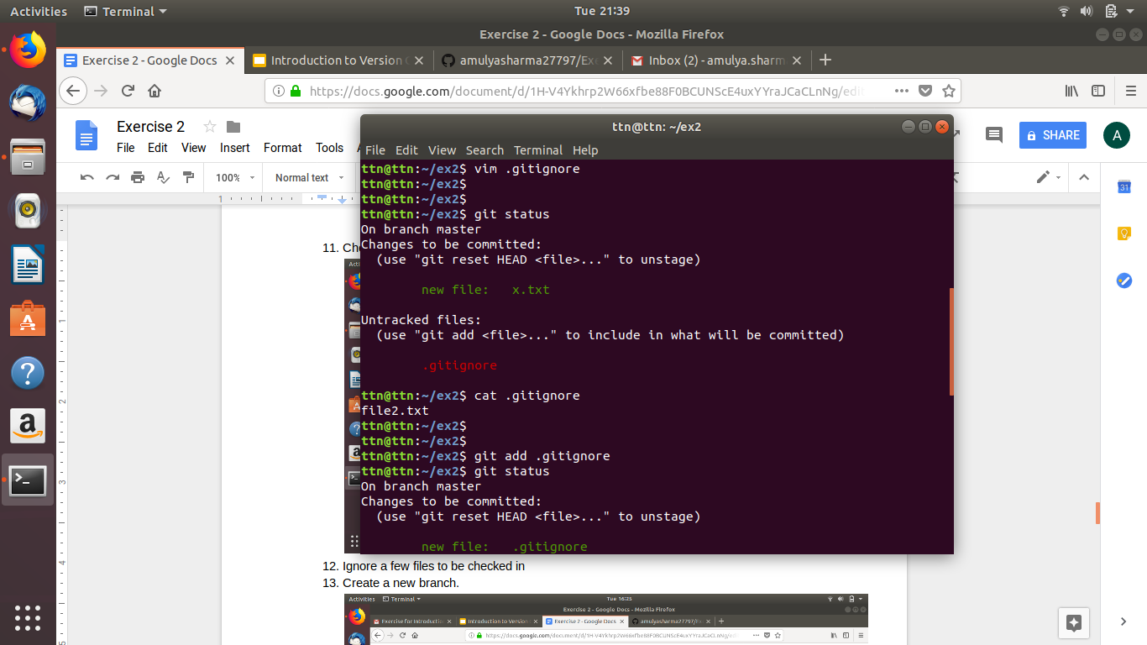
- Create a new branch.
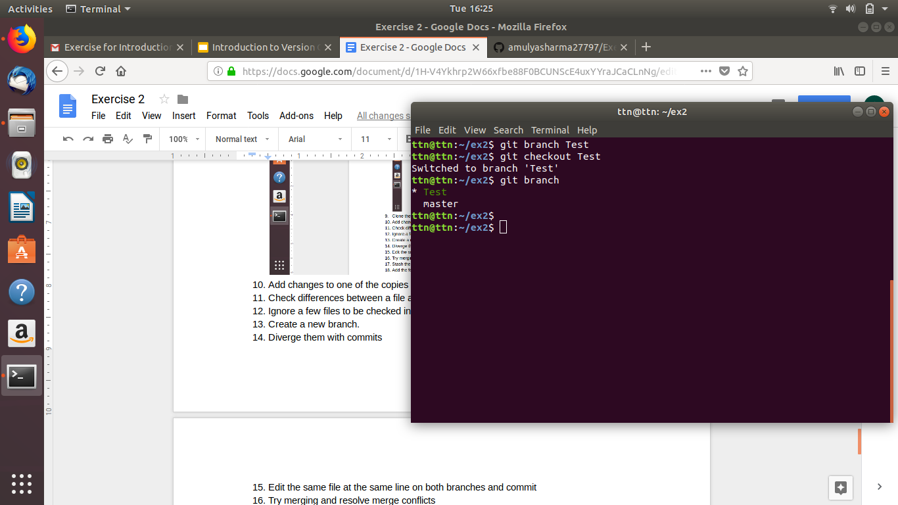
- Diverge them with commits
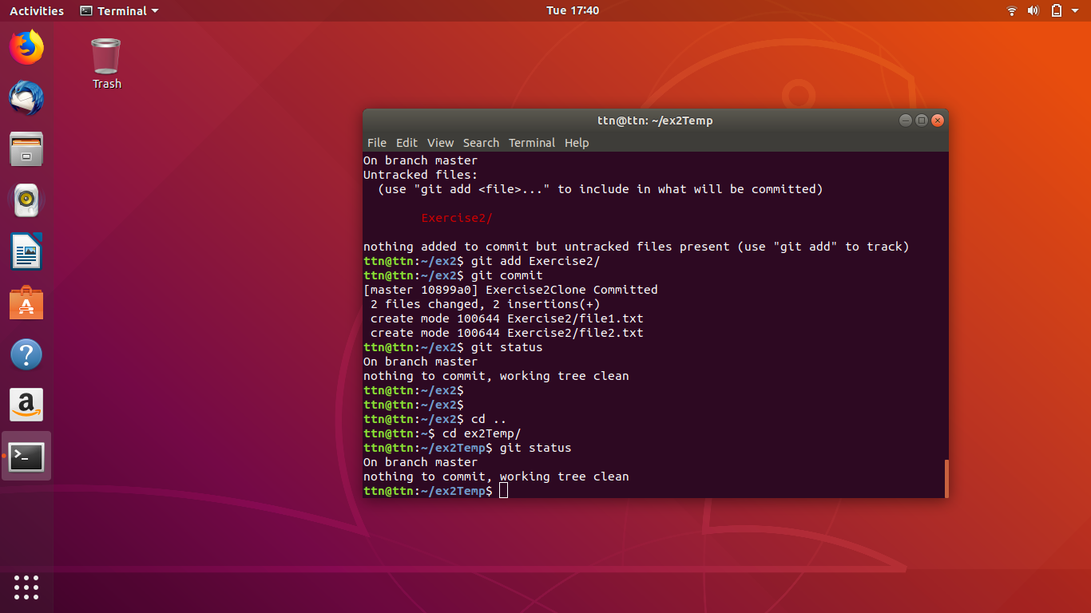
- Edit the same file at the same line on both branches and commit
- Try merging and resolve merge conflicts
- Stash the changes and pop them
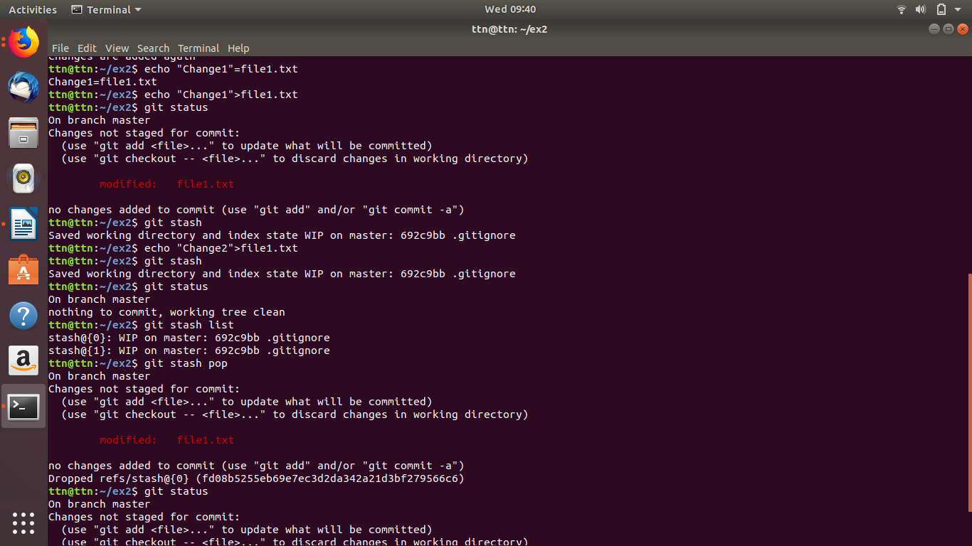
- Add the following code to your .bashrc file : color_prompt="yes"
parse_git_branch() {
git branch 2> /dev/null | sed -e '/^[^*]/d' -e 's/* \(.*\)/(\1)/'
}
if [ "$color_prompt" = yes ]; then
PS1='\u@\h\[\033[00m\]:\[\033[
else
PS1='\u@\h:\W $(parse_git_branch)\$ '
fi
unset color_prompt force_color_prompt
